**Name: Brijesh Rameshbhai Rohit**

**Admission number: U19CS009**

**SYSTEM SOFTWARES**

**ASSIGNMENT 1**

**1) Write a C program to test whether a given identifier is valid or not.**

**Code:**

|  |
| --- |
| **//u19cs009**  **/*Brijesh Rohit*/**  **#include <stdbool.h>**  **#include <stdio.h>**  **#include <string.h>**  **#include <stdlib.h>**  **#include <ctype.h>**  **char keywords[32][10] = {**  **"auto","case","char","continue","default","do","else","double",**  **"const","enum","extern","float","for","goto","if","int","while",**  **"break","long","register","return","short","signed","sizeof",**  **"static","struct","switch","typedef","union","unsigned","void",**  **"volatile"**  **};**  **bool isKeyword(char* str)**  **{**  **for(int i = 0 ; i < 32 ; i++)**  **{**  **if(!strcmp(str,keywords[i]))**  **return true;**  **}**  **return false;**  **}**  **bool isIdentifier(char* str)**  **{**  **if (isKeyword(str))**  **return false;**  **if (!isalpha(str[0]) && str[0] != '_')**  **return false;**  **for (int i = 1; i < strlen(str); i++)**  **{**  **if (!isalnum(str[i]))**  **return false;**  **}**  **return true;**  **}**  **int main()**  **{**  **char str[100];**  **printf("Enter the string : ");**  **scanf("%s", str);**  **if (isIdentifier(str))**  **{**  **printf("Given string is a Valid Identifier!!!\n");**  **}**  **else {**  **printf("Given string is an Invalid identifier!!!\n");**  **}**  **return 0;**  **}** |

**Output:**

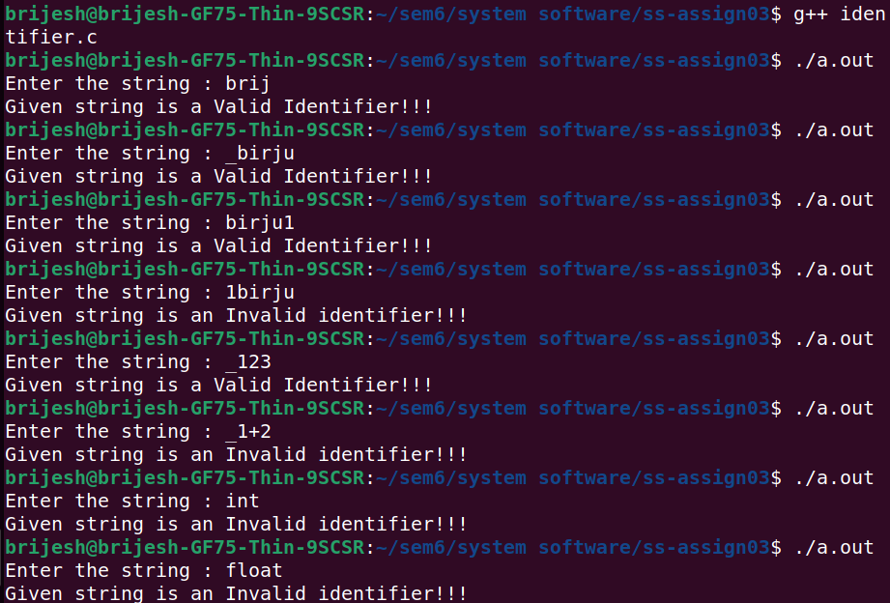

**2) Write a C program to identify whether a given line is a comment or not.**

**Code:**

|  |
| --- |
| #include <stdbool.h>  #include <stdio.h>  #include <string.h>  #include <stdlib.h>  #include <ctype.h>  void parseString(char *str)  {  int i = 0, j = 0;  while (str[i] == ' ')  i++;  while (i < strlen(str))  {  str[j] = str[i];  i++;  j++;  }  str[j] = '\0';  j = strlen(str) - 1;  while (str[j] == ' ')  j--;  str[j + 1] = '\0';  }  bool singlelinecomment(char* str, int s)  {  while (str[s] == ' ') s++;  int l = strlen(str) - s;  if (l < 2) return false;  if (str[s] != '/' || str[s + 1] != '/') return false;  return true;  }  bool multilinecomment(char* str, int s)  {  while (str[s] == ' ') s++;  int l = strlen(str) - s;  if (l < 4) return false;  if (str[s] != '/' || str[s + 1] != '*') return false;  int end = -1;  for (int i = s + 2; i < strlen(str) - 1; i++)  {  if (str[i] == '*' && str[i + 1] == '/')  {  end = i + 1;  break;  }  }  if (end == -1) return false;  if (end != strlen(str) - 1) return singlelinecomment(str, end + 1) || multilinecomment(str, end + 1);  return true;  }  int main()  {  char string[100];  printf("Enter the string : ");  scanf("%[^\n]s", string);  parseString(string);  if (singlelinecomment(string, 0))  printf("String is single line comment!!!\n");  else if (multilinecomment(string, 0))  printf("String is multiline comment!!!\n");  else  printf("String is not a comment!!!\n");  return 0;  } |

**Output:**

