**Name: Brijesh Rameshbhai Rohit**

**Admission number : U19CS009**

**SS-ASSIGNMENT-08**

1. Write a Lex program to count the number of lines, characters and words of the given input file.

CODE :

| **%{**  **#include<stdio.h>**  **int countLine = 0, countWords = 0, countChars = 0;**  **%}**  **%%**  **\n {countLine++;}**  **[^ \n\t]+ {countWords++, countChars+=yyleng-1;}**  **. {countChars++;}**  **%%**  **int yywrap(void){}**  **int main(int argc, char*argv[])**  **{**  **yyin=fopen(argv[1],"r");**  **yylex();**    **printf("Number of lines : %d\n", countLine);**  **printf("Number of words : %d\n", countWords);**  **printf("Number of chars : %d\n", countChars);**  **}** |
| --- |

INPUT TEXT FILE :

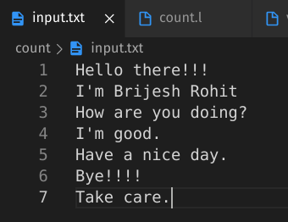

OUTPUT :

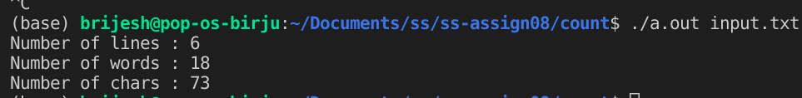

2. Write a lex program to find out the total number of vowels, and consonants from the given input string.

CODE :

| **%{**  **#include<stdio.h>**  **int vowels=0, consonants=0, chars=0;**  **%}**  **%%**  **[aeiouAEIOU] {vowels++;chars++;}**  **[a-zA-Z] {consonants++;chars++;}**  **. {chars++;}**  **%%**  **int yywrap() {}**  **int main() {**  **printf("Enter string : ");**  **yylex();**  **printf("\nNumber of vowel : %d\n", vowels);**  **printf("Number of consonants : %d\n", consonants);**  **printf("Number of chars : %d\n", chars);**  **return 0;**  **}** |
| --- |

OUTPUT :

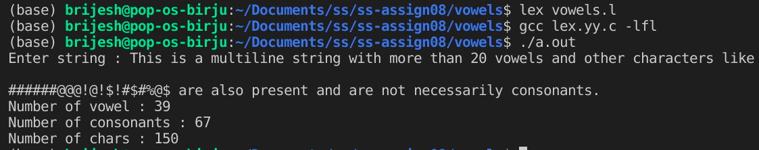

3. Write a Lex Program to convert Lowercase string to Upper case. Input:abc Output: ABC

CODE :

| **%{**  **#include<stdio.h>**  **#include<stdlib.h>**  **#include<string.h>**  **%}**  **%%**  **[a-z] printf("%c",yytext[0] - ('a' - 'A'));**  **[A-Z] printf("%c",yytext[0] + ('a' - 'A'));**  **. printf("%c",yytext[0]);**  **%%**  **int yywrap(){}**  **int main(){**  **printf("Enter string : ");**  **yylex();**  **printf("\n");**  **return 0;**  **}** |
| --- |

OUTPUT :

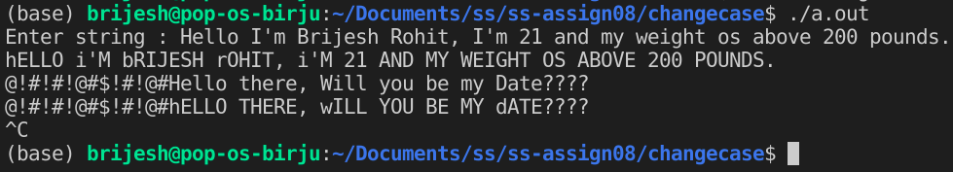

4. Write a Lex program to check valid/invalid

(a) Mobile number (considering 10-digit mobile number followed by country code +91)

(b) Email address

CODE :

| **%{**  **#include<stdio.h>**  **int flag = 0;**  **%}**  **%%**  **[a-z.0-9_]+@[a-z]+".com"|".in"|".org" flag = 1;**  **[+91][1-9][0-9]{9} {if(yyleng == 13)flag = 1;}**  **%%**  **int yywrap(){}**  **int main()**  **{**  **printf("Please enter your email/mobile number with initials : ");**  **yylex();**  **printf("\n");**  **int flag = 1;**  **if (flagemail == 1)**  **{**  **printf("Accepted\n");**  **flag = 0;**  **}**  **if(flag)**  **printf("Invalid input\n");**  **return 0;**  **}** |
| --- |

OUTPUT :

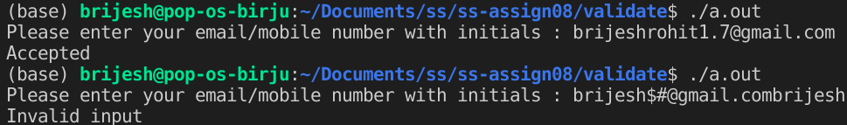

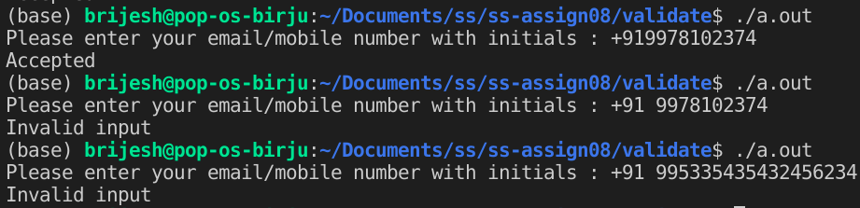

5. Write a Lex program to implement a simple Calculator.

CODE :

| **%{**  **#include<stdio.h>**  **char op;**  **float num1=0, num2=0;**  **int flag = 0, flag1 = 0;**  **%}**  **%%**  **([0-9])+ {if(flag==0) {num1=atoi(yytext);}else{num2=atoi(yytext);}};**  **([0-9])*[.]([0-9])* {if(flag==0) {num1=atof(yytext);}else{num2=atof(yytext);}};**  **([/*+-]) {op=yytext[0];flag=1;};**  **\n {flag=0;if(op=='+')printf("Answer: %f\n",num1+num2); else if(op=='-')printf("Answer: %f\n",num1-num2); else if(op=='*')printf("Answer: %f\n",num1*num2);else if(num2 ==0)printf("Division with 0 is invalid\n"); else if(op=='/')printf("Answer: %f\n",num1/num2);};**  **. {};**  **%%**  **int main()**  **{**  **yylex();**  **return 0;**  **}** |
| --- |

OUTPUT :

