when NULLs are possible in the data, a predicate can evaluate

to true, false, and unknown. This type of logic is known as ***three-valued logic*.**

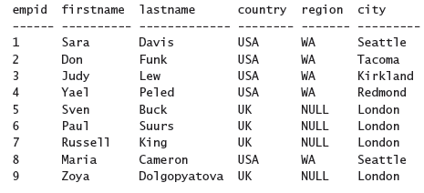

SELECT empid, firstname, lastname, country, region, city

FROM HR.Employees

WHERE country = N'USA';

When NULLs are not possible in the data the predicate can evaluate to true or false. The type of logic used in such a case is known as **two-valued logic**. The **WHERE filter** returns only the rows for which the predicate evaluates to **true.**

Consider :

Country: UK Region: NULL City: London

SELECT empid, firstname, lastname, country, region, city FROM HR.Employees

WHERE region <> N'WA';

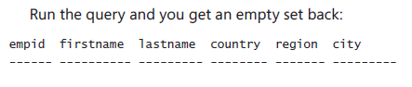

You get an unknown when at least one operand is NULL; for example, NULL and WA, or even NULL and NULL.

SELECT empid, firstname, lastname, country, region, city

FROM HR.Employees

WHERE region <> N'WA' OR region IS NULL;