**Major Project**

**Report**

On

**“Number Plate**

**Recognition System”**

# Certificate

This is to certify that the Project Report entitled ," **Number Plate Recognition**

**System** ” submitted by **"Brijesh Yadav, Abhishek Gupta, Abhishek Yadav**” to The Dr AITH Kanpur, India, is a record of Bonafede Project work carried out by him/her under my/our supervision and guidance and is worthy of consideration for the award of the degree of Bachelor of Technology in Information Technology of the University.

# ACKNOWLEDGEMENT

The opportunity to work on this project was a great chance for learning and professional development. Therefore, we consider ourselves lucky as we were provided with an opportunity to be a part of it.

We would like to express our deepest thanks to Ms. Yogita (project mentor) and other faculty members for taking part in useful decision & giving necessary advice and guidance and arranged all facilities needed. We choose this moment to acknowledge their contribution gratefully.

We perceive this opportunity as a big milestone in our career development. We will strive to use gained skills and knowledge in the best possible way in order to attain desired career objectives.

We are also thankful to all the members of the faculty of our institute for their constant encouragement and valuable inputs from time to time throughout the course of our studies.

# ABSTRACT

With the advent of emerging technologies and the rapid growth of Internet, the world is moving towards e world where most of the things are automated and available remotely. With this the security systems are also been updated and automated. With automation the tracking of vehicles manually was really hard to be done manually but with the automation system the manual tracking load is to be shifted on machine side using the machine learning. With our project we see what are the capabilities of machine learning in the near future and how its going to solve various problems that were nearly difficult to handle nowadays

# INTRODUCTION

Vehicle tracking system is system that uses automatic number-plate recognition, a technology that has optical character recognition on images to read vehicle registration plates to create vehicle location data. It can use existing closed-circuit television, road-rule enforcement cameras, or cameras specifically designed for the task. ANPR is used by police forces around the world for law enforcement purposes, including to check if a vehicle is registered or licensed. It is also used for electronic toll collection on pay-per-use roads and as a method of cataloguing the movements of traffic, for example by highways agencies.

**Automatic Number Plate Recognition System**

**About :**

Number plate recognition system(NPRS) uses optical character recognition(OCR) on images taken by cameras. In certain countries, number plate switched to a different style, one of the changes made was to the FONT, introducing small gaps in some letters(such as P and R) to make them more distinct and therefore more legible to such systems. Some license plate arrangements use variations in font sizes and positioning- NPRS systems must be able to cope with such differences in order to be truly effective. More complicated systems can cope with international variants, though many programs are individually tailored to each country.

**Why Choose this project?**

We know India is the second most populous country with approximately one billion people.

So there are multiple uses of NPRS like in highways monitoring, parking management, neighbourhood law enforcement security etc,.

We want to deploy this system to every society and neighbourhood to enhance the vehicle monitoring systems. We plan to achieve this goal by making it a cost-effective project.

**Technologies used:**

* It uses optical character recognition (OCR) on images taken by cameras (Tesseract)
* Python Imaging Library (abbreviated as PIL) (in newer versions known as Pillow) is a free library for the Python programming language that adds support for opening, manipulating, and saving many different image file formats.
* OpenCV (Open Source Computer Vision) is a library of programming functions mainly aimed at real-time computer vision. In simple language it is library used for Image Processing. It is mainly used to do all the operation related to Images.
* Execution:
  + Vehicle image capture
  + Numberplate Isolation
  + Character segmentation and recognition

**Difference in other similar projects:**

* Basically all of the existing projects which we are studying are using infrared light to detect the number plate. We in our project will be trying to create ANPR in which user can use any camera to detect the number plate. But for which it has to pass some certain conditions.
* The user’s camera should be able to capture proper and clear picture. If the picture quality will be poor then the system might not to able to detect the characters of the number plate
* It might misread some of the characters due to which the user has to bear a huge loss and a huge fault in data entry.
* The second condition is that the object should not be in a fast motion. It is because we are using some cheap and cost-effective cameras and those cameras might not be so powerful as compared to high power cameras.
* So these cameras might not be able to capture a fast-moving object which will return in a low and blur image quality and hence we will not be able to get the results.

**Applications:**

* Parking
* Access Control
* Tolling
* Stolen cars
* Enforcement
* Journey Time Measurement

# TABLE OF CONTENTS

1. Certificate
2. Acknowledgement
3. Abstract
4. Algorithm
5. Working
6. Code Implementation and output
7. Diagrams
8. References

# Algorithms

* **Plate localization** – responsible for finding and isolating the plate on the picture.
* **Plate orientation and sizing** – compensates for the skew of the plate and adjusts the dimensions to the required size.
* **Normalization** – adjusts the brightness and contrast of the image.
* **Character segmentation** – finds the individual characters on the plates.
* **Optical character recognition**.
* **Syntactical/Geometrical analysis** – check characters and positions against country-specific rules.

The averaging of the Recognized value over multiple fields/images to produce a more reliable or confident result. Especially since any single image may contain a reflected light flare, be partially obscured or other temporary effect.

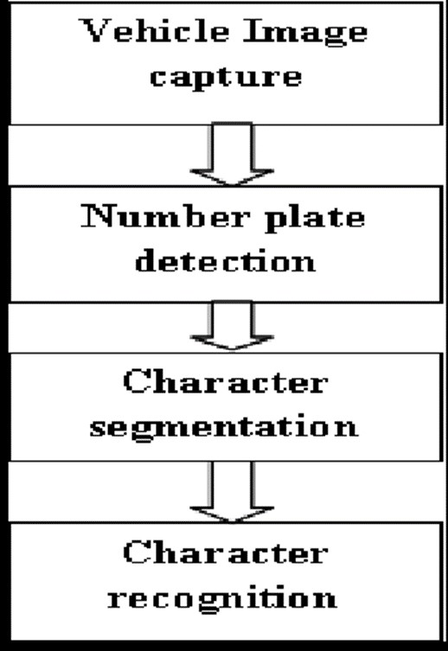

**Working of the Project include following steps-**

* Number plate recognition System will extract out the value of number plate.
* This value is checked on the online database.
* Then this value if fount in the database , creates an array of objects.
* The array is named on the number plate’s value itself.
* Multiple cameras been installed at different places with their location coordinates.
* The current camera co-ordinate is then pushed to the array as an location object.
* Multiple cameras detecting the registration number add their location coordinate to the array.
* In array these location objects are added in ordered form.
* The Location object has geometrical location co-ordinates along with the time stamp.
* This array can be output to other security system for monitoring purpose.

But with this system we have multiple challenges to deal with such as-

* Poor [file resolution,](https://en.wikipedia.org/w/index.php?title=File_resolution&action=edit&redlink=1) usually because the plate is too far away but sometimes resulting from the use of a low-quality camera.
* [Blurry](https://en.wikipedia.org/wiki/Focus_(optics)) images, particularly [motion blur.](https://en.wikipedia.org/wiki/Motion_blur)
* Poor lighting and low contrast due to [overexposure,](https://en.wikipedia.org/wiki/Exposure_(photography)) [reflection](https://en.wikipedia.org/wiki/Reflection_(physics)) or shadows.
* An object obscuring (part of) the plate, quite often a tow bar, or dirt on the plate.
* Read license plates that are different at the front and the back because of towed trailers, campers, etc.

**CODE IMPLEMENTATION AND OUTPUT**

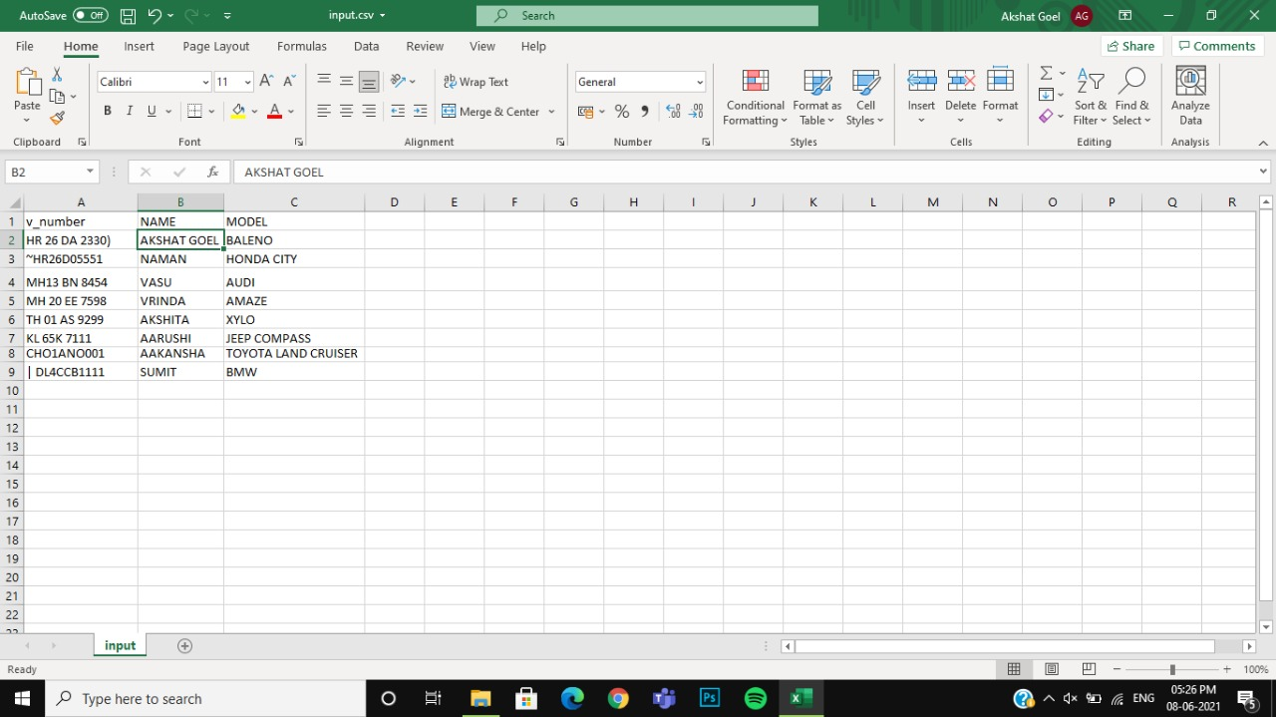

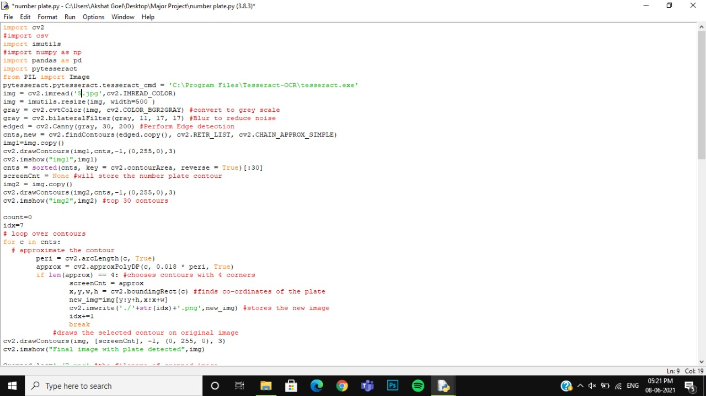

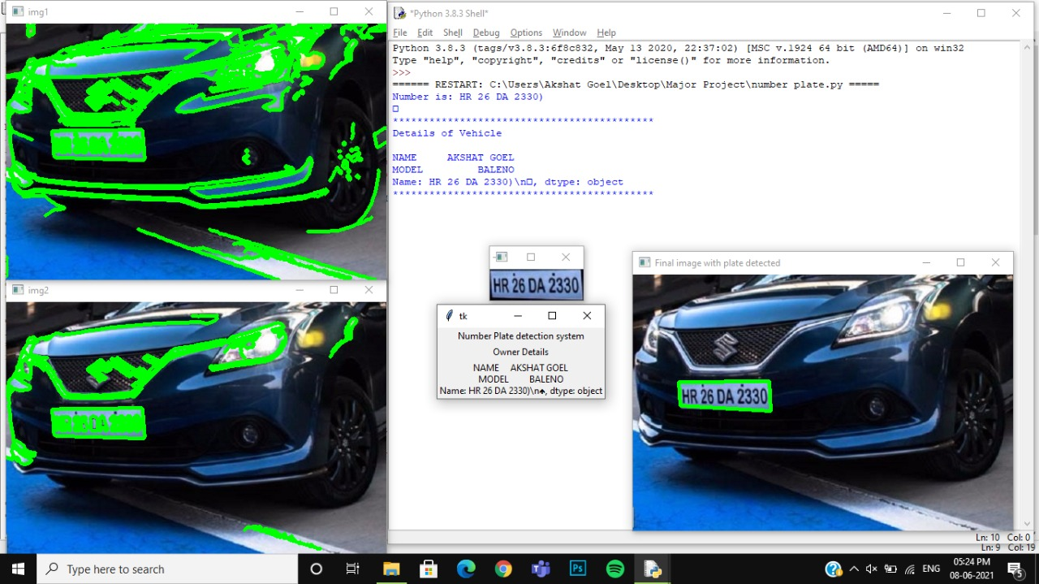

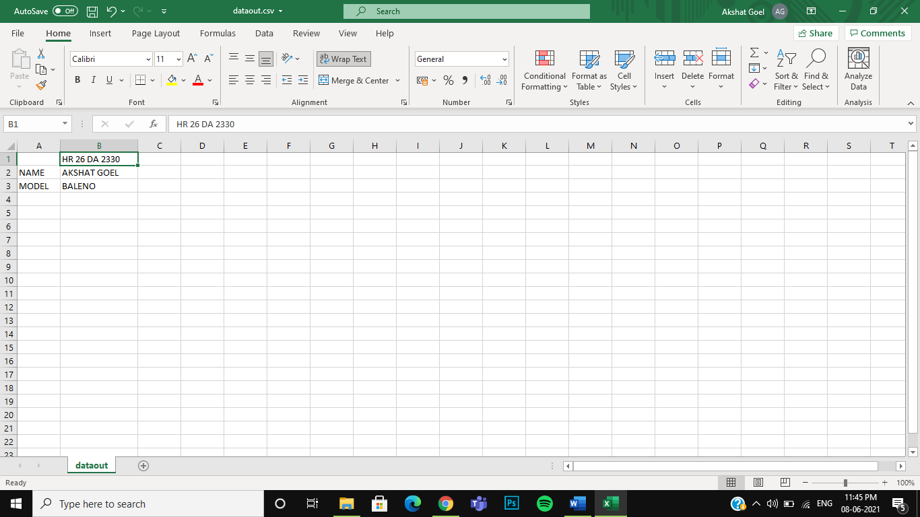

Use Case Diagram:

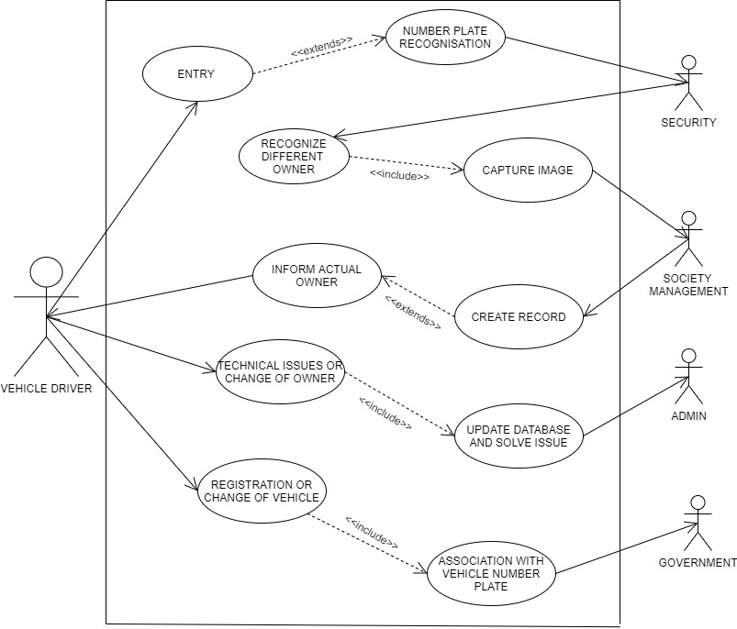

Gantt chart: 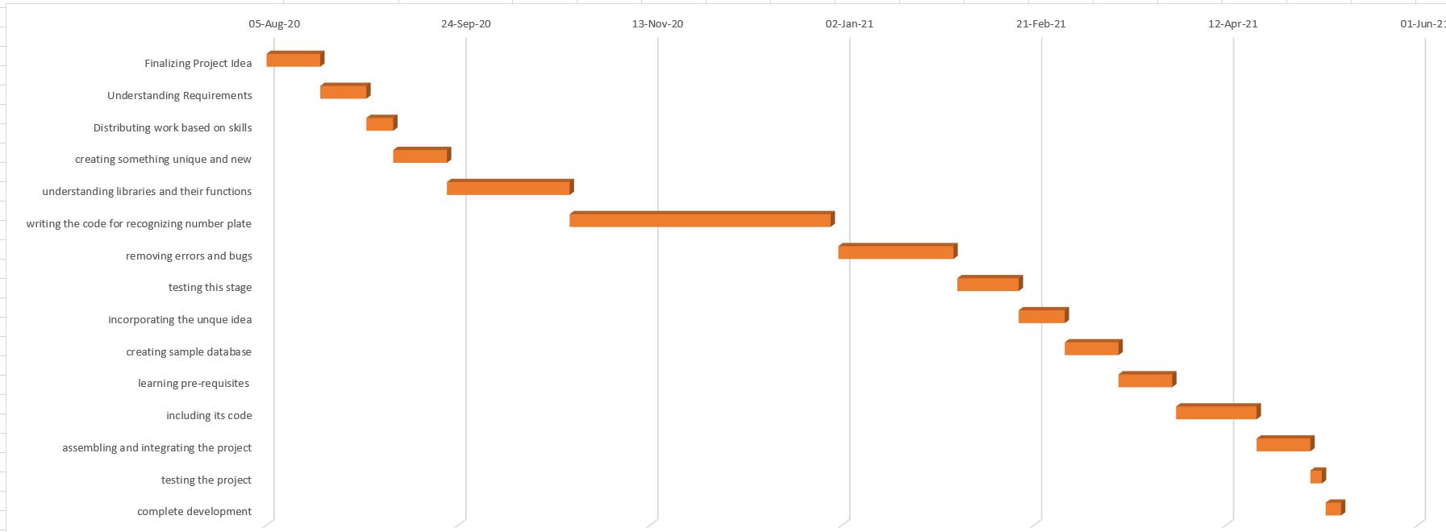

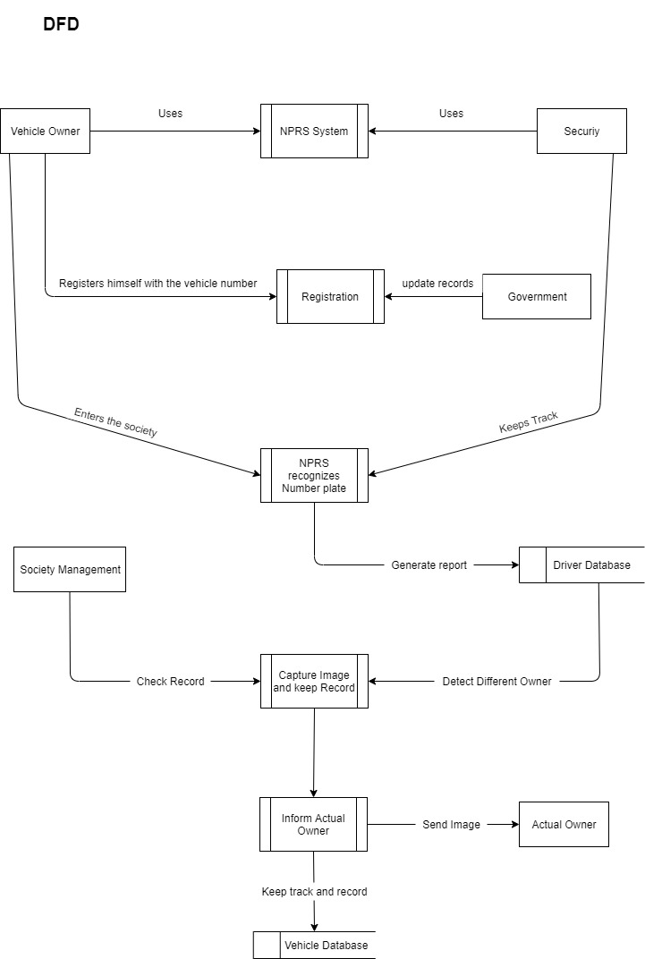

# References

<https://www.tutorialspoint.com/opencv/opencv_reading_images.htm>

<https://www.tutorialspoint.com/pycharm/>

[https://www.pyimagesearch.com/2018/07/19/opencv-tutorial-a-guide-to-learnopencv/](https://www.pyimagesearch.com/2018/07/19/opencv-tutorial-a-guide-to-learn-opencv/)