**CS-4780 Project 2**

**Brij Shah (CIN: 305436344)**

**Hitarth Shah (CIN: 305084889)**

**RSA-Signature**

1. **Programming environment.**

* Run Eclipse.
* Import the java files.

1. **User manual: how to compile and run program.**

Sequence to run program:

* First run KeyGen.java, it will generate public and private keys and create two files **privkey.rsa** and **pubkey.rsa**.
* Now run main.java and choose option 1 to send file and file name as **test.txt.** (Assuming you already have test.txt under your file directory.) and it will genarte signed file named as test.txt.signed.
* Now run ChangeByte.java and enter file name as **test.txt.signed.** Then enter an index to change byte i.e 1.
* Now again run main.java and select option 2 as receive file and enter file name as test.txt.signed and it will show weather the file has been tempered or not.

C) **Screenshot of testing.**

1. **Running KeyGen.java**

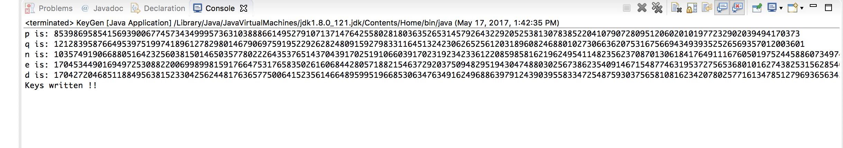

1. **Running Main.java**

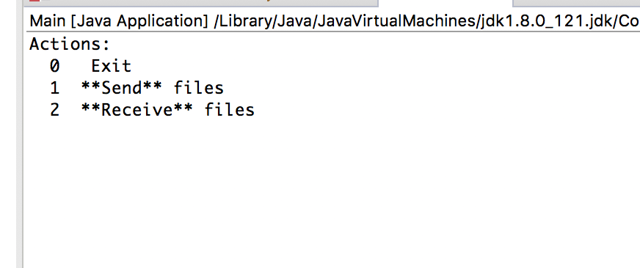

1. **Sending file.**

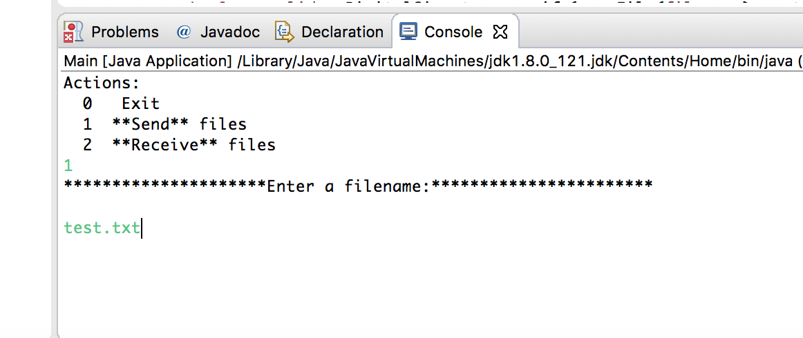

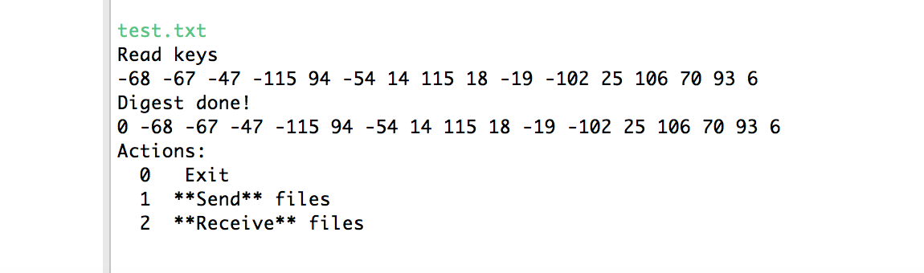

1. **Changing bytes by running ChangeByte.java.**

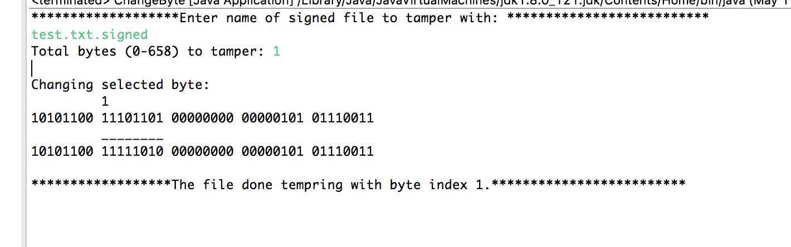

**5.Reciving file and checking for tempering by running Main.java.**

