

**CODE LAB**







**Introduction**

The Application is aimed at creating an online coding environment for competitive programmers where they can practice and solve a wide range of question, improve their problem-solving skills and test their skills on Data Structures & Algorithms from the comfort of their home.

The application has two levels of users:

1. Administrator Level
2. User Level

The Application will provide the administrator with the facility to add new question set and remove users.

The Application will provide the users with the opportunity to register himself, to view his/her past records of solved questions, solve a new question of his choice.

**Online Complier**

The Application also provides the functionality of leaderboard ranking.

With the help of JDoodle online compiler API, we allow users to write programs in a variety of programming languages like C, C++, Java, Python, Javascript and many more.

**Cookies**

We also have enabled users to keep logged in for a month with the help of cookies with store session data of the user. User doesn’t have to login every time he visits our website, thus adding more to user comfort unless he/she logs out.

**Canvas**

We have provided user with a whiteboard using HTML Canvas. It provides users to perform rough work for questions and download it as an image for future reference.

**IDE (Code Editor)**

We have provided an IDE with a powerful IDE to write codes in 20+ languages. IDE is integrated with popular Dark, Light & various colourful Themes like Monokai, Chrome, Xcode, Github, etc. User can change font size as per his convenience. Code is structured and can be copied or downlaoded.

**Leader Board**

We have provided users with a leaderboard ranking table to know their status and compete with other programmers.

**Technology Used**

As this application is a web-based application so we have used web technologies like:

**Frontend:**

1. HTML 5
2. CSS
3. Bootstrap 5
4. ES6(JavaScript)
5. React JS

**Backend:**

1. JavaScript
2. Node.js
3. Express.js
4. MySQL

**Hosting:**

1. phpMyAdmin.co

**Steps to Open Project:**

## In Frontend

### npm start

Runs the app in the development mode.  
Open [http://localhost:3000](http://localhost:3000/) to view it in the browser.

The page will reload if you make edits.  
You will also see any lint errors in the console.

## In Backend

### nodemon server.js

Runs the server in the development mode at [http://localhost:5000](http://localhost:5000/)  
It will auto save and restart server every time you make edits.  
**Note: If nodemon not installed run npm i -g nodemon**

**UI**

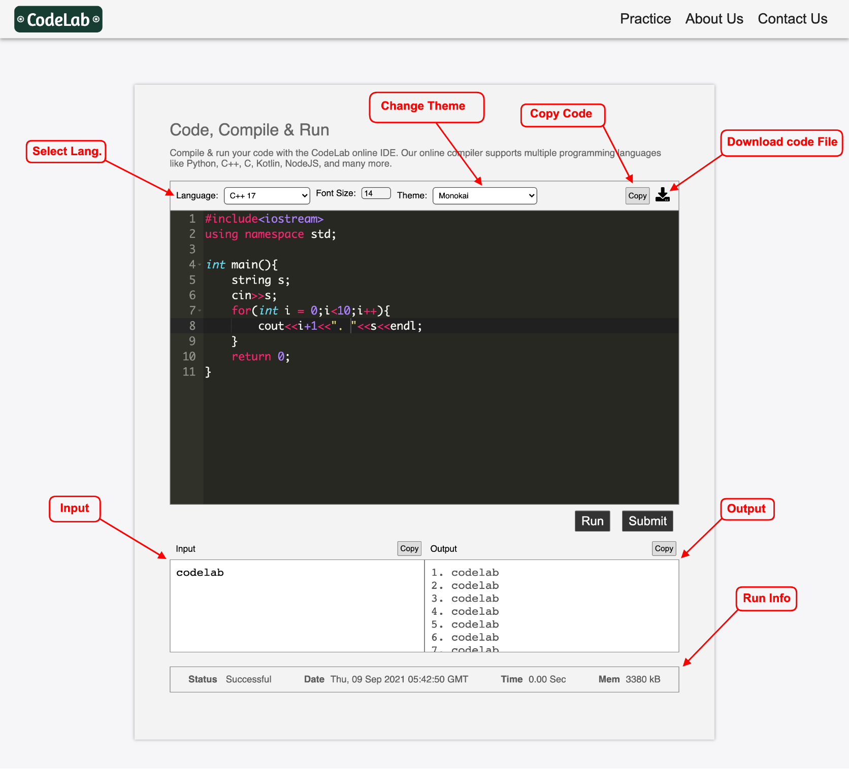

**Database Designing**

