* **Your network diagram.**

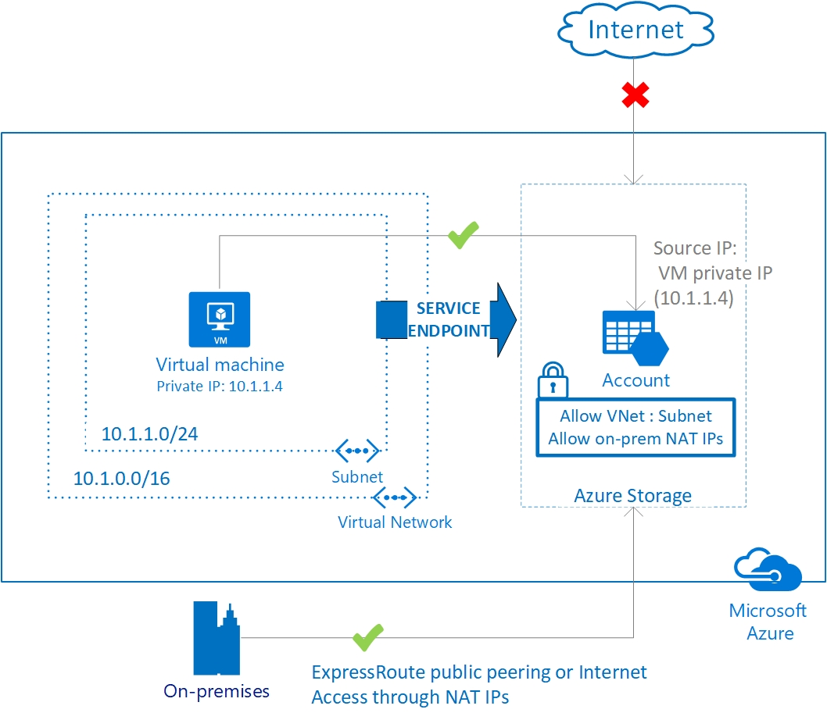

* **A description of the deployment.**

The infrastructure was built on a containerized versions of ELK stack, that is Elasticsearch, Logstash and Kibana. The data was then transferred the collection of data into an Elasticsearch for analyzing.

* **Tables specifying access policies and network addresses.**

| **IP Address** | **IP Address Wildcard Mask** | **Determined Address Range** |
| --- | --- | --- |
| 0.0.0.0 | 255.255.255.255 | Any IP address |
| 13.18.0.0 | 0.0.255.255 | IP addresses on network segment 13.18.0.0/16 |
| 13.18.5.2 | 0.0.0.0 | Only host address 13.18.5.2 |
| 13.18.8.0 | 0.0.0.7 | IP addresses on network segment 13.18.8.0/29 |
| 13.18.8.8 | 0.0.0.7 | IP addresses on network segment 13.18.8.8/29 |
| 13.1.2.0 | 0.0.254.255 (discontinuous 1s and 0s in wildcard mask) | IP addresses that are in the range of 13.1.0.0/24 and 13.1.254.0/24 and have an even number in the third byte, for example, 13.1.0.0/24, 13.1.2.0/24, 13.1.4.0/24, and 13.1.6.0/24 |

* **A description of the investigation you completed using Kibana.**

Kibana was exclusively used for EDA and creation of visualization to understand the data. The initial questions that are answered using Kababa are:

* What are the common terms used by users of the OS
* What is the total number of unique users using the system?
* What are the tweets and the number of unique search terms are used.
* How many likes does the person has in the search term.

When scanning through the fields, the following fields are used; full_text, user_created_at, and user_created_at. When the language field later fielded how what sentiments per language wou;d be, non-english are figured as follows.

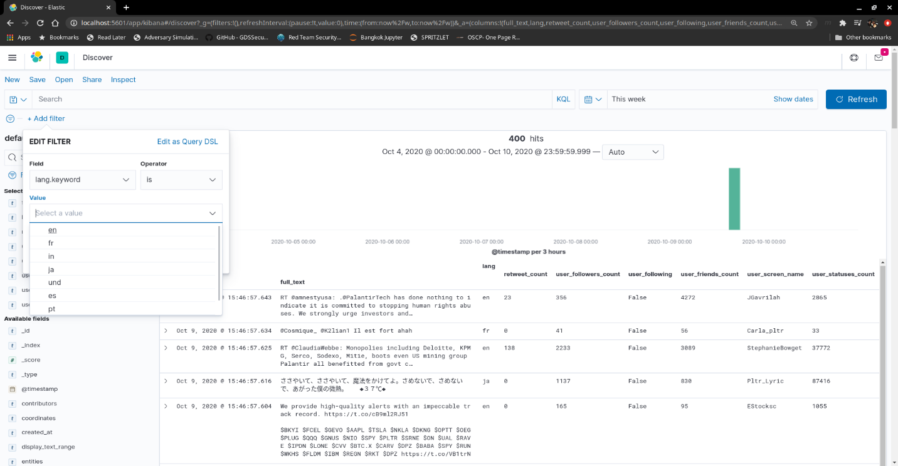

When scanning through the full_text, there are retweets in the full_text that Kabana , then a bunch of retweet that are aggregated that are accounted of 262 tweets. The top retweets accounts for 19.2%, the following screenshot.

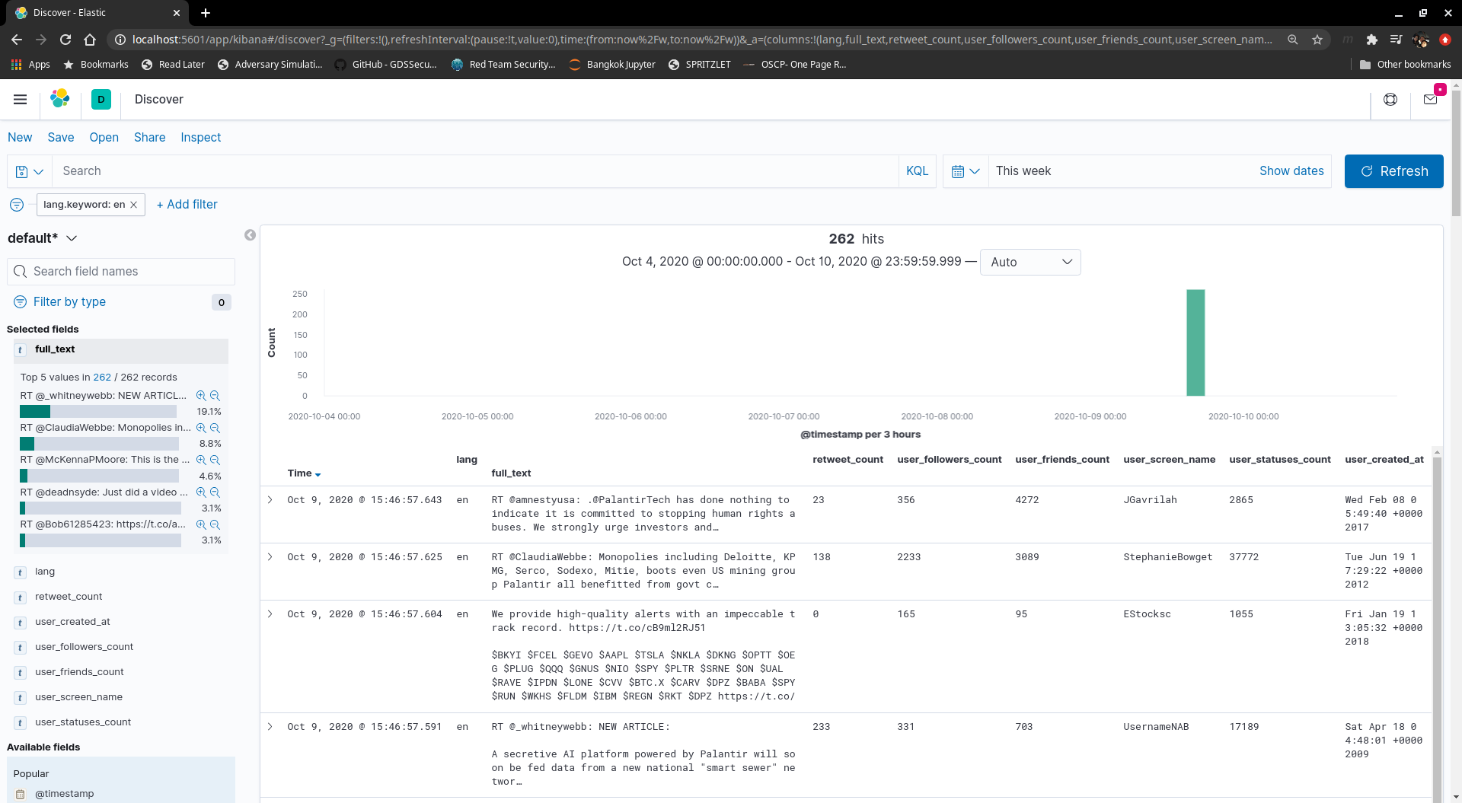

When scanning through the defaults, the fields that was as follows;

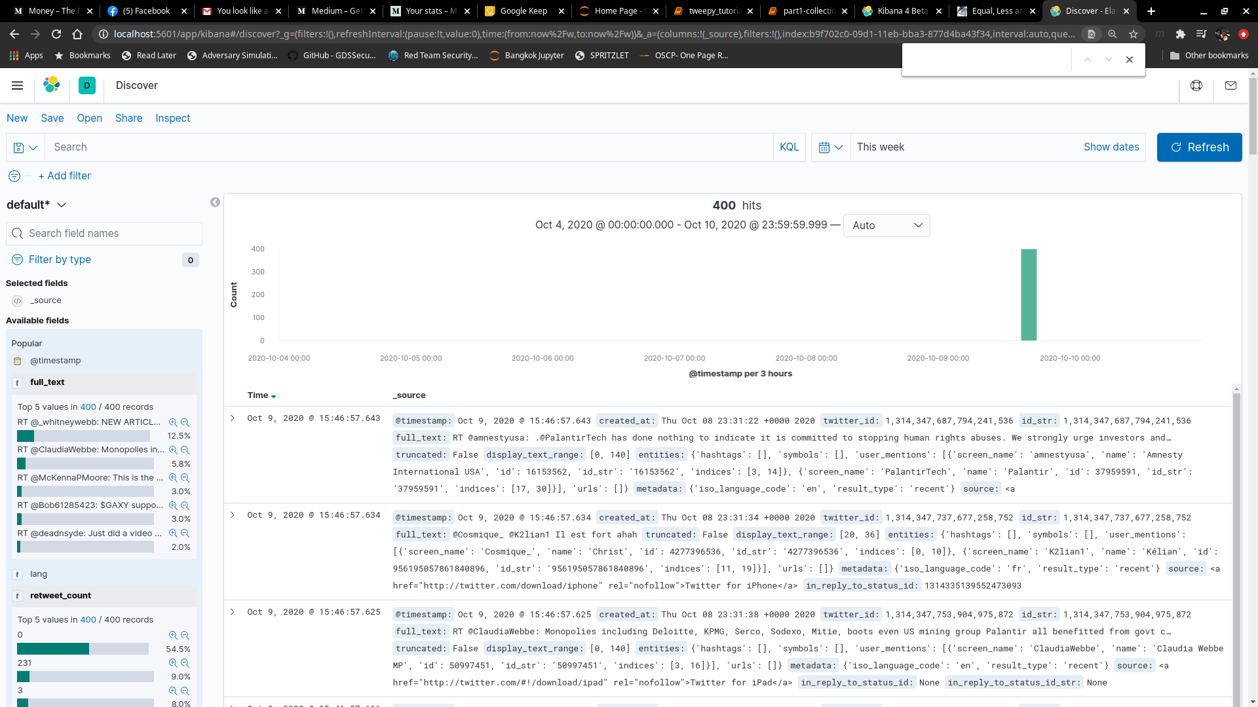

When the above visualization was created, the below was the result.

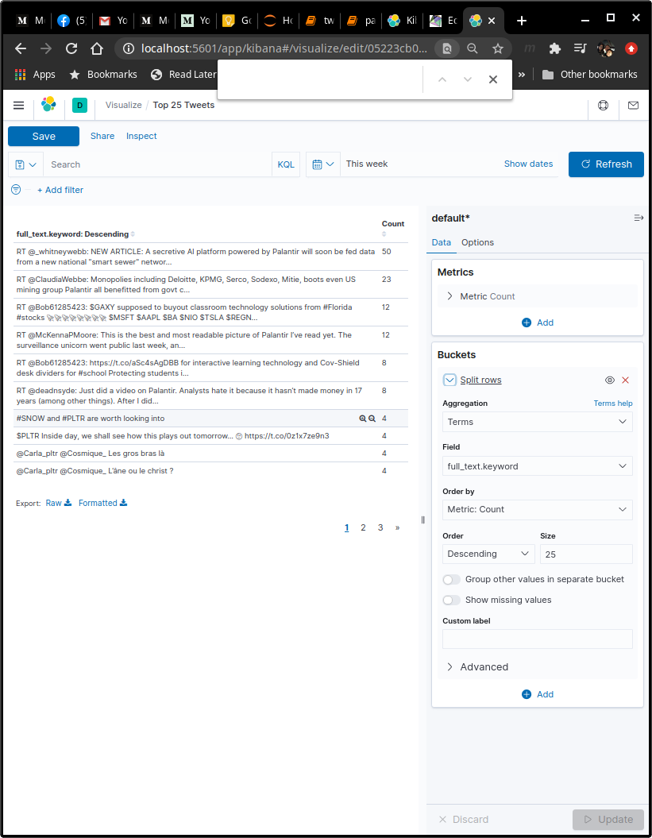

* **Usage instructions.**

Visualization Instructions

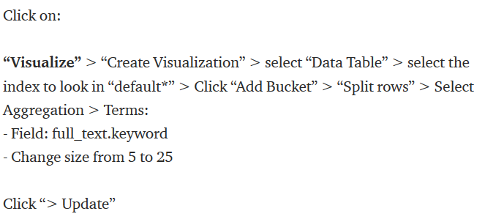

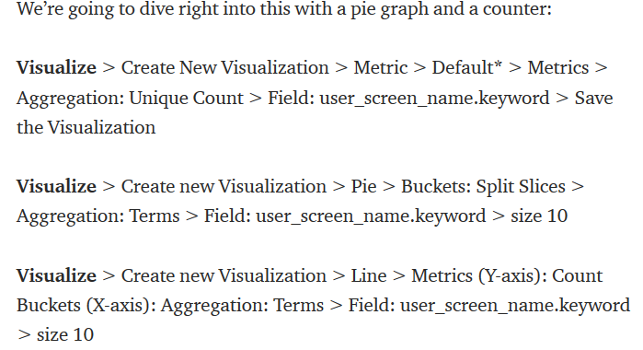

After creating the visualizations, go to the dashboard and add visualizations. The following screenshot is made.

