Date: 10/08/2026
Reference: KYC-2026-0042
Know Your Client (KYC)
Newoon LLC, as a registered business support services provider in the Qatar Financial Centre (“QFC”), is required to obtain, maintain, and keep up to date “Know Your Client” (“KYC”) information for all clients in line with applicable regulatory and compliance requirements. Accordingly, we would be grateful if you could provide the information and supporting documentation requested below, to enable us to complete and/or update our records.

A. GENERAL COMPANY INFORMATION
Date: 2026-08-10 | KYC Number: KYC-2026-0042
Legal Name of Company: Gulf Horizon Strategic Holdings and Investments W.L.L. (Qatar Financial Centre Branch) | Commercial Registration No.: 00000(QFC)
Tax Identification No.: - | Date of Incorporation: 2026-04-09
Country of Incorporation: Qatar | Legal Form: LLC
Registered Office Address: QFC Tower 1, Office No. 4, Floor 9, Doha, Qatar | Telephone: +974 0000 0000
Email: contact@example.test | Website: -
Main purpose / nature of business: Holding company | License activities: Holding company activities; management consultancy; investment advisory to affiliated entities; real estate holding; procurement and logistics coordination for group companies across the GCC and Europe.  Second line entered by the user.
Related Industry: Finance | Nature of prospective service from Newoon: N022 - Temporary Secretary and QFC Compliance Service, N025 - Assistant with Company Initial Setup Tasks

B. CONTROL / INTEREST DETAILS
Type | Full name | Nationality / country | DOB / Incorporation | QID / Passport / CR | Shareholder % | Address | Linked client | Beneficial person
Corporate | Gulf Horizon Strategic Holdings and Investments W.L.L. | Qatar | 2010-01-15 | ID-H1-2026-0002 | 60 | Building 12, Street 840, Zone 66, West Bay, Doha, State of Qatar | - | No
Corporate | Société Générale de Participations Européennes S.à r.l. | Luxembourg | 2010-01-15 | ID-H2-2026-0002 | 25 | Building 12, Street 840, Zone 66, West Bay, Doha, State of Qatar | - | No
Individual | محمد بن عبدالله آل ثاني | Qatar | 1975-06-03 | ID-I1-2026-0002 | 15 | Building 12, Street 840, Zone 66, West Bay, Doha, State of Qatar | - | Yes
Individual | Johnathan Alexander Montgomery-Fitzgerald III | United Kingdom | 1975-06-03 | ID-I2-2026-0002 | 40 | Building 12, Street 840, Zone 66, West Bay, Doha, State of Qatar | - | Yes
Individual | Priya Raghunathan Venkataraman | India | 1975-06-03 | ID-I3-2026-0002 | 35 | Building 12, Street 840, Zone 66, West Bay, Doha, State of Qatar | - | Yes
Corporate | Desert Pearl Family Trust Company Limited | Cayman Islands | 2010-01-15 | ID-C3-2026-0002 | 25 | Building 12, Street 840, Zone 66, West Bay, Doha, State of Qatar | - | No
Individual | Élodie Marchand-Dubois | France | 1975-06-03 | ID-I4-2026-0002 | 50 | Building 12, Street 840, Zone 66, West Bay, Doha, State of Qatar | - | Yes
Individual | Kenji Watanabe | Japan | 1975-06-03 | ID-I5-2026-0002 | 50 | Building 12, Street 840, Zone 66, West Bay, Doha, State of Qatar | - | No
Individual | Lukas Schneider | Germany | 1975-06-03 | ID-I6-2026-0002 | 100 | Building 12, Street 840, Zone 66, West Bay, Doha, State of Qatar | - | Yes
Individual | Orphaned Row Example (parent removed) | Oman | 1975-06-03 | ID-I7-2026-0002 | 5 | Building 12, Street 840, Zone 66, West Bay, Doha, State of Qatar | - | No
Total shareholder %: 105% | Total UBO %: 0%
Beneficial person different from listed parties: Yes
Beneficial structure notes: Ultimate control is exercised through Gulf Horizon Strategic Holdings and a family trust company.

Control Structure
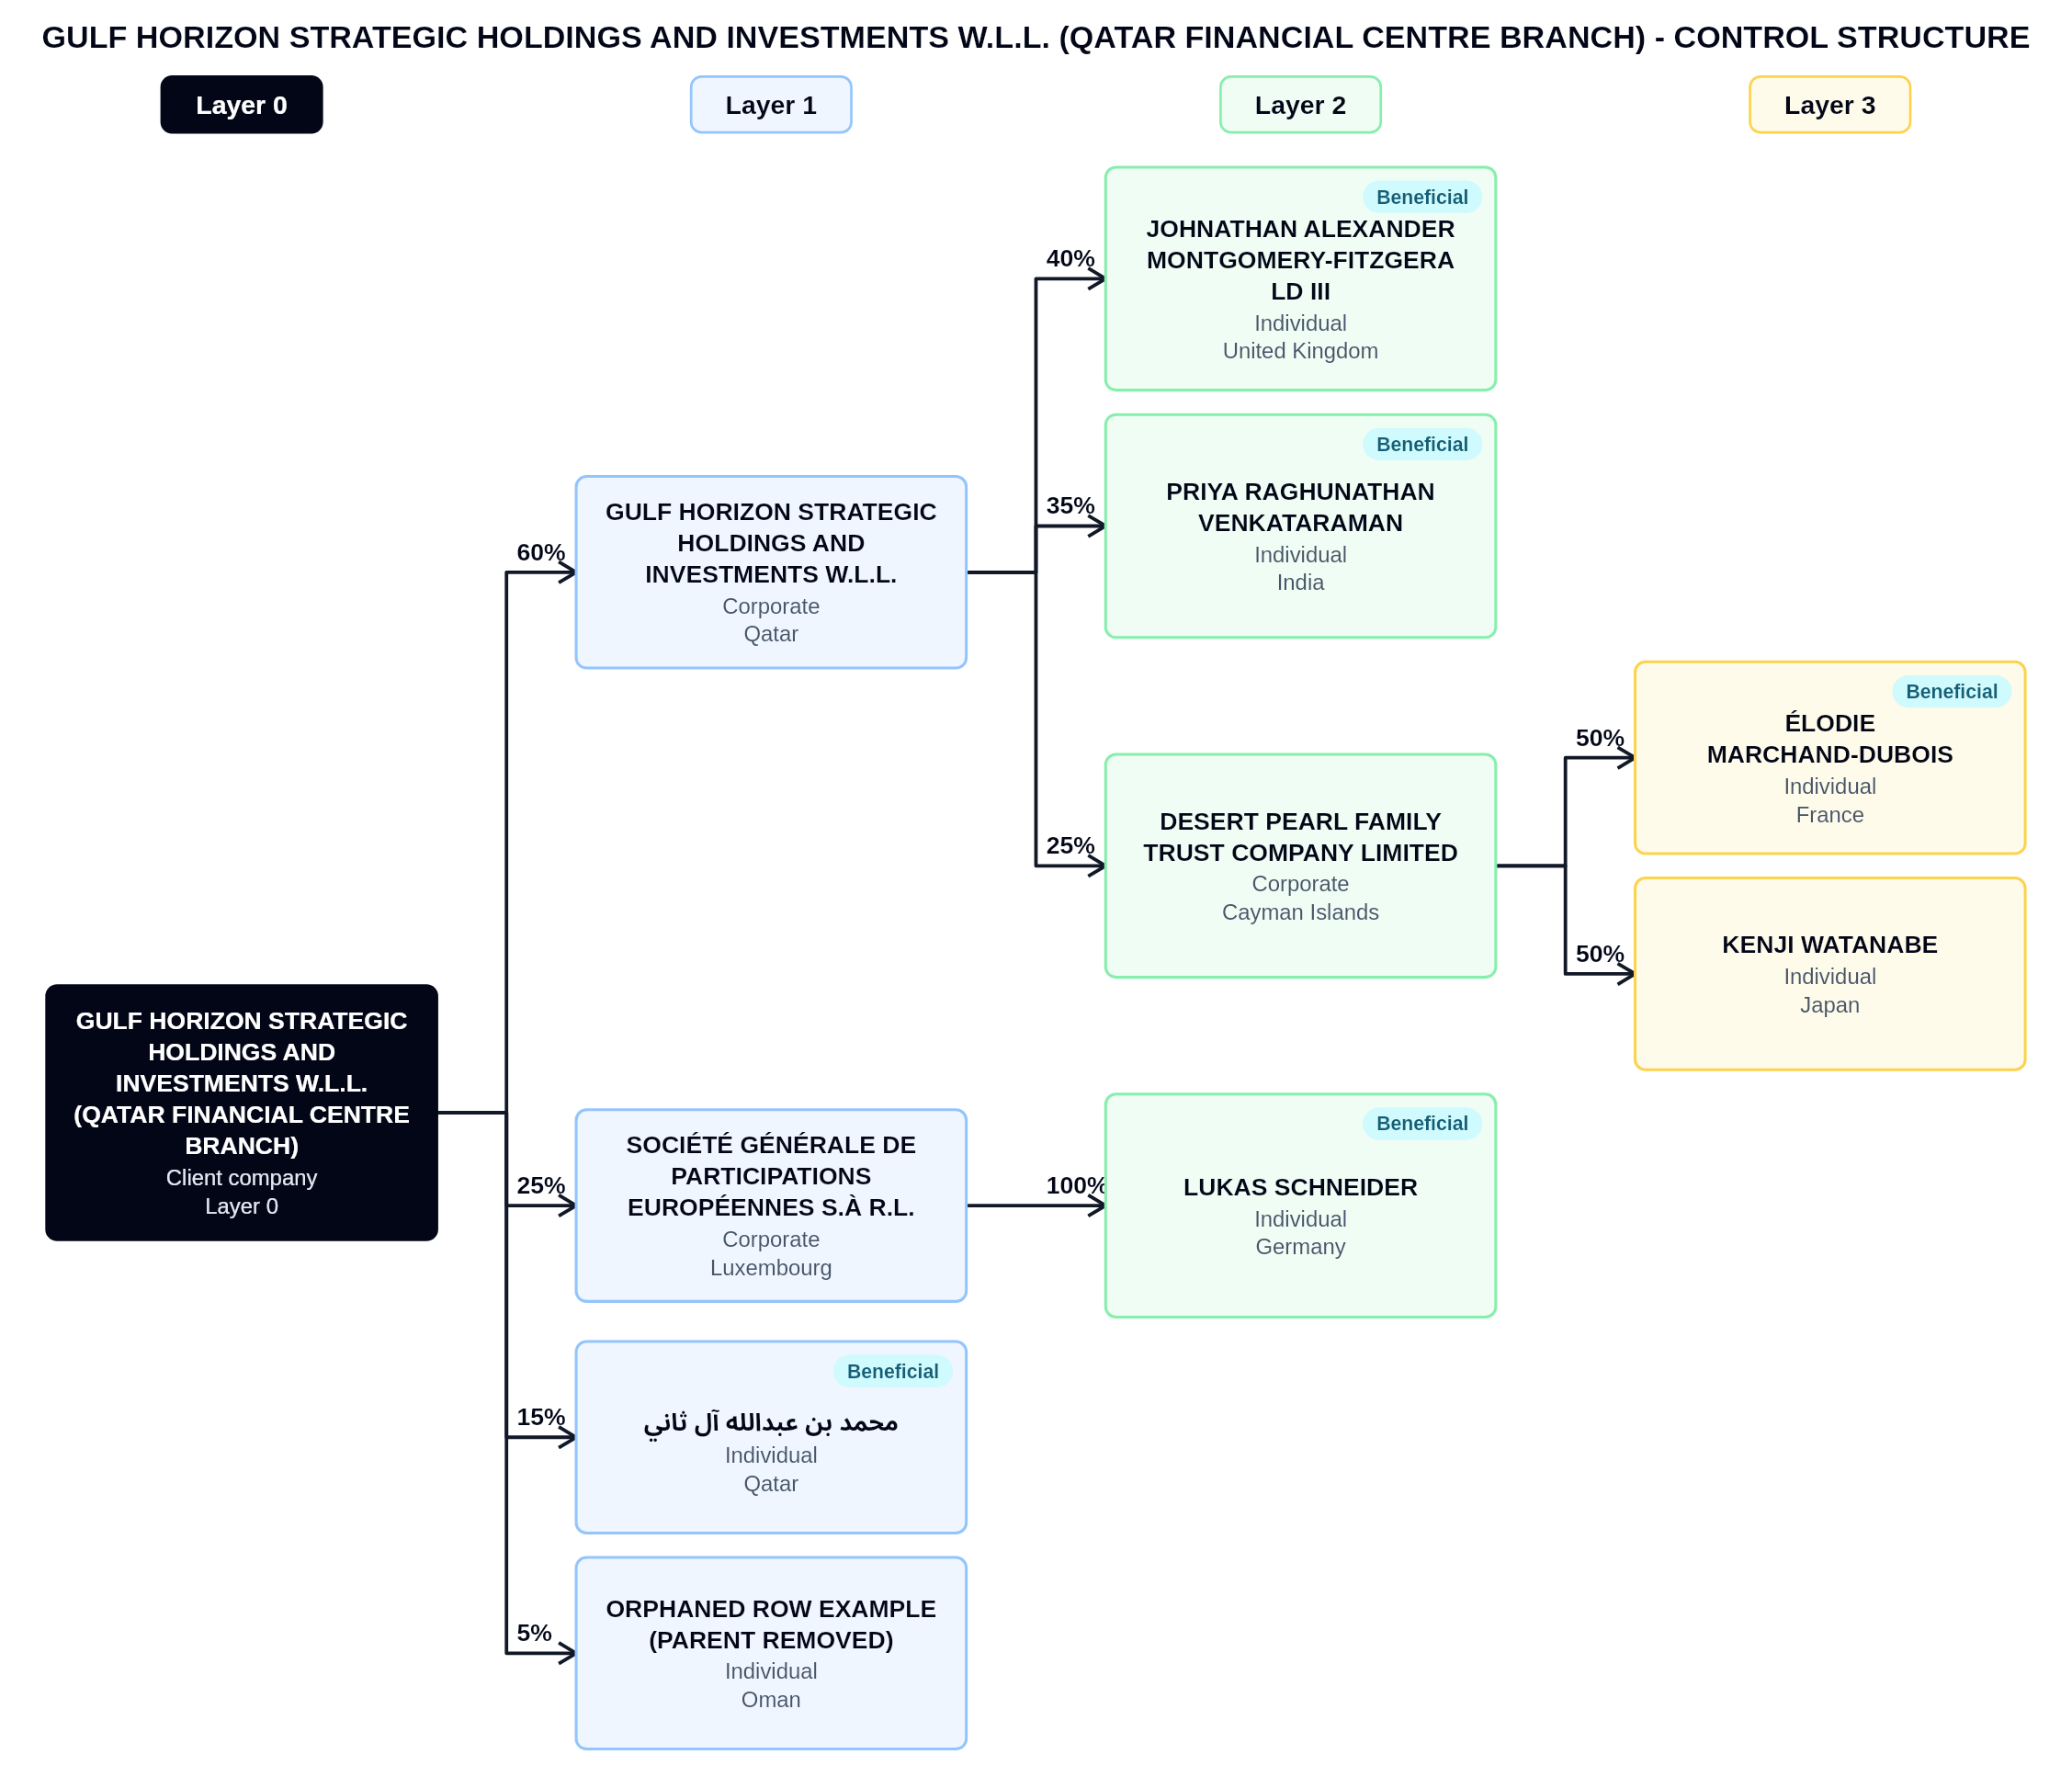

Beneficial person | Nationality | DOB | Identity No. | UBO % | Address
محمد بن عبدالله آل ثاني | Qatar | 1975-06-03 | ID-I1-2026-0002 | 15 | Building 12, Street 840, Zone 66, West Bay, Doha, State of Qatar
Johnathan Alexander Montgomery-Fitzgerald III | United Kingdom | 1975-06-03 | ID-I2-2026-0002 | 40 | Building 12, Street 840, Zone 66, West Bay, Doha, State of Qatar
Priya Raghunathan Venkataraman | India | 1975-06-03 | ID-I3-2026-0002 | 35 | Building 12, Street 840, Zone 66, West Bay, Doha, State of Qatar
Élodie Marchand-Dubois | France | 1975-06-03 | ID-I4-2026-0002 | 50 | Building 12, Street 840, Zone 66, West Bay, Doha, State of Qatar
Lukas Schneider | Germany | 1975-06-03 | ID-I6-2026-0002 | 100 | Building 12, Street 840, Zone 66, West Bay, Doha, State of Qatar

C. MANAGER / AUTHORIZED SIGNATORY / DIRECTORS / SECRETARY
Full name | Position | Entity | Nationality | Address | DOB | ID No. | Signatory
Johnathan Alexander Montgomery-Fitzgerald III | Chief Executive Officer | Gulf Horizon Strategic Holdings and Investments W.L.L. | United Kingdom | Tower 3, Floor 41, The Pearl, Doha | 1979-11-20 | PASSPORT-XX-000 | Yes
Priya Raghunathan Venkataraman | Director | Gulf Horizon Strategic Holdings and Investments W.L.L. | India | Doha, Qatar | 1979-11-21 | PASSPORT-XXX-001 | No
محمد بن عبدالله آل ثاني | Company Secretary | Gulf Horizon Strategic Holdings and Investments W.L.L. | Qatar | Tower 3, Floor 41, The Pearl, Doha | 1979-11-22 | PASSPORT-XXXX-002 | Yes
Lukas Schneider | Authorised Signatory | Gulf Horizon Strategic Holdings and Investments W.L.L. | Germany | Doha, Qatar | 1979-11-23 | PASSPORT-XXXXX-003 | No
Élodie Marchand-Dubois | Finance Director | Gulf Horizon Strategic Holdings and Investments W.L.L. | France | Tower 3, Floor 41, The Pearl, Doha | 1979-11-24 | PASSPORT-XXXXXX-004 | Yes
- | Director | Gulf Horizon Strategic Holdings and Investments W.L.L. | - | Doha, Qatar | - | - | No

D. COMPLIANCE AND RISK INFORMATION
Any PEP exposure?: Yes | PEP details: One beneficial person holds a senior government advisory role.
Any sanction exposure?: - | Sanction details: -
Any dual citizenship?: Yes | Dual citizenship details: United Kingdom and Ireland.

E. KEY COMMUNICATION PERSON
Full name: Priya Raghunathan Venkataraman | Position / Job title: Head of Group Compliance
Nationality: India | QID / Passport Number: -
Mobile Number: +974 5555 1234 | Email: priya.venkataraman@gulf-horizon.example.test

F. REQUIRED DOCUMENTS CHECKLIST
Document | Received
Commercial Registration / CR Extract | ☑
Entity Card / Computer Card | ☑
Certificate of Incorporation | ☑
Articles of Association | ☑
QID / Passport copies | ☑
CR of legal entity parties | ☐
National address certificates | ☑
Latest Audited Financial Statements | ☐
Tax Card | ☑

Additional notes for KYC preparation documents: -

G. CLIENT DECLARATION
Full name: Johnathan Alexander Montgomery-Fitzgerald III | Position: Director
Date: 2026-10-05 | Authorized signature: -
Company stamp: -

H. INTERNAL USE ONLY
Risk classification: High | Due diligence type: Enhanced
AML SUPERVISOR
Date: 2026-08-10
Comments:
The Company is a holding company of an existing client. No adverse media, sanctions, or PEP concerns were identified in respect of the UBO, Director, and SEF. The KYC has been prepared and submitted to the DMLRO for review.
DMLRO
Name: Sample DMLRO | Date: 2026-08-10
Signature:   | Risk classification: Low
Decision: Approve
Conditions: -
Reason: -
Comments:
PEP exposure confirmed; enhanced due diligence applied. Source of wealth evidence reviewed and accepted.
MLRO
Name: Sample MLRO | Date: 2026-08-10
Signature:   | Final decision: Send to SEF
Final risk classification: High
Risk reason category: PEP exposure
Risk explanation: Beneficial person is a domestic PEP.
Conditions: -
Comments:
Enhanced due diligence completed. Annual review required.
Source of wealth and ownership documentation were reviewed. This paragraph must use the full available width.
- Monitor changes in ownership.
- Escalate material risk changes.
SEF
Name: Sample SEF Member | Date: 2026-10-05
Signature:   | Management decision: Approve
Conditions: -
Comments:
Approved subject to annual review.

