Date: 10/08/2026
Reference: KYC-2026-0001
Know Your Client (KYC)
Newoon LLC, as a registered business support services provider in the Qatar Financial Centre (“QFC”), is required to obtain, maintain, and keep up to date “Know Your Client” (“KYC”) information for all clients in line with applicable regulatory and compliance requirements. Accordingly, we would be grateful if you could provide the information and supporting documentation requested below, to enable us to complete and/or update our records.

A. GENERAL COMPANY INFORMATION
Date: 2026-08-10 | KYC Number: KYC-2026-0001
Legal Name of Company: EXAMPLE HOLDINGS LLC | Commercial Registration No.: 00000(QFC)
Tax Identification No.: T00000 | Date of Incorporation: 2026-04-09
Country of Incorporation: Qatar | Legal Form: LLC
Registered Office Address: QFC Tower 1, Office No. 4, Floor 9, Doha, Qatar | Telephone: +974 0000 0000
Email: contact@example.test | Website: -
Main purpose / nature of business: Holding company | License activities: To hold subsidiaries and assets, provide intra-group financing, guarantees and security, and undertake related ancillary activities for the benefit of the Holding Company Group.
Related Industry: Finance | Nature of prospective service from Newoon: N022 - Temporary Secretary and QFC Compliance Service, N025 - Assistant with Company Initial Setup Tasks

B. CONTROL / INTEREST DETAILS
Type | Full name | Nationality / country | DOB / Incorporation | QID / Passport / CR | Shareholder % | Address | Linked client | Beneficial person
Individual | ALEX MORGAN | France | 1980-03-13 | Passport-SAMPLE123  QID-SAMPLE456 | 100 | Zone No. 38, Street No. 920, Building No. 97, Doha, Qatar | - | Yes
Total shareholder %: 100% | Total UBO %: 0%
Beneficial person different from listed parties: Yes
Beneficial structure notes: -

Control Structure
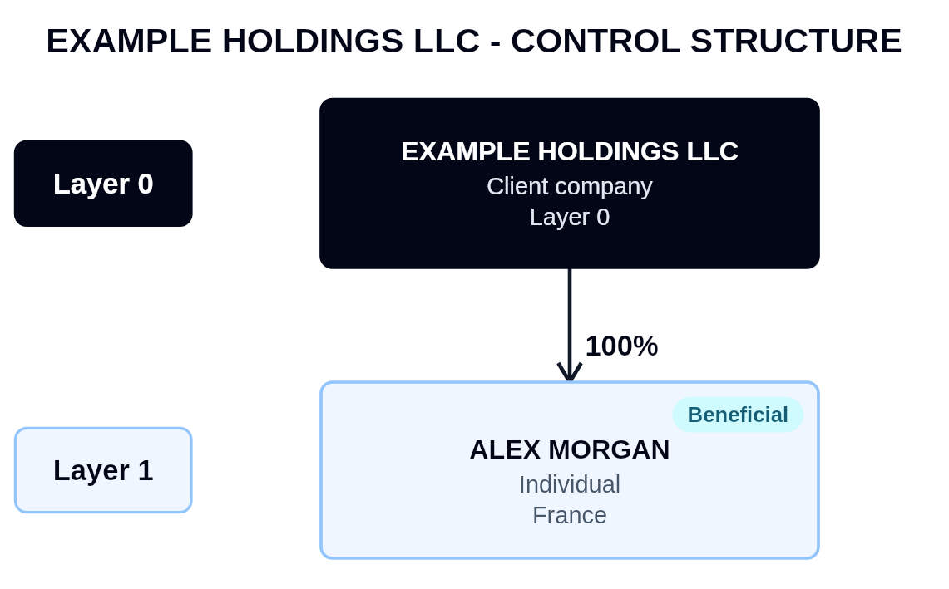

Beneficial person | Nationality | DOB | Identity No. | UBO % | Address
ALEX MORGAN | France | 1980-03-13 | Passport-SAMPLE123  QID-SAMPLE456 | 100 | Zone No. 38, Street No. 920, Building No. 97, Doha, Qatar

C. MANAGER / AUTHORIZED SIGNATORY / DIRECTORS / SECRETARY
Full name | Position | Entity | Nationality | Address | DOB | ID No. | Signatory
ALEX MORGAN | Director, SEF, Beneficial Person | EXAMPLE HOLDINGS LLC | France | Zone No. 38, Street No. 920, Building No. 97, Doha, Qatar | 1980-03-13 | Passport-SAMPLE123  QID-SAMPLE456 | Yes
JORDAN SAMPLE EXAMPLE PERSON | Secretary | EXAMPLE HOLDINGS LLC | Sri Lanka | - | 1997-09-17 | Passport-SAMPLE789  QID-SAMPLE012 | No

D. COMPLIANCE AND RISK INFORMATION
Any PEP exposure?: No | PEP details: -
Any sanction exposure?: No | Sanction details: -
Any dual citizenship?: No | Dual citizenship details: -

E. KEY COMMUNICATION PERSON
Full name: ALEX MORGAN | Position / Job title: Director, SEF, Authorized Signatory
Nationality: France | QID / Passport Number: Passport-SAMPLE123  QID-SAMPLE456
Mobile Number: +974 0000 0000 | Email: alex@example.test

F. REQUIRED DOCUMENTS CHECKLIST
Document | Received
Commercial Registration / CR Extract | ☑
Entity Card / Computer Card | ☑
Certificate of Incorporation | ☑
Articles of Association | ☑
QID / Passport copies | ☑
CR of legal entity parties | ☐
National address certificates | ☑
Latest Audited Financial Statements | ☐
Tax Card | ☑

Additional notes for KYC preparation documents: -

G. CLIENT DECLARATION
Full name: ALEX MORGAN | Position: Director
Date: 2026-08-10 | Authorized signature:  
Company stamp:


H. INTERNAL USE ONLY
Risk classification: Low | Due diligence type: Simplified
AML SUPERVISOR
Date: 2026-08-10
Comments:
The Company is a holding company of an existing client. No adverse media, sanctions, or PEP concerns were identified in respect of the UBO, Director, and SEF. The KYC has been prepared and submitted to the DMLRO for review.
DMLRO
Name: Sample DMLRO | Date: 2026-08-10
Signature:   | Risk classification: Low
Decision: Approve
Conditions: -
Reason: -
Comments:
No red flags were identified during screening and risk rating. Client has been classified as low risk and hence simplified due diligence has been performed.
MLRO
Name: Sample MLRO | Date: 2026-08-10
Signature:   | Final decision: Approve
Final risk classification: Low
Risk reason category: -
Risk explanation: -
Conditions: -
Comments:
Approve to proceed with the EL.

Low Risk.
SEF
Name: - | Date: -
Signature: - | Management decision: -
Conditions: -
Comments:
-

