Date: 2026-10-04 Reference: KYC‑SAMPLE‑0001
Know Your Client (KYC)
Newoon LLC, as a registered business support services provider in the Qatar Financial Centre (QFC), is required to obtain, maintain and keep up to date Know Your Client information for all clients in line with applicable regulatory and compliance requirements. We request the following information and supporting documentation to understand your business and complete our due diligence.
A. General Company Information
Legal name:  Example Consultancy LLC | Commercial registration number:  SAMPLE-02741
Tax identification number:  SAMPLE-T02741 | Date of incorporation:  2024-09-24
Country of incorporation:  Qatar | Legal form:  LLC
Registered office address:  Floor 1, Office 233, Business Centre, Doha, Qatar | Telephone:  +974 0000 0000
Email:  contact@example.test | Website:  https://example.test
Business nature:  Project Management | License activities:  Project and programme management services. Providing project management support to corporate clients.
Related industry:  Professional Services | Requested services:  Secretary and QFC Compliance Service, Immigration signatory services

B. Ownership and Beneficial Owners
Full name | Nationality | Birth date | Identity number | Interest % | Address
Alex Morgan | France | 1980-03-13 | SAMPLE-123456789 | 100 | Doha, Qatar

Total shareholder ownership: 100%
Ultimate Beneficial Owners
Full name | Nationality | Birth date | Identity number | Interest % | Address
Alex Morgan | France | 1980-03-13 | SAMPLE-123456789 | 100 | Doha, Qatar

Total UBO ownership: 100%
Beneficial owners differ from shareholders: No
Direct ownership by the beneficial owner.
Ownership Structure
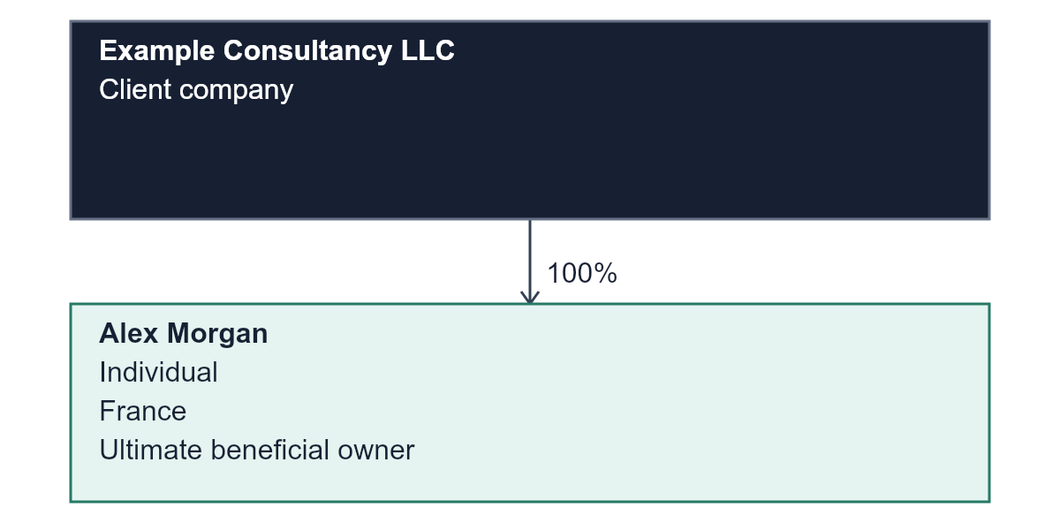
Party | Parent entity | Ownership % | Beneficial person
Alex Morgan | Example Consultancy LLC | 100 | Yes

C. Managers Directors Secretary and Signatories
Full name | Position | Entity | Nation | Address | Birth date | ID No. | Signer
Alex Morgan | Director | Example Consultancy LLC | France | Doha, Qatar | 1980-03-13 | SAMPLE-123456789 | Yes

D. Compliance and Risk Information
Question | Response | Details / supporting documents
Politically exposed person exposure | No | -
Sanction exposure | No | -
Dual citizenship | No | -

E. Key Communication Person
Full name:  Alex Morgan | Position:  Director
Nationality:  France | QID / Passport:  SAMPLE-123456789
Mobile number:  +974 0000 0000 | Email:  alex@example.test

F. Required Documents
Document | Received | Uploaded files
Commercial Registration | Yes | Commercial-Registration-sample.pdf
Certificate of Incorporation | Yes | Certificate-of-Incorporation-sample.pdf
QID / Passport copies | Yes | QID-Passport-copies-sample.pdf
Articles of Association | Yes | Articles-of-Association-sample.pdf

Additional Documents
National-address-sample.pdf
Sample supporting documents for visual quality assurance.
G. Client Declaration
I confirm that the information and documents provided are true, complete and up to date, and that I am authorised to represent the entity.
Full name:  Alex Morgan | Position:  Director
Date:  2026-10-04 | Authorized signature:  -
Company stamp:
-

H. Internal Use Only
Accuracy confirmed:  Yes | Clarification / findings:  -
Risk classification:  MEDIUM | Due diligence type:  REGULAR

AML Supervisor
Name:  Sample Reviewer | Signature:  -
Date:  2026-10-04 | Review findings:  Risk classification: MEDIUM  Due diligence type: REGULAR

DMLRO
Name:  Sample DMLRO | Signature:  -
Date:  - | Review findings:  Decision: APPROVED

MLRO
Name:  Sample MLRO | Signature:  -
Date:  - | Review findings:  Final decision: APPROVED  Final risk classification: MEDIUM

SEF
Name:  Sample SEF | Signature:  -
Date:  - | Review findings:  Management decision: APPROVED

