Photosynthesis Learning Guide
The high-yield science behind your CER test, tied to your own packets
Sources: [P1] Photosynthesis and Respiration · [P2] the simulation lab · [P3] your Mauna Loa notes

How to use this guide
- Parts 1–4: the core science for every Reasoning section. Parts 5–6 matter most: the lab, your own Part III data (your Evidence) and what controls the rate — lab Part VII is the model for the test. Parts 7–9: carbon cycle, humans, Keeling Curve. Parts 10–11: vocabulary and a self-check.
- The other guides: Guide 2 (CER Prep Guide) — how to write C-E-R · Guide 3 (Mock CER Questions) · Guide 4 (Cheat Sheet) · Guide 5 (Detected Errors) — all your worksheet fix-its, in detail. Codes: [P1 Q9] = Packet 1, question 9 · [P2 Part III] = the lab · [P3] = your Mauna Loa notes.

WHAT'S INSIDE
- Part 1 · The big picture: energy flows, matter cycles
- Part 2 · Photosynthesis up close
- Part 3 · Cellular respiration up close
- Part 4 · Partners: how the two connect
- Part 5 · Measuring it: the simulation lab
- Part 6 · What controls the rate: light, color, temperature, CO₂
- Part 7 · The carbon cycle
- Part 8 · Humans & the carbon cycle
- Part 9 · Mauna Loa & the Keeling Curve
- Part 10 · Vocabulary
- Part 11 · Quick self-check

● KEY IDEA — The 60-second version
- Photosynthesis (chloroplasts): 6CO₂ + 6H₂O + light energy → C₆H₁₂O₆ + 6O₂. Light energy is stored as chemical energy in glucose.
- Cellular respiration (mitochondria; plants AND animals; 24/7): C₆H₁₂O₆ + 6O₂ → 6CO₂ + 6H₂O + energy (ATP).
- Each one’s products are the other’s reactants: matter cycles; energy flows (in as light, out as heat).
- Lab: DO difference (net) = O₂ made − O₂ used; O₂ production (gross) = DO difference + 0.1939; near zero at 20–40 % light, then a steady rise — light was the limiting factor from 40 % to 100 %.
- Carbon cycle: photosynthesis removes CO₂; respiration and combustion add it. Keeling Curve: a yearly zig-zag on a long rise (about 313 ppm in 1958 → about 432 ppm in May 2026).

Part 1 · The big picture: energy flows, matter cycles
Every living thing needs energy and matter (atoms to build its body). Producers (plants, algae) make their own food by photosynthesis. Consumers (animals) eat other living things. Decomposers (fungi, bacteria, worms) break down dead things and wastes, returning matter to the air and soil.

Following the energy: from the sun to an athlete [P1 Q11–12]
In [P1 Q11–12] you traced your meal back to plants — exactly right. Figure 1 adds the two links a CER answer needs: how the energy is stored and how it is released.
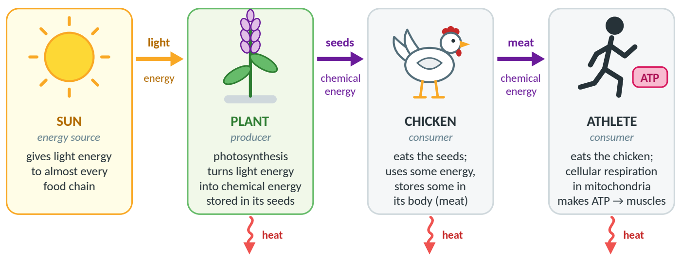
Figure 1. The energy chain from [P1 Q12]: light energy → chemical energy in food → ATP in the athlete’s cells. Some energy is lost as heat at every step.
√ FIX-IT FROM YOUR WORKSHEET — [P1 Q12] — add the two missing links
Add: (1) photosynthesis stores light energy as chemical energy in glucose/starch in the seeds, and (2) the athlete’s cells release it by cellular respiration in their mitochondria as ATP, which powers the muscles. For [P1 Q11], trace a second food too: pizza crust is made from wheat, a plant.

Figure 2. Matter (gray) loops; energy (yellow in, red out) flows through once. | 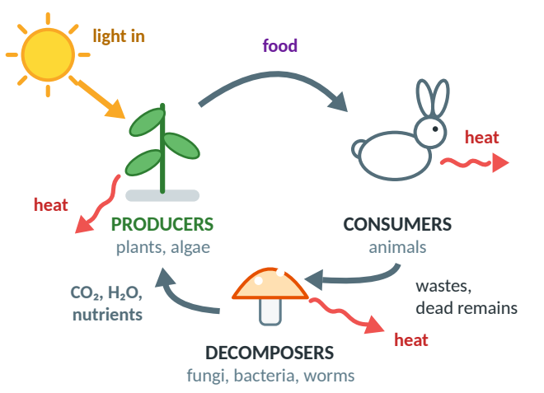
  ● KEY IDEA — Matter cycles; energy flows
  Matter (CO₂, H₂O, glucose, O₂) is recycled: the same atoms go round and round [P1 Q3].
  Energy is not recycled: it enters as light, is stored in food, is used as ATP and leaves as heat — so sunlight must be constantly available [P1 Q4].

Part 2 · Photosynthesis up close
Photosynthesis is the process in which producers use light energy to turn carbon dioxide and water into glucose (a sugar) and oxygen. It happens in chloroplasts, where the green pigment chlorophyll captures the light.
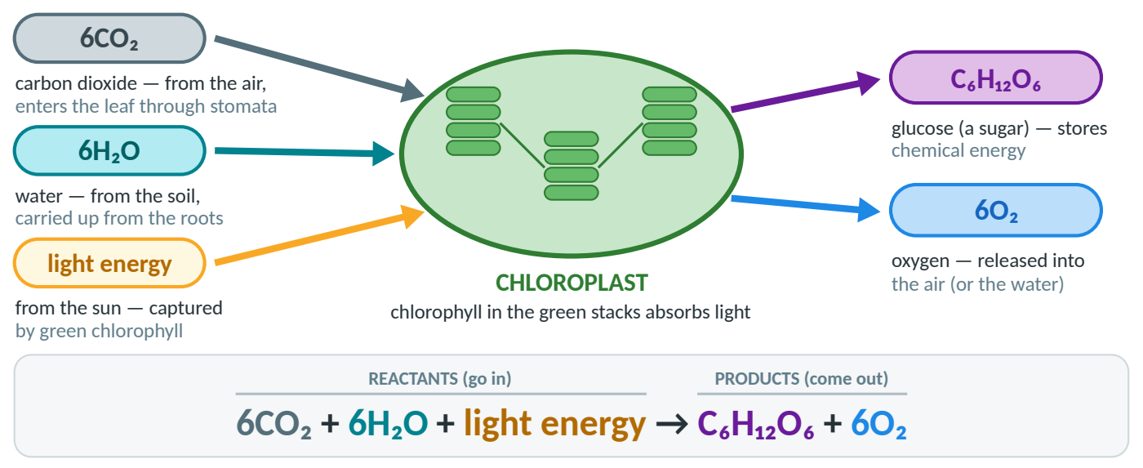
Figure 3. Photosynthesis, color-coded. Reactants go into the chloroplast; products come out. Light is the energy input.
→ REASONABLE INFERENCE (beyond the packets) — Where the inputs come from
CO₂ enters the leaf through tiny pores called stomata, and O₂ leaves the same way. Water comes up from the roots through the stem and leaf veins. (For your lab’s aquatic plant, CO₂ and O₂ are dissolved in the water.)

Zooming in: leaf → cell → chloroplast → chlorophyll
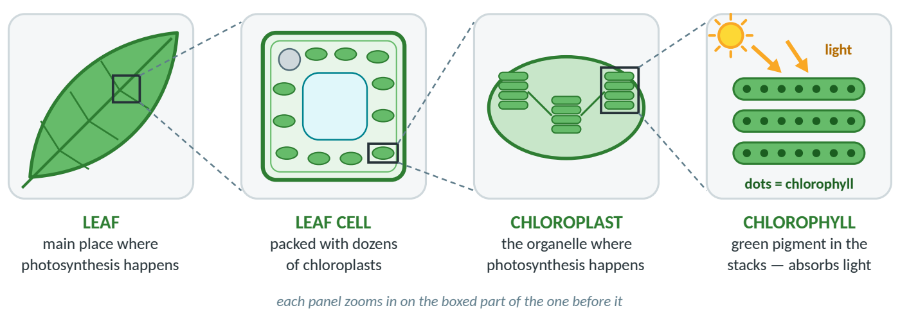
Figure 4. From leaf to chlorophyll. Leaf cells are packed with chloroplasts [P1 Q5].

The energy change: light → chemical
Photosynthesis stores energy: light energy becomes chemical energy in the bonds of glucose. The plant uses some glucose for its own respiration, stores some as starch (seeds, roots, fruit) and builds new cells with the rest.
→ REASONABLE INFERENCE (beyond the packets) — Enrichment: where does the O₂ come from?
From splitting water (H₂O) with light energy — not from CO₂, whose carbon ends up in glucose.

Part 3 · Cellular respiration up close
Cellular respiration is the process in which cells break down glucose using oxygen to release its stored energy as ATP; carbon dioxide and water are released. It happens in the mitochondria of plant AND animal cells.
ATP — the cell’s energy currency. Glucose holds a lot of energy, but cells can’t “spend” it directly. Cellular respiration transfers its energy into many small, usable packets called ATP — like changing a big bill into coins.  Every job a cell does is paid for with ATP: muscles contracting, building new cells, moving materials, sending nerve signals — and, in plants, growing. Some energy is always lost as heat along the way.  Figure 5. Respiration turns stored energy (glucose) into spendable energy (ATP). | 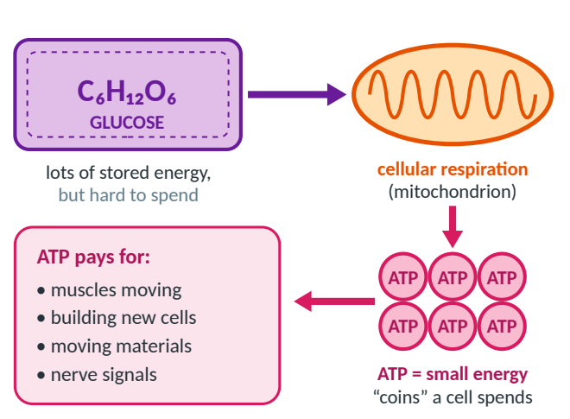

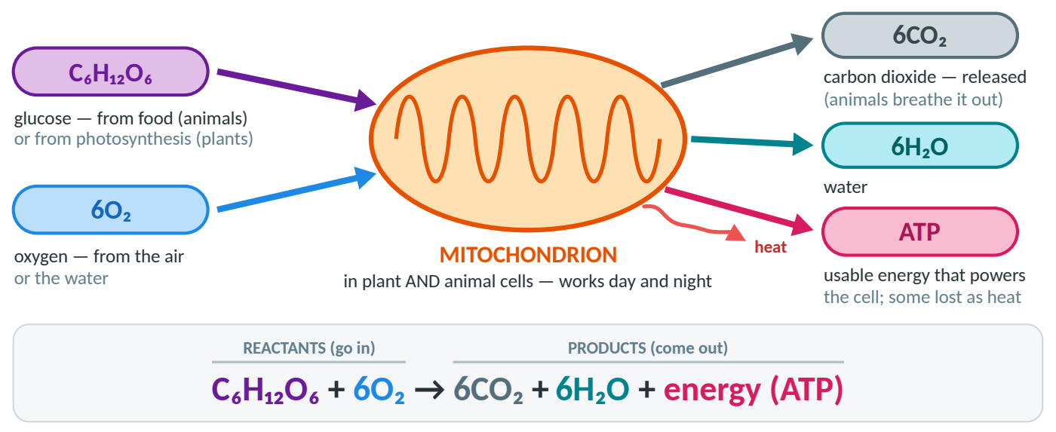
Figure 6. Cellular respiration, color-coded. Glucose and O₂ go into the mitochondrion; CO₂, H₂O and ATP come out, and some energy is lost as heat.

Respiration ≠ breathing
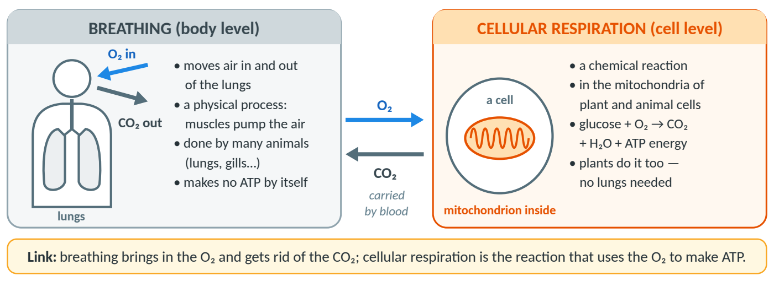
Figure 7. Breathing and cellular respiration are different things that work together.
! WATCH OUT — Two classic mistakes
- “Respiration = breathing.” Breathing moves gases in and out of the lungs; cellular respiration is a chemical reaction in the mitochondria of cells.
- Forgetting that plants respire. Plants respire 24/7; photosynthesis needs light. By day a plant usually makes more O₂ than it uses; at night it only respires, using O₂ and releasing CO₂.

Part 4 · Partners: how the two connect
The two processes are partners. Here they are side by side; Figure 8 redraws Model 1 [P1 Model 1] to show how they form a loop — what one makes, the other uses.
 | Photosynthesis | Cellular respiration
Organelle | chloroplast | mitochondrion
Reactants (in) | 6CO₂ + 6H₂O + light energy | C₆H₁₂O₆ + 6O₂
Products (out) | C₆H₁₂O₆ + 6O₂ | 6CO₂ + 6H₂O + energy (ATP)
Energy | stores it: light → chemical energy in glucose | releases it: glucose → ATP (+ heat)
Who does it | producers: plants, algae | almost all living things: plants, animals, fungi…
When | only when there is light | all the time, day and night
Effect on air/water | removes CO₂, adds O₂ | removes O₂, adds CO₂

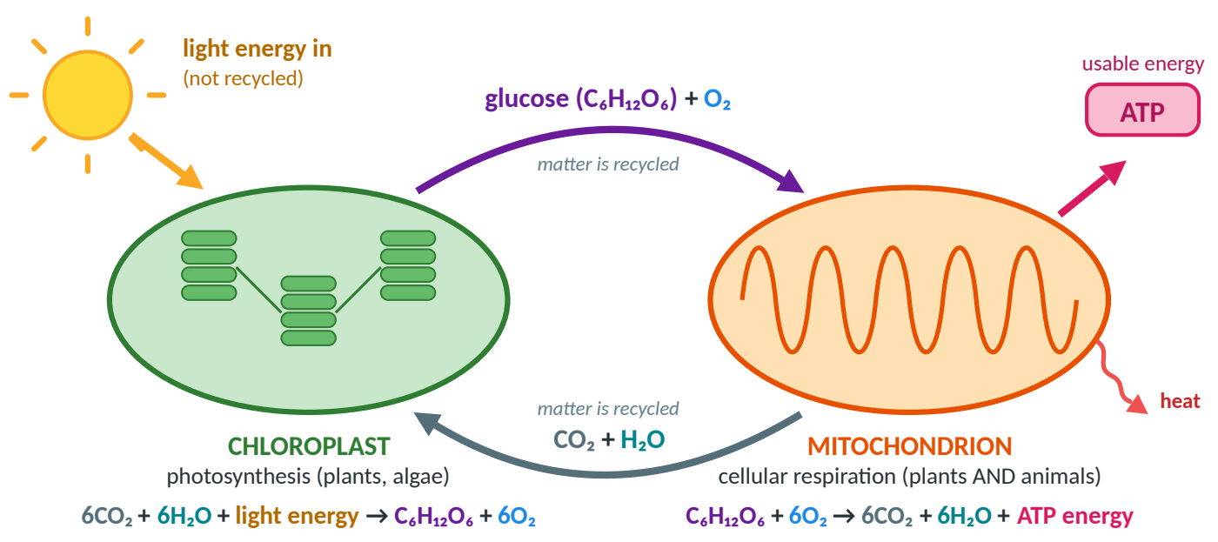
Figure 8. Model 1, redrawn. Glucose and O₂ from the chloroplast feed the mitochondrion; CO₂ and H₂O come back. Light comes in; ATP and heat go out.
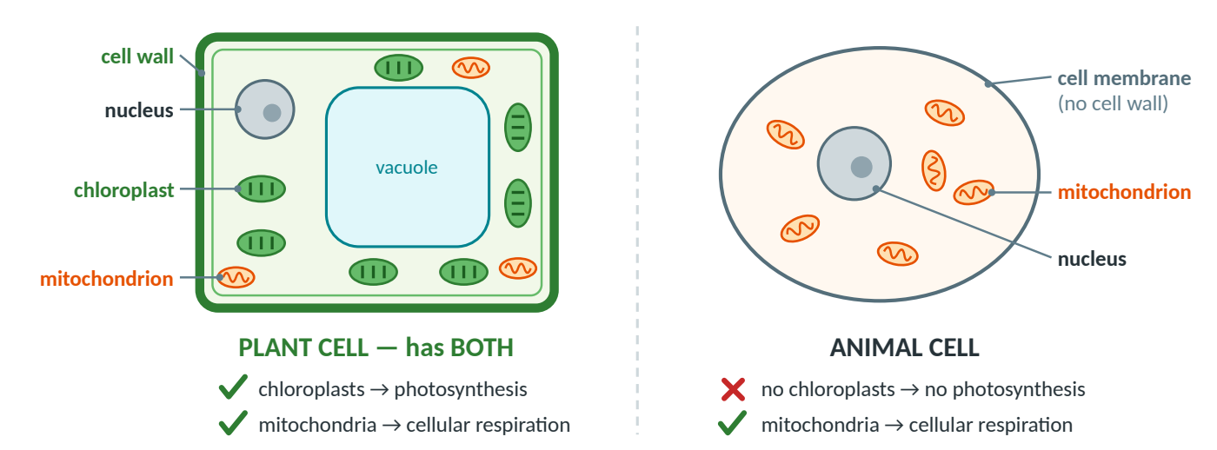
Figure 9. Plant cells have chloroplasts AND mitochondria, so they do both processes. Animal cells have mitochondria but no chloroplasts [P1 Q5–8].
Plant cells need mitochondria too: glucose is stored energy, and cellular respiration turns it into usable ATP [P1 Q6]. Animals have no chloroplasts, so they get glucose by eating [P1 Q7].
√ FIX-IT FROM YOUR WORKSHEET — Quick fix-its from Packet 1 — full details in Guide 5 (Detected Errors)
- [P1 Q9] First half √ correct. But glucose + O₂ are exactly photosynthesis’s products, and ATP is a product of respiration. End with: “The only difference is energy: photosynthesis takes in light; respiration releases energy as ATP.”
- [P1 Q10] You meant chloroplasts — animals do have mitochondria (your Q8). Add interdependence: plants use CO₂ from respiration; decomposers recycle matter.
- [P1 Q14] Formulas and CO₂ circles √ correct; only the energy labels got swapped: light energy goes IN to photosynthesis; ATP comes OUT of respiration.

Part 5 · Measuring it: the simulation lab
In the lab [P2] a simulated aquatic plant sat in a tank. The simulation tracked dissolved oxygen (DO) — the O₂ gas dissolved in the water, in mg/L — over a 60-minute run; you read the start and end values off its graph.  You could change the number of fish and plants, the light intensity, the light color and the temperature. Your team did Part III. Driving question: How does light intensity affect oxygen production during photosynthesis?  Figure 10. Your Part III setup: only the light intensity was changed. | 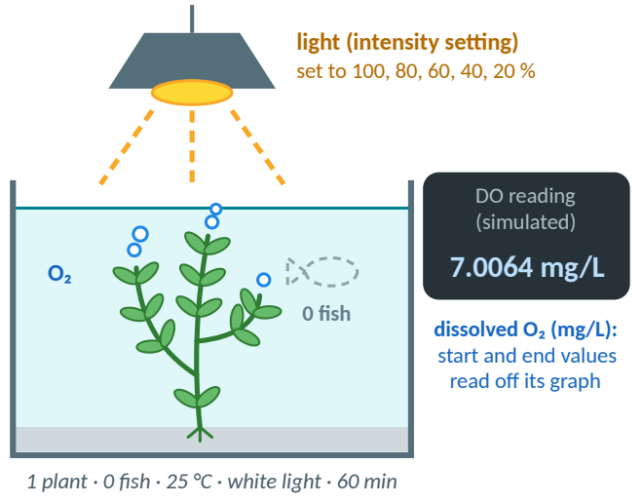

Experimental design (CER tests ask about this)
Term | What it means | In your Part III test
Independent variable | what you changed | light intensity: 100, 80, 60, 40, 20 %
Dependent variable | what you measured | O₂ production (mg/L per hour), from DO start and end
Controlled variables | kept the same | 0 fish, 1 plant, 25 °C, white light, 60-minute run
Control / baseline | factor removed | Part II dark run (0 % light): respiration only, −0.1939 mg/L per hour
Repeated trials | test run more than once | Part II: 3 trials, averaged. Part III: 1 trial per level (a limitation)

The baseline [P2 Part II]: three dark runs (0 % light) measured respiration alone. Averaging repeated trials makes the value more reliable, and the trial-to-trial spread (up to 0.0065) shows how big a difference must be before you can trust it.
Part II trial (0 % light) | DO start (mg/L) | DO end (mg/L) | DO difference (mg/L per hour)
Trial 1 | 7.0735 | 6.8794 | −0.1941
Trial 2 | 7.0476 | 6.8568 | −0.1908
Trial 3 | 7.0735 | 6.8762 | −0.1973
Average (your sheet) | 7.0647 | 6.8709 | −0.1939 (exact: −0.1941)

√ FIX-IT FROM YOUR WORKSHEET — Your Part III prediction
“Light intensity decreases oxygen production” is the opposite of what you found. Predictions may be wrong, but write a testable If… then… because…: “If light intensity increases, then O₂ production will increase, because light is the energy source for photosynthesis.”

DO difference vs. O₂ production: the oxygen bank account
With the light on, the plant does two things at once: photosynthesis adds O₂ (a deposit) and respiration uses O₂ (a withdrawal). The DO reading only shows the change in the balance.
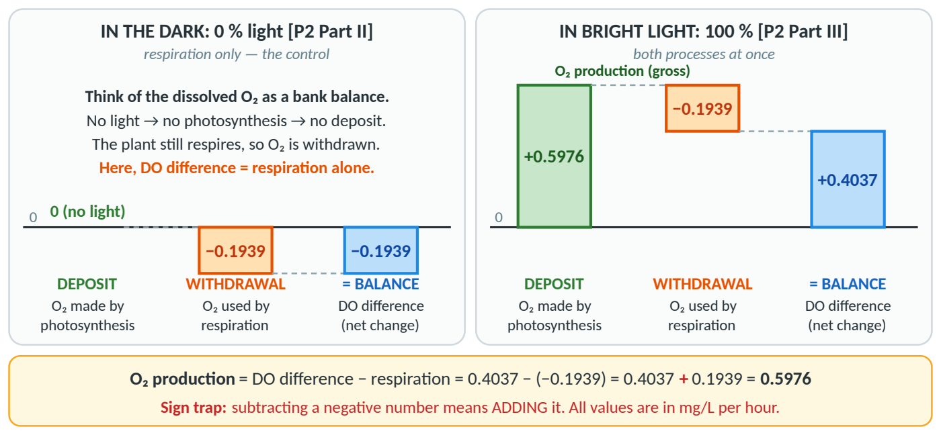
Figure 11. The oxygen bank account. In the dark, the only change is the respiration withdrawal. At 100 % light the DO reading shows the net change (+0.4037); the total O₂ made (0.5976) is that plus the 0.1939 used by respiration.
● KEY IDEA — Two different numbers — use the packet words
- DO difference (net change) = DO end − DO start = O₂ made − O₂ used. In the dark it is just respiration (−0.1939).
- O₂ production (gross) = all the O₂ made by photosynthesis = DO difference + 0.1939.
- Sign trap: the sheet says DO difference − respiration, and respiration is negative: 0.4037 − (−0.1939) = 0.4037 + 0.1939 = 0.5976. Mind the time basis too: per hour (60-minute run); per minute = ÷ 60.

Your Part III data, corrected
Highlighted = corrected from your sheet [P2 Part III]. O₂ production = DO difference + 0.1939; per minute = ÷ 60.
Light (%) | DO start (mg/L) | DO end (mg/L) | DO difference (net, mg/L per hour) | O₂ production (gross, mg/L per hour) | O₂ production (mg/L per minute)
100 | 7.0064 | 7.4101 | +0.4037 | 0.5976 | 0.0100 (not 0.001)
80 | 7.038 | 7.2464 | +0.2084 | 0.4023 | 0.0067
60 | 7.0587 | 7.0633 | +0.0046 | 0.1985 | 0.0033
40 | 7.0009 | 6.8072 | −0.1937 | 0.0002 (not 0.0102) | ≈ 0 (0.000003)
20 | 7.0677 | 6.8749 | −0.1928 | 0.0011 | 0.00002

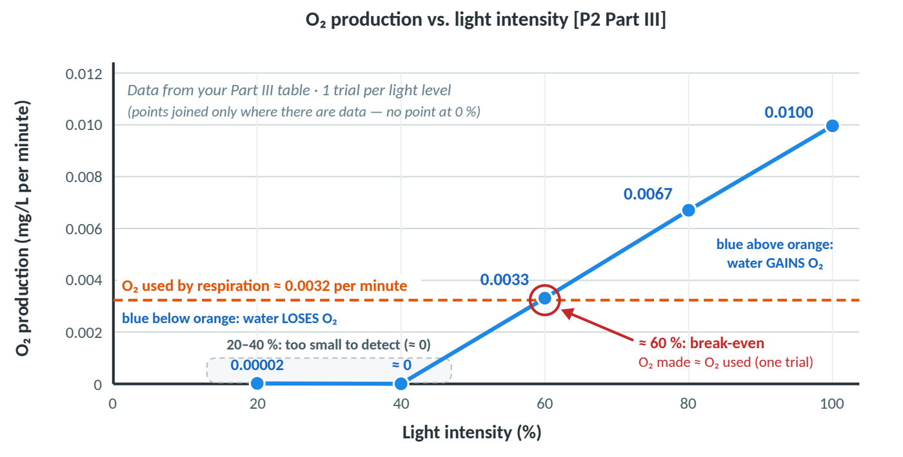
Figure 12. O₂ production per minute vs. light intensity, from your corrected table. The orange line is the O₂ used by respiration (0.1939 ÷ 60); where the blue line crosses it (near 60 %) the plant breaks even.
√ FIX-IT FROM YOUR WORKSHEET — Your Part III graph [P2 Part III Q7]
√ Axis titles with units, and 80 % and 100 % plotted correctly. To fix: your line dips below zero near 60 %, but your table says +0.0033 (every value is positive). Graph rules: independent variable on x, dependent on y, even scales, units, mark the points, a title, x-axis at 0, and don’t draw beyond the data (no line back to 0 %).

What your data show
- 20 % and 40 %: the DO fell about as much as in the dark (−0.1928 and −0.1937 vs. −0.1939), so photosynthesis was too small to detect in these data (0.0011 and 0.0002 are smaller than the trial-to-trial spread of about 0.003–0.006). Real plants do photosynthesize in dim light; this is just what these data show.
- Near 60 % (one trial): DO difference ≈ 0 (+0.0046): O₂ made ≈ O₂ used — a break-even point (the light compensation point; inference). Above it the water gains O₂; below it, it loses O₂.
- From 40 % up, each +20 % of light added about 0.20 mg/L per hour (0.0002 → 0.1985 → 0.4023 → 0.5976): a steady straight-line rise with no leveling off, so light was the limiting factor from 40 % to 100 %. Above 100 % is outside the data — we can’t say.
- Hidden assumption (great for a Level-4 answer): respiration can only be measured in the dark, so the worksheet assumes the plant respires at the same rate in light as in dark. (The tiny averaging slip, −0.1939 vs. −0.1941, changes nothing; this guide uses your −0.1939.)

Model CER — How does light intensity affect O₂ production? [P2 Part III] · see Guide 2 (CER Prep Guide)
CLAIM  answers the question | As light intensity increases, the plant’s O₂ production increases: it stayed near zero at 20–40 %, then rose steadily from 40 % to 100 %.
EVIDENCE  specific data / facts | - O₂ production was only 0.0011 and 0.0002 mg/L per hour at 20 % and 40 % light, then rose to 0.1985 at 60 %, 0.4023 at 80 % and 0.5976 at 100 %.  - At 20 % and 40 % the DO fell by 0.1928 and 0.1937 mg/L per hour — about the same as in the dark (−0.1939).
REASONING  the science “why” | Light is the energy source for photosynthesis. More light means chlorophyll in the chloroplasts absorbs more light energy, so photosynthesis runs faster and releases more O₂, one of its products. Cellular respiration uses O₂ all the time, so in dim light (20–40 %) it used O₂ much faster than photosynthesis made it, and the DO fell by about as much as in the dark. Because O₂ production never leveled off, light was the limiting factor from 40 % to 100 %.

Part 6 · What controls the rate: light, color, temperature, CO₂
A limiting factor is whatever is in shortest supply and holds the rate back — like the narrowest part of a pipe. The classic three for photosynthesis are light intensity, temperature and CO₂ concentration; light color matters too.  Light intensity (your team, Part III): more light → more light energy absorbed by chlorophyll → faster photosynthesis → more O₂. Your O₂ production stayed near zero at 20–40 %, then rose steadily from 40 % to 100 % with no leveling off, so light was the limiting factor from 40 % to 100 %. With even more light, another factor would eventually limit it (inference). Class best: 100 % [P2 Part VI].  Figure 13. The limiting-factor idea: the narrowest section sets the flow. | 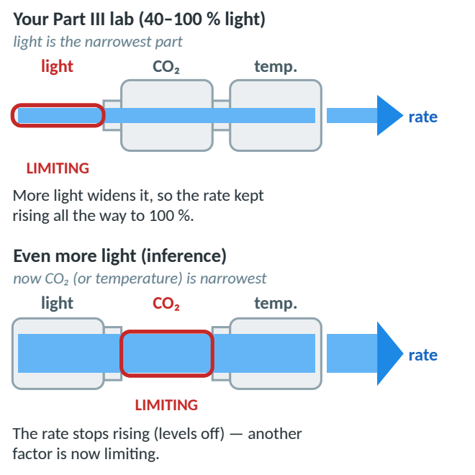

→ REASONABLE INFERENCE (beyond the packets) — CO₂ and going further
CO₂ is a reactant: more of it (e.g., baking-soda water) speeds up photosynthesis until another factor limits it — then the curve levels off. Other ways to measure the rate: count the O₂ bubbles from Elodea, or time how fast leaf disks float up. Where does a plant’s mass come from? Mostly from CO₂ in the air built into glucose, not from the soil.

Light color (Part IV, another team)
Class result: white light gave the most O₂ [P2 Part VI]. Your reason (“white contains the most colors”) is on the right track — sharpen it:  - Chlorophyll absorbs mostly red and blue/violet light and reflects green — that is why leaves look green.  - White light contains red and blue (and every other color), so the plant gets more light energy it can use.  - Among single colors, red and blue should work best and green worst.  Figure 14. Chlorophyll absorbs blue/violet and red, and reflects green (illustrative shape; inference). | 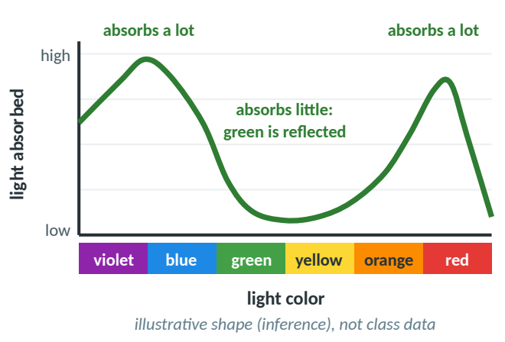

Temperature (Part V, another team)
The class’s best tested temperature was 20 °C [P2 Part VI]. Only 15, 20, 25, 30 and 35 °C were tested, so the true optimum is somewhere between 15 and 25 °C. Say “the class’s results showed…”, not “plants are always best at 20 °C”.  Too cold: molecules move and collide more slowly, so the enzyme-driven reactions slow down. Warmer than the optimum: O₂ production falls because enzymes work less efficiently; respiration also speeds up and uses more O₂, so the net gain (the DO difference) falls even faster.  Figure 15. How temperature can affect the rates (illustrative shapes, not class data). | 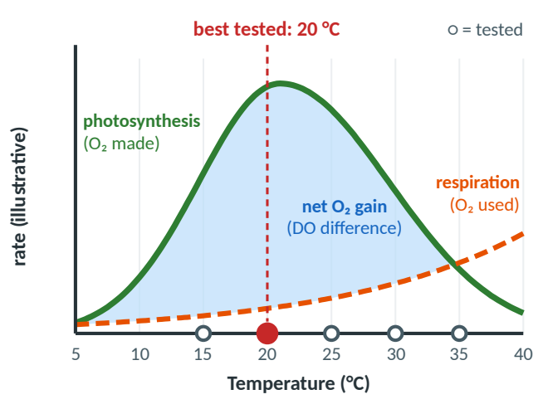

√ FIX-IT FROM YOUR WORKSHEET — “At higher temps (>20 °C), enzymes are denatured” [P2 Part VI]
Your cold-side reason is √ correct. But enzymes do not denature just above 20 °C — above the optimum they simply work less efficiently while respiration speeds up. Real denaturing of most plant enzymes needs about 40 °C or more.

What is productivity? [P2 Part VI Q2]
√ FIX-IT FROM YOUR WORKSHEET — Unanswered on your sheet — here is the idea
Productivity = the rate at which producers make organic compounds (food such as glucose); the sheet’s “release” wording is garbled. Why DO? O₂ is released in a fixed ratio as glucose is made (6 O₂ per glucose) and is easy to measure in water, so DO is a stand-in (proxy) for how fast food is made. More than oxygen? Yes — it really means making organic compounds (glucose → starch → new plant material); O₂ is just the easiest product to measure. The DO difference measures net productivity (after the plant’s own respiration).

Putting it together: the optimal ecosystem [P2 Part VII]
Part VII — the model for your CER test — asks for the best conditions and how many fish the tank can support. Class results: 100 % light, white light, about 20 °C (best tested). The logic: fish only respire (use O₂, release CO₂). The tank stays healthy only while the DO difference stays ≥ 0. One plant at 100 % white light and 25 °C gave +0.4037 mg/L per hour — that surplus is the O₂ “budget” for the fish.
- Example — HYPOTHETICAL PRACTICE DATA: if one fish used 0.10 mg/L per hour, the tank could support 4 fish (4 × 0.10 = 0.40 ≤ 0.4037, leaving +0.0037: a very thin margin — inside the trial-to-trial spread) but not 5 (0.50 > 0.4037). Find the real number: the +0.4037 was measured at 25 °C, so first re-measure the plant-only run at your chosen conditions; then add fish one at a time, rerun, and keep the last number with DO difference ≥ 0. More plants or better conditions raise the budget.
- Interdependence [P1 Q10]: the fish supply CO₂ for the plant’s photosynthesis; the plant supplies O₂ for the fish.
- Night check (inference): at night there is no surplus — everything only respires. Over 24 hours (12 h light, 12 h dark) with the HYPOTHETICAL 0.10 mg/L per hour per fish (n = number of fish): 12(0.4037 − 0.10n) − 12(0.1939 + 0.10n) ≥ 0 → n ≤ 1. So a real tank supports far fewer fish unless you add plants.

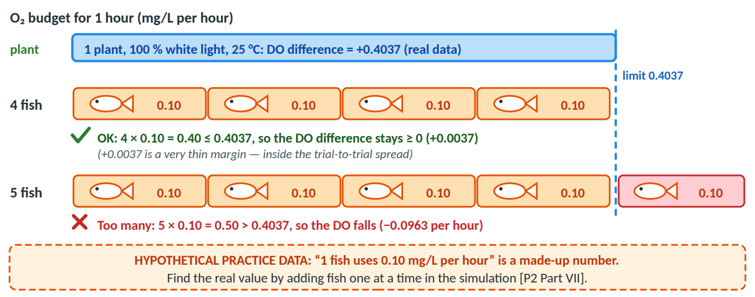
Figure 16. The O₂ budget. The plant’s surplus (+0.4037, real data, measured at 25 °C) is the most the fish can use. The 0.10 mg/L per hour per fish is HYPOTHETICAL PRACTICE DATA.
! WATCH OUT — Before the test: get the real Part IV and V numbers
Your sheet is blank for Parts IV (color) and V (temperature) — correct, other teams did them. Ask classmates for their actual data so you can quote real numbers as evidence.

Part 7 · The carbon cycle
Model 2 [P1 Model 2] shows carbon moving between the air, living things and underground stores. The lettered arrows (A–D) move CO₂ into or out of the air.
Arrow | Process | CO₂ in the air | Who does it
A | decomposer respiration (decay) | adds | fungi, bacteria, worms
B | animal respiration | adds | animals (the rabbit)
C | plant respiration | adds | plants
D | photosynthesis | removes | plants (producers)
Combustion | burning fossil fuels | adds | humans: cars, factories, power plants
The other arrows (feeding, death, wastes, decay, fossil-fuel formation) move carbon between living things and the carbon stores.

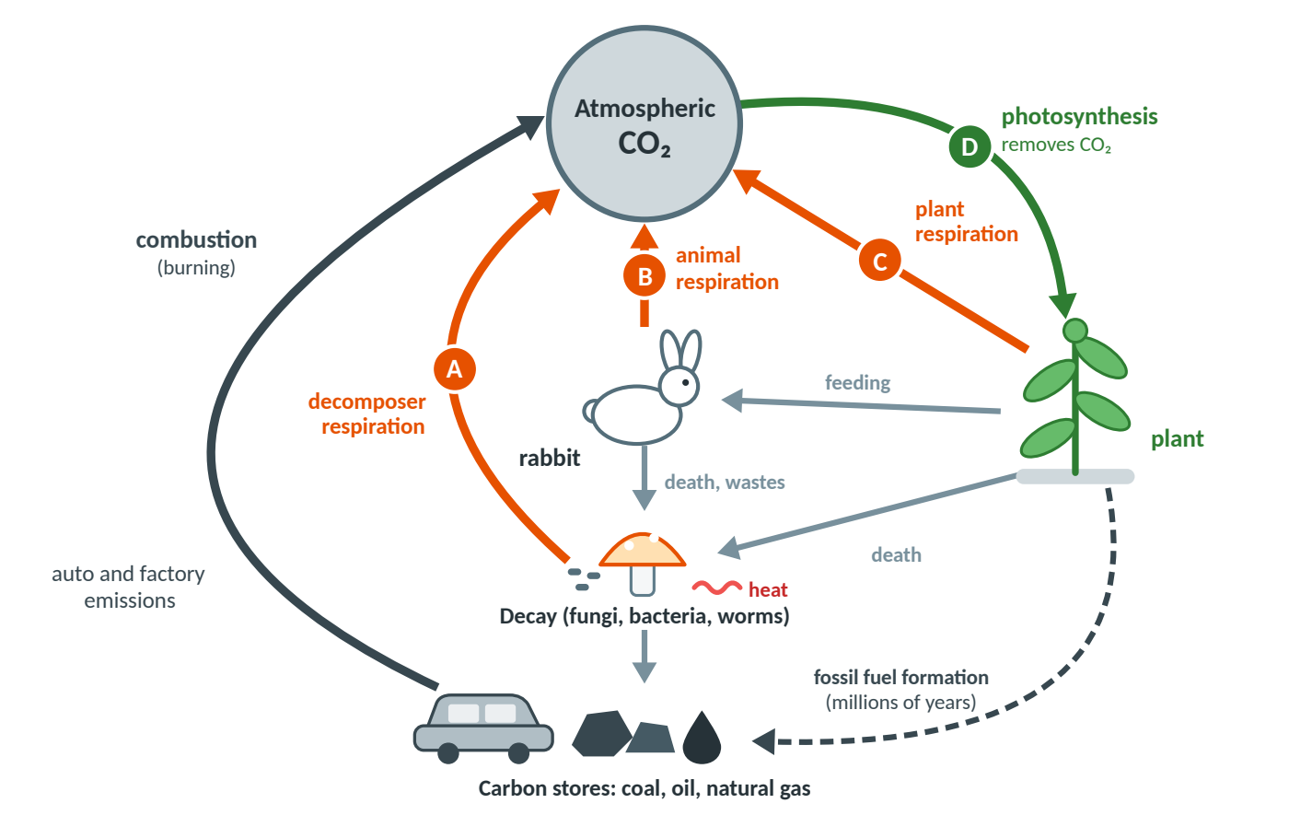
Figure 17. Model 2, redrawn. Green = photosynthesis, which removes CO₂; orange = respiration (the packet’s red stars), which adds CO₂; dark gray = combustion and fossil-fuel formation; light gray = carbon moving through food, death, wastes and decay.

The natural balance [P1 Q18]
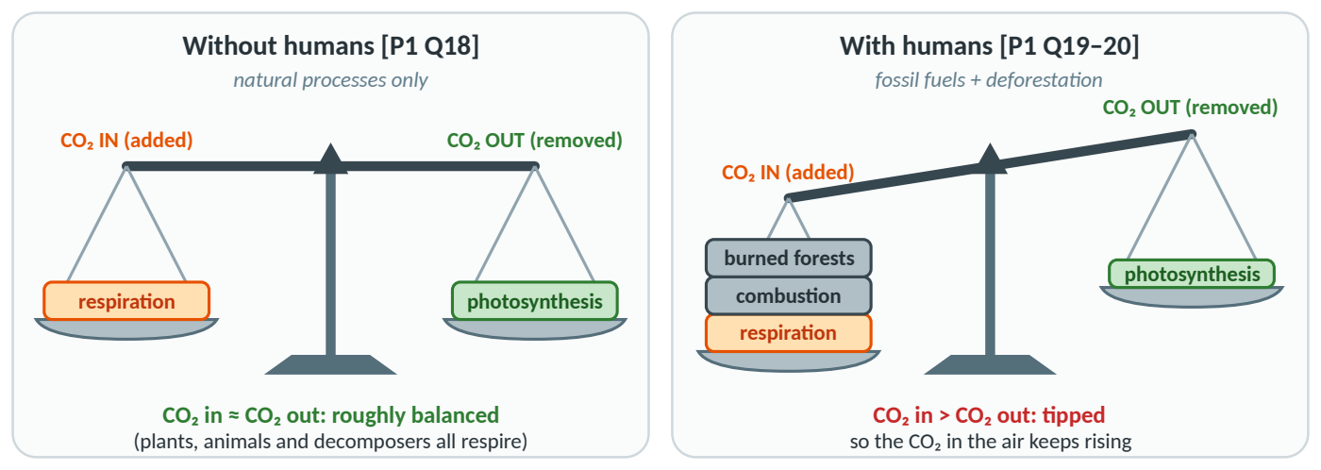
Figure 18. Your [P1 Q18] answer was strong. Left: without humans, the CO₂ added by respiration ≈ the CO₂ removed by photosynthesis, so the amount in the air stays roughly constant (an equilibrium). Right: burning fossil fuels and forests adds extra CO₂ and tips the balance [P1 Q19–20].
√ FIX-IT FROM YOUR WORKSHEET — [P1 Q13] and [P1 Q16]
Q13: green at D, red at C and A — √ correct — but you missed B (animal respiration). Q16: add decay (decomposition) as its own process, and swap the vague “metabolism” for feeding/digestion and excretion of wastes. Fossil-fuel formation = burial + heat + pressure over millions of years.

Part 8 · Humans & the carbon cycle
Fossil fuels (coal, oil, gas) hold carbon stored underground for millions of years. In about 200 years, humans have burned carbon that took millions of years to store, adding CO₂ far faster than nature can absorb it [P1 Q19].  Deforestation has two effects [P1 Q20]: fewer trees remove CO₂, and burning or rotting trees release their stored carbon.  The bathtub idea: CO₂ in the air is like water in a tub. It rises whenever more flows in (respiration + combustion) than drains out (photosynthesis).  Figure 19. The bathtub model of atmospheric CO₂. | 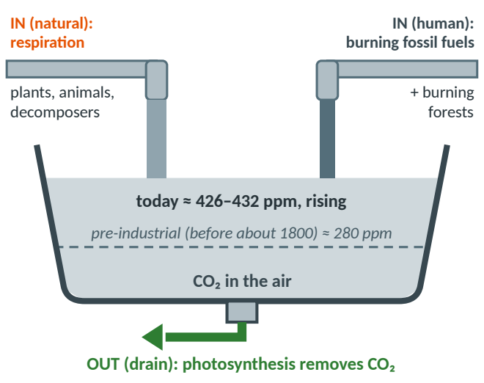

Ethanol fuel [P1 Q21]: pros | Cons
Renewable: crops can be regrown.  Plants absorb CO₂ as they grow, released again when the ethanol burns — so it is close to carbon-neutral. | Needs lots of water, land and fertilizer; can raise food prices.  Farm machines and transport run on fossil fuels — so it is not exactly carbon-neutral (your own con shows why).

CO₂-free electricity [P1 Q22]: solar, wind, geothermal — √ correct (hydroelectric is another). Your point that solar is promising with batteries for night is a good one.

Part 9 · Mauna Loa & the Keeling Curve
Mauna Loa is a still-active volcano in Hawaii; its observatory, about 3,400 m high, samples large, well-mixed air masses [P3]. Charles David Keeling began measuring CO₂ there in March 1958 at about 313 ppm (Scripps first reading; ppm = parts per million: CO₂ molecules per million air molecules); the graph of his data is the Keeling Curve. May 2026: record peak, about 432 ppm (Scripps; NOAA). Sept 2026: about 426 ppm (NOAA, preliminary). Pre-industrial (before about 1800): about 280 ppm (ice cores).
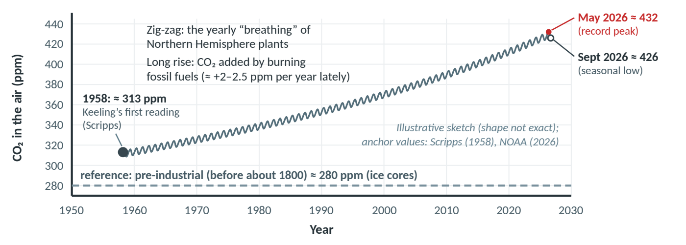
Figure 20. The Keeling Curve (illustrative sketch, real anchor values). CO₂ rises even though it drops every summer, because each year more is added (mostly by burning fossil fuels) than removed — recently about +2–2.5 ppm per year on average.

Why the yearly zig-zag? The running total
The CO₂ level is a running total — like water in a bathtub. In fall and winter, leaves drop and photosynthesis slows, but respiration and decay (microbes breaking down fallen leaves) keep adding CO₂, so the level keeps rising until it peaks in May, just as leaves come back. Months of strong summer photosynthesis then pull it down to the low in Sept/Oct. The swing comes mostly from the huge forests of the Northern Hemisphere. The Southern Hemisphere has the opposite pattern, and a weaker one, because it has less land and so fewer land plants [P3].
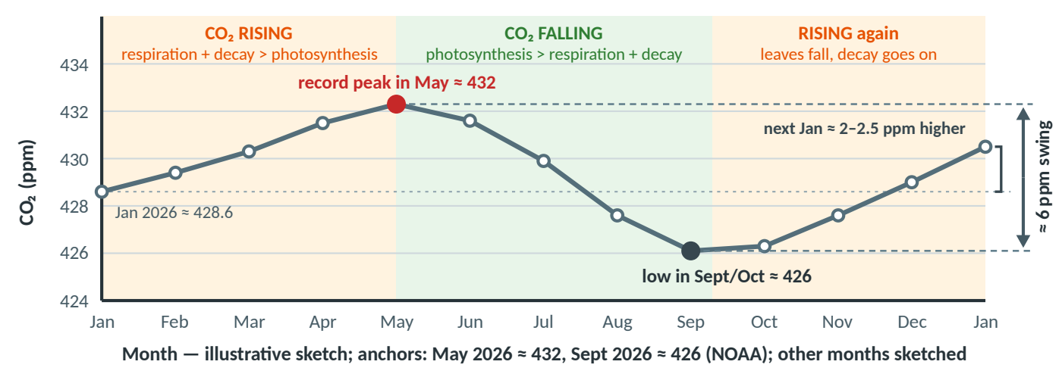
Figure 21. One year at Mauna Loa (illustrative): CO₂ climbs to a May peak and falls to a Sept/Oct low — a swing of about 6 ppm.

Two fix-its from your Mauna Loa notes [P3 p.1]
√ FIX-IT FROM YOUR WORKSHEET — “Photosynthesis is a delayed reaction”
Partly right: the observation is correct (more CO₂ in spring than fall; peak in May, low in Sept/Oct), and the level does lag behind the seasons. But photosynthesis itself starts within seconds of light. The lag happens because the level is a running total: it keeps climbing until photosynthesis removes more than respiration and decay add.

√ FIX-IT FROM YOUR WORKSHEET — “Cellular respiration… has a negligible effect on CO₂”
Likely a note-taking slip. Respiration (plants, animals and especially decomposers) releases a huge amount of CO₂ — about as much as photosynthesis removes each year (the balance in your own [P1 Q18]) — and it pushes CO₂ up every fall and winter. The lesson probably meant: respiration goes on all year, so the big season-to-season change comes mostly from photosynthesis switching up and down.

§ WHERE THIS COMES FROM — Other notes, polished [P3]
- “Regular” vs. “rampant” CO₂ (class terms) = CO₂ from natural sources vs. human-caused CO₂ — the same molecule, a different source. And respiration breaks down glucose (with O₂) to make ATP.
- CO₂ began rising with the Industrial Revolution (1800s), from a pre-industrial level (before about 1800) of about 280 ppm; the rise sped up sharply after WWII.
- √ Right in your notes: extra CO₂ from burning fossil fuels builds up faster than Earth can absorb it, and more CO₂ traps more heat. (Deforestation is a second human source [P1 Q20].)

Part 10 · Vocabulary
Term | Plain-English meaning | Example
Photosynthesis | Producers use light energy to make glucose + O₂ from CO₂ + water. | leaves on a sunny day
Cellular respiration | Cells break down glucose with O₂ to release its energy as ATP (+ CO₂ and water). | muscle cells; plants, 24/7
Chloroplast | The organelle (cell part) where photosynthesis happens. | green ovals in leaf cells
Chlorophyll | Green pigment that absorbs light (mostly red and blue/violet). | why leaves look green
Mitochondrion (pl. mitochondria) | The organelle where cellular respiration makes ATP. | in plant AND animal cells
Glucose (C₆H₁₂O₆) | A sugar that stores chemical energy. | stored as starch in seeds
ATP | The cell’s small, usable packets of energy (“energy currency”). | powers muscle movement
Reactant / product | What goes into a reaction / what comes out of it. | CO₂ in / O₂ out
Light / chemical energy | Energy carried by light / stored in the bonds of molecules. | photosynthesis: light → chemical
Stomata | Tiny leaf pores that let CO₂ in and O₂ out. | mostly under the leaf
Producer / consumer / decomposer | Makes its own food / eats others / breaks down dead matter. | grass / rabbit / mushroom
Interdependence | Living things depend on each other. | fish give CO₂; plants give O₂
Dissolved oxygen (DO) | O₂ gas dissolved in water, measured in mg/L. | the simulation’s DO reading
DO difference (net) | DO end − DO start = O₂ made − O₂ used. | +0.4037 at 100 % light
O₂ production (gross) | Total O₂ made by photosynthesis = DO difference + 0.1939. | 0.5976 at 100 % light
Independent / dependent variable | What you change on purpose / what you measure. | light % / O₂ production
Controlled variable | Kept the same so the test is fair. | 25 °C, white light, 0 fish
Control (baseline) | A comparison run with the factor removed. | Part II dark run
Limiting factor | The factor in shortest supply that holds the rate back. | light, 40–100 % in Part III
Break-even point | Light level where O₂ made = O₂ used (light compensation point). | near 60 % in your data
Enzyme / denature | Protein that speeds up a reaction / loses its shape in high heat. | most plant enzymes: 40 °C+
Optimum temperature | The temperature at which a process works best. | best tested ≈ 20 °C
Productivity | The rate at which producers make organic compounds (food). | estimated from DO
Carbon cycle | The path carbon atoms take between the air, living things and underground stores. | Model 2 [P1]
Combustion / fossil fuels | Burning (makes CO₂) / coal, oil, gas formed over millions of years. | cars, power plants
Carbon-neutral | Adds no more CO₂ to the air than it removes overall. | ethanol: close, not exactly
Equilibrium (balance) | Amount in ≈ amount out, so the total stays steady. | natural carbon cycle [P1 Q18]
ppm / Keeling Curve | CO₂ molecules per million air molecules / the Mauna Loa CO₂ graph. | ≈ 432 ppm in May 2026

Part 11 · Quick self-check
Cover the answers (or use the flip cards in the HTML version). If you miss one, reread the part in brackets.
1. Write the photosynthesis equation. (Part 2)  Answer: 6CO₂ + 6H₂O + light energy → C₆H₁₂O₆ + 6O₂ | 2. Write the cellular respiration equation. (Part 3)  Answer: C₆H₁₂O₆ + 6O₂ → 6CO₂ + 6H₂O + energy (ATP)

3. Which energy goes IN to photosynthesis, and which comes OUT of respiration? (Part 4)  Answer: Light energy goes in; respiration releases energy as ATP (usable energy), plus some heat. | 4. Do plants do cellular respiration? When? (Part 3)  Answer: Yes — in their mitochondria, all the time, in light and dark.

5. How is breathing different from cellular respiration? (Part 3)  Answer: Breathing moves gases in and out of the lungs; cellular respiration is a chemical reaction in mitochondria that makes ATP. | 6. Why must sunlight be constantly available? (Part 1)  Answer: Energy is not recycled — it flows through living things and leaves as heat [P1 Q4].

7. What does the DO difference measure? How do you get O₂ production from it? (Part 5)  Answer: The net change: O₂ made − O₂ used. O₂ production = DO difference − (−0.1939) = DO difference + 0.1939. | 8. O₂ production at 100 % and at 20 % light? (Part 5)  Answer: 0.5976 and 0.0011 mg/L per hour.

9. What happened near 60 % light? (Part 5)  Answer: DO difference ≈ 0 (+0.0046): break-even, O₂ made ≈ O₂ used (one trial). | 10. What was the limiting factor in Part III, and how do you know? (Parts 5–6)  Answer: Light: O₂ production rose ≈0.20 mg/L per hour per +20 % of light from 40 % up, with no leveling off.

11. Name the independent, dependent and controlled variables in Part III. (Part 5)  Answer: IV: light intensity. DV: O₂ production (mg/L per hour). Controlled: 0 fish, 1 plant, 25 °C, white light, 60 min. | 12. Why is the Part II dark run the control? (Part 5)  Answer: No light → no photosynthesis, so it measures respiration alone: the baseline (−0.1939 mg/L per hour).

13. Which colors does chlorophyll absorb best? (Part 6)  Answer: Red and blue/violet; green is reflected (why leaves look green). | 14. Why is “enzymes denature just above 20 °C” wrong? (Part 6)  Answer: Above the optimum enzymes just work less efficiently and respiration speeds up; real denaturing needs about 40 °C or more.

15. Which Model 2 arrows add CO₂ to the air, and which removes it? (Part 7)  Answer: A, B, C (respiration) and combustion add CO₂; D (photosynthesis) removes it. | 16. Why does CO₂ keep rising if plants remove it every summer? (Parts 8–9)  Answer: Each year more is added (mostly fossil fuels) than removed — recently about +2–2.5 ppm per year.

17. Why does Mauna Loa CO₂ peak in May and hit a low in Sept/Oct? (Part 9)
Answer: All fall and winter respiration and decay add more than photosynthesis removes, so the running total climbs until leaves return in May; summer photosynthesis then draws it down until Sept/Oct.

