CER Prep Guide
How to prepare for, organize, and answer photosynthesis CER questions
Claim · Evidence · Reasoning — step by step, with model answers built from your own lab data

Your test will ask you to write CER answers about photosynthesis and cellular respiration. This guide shows you how to do that every time: a 5-step method, claim templates, a toolkit of science principles for your reasoning, three fully worked examples, and a test-day plan. Every example comes from your own packets, so the numbers will look familiar.
Packet codes: [P1] “Photosynthesis and Respiration” worksheet (Model 1, Q1–12; Model 2 carbon cycle, Q13–22) · [P2] “Photosynthesis & Cellular Respiration Simulation” lab, Parts I–VII (your team did Part III, Light Intensity) · [P3] your notes “Mauna Loa & the Rise of CO₂”.
WHAT'S INSIDE
- 1 · What CER is  - 2 · How CER is graded  - 3 · The 5-step CER method  - 4 · Writing strong claims | - 5 · Choosing evidence  - 6 · Building reasoning  - 7 · Counterclaim and rebuttal  - 8 · Three worked examples | - 9 · Upgrade a weak answer  - 10 · Common mistakes  - 11 · Sentence starters  - 12 · Test-day game plan

1 · What CER is — and why teachers use it
CER stands for Claim, Evidence, Reasoning. It is how scientists argue: they give an answer, prove it with data, and explain the science that connects the two. A CER answer is not a summary of the whole lab. It is a short, focused argument that answers one question.
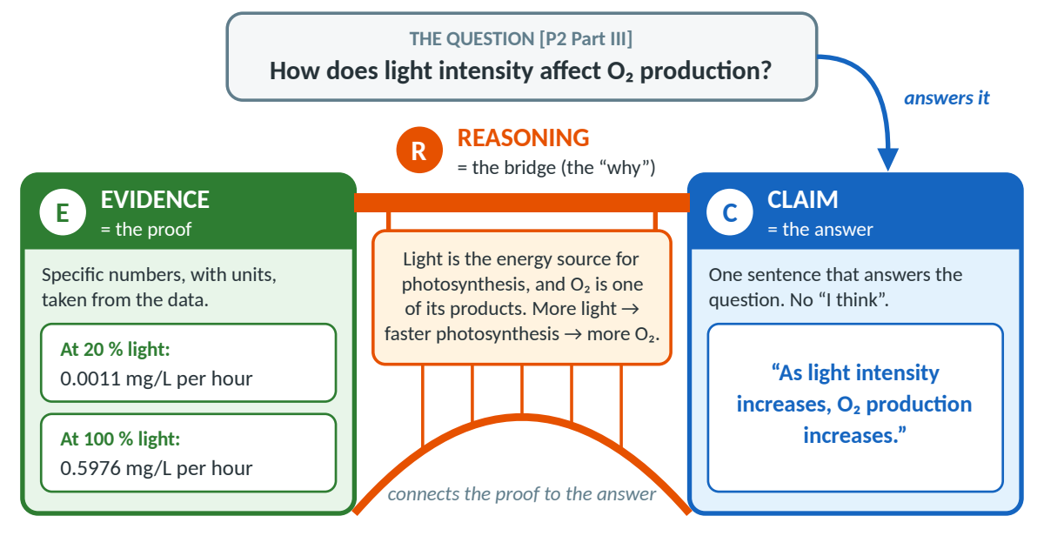
Figure 1. Anatomy of a CER answer. The claim answers the question, the evidence proves it, and the reasoning is the bridge that explains why the evidence supports the claim (example: [P2 Part III]).
Why teachers use CER. It shows real understanding: anyone can copy a number, but explaining why it came out that way proves you know the science. It is fair to grade, because each part earns its own points (Section 2). And it is this unit’s big task: [P2 Part VII] asks you to “write a claim, provide evidence (numbers), and a scientific explanation incorporating photosynthesis and respiration. (Color code or label your C, E, and R.)”
→ TIP — Color code AND label
Claim = blue [C] · Evidence = green [E] · Reasoning = orange [R]. Always write the letters too, so your answer still works in pencil, on a black-and-white copy, and for color-blind readers. Every model answer in this guide is labeled this way.

2 · How CER answers are graded
Most 9th-grade CER rubrics look like this one (6 points). Your teacher’s may differ slightly, but the habits that earn points are the same. Notice that half the points are for reasoning.
Part | 0 points | 1 point | 2 points | 3 points
Claim (0–1) | Missing, wrong, or does not answer the question | Accurate, complete, answers the question | — | —
Evidence (0–2) | None, wrong, or not related to the claim | Vague, or only one data point | At least 2 specific, accurate data points with units that support the claim | —
Reasoning (0–3) | Wrong science, or missing | Restates the evidence or is vague | Correct principle, but a weak link to the evidence | Correct principle(s) + explicitly links evidence to claim + correct vocabulary

Same question, two answers: 6/6 vs 3/6
Question: In Part III, why did the dissolved oxygen (DO) go down at 20 % light but go up at 100 % light? [P2 Part III]
Part | √ 6/6 answer | × 3/6 answer
Claim | [C] At 20 % light the plant’s respiration used more O₂ than photosynthesis made, so the DO fell; at 100 % light photosynthesis made more O₂ than respiration used, so the DO rose.  1/1 answers both halves of the question. | [C] The DO went down at 20 % because there wasn’t much light, and it went up at 100 % because there was more light.  1/1 answers the question in one sentence.
Evidence | [E] At 20 % the DO fell by 0.1928 mg/L per hour, almost the same as in the dark run (−0.1939 mg/L per hour, Part II). At 100 % it rose by 0.4037 mg/L per hour (7.0064 → 7.4101 mg/L).  2/2 specific numbers with units, plus the dark-run baseline. | [E] At 100 % it went up by 0.4037.  1/2 only one number, with no unit (0.4037 what?). Nothing at all for 20 %.
Reasoning | [R] Plants do both processes at once. Respiration in the mitochondria uses O₂ all the time; photosynthesis in the chloroplasts uses light energy and releases O₂ as a product. The DO difference is the net: O₂ made − O₂ used. At 20 % photosynthesis added almost nothing (0.0011 mg/L per hour), so the DO fell as in the dark; at 100 % it made 0.5976, more than the 0.1939 used, so the water gained O₂.  3/3 both processes, organelles, O₂ as a product, and “net = made − used” tied to the numbers. | [R] Plants need light to do photosynthesis, which makes oxygen.  1/3 vague. Photosynthesis making O₂ cannot explain why the DO went down: respiration is missing, and nothing links back to the numbers.

To turn the 3/6 into a 6/6: add the 20 % numbers with units, name respiration (uses O₂ all the time, in the mitochondria), and explain “DO difference = O₂ made − O₂ used”.
Score your own CER (use this on every practice answer)
 | Check | Points
□ | Claim — one sentence, accurate, answers the exact question (no “I think”) | 1
□ | Evidence — at least one specific, accurate number with its unit | 1
□ | Evidence — a second data point or a comparison (“from __ to __”) that supports the claim | 1
□ | Reasoning — names the correct science principle (e.g., light is the energy source; respiration uses O₂) | 1
□ | Reasoning — explicitly links the evidence to the claim (“This shows… because… therefore…”) | 1
□ | Reasoning — correct vocabulary: reactant/product, chloroplast/mitochondrion, light energy/ATP | 1
 | Total | 6

3 · The 5-step CER method
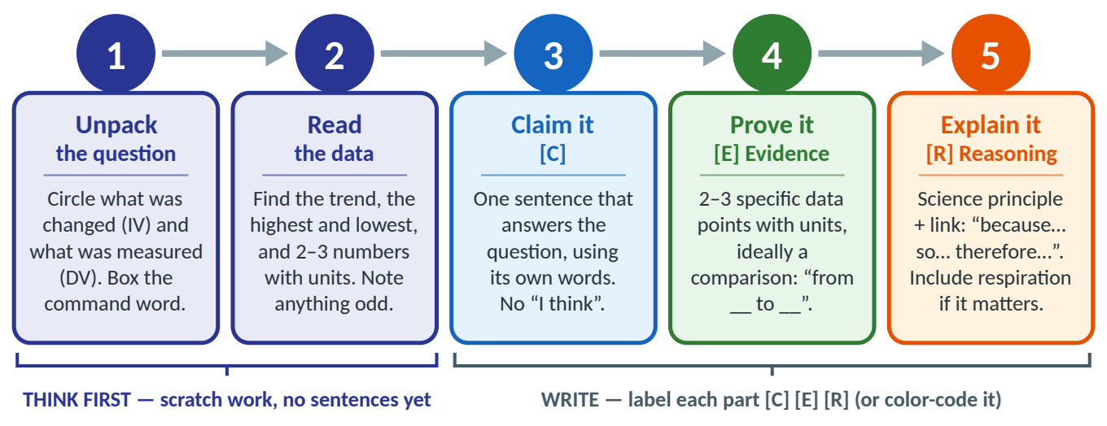
Figure 2. The 5-step CER method — use it on every CER question. Steps 1–2 are thinking (scratch work only); steps 3–5 are writing, one labeled part at a time.
Step | How to think: ask yourself… | Mini example (your Part III light data) | Watch out
1 · Unpack | What changed (IV)? What was measured (DV)? What does the command word (describe, explain, compare) want? | “How does light intensity (IV) affect O₂ production (DV)?” → a trend question → trend template. | Is it asking for O₂ production or DO difference?
2 · Read the data | What is the pattern? Highest? Lowest? Anything odd? | Flat near 0 at 20–40 %, then a steady rise; highest 0.5976 mg/L per hour at 100 %. Odd: 0.0011 (20 %) > 0.0002 (40 %), but both ≈ 0. | Per hour or per minute?
3 · Claim it [C] | Does my one sentence answer the exact question? | “As light intensity increases, O₂ production increases.” | No “I think”; don’t claim beyond the data.
4 · Prove it [E] | Could someone check these numbers in the table? | “O₂ production rose from 0.0011 mg/L per hour at 20 % to 0.5976 mg/L per hour at 100 %.” | No unit = vague. Don’t copy the whole table.
5 · Explain it [R] | WHY does the evidence support the claim? Which principle? Is respiration involved? | “Light is the energy source for photosynthesis: more light → more energy absorbed by chlorophyll → faster photosynthesis → more O₂ (a product).” | Don’t just repeat the evidence.

4 · Writing strong claims
A strong claim answers the exact question, uses the question’s own variables, gives a direction (increases/decreases), and stays inside what was tested. The question’s wording tells you the template:
Question type | Claim template | Example from your packets
Trend — “How does X affect Y?” | “As [IV] increases, [DV] increases / decreases.” | “As light intensity increases, O₂ production increases.” [P2 Part III]
Best condition — “Which is best / optimal?” | “[Condition] gives the most [DV].” | “100 % light gave the most O₂ production of the light levels tested.” [P2 Part III]
Comparison — “Compare A and B.” | “[A] produced more [DV] than [B].” | “At 100 % light the plant produced more O₂ than at 60 % light.” [P2 Part III]
Mechanism — “Why does … happen?” | “[Pattern] happens because [process].” | “CO₂ at Mauna Loa falls each summer because Northern-Hemisphere plants remove more CO₂ by photosynthesis than respiration and decay add.” [P3]
Model-based — “What will happen if…?” | “[Action] will increase / decrease [quantity].” | “Burning fossil fuels will increase the amount of CO₂ in the atmosphere.” [P1 Model 2, Q19]

Quick practice: write the claim (then check)
1. Which light intensity gave the most O₂ production in Part III? (best condition)
2. Why did the DO go down in the Part II dark run? (mechanism)
3. What would happen to atmospheric CO₂ if a large forest were cut down and burned? [P1 Q20] (model-based)
Answers
- “100 % light gave the most O₂ production of the light levels tested (20–100 %).” Not “100 % is the best light for plants”: you only tested up to 100 %.
- “The DO went down in the dark because the plant’s cellular respiration used O₂ while no photosynthesis was happening.”
- “Cutting down and burning a large forest would increase the amount of CO₂ in the atmosphere.” (Fewer plants remove CO₂, and burning releases the trees’ stored carbon.)

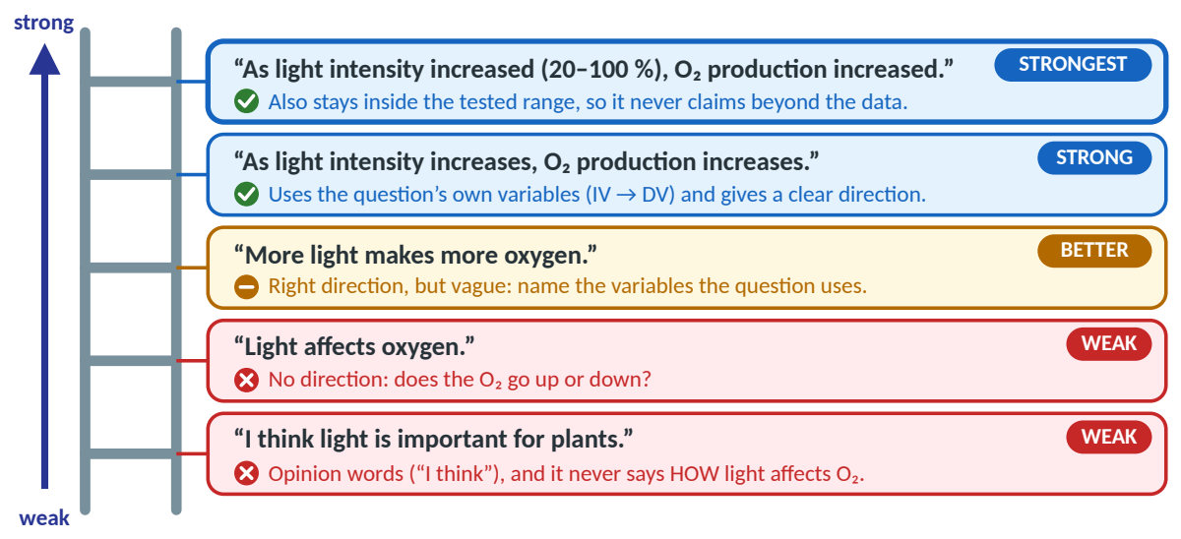
Figure 3. The claim ladder: climb from a weak claim to a strong one (your Part III question). Your own Q8 conclusion, “Higher light intensity generally means higher oxygen production”, is already on rung 4 — nice! Section 9 turns it into a full CER.

5 · Choosing evidence
Evidence is the specific data that proves your claim. Choose the right numbers, not all of them.

How much evidence is enough?
- 2–3 data points, with units, that directly support the claim. A change (“from 0.0011 to 0.5976 mg/L per hour”) beats five numbers with no comparison. Describe the pattern in words too: “From 40 % up, each extra 20 % of light added about 0.20 mg/L per hour.”
- Include the baseline when you explain a change: the Part II dark run (−0.1939 mg/L per hour) shows what respiration alone does.

Data quality: how far can you trust the numbers?
- Trials and noise: Part II averaged 3 trials (−0.1941, −0.1908, −0.1973 → −0.1939 mg/L per hour), which differ by up to 0.0065, so values smaller than about ±0.005 (like 0.0011 and 0.0002) can’t be told apart from zero. Part III used only 1 trial per light level — a limitation worth naming.
- Controls: the Part II dark run is the baseline (respiration alone), and everything except light was kept the same (0 fish, 1 plant, 25 °C, white light, 60 minutes), so light caused the change in O₂ production.

DO difference vs O₂ production — and the sign trap
Your table has two different “oxygen” numbers. The DO difference (= net change, end − start) is what you measured: O₂ made − O₂ used. O₂ production (= gross) is the total O₂ made by photosynthesis. The worksheet formula is O₂ production = DO difference − respiration. Because respiration is a negative number (−0.1939), subtracting it means adding 0.1939: −(−0.1939) = +0.1939. Quote the right one, and name it: how much O₂ the plant made → O₂ production (0.5976 at 100 %); what happened to the O₂ in the water → DO difference (+0.4037 at 100 %).
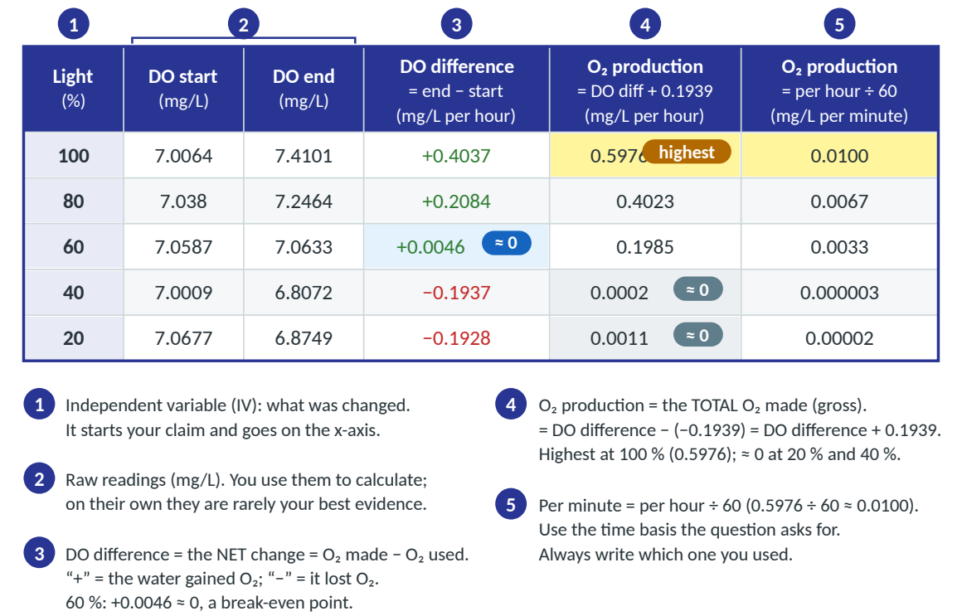
Figure 4. How to read your Part III data table: five columns, five jobs.
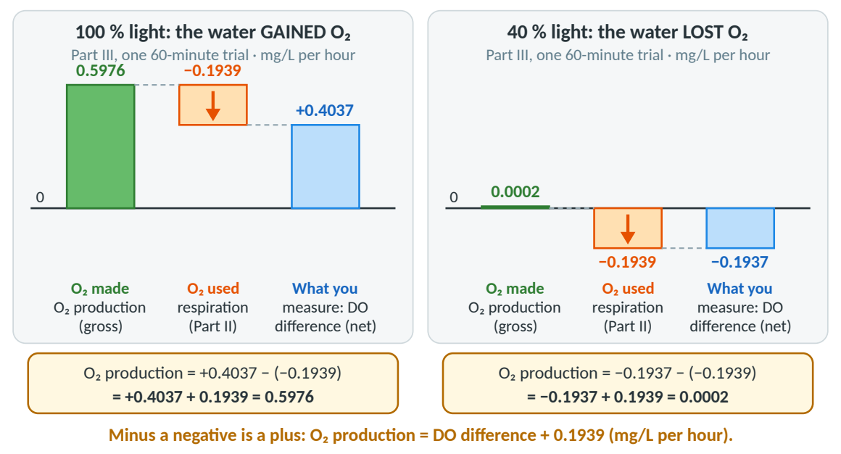
Figure 5. What you measure (DO difference) = O₂ made − O₂ used. Add back the respiration to get O₂ production. Data: your Part III table and Part II respiration rate.
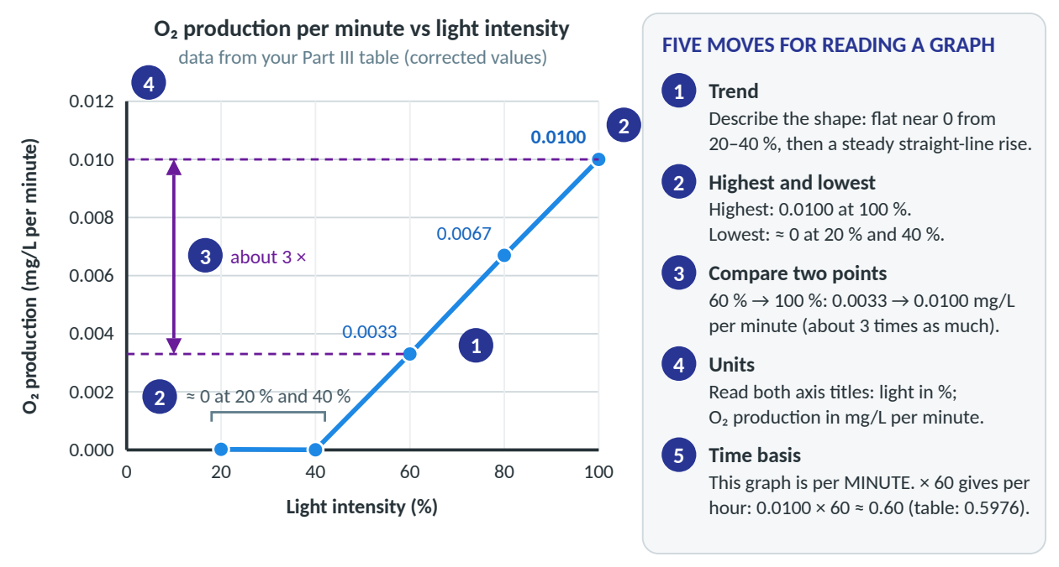
Figure 6. Five moves for reading a graph, shown on the correct graph of your Part III data (per minute).

6 · Building reasoning
Reasoning is worth the most points (3 of 6). It has two parts: a science principle (a rule that is always true) and a link showing how it explains your evidence. Pick the 1–3 principles that fit from this toolkit.
# | The Reasoning Toolkit: principle in one line († = standard biology a little beyond your packets) | Use it when…
1 | Light is the energy source for photosynthesis; its energy is stored as chemical energy in glucose. | light intensity or color; “where does the energy come from?”
2 | O₂ is a product of photosynthesis: more photosynthesis → more O₂ released. | your evidence is DO or O₂ production
3 | CO₂ is a reactant of photosynthesis: photosynthesis removes CO₂ from the air or water. | Keeling Curve; carbon cycle; plant-and-fish tanks
4 | Respiration uses O₂ and releases CO₂ all the time (light or dark), in the mitochondria, making ATP. | the DO fell; the dark run; fish; CO₂ rising in fall
5 | Plants do both (chloroplasts AND mitochondria). Animals only respire. Decomposers respire too. | “Do plants need mitochondria?” [P1 Q5–10]
6 | Net vs gross: DO difference = O₂ made − O₂ used; O₂ production = total O₂ made. | why the DO rose or fell; finding O₂ production
7 † | Chlorophyll absorbs mostly red and blue/violet light and reflects green. White light contains all colors. | light color (Part IV)
8 † | Enzymes have an optimum temperature: slower below it, less efficient above it; respiration speeds up when warmer. | temperature (Part V); “why not hotter?”
9 † | Limiting factors: the rate is held back by whichever factor is in shortest supply (light, CO₂, temperature). | “Why did it keep rising?” “What else limits it?”
10 | Carbon cycle balance: without humans, CO₂ taken in by photosynthesis ≈ CO₂ returned by respiration and decay. | Model 2 questions [P1 Q18]
11 | Fossil fuels release stored carbon: burning moves ancient carbon into the air as CO₂; deforestation removes CO₂ absorbers. | human impact; the long-term rise [P1 Q19–20]
12 | The CO₂ level is a running total (like water in a bathtub): it rises whenever more is added than removed. | why CO₂ peaks in May; why CO₂ keeps rising [P3]

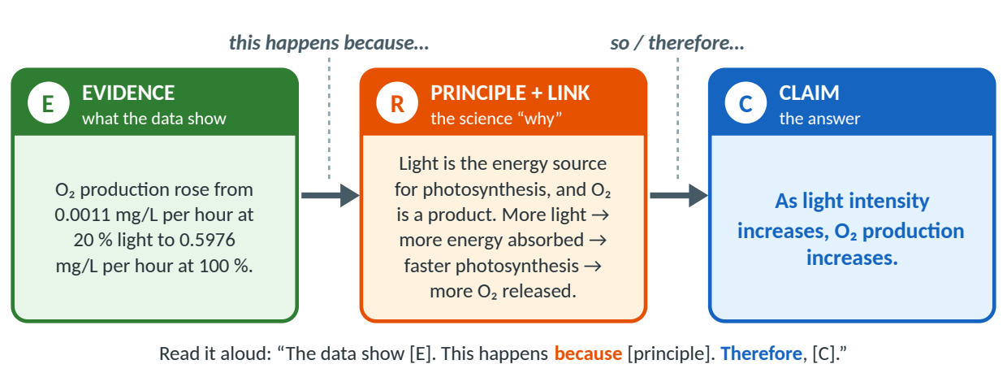
Figure 7. The because-chain: evidence → principle → claim. Every link has to be there.
◊ HOW TO THINK ABOUT IT
Linking words that make the link visible: this shows that… · this happens because… · since… · therefore… · as a result… · this means… · …which is why… · at the same time… (more in Section 11). The delete test: cover your reasoning. If your answer still says the same thing, the reasoning only repeated the evidence.

7 · Counterclaim and rebuttal (CERR)
When a question gives an opposing idea (“A student says…”) or asks you to argue or evaluate, add a counterclaim (a reasonable opposing idea, such as a watch-out from Section 10) and a rebuttal (evidence + reasoning that show why it is weaker). A good rebuttal can lift a strong answer to an excellent one.
Sentence frames, in order: (1) state the counterclaim fairly: “Some might argue that…” (2) point to evidence against it: “However, the data show…” (3) explain the science: “This is because…” (4) return to your claim: “Therefore…”
▪ EXAMPLE — Worked rebuttal: “Plants don’t need mitochondria because they make their own food.”
[C] Plants need mitochondria, because plant cells carry out cellular respiration. Some might argue that plants don’t need mitochondria because they make their own food. [E] However, in the Part II dark run (0 % light, 0 fish, 1 plant) the DO fell in all three trials: −0.1941, −0.1908 and −0.1973 mg/L per hour (average −0.1939). [R] With no light there was no photosynthesis, and with no fish the plant was the only organism in the tank. The process that uses up O₂ is cellular respiration, which happens in the mitochondria. Making food is not the same as using it: the plant makes glucose by photosynthesis, but its cells still break that glucose down in their mitochondria to release energy as ATP. Therefore, the counterclaim is wrong: plants need both chloroplasts and mitochondria [P1 Q6].

8 · Three fully worked examples (think-aloud)
Try each question yourself first (about 10 minutes), then open the model answer. Each example shows the thinking for every step, a 6/6 model answer and why it earns 6/6, and two tempting wrong versions.

Example A · Light intensity and oxygen production
Data: your Part III table (Figure 4, Figure 6) · [P2 Part III] · question type: trend
Question. How does light intensity affect oxygen production during photosynthesis? Use your Part III data and explain your answer in terms of photosynthesis and respiration.
Step | What you think (out loud)
1 · Unpack | IV = light intensity (%); DV = O₂ production (mg/L per hour). “How does X affect Y?” → trend claim. “Photosynthesis and respiration” → my reasoning needs BOTH.
2 · Read the data | O₂ production 0.0011, 0.0002, 0.1985, 0.4023, 0.5976 (20 → 100 %): flat near 0, then up about 0.20 per +20 %. DO difference −0.1928 at 20 % but +0.4037 at 100 %.
3 · Claim | Trend template, plus “in the range we tested” so I don’t claim beyond the data.
4 · Evidence | Lowest vs highest (0.0011 → 0.5976), the steady step size, and the DO difference switching from − to +.
5 · Reasoning | Toolkit #1 (light = energy), #2 (O₂ = product), #4 (respiration all the time), #6 (net vs gross), #9 (limiting factor), each linked to a number.

Model answer — Example A (6/6)
CLAIM  answers the question | In the range we tested (20–100 %), as light intensity increases, the plant’s O₂ production increases.
EVIDENCE  specific data / facts | - O₂ production rose from 0.0011 mg/L per hour at 20 % light to 0.5976 mg/L per hour at 100 % light.  - From 40 % up, each extra 20 % of light added about 0.20 mg/L per hour (0.0002 → 0.1985 → 0.4023 → 0.5976).  - The water went from losing O₂ (DO difference −0.1928 mg/L per hour at 20 %) to gaining it (+0.4037 at 100 %).
REASONING  the science "why" | Light is the energy source for photosynthesis (6CO₂ + 6H₂O + light energy → C₆H₁₂O₆ + 6O₂). Chlorophyll in the chloroplasts absorbs light energy, so more light means faster photosynthesis and more O₂, a product, released. At the same time the plant’s mitochondria use O₂ for cellular respiration, light or dark (−0.1939 mg/L per hour in the Part II dark run). At low light respiration used more O₂ than photosynthesis made, so the DO fell; at high light photosynthesis made more than respiration used, so the DO rose. Because O₂ production was still rising steadily at 100 %, light was the limiting factor over the whole range we tested.

Why it scores 6/6. C (1) exact question, a direction, inside the tested range. E (2) three specific comparisons with units. R (3) energy source, product, organelles, respiration at the same time, every number linked.
! WATCH OUT — Two tempting wrong versions
- “Higher light means more oxygen because plants need light. At 100 % it was 0.5976.” → 3/6 (C 1 · E 1 · R 1). One number, no unit, no comparison. “Plants need light” has no energy, no product, no respiration.
- “As light increases, O₂ production increases. At 100 % it was 0.4037 and at 40 % it was −0.1937, so at 40 % there was no photosynthesis. 200 % light would be even better.” → 1/6 (C 1 · E 0 · R 0). Quotes the DO difference as O₂ production (sign trap). The DO fell because respiration outpaced photosynthesis, not because it stopped. 200 % is beyond the data.

Example B · Why CO₂ peaks in May (the Keeling Curve)
Data: your notes [P3] + NOAA / Scripps monthly values · question type: mechanism
Question. The Keeling Curve shows that CO₂ at Mauna Loa rises and falls every year. It is highest in May and lowest in September–October. Explain this seasonal pattern using photosynthesis and cellular respiration.
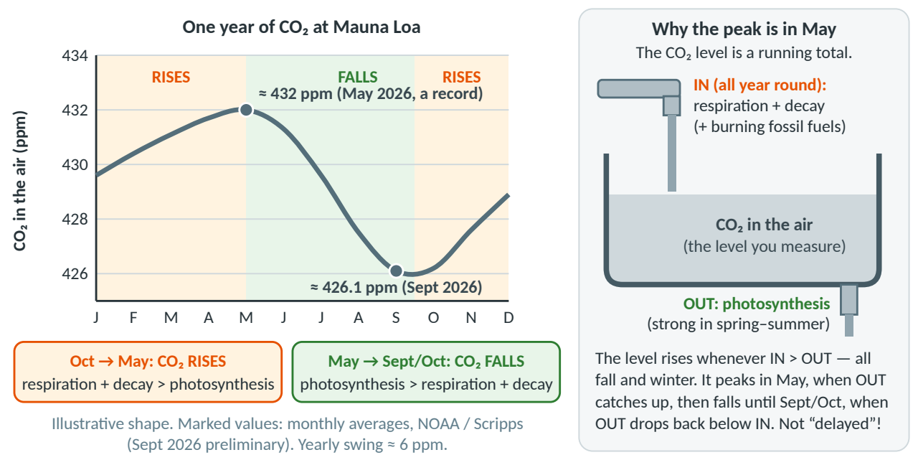
Figure 8. Left: one year of CO₂ at Mauna Loa (illustrative shape with two real monthly values). Right: the bathtub model — the CO₂ level is a running total.
Step | What you think (out loud)
1 · Unpack | “Explain this pattern” → mechanism claim: “[Pattern] happens because [process].” Use both processes. The “variable” is the season.
2 · Read the data | Peak ≈ 432 ppm (May 2026); low ≈ 426.1 ppm (Sept 2026, preliminary): about 6 ppm lower. Repeats every year; the Southern Hemisphere is opposite and weaker [P3].
3 · Claim | Mechanism template. Trap: my notes say “photosynthesis is a delayed reaction” (watch-out 8). The real reason is the running total.
4 · Evidence | The two monthly values in ppm, the size of the swing, and the timing (high in May, low in Sept/Oct).
5 · Reasoning | Toolkit #3 (CO₂ is a reactant), #4 (respiration and decay all year), #12 (running total). Explain the fall, the rise, and why the turn comes in May.

Model answer — Example B (6/6)
CLAIM  answers the question | CO₂ at Mauna Loa peaks in May and is lowest in September–October because Northern-Hemisphere plants remove CO₂ by photosynthesis mainly in spring and summer, while respiration and decay add CO₂ all year.
EVIDENCE  specific data / facts | - CO₂ peaked at about 432 ppm in May 2026 (a record) and fell to about 426.1 ppm by September 2026 (NOAA, preliminary): a drop of about 6 ppm in one growing season.  - The pattern repeats every year, and the Southern Hemisphere, with less land and fewer land plants, shows the opposite, weaker pattern [P3].
REASONING  the science "why" | Photosynthesis uses CO₂ as a reactant (6CO₂ + 6H₂O + light energy → C₆H₁₂O₆ + 6O₂). From May to September, trees in full leaf remove more CO₂ than respiration and decay add, so the level falls. In fall the leaves drop and photosynthesis slows, but cellular respiration by plants, animals and especially decomposers breaking down fallen leaves keeps releasing CO₂, so from October to May more CO₂ is added than removed. The CO₂ level is a running total, like water in a bathtub: it keeps rising while more flows in than out, peaks in May when photosynthesis catches up, and is lowest in Sept/Oct when photosynthesis drops back below respiration. Photosynthesis is not “delayed”; the level just takes months to build up and draw down.

Why it scores 6/6. C (1) pattern + cause. E (2) two real values with units and dates, the swing, the hemispheres. R (3) CO₂ as a reactant, respiration and decay all year, and the running total that explains the timing — the hardest part.
! WATCH OUT — Two tempting wrong versions
- “CO₂ is higher in spring because photosynthesis is a delayed reaction: it takes time to remove CO₂.” → 0/6 (C 0 · E 0 · R 0). Keeps a mistaken note (watch-out 8): photosynthesis starts within seconds of light. No numbers, no respiration.
- “CO₂ goes up and down because people burn more fossil fuels in winter. Respiration is constant, so it has a negligible effect.” → 0/6 (C 0 · E 0 · R 0). Fossil fuels explain the long-term rise, not the yearly zig-zag. Respiration plus decay release about as much CO₂ each year as photosynthesis removes (watch-out 8).

Example C · Optimal ecosystem productivity — and how many fish?
Data: class results [P2 Part VI] + your Part III data + HYPOTHETICAL PRACTICE DATA for the fish · [P2 Part VII] · question type: best condition + model
Question [P2 Part VII]. After your tests, what were the optimal conditions and why? How many fish could that environment support? Write a claim, provide evidence (numbers), and a scientific explanation incorporating photosynthesis and respiration. (Color code or label your C, E, and R.)
Step | What you think (out loud)
1 · Unpack | Two questions in one: (a) optimal conditions, (b) how many fish. “Photosynthesis and respiration” → both in my reasoning. “Label your C, E, and R” → write [C] [E] [R].
2 · Read the data | Class results: 100 % light, white light, 20 °C best tested (only 15, 20, 25, 30, 35 °C). One plant at 100 % white light: DO difference +0.4037 mg/L per hour = the O₂ “budget” for fish. Fish (HYPOTHETICAL): 0.10 each.
3 · Claim | Best-condition template + a number: 100 % light, white light, about 20 °C, about 4 fish. Say “best tested”.
4 · Evidence | Light: 0.0011 → 0.5976 mg/L per hour. Color, temperature: class results (+ real Part IV/V numbers). Fish: 4 × 0.10 = 0.40 ≤ 0.4037; 5 × 0.10 = 0.50 > 0.4037.
5 · Reasoning | Toolkit #1, #7, #8 for the conditions; #4, #5 for the fish (fish only respire; healthy only while O₂ made ≥ O₂ used). Bonus: fish CO₂ feeds the plant [P1 Q10].

Which numbers are real? Your Part III data and the class results (100 % light, white light, about 20 °C) are real; get the missing Part IV/V numbers from classmates. The O₂ one fish uses (0.10 mg/L per hour) is HYPOTHETICAL PRACTICE DATA; your Part VII runs give the real value.
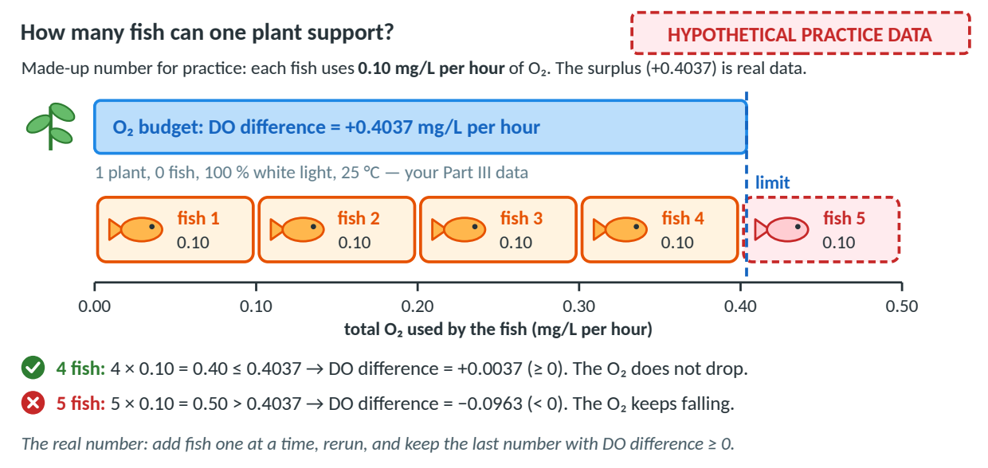
Figure 9. The fish “O₂ budget”. The fish numbers are HYPOTHETICAL PRACTICE DATA; the +0.4037 surplus is your real Part III value (1 plant, 100 % white light, 25 °C).
Model answer — Example C (6/6), written as a labeled paragraph
[C] The optimal conditions were 100 % light intensity, white light, and about 20 °C (the best temperature we tested), and under these conditions one plant could support about 4 fish. [E] In Part III, O₂ production rose from 0.0011 mg/L per hour at 20 % light to 0.5976 mg/L per hour at 100 %. The class results showed white light gave the most O₂ of the colors tested and 20 °C was best of the five temperatures tested (15–35 °C) [add your class’s Part IV and V numbers here]. One plant at 100 % white light (25 °C, Part III) had a DO difference of +0.4037 mg/L per hour, an O₂ surplus. Using HYPOTHETICAL PRACTICE DATA of 0.10 mg/L per hour per fish, 4 fish use 0.40 (DO difference +0.0037, still ≥ 0), but 5 fish use 0.50 (DO difference −0.0963, so the O₂ falls). [R] Photosynthesis in the chloroplasts uses light energy, CO₂ and H₂O to make glucose and releases O₂ as a product. Bright light supplies the most energy, white light contains the red and blue light that chlorophyll absorbs best, and the enzymes of photosynthesis work best near their optimum temperature. Cellular respiration in the mitochondria of the plant and the fish uses O₂ all the time, and fish only respire. The tank stays healthy only while O₂ made ≥ O₂ used (DO difference ≥ 0), so the fish’s total respiration must fit inside the plant’s surplus of about 0.40 mg/L per hour: 4 fish fit, 5 do not. The fish also release CO₂, a reactant the plant needs, so plant and fish depend on each other.

Why it scores 6/6. C (1) both parts (conditions + fish). E (2) real numbers with units, class results, and labeled practice numbers. R (3) both processes, organelles, reactants/products, and the rule “O₂ made ≥ O₂ used” that turns numbers into a fish count.
→ REASONABLE INFERENCE (beyond the packets) — Level-4 thinking
The +0.4037 surplus was measured at 25 °C; at the best tested 20 °C it is probably a little larger, so rerun to check. At night there is no photosynthesis, so no surplus, and the DO falls. And 4 fish leave a margin of only 0.0037 mg/L per hour (about the size of the trial-to-trial spread), so a careful scientist might choose fewer fish.

! WATCH OUT — Two tempting wrong versions
- “The best conditions are 100 % light, white light and 20 °C because plants need light. The tank could hold lots of fish.” → 1/6 (C 0 · E 0 · R 1). No numbers. “Lots of fish” does not answer “how many”. No respiration, though the question asks for it.
- “20 °C is best because above 20 °C the enzymes denature. More fish is better because fish make CO₂, so 10 fish would make the plant grow fastest.” → 0/6 (C 0 · E 0 · R 0). Enzymes don’t denature just above 20 °C (watch-out 10). It ignores that fish use O₂: with the practice data, 10 fish would use 1.0 mg/L per hour, over twice the surplus.

9 · Upgrade a weak answer
Use the rubric like a repair manual: check the claim, then the evidence, then the reasoning, and fix the weakest part first. Try each upgrade before you open the answer.

Weak answer 1 — your own Part III conclusion [P2 Part III Q8]
“Higher light intensity generally means higher oxygen production.” (About 1/6 as a CER: a good claim, but no evidence and no reasoning.)
- Fix C: keep it (it has a direction); say “O₂ production” and swap “generally” for the tested range.
- Fix E: add a comparison with units: 0.0011 → 0.5976 mg/L per hour; DO difference −0.1928 → +0.4037.
- Fix R: light = energy source; O₂ = product; respiration uses O₂ at the same time.

Upgraded answer 1 (6/6)
[C] In the range we tested (20–100 %), higher light intensity means higher O₂ production. [E] O₂ production rose from 0.0011 mg/L per hour at 20 % light to 0.5976 mg/L per hour at 100 %, and the DO difference changed from −0.1928 to +0.4037 mg/L per hour. [R] Light is the energy source for photosynthesis, so more light lets the chloroplasts make glucose faster and release more O₂, a product. The plant’s mitochondria use O₂ for respiration all the time, so at low light the DO fell; at high light photosynthesis made more O₂ than respiration used, so the DO rose.

Weak answer 2 — the temperature reason [P2 Part VI]
“20 °C is best because at higher temperatures the enzymes are denatured.” (About 1/6: a claim with no numbers and a science error.)
- Fix C: say “best tested”: only 15–35 °C in 5 °C steps were tested, so the true optimum is between 15 and 25 °C.
- Fix E: get the class’s Part V numbers: O₂ production at 20 °C vs a cooler and a warmer temperature, with units.
- Fix R: above the optimum, enzymes work less efficiently (real denaturing needs roughly 40 °C+), and respiration speeds up.

Upgraded answer 2 (6/6 once you fill in your class’s numbers)
[C] Of the temperatures we tested (15–35 °C), 20 °C gave the most O₂ production. [E] At 20 °C, O₂ production was ___ mg/L per hour, compared with ___ mg/L per hour at 15 °C and ___ mg/L per hour at 30 °C [your class’s Part V data]. [R] Photosynthesis is run by enzymes, which work fastest near an optimum temperature. Below it, molecules move and collide more slowly, so the reactions slow down. Above it, the enzymes work less efficiently (real denaturing needs roughly 40 °C or more), and the plant’s respiration speeds up and uses more O₂, so the water gains less O₂.

Weak answer 3 — burning fossil fuels [P1 Model 2, Q19]
Question: How does burning fossil fuels affect the carbon cycle? Weak answer: “It makes pollution and is bad for the environment.” (0/6: true-ish, but it does not answer the question.)
- Fix C: use the model-based template: “[Action] will increase / decrease [quantity].”
- Fix E: Model 2’s combustion arrow + real data: about 313 ppm (1958) → about 432 ppm (May 2026); about 280 ppm before the Industrial Revolution.
- Fix R: natural balance [P1 Q18] + stored carbon released faster than photosynthesis removes it + running total.

Upgraded answer 3 (6/6)
[C] Burning fossil fuels increases the amount of CO₂ in the atmosphere and upsets the balance of the carbon cycle. [E] In Model 2, combustion moves carbon from carbon stores (coal, oil, natural gas) into atmospheric CO₂ [P1 Model 2]. At Mauna Loa, CO₂ rose from about 313 ppm in 1958 to about 432 ppm in May 2026, far above the pre-industrial level of about 280 ppm (Scripps / NOAA). [R] Without humans, the CO₂ taken in by photosynthesis roughly equals the CO₂ returned by respiration and decay, so the level stays about constant [P1 Q18]. Burning fossil fuels adds carbon stored for millions of years to the air as CO₂, faster than photosynthesis can remove it. Because the CO₂ level is a running total, adding more than is removed each year makes it keep rising (recently about 2–2.5 ppm per year).

10 · Common mistakes (and one-line fixes)
# | Watch-out | One-line fix
1 | Swapping the energy labels (light in for photosynthesis, ATP out for respiration) | Photosynthesis takes in light energy; respiration releases energy as ATP.
2 | Forgetting plants also respire | Plants have chloroplasts AND mitochondria; they respire 24/7, light or dark.
3 | Saying animals lack mitochondria | Animals have mitochondria; what they lack is chloroplasts.
4 | Mixing up DO difference (net) and O₂ production (gross) — and the minus-a-negative sign trap | O₂ production = DO difference − (−0.1939) = DO difference + 0.1939.
5 | Evidence without numbers/units | Every evidence sentence gets a number + unit (mg/L per hour, %, °C, ppm).
6 | Reasoning that just repeats the evidence | Add a principle (“because light is the energy source…”) and link it.
7 | Claiming beyond the data (e.g., “200 % light would be even better”) | Say “in the range we tested (20–100 %)”.
8 | Keeping the mistaken notes (“respiration is negligible”, “photosynthesis is delayed”) | Respiration + decay release about as much CO₂ as photosynthesis removes; the level is a running total.
9 | “Respiration = breathing” | Breathing moves gases; cellular respiration is a chemical reaction in mitochondria.
10 | Saying enzymes “denature” just above 20 °C | Above the optimum they work less efficiently; denaturing needs roughly 40 °C+.
11 | Graph not matching the table / uneven scale / drawing beyond the data | IV on x, DV on y, even ticks, mark every point, stop at the last point.
12 | Forgetting units and the time basis (per hour vs per minute) | Write “mg/L per hour” or “mg/L per minute”; per minute = per hour ÷ 60.

11 · Sentence starters and transition words
Borrow these when you get stuck. They work for any CER question.
Part | Sentence starters | Linking / transition words
[C] Claim | “As ___ increases, ___ increases / decreases.” · “___ gave the most ___.” · “___ happens because ___.” · “___ will increase / decrease ___.” | none needed: just answer the question
[E] Evidence | “The data show that…” · “In Part ___, ___ rose from ___ to ___ (units).” · “At ___, ___ was ___, compared with ___ at ___.” · “According to Model 2…” | for example · compared with · from … to … · while · in contrast
[R] Reasoning | “This happens because…” · “Since ___ is a reactant / product of ___, …” · “This shows that…” · “At the same time, respiration…” | because · since · therefore · so · as a result · this means · which is why
Counterclaim & rebuttal | “Some might argue that…” · “However, the data show…” · “This idea is weaker because…” | however · although · even though · on the other hand
Wrap-up (optional) | “Therefore, ___.” · “Overall, the evidence supports the claim that ___.” | therefore · overall · in conclusion

12 · Test-day game plan

Before the test
When | What to do
First: as soon as you can | Get the real Part IV (light color) and Part V (temperature) numbers from classmates and write them into your packet: your sheet is blank there (other teams did those parts), and a Part VII-style question needs them as evidence. Fix your worksheet slips with Guide 5 (Detected Errors).
3–4 days before | Read Guide 1 (Learning Guide), Parts 1–6; then reread Sections 3–6 of this guide.
2 days before | Level 1–2 mock questions in Guide 3 (Mock CER Questions) on a timer; score each with the Section 2 checklist.
1 day before | Level 3–4 mock questions; reread Sections 8 and 10 here.
The night before | Read Guide 4 (Cheat Sheet) twice, then the “Top 5 fixes” in Guide 5 (Detected Errors); say both equations aloud with the right energy labels. Then sleep.
The morning of | Write the 5 steps and both equations from memory (on scratch paper, if allowed).

During the test
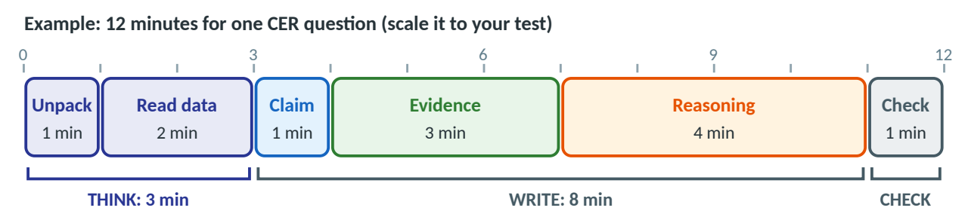
Figure 10. A time plan for one CER question. Reasoning gets the most time because it is worth the most points (3 of 6).
Unpack → data → C → E → R: circle the IV and DV, find the trend and 2–3 numbers, then write C, E and R, labeling each part [C] [E] [R] (or color-coding it). If the question says “photosynthesis and respiration”, use both. Stuck? Write C and E first (3 points), then come back.
Final 30-second check
 | Check | Points
□ | My claim is one sentence and answers the exact question (no “I think”). | 1
□ | I used at least 2 numbers, each with a unit and time basis — and the right oxygen number (DO difference vs O₂ production). | 1
□ | I named the science principle(s): reactant/product, organelle, energy. | 1
□ | I linked my evidence to my claim (“This shows… because… therefore…”). | 1
□ | I mentioned respiration happening at the same time (if O₂ or CO₂ is involved). | 1
□ | I labeled [C], [E], [R] and did not claim beyond the data. | 1
 | Total | 6

Quick self-check before the test
1. What does each part of a CER do?
Answer: Claim answers the question in one sentence; Evidence proves it with specific numbers and units; Reasoning explains WHY, using a science principle linked to the evidence.
2. At 100 % light, is the O₂ production 0.5976 or 0.4037 mg/L per hour?
Answer: 0.5976 is the O₂ production (gross); 0.4037 is the DO difference (net).
3. Why did the DO fall at 20 % light?
Answer: Respiration used more O₂ (0.1939) than photosynthesis made (0.0011 mg/L per hour).
4. Why does CO₂ at Mauna Loa peak in May?
Answer: It is a running total: respiration and decay add more CO₂ than photosynthesis removes until spring photosynthesis catches up.
You have got this. Your Part III data are solid and your conclusion was right. On test day, add the numbers and the WHY.

