Mock CER Questions
12 practice questions in 4 levels, with hints and a full answer key
Photosynthesis and cellular respiration · Claim, Evidence, Reasoning

WHAT'S INSIDE
- How to use this set
- Level 1 · Warm-up (Q1–Q3)
- Level 2 · Data analysis (Q4–Q6)
- Level 3 · Scenario and transfer (Q7–Q9)
- Level 4 · Challenge (Q10–Q12)
- Answer key
- Score tracker

How to use this set
These 12 questions climb like a staircase, from warm-ups to test-level challenges. Every question is built on the packets you worked through in class: the POGIL worksheet [P1], the simulation lab [P2] and your Mauna Loa notes [P3]. Many use your own lab numbers.
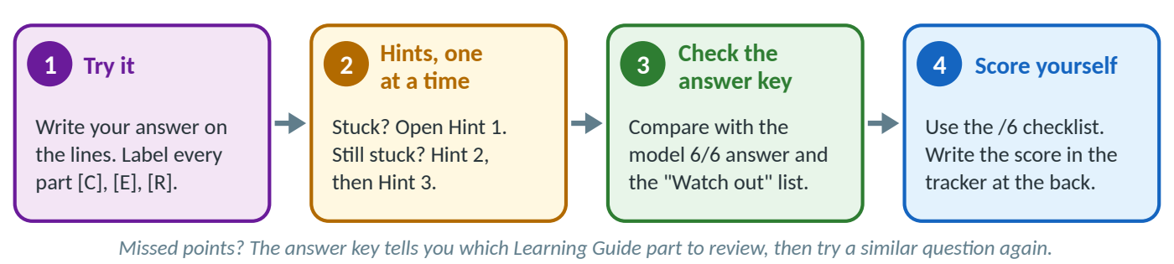
Figure 1. The routine for every question. Open the hints one at a time, and only after a real try.
Level | Questions | What it practices
Level 1 · Warm-up | Q1–Q3 | One data set or one model; a clear claim; the basic science of both processes.
Level 2 · Data analysis | Q4–Q6 | Tables and graphs: trends, best conditions, units, and DO difference vs. O₂ production.
Level 3 · Scenario / transfer | Q7–Q9 | New situations: the Keeling Curve, a sealed-tube experiment, a cleared forest.
Level 4 · Challenge | Q10–Q12 | Multi-step answers: an oxygen budget, a counterclaim and rebuttal, and upgrading a weak answer.

→ TIP — Real data vs. practice data
Numbers from your packets or from NOAA always say where they come from. Numbers made up for practice are always marked HYPOTHETICAL PRACTICE DATA, both in the question and inside the figure. Other teams did Part IV (light color) and Part V (temperature): before the test, ask them for their real numbers and redo Q5 and Q6 with them.
In the interactive (HTML) version, hints and answers stay hidden until you click. On paper they are printed, so cover them with a sheet of paper while you work.

The scoring rubric (/6)
Part | Points | Full points | Partial points
[C] Claim | 0–1 | Accurate, complete, answers the question in one sentence (no "I think"). | 0 = missing, wrong, or does not answer the question.
[E] Evidence | 0–2 | At least 2 specific, accurate data points with units that support the claim (a comparison is best). | 1 = vague ("it went up") or only one data point.
[R] Reasoning | 0–3 | Correct science principle(s) + an explicit link from the evidence to the claim + correct vocabulary. | 2 = principle but weak link; 1 = repeats the evidence or is vague; 0 = wrong science.

Your teacher's rubric may differ slightly, but the habits that earn points are the same.

Label and color your C, E and R
Your lab's CER prompt says "Color code or label your C, E, and R" [P2 Part VII]. Do both: the letter labels still work in black-and-white printing and for color-blind readers. In this booklet: [C] Claim = blue · [E] Evidence = green · [R] Reasoning = orange. A short example:
▪ EXAMPLE
[C] In the light, the water plant added oxygen to the water. [E] At 100 % light the DO rose from 7.0064 to 7.4101 mg/L in 60 minutes (+0.4037 mg/L per hour). [R] O₂ is a product of photosynthesis, which needs light energy; in bright light the plant's photosynthesis made more O₂ than its respiration used, so the dissolved O₂ went up.

The 5-step CER method (used in every answer key)
- Unpack the question: circle the variables (what changed? what was measured?) and the command word.
- Read the data: find the trend, the highest and lowest, and 2–3 numbers with units; note anything odd.
- Claim it: one sentence that answers the question in its own words.
- Prove it (Evidence): 2–3 specific data points with units, ideally a comparison ("from __ to __").
- Explain it (Reasoning): the science "because": reactants, products, organelle, energy, and respiration happening at the same time.

Level 1 · Warm-up (Q1–Q3)
Q1 | Do plants do cellular respiration?  Level 1 · Warm-up · Grounded in: [P2 Part II] (your real data)

In Part II of the simulation lab you set the light to 0 %, put 1 plant and 0 fish in the water, and ran the simulation three times (25 °C, 60 minutes each). Dissolved oxygen (DO) is the oxygen gas dissolved in the water, in mg/L. Use the data in Figure 2 to answer: Do plants do cellular respiration? Write a full CER and label each part [C], [E], [R].
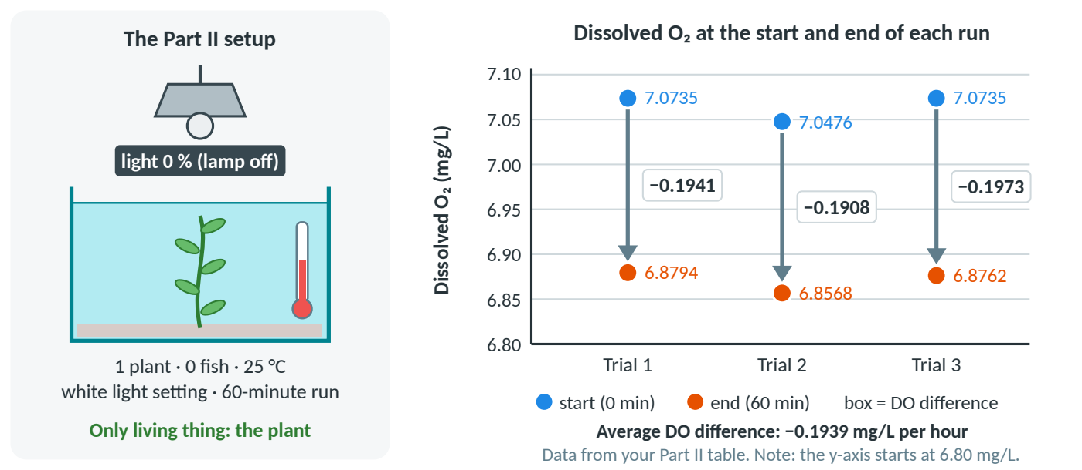
Figure 2. Your Part II dark-run data: DO at the start and end of each 60-minute run (from your Part II table).
§ Grounded in: [P2 Part II] Respiration (your own table) and [P1 Q6] (do plant cells have mitochondria?).
Your answer (label each part [C], [E], [R]; continue on paper if you need more room):

? Hint 1 — nudge | ? Hint 2 — stronger | ? Hint 3 — almost there
What does 0 % light switch off? With 0 fish, which living thing is left to change the oxygen level? | Did the DO go up or down in every trial? Which process uses up O₂? Quote at least two numbers with units. | Start with "Yes, plants…". Evidence: DO fell in all 3 trials (e.g., 7.0735 → 6.8794 mg/L); average −0.1939 mg/L per hour. Reasoning: the respiration equation, where it happens, and why only the plant could use the O₂.

→ Jump to the answer key for Q1 (at the back of this booklet)

Q2 | Which arrows in the carbon cycle are cellular respiration?  Level 1 · Warm-up · Grounded in: [P1 Model 2], [P1 Q13–15]

Figure 3 is the carbon-cycle model from your POGIL packet, redrawn. The four lettered processes A–D are not named. Claim which lettered processes release CO₂ into the atmosphere by cellular respiration, and which organisms carry out each one. Then explain why the remaining letter is different. Your evidence is the model itself: where each arrow starts, where it ends, and which way it points. Label [C], [E], [R].
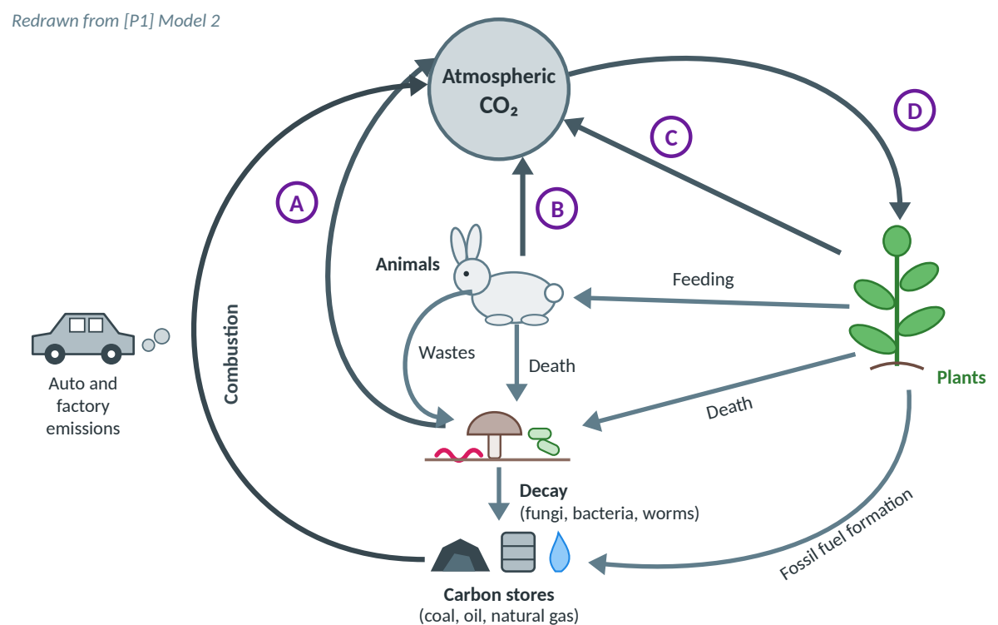
Figure 3. The carbon cycle, redrawn from [P1] Model 2. A–D are processes for you to identify.
§ Grounded in: [P1] Model 2 and Q13–15 (the green and red stars). Decomposers = fungi, bacteria and worms that break down dead matter and wastes.
Your answer (label each part [C], [E], [R]; continue on paper if you need more room):

? Hint 1 — nudge | ? Hint 2 — stronger | ? Hint 3 — almost there
Trace each lettered arrow from tail to head. Which arrows carry CO₂ into the atmosphere, and which take it out? | Every organism that breaks down food for energy respires, not only animals. What sits at the start of each arrow that points into the atmosphere? | Three letters are respiration. The fourth is the only lettered arrow going from the atmosphere into an organism. Don't skip the rabbit or the decomposers.

→ Jump to the answer key for Q2 (at the back of this booklet)

Q3 | Where does the energy an athlete uses come from?  Level 1 · Warm-up · Grounded in: [P1 Model 1], [P1 Q4], [P1 Q11–12]

During a football game, an athlete's muscles use a lot of energy. The athlete's last meal was a chicken sandwich, and the chicken was raised on corn seeds. Use the model in Figure 4 to claim where the athlete's energy originally comes from, and explain each step of how it gets to the muscles, including what form the energy is in along the way. Label [C], [E], [R].
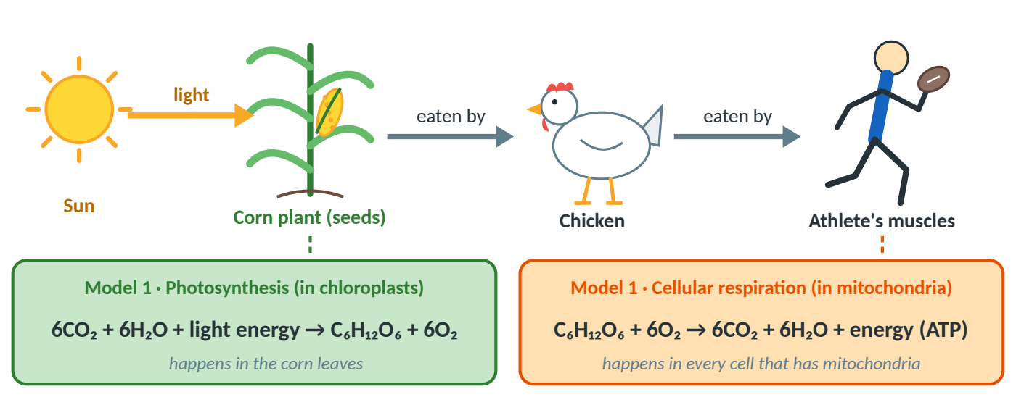
Figure 4. An energy chain from the sun to an athlete, with the two equations from [P1] Model 1.
§ Grounded in: [P1] Model 1 (the two equations), Q4 (the one input that is not recycled) and Q11–12 (your foods and the athlete).
Your answer (label each part [C], [E], [R]; continue on paper if you need more room):

? Hint 1 — nudge | ? Hint 2 — stronger | ? Hint 3 — almost there
Follow the energy backwards, from the athlete's muscles to the very start of the chain. Where does it begin? | Energy changes form along the way. In which molecule does the corn store it? Which process in the athlete's own cells gets it back out, and in what usable form? | Two links: photosynthesis in the corn's chloroplasts turns light energy into chemical energy in glucose (starch in seeds); cellular respiration in the athlete's mitochondria releases it as ATP.

→ Jump to the answer key for Q3 (at the back of this booklet)

Level 2 · Data analysis (Q4–Q6)
Q4 | How does light intensity affect O₂ production?  Level 2 · Data analysis · Grounded in: [P2 Part III] (your team's real data, corrected)

Your team ran Part III with 1 plant, 0 fish, white light, 25 °C, for 60 minutes at each light level. Here is your data with one arithmetic slip fixed (the 40 % O₂ production is 0.0002, not 0.0102). Respiration from Part II = −0.1939 mg/L per hour.
Light (%) | DO start (mg/L) | DO end (mg/L) | DO difference (mg/L per hour) | O₂ production (mg/L per hour) | O₂ production per minute
100 | 7.0064 | 7.4101 | +0.4037 | 0.5976
80 | 7.038 | 7.2464 | +0.2084 | 0.4023
60 | 7.0587 | 7.0633 | +0.0046 | 0.1985
40 | 7.0009 | 6.8072 | −0.1937 | 0.0002
20 | 7.0677 | 6.8749 | −0.1928 | 0.0011
Your Part III data (corrected). O₂ production = DO difference − respiration = DO difference + 0.1939.

- Finish the table: O₂ production per minute = O₂ production ÷ 60.
- Graph it on graph paper: O₂ production per minute vs. light intensity. Graph rules: independent variable on the x-axis, even scales, axis titles with units, every point marked, a title, no line where there is no data.
- Write a CER: How does light intensity affect oxygen production during photosynthesis? Use at least two numbers with units. Label [C], [E], [R].

§ Grounded in: [P2 Part III] Q5–9: your table, your graph and your written conclusion.
Your answer (label each part [C], [E], [R]; continue on paper if you need more room):

? Hint 1 — nudge | ? Hint 2 — stronger | ? Hint 3 — almost there
Which variable did you change, and which did you measure? Those go on the x- and y-axes. What pattern do you see from 20 % to 100 %? | Per minute = per hour ÷ 60 (e.g., 0.4023 ÷ 60 = 0.0067). For evidence, compare the lowest and highest light levels with units, and the size of each +20 % step. | Claim template: "As light intensity increases, O₂ production increases." Reasoning: light is the energy source; chlorophyll absorbs it; O₂ is a product. Explain why the DO fell at 20 % and 40 %.

→ Jump to the answer key for Q4 (at the back of this booklet)

Q5 | Which light color is best for photosynthesis?  Level 2 · Data analysis · Grounded in: [P2 Part IV] (procedure) · HYPOTHETICAL PRACTICE DATA

Teams 2, 5 and 8 ran Part IV (light color). We don't have their numbers, so this question uses HYPOTHETICAL PRACTICE DATA: made up, but realistic. Setup: 1 plant, 0 fish, 100 % intensity, 25 °C, 60 minutes per color. Figure 5 shows O₂ production (the bars) and the DO difference (the row under the colors). Claim which light color gave the most O₂ production and which gave the least, and explain why. Label [C], [E], [R].
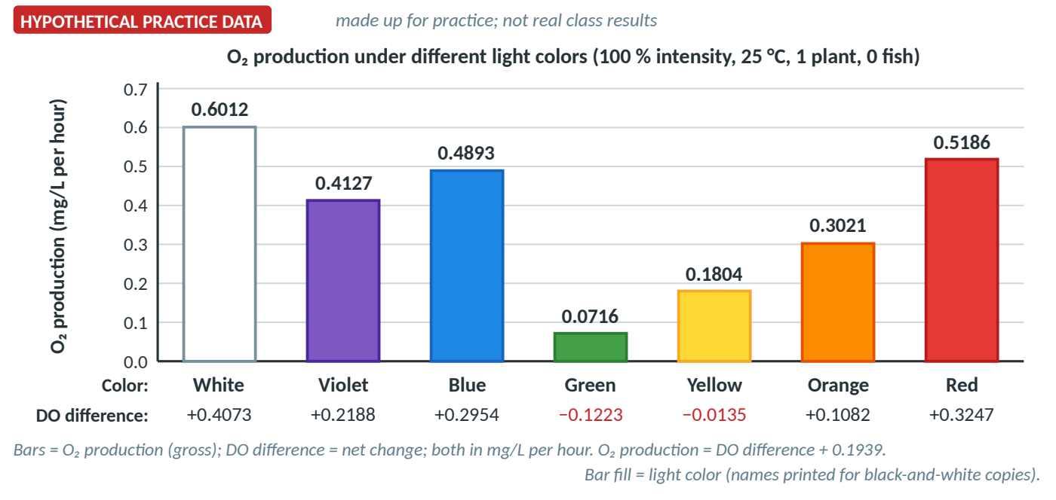
Figure 5. HYPOTHETICAL PRACTICE DATA: O₂ production and DO difference under seven light colors.
§ Grounded in: [P2 Part IV] procedure and the class result in [P2 Part VI] (best color: white). For the real numbers, ask Teams 2, 5 or 8.
Your answer (label each part [C], [E], [R]; continue on paper if you need more room):

? Hint 1 — nudge | ? Hint 2 — stronger | ? Hint 3 — almost there
Find the tallest and the shortest bar. What does a leaf do with green light? Why do leaves look green? | Which two single colors are highest? Chlorophyll absorbs light for photosynthesis; reflected light can't power it. What does green's negative DO difference mean? | Claim: white most, green least; red and blue are the best single colors. Reasoning: chlorophyll absorbs mostly red and blue/violet and reflects green; white light contains every color.

→ Jump to the answer key for Q5 (at the back of this booklet)

Q6 | What temperature is best, and why does O₂ production drop when it is warmer?  Level 2 · Data analysis · Grounded in: [P2 Part V] (procedure) · HYPOTHETICAL PRACTICE DATA

Teams 3, 4 and 9 ran Part V (temperature), so this is HYPOTHETICAL PRACTICE DATA too. Setup: 1 plant, 0 fish, 100 % white light. At each temperature, respiration was measured first in the dark (like Part II), then the DO difference in the light; O₂ production = light DO difference − dark DO difference. Claim which tested temperature gave the most O₂ production, and explain why it was lower at both colder and warmer temperatures. Use both lines in Figure 6. Label [C], [E], [R].
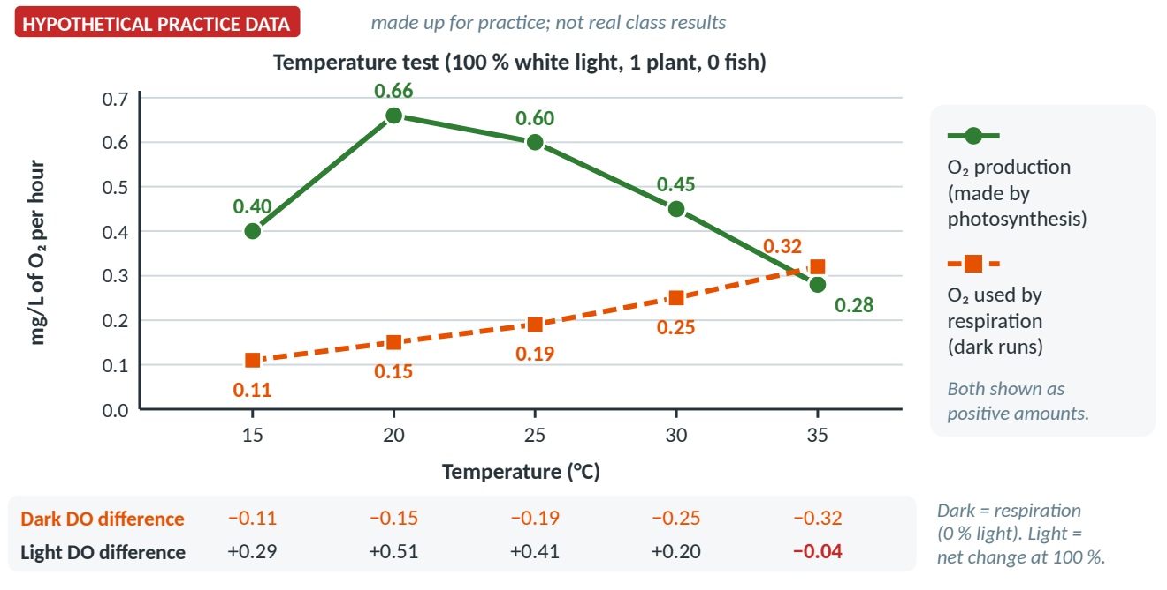
Figure 6. HYPOTHETICAL PRACTICE DATA: O₂ production and O₂ used by respiration (mg/L per hour) at five temperatures.
§ Grounded in: [P2 Part V] procedure and the class result in [P2 Part VI] (best tested temperature: about 20 °C). For the real numbers, ask Teams 3, 4 or 9.
Your answer (label each part [C], [E], [R]; continue on paper if you need more room):

? Hint 1 — nudge | ? Hint 2 — stronger | ? Hint 3 — almost there
Find the peak of the green line. Then follow the orange line: what happens to respiration as it gets warmer? | Both processes are run by enzymes. What happens to enzyme reactions when it is too cold? Too warm? What does a light DO difference of −0.04 at 35 °C mean? | Claim: 20 °C gave the most (0.66 mg/L per hour). Reasoning: cold = slower collisions; warmer = enzymes less efficient (O₂ production falls); respiration also speeds up, so the DO difference falls even faster. Only five temperatures were tested.

→ Jump to the answer key for Q6 (at the back of this booklet)

Level 3 · Scenario and transfer (Q7–Q9)
Q7 | Why does CO₂ at Mauna Loa rise and fall every year?  Level 3 · Scenario / transfer · Grounded in: [P3 p.1–2], [P1 Model 2] · NOAA data

Figure 7 shows the monthly average CO₂ at Mauna Loa, Hawaii, from September 2025 to September 2026 (ppm = parts per million). September 2025, May 2026 and September 2026 are NOAA values; the months in between are approximate, for practice. Make a claim that explains (a) why CO₂ peaks in May and is lowest in September/October, and (b) why September 2026 is higher than September 2025. Label [C], [E], [R].
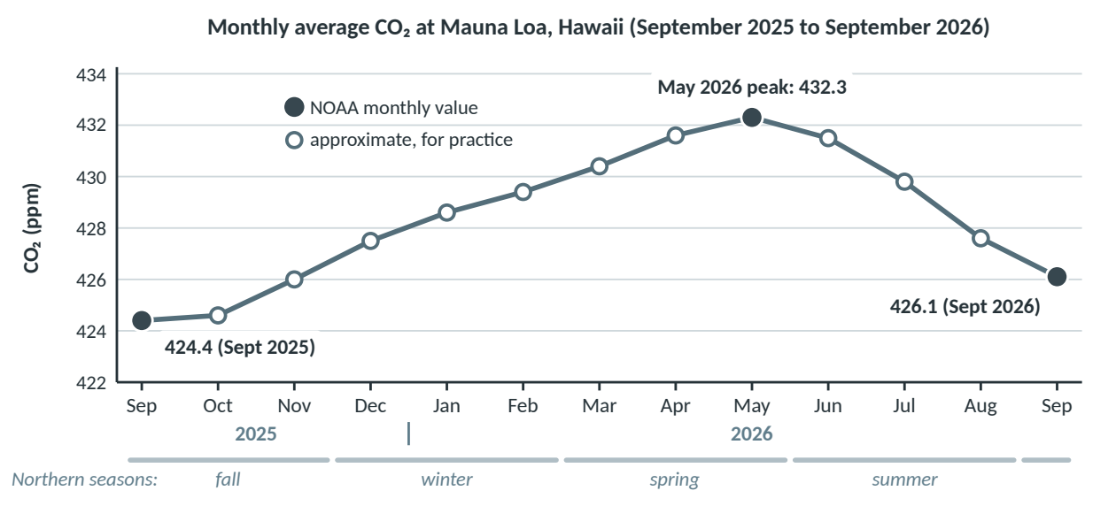
Figure 7. One year of the Keeling Curve. Filled dots: NOAA monthly values (September 2026 is preliminary). Open dots: approximate, for practice.
§ Grounded in: [P3] your Mauna Loa notes (the starred bullets on spring/fall and on fossil fuels) and [P1] Model 2. Data: NOAA Global Monitoring Laboratory, Mauna Loa monthly means.
Your answer (label each part [C], [E], [R]; continue on paper if you need more room):

? Hint 1 — nudge | ? Hint 2 — stronger | ? Hint 3 — almost there
Most of Earth's land plants are in the Northern Hemisphere. What are they doing in summer? In winter? | Think of CO₂ as water in a bathtub: it rises whenever more goes in than out. What adds CO₂ all year? What removes a lot only while leaves are out? What adds a bit more every year? | CO₂ falls May to September as Northern plants photosynthesize strongly; it rises October to May as respiration and decay continue while photosynthesis slows. Fossil-fuel burning adds more each year than the cycle removes.

→ Jump to the answer key for Q7 (at the back of this booklet)

Q8 | What do a snail and a water plant do to the CO₂ in a sealed tube?  Level 3 · Scenario / transfer · Grounded in: [P1 Model 1], [P1 Q10] · HYPOTHETICAL PRACTICE DATA

A new experiment (not from your packets) with HYPOTHETICAL PRACTICE DATA. Bromothymol blue (BTB) is a color indicator: CO₂ dissolved in water makes it slightly acidic, which turns BTB from blue to green to yellow. Five sealed tubes all started GREEN and were left for 24 hours (Figure 8). Make a claim about how the snail and the water plant each change the CO₂ in the water, and explain why Tube 4 stayed green but Tube 5 turned yellow. Label [C], [E], [R].
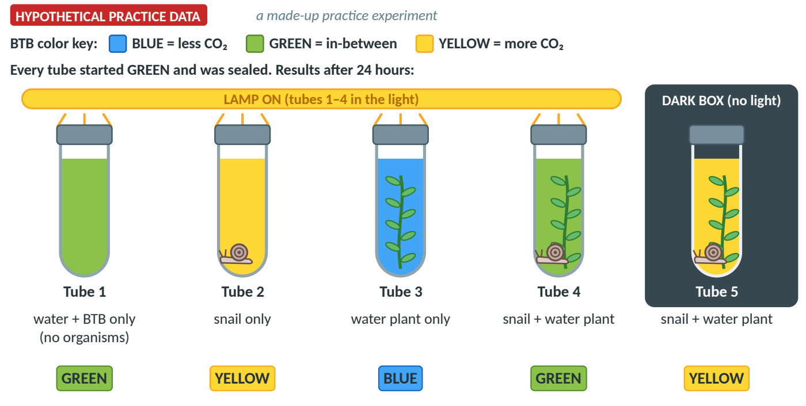
Figure 8. HYPOTHETICAL PRACTICE DATA: BTB colors after 24 hours. Tube 1 is the control (no organisms).
§ Grounded in: [P1] Model 1 (the two equations) and Q10 (do plants and animals depend on each other?), applied to a new setup.
Your answer (label each part [C], [E], [R]; continue on paper if you need more room):

? Hint 1 — nudge | ? Hint 2 — stronger | ? Hint 3 — almost there
Start with the control, Tube 1: why does it matter that it stayed green? Then compare each tube with it. | Which organism can only add CO₂? Which can also remove it, and what does it need? Tubes 4 and 5 hold the same organisms: what is the only difference? | Snail: adds CO₂ (respiration). Plant: removes CO₂ in light (photosynthesis), adds it in the dark (respiration only). Tube 4: about balanced. Tube 5: no light, so CO₂ built up.

→ Jump to the answer key for Q8 (at the back of this booklet)

Q9 | Predict: what happens to atmospheric CO₂ when a forest is cleared and burned?  Level 3 · Scenario / transfer · Grounded in: [P1 Model 2], [P1 Q18–20] · Scripps / NOAA data

A region cuts down and burns a large forest to make farmland, and builds a new coal power plant (Figure 9). Use the carbon-cycle model (Model 2, redrawn in Figure 3) to predict what will happen to the amount of CO₂ in the atmosphere, and explain why. Use the model's arrows and the real CO₂ record as evidence. Label [C], [E], [R].
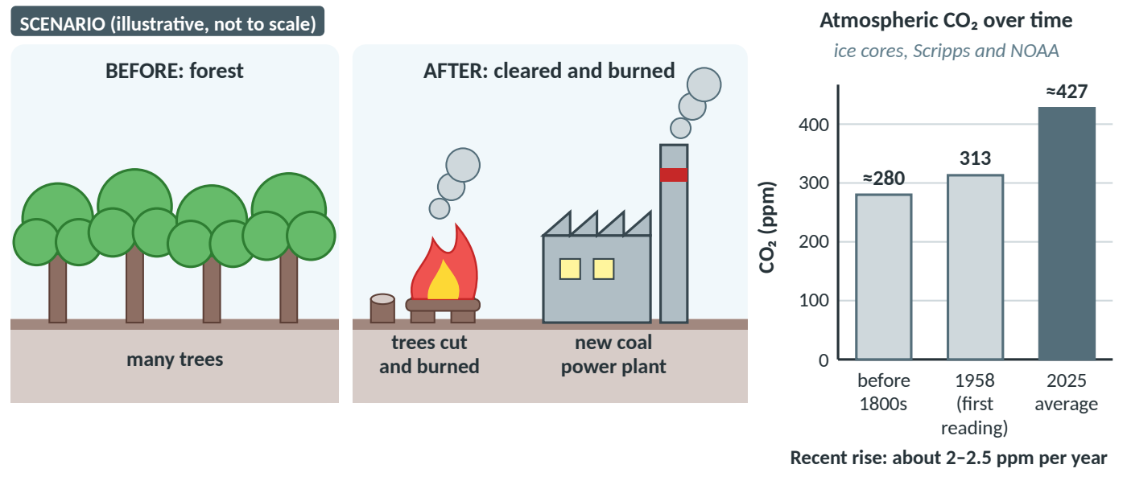
Figure 9. Left: the scenario (illustrative, not to scale). Right: real atmospheric CO₂ (ice cores; Scripps, March 1958; NOAA, 2025 average).
§ Grounded in: [P1] Model 2 and Q18 (the natural balance), Q19 (burning fossil fuels) and Q20 (deforestation).
Your answer (label each part [C], [E], [R]; continue on paper if you need more room):

? Hint 1 — nudge | ? Hint 2 — stronger | ? Hint 3 — almost there
In Model 2, which lettered arrow takes CO₂ out of the atmosphere, and who does it? What happens to it when the trees are gone? | Which arrows put CO₂ into the atmosphere? Burning trees and coal are both combustion. Where was that carbon before, and for how long? | Claim: CO₂ will increase. Fewer trees = less photosynthesis (arrow D); burning wood and coal = more combustion; leftover wood decays. Without humans in ≈ out [P1 Q18]; now in > out.

→ Jump to the answer key for Q9 (at the back of this booklet)

Level 4 · Challenge (Q10–Q12)
Q10 | Design the optimal ecosystem: how many fish can one plant support?  Level 4 · Challenge · Grounded in: [P2 Part VI–VII], [P2 Parts II–III] · fish value is HYPOTHETICAL

This is the Part VII question from your lab, the model for your test: "What do you think the optimal ecosystem productivity is if fish are added? What should the temperature, light intensity, and light color be? How many fish could that environment support?" Use Figure 10; the fish value is HYPOTHETICAL PRACTICE DATA. (a) Claim the best conditions and how many fish one plant could support, with numbers as evidence and reasoning that includes both photosynthesis and respiration. (b) Explain what would change at night (no light), using numbers.
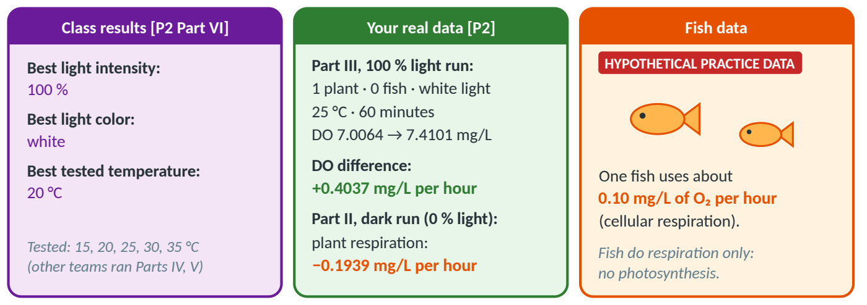
Figure 10. Data for Q10: class results, your real Part II and Part III numbers, and a HYPOTHETICAL fish value.
§ Grounded in: [P2 Part VI] (class results), [P2 Part VII] (the CER prompt: "Color code or label your C, E, and R"), [P2 Parts II–III] (your runs) and [P1 Q10] (plants and animals depend on each other).
Your answer (label each part [C], [E], [R]; continue on paper if you need more room):

? Hint 1 — nudge | ? Hint 2 — stronger | ? Hint 3 — almost there
What does each fish do to the O₂? The tank stays healthy only if the DO difference stays at zero or above. Which number is the plant's extra O₂? | Treat +0.4037 mg/L per hour as an O₂ "budget"; each fish "spends" 0.10. How many fit? At night, which process stops and which keeps going? | 4 × 0.10 = 0.40 ≤ 0.4037 (fits); 5 × 0.10 = 0.50 (too many). Night: no photosynthesis, so plant (−0.1939) + 4 fish (−0.40) ≈ −0.59 mg/L per hour. Note: +0.4037 was measured at 25 °C.

→ Jump to the answer key for Q10 (at the back of this booklet)

Q11 | Counterclaim and rebuttal: is cellular respiration "negligible"?  Level 4 · Challenge · Grounded in: [P3 p.1], [P2 Part II], [P1 Model 2, Q18] · NOAA data

A classmate wrote the statement in Figure 11. Do you agree? Write a CER that evaluates the statement using all three sources, and include a counterclaim and a rebuttal (CERR): state the classmate's view fairly, then use evidence to show why it is weaker. Label [C], [E], [R], plus [Counterclaim] and [Rebuttal].
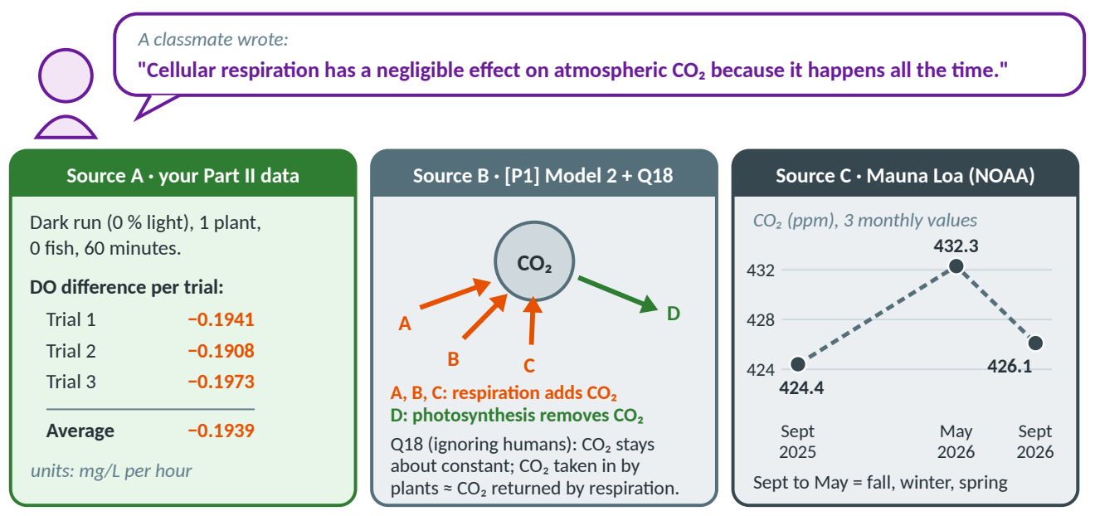
Figure 11. The classmate's statement and three sources: your Part II data, [P1] Model 2 with Q18, and NOAA values for Mauna Loa.
§ Grounded in: A sentence like this appears in your Mauna Loa notes [P3 p.1], probably a note-taking slip. Sources: [P2 Part II], [P1] Model 2 and Q18, NOAA (the same values as Q7).
Your answer (label each part [C], [E], [R]; continue on paper if you need more room):

? Hint 1 — nudge | ? Hint 2 — stronger | ? Hint 3 — almost there
Does "happens all the time" mean "small"? Think of a faucet that is always on. | A: how much O₂ did ONE plant use per hour, and what does respiration release? B: how big is respiration compared with photosynthesis? C: what does CO₂ do from September to May? | Claim: respiration has a large effect: it returns about as much CO₂ as photosynthesis removes and drives the 7.9 ppm fall-winter rise. Rebuttal: constant ≠ small; the seasonal change comes mostly from photosynthesis switching.

→ Jump to the answer key for Q11 (at the back of this booklet)

Q12 | Critique and upgrade: fix a weak answer and a flawed graph  Level 4 · Challenge · Grounded in: [P2 Part III] Q7–9

Below is an example answer to the Part III question "How does light intensity affect oxygen production during photosynthesis?" and the graph that came with it (Figure 12). Both are based on a real Part III answer and graph, redrawn for practice, and both have problems. (a) Find at least 4 problems (in the answer, the graph, or both) and say how to fix each one. (b) Rewrite the answer so it would earn 6/6, using the corrected table in Q4. Label [C], [E], [R].
EXAMPLE ANSWER (find the problems)
Claim: I think light affects oxygen.
Evidence: The graph goes up when the light goes up. At 100 % the oxygen was 0.001.
Reasoning: This is because light intensity increases oxygen production, so more light means more oxygen. Plants need light.

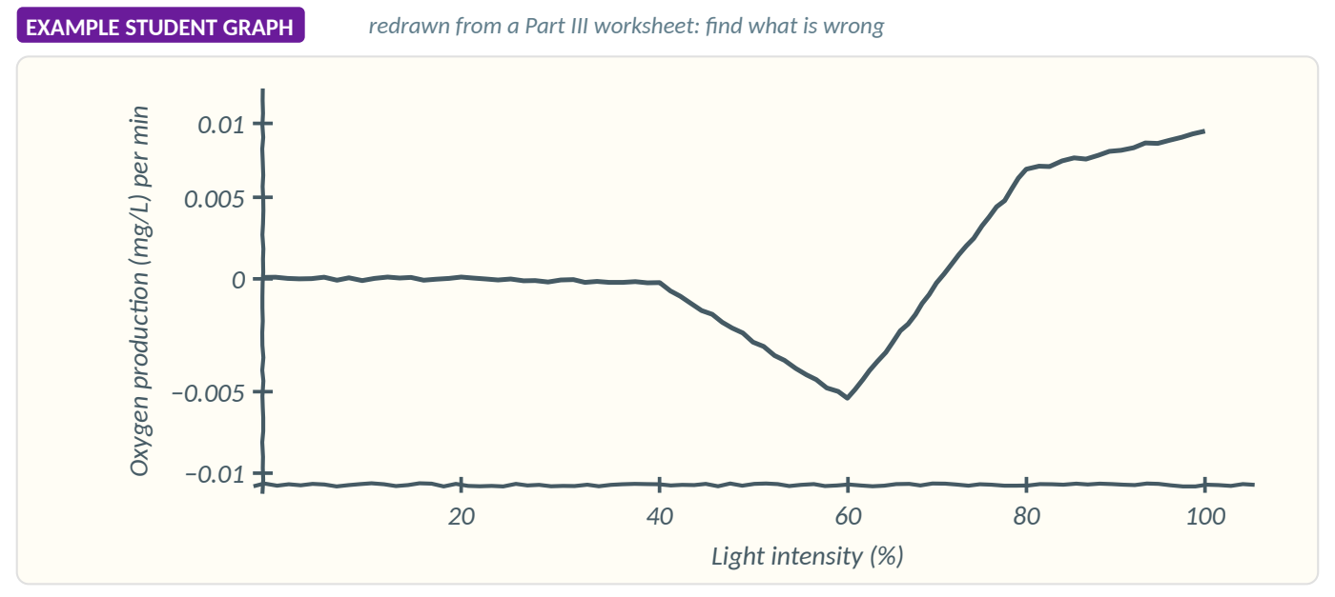
Figure 12. A graph like the one on a Part III worksheet, redrawn (it has several problems).
§ Grounded in: [P2 Part III] Q7 (the graph), Q8 (the one-sentence conclusion) and Q9 (the paragraph), plus the graph rules in Q4.
Graph-rules check (use it on the example graph, then on your own graphs)
 | Graph rule | Example graph OK?
□ | Independent variable (light %) on the x-axis; dependent variable (O₂ production) on the y-axis.
□ | Even scales: equal steps have equal gaps; the axes cross at zero.
□ | Axis titles with units, including the time basis (per minute or per hour).
□ | Every data point marked, and the points match the table.
□ | A title; no line drawn where there is no data.

(a) Problems and how to fix them:

(b) Your 6/6 rewrite (label each part [C], [E], [R]):

? Hint 1 — nudge | ? Hint 2 — stronger | ? Hint 3 — almost there
Check the answer against the rubric one part at a time. Does the claim answer the question? Two numbers with units? Does the reasoning explain why? | Compare every number in the answer and every point on the graph with the Q4 table. Then run the graph-rules check above. | Problems include: "I think" and no direction; 0.001 should be 0.0100 mg/L per minute; the reasoning repeats the claim; the graph dips below zero at 60 % (table: +0.0033), uneven y-axis, line back to 0 %, no points, no title.

→ Jump to the answer key for Q12 (at the back of this booklet)

Answer key
Try each question first. Every colored CER box below is a model answer that earns 6/6. Under it: how to think it through (the 5-step method), the mistakes to watch for, the lesson to review, and a scoring guide with one box per point. Score yourself honestly, then write your score in the score tracker at the end.

Answer key · Q1: Do plants do cellular respiration?
CLAIM  answers the question | Yes. Plants do cellular respiration: in the dark, the plant used up dissolved oxygen.
EVIDENCE  specific data / facts | - With 0 % light, 1 plant and 0 fish, the DO fell in all 3 trials (e.g., Trial 1: 7.0735 → 6.8794 mg/L).  - The average DO difference was −0.1939 mg/L per hour; the trials agree within 0.0065 mg/L.
REASONING  the science "why" | Cellular respiration uses O₂ (C₆H₁₂O₆ + 6O₂ → 6CO₂ + 6H₂O + ATP) in the mitochondria, which plant cells have along with chloroplasts. With 0 % light there was no photosynthesis to add O₂, and with 0 fish the plant was the only living thing, so the steady DO drop must be the plant's own respiration, turning its glucose into ATP. This dark run is the control that measures respiration alone.

◊ How to think about it (5 steps) | ! Watch out | Scoring guide · Q1 (/6)
1 Unpack: yes/no; a control run.  2 Read: all 3 trials fell about 0.19 mg/L.  3 Claim: "Yes, plants do respire."  4 Prove: one trial + the average.  5 Explain: O₂ used; rule out light, fish. | - Forgetting plants respire (watch-out 2).  - Respiration = breathing (watch-out 9).  - No units (watch-out 5). | □ [C] Yes, plants respire.  □ [E] A trial's DO start → end, in mg/L.  □ [E] The average, −0.1939 mg/L per hour.  □ [R] Respiration uses O₂ (mitochondria).  □ [R] Rules out light and fish.  □ [R] Links the DO drop to respiration.
Evidence, 1/2 vs 2/2: "The oxygen went down" earns 1/2. "DO fell from 7.0735 to 6.8794 mg/L in Trial 1, and the average was −0.1939 mg/L per hour" earns 2/2. Review: Learning Guide, Parts 3 and 5.

Answer key · Q2: Which arrows are cellular respiration?
CLAIM  answers the question | A, B and C release CO₂ by cellular respiration: A by decomposers (fungi, bacteria, worms), B by animals (the rabbit) and C by plants. D is photosynthesis, which removes CO₂.
EVIDENCE  specific data / facts | - Arrows B (from the rabbit), C (from the plant) and A (from Decay) all point into Atmospheric CO₂.  - Arrow D is the only lettered arrow going the other way: from Atmospheric CO₂ into the plant.
REASONING  the science "why" | CO₂ is a product of respiration (C₆H₁₂O₆ + 6O₂ → 6CO₂ + 6H₂O + ATP), so respiration arrows carry CO₂ into the air. Animals, plants and decomposers all break down food for energy (decomposers break down dead matter and wastes), so B, C and A are all respiration. CO₂ is a reactant of photosynthesis, so arrow D carries it out of the air into the plant. Combustion also adds CO₂, but it is burning outside living cells, not respiration.

◊ How to think about it (5 steps) | ! Watch out | Scoring guide · Q2 (/6)
1 Unpack: which letters? which organisms?  2 Read: follow each arrow tail → head.  3 Claim: "A, B, C = respiration."  4 Prove: describe 2–3 arrows.  5 Explain: CO₂ = respiration product. | - Forgetting plants respire (watch-out 2): arrow C.  - Missing B or A: animals, decomposers.  - Combustion is not respiration. | □ [C] A, B, C, with the organisms.  □ [E] B and C point into the air.  □ [E] A points in, or D points out.  □ [R] CO₂ is a product of respiration.  □ [R] All three groups break down food.  □ [R] D: CO₂ is a photosynthesis reactant.
Evidence, 1/2 vs 2/2: "The arrows point to the CO₂" earns 1/2. "Arrow B goes from the rabbit up to Atmospheric CO₂, and arrow A goes from Decay to Atmospheric CO₂" earns 2/2. Review: Learning Guide, Parts 7 and 3.

Answer key · Q3: Where does an athlete's energy come from?
CLAIM  answers the question | The athlete's energy comes from sunlight: the corn captured it by photosynthesis, it passed along the food chain as chemical energy in food, and the athlete's cells released it as ATP by cellular respiration.
EVIDENCE  specific data / facts | - The chain is sun → corn plant (seeds) → chicken → athlete; the only energy input is sunlight.  - Model 1: photosynthesis takes in light energy and makes glucose; respiration uses glucose and releases energy as ATP.
REASONING  the science "why" | In the corn's chloroplasts, photosynthesis turns light energy into chemical energy stored in glucose (kept as starch in the seeds). The chicken eats the seeds and stores some of that energy in its body. In the athlete's muscle cells, cellular respiration in the mitochondria breaks down glucose with O₂ and releases the energy as ATP, which powers the muscles. Energy flows one way and some is lost as heat at each step; it is not recycled [P1 Q4], so sunlight must keep coming.

◊ How to think about it (5 steps) | ! Watch out | Scoring guide · Q3 (/6)
1 Unpack: where from AND how?  2 Read: sun → corn → chicken → athlete.  3 Claim: "From sunlight, via food."  4 Prove: the chain + both equations.  5 Explain: light → glucose → ATP. | - Swapped energy labels (watch-out 1).  - Missing links: glucose and ATP.  - "Energy is recycled": it flows. | □ [C] From sunlight, through food.  □ [E] The chain sun → … → athlete.  □ [E] Light energy in; ATP out.  □ [R] Photosynthesis stores it in glucose.  □ [R] Respiration releases it as ATP.  □ [R] Energy flows; not recycled.
Evidence, 1/2 vs 2/2: "The chicken ate plants" earns 1/2. "The chain is sun → corn → chicken → athlete, and photosynthesis takes in light energy and makes glucose" earns 2/2. Review: Learning Guide, Parts 1 and 4.

Answer key · Q4: Light intensity and O₂ production
Step 1, the per-minute column: 100 % → 0.0100 (0.00996) · 80 % → 0.0067 · 60 % → 0.0033 · 40 % → about 0.000003 (≈0) · 20 % → 0.00002 (≈0) mg/L per minute. Step 2: compare your graph with Figure 13.
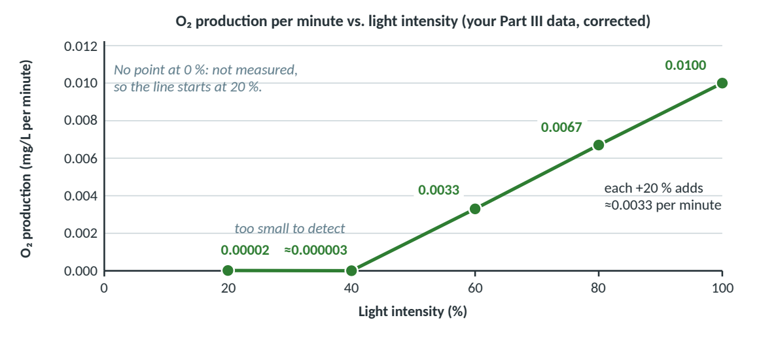
Figure 13. A correct graph: even scales, units, all 5 points marked, a title, no line before 20 %, never below zero.
CLAIM  answers the question | As light intensity increases, O₂ production increases; from 40 % to 100 % light it rose steadily, in a straight line.
EVIDENCE  specific data / facts | - O₂ production was 0.5976 mg/L per hour (0.0100 per minute) at 100 % light but only 0.0011 mg/L per hour at 20 %.  - From 40 % up, each +20 % of light added about 0.20 mg/L per hour (0.0002 → 0.1985 → 0.4023 → 0.5976).
REASONING  the science "why" | Light is the energy source for photosynthesis (6CO₂ + 6H₂O + light energy → C₆H₁₂O₆ + 6O₂). Chlorophyll in the chloroplasts absorbs it, so more light means faster photosynthesis and more O₂ (a product) released. Respiration uses O₂ all the time (−0.1939 mg/L per hour), so at 20 % and 40 % the DO fell: photosynthesis there was too small to detect. The rise never leveled off, so light was still the limiting factor at 100 %; the data can't show what happens above 100 %.

◊ How to think about it (5 steps) | ! Watch out | Scoring guide · Q4 (/6)
1 Unpack: IV = light %; DV = O₂.  2 Read: ≈0 at 20–40 %; top at 100 %.  3 Claim: the trend template.  4 Prove: low vs. high + the step size.  5 Explain: light energy → more O₂. | - Sign trap (watch-out 4): + 0.1939.  - Graph below zero (watch-out 11).  - Per hour vs. per minute (watch-out 12). | □ [C] More light → more O₂.  □ [E] Low vs. high light, with units.  □ [E] The ≈0.20 step (or DO −0.1928 → +0.4037).  □ [R] Light = energy; chlorophyll; O₂ product.  □ [R] Respiration explains the DO drop.  □ [R] Links back; nothing beyond 100 %.
Evidence, 1/2 vs 2/2: "The more light, the more oxygen" earns 1/2. "At 100 % light O₂ production was 0.5976 mg/L per hour, but at 20 % only 0.0011 mg/L per hour" earns 2/2. Review: Learning Guide, Parts 5 and 6.

Answer key · Q5: Which light color is best?
CLAIM  answers the question | White light gave the most O₂ production and green the least; of the single colors, red and blue gave the most.
EVIDENCE  specific data / facts | - White 0.6012, red 0.5186 and blue 0.4893 mg/L per hour, but green only 0.0716, about one-eighth of white (HYPOTHETICAL PRACTICE DATA).  - Under green light the DO difference was −0.1223 mg/L per hour: the water lost O₂ with the lamp on.
REASONING  the science "why" | Chlorophyll in the chloroplasts absorbs mostly red and blue/violet light and reflects green (that is why leaves look green). Only absorbed light can power photosynthesis, so under green light the plant made less O₂ than its respiration used and the DO fell, while red and blue light drove fast photosynthesis and released more O₂. White light contains every color, including red and blue, so the plant absorbed the most energy and made the most O₂, matching the class result [P2 Part VI].

◊ How to think about it (5 steps) | ! Watch out | Scoring guide · Q5 (/6)
1 Unpack: IV = color; best AND worst.  2 Read: white top; green bottom.  3 Claim: "White most; green least."  4 Prove: best, worst, a comparison.  5 Explain: absorbed vs. reflected light. | - "White is brightest": all at 100 %.  - "Plants absorb green": they reflect it.  - Net vs. gross (watch-out 4). | □ [C] White most, green least.  □ [E] Best color value, with units.  □ [E] Green's value or a comparison.  □ [R] Chlorophyll absorbs red/blue.  □ [R] Absorbed light powers it → O₂.  □ [R] White has every color.
Evidence, 1/2 vs 2/2: "Green was the lowest" earns 1/2. "Green gave only 0.0716 mg/L per hour of O₂ production, compared with 0.6012 for white" earns 2/2. Review: Learning Guide, Parts 6 and 2. White (0.6012) is close to your real 100 % run (0.5976): same conditions.

Answer key · Q6: What temperature is best?
CLAIM  answers the question | Of the temperatures tested, 20 °C gave the most O₂ production; it was lower at both colder and warmer temperatures.
EVIDENCE  specific data / facts | - O₂ production peaked at 0.66 mg/L per hour at 20 °C, vs. 0.40 at 15 °C and 0.28 at 35 °C (HYPOTHETICAL PRACTICE DATA).  - Respiration rose from 0.11 to 0.32 mg/L per hour (15 → 35 °C); at 35 °C the light DO difference was −0.04.
REASONING  the science "why" | Photosynthesis is run by enzymes, which have an optimum temperature. At 15 °C molecules move and collide less, so it is slower; above the optimum the enzymes work less efficiently as they start to change shape, so O₂ production falls again. Respiration also speeds up with warmth (0.11 → 0.32 mg/L per hour), so the DO difference (net) falls even faster: +0.51 mg/L per hour at 20 °C but −0.04 mg/L per hour at 35 °C, when respiration used more than photosynthesis made. Only 5-degree steps were tested, so the true optimum lies somewhere between 15 and 25 °C.

◊ How to think about it (5 steps) | ! Watch out | Scoring guide · Q6 (/6)
1 Unpack: IV = temperature.  2 Read: peak at 20 °C; respiration rises.  3 Claim: "Of those tested, 20 °C…".  4 Prove: peak vs. both sides.  5 Explain: enzyme optimum + respiration. | - "Denatured at 21 °C" (watch-out 10).  - Ignoring respiration.  - Beyond the data (watch-out 7). | □ [C] 20 °C (best tested).  □ [E] Peak vs. colder and warmer.  □ [E] Respiration trend or −0.04.  □ [R] Enzyme optimum; cold = slow.  □ [R] Warm = less efficient.  □ [R] Respiration rises → less gain.
Evidence, 1/2 vs 2/2: "20 °C was highest" earns 1/2. "O₂ production was 0.66 mg/L per hour at 20 °C, but 0.40 at 15 °C and 0.28 at 35 °C" earns 2/2. Review: Learning Guide, Parts 6 and 3.

Answer key · Q7: The Keeling Curve's yearly zig-zag
CLAIM  answers the question | CO₂ falls from May to September because Northern-Hemisphere plants photosynthesize strongly while in leaf, and rises from fall to May because respiration and decay keep adding CO₂ while photosynthesis slows. September 2026 is higher than September 2025 because burning fossil fuels adds more CO₂ each year than the cycle removes.
EVIDENCE  specific data / facts | - CO₂ rose from 424.4 ppm (Sept 2025) to 432.3 ppm (May 2026), +7.9 ppm, then fell to 426.1 ppm (Sept 2026), −6.2 ppm in 4 months.  - September 2026 was 1.7 ppm higher than September 2025.
REASONING  the science "why" | Photosynthesis removes CO₂ from the air; respiration by plants, animals and especially decomposers adds it all year. Most land plants are in the Northern Hemisphere: in spring and summer, trees in full leaf remove more CO₂ than respiration adds, so the level falls until September/October. In fall and winter, photosynthesis slows but respiration and the decay of fallen leaves continue, so CO₂ builds up (like water in a bathtub) until May. On top of this, burning fossil fuels adds carbon stored for millions of years faster than nature removes it, so each low is higher than the last.

◊ How to think about it (5 steps) | ! Watch out | Scoring guide · Q7 (/6)
1 Unpack: two parts: zig-zag + rise.  2 Read: 424.4 → 432.3 → 426.1 ppm.  3 Claim: one clause per part.  4 Prove: rise, drop, Sept vs. Sept.  5 Explain: photosynthesis vs. decay. | - "Photosynthesis is delayed" (watch-out 8).  - "Respiration is negligible" (watch-out 8).  - Units: ppm, not mg/L. | □ [C] Explains the cycle and the rise.  □ [E] May peak, Sept low (ppm).  □ [E] Sept to Sept: +1.7 ppm.  □ [R] Photosynthesis removes CO₂.  □ [R] Leaves off → CO₂ builds up.  □ [R] Fossil fuels add more each year.
Evidence, 1/2 vs 2/2: "CO₂ is highest in May" earns 1/2. "CO₂ peaked at 432.3 ppm in May 2026 and fell to 426.1 ppm by September 2026" earns 2/2. Review: Learning Guide, Parts 9 and 8.

Answer key · Q8: The sealed-tube experiment
CLAIM  answers the question | The snail adds CO₂ by cellular respiration; the water plant removes CO₂ by photosynthesis in the light but adds CO₂ in the dark, when it can only respire. That is why Tube 4 (light) stayed green and Tube 5 (dark) turned yellow.
EVIDENCE  specific data / facts | - Tube 1 (no organisms) stayed GREEN; Tube 2 (snail, light) turned YELLOW; Tube 3 (plant, light) turned BLUE.  - Tube 4 (snail + plant, light) stayed GREEN; Tube 5 (snail + plant, dark) turned YELLOW.
REASONING  the science "why" | The snail, an animal, only does cellular respiration, which releases CO₂, so Tube 2 turned yellow even in light. The plant does both: in light its photosynthesis uses CO₂ faster than its respiration releases it (Tube 3 blue). In Tube 4, photosynthesis used about as much CO₂ as the snail and plant released, so it stayed green; in Tube 5 there was no light and so no photosynthesis, and the CO₂ from both built up (yellow). Tube 1 shows BTB alone doesn't change. The snail's CO₂ feeds the plant's photosynthesis: they depend on each other.

◊ How to think about it (5 steps) | ! Watch out | Scoring guide · Q8 (/6)
1 Unpack: each organism; Tube 4 vs. 5.  2 Read: decode colors; Tube 1 = control.  3 Claim: snail adds; plant removes.  4 Prove: tubes by number + color.  5 Explain: photosynthesis needs light. | - Forgetting plants respire (watch-out 2).  - BTB shows CO₂, not O₂.  - Skipping the control (Tube 1). | □ [C] Snail adds; plant removes in light.  □ [E] Tubes 2 and 3 with colors.  □ [E] Tubes 4 and 5 with colors.  □ [R] Respiration releases CO₂.  □ [R] Photosynthesis uses CO₂ (light).  □ [R] Explains Tube 4 vs. Tube 5.
Evidence, 1/2 vs 2/2: "The snail tube changed color" earns 1/2. "Tube 2 (snail only) turned yellow, but Tube 3 (plant only) turned blue" earns 2/2. Review: Learning Guide, Parts 4 and 5.

Answer key · Q9: Clearing and burning a forest
CLAIM  answers the question | Clearing and burning the forest and burning more coal will increase atmospheric CO₂, and make it rise faster.
EVIDENCE  specific data / facts | - In Model 2, only arrow D (photosynthesis, atmosphere → plants) removes CO₂; the combustion arrow carries carbon from carbon stores into Atmospheric CO₂.  - The real record: about 280 ppm before the 1800s, 313 ppm in 1958, about 427 ppm in 2025.
REASONING  the science "why" | Without humans, CO₂ taken in by photosynthesis ≈ CO₂ returned by respiration, so the level stays about constant [P1 Q18]. Fewer trees means less photosynthesis, so less CO₂ is removed. Burning the trees and the coal (combustion) quickly releases carbon stored for decades in wood and for millions of years in coal, and decomposers breaking down leftover wood add more by respiration. More in and less out upsets the balance, so CO₂ rises, as the real record shows.

◊ How to think about it (5 steps) | ! Watch out | Scoring guide · Q9 (/6)
1 Unpack: a prediction + why.  2 Read: arrows in vs. out of the air.  3 Claim: "CO₂ will increase."  4 Prove: arrow D, combustion, ppm.  5 Explain: less out + more in. | - "New trees will fix it": decades.  - Only one side: removal AND release.  - Fuels store carbon, not CO₂. | □ [C] CO₂ will increase.  □ [E] Arrow D removes CO₂.  □ [E] Combustion or the ppm record.  □ [R] Natural balance [P1 Q18].  □ [R] Less photosynthesis → less out.  □ [R] Combustion/decay → more in.
Evidence, 1/2 vs 2/2: "There will be fewer trees" earns 1/2. "Arrow D (photosynthesis) is the only lettered arrow that removes CO₂, and CO₂ rose from 313 ppm (1958) to about 427 ppm (2025)" earns 2/2. Review: Learning Guide, Parts 7 and 8.

Answer key · Q10: The optimal ecosystem and the fish budget
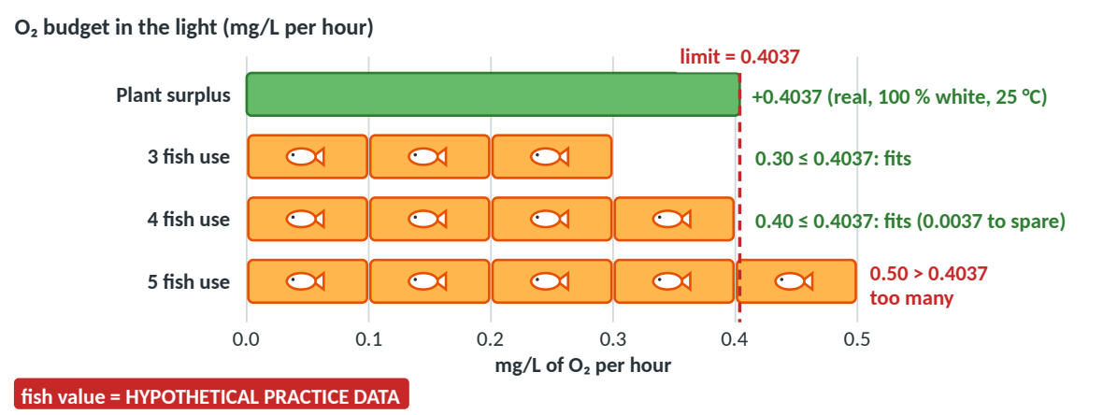
Figure 14. The O₂ budget in the light: the plant's real surplus vs. the O₂ used by 3, 4 and 5 fish (fish value HYPOTHETICAL).
CLAIM  answers the question | The best ecosystem uses 100 % white light at about 20 °C (best tested), and one plant could support about 4 fish in the light; at night the tank would lose oxygen, so a real tank needs fewer fish or more plants.
EVIDENCE  specific data / facts | - Class results [P2 Part VI]: 100 % light, white, 20 °C. One plant at 100 % white light, 25 °C: DO difference +0.4037 mg/L per hour (your data).  - At 0.10 per fish (HYPOTHETICAL): 4 fish use 0.40 ≤ 0.4037 (fits); 5 use 0.50 > 0.4037. Night: −0.1939 + 4 × (−0.10) = −0.5939 mg/L per hour.
REASONING  the science "why" | In light, photosynthesis adds O₂ while respiration by the plant and the fish uses it all the time; the tank stays healthy only while O₂ made ≥ O₂ used (DO difference ≥ 0). Bright white light at about 20 °C makes photosynthesis fastest (light is the energy source; white contains the red and blue chlorophyll absorbs; 20 °C is near the enzymes' optimum). The 0.40 surplus covers 4 fish, not 5, and the fish's CO₂ feeds photosynthesis [P1 Q10]. At night only respiration happens, so the DO falls about 0.59 mg/L per hour: a real tank needs a margin. (+0.4037 was measured at 25 °C; rerun at 20 °C to check.)

→ REASONABLE INFERENCE (beyond the packets)
If the night lasted 12 hours: 12 × 0.5939 ≈ 7.1 mg/L, about all the O₂ the water started with (about 7 mg/L). With these numbers, 4 fish only work while the light is on, which is why real tanks need more plants (or an air pump) than the daytime budget suggests.

◊ How to think about it (5 steps) | ! Watch out | Scoring guide · Q10 (/6)
1 Unpack: conditions, fish, night.  2 Read: +0.4037; 0.10 per fish.  3 Claim: conditions + 4 fish + night.  4 Prove: class results + budget math.  5 Explain: O₂ made ≥ O₂ used. | - Net vs. gross (watch-out 4): use +0.4037.  - Per hour throughout (watch-out 12).  - 25 °C ≠ 20 °C (watch-out 7). | □ [C] Conditions + about 4 fish.  □ [E] Class results + 0.4037.  □ [E] 4 × 0.10 fits; 5 × 0.10 does not.  □ [R] O₂ made ≥ O₂ used.  □ [R] Why the conditions help.  □ [R] Night: respiration only.
Evidence, 1/2 vs 2/2: "The plant makes enough oxygen for some fish" earns 1/2. "The DO difference was +0.4037 mg/L per hour; 4 fish × 0.10 = 0.40 fits, but 5 × 0.10 = 0.50 does not" earns 2/2. Review: Learning Guide, Parts 5, 6 and 4.

Answer key · Q11: Is respiration "negligible"?
Model CERR answer: claim, evidence, reasoning, then counterclaim + rebuttal
CLAIM  answers the question | I disagree: cellular respiration has a large effect on atmospheric CO₂. It returns about as much CO₂ as photosynthesis removes, and it drives the rise in CO₂ every fall and winter.
EVIDENCE  specific data / facts | - A: one plant used 0.1939 mg/L of O₂ per hour in the dark (all 3 trials), releasing CO₂ as it did. B: three of Model 2's four lettered arrows (A, B, C) are respiration, and [P1 Q18] says plant uptake ≈ respiration.  - C: CO₂ rose 7.9 ppm from September 2025 (424.4) to May 2026 (432.3); the yearly rise was only 1.7 ppm.
REASONING  the science "why" | Respiration happens in every plant, animal and decomposer, all day and night, so it releases about as much CO₂ as photosynthesis removes; that is why nature stays balanced [P1 Q18]. When Northern-Hemisphere photosynthesis slows in fall and winter, respiration and decay keep going and CO₂ climbs 7.9 ppm in eight months, more than four times the 1.7 ppm the level gained over the whole year.  [Counterclaim] Some might argue respiration can't matter because it is constant. [Rebuttal] However, constant does not mean small. The season-to-season change does come mostly from photosynthesis switching up and down, but if respiration stopped, the fall-and-winter rise in Source C would disappear. So its effect is huge, not negligible.

◊ How to think about it (5 steps) | ! Watch out | Scoring guide · Q11 (/6)
1 Unpack: evaluate + CERR.  2 Read: one fact from A, B and C.  3 Claim: disagree + the reason.  4 Prove: numbers from two sources.  5 Explain: flow in ≈ out; rebut fairly. | - "Negligible" is a note slip (watch-out 8).  - Rebuttal = evidence, not a repeat.  - Be fair to the counterclaim. | □ [C] Disagrees: the effect is large.  □ [E] Two sources, with numbers.  □ [E] The third source.  □ [R] Respiration ≈ photosynthesis.  □ [R] Explains the fall–winter rise.  □ [R] Fair counterclaim + rebuttal.
Evidence, 1/2 vs 2/2: "Respiration happens a lot" earns 1/2. "From September 2025 to May 2026 CO₂ rose from 424.4 to 432.3 ppm, and one plant used 0.1939 mg/L of O₂ per hour in the dark" earns 2/2. Review: Learning Guide, Parts 9 and 7; CER Prep Guide (CERR).

Answer key · Q12: Critique and upgrade
(a) Problems. Any 4 real problems from the answer and the graph count (there are at least 11). Score part (a) by counting the problems you found and fixed.
Problem in the example answer | How to fix it
Claim starts with "I think" and has no direction ("affects"). | State the trend: "As light intensity increases, O₂ production increases."
Evidence is vague ("the graph goes up") and has only one number. | Give 2–3 specific values from the table, ideally lowest vs. highest.
0.001 is a copying slip, with no units or time basis. | 0.5976 ÷ 60 = 0.00996 ≈ 0.0100 mg/L per minute.
Reasoning repeats the claim ("…because light increases oxygen"). | Explain why: light energy, chlorophyll, chloroplast, O₂ is a product.
Reasoning ignores respiration. | Explain why the DO fell at 20 % and 40 % (respiration > photosynthesis).

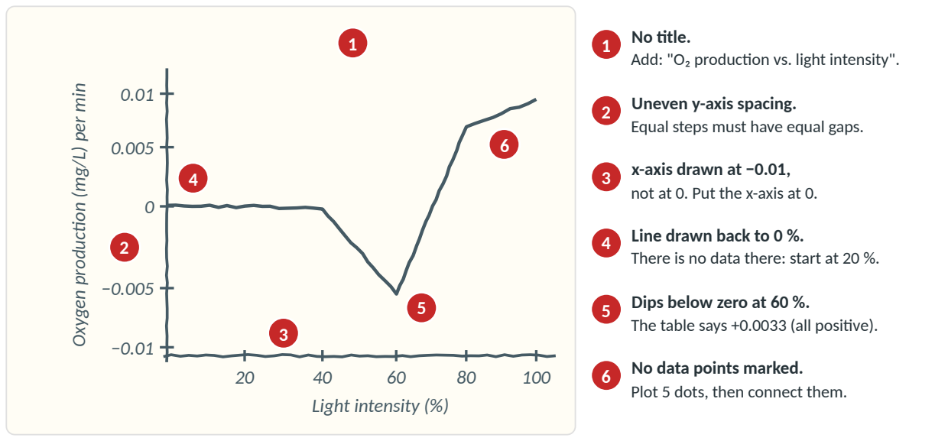
Figure 15. The example graph's problems, numbered, with fixes. Done well: both axes have titles with units, and 80 % and 100 % are close to the right values.
√ MODEL ANSWER — (b) Model rewrite (earns 6/6), as a labeled paragraph
[C] O₂ production stayed near zero at low light (20–40 %) and then rose steadily as light intensity increased from 40 % to 100 %. [E] At 20 % light, O₂ production was only 0.0011 mg/L per hour (0.00002 mg/L per minute), but at 100 % it was 0.5976 mg/L per hour (0.0100 mg/L per minute). From 40 % to 100 %, each +20 % of light added about 0.20 mg/L per hour (0.0002 → 0.1985 → 0.4023 → 0.5976). [R] Light is the energy source for photosynthesis (6CO₂ + 6H₂O + light energy → C₆H₁₂O₆ + 6O₂). Chlorophyll in the chloroplasts absorbs the light, so more light means faster photosynthesis and more O₂, a product, released. At 20 % and 40 % the DO fell (−0.1928 and −0.1937 mg/L per hour) because the plant's respiration (0.1939 mg/L per hour) used O₂ much faster than photosynthesis made it (only 0.0011 and 0.0002 mg/L per hour), so the DO fell almost as much as in the dark. The rise had not leveled off at 100 %, so light was still the limiting factor, but these data can't tell us what happens above 100 %.

◊ How to think about it (5 steps) | ! Watch out | Scoring guide · Q12 (b) (/6)
1 Unpack: critique, then rewrite.  2 Read: check numbers vs. Q4 table.  3 Claim: a direction; no "I think".  4 Prove: 2–3 numbers + units.  5 Explain: replace the circular "because". | - Circular reasoning (watch-out 6).  - Graph ≠ table (watch-out 11).  - 0.001 ≠ 0.0100 (watch-out 12). | □ [C] A trend claim, no "I think".  □ [E] Two correct values + units.  □ [E] A comparison; 0.0100 per minute.  □ [R] Light energy → more O₂.  □ [R] Respiration explains the DO drop.  □ [R] Links back; nothing beyond 100 %.
Evidence, 1/2 vs 2/2: "The graph goes up" earns 1/2. "At 20 % light O₂ production was only 0.0011 mg/L per hour, but at 100 % it was 0.5976 mg/L per hour" earns 2/2. Review: Learning Guide, Part 5 (graph rules); Detected Errors.

Score tracker
Write your score for each question. In the last column, note which part lost points (C, E or R) and what to review.
Q | Level | Topic | Score | What I missed → what to review
Q1 | Warm-up | Do plants do cellular respiration? | /6
Q2 | Warm-up | Respiration arrows in the carbon cycle | /6
Q3 | Warm-up | Where an athlete's energy comes from | /6
Q4 | Data analysis | Light intensity (your Part III data) | /6
Q5 | Data analysis | Light color (practice data) | /6
Q6 | Data analysis | Temperature (practice data) | /6
Q7 | Scenario | Keeling Curve: the yearly zig-zag | /6
Q8 | Scenario | Snail, plant and BTB tubes | /6
Q9 | Scenario | Clearing and burning a forest | /6
Q10 | Challenge | Optimal ecosystem and the fish budget | /6
Q11 | Challenge | Counterclaim and rebuttal | /6
Q12 | Challenge | Critique and upgrade (part b) | /6
Total |  |  | /72

What your score means and what to review
Usual score | What it means | What to do next
6/6 | Test-ready for this kind of question. | Time yourself on a Level 3 or 4 question (about 10–15 minutes).
4–5 | Close: one missing number or a weak "why". | Re-read that question's Watch out box; rewrite only the part that lost points.
2–3 | The idea is there; evidence or science is thin. | Redo it with the 5-step method, then read the Learning Guide part listed.
0–1 | Start with the basics; that is what this is for. | Read the listed Learning Guide parts, then retry Q1–Q3 before moving up.

● KEY IDEA — Look for your pattern
- Losing Claim points? Use a claim template (trend, best condition, comparison, mechanism, model-based) and answer the exact question.
- Losing Evidence points? Quote two numbers with units and a time basis, ideally "from __ to __" (watch-outs 5 and 12).
- Losing Reasoning points? Name the process, its reactants or products, the organelle and the energy, then link back with "so…" (watch-out 6).
- Mixing up net and gross? DO difference = net change; O₂ production = DO difference + 0.1939 (watch-out 4).

Before the test: last checks
 | To do | Done on
□ | Get the real Part IV (light color) and Part V (temperature) results from Teams 2, 5, 8 and 3, 4, 9, and redo Q5 and Q6 with them.
□ | Redo every question you scored 4 or less, this time without the hints.
□ | Write both equations from memory with the energy the right way round: light energy in (photosynthesis), ATP out (respiration).
□ | Explain out loud: DO difference (net change) vs. O₂ production (gross) = DO difference + 0.1939.
□ | Time yourself on Q10, the Part VII question: plan for 3 minutes, write for 12.
□ | Read the watch-out list in the CER Prep Guide the night before.

