Photosynthesis CER Cheat Sheet
The science, the lab, the CER method and the traps. Sources: [P1] POGIL worksheet · [P2] simulation lab · [P3] Mauna Loa notes

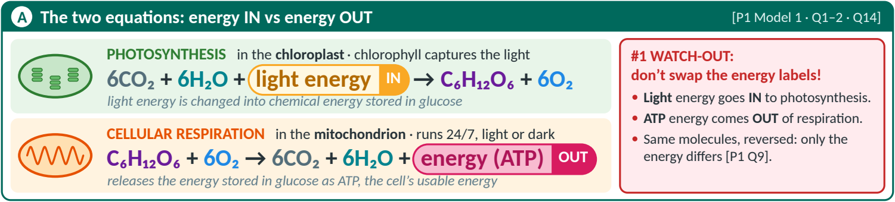
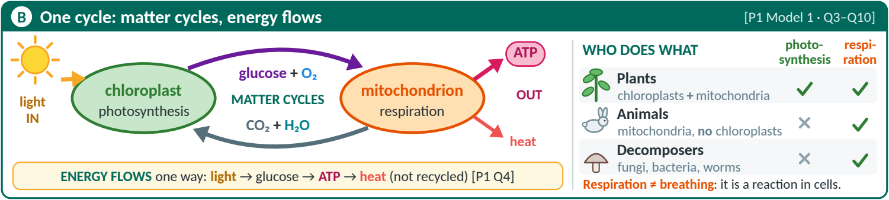
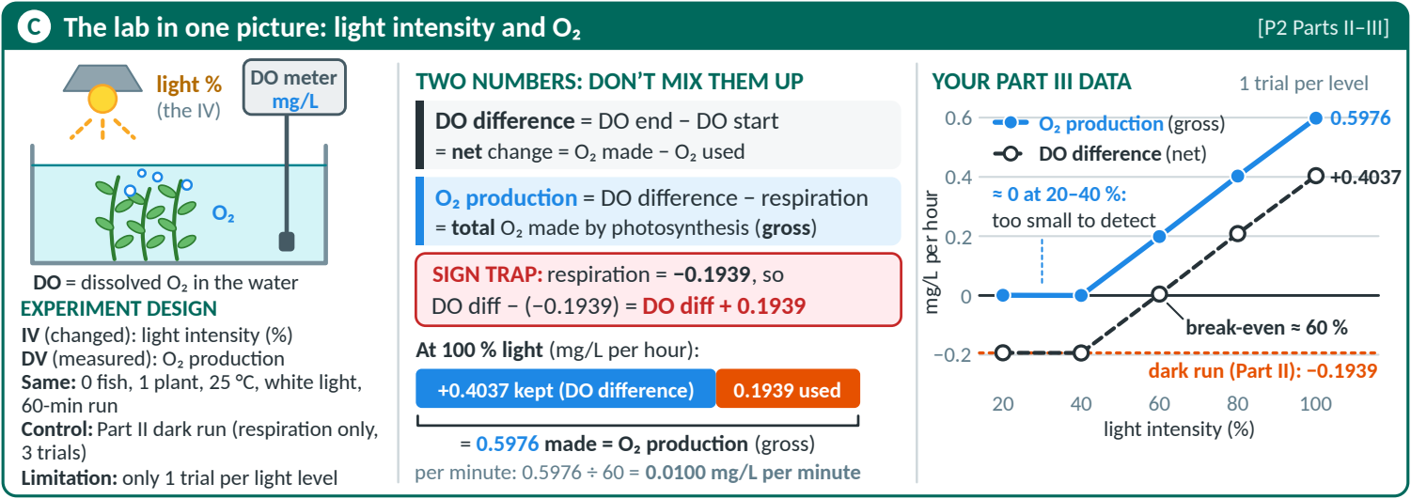
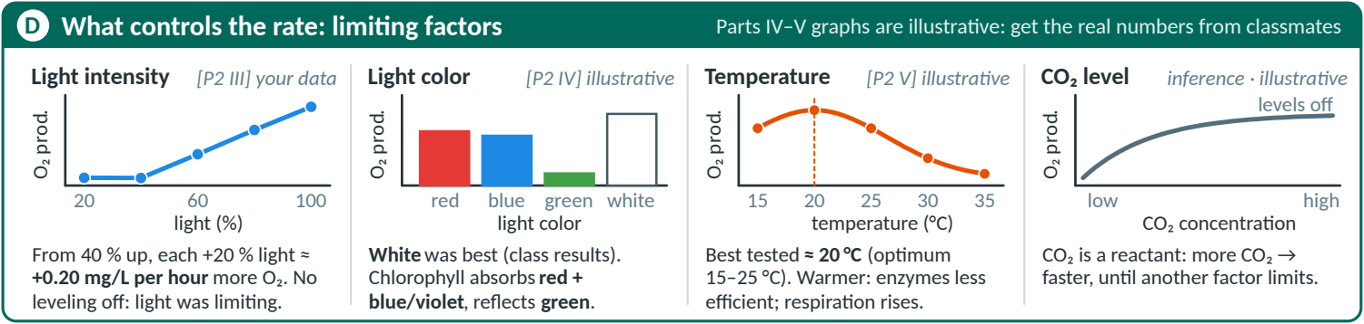

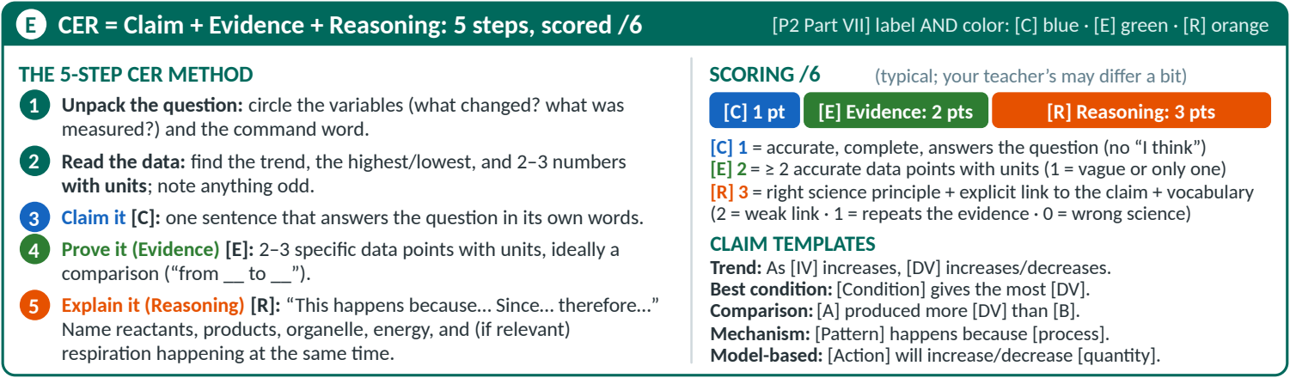
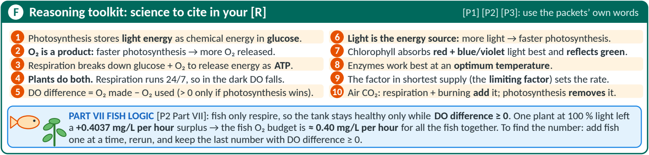
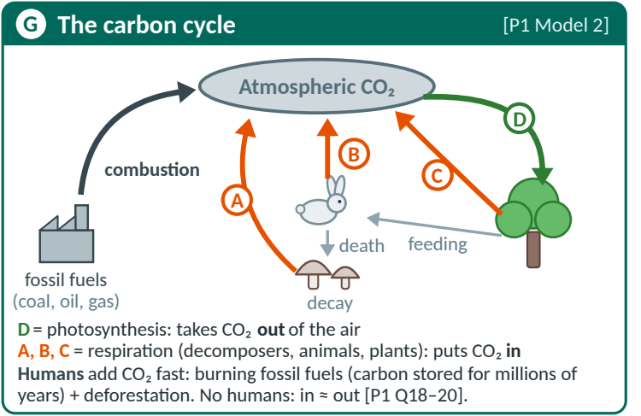 | 

