Detected Errors in Your Worksheets
A complete, kind fix-it list for your three photosynthesis packets
Every item here is fixable — and fixing it now means it can’t cost you points on the CER test.

Every answer, number and drawing in your three packets was checked: the POGIL worksheet [P1], the simulation lab [P2], and your Mauna Loa notes [P3]. All the lab math was recalculated, and your graph was compared with your table. Most of your work is correct — often very strong (see Part C). The items below are the places where a fix will make your CER answers more accurate.
WHAT'S INSIDE
- Part A · Errors to fix
- Part B · Polish: right idea, make it sharper
- Part C · What you nailed

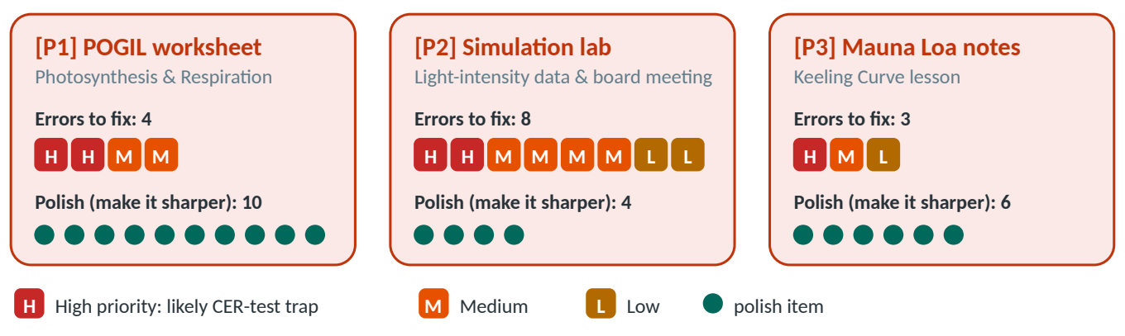
Figure 1. What was found in each packet. H/M/L = priority; teal dots = “polish” items (right idea, could be sharper).
Your top 5 fixes before the test (tick them off)
 | Check
□ | Energy labels: photosynthesis takes in LIGHT energy; respiration releases ATP energy (E4, E1).
□ | Who has what: animals have mitochondria; plants have chloroplasts AND mitochondria and do both processes (E2).
□ | Your data: fix the 100 % and 40 % values and redraw the graph so it matches the table — no dip below zero (E7, E8, E9).
□ | Keeling Curve: respiration is NOT negligible; the CO₂ level is a running total (E13, E14).
□ | Practice the Part VII CER (best conditions + how many fish), and get the real Part IV/V class numbers (E12).

→ TIP — How to read each item
Each error has four parts: You wrote (what is on your sheet) → What’s off → Full-credit version (what a top answer says) → Why it matters on a CER test. Start with the High priority items — they are the most likely test traps.

Part A · Errors to fix

[P1] Photosynthesis and Respiration (POGIL worksheet)
E1 | Q9: the energy exception is in the wrong half  [P1] p.2, Q9 · Science (half right) · Medium priority
You wrote | “The reactants of photosynthesis are the products of respiration, except for sunlight energy, and the reactants of respiration are the products of photosynthesis, except for ATP energy.”
What's off | The first half is right. In the second half there is no exception: glucose + O₂ (respiration’s reactants) are exactly what photosynthesis makes. ATP is a product of respiration, not one of its reactants, so “except for ATP” suggests ATP goes into respiration.
Full-credit version | “The products of respiration (CO₂ and H₂O) are the reactants of photosynthesis, and the products of photosynthesis (glucose and O₂) are the reactants of respiration. The only difference is energy: photosynthesis takes in light energy, and respiration releases energy as ATP.”
Why it matters on a CER test | Energy is the #1 trap on this test: matter cycles, but energy does not. Getting “light in, ATP out” exactly right shows you understand both processes.

E2 | Q10: animals DO have mitochondria  [P1] p.2, Q10 · Contradiction / science error · High priority
You wrote | “…but animals can only go through respiration on their own because they don’t have mitochondria.”
What's off | Animals do have mitochondria — that is where their cellular respiration happens (you said so yourself in Q2a and Q8). You almost certainly meant chloroplasts. Also, “plants can survive on their own” is only partly true: plants still use CO₂ released by respiration (their own, animals’, and decomposers’), and decomposers recycle matter.
Full-credit version | “We partly agree. Plants have chloroplasts and mitochondria, so they can make their own glucose and also break it down for ATP. Animals have mitochondria but no chloroplasts, so they must eat plants (or animals that ate plants) to get glucose. But plants aren’t completely independent: they use CO₂ released by the respiration of animals and decomposers, so the two depend on each other.”
Why it matters on a CER test | A one-word slip (mitochondria ↔ chloroplasts) turns a correct idea into a science error and contradicts your own earlier answers. On a CER test, a contradiction can cost the reasoning points.

E3 | Q13: the missing red star at B  [P1] p.4, Q13 (Model 2) · Incomplete · Medium priority
You wrote | Green star at D; red stars at C and A; nothing at B.
What's off | Arrow B goes from the rabbit up to atmospheric CO₂ — that is animal respiration, so it needs a red star. Your D (photosynthesis), C (plant respiration) and A (decomposer respiration, the Q15 idea) are all correct.
Full-credit version | Green star: D. Red stars: B and C — plus A once you know decomposers respire (Q15). See Figure 2.
Why it matters on a CER test | Carbon-cycle questions often ask which organisms release CO₂. The complete answer is plants, animals and decomposers — leaving out animals is a common way to lose a point.

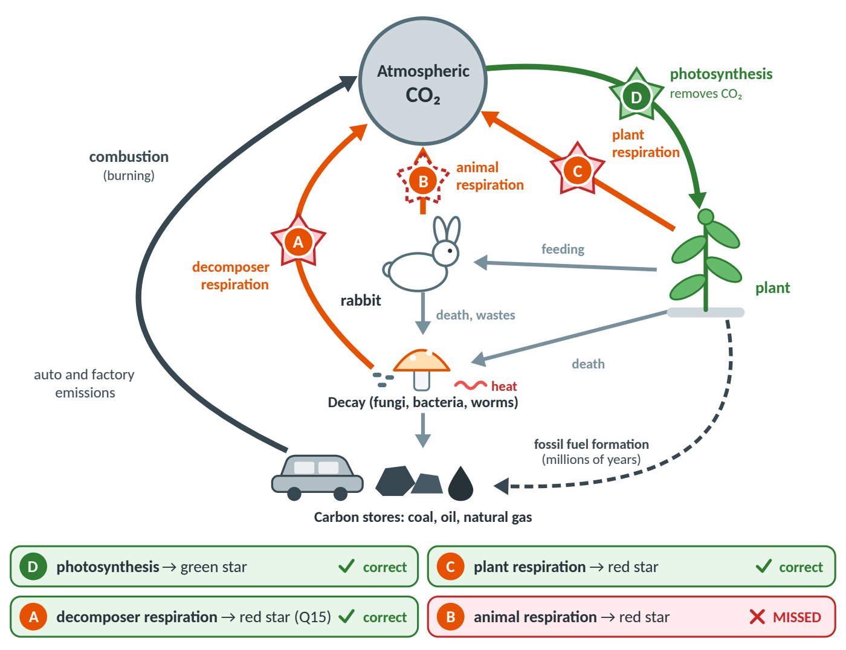
Figure 2. Where the stars go on Model 2 [P1]. Letters and words are included, so the colors are not needed to read it.
E4 | Q14: the energy labels are swapped  [P1] p.4, Q14 · Science error · High priority
You wrote | Respiration: C₆H₁₂O₆ + 6O₂ → 6CO₂ + 6H₂O + energy, with “(sunlight)” written over “energy”. Photosynthesis: 6CO₂ + 6H₂O + energy → C₆H₁₂O₆ + 6O₂, with “(ATP)” written over “energy”.
What's off | The two labels are switched. Photosynthesis takes in light (sunlight) energy; respiration releases energy as ATP. This also contradicts your own correct answers to Q1b (“sunlight energy”) and Q2c (“ATP energy”). Your formulas, coefficients and circled CO₂ are all correct.
Full-credit version | Photosynthesis: 6CO₂ + 6H₂O + light energy → C₆H₁₂O₆ + 6O₂. Respiration: C₆H₁₂O₆ + 6O₂ → 6CO₂ + 6H₂O + energy (ATP). “Label” also means naming each substance: carbon dioxide, water, glucose, oxygen, energy.
Why it matters on a CER test | This is the single most likely trap on the test. If your reasoning says respiration uses sunlight, the science is wrong and the reasoning points are lost.

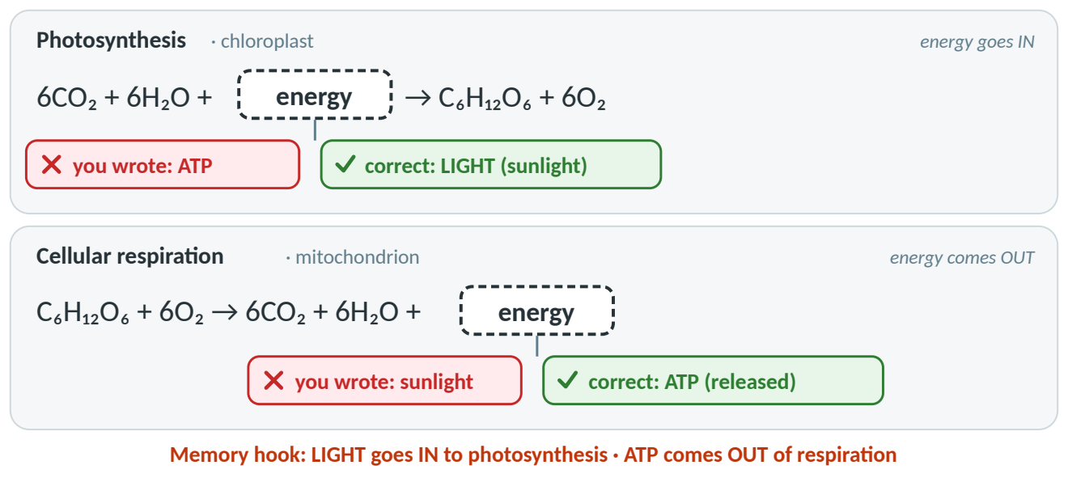
Figure 3. Q14 fixed: light energy goes IN to photosynthesis; ATP energy comes OUT of respiration.

[P2] Photosynthesis & Cellular Respiration Simulation (lab)
E5 | Part II: a small slip in the averages  [P2] p.1, Part II · Math / data · Low priority
You wrote | Average start 7.0647, average end 6.8709, average difference −0.1939 mg/L per hour.
What's off | Your three trial differences (−0.1941, −0.1908, −0.1973) are all correct. Their average is (−0.1941 − 0.1908 − 0.1973) ÷ 3 = −0.1941 (the start and end averages are 7.0649 and 6.8708). The slip is tiny (0.0002) and changes no conclusion — the other study guides keep your −0.1939 so their numbers match your sheet.
Full-credit version | Respiration = −0.1941 mg/L per hour (average of the three dark trials). Tip: average the three differences directly, and re-check with a calculator.
Why it matters on a CER test | Teachers check that evidence numbers are calculated correctly. Tiny slips are usually forgiven, but double-checking protects your evidence points.

E6 | Part III prediction: unclear, and opposite to your result  [P2] p.2, Part III prediction · Wording · Low priority
You wrote | “Light intensity decreases oxygen production during photosynthesis.”
What's off | It doesn’t say which way light changes (more light or less light?), and as written it says light reduces O₂ — the opposite of what you found. A prediction is allowed to turn out wrong, but it should be clear, testable, and give a reason.
Full-credit version | “If light intensity increases, then oxygen production will increase, because light is the energy source for photosynthesis, which releases O₂.”
Why it matters on a CER test | If–then–because is the same thinking as Claim + Reasoning. Practicing it makes your CER claims sharper.

E7 | Part III table: the 100 % per-minute value is off by 10×  [P2] p.2, Part III table · Math / data · Medium priority
You wrote | O₂ production per minute at 100 % light: 0.001
What's off | 0.5976 ÷ 60 = 0.00996 ≈ 0.0100. As written, the table says 100 % light made less O₂ per minute than 60 % or 80 % — which isn’t true. (Your graph shows about 0.0097 at 100 %, so you clearly knew the right value; it’s a copying slip.)
Full-credit version | 100 % light → 0.0100 mg/L per minute.
Why it matters on a CER test | Evidence must be accurate. One misplaced decimal can make your evidence contradict your own claim.

E8 | Part III table: the 40 % O₂ production  [P2] p.2, Part III table · Math / data (sign trap) · Medium priority
You wrote | At 40 %: O₂ production 0.0102; per minute 0.0002.
What's off | O₂ production = DO difference − respiration = −0.1937 − (−0.1939) = −0.1937 + 0.1939 = 0.0002 mg/L per hour, not 0.0102. The per-minute value is then 0.0002 ÷ 60 ≈ 0.000003 (essentially 0). Your 0.0002 per minute came from carrying the wrong 0.0102 forward.
Full-credit version | 40 % → O₂ production 0.0002 mg/L per hour → about 0.000003 mg/L per minute (≈ 0). Your other O₂-production (per-hour) values — 100 %, 80 %, 60 % and 20 % — are correct; see the corrected table below.
Why it matters on a CER test | The “minus a negative” step is a classic trap. Write the signs out every time: −(−0.1939) = +0.1939.

Light (%) | DO difference (mg/L per hour) | O₂ production (mg/L per hour) | O₂ production per minute
100 | +0.4037 | 0.5976 | 0.0100 (you wrote 0.001)
80 | +0.2084 | 0.4023 | 0.0067
60 | +0.0046 | 0.1985 | 0.0033
40 | −0.1937 | 0.0002 (you wrote 0.0102) | ≈ 0.000003 (you wrote 0.0002)
20 | −0.1928 | 0.0011 | 0.00002
Your Part III table, corrected (green cells = fixed). Respiration used: −0.1939 mg/L per hour, as on your sheet.

E9 | Part III graph: it doesn’t match your table  [P2] p.2, Part III Q7 graph · Graph · High priority
You wrote | A line that stays at 0 from 0–40 %, dips below zero (about −0.0055) near 60 %, then rises to about 0.0069 at 80 % and 0.0097 at 100 %.
What's off | Every O₂-production value in your table is positive — at 60 % it is +0.0033 — so the dip below zero isn’t in your data. Other fixes: mark each data point; don’t draw the line back to 0 % (there’s no data there); keep the y-axis spacing even; put the x-axis at 0; add a title. Good news: both axes have titles and units, and your 80 % and 100 % points are right.
Full-credit version | Plot (20, ≈0), (40, ≈0), (60, 0.0033), (80, 0.0067), (100, 0.0100): flat near zero, then a steady straight-line rise — never below zero (Figure 5).
Why it matters on a CER test | Graphs are evidence. A graph that disagrees with its own table makes your evidence look unreliable.

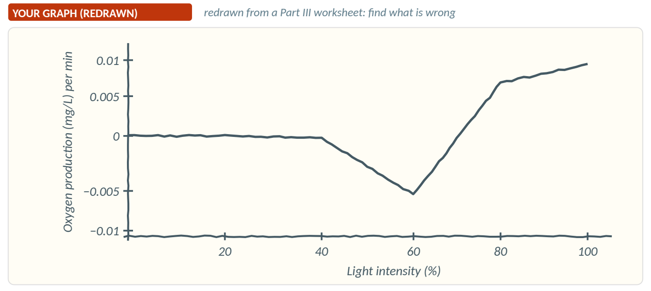
Figure 4. Your Q7 graph, traced from the worksheet. Spot the dip below zero near 60 %.
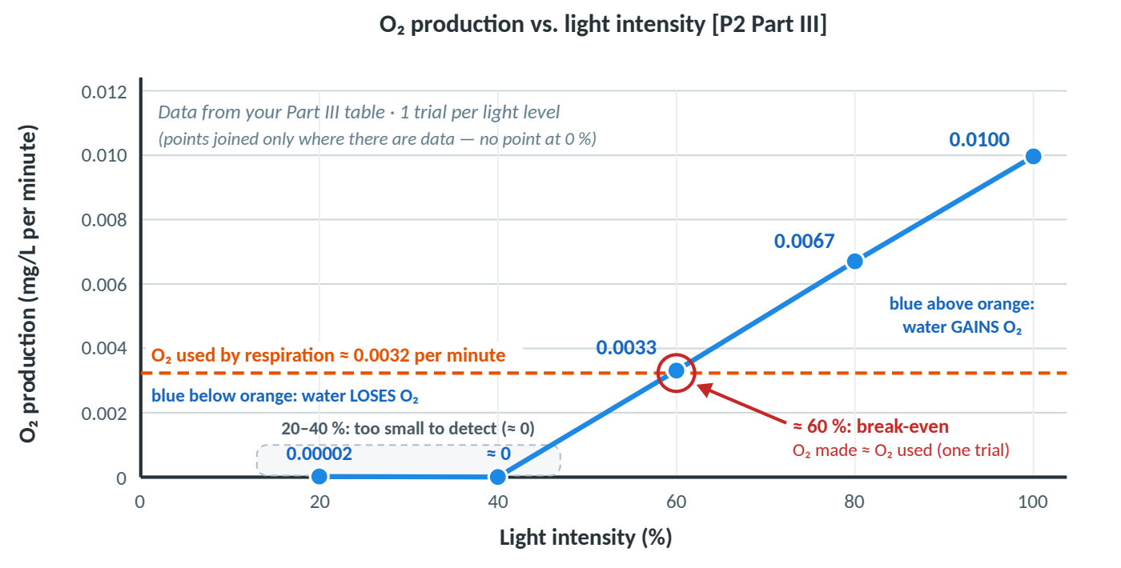
Figure 5. The correct graph of your own Part III data (O₂ production per minute).
E10 | Board meeting: enzymes don’t denature just above 20 °C  [P2] p.5, Part VI table (temperature) · Science · Medium priority
You wrote | “~20 °C … At higher temps (>20 °C), enzymes, proteins to speed up chemical reactions, are denatured.”
What's off | Enzymes don’t fall apart just above 20 °C. Above the best temperature they work less efficiently (they start to lose their shape), and the plant’s respiration speeds up, using more O₂ — so the net oxygen drops. True denaturing of most plant enzymes needs much higher temperatures (roughly 40 °C or more). Also, only 15, 20, 25, 30 and 35 °C were tested, so 20 °C is the best tested temperature.
Full-credit version | “About 20 °C gave the most O₂ of the temperatures tested. Colder: molecules move and collide more slowly, so enzyme reactions are slow. Warmer: enzymes work less well and the plant’s respiration uses more O₂. Very hot (about 40 °C or more): enzymes denature.”
Why it matters on a CER test | “Denature” is a strong word; using it at the wrong temperature is a science error that can cost the reasoning point.

E11 | The productivity question was left blank  [P2] p.5, Part VI Q2 · Unanswered · Medium priority
You wrote | (blank) — “Why do we use dissolved oxygen as a measure of productivity? Does productivity include more than oxygen?”
What's off | Worth knowing, because it explains why the whole lab works. (The worksheet’s definition is a little garbled: productivity is the rate at which producers make organic compounds.)
Full-credit version | “Plants release O₂ as they make glucose — 6 O₂ for every glucose — so the O₂ added to the water tracks how fast the plant is making food, and dissolved oxygen is easy to measure. Yes, productivity includes more than oxygen: it really means making organic compounds like glucose, starch and new plant material. O₂ is just the easiest product to measure.”
Why it matters on a CER test | Expect a reasoning question like “Why does more O₂ mean more photosynthesis?” This is the answer.

E12 | Part VII: the CER task isn’t done yet  [P2] p.6, Part VII · Not done yet · High priority
You wrote | (blank) — predict the best conditions and how many fish the tank can support, test it, then write a claim, evidence (numbers) and reasoning, color-coded or labeled.
What's off | It may not have been assigned yet — but it is the exact format of a CER test question, so practice it now.
Full-credit version | Best conditions from the class: 100 % light, white light, about 20 °C (best tested). Fish only respire, so fish can be added only while the DO difference stays ≥ 0. One plant at 100 % white light (25 °C) made a surplus of +0.4037 mg/L per hour, so all the fish together can use no more than about 0.40 mg/L per hour. Add fish one at a time and keep the last number with a DO difference ≥ 0. Get the real Part IV (color) and Part V (temperature) numbers from classmates before the test.
Why it matters on a CER test | Practice it with Mock Question Q10 in Guide 3 (Mock CER Questions) and worked example C in Guide 2 (CER Prep Guide).

[P3] Notes: Mauna Loa & the Rise of CO₂
E13 | Notes: “photosynthesis is a delayed reaction”  [P3] p.1 (starred note) · Science (partly right) · Medium priority
You wrote | “Photosynthesis takes time to take CO₂ from the atmosphere, which is why … there is more CO₂ in the atmosphere in the spring than in the fall. Photosynthesis is a delayed reaction.”
What's off | Partly right! CO₂ really is higher in spring (peak in May) than in fall (low in September–October), and the CO₂ level does lag behind the seasons. But photosynthesis itself isn’t delayed — it starts within seconds of light. The lag happens because the CO₂ level is a running total, like water in a bathtub (Figure 6).
Full-credit version | “All fall and winter, respiration and decay add more CO₂ than photosynthesis removes, so CO₂ keeps rising until the leaves come back — it peaks in May. Then months of strong photosynthesis remove more than respiration adds, so CO₂ falls until its low point in September–October.”
Why it matters on a CER test | Keeling-curve questions are a favorite “explain the pattern” CER. The running-total idea is the reasoning teachers look for.

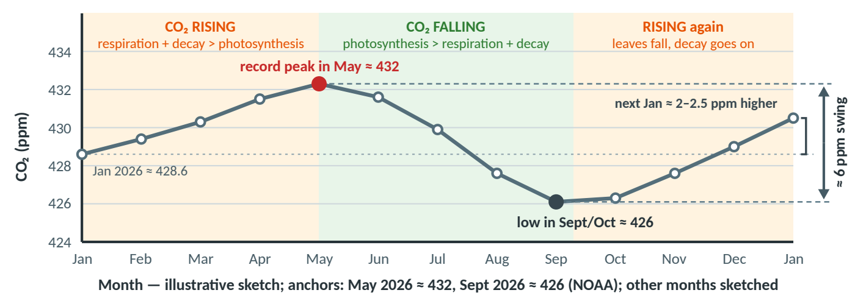
Figure 6. One year at Mauna Loa (illustrative shape; peak ≈432 ppm in May 2026, ≈426 ppm in September 2026, NOAA). The level rises while CO₂ in > CO₂ out, and falls while out > in.
E14 | Notes: respiration is NOT negligible  [P3] p.1 · Science · High priority
You wrote | “Cellular respiration is a constant factor, so it’s happening all the time, which is why it has a negligible effect on CO₂ in the atmosphere.”
What's off | Respiration by plants, animals and especially decomposers releases a huge amount of CO₂ — about as much as photosynthesis removes in a year. That is exactly the balance you described in POGIL Q18. It is what makes CO₂ rise every fall and winter. Something that happens all the time still adds CO₂ all the time. (The lesson probably meant: because respiration goes on all year, the big season-to-season change comes mostly from photosynthesis turning up and down.)
Full-credit version | “Respiration happens all year and releases about as much CO₂ as photosynthesis removes. When photosynthesis slows in fall and winter, respiration and decay keep going, so CO₂ rises. The seasonal zig-zag comes mainly from photosynthesis changing with the seasons.”
Why it matters on a CER test | This note contradicts your own Q15 (decomposers respire) and Q18 (balance). Mock Question Q11 asks you to rebut exactly this claim.

E15 | Notes: when the CO₂ rise started  [P3] p.2 · Nuance · Low priority
You wrote | “The increase of rampant CO₂ started after WW2.”
What's off | The human-caused rise began with the Industrial Revolution (1800s), when CO₂ was about 280 ppm. After WWII the rise sped up a lot, because far more fossil fuel was burned from the 1950s on.
Full-credit version | “CO₂ started rising with the Industrial Revolution and sped up sharply after WWII.”
Why it matters on a CER test | Background facts aren’t usually the CER focus, but accurate facts make your reasoning more convincing.

Part B · Polish: right idea, make it sharper
These answers are basically correct. Each upgrade below makes them more precise — exactly the kind of detail that turns a 4/6 CER into a 6/6.
Where | Quick upgrade
[P1] Q5 | Chloroplasts are mainly in leaf and green-stem cells; root cells (no light) have none.
[P1] Q6 | Say why plants need mitochondria: plant cells do cellular respiration to turn the glucose they made into ATP. (“All cells” is too broad: bacteria have none.)
[P1] Q7 | Give the reason: animals can’t photosynthesize, so they get glucose by eating.
[P1] Q11 | Trace a second food too, e.g., pizza crust = wheat; cheese = milk from cows that ate grass.
[P1] Q12 | Important for CER: add the two missing links — photosynthesis stores light energy as chemical energy in glucose/starch (in the seed), and the athlete’s cells release it by cellular respiration in mitochondria as ATP, which powers the muscles.
[P1] Q14 | “Write and label” = name every substance (glucose, oxygen, carbon dioxide, water, energy).
[P1] Q16 | You already have combustion, fossil-fuel formation and feeding/wastes. Add decay (decomposition). “Metabolism” is too vague (it includes respiration) — say feeding/digestion and excretion. Fossil fuels form by burial + heat + pressure over millions of years.
[P1] Q19 | Fossil fuels store carbon; burning combines it with O₂ to make CO₂. Grammar: “levels … increase”.
[P1] Q21 | Connect your own pro and con: because farm machines burn fossil fuels, ethanol is close to carbon-neutral, not exactly zero. (The corn is regrown; the ethanol is burned.)
[P1] Q22 | Batteries store solar power for night (they don’t collect it). Geothermal heat makes steam, and the steam spins the turbines.
[P2] Part III table | Record every value to the same 4 decimals (80 % start: 7.0380) and write units in the headings (mg/L, mg/L per hour).
[P2] Part III Q8 | Add numbers: “O₂ production rose from about 0 at 20–40 % light to 0.0100 mg/L per minute at 100 %.” Drop “generally” once your graph is fixed.
[P2] Part III Q9 | Name the 3 factors (light intensity, CO₂, temperature); say O₂ is a product of photosynthesis, so faster photosynthesis = more O₂; explain why DO fell at low light (respiration > photosynthesis); fix the fragment “Photosynthesis 3 main factors”.
[P2] Part VI (light color) | Add the key idea: chlorophyll absorbs mostly red and blue light and reflects green, so green light gives the least O₂; white light contains red and blue.
[P3] respiration note | “Respiration breaks down glucose (with O₂) to make ATP; CO₂ and H₂O are released.” (It doesn’t make glucose.)
[P3] “regular” / “rampant” CO₂ | Keep the class words, but add the standard ones: CO₂ from natural sources vs human-caused (anthropogenic) CO₂. It’s the same molecule; only the source differs.
[P3] “the opposite is true” | Spell it out: in fall and winter, leaves drop and photosynthesis slows, while respiration and decay keep releasing CO₂ — so CO₂ rises.
[P3] Southern Hemisphere | Its cycle is weaker because it has less land, so fewer land plants (most of it is ocean).
[P3] human sources | Add deforestation (cutting and burning forests) as a second human source — you explained it well in POGIL Q20.
[P3] Keeling Curve | The Keeling Curve is the graph of the measurements (started 1958 at about 313 ppm): a yearly zig-zag on a steadily rising trend (about 432 ppm at the May 2026 peak).

Part C · What you nailed
Plenty of your work is already full-credit. Keep doing these things:
- Model 1 basics are all correct [P1 Q1–4]: organelles, reactants, products, the four recycled substances, and sunlight as the one input that isn’t recycled.
- Food-chain tracing [P1 Q11–12]: clear, logical steps from your meal back to the sun.
- Carbon-cycle reasoning [P1 Q17–20]: your Q18 balance statement (CO₂ taken in by plants = CO₂ returned by respiration) is exactly right; Q19 correctly says the problem is the rate of release; Q20 covers both effects of deforestation.
- Ethanol pros and cons [P1 Q21]: balanced and thoughtful, including the hidden fossil-fuel use of farm machines and the effect on food prices.
- Model 2 stars at D, C and A [P1 Q13, Q15]: right, with sound reasoning that decomposers respire.
- Lab math [P2 Parts II–III]: every trial DO difference is correct, and you handled the tricky “DO difference − (negative respiration)” formula correctly in four of five rows.
- Graph basics [P2 Part III]: both axes have titles and units; the 80 % and 100 % points are correct.
- Board-meeting reasons [P2 Part VI]: you explained light intensity and color in terms of chlorophyll absorbing light energy.
- Mauna Loa notes [P3]: correct facts on the observatory (about 3,400 m up), spring leaf-out drawing CO₂ down, the weaker Southern-Hemisphere cycle, and extra CO₂ trapping more heat.

● KEY IDEA — The big picture
Your understanding is solid. Most fixes are about precision — the right energy label, the right organelle, the right sign in a calculation, a graph that matches its table. Those are exactly the details a CER grader checks, so fixing them now is the fastest way to raise your score.
Next: use Guide 3 (Mock CER Questions) — Q4, Q10, Q11 and Q12 practice the exact skills from this list.

