Requirement Specifications

To accommodate the new requirement of “POP wise sales and inventory management for SnD Lite” we need to have a system with the following functionalities :
- The Database will be hosted on a centralized server at HO.
- Users will have the client application on their android device.
- User will be able to manage the inventory on server.
- POP census will be managed by Helpdesk.
- At distribution office, before the start of sales journey user will connect the device to the main server at HO (through wifi/GPRS) and will download the specific sections/POPs related to the journey cycle along with inventory.
- User then will disconnect the device from server since, no connectivity to server will be required during the sales related transactions.
- Through the application user will capture the POP wise sales through out the journey and will return to the distribution office.
- On return to office, from sales journey, user will again connect the device to the main server at HO, make the required sale returns and upload the sales data.
- At the server all processing will be done including stock management during “Data Upload”.
- At the end of the days working user will close the working day.

Details
SnD Light User

- There will be two logins, one for Distributor and for DSR.

GPRS will invoke automatically on this screen to
authenticate the user.
User will enter:
- Distributor
- User Id
- Password
And will click on Login button

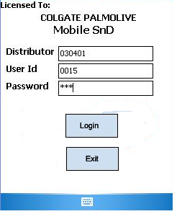

- After successful login through Distributor user, following screen will appear:

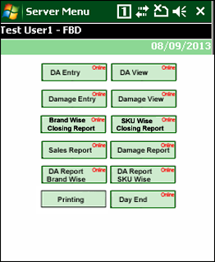

DA Entry: To received stock, this option will work through internet connectivity.
Stock Adjustment: To manage damaged stock. (User will only be able to convert stock from saleable to damaged)
Day End: To close current working day.
Print: To print cash memos.
Repots: Sales & inventory reports.

DA Entry

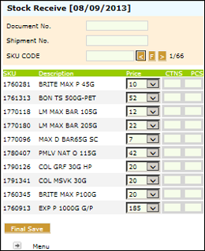

DA Edit/View

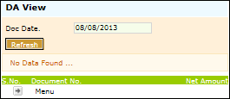

Damaged Adjustment Entry

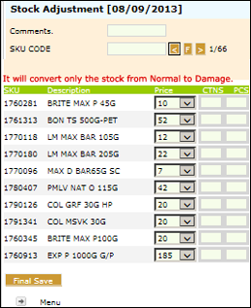

Damaged Adjustment Edit/View
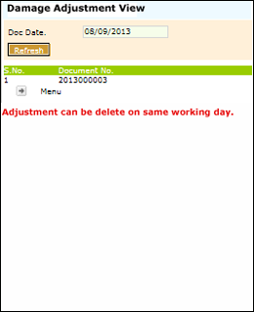

Closing Stock (BrandWise )Report

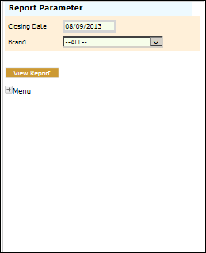

User will enter required date and brand, and will press View Report button to view the following report:

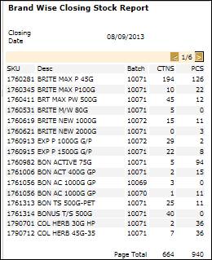

Closing Stock (SKU Wise )Report

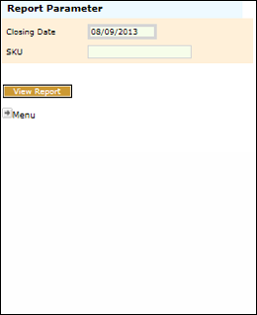

User will enter required date and brand, and will press View Report button to view the following report:

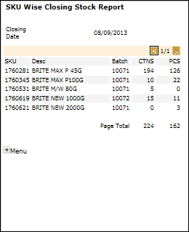

Sales Report

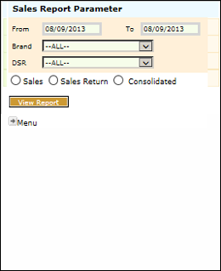

User will enter From date, To Date, Brand, DSR and select any of available report type (Sales, Sales Return, Consolidate) and would press View Report button to view the following report:

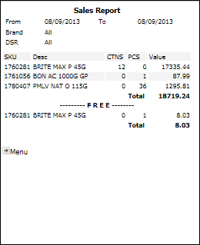

Damage Report

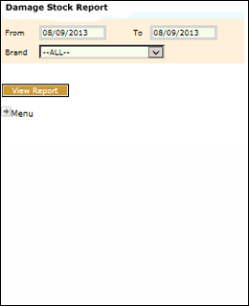

User will enter From date, To Date and Brand and would press View Report button to view the following report:

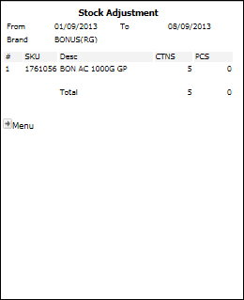

DA Report Brand Wise

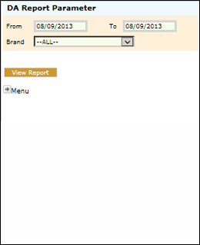

User will enter From date, To Date and Brand and would press View Report button to view the following report:

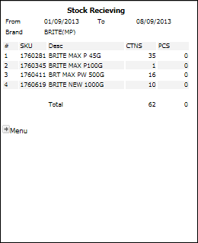

DA Report SKU Wise

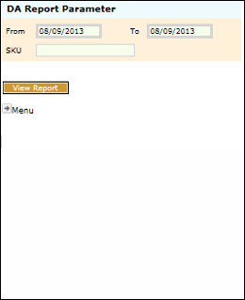

User will enter From date, To Date and SKU and would press View Report button to view the following report:

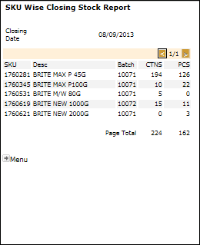

User can access print menu but click on PRINT BUTTON from main menu.

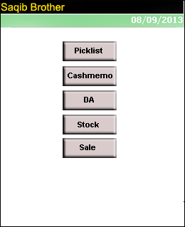

By clicking Picklist button following screen will appear to print picklist.

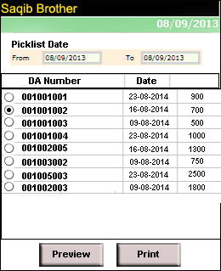

User will use cashmemo button for cashmemo printing

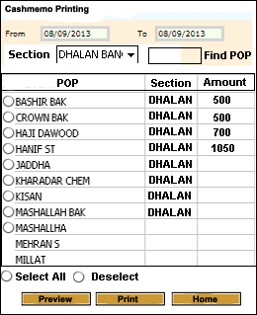

- After successful login through DSR’s user, following screen will appear:

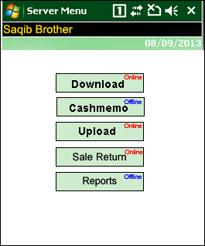

Download: To download PJP, stock, schemes, selling category, last three cashmemo of all the POPs of sections
Cashmemo: To make offline order.
Upload : To upload cashmemos of the day.
Print: To print cash memos. (After Upload)
Sales Return: To make POP wise sales return.
Reports: Sales and Inventory reports

Download PJP / Stock / Out standing Cashmemo / Schemes

User will click on download button to download stock / out standing cashmemo / schemes as per working date.

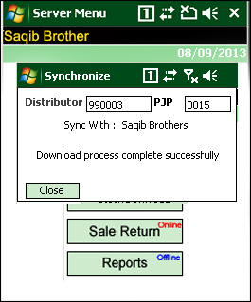

After successful download user will click on cashmemo button to create cashmemo as per following screen.
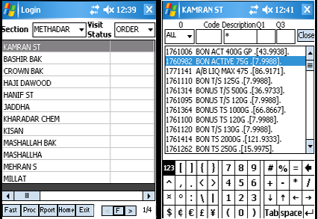

After cashmemo working user will use UPLOAD button to upload all cashmemo to SND server.

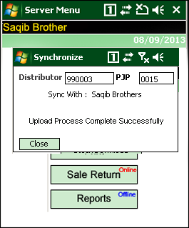

After cashmemo upload user will use sale return option by clicking SALES RETURN button.

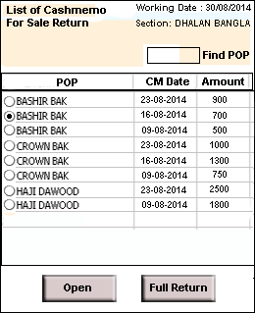

Below screen will use to check all provided reports.

