|  |
| --- |
|  |
| ShowTime Video Rental System |
| Software Requirements Specification |
|  |
| **Shailesh,Vinay,Madhumathi,Hemanth AC, Rupal**  **Brillio Technologies** |
| **5/10/2015** |

|  |
| --- |
| This document details requirements for Video Rental System owned by Brillio Technologies. |

**Document Revision History**

|  |  |  |  |  |  |
| --- | --- | --- | --- | --- | --- |
| **Version No.** | **Date** | **Author** | **Reviewed By** | **Status** | **Comment** |
| 1.0 | 5/10/15 | S.S, M.B,R.S, V.KN,H.AC | Vinod Kumar |  |  |
|  |  |  |  |  |  |
|  |  |  |  |  |  |

**Acronyms and Abbreviations**

|  |  |
| --- | --- |
| **Abbreviation** | **Description** |
|  |  |
|  |  |
|  |  |

Table of Contents

1 Introduction 5

1.1 Purpose 5

1.2 Organization of the Document 5

1.3 Intended Audience 5

1.4 Product Scope 5

1.5 References 6

2 Overall Description 6

2.1 Product Perspective 6

2.2 Product Functions 7

2.3 User Classes and Characteristics 7

2.4 Operating Environment 8

2.4.1 Hardware Requirements 8

The Hardware Requirements are: 8

2.4.2 Software Requirements 8

2.5 Design and Implementation Constraints 8

2.6 User Documentation 8

2.7 Assumptions and Dependencies 8

3 External Interface Requirements 8

3.1 User Interfaces 8

3.2 Hardware Interfaces 9

3.3 Software Interfaces 9

3.4 Communications Interfaces 9

4 System Features 10

4.1 Registration 10

4.1.1 Description and Priority 10

4.1.2 Stimulus/Response Sequences 10

4.1.3 Functional Requirements 10

4.2 Updation from User 10

4.2.1 Description and Priority 10

4.2.2 Stimulus/Response Sequences 10

4.2.3 Functional Requirements 10

4.3 General Orders [Unregistered Customers] 10

4.3.1 Description and Priority 10

4.3.2 Stimulus/Response Sequences 11

4.3.3 Functional Requirements 11

4.4 Search Videos 11

4.4.1 Description and Priority 11

4.4.2 Stimulus/Response Sequences 11

4.4.3 Functional Requirements 11

4.5 Cart 11

4.5.1 Description and Priority 11

4.5.2 Stimulus/Response Sequences 11

4.5.3 Functional Requirements 11

4.6 Payment 11

4.6.1 Description and Priority 11

4.6.2 Stimulus/Response Sequences 12

4.6.3 Functional Requirements 12

4.7 Penalty 12

4.7.1 Description and Priority 12

4.7.2 Stimulus/Response Sequences 12

4.7.3 Functional Requirements 12

4.8 Recommendation 12

4.8.1 Description and Priority 12

4.8.2 Stimulus/Response Sequences 12

4.8.3 Functional Requirements 12

4.9 Admin 12

4.9.1 Description and Priority 12

4.9.2 Stimulus/Response Sequences 12

4.9.3 Functional Requirements 13

5 Other Non-functional Requirements 13

5.1 Performance Requirements 13

5.2 Safety Requirements 13

5.3 Security Requirements 13

5.4 Software Quality Attributes 13

➢ Reliability 13

• Measure if product is reliable enough to sustain in any condition. 13

• It should give consistently correct results. 13

• Product reliability is measured in terms of working of project under different working environment and different conditions. 13

6 Appendix A: Glossary 14

# 

# Introduction

## Purpose

The purpose of this document is to present a detailed description of the Video Rental System (VRS). It will explain the purpose and features of the VRS, the interfaces of the system, what the system will do, the constraints under which it must operate and how the system will react to external stimuli. This document is intended for both the developers and testers of the system.

The version we are using is Version 1.0.

## Organization of the Document

|  |  |
| --- | --- |
| **Heading** | **Style** |
| Heading | Font size =14 and Font-colour: Dark blue |
| Sub Heading | Font size =13 and Font-colour: Blue |
| Content | Font size =11 and Font-colour: Black |

## Intended Audience

The intended audience of this document includes the owner of the video store and the end users of the VRS. Other intended audience includes the development team such as the requirements team, requirements analyst, design team, core developers, testing team and other members of the developing organization.

## Product Scope

The sole purpose of the product is to provide convenient, cost effective, efficient way of searching videos online and ordering video from user. The new VRS will allow the following functionality online:

* Registration
* Membership
* Search for videos
* Rent videos
* Recommendation
* Bill Generation

The user functionality:

* Use the VRS to process the rented or returned videos
* Add or remove videos to/from his store’s video inventory
* Update video information.

## References

* Books :

1. An Integrated Approach Software Engineering Third Edition by Pankaj Jalote.
2. Complete Reference to Java by Herb Schildt.

* Websites :

1. http://channel9movies.com/Channel9.swf

# Overall Description

## Product Perspective

Video rental system is web-based system. The proposed system will take care of registration, membership, searching different videos available, renting and bill generation. The user will have functionality of adding, removing videos and also updating video details. The system provides a secure environment for all financial transactions and for the storing and retrieving of confidential member information. Customer can recommend different videos which he is interested but currently not available in the video store.

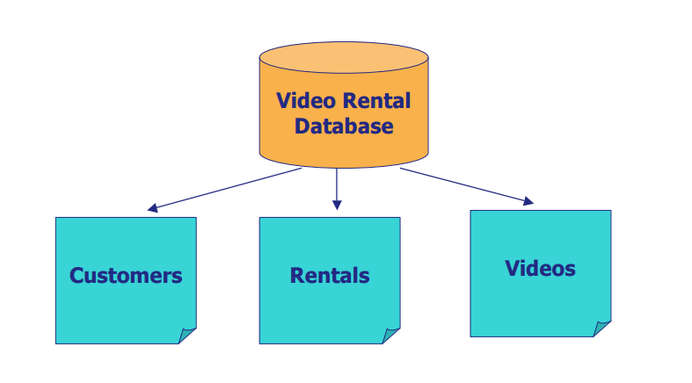

## Product Functions

The following is the sequence of functions to be performed by our software to facilitate the end user.

* Registration
* Search
* Bill Generation
* User can modify or add or delete video
* Feedback
* Recommendation

## User Classes and Characteristics

Operation of the proposed system depends on its various users. These various user-types are mentioned below.

1. User  
2. Customer

User: Add, modify and delete of videos is handled by user. Registration is done by user.

Customer: search, pick Up, and recommendation.

## Operating Environment

### Hardware Requirements

### The Hardware Requirements are:

* RAM: 1 GB
* Processor: Pentium - IV onwards
* HDD Space: 10 GB or more

### Software Requirements

The Software requirements are :

* Operating System – Windows, Linux
* Internet Browser (Mozilla Firefox/Google Chrome/IE 7-8)
* Front End – HTML,CSS, JavaScript, JQuery
* Front End Tool – Eclipse MARS
* Back End – My SQL
* Web server - Apache Tomcat 8

## Design and Implementation Constraints

* User must keep updated information of all the videos available in the store.

## User Documentation

* The product is under development stage and requires a complete implemented prototype to explain the user documentation. Once the prototype is designed and implemented online manuals, user manuals can be provided.

## Assumptions and Dependencies

* All the data entered will be correct and up to date.
* This software package is developed using java as front end which is supported by Oracle, MySQL as the back end which is supported by Window 7.
* There is only one Administrator.
* Proper browsers should be installed
* Customers are registered in the shop by user.
* Customer has to pick and return videos.

# External Interface Requirements

## User Interfaces

The user interface should be simple and easy to understand and use. It should be an interactive interface . The software provides good graphical interface for the user.

* User (Server Side): User can add, remove and update video details and will have all the details of videos available.

## Hardware Interfaces

* Operating system: window, Linux
* Hard Disk: 5 GB
* RAM: 1GB
* Processor: Pentium(R) Dual-core CPU

## Software Interfaces

* Operating System
* Browser

## Communications Interfaces

* Email
* Web Browsers
* http/ https
* FTP

# System Features

## Registration

### Description and Priority

* Customer registration can be done by providing a few mandatory details by the user.
* High Priority: 9

### Stimulus/Response Sequences

* Provide membership id.

### Functional Requirements

1. Form level validation will be carried out in case mandatory input is not provided.
2. Valid credentials should be entered.
3. If any customer wants to register for VRS, they must pay the specified amount of registration if he/she is opting for membership.

## Updation from User

### Description and Priority

* User should log-in with correct credentials.
* User can add, modify and delete videos anytime.
* High Priority: 7

### Stimulus/Response Sequences

* All the details should get reflected in database in minimum time.

### Functional Requirements

* Form level validation will be carried out in case mandatory input is not provided.
* Valid credentials should be entered.
* user can set the prices for different videos.

## Search Videos

### Description and Priority

* Customer, user and admin can search videos.
* High Priority: 9

### Stimulus/Response Sequences

* Video is available or not will be displayed to the customers.

### Functional Requirements

* Customer can filter his search based on his preferences like genre, video-type, title, cast and year.

## Bill generation

### Description and Priority

* After selecting videos user can generate bill.
* High Priority: 6

### Stimulus/Response Sequences

* Bill will be issued.

### Functional Requirements

* Customer can select different payment options customer wants.

## Penalty

### Description and Priority

* User has to pay penalty in different scenarios.
* High Priority: 8

### Stimulus/Response Sequences

* Penalty details will be updated by user in the system.

### Functional Requirements

* User has to pay penalty in case of any physical damage to disc.
* User has to pay penalty in case of any delay in submission of disc.

## Recommendation

### Description and Priority

* If user wishes, he can recommend videos which are not available.
* High Priority: 5

### Stimulus/Response Sequences

* Notification will be sent to the customer.

### Functional Requirements

* User can recommend some videos which are not available in the database.

# Other Non-functional Requirements

## Performance Requirements

* The system need to be reliable
* If unable to process the request then appropriate error message
* Web pages are loaded within few seconds

## Safety Requirements

* The details need to be maintained properly
* Users must be authenticated
* The database must be kept backed up

## Security Requirements

* After entering the password and user id the customer, user and admin can access their profile.
* The details of user must be safe and secure.

## Software Quality Attributes

## **Reliability**

## Measure if product is reliable enough to sustain in any condition.

## It should give consistently correct results.

## Product reliability is measured in terms of working of project under different working environment and different conditions.

* **Usability**
* This can be measured in terms of ease of use.
* Application should be user friendly. Should be easy to learn. Navigation should be simple.
* The system must be:
* Easy to use for input preparation, operation, and interpretation of output.
* Provide consistent user interface standards or conventions with our other frequently used systems.
* Easy for new or infrequent users to learn to use the system.

# Appendix A: Glossary

SRS: Software Requirements Specification

VRS: Video Rental System