Docker容器技术

Centos虚拟机安装：
把 CentOS-7 Minimal ISO 放到 VMware 里运行：
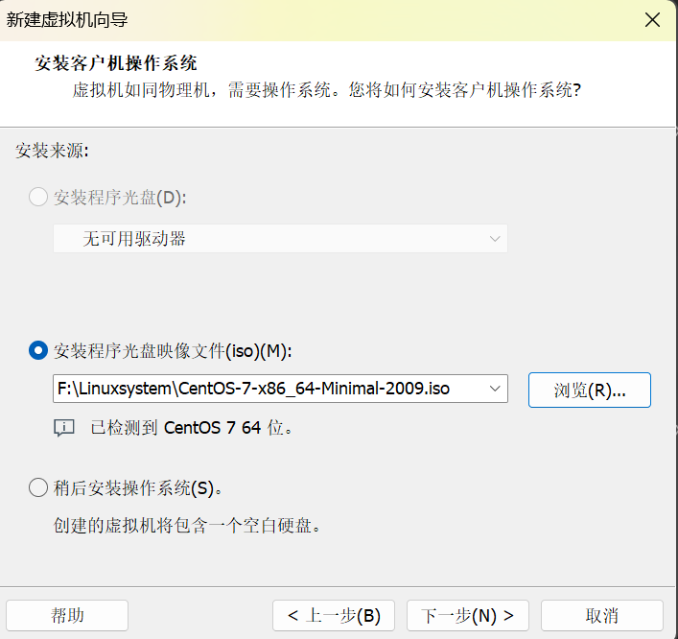
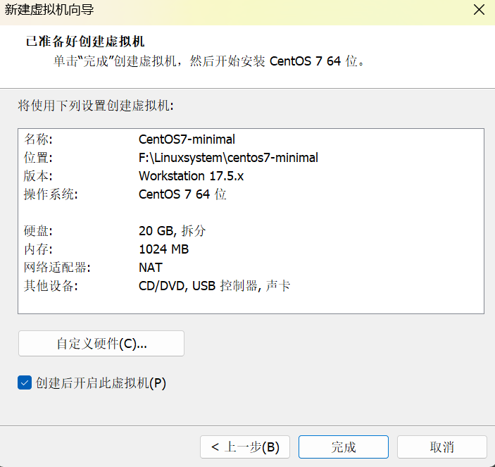
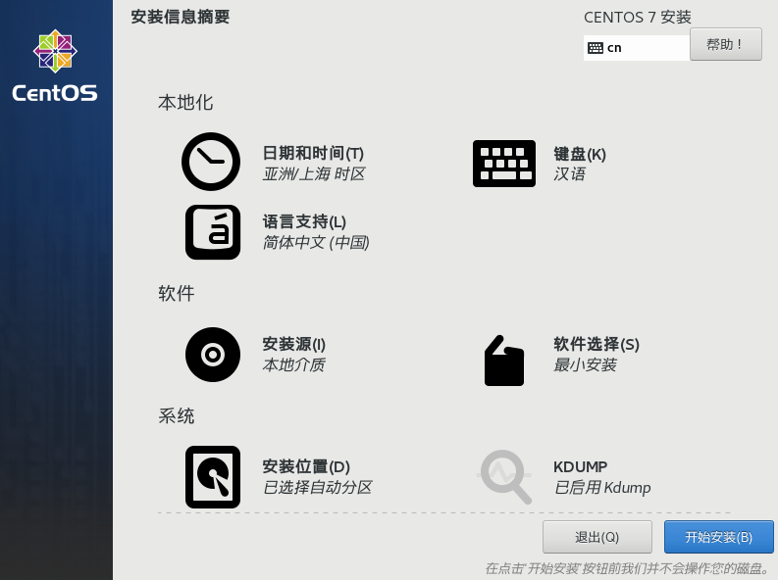
Ip addr
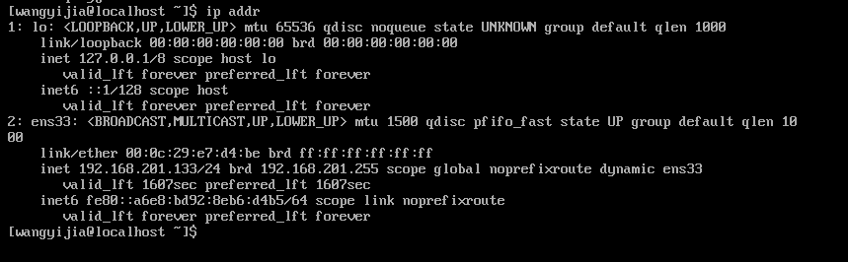
192.168.201.133
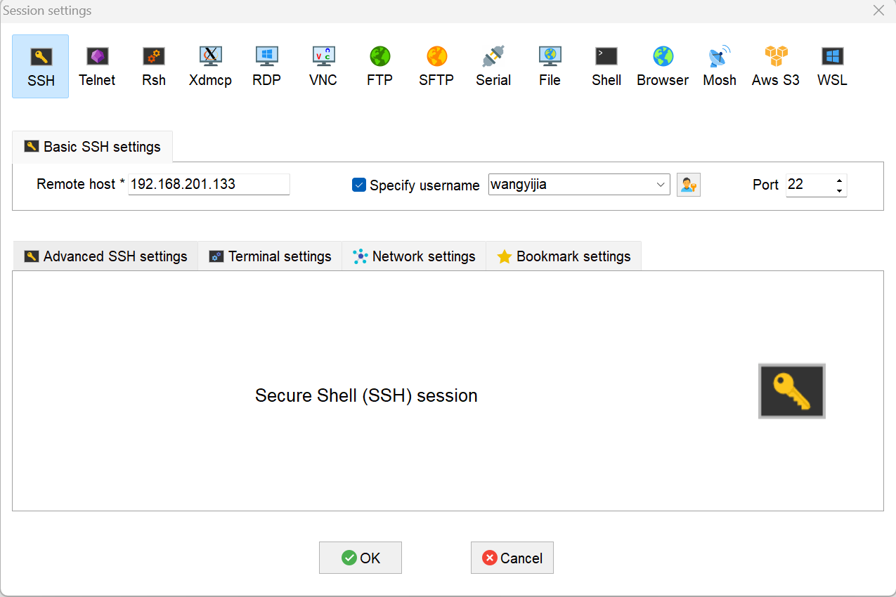

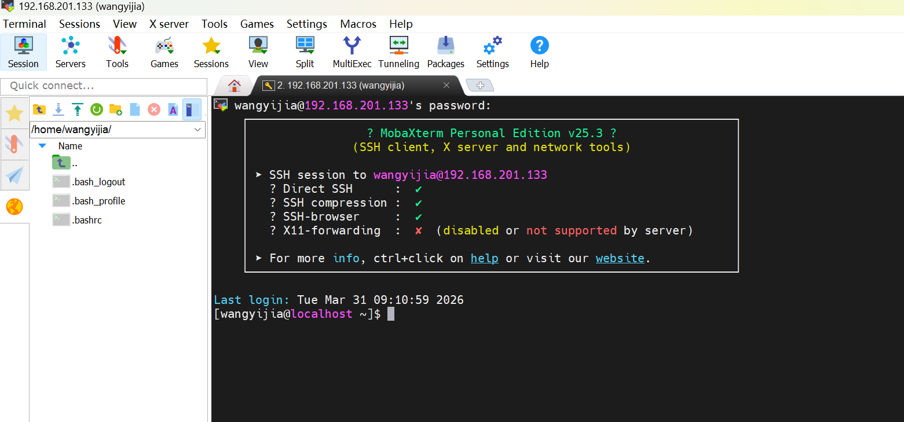
sudo systemctl disable --now firewalld
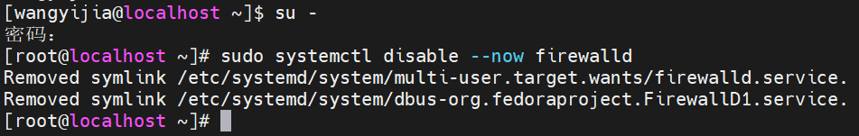
进入源目录并清理旧文件：
cd /etc/yum.repos.d/
sudo rm -fr *.repo
拖拽centos7.repo
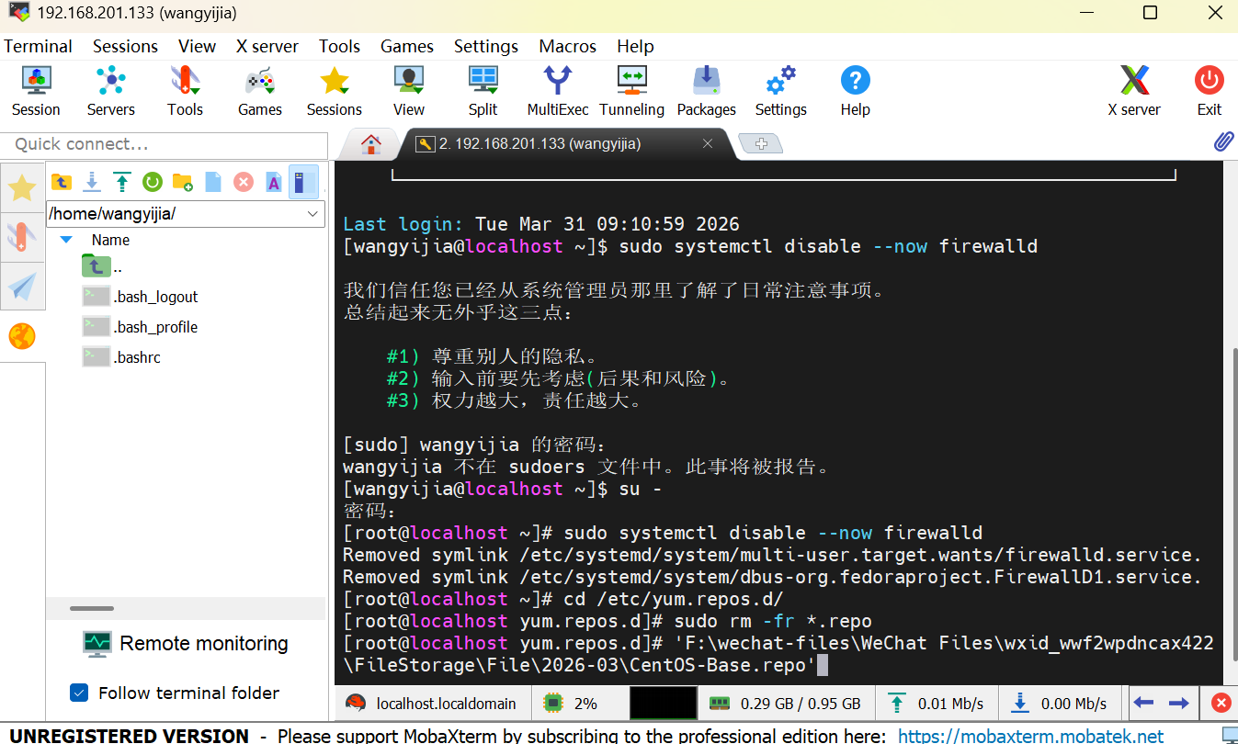
vi /etc/yum.repos.d/CentOS-Base.repo
粘贴内容并保存
按 i 键进入「插入模式」（左下角会显示 -- INSERT --）
在命令行区域右键点击，粘贴刚才复制的内容
按 Esc 键退出插入模式
输入 :wq 并按回车，保存文件并退出
[base]
name=CentOS-$releasever - Base - mirrors.aliyun.com
failovermethod=priority
baseurl=http://mirrors.aliyun.com/centos/$releasever/os/$basearch/
gpgcheck=1
gpgkey=http://mirrors.aliyun.com/centos/RPM-GPG-KEY-CentOS-7

[updates]
name=CentOS-$releasever - Updates - mirrors.aliyun.com
failovermethod=priority
baseurl=http://mirrors.aliyun.com/centos/$releasever/updates/$basearch/
gpgcheck=1
gpgkey=http://mirrors.aliyun.com/centos/RPM-GPG-KEY-CentOS-7

[extras]
name=CentOS-$releasever - Extras - mirrors.aliyun.com
failovermethod=priority
baseurl=http://mirrors.aliyun.com/centos/$releasever/extras/$basearch/
gpgcheck=1
gpgkey=http://mirrors.aliyun.com/centos/RPM-GPG-KEY-CentOS-7

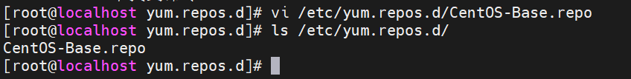
文件创建成功
yum clean all
yum makecache
yum repolist
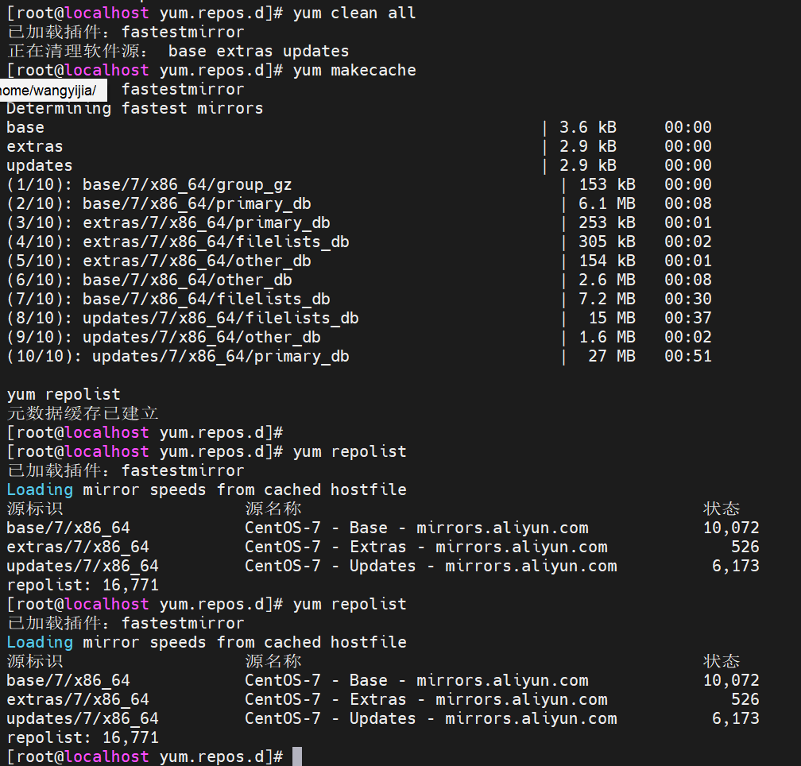
执行完 yum repolist 后，能看到仓库列表就代表配置完成，可以继续安装 Docker 了。
配置docker软件源
[root@server1 ~]# vi /etc/yum.repos.d/docker.repo
[docker]
name=docker-ce
baseurl=https://mirrors.tuna.tsinghua.edu.cn/docker-ce/linux/centos/7/x86_64/stable/
gpgcheck=0

安装docker-ce
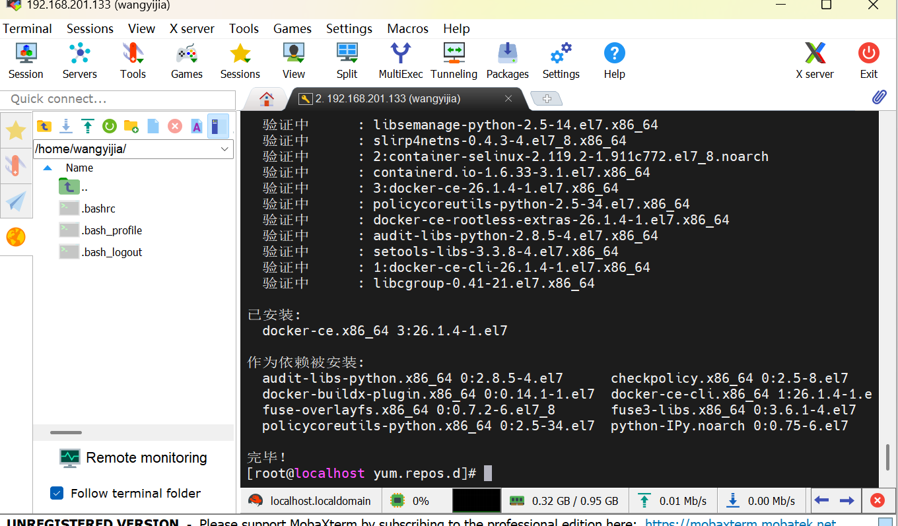
[root@server1 ~]# yum install -y docker-ce

启动服务
[root@server1 ~]# systemctl enable --now docker
[root@server1 ~]# docker info
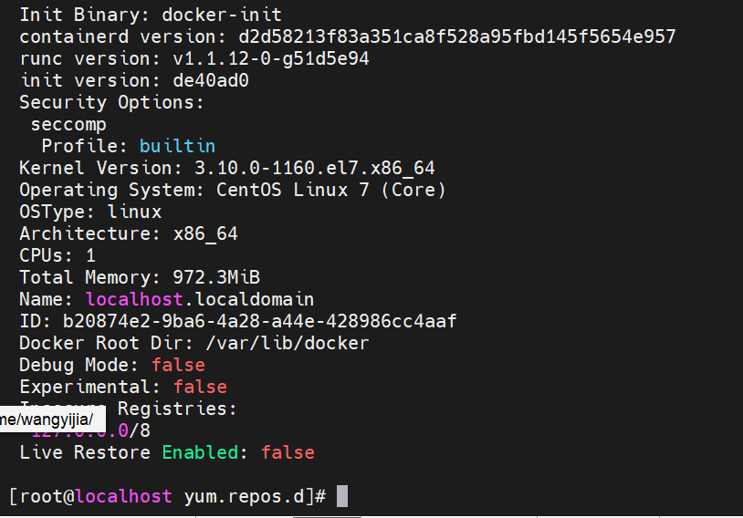

激活内核选项（可选）
[root@server1 ~]# vim /etc/sysctl.d/docker.conf
net.bridge.bridge-nf-call-iptables = 1
net.bridge.bridge-nf-call-ip6tables = 1
net.ipv4.ip_forward = 1

[root@server1 ~]# sysctl --system
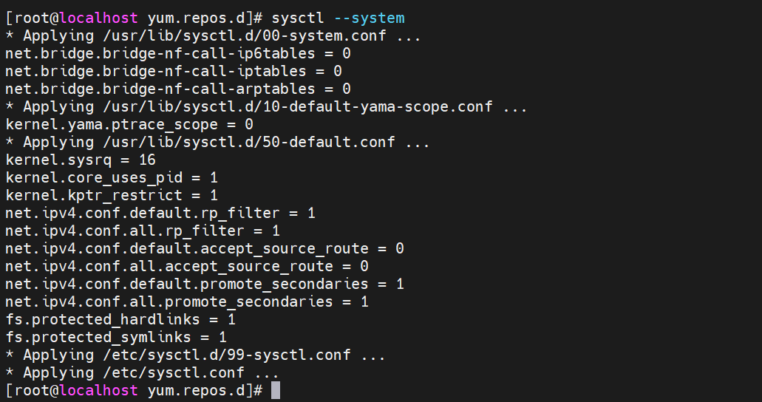

重启docker服务
[root@server1 ~]# systemctl restart docker
配置镜像加速器
echo '{"registry-mirrors":["https://docker.1ms.run"],"dns": ["8.8.8.8", "114.114.114.114"]}' | sudo tee /etc/docker/daemon.json > /dev/null

systemctl daemon-reload
systemctl restart docker
测试：
查询镜像：
docker search docker.1ms.run/nginx
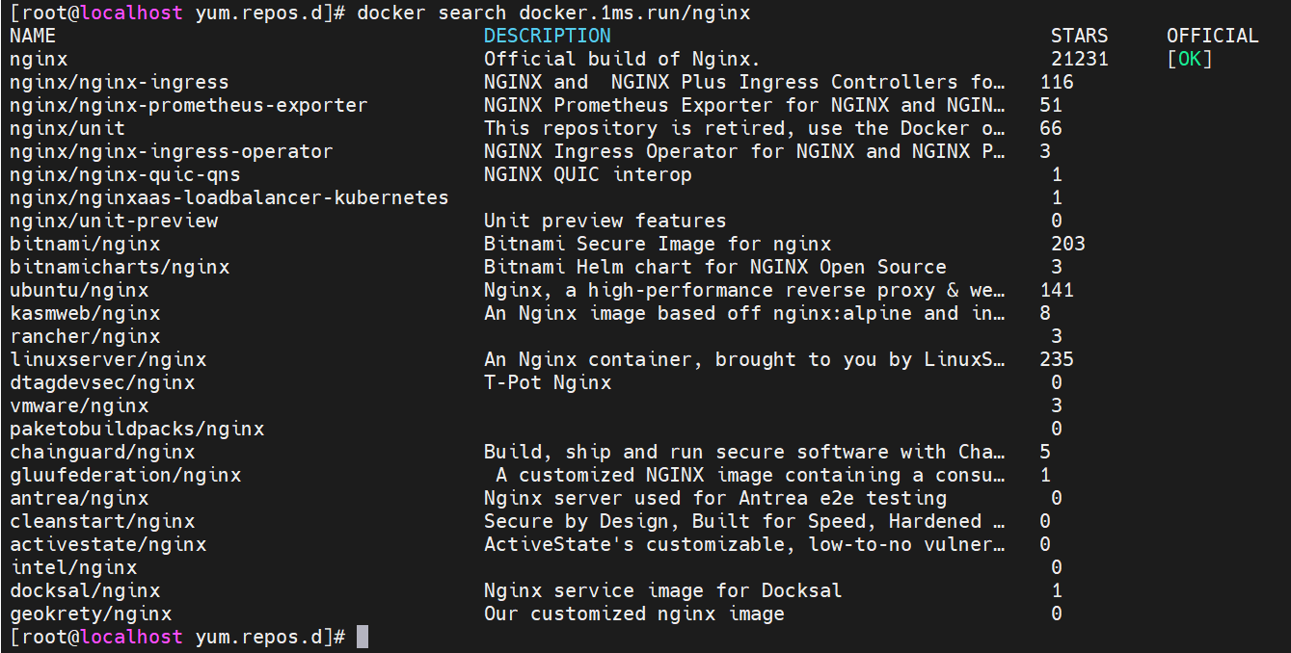
docker search docker.1ms.run/yakexi007
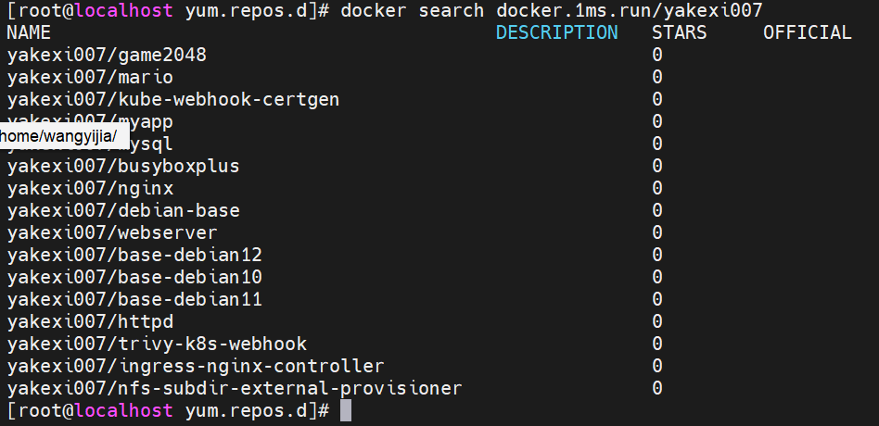

拉取镜像：
docker pull docker.1ms.run/busybox
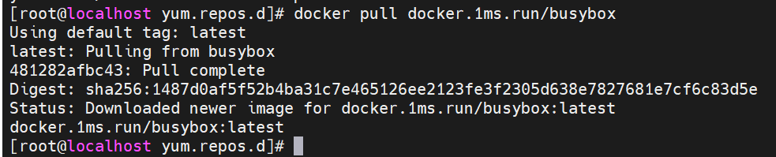
docker pull docker.1ms.run/yakexi007/game2048

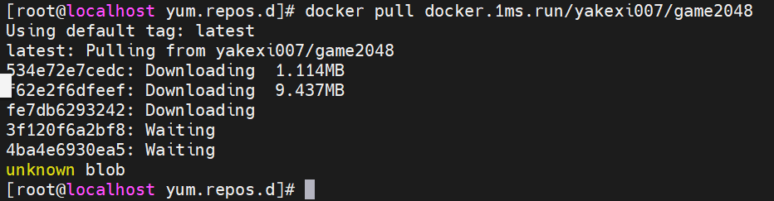
列出镜像：
docker images
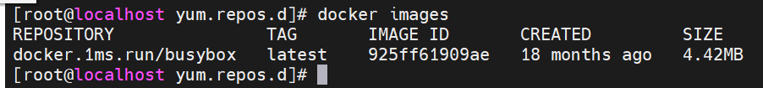
给镜像打标签（可选）
docker pull docker.1ms.run/busybox:latest busybox:latest
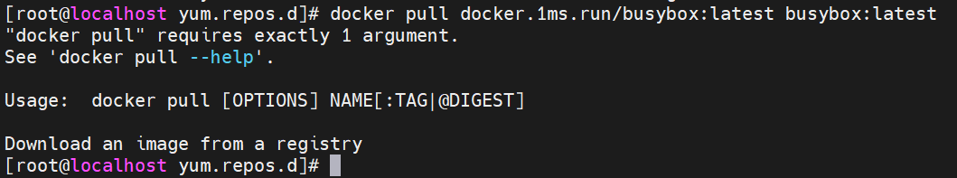
运行容器：
docker run -d --name game2048 -p 80:80 docker.1ms.run/yakexi007/game2048
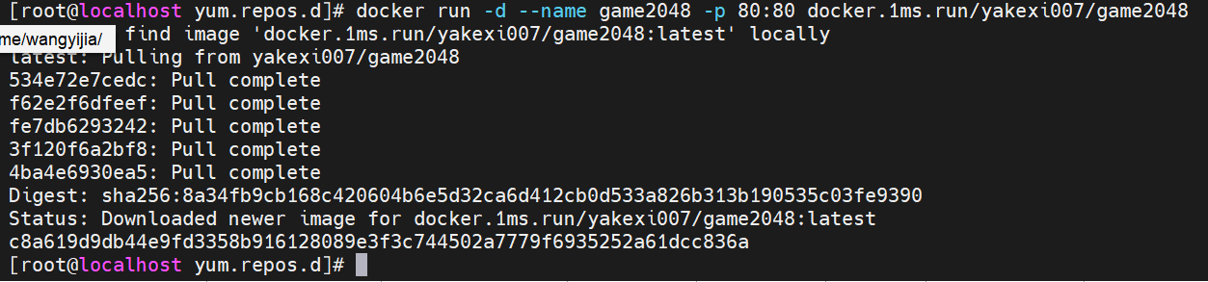
显示容器：
docker ps
ip a
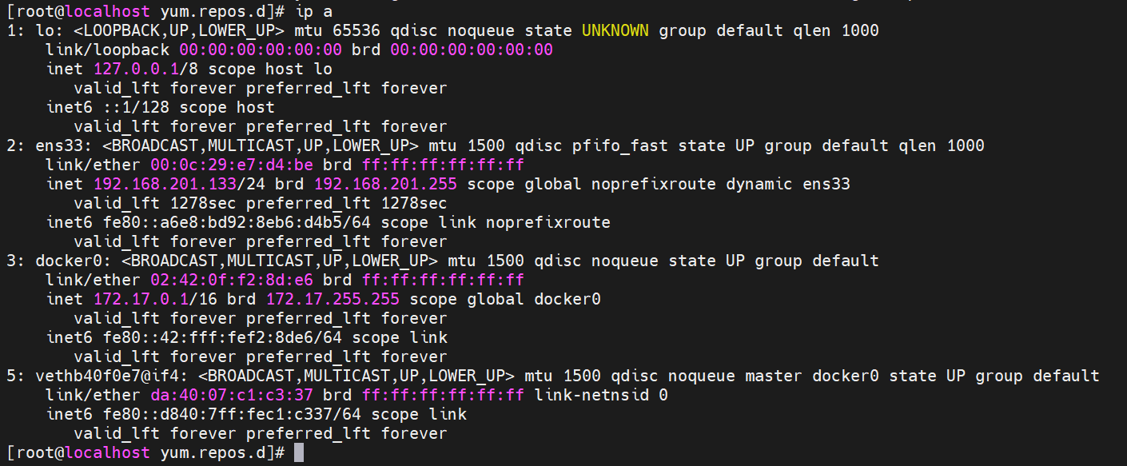
将game2048.tar拖拽入左侧结构树
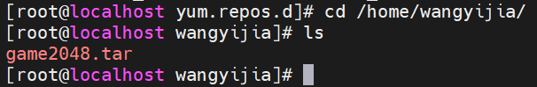
已存在，上传成功
加载docker镜像
sudo docker load -i game2048.tar
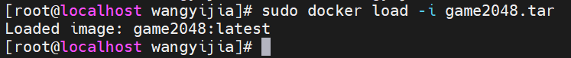
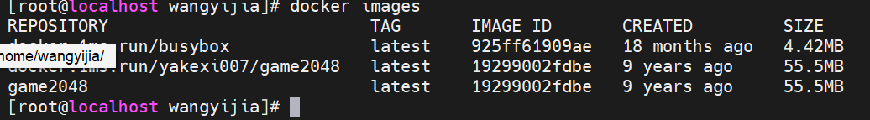
运行2048游戏容器
docker run -d --name game2048 -p 80:80 game2048
game2048 这个名字已经被用过了，不能重复用，必须先删掉旧的！
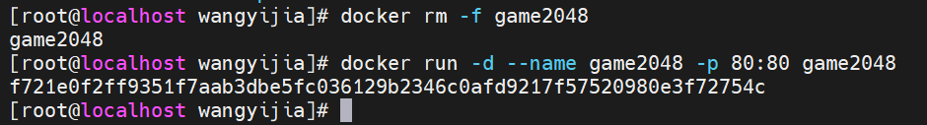
出现一长串字符串（容器 ID），就说明启动成功了！
Docker ps确认容器正在运行
浏览器地址栏输入：http://192.168.201.133:80
进入游戏界面
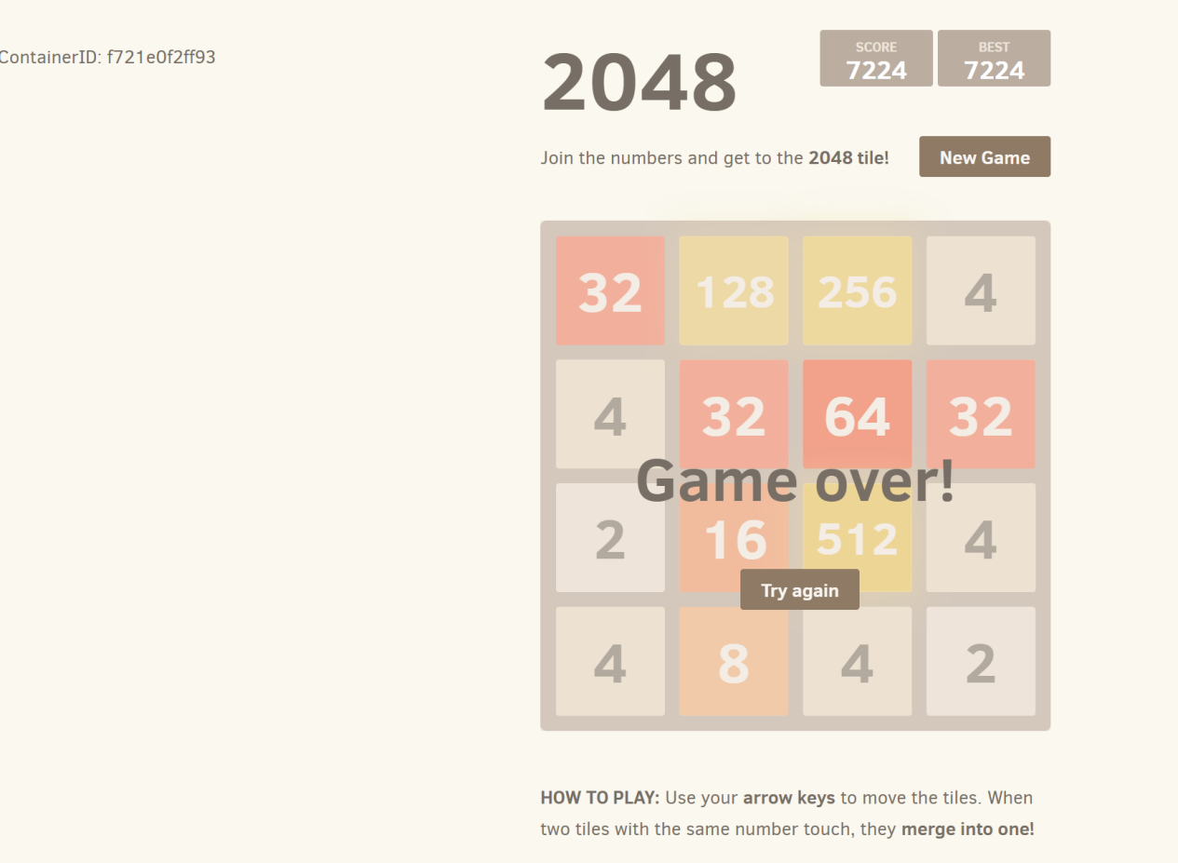

docker操作命令
命令补全（需要注销当前终端，重连后生效）
[root@server1 ~]# yum install -y bash-completion
拉取镜像
[root@server1 ~]# docker pull busybox
列出镜像
[root@server1 ~]# docker images
运行容器
[root@server1 ~]# docker run busybox echo "hello world"
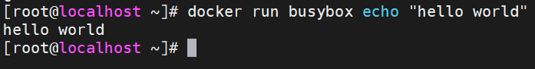
交互式运行容器
[root@server1 ~]# docker run -it --name helloworld busybox
/ # touch file1
/ # touch file2
/ # exit
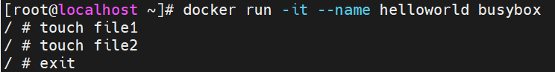
显示运行的容器
[root@server1 ~]# docker ps
显示所有容器
[root@server1 ~]# docker ps -a
启动容器
[root@server1 ~]# docker start helloworld
连接容器
[root@server1 ~]# docker attach helloworld
输入快捷键“ ctrl+pq” 分离容器，但容器继续运行。
显示运行的容器
[root@server1 ~]# docker ps
列出容器或镜像的详情
[root@server1 ~]# docker inspect helloworld
监控容器
[root@server1 ~]# docker stats helloworld
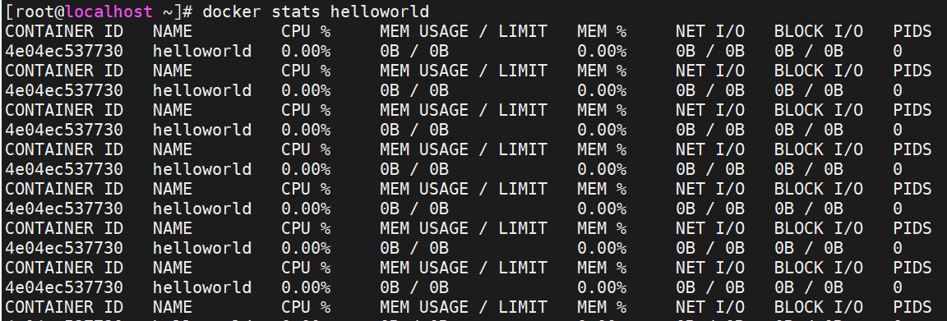
[root@server1 ~]# docker top helloworld

查看容器日志
[root@server1 ~]# docker logs helloworld
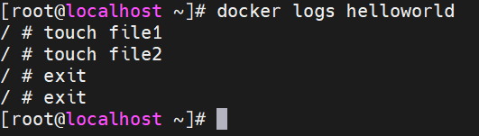
在后台运行容器
[root@server1 ~]# docker run --name logfollow -d busybox sh -c "while true; do date; sleep 5; done"

实时查看容器日志
[root@server1 ~]# docker logs -f logfollow

把日志记录到syslog
[root@server1 ~]# docker run --name syslog -d --log-driver="syslog" busybox sh -c "while true; do date; sleep 5; done"

[root@server1 ~]# tail -f /var/log/messages

停止容器
[root@server1 ~]# docker stop syslog
[root@server1 ~]# docker kill logfollow

强制删除容器
[root@server1 ~]# docker rm -f syslog logfollow

删除所有容器
[root@ecs ~]# docker rm -f $(docker ps -a -q)
删除镜像
[root@ecs ~]# docker rmi busybox

部署应用堆栈
需要有前端后台
.tar文件老师下发，或者自行拉取
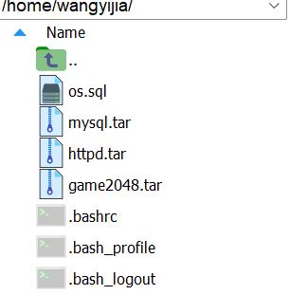
# 拉取 MySQL 镜像（这里用 8.0 版本，稳定常用）
docker pull mysql:8.0
# 拉取 Apache httpd 镜像
docker pull httpd:latest
导入本地镜像
docker load -i mysql.tar
docker load -i httpd.tar

显示镜像列表
docker images

创建数据库容器
docker run -d -p 3306:3306 -e MYSQL_ROOT_PASSWORD=redhat --name dbserver mysql

安装mysql客户端
yum install -y mysql

导入数据
mysql -h 127.0.0.1 -u root -predhat < os.sql

创建web容器
docker run -d -p 80:80 --link dbserver:db --name webserver httpd:webapp

访问测试（替换为自己主机IP）
http://116.63.37.128
http://116.63.37.128/cgi-bin/action

清除所有容器
docker rm -f $(docker ps -aq)
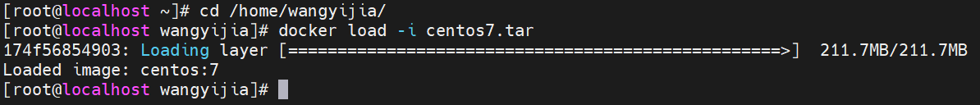

docker pull docker.1ms.run/busybox
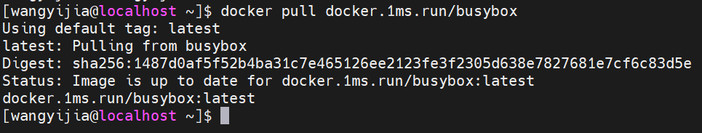

docker tag docker.1ms.run/busybox:latest busybox:latest
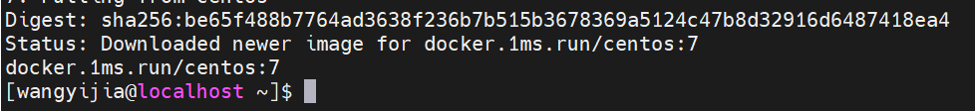
docker pull docker.1ms.run/nginx
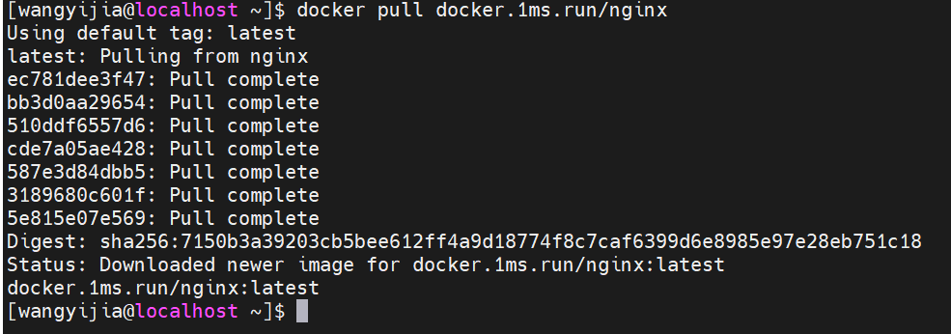

docker tag docker.1ms.run/nginx:latest nginx:latest
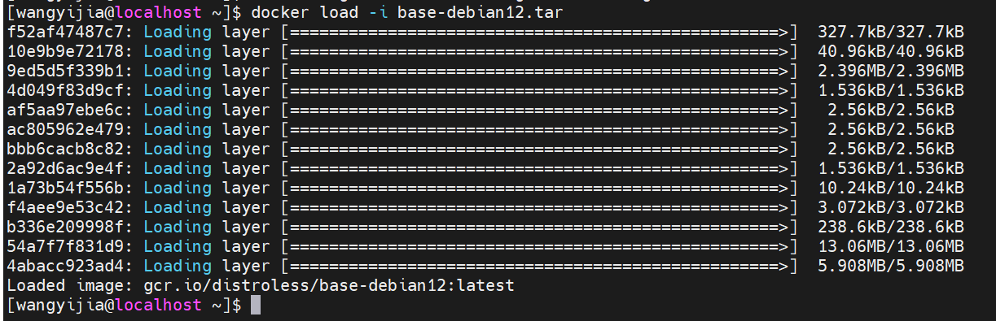
docker save -o webserver.tar webserver:v4
导入本地镜像
docker load -i mysql.tar
docker load -i httpd.tar

显示镜像列表
docker images

创建数据库容器
docker run -d -p 3306:3306 -e MYSQL_ROOT_PASSWORD=redhat --name dbserver mysql

安装mysql客户端
yum install -y mysql
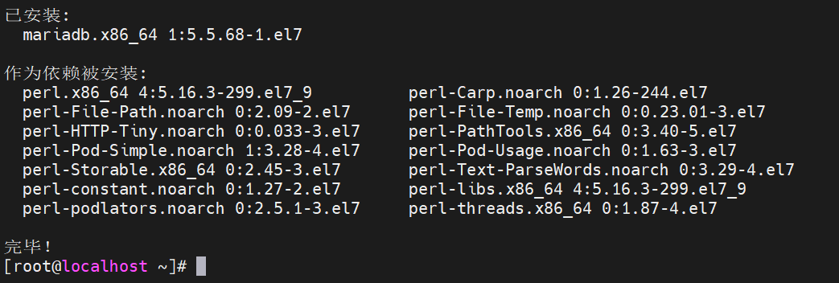

导入数据
mysql -h 127.0.0.1 -u root -predhat < os.sql

创建web容器
docker run -d -p 80:80 --link dbserver:db --name webserver httpd:webapp

访问测试（替换为自己主机IP）
http://116.63.37.128
http://116.63.37.128/cgi-bin/action
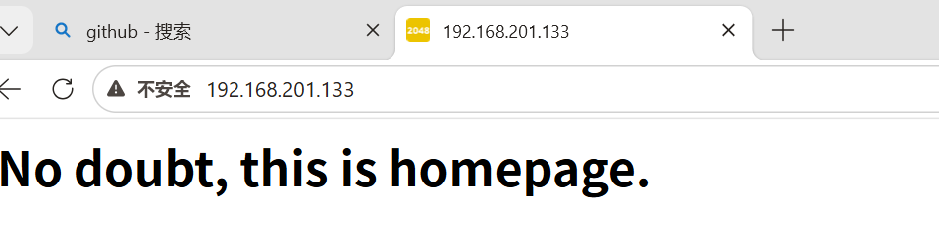
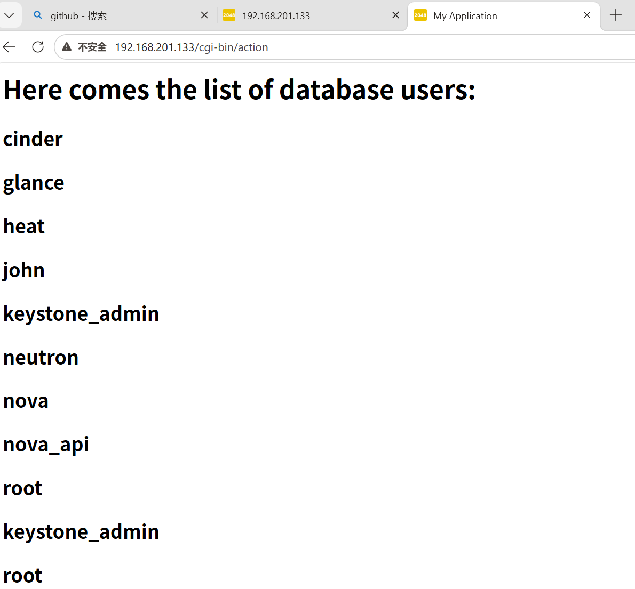

清除所有容器
docker rm -f $(docker ps -aq)

完整镜像创建：
[root@server1 ~]# mdkir docker
[root@server1 ~]# cd docker/
[root@server1 docker]# vim Dockerfile

FROM centos:7
RUN rm -f /etc/yum.repos.d/*
COPY CentOS-Base.repo /etc/yum.repos.d/
ADD nginx-1.28.0.tar.gz /mnt
WORKDIR /mnt/nginx-1.28.0
RUN yum install -y gcc make pcre-devel openssl-devel
RUN sed -i 's/CFLAGS="$CFLAGS -g"/#CFLAGS="$CFLAGS -g"/g' auto/cc/gcc
RUN ./configure --with-http_ssl_module --with-http_stub_status_module
RUN make
RUN make install
EXPOSE 80
VOLUME ["/usr/local/nginx/html"]
CMD ["/usr/local/nginx/sbin/nginx", "-g", "daemon off;"]

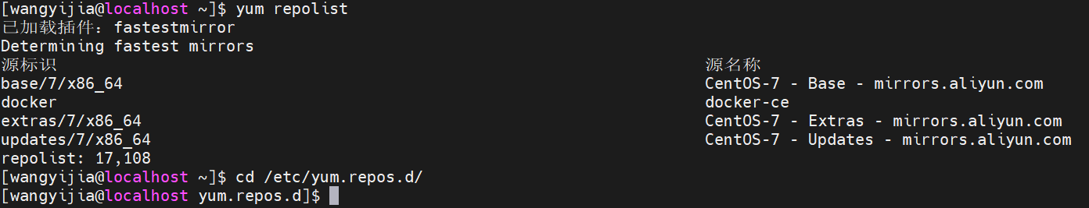

将两个文件复制到docker中来：
cp /etc/yum.repos.d/CentOS-Base.repo .
cp /home/wangyijia/nginx-1.28.0.tar.gz .
确保资源文件都在当前目录
[root@server1 docker]# ls
CentOS-Base.repo Dockerfile nginx-1.28.0.tar.gz

构建镜像：docker build -t webserver:v1 .不要忘了. 表示当前目录。
[wangyijia@localhost docker]$ docker images webserver
REPOSITORY TAG IMAGE ID CREATED SIZE
webserver v1 83314380bdcf 11 minutes ago 553MB

docker history webserver:v1

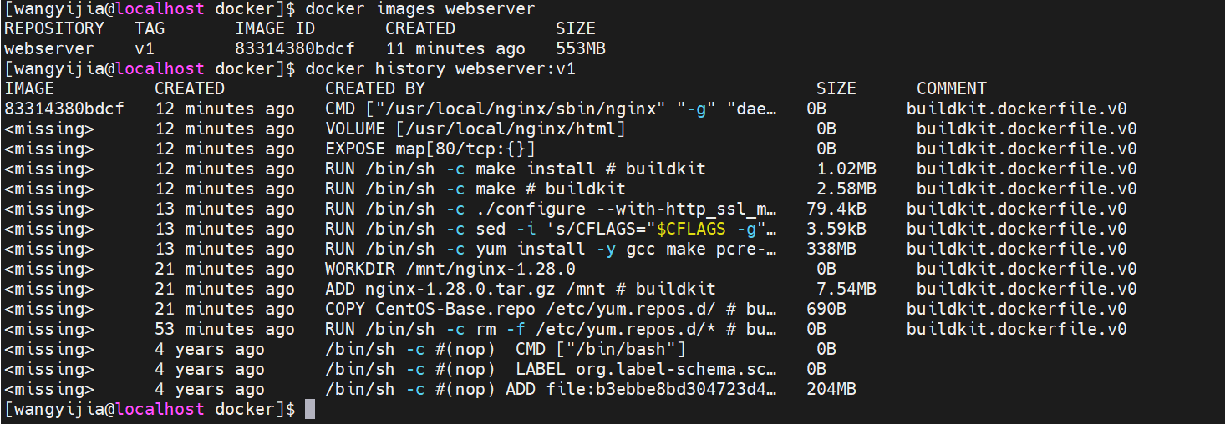
清理所有停止的容器
docker container prune
启动容器
docker run -d --name web1 webserver:v1
查看容器详情
docker inspect web1
数据卷挂载
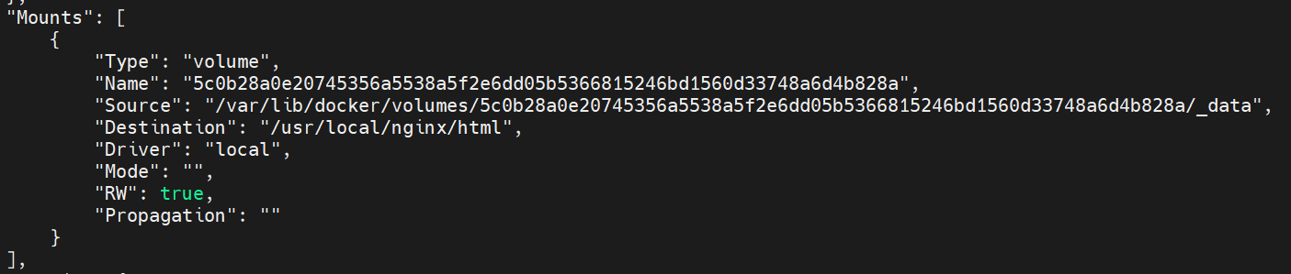
自动分配的ip
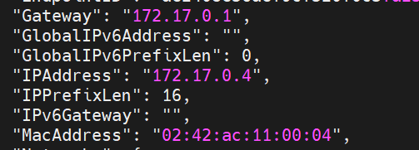
访问容器
curl 172.17.0.4
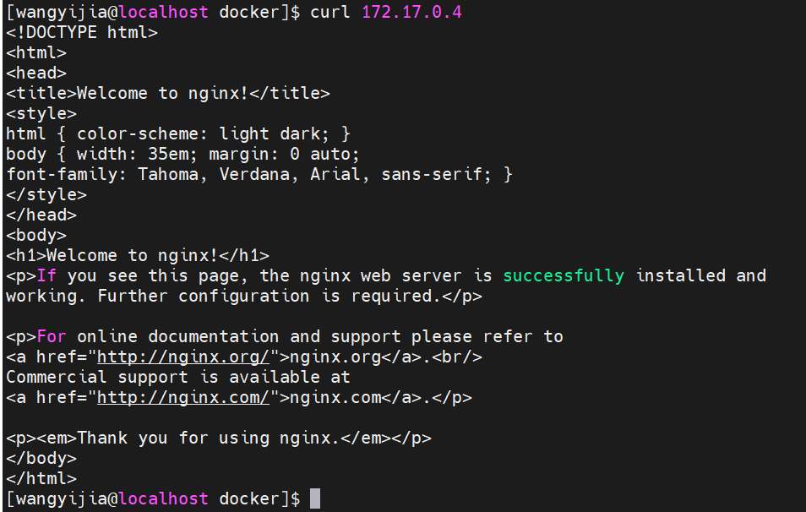
容器内部 IP 是 Docker 网桥分配的，仅用于容器间通信，外部网络无法路由。

镜像优化

缩减镜像层
[wangyijia@localhost docker]# vim Dockerfile
FROM centos:7
RUN rm -f /etc/yum.repos.d/*
COPY CentOS-Base.repo /etc/yum.repos.d/
ADD nginx-1.28.0.tar.gz /mnt
WORKDIR /mnt/nginx-1.28.0
RUN yum install -y gcc make pcre-devel openssl-devel && sed -i 's/CFLAGS="$CFLAGS -g"/#CFLAGS="$CFLAGS -g"/g' auto/cc/gcc && ./configure --with-http_ssl_module --with-http_stub_status_module && make && make install && cd .. && rm -fr nginx-1.28.0 && yum clean all
EXPOSE 80
VOLUME ["/usr/local/nginx/html"]
CMD ["/usr/local/nginx/sbin/nginx", "-g", "daemon off;"]

[wangyijia@localhost docker]# docker build -t webserver:v2 .

[wangyijia@localhost docker]$ docker images webserver
REPOSITORY TAG IMAGE ID CREATED SIZE
webserver v2 4417a038ebb1 16 minutes ago 318MB
webserver v1 83314380bdcf About an hour ago 553MB

多阶段构建
[wangyijia@localhost docker]# vim Dockerfile
FROM centos:7 as build
RUN rm -f /etc/yum.repos.d/*
COPY CentOS-Base.repo /etc/yum.repos.d/
ADD nginx-1.28.0.tar.gz /mnt
WORKDIR /mnt/nginx-1.28.0
RUN yum install -y gcc make pcre-devel openssl-devel && sed -i 's/CFLAGS="$CFLAGS -g"/#CFLAGS="$CFLAGS -g"/g' auto/cc/gcc && ./configure --with-http_ssl_module --with-http_stub_status_module && make && make install && cd .. && rm -fr nginx-1.28.0 && yum clean all

FROM centos:7
COPY --from=build /usr/local/nginx /usr/local/nginx
EXPOSE 80
VOLUME ["/usr/local/nginx/html"]
CMD ["/usr/local/nginx/sbin/nginx", "-g", "daemon off;"]

[wangyijia@localhost docker]# docker build -t webserver:v3 .

[wangyijia@localhost docker]# docker images webserver
REPOSITORY TAG IMAGE ID CREATED SIZE
webserver v3 1ac964f2cefe 29 seconds ago 205MB
webserver v2 caf0f80f2332 3 minutes ago 287MB
webserver v1 bfd6774cc216 About an hour ago 328MB

使用最精简的基础镜像
导入基础镜像
[wangyijia@localhost ~]$ docker load -i base-debian12.tar
Loaded image: gcr.io/distroless/base-debian12:latest

[wangyijia@localhost ~]$ mkdir new
[wangyijia@localhost ~]$ cd new
[wangyijia@localhost new]$ vim Dockerfile

FROM nginx:latest as base

RUN mkdir -p /opt/var/cache/nginx && \
cp -a --parents /usr/lib/nginx /opt && \
cp -a --parents /usr/share/nginx /opt && \
cp -a --parents /var/log/nginx /opt && \
cp -aL --parents /var/run /opt && \
cp -a --parents /etc/nginx /opt && \
cp -a --parents /etc/passwd /opt && \
cp -a --parents /etc/group /opt && \
cp -a --parents /usr/sbin/nginx /opt && \
cp -a --parents /usr/sbin/nginx-debug /opt && \
cp -a --parents /lib/x86_64-linux-gnu/ld-* /opt && \
cp -a --parents /usr/lib/x86_64-linux-gnu/libpcre* /opt && \
cp -a --parents /lib/x86_64-linux-gnu/libz.so.* /opt && \
cp -a --parents /lib/x86_64-linux-gnu/libc* /opt && \
cp -a --parents /lib/x86_64-linux-gnu/libdl* /opt && \
cp -a --parents /lib/x86_64-linux-gnu/libpthread* /opt && \
cp -a --parents /lib/x86_64-linux-gnu/libcrypt* /opt && \
cp -a --parents /lib/x86_64-linux-gnu/libzstd* /opt && \
cp -a --parents /usr/lib/x86_64-linux-gnu/libssl.so.* /opt && \
cp -a --parents /usr/lib/x86_64-linux-gnu/libcrypto.so.* /opt

FROM base-debian12:latest

COPY --from=base /opt /

EXPOSE 80 443

ENTRYPOINT ["nginx", "-g", "daemon off;"]

[wangyijia@localhost new]$ docker build -t webserver:v4 .
会报错，替换第二个FROM:FROM gcr.io/distroless/base-debian12:latest
我没做v3的实验
[wangyijia@localhost new]$ docker images webserver
REPOSITORY TAG IMAGE ID CREATED SIZE
webserver v4 d9b2a8d70786 2 minutes ago 61.6MB
webserver v2 4417a038ebb1 44 minutes ago 318MB
webserver v1 83314380bdcf 2 hours ago 553MB

[root@server1 new]# docker run -d --name web1 webserver:v4
[root@server1 new]# curl 172.17.0.2

Docker仓库

docker hub
注册账号新建仓库：

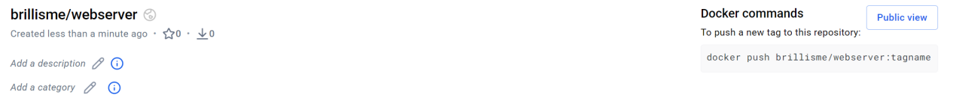
客户端登录docker hub
[wangyijia@localhost ~]$ docker login
Log in with your Docker ID or email address to push and pull images from Docker Hub. If you don't have a Docker ID, head over to https://hub.docker.com/ to create one.
You can log in with your password or a Personal Access Token (PAT). Using a limited-scope PAT grants better security and is required for organizations using SSO. Learn more at https://docs.docker.com/go/access-tokens/

Username: brillisme
Password:
Error response from daemon: Get "https://registry-1.docker.io/v2/": context deadline exceeded (Client.Timeout exceeded while awaiting headers)
[wangyijia@localhost ~]$
网络不通，登录超时。
sudo systemctl stop firewalld
还是不行，docker hub就不操作了。
修改docker代理配置
sudo vi /etc/systemd/system/docker.service.d/http-proxy.conf

[Service]
Environment="HTTP_PROXY=http://192.168.0.103:7897"
Environment="HTTPS_PROXY=http://192.168.0.103:7897"
Environment="NO_PROXY=localhost,127.0.0.1,::1"
重载配置、重启 Docker
sudo systemctl daemon-reload
sudo systemctl restart docker
登录成功！
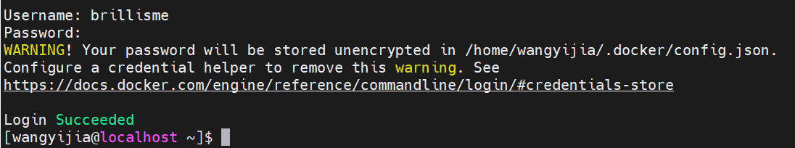
上传镜像
[wangyijia@localhost ~]$ docker tag webserver:v4 brillisme/webserver:v4
[wangyijia@localhost ~]$ docker push brillisme/webserver:v4
The push refers to repository [docker.io/brillisme/webserver]
30b226741ae4: Pushed
4abacc923ad4: Pushed
54a7f7f831d9: Pushed
b336e209998f: Pushed
f4aee9e53c42: Pushed
1a73b54f556b: Pushed
2a92d6ac9e4f: Pushed
bbb6cacb8c82: Pushed
ac805962e479: Pushed
af5aa97ebe6c: Pushed
4d049f83d9cf: Pushed
9ed5d5f339b1: Pushed
10e9b9e72178: Pushed
f52af47487c7: Pushed
v4: digest: sha256:ee4d917da09bc5cf82d0087f427e41aad61b82078afd518294f5b001a6002415 size: 3236
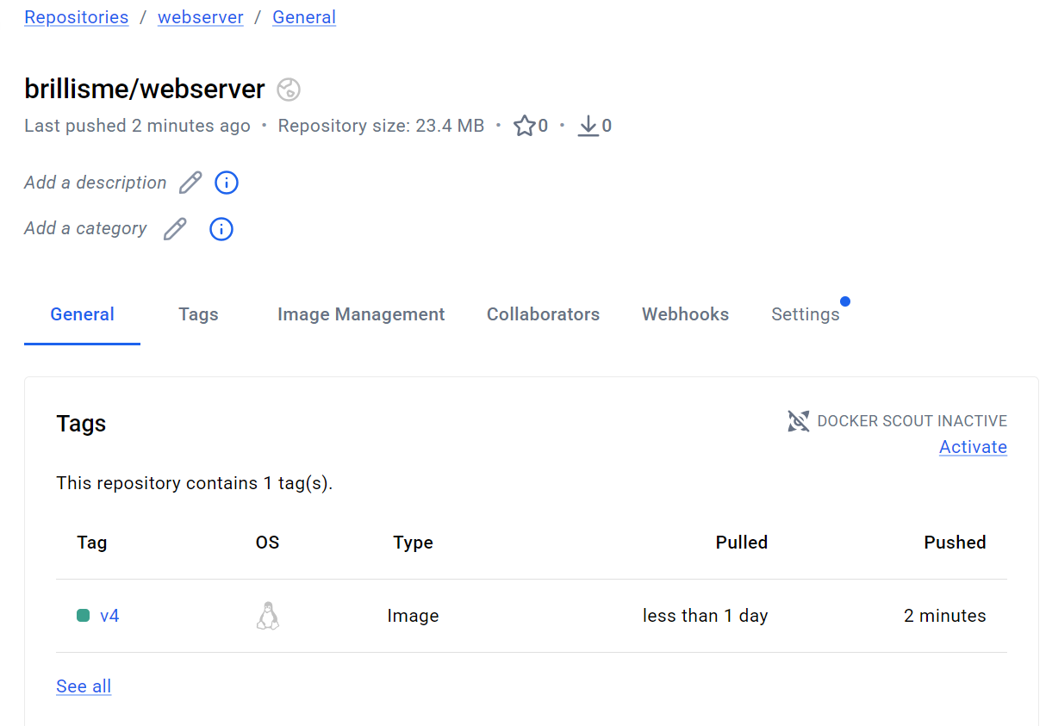
上传成功！

registry私有仓库
官网： https://docs.docker.com/registry/deploying/
拉取registry镜像
docker pull registry

运行registry仓库
docker run -d --name registry -p 5000:5000 -v /opt/registry:/var/lib/registry registry

列出容器
docker ps -l
配置仓库自启动
vim /etc/systemd/system/registry.service

[Unit]
Description=Registry
Requires=docker.service
After=docker.service

[Service]
Type=simple
Restart=always
ExecStart=/usr/bin/docker start -a registry
ExecStop=/usr/bin/docker stop registry

[Install]
WantedBy=multi-user.target
刷新配置
systemctl daemon-reload

停止容器
docker stop registry

设置开机自启
systemctl enable --now registry
docker ps -l

上传镜像
docker tag busybox:latest localhost:5000/busybox:latest
docker push localhost:5000/busybox

查询镜像
[root@localhost docker]# curl http://localhost:5000/v2/busybox/tags/list
{"name":"busybox","tags":["latest"]}
下载镜像
[root@localhost docker]# docker pull localhost:5000/busybox
Using default tag: latest
latest: Pulling from busybox
Digest: sha256:11f85134f388cff5f4c66f9bb4c5942249c1f6f7eb8b3889948d953487b5f7a8
Status: Image is up to date for localhost:5000/busybox:latest
localhost:5000/busybox:lates

insecure registry
配置使用非加密端口(替换为实际仓库IP)

[root@localhost docker]# vim /etc/docker/daemon.json
{
"insecure-registries" : ["http://192.168.201.133:5000"]
}

[root@localhost docker]# systemctl restart docker
[root@localhost docker]# docker pull 192.168.201.133:5000/nginx
拉取镜像
[root@server2 docker]# docker pull 192.168.201.133:5000/nginx
使用这个一直出错，就用回环地址：
[root@localhost docker]# cat > /etc/docker/daemon.json <<EOF
> {
> "insecure-registries": ["127.0.0.1:5000"]
> }
> EOF
[root@localhost docker]# systemctl restart docker
[root@localhost docker]# docker tag nginx 127.0.0.1:5000/nginx
[root@localhost docker]# docker push 127.0.0.1:5000/nginx
[root@localhost docker]# docker pull 127.0.0.1:5000/nginx
Using default tag: latest
latest: Pulling from nginx
Digest: sha256:d5590adee87e29c44bc13bfae4492585c861b9893e60b48c86728bf179f5d096
Status: Image is up to date for 127.0.0.1:5000/nginx:latest
127.0.0.1:5000/nginx:latest

仓库加密

wget https://mirrors.aliyun.com/epel/7/x86_64/Packages/o/openssl11-1.1.1k-7.el7.x86_64.rpm
wget https://mirrors.aliyun.com/epel/7/x86_64/Packages/o/openssl11-libs-1.1.1k-7.el7.x86_64.rpm

# 第二步：安装
sudo yum install -y openssl11-1.1.1k-7.el7.x86_64.rpm openssl11-libs-1.1.1k-7.el7.x86_64.rpm
添加域名解析
[root@localhost ~]# echo "192.168.201.133 localhost reg.westos.org" | sudo tee -a /etc/hosts
192.168.201.133 server1.reg.westos.org
[root@localhost ~]# cat /etc/hosts
127.0.0.1 localhost localhost.localdomain localhost4 localhost4.localdomain4
::1 localhost localhost.localdomain localhost6 localhost6.localdomain6
192.168.201.133 localhost reg.westos.org

用 OpenSSL 生成 HTTPS 自签名证书 + 私钥，用于给 Docker 私有仓库做加密认证，让仓库支持 HTTPS 访问:
[root@server1 ~]# mkdir certs
[root@server1 ~]# openssl11 req -newkey rsa:4096 -nodes -sha256 -keyout certs/westos.org.key -addext "subjectAltName = DNS:reg.westos.org" -x509 -days 365 -out certs/westos.org.crt

域名保持一致
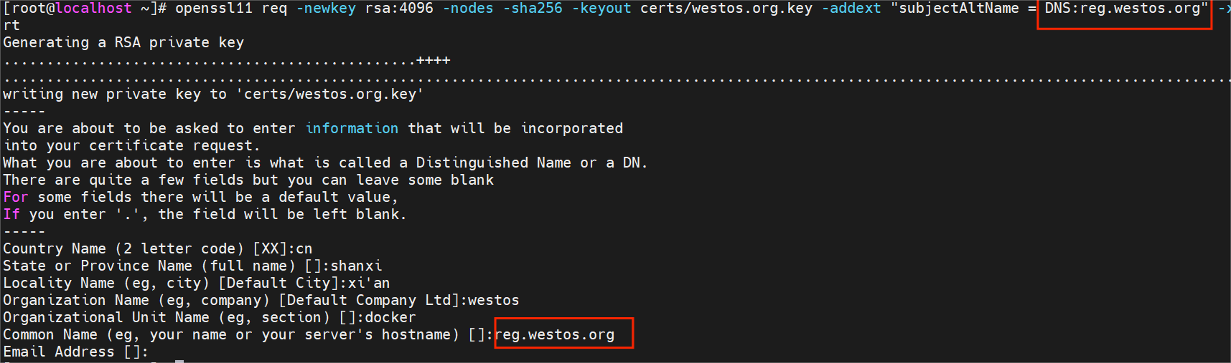
[root@localhost ~]# docker run -d -p 443:443 --restart=always --name registry -v /opt/registry:/var/lib/registry -v /root/certs:/certs -e REGISTRY_HTTP_ADDR=0.0.0.0:443 -e REGISTRY_HTTP_TLS_CERTIFICATE=/certs/westos.org.crt -e REGISTRY_HTTP_TLS_KEY=/certs/westos.org.key registry
部署客户端证书，不然会报错
[root@localhost ~]# docker tag nginx:latest reg.westos.org/nginx:latest

[root@localhost ~]# docker push reg.westos.org/nginx:latest
The push refers to repository [reg.westos.org/nginx]
Get "https://reg.westos.org/v2/": EOF

信任配置：
[root@localhost ~]# mkdir -p /etc/docker/certs.d/reg.westos.org/
[root@localhost ~]# cp /root/certs/westos.org.crt /etc/docker/certs.d/reg.westos.org/ca.crt
[root@localhost ~]# cp /root/certs/westos.org.crt /etc/pki/ca-trust/source/anchors/
[root@localhost ~]# update-ca-trust
[root@localhost ~]# systemctl restart docker

验证

[root@server1 ~]# docker push reg.westos.org/nginx:latest
再加一行域名解析：
echo "192.168.201.133 reg.westos.org" | sudo tee -a /etc/hosts
[root@server1 reg.westos.org]# curl -k https://reg.westos.org/v2/_catalog
{"repositories":["nginx"]}
以上还是EOF不行，把域名指向本机：
echo "127.0.0.1 reg.westos.org" >> /etc/hosts
systemctl restart network
systemctl restart docker
docker push reg.westos.org/nginx:latest

仓库认证
[root@localhost ~]# mkdir auth
[root@localhost ~]# htpasswd -Bc auth/htpasswd admin
New password:
Re-type new password:
Adding password for user admin

第二次添加不要加“-c”选项，不然会覆盖
[root@localhost ~]# htpasswd -B auth/htpasswd wxh
New password:
Re-type new password:
Adding password for user wxh

[root@localhost ~]# cat auth/htpasswd
admin:$2y$05$t4cfaZI7q7QqQdJNJuG.zewaua4ZsSXL4FZ26G0PwuprTB2D6vcHK
wxh:$2y$05$wMZPAV0qiHYkXFOT050tCuefyj.d5A/lfVYZ/qdyWtH/lMiYdU3vW

删除registry，重建
[root@server1 ~]# docker rm -f registry
[root@server1 ~]# docker run -d -p 443:443 --restart=always --name registry -v /opt/registry:/var/lib/registry -v /root/certs:/certs -e REGISTRY_HTTP_ADDR=0.0.0.0:443 -e REGISTRY_HTTP_TLS_CERTIFICATE=/certs/westos.org.crt -e REGISTRY_HTTP_TLS_KEY=/certs/westos.org.key -v /root/auth:/auth -e "REGISTRY_AUTH=htpasswd" -e "REGISTRY_AUTH_HTPASSWD_REALM=Registry Realm" -e REGISTRY_AUTH_HTPASSWD_PATH=/auth/htpasswd registry

登录仓库，不然无法上传下载
[root@server1 ~]# docker login reg.westos.org
Username: admin
Password:
WARNING! Your password will be stored unencrypted in /root/.docker/config.json.
Configure a credential helper to remove this warning. See
https://docs.docker.com/engine/reference/commandline/login/#credentials-store

Login Succeeded
[root@server1 ~]# cat .docker/config.json
{
"auths": {
"reg.westos.org": {
"auth": "YWRtaW46d2VzdG9z"
}
}
}

验证
[root@server1 ~]# docker tag busybox:latest reg.westos.org/busybox:latest
[root@server1 ~]# docker push reg.westos.org/busybox:latest

[root@server1 ~]# curl -k https://reg.westos.org/v2/_catalog -u admin:westos
{"repositories":["busybox","nginx"]}

登出
[root@server1 ~]# docker logout reg.westos.org

server2上移除非安全仓库设置
[root@server2 docker]# mv daemon.json /mnt/
[root@server2 docker]# systemctl restart docker

添加解析
[root@server2 ~]# vim /etc/hosts
...
192.168.56.11 server1 reg.westos.org

拷贝证书
[root@server1 ~]# cd /etc/docker/
[root@server1 ~]# scp -r certs.d/ server2:/etc/docker/

登录远程仓库
[root@server2 docker]# docker login reg.westos.org
Username: wxh
Password:
WARNING! Your password will be stored unencrypted in /root/.docker/config.json.
Configure a credential helper to remove this warning. See
https://docs.docker.com/engine/reference/commandline/login/#credentials-store

Login Succeeded

拉取镜像
[root@server2 docker]# docker pull reg.westos.org/busybox
Using default tag: latest
latest: Pulling from busybox
205dae5015e7: Pull complete
Digest: sha256:907ca53d7e2947e849b839b1cd258c98fd3916c60f2e6e70c30edbf741ab6754
Status: Downloaded newer image for reg.westos.org/busybox:latest
reg.westos.org/busybox:latest

harbor企业级私有仓库

安装harbor
删除之前部署的registry，不然会冲突
[root@server1 ~]# docker rm -f registry

部署证书
[root@server1 ~ ]# mkdir /data
[root@server1 ~ ]# cp -r certs /data

[root@localhost wangyijia]# tar zxf harbor-offline-installer-v2.14.0.tgz
[root@localhost wangyijia]# cd harbor/
[root@localhost harbor]# cp harbor.yml.tmpl harbor.yml

[root@localhost harbor]# vim harbor.yml
hostname: reg.westos.org

http:
# port for http, default is 80. If https enabled, this port will redirect to https port
port: 80

https:
# https port for harbor, default is 443
port: 443
# The path of cert and key files for nginx
certificate: /data/certs/westos.org.crt
private_key: /data/certs/westos.org.key

...
harbor_admin_password: westos

部署harbor
[root@server1 harbor]# ./install.sh --with-trivy
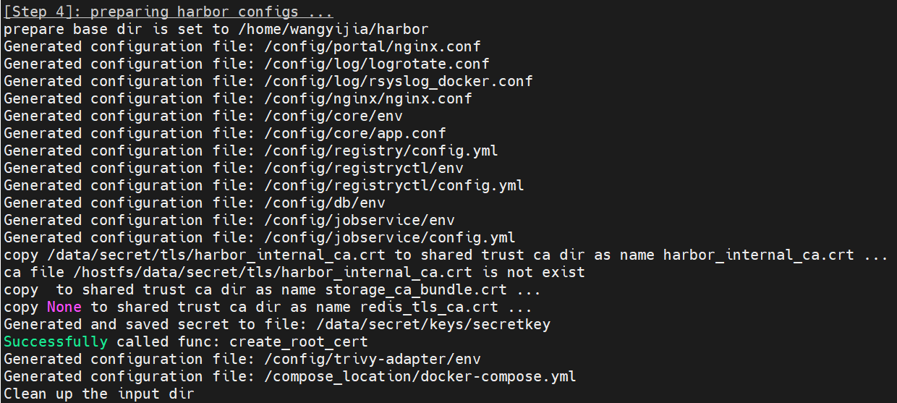
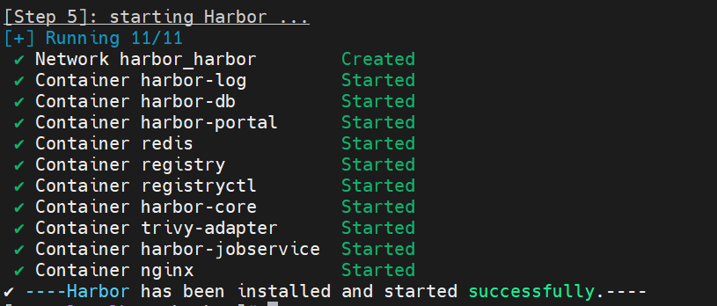
查看镜像
docker compose images
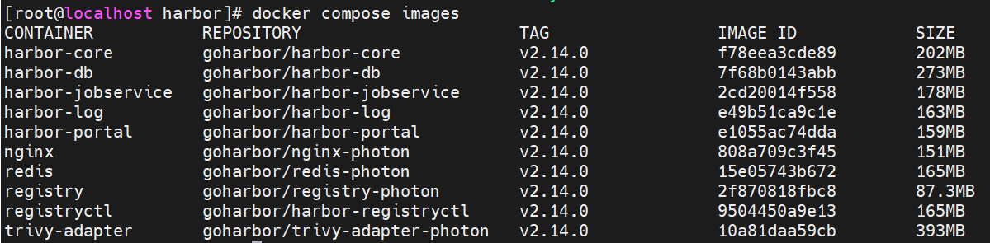
查看启动的容器
docker compose ps
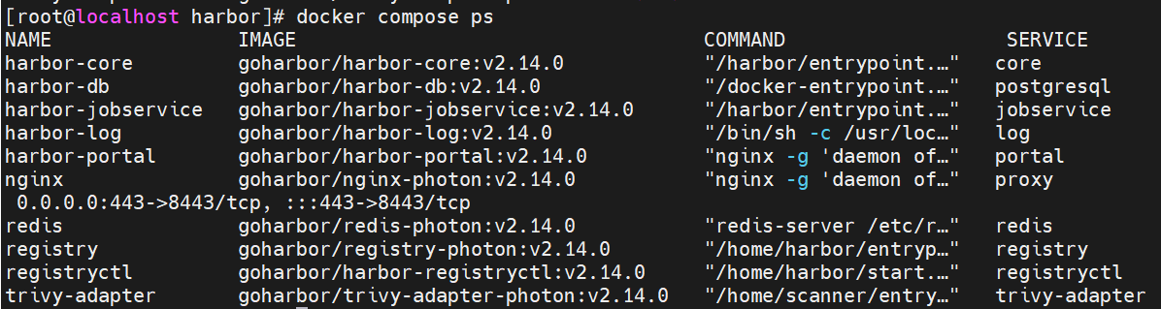
查看服务日志
docker compose logs

harbor使用
登录仓库
[root@localhost ~]# docker login reg.westos.org
失败，关掉https,改用http.
Username: admin
Password:
WARNING! Your password will be stored unencrypted in /root/.docker/config.json.
Configure a credential helper to remove this warning. See
https://docs.docker.com/engine/reference/commandline/login/#credentials-store

Login Succeeded

给镜像打标签
[root@server1 ~]# docker tag busybox:latest reg.westos.org/library/busybox:latest
[root@server1 ~]# docker tag nginx:latest reg.westos.org/library/nginx:latest

上传镜像
[root@server1 ~]# docker push reg.westos.org/library/nginx:latest
[root@server1 ~]# docker push reg.westos.org/library/busybox:latest

Docker安全

cpu资源限制
创建一个交互式容器，并限制其 CPU 使用量不超过 20%
[wangyijia@localhost ~]$ docker run -it --rm --cpu-period 100000 --cpu-quota 20000 busybox sh -c "while true; do :; done"

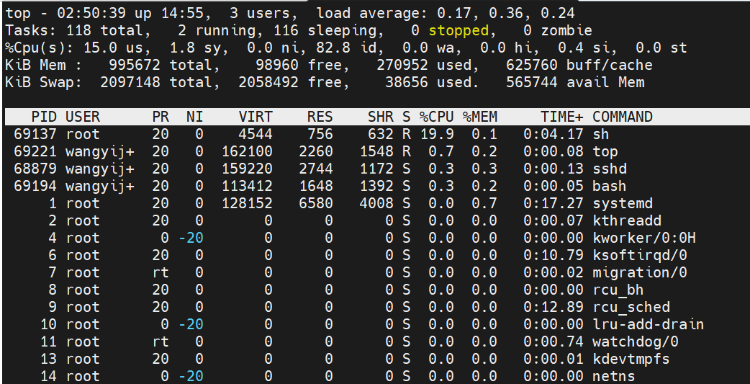
PID 69137 的 sh 进程（我启动的 busybox 死循环容器），%CPU 稳定在 19.9%，完美符合 --cpu-period 100000 --cpu-quota 20000 设定的 20% 上限。
总 CPU 空闲率 %Cpu(s): 82.8 id，说明系统资源充足，限制生效且无异常。

cpu优先级
[wangyijia@localhost proc]$ docker run -it --rm busybox
/ # dd if=/dev/zero of=/dev/null &
再开一个终端执行：

[wangyijia@reg ~]$ docker run -it --rm --cpu-shares 100 busybox
/ # dd if=/dev/zero of=/dev/null &
在宿主机top:
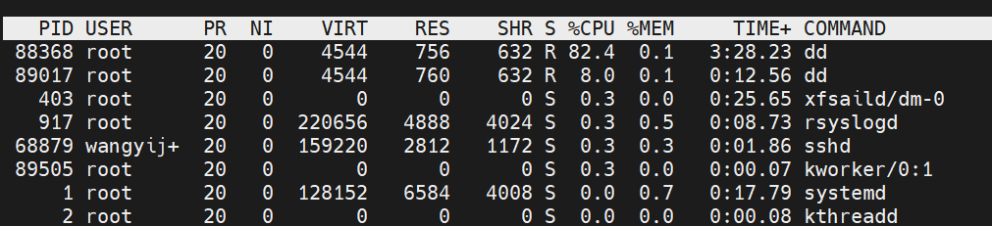
资源抢占生效。

内存资源限制
创建容器并严格限制其内存使用总量不超过 200MB
# docker run -d --name demo --memory 200M --memory-swap=200M nginx
查看容器内存限制配置

[wangyijia@localhost ~]$ docker run -d --name demo --memory 200M --memory-swap=200M nginx
e994fb7bcc8ce9b92cad367a38103a608f5565f7ec897d1644bf44c64fb5f188
[wangyijia@localhost ~]$ docker inspect -f '{{.HostConfig.Memory}} {{.HostConfig.MemorySwap}}' demo
209715200 209715200

lxcfs隔离
下载lxcf文件：
[wangyijia@localhost ~]$ yum install -y lxcfs-2.0.5-3.el7.centos.x86_64.rpm
[root@server1 ~]# yum install -y lxcfs
[root@server1 ~]# systemctl start lxcfs
[root@server1 ~]# docker run -it -m 256m \
-v /var/lib/lxcfs/proc/cpuinfo:/proc/cpuinfo:rw \
-v /var/lib/lxcfs/proc/diskstats:/proc/diskstats:rw \
-v /var/lib/lxcfs/proc/meminfo:/proc/meminfo:rw \
-v /var/lib/lxcfs/proc/stat:/proc/stat:rw \
-v /var/lib/lxcfs/proc/swaps:/proc/swaps:rw \
-v /var/lib/lxcfs/proc/uptime:/proc/uptime:rw \
Busybox

容器特权
默认容器内的用户是受限的
[root@server1 ~]# docker run -it --rm busybox
/ # ip a
1: lo: <LOOPBACK,UP,LOWER_UP> mtu 65536 qdisc noqueue qlen 1000
link/loopback 00:00:00:00:00:00 brd 00:00:00:00:00:00
inet 127.0.0.1/8 scope host lo
valid_lft forever preferred_lft forever
14: eth0@if15: <BROADCAST,MULTICAST,UP,LOWER_UP,M-DOWN> mtu 1500 qdisc noqueue
link/ether 02:42:ac:11:00:02 brd ff:ff:ff:ff:ff:ff
inet 172.17.0.2/16 brd 172.17.255.255 scope global eth0
valid_lft forever preferred_lft forever
/ # id
uid=0(root) gid=0(root) groups=0(root),10(wheel)
/ # ip link set down eth0
ip: SIOCSIFFLAGS: Operation not permitted
/ # fdisk -l

开启容器特权

[wangyijia@localhost proc]$ docker run -it --rm --privileged busybox
/ # fdisk -l
Disk /dev/sda: 20 GB, 21474836480 bytes, 41943040 sectors
2610 cylinders, 255 heads, 63 sectors/track
Units: sectors of 1 * 512 = 512 bytes

Device Boot StartCHS EndCHS StartLBA EndLBA Sectors Size Id Type
/dev/sda1 * 0,32,33 130,170,40 2048 2099199 2097152 1024M 83 Linux
/dev/sda2 130,170,41 1023,254,63 2099200 41943039 39843840 18.9G 8e Linux LVM
Disk /dev/dm-0: 17 GB, 18249416704 bytes, 35643392 sectors
2218 cylinders, 255 heads, 63 sectors/track
Units: sectors of 1 * 512 = 512 bytes

Disk /dev/dm-0 doesn't contain a valid partition table
Disk /dev/dm-1: 2048 MB, 2147483648 bytes, 4194304 sectors
261 cylinders, 255 heads, 63 sectors/track
Units: sectors of 1 * 512 = 512 bytes

Disk /dev/dm-1 doesn't contain a valid partition table
/ # ip link set down eth0
/ # ip link set up eth0

设置容器白名单

[wangyijia@localhost proc]$ docker run -it --rm --cap-add=NET_ADMIN busybox
/ # fdisk -l
/ # ip a a 10.0.0.1/24 dev eth0
/ # ip a
1: lo: <LOOPBACK,UP,LOWER_UP> mtu 65536 qdisc noqueue qlen 1000
link/loopback 00:00:00:00:00:00 brd 00:00:00:00:00:00
inet 127.0.0.1/8 scope host lo
valid_lft forever preferred_lft forever
inet6 ::1/128 scope host
valid_lft forever preferred_lft forever
192: eth0@if193: <BROADCAST,MULTICAST,UP,LOWER_UP,M-DOWN> mtu 1500 qdisc noqueue
link/ether 02:42:ac:11:00:03 brd ff:ff:ff:ff:ff:ff
inet 172.17.0.3/16 brd 172.17.255.255 scope global eth0
valid_lft forever preferred_lft forever
inet 10.0.0.1/24 scope global eth0
valid_lft forever preferred_lft forever
/ # ip a d 10.0.0.1/24 dev eth0
/ # ip a

