1 Docker镜像管理

1.1 CentOS环境配置
新建虚拟机：打开 VMware Workstation，创建新虚拟机，选择典型配置，加载 CentOS-7-x86_64-Minimal-2009.iso 镜像文件。
系统配置：操作系统选择 Linux-CentOS7 64 位，自定义虚拟机名称与存储路径，配置磁盘容量≥20GB，拆分多文件存储。
硬件参数调整：自定义硬件，内存≥2GB、CPU≥1 核，网络适配器设置为NAT 模式。
系统安装部署：开机引导进入系统安装界面，选择安装语言，配置系统安装磁盘、开启网卡并记录 IP 地址，设置 root 管理员密码，等待系统安装完成后重启虚拟机。
初始化登录：重启后使用 root 账号与预设密码登录系统，完成 CentOS7 环境初始化搭建。
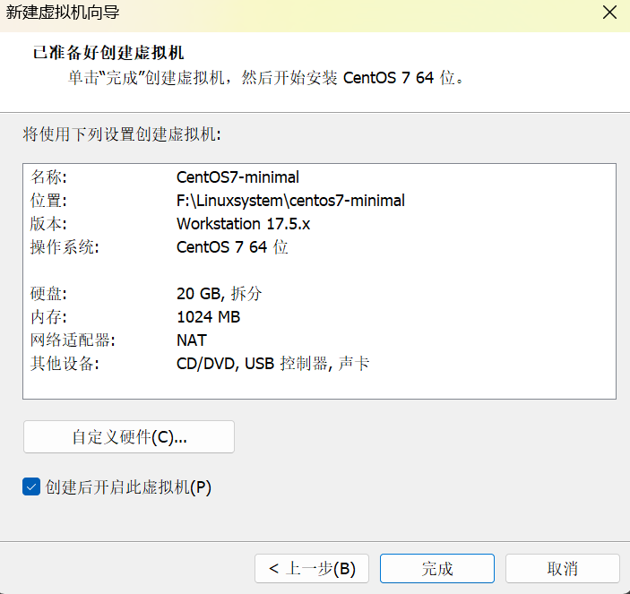
查看IP:
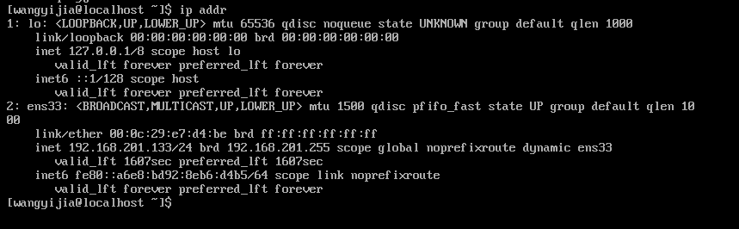
远程连接：
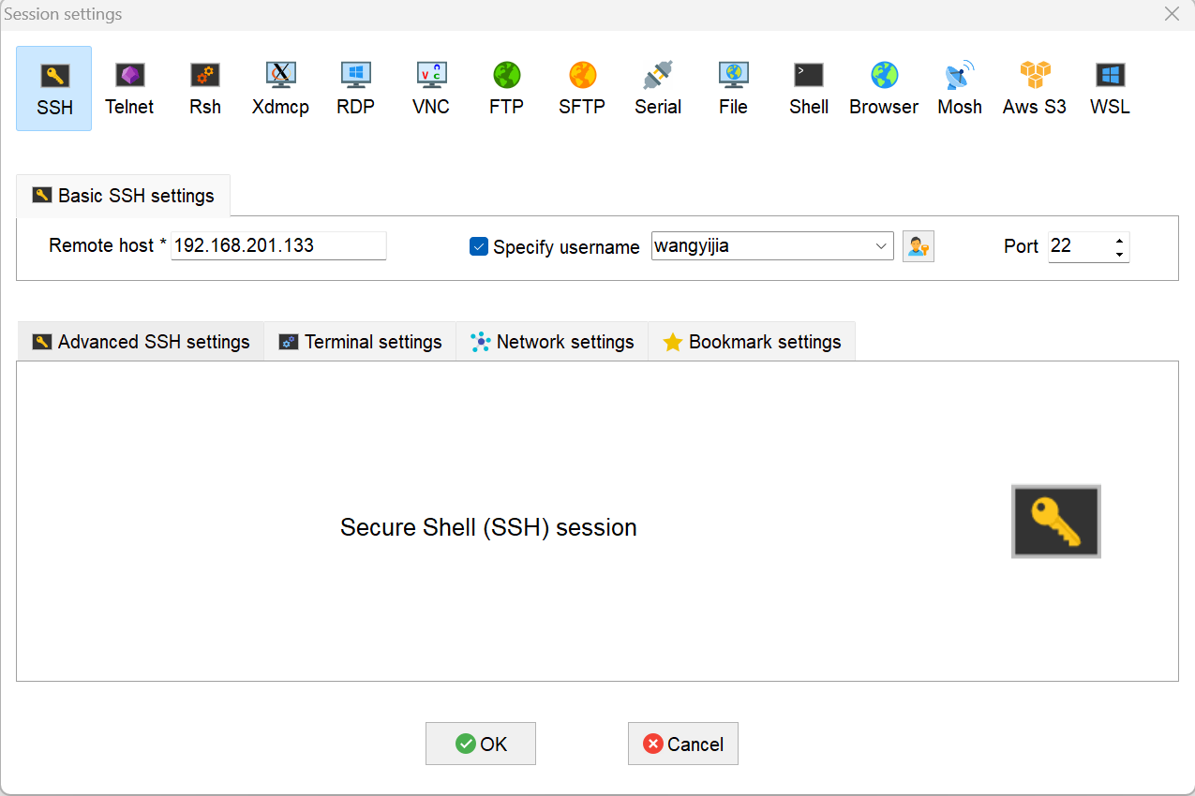
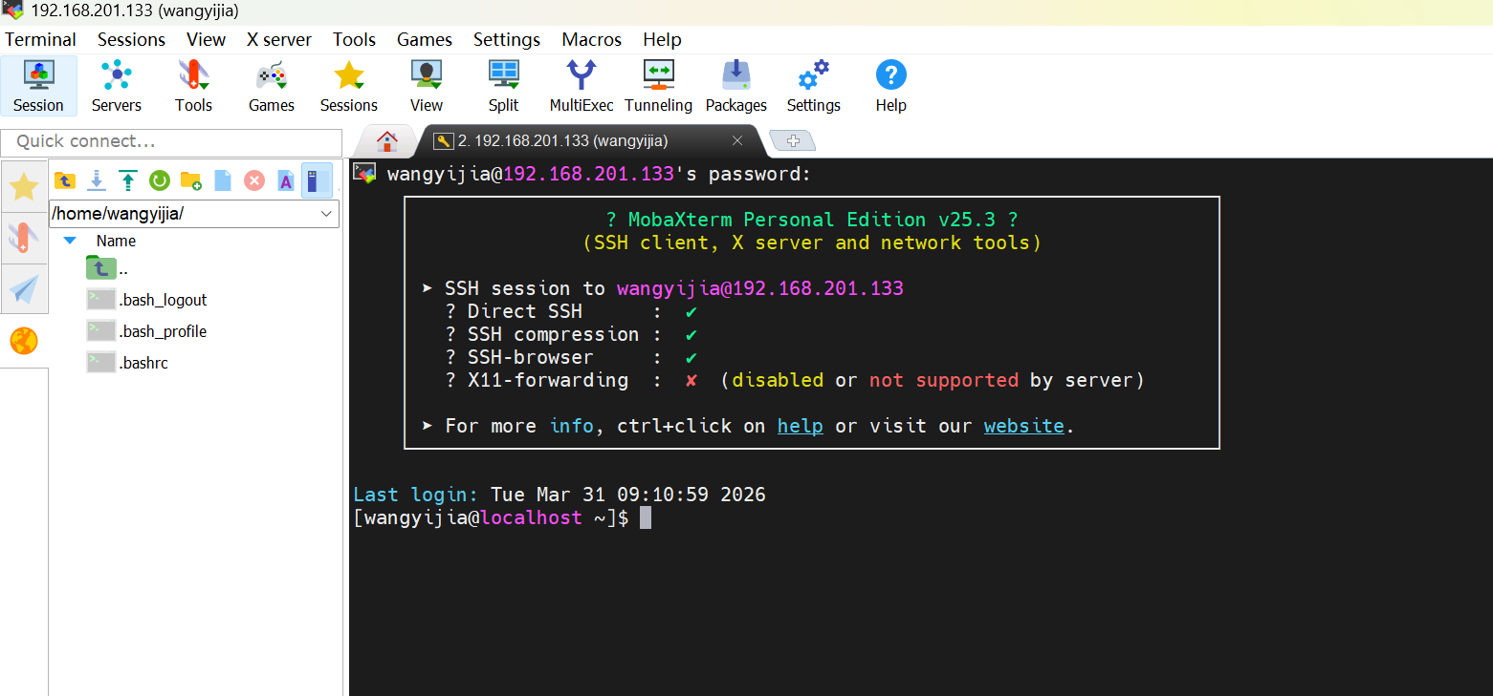
进入源目录并清理旧文件：
cd /etc/yum.repos.d/
sudo rm -fr *.repo
拖拽centos7.repo
vi /etc/yum.repos.d/CentOS-Base.repo
粘贴内容并保存
按 i 键进入「插入模式」（左下角会显示 -- INSERT --）
在命令行区域右键点击，粘贴刚才复制的内容，按 Esc 键退出插入模式，输入 :wq 并按回车，保存文件并退出
[base]
name=CentOS-$releasever - Base - mirrors.aliyun.com
failovermethod=priority
baseurl=http://mirrors.aliyun.com/centos/$releasever/os/$basearch/
gpgcheck=1
gpgkey=http://mirrors.aliyun.com/centos/RPM-GPG-KEY-CentOS-7
[updates]
name=CentOS-$releasever - Updates - mirrors.aliyun.com
failovermethod=priority
baseurl=http://mirrors.aliyun.com/centos/$releasever/updates/$basearch/
gpgcheck=1
gpgkey=http://mirrors.aliyun.com/centos/RPM-GPG-KEY-CentOS-7
[extras]
name=CentOS-$releasever - Extras - mirrors.aliyun.com
failovermethod=priority
baseurl=http://mirrors.aliyun.com/centos/$releasever/extras/$basearch/
gpgcheck=1
gpgkey=http://mirrors.aliyun.com/centos/RPM-GPG-KEY-CentOS-7
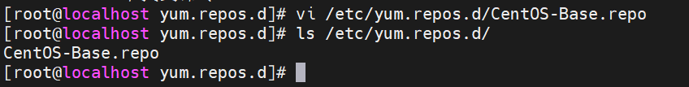
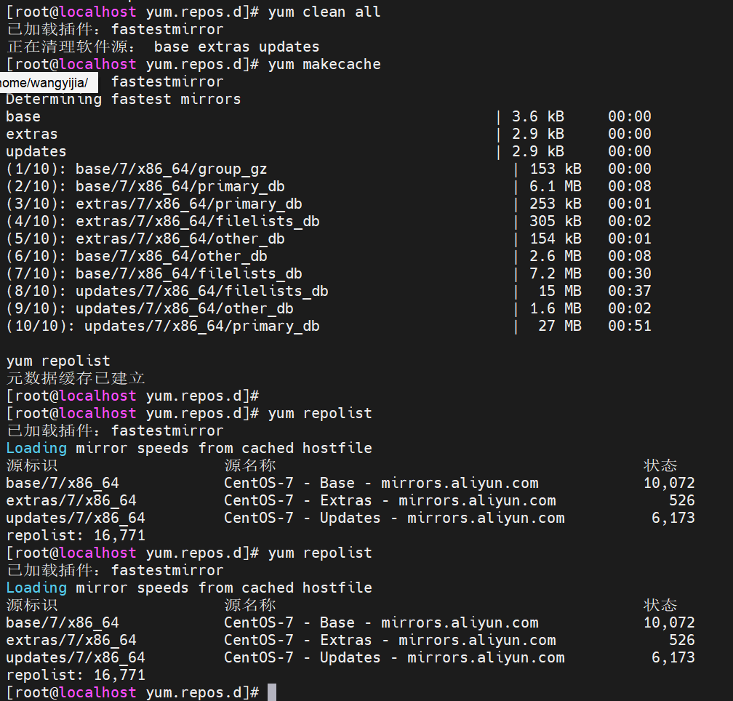
执行完 yum repolist 后，能看到仓库列表就代表配置完成，可以继续安装 Docker 了。
配置docker软件源
[root@server1 ~]# vi /etc/yum.repos.d/docker.repo
[docker]
name=docker-ce
baseurl=https://mirrors.tuna.tsinghua.edu.cn/docker-ce/linux/centos/7/x86_64/stable/
gpgcheck=0
安装docker-ce[root@server1 ~]# yum install -y docker-ce
启动服务[root@server1 ~]# systemctl enable --now docker
[root@server1 ~]# docker info
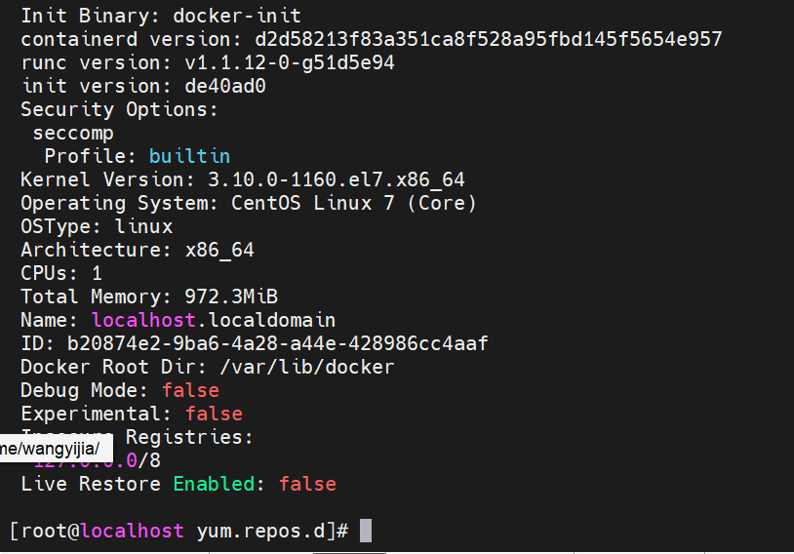
激活内核选项（可选）
[root@server1 ~]# vim /etc/sysctl.d/docker.conf
net.bridge.bridge-nf-call-iptables = 1
net.bridge.bridge-nf-call-ip6tables = 1
net.ipv4.ip_forward = 1
[root@server1 ~]# sysctl --system
重启docker服务
[root@server1 ~]# systemctl restart docker
配置镜像加速器
echo '{"registry-mirrors":["https://docker.1ms.run"],"dns": ["8.8.8.8", "114.114.114.114"]}' | sudo tee /etc/docker/daemon.json > /dev/null
systemctl daemon-reload
systemctl restart docker
测试：查询镜像： docker search docker.1ms.run/nginx
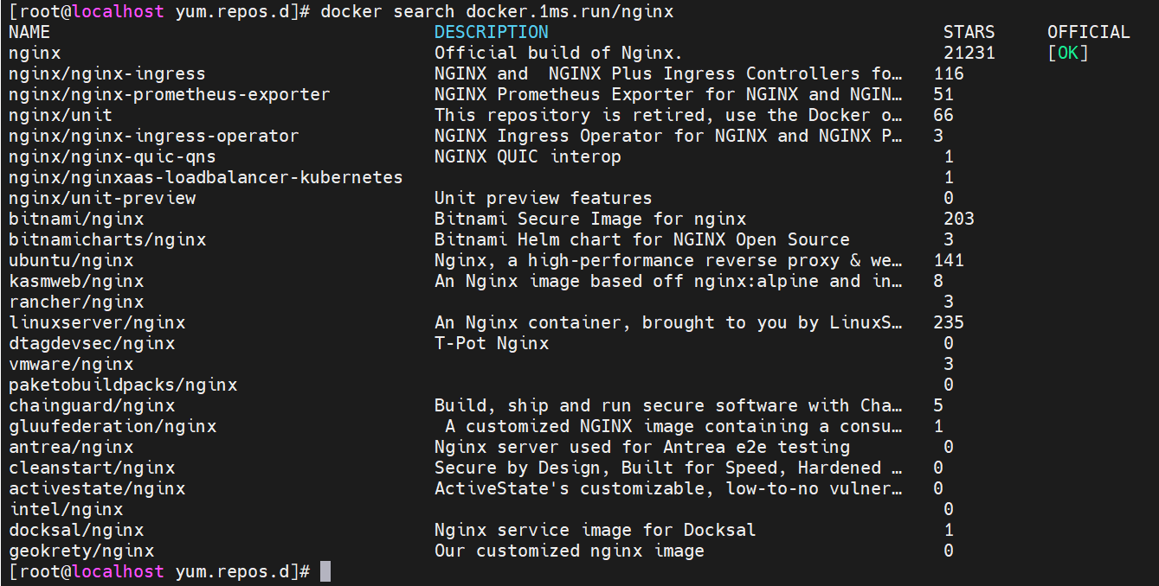
docker search docker.1ms.run/yakexi007
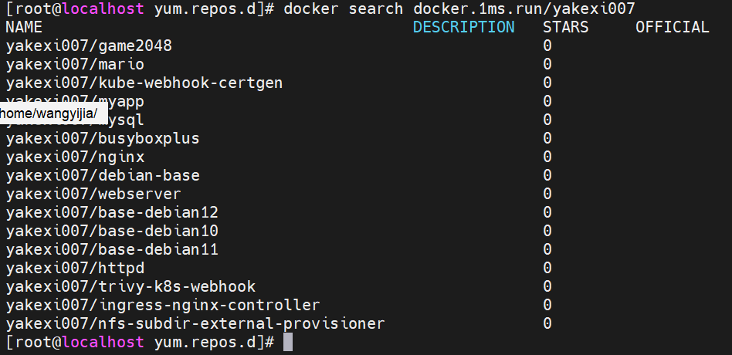
拉取镜像：
docker pull docker.1ms.run/busybox
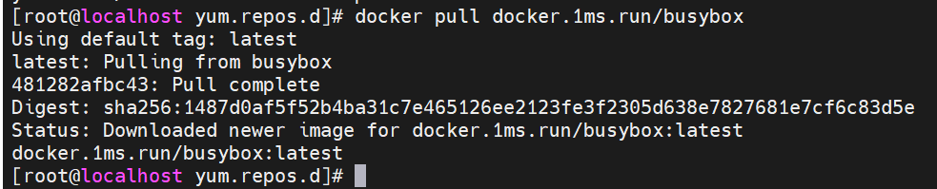
docker pull docker.1ms.run/yakexi007/game2048
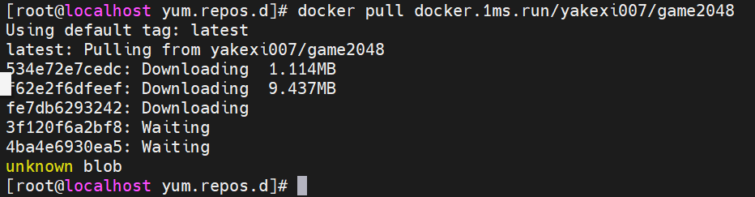
列出镜像：docker images
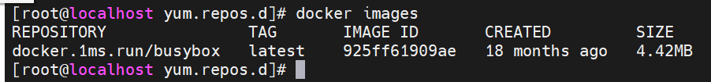
给镜像打标签（可选）
docker pull docker.1ms.run/busybox:latest busybox:latest
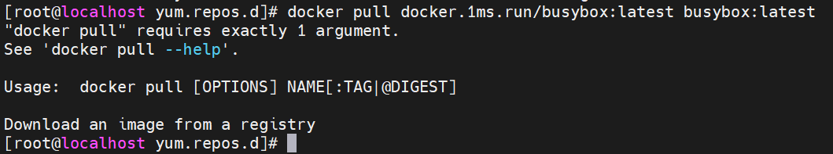
运行容器：
docker run -d --name game2048 -p 80:80 docker.1ms.run/yakexi007/game2048
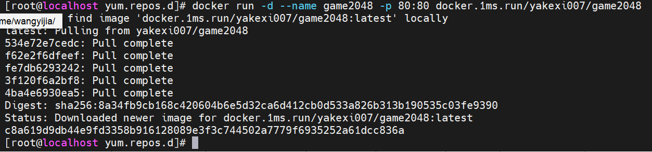
显示容器：docker ps
将game2048.tar拖拽入左侧结构树
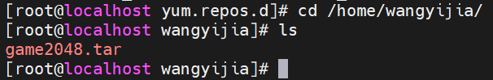
已存在，上传成功，加载docker镜像
sudo docker load -i game2048.tar
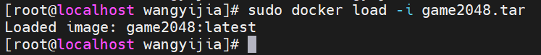
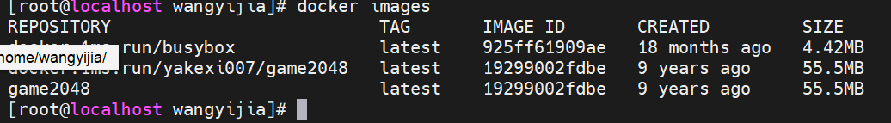
运行2048游戏容器docker run -d --name game2048 -p 80:80 game2048
game2048 这个名字已经被用过了，不能重复用，必须先删掉旧的！
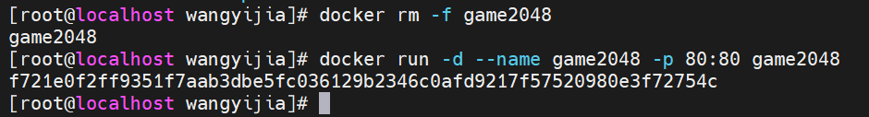
出现一长串字符串（容器 ID），就说明启动成功了！
Docker ps确认容器正在运行，浏览器地址栏输入：http://192.168.201.133:80，进入游戏界面
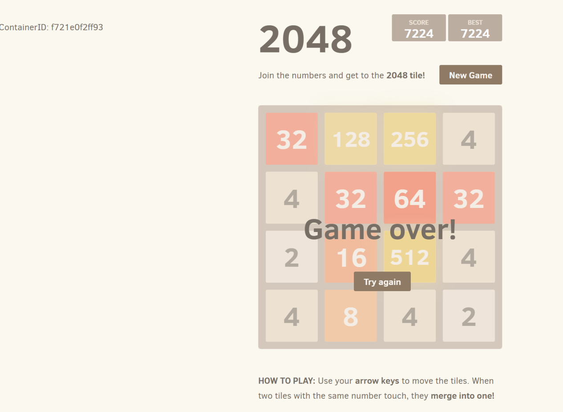

1.2 docker操作命令
命令补全（需要注销当前终端，重连后生效）
[root@server1 ~]# yum install -y bash-completion
拉取镜像[root@server1 ~]# docker pull busybox
列出镜像[root@server1 ~]# docker images
运行容器[root@server1 ~]# docker run busybox echo "hello world"
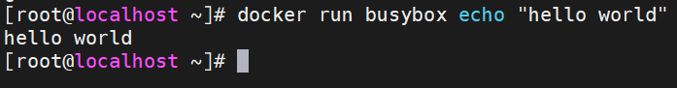
交互式运行容器[root@server1 ~]# docker run -it --name helloworld busybox
/ # touch file1
/ # touch file2
/ # exit
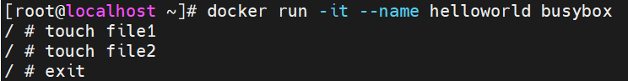
显示运行的容器[root@server1 ~]# docker ps
显示所有容器[root@server1 ~]# docker ps -a
启动容器[root@server1 ~]# docker start helloworld
连接容器[root@server1 ~]# docker attach helloworld
输入快捷键“ ctrl+pq” 分离容器，但容器继续运行。
显示运行的容器[root@server1 ~]# docker ps
列出容器或镜像的详情[root@server1 ~]# docker inspect helloworld
监控容器[root@server1 ~]# docker stats helloworld
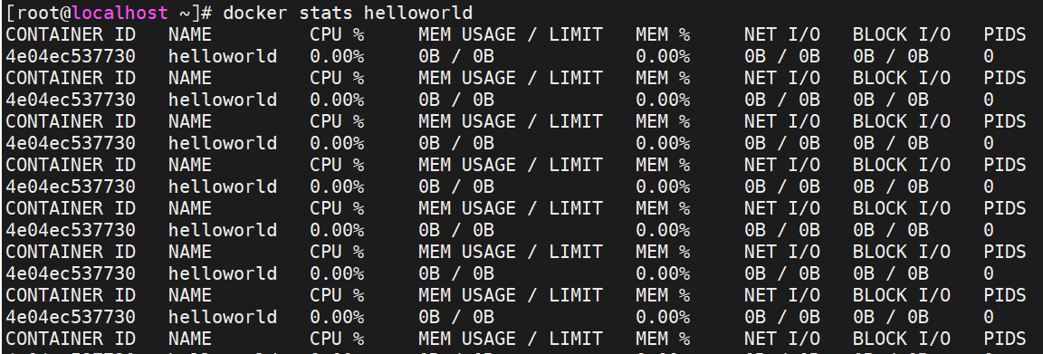
[root@server1 ~]# docker top helloworld
查看容器日志[root@server1 ~]# docker logs helloworld
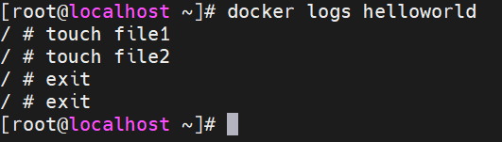
在后台运行容器
[root@server1 ~]# docker run --name logfollow -d busybox sh -c "while true; do date; sleep 5; done"
实时查看容器日志
[root@server1 ~]# docker logs -f logfollow
把日志记录到syslog
[root@server1 ~]# docker run --name syslog -d --log-driver="syslog" busybox sh -c "while true; do date; sleep 5; done"
[root@server1 ~]# tail -f /var/log/messages
停止容器
[root@server1 ~]# docker stop syslog
[root@server1 ~]# docker kill logfollow
强制删除容器[root@server1 ~]# docker rm -f syslog logfollow
删除所有容器[root@ecs ~]# docker rm -f $(docker ps -a -q)
删除镜像[root@ecs ~]# docker rmi busybox

1.3 部署应用堆栈
需要有前端后台，.tar文件老师下发，或者自行拉取
# 拉取 MySQL 镜像（这里用 8.0 版本，稳定常用）
docker pull mysql:8.0
# 拉取 Apache httpd 镜像
docker pull httpd:latest
导入本地镜像
docker load -i mysql.tar
docker load -i httpd.tar
显示镜像列表docker images
创建数据库容器docker run -d -p 3306:3306 -e MYSQL_ROOT_PASSWORD=redhat --name dbserver mysql
安装mysql客户端yum install -y mysql
导入数据mysql -h 127.0.0.1 -u root -predhat < os.sql
创建web容器
docker run -d -p 80:80 --link dbserver:db --name webserver httpd:webapp
访问测试（替换为自己主机IP），http://116.63.37.128
http://116.63.37.128/cgi-bin/action
清除所有容器docker rm -f $(docker ps -aq)
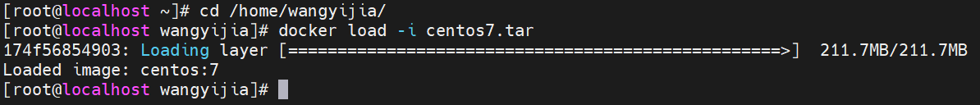
docker pull docker.1ms.run/busybox
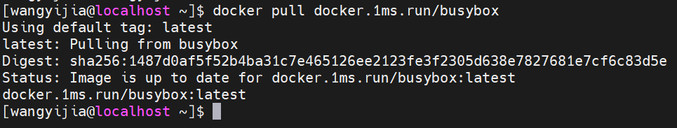
docker tag docker.1ms.run/busybox:latest busybox:latest
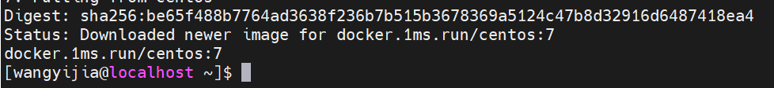
docker pull docker.1ms.run/nginx
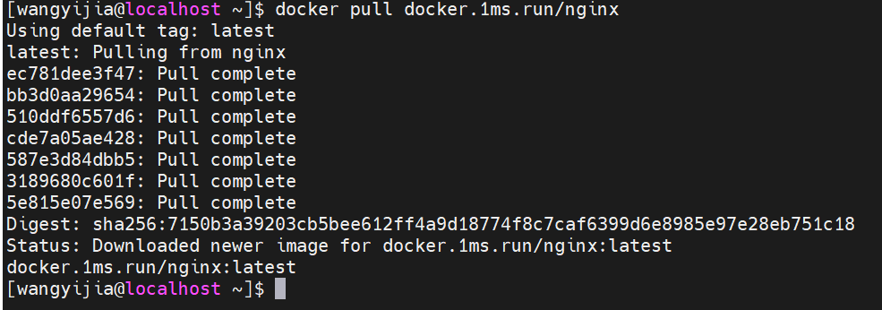
docker tag docker.1ms.run/nginx:latest nginx:latest
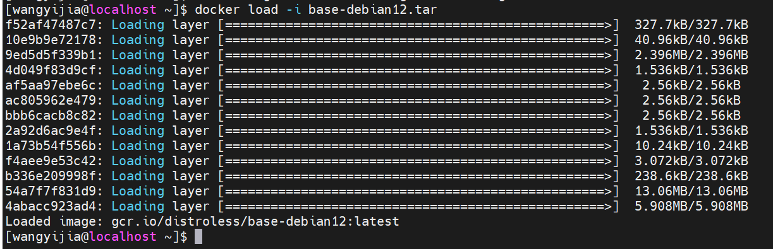
docker save -o webserver.tar webserver:v4
导入本地镜像
docker load -i mysql.tar
docker load -i httpd.tar
显示镜像列表docker images
创建数据库容器
docker run -d -p 3306:3306 -e MYSQL_ROOT_PASSWORD=redhat --name dbserver mysql
安装mysql客户端yum install -y mysql
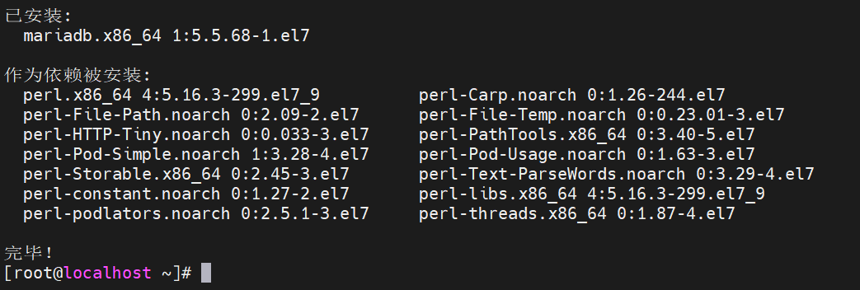
导入数据mysql -h 127.0.0.1 -u root -predhat < os.sql
创建web容器
docker run -d -p 80:80 --link dbserver:db --name webserver httpd:webapp
访问测试（替换为自己主机IP）
http://116.63.37.128，http://116.63.37.128/cgi-bin/action
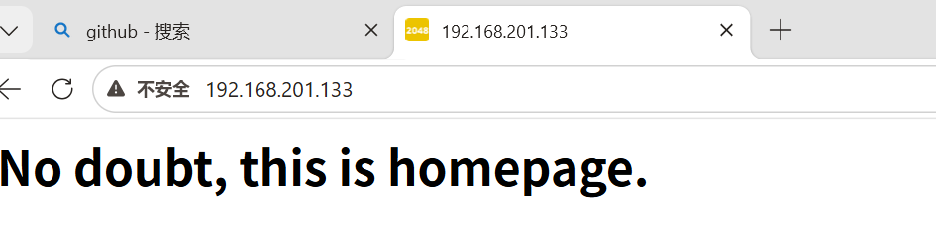
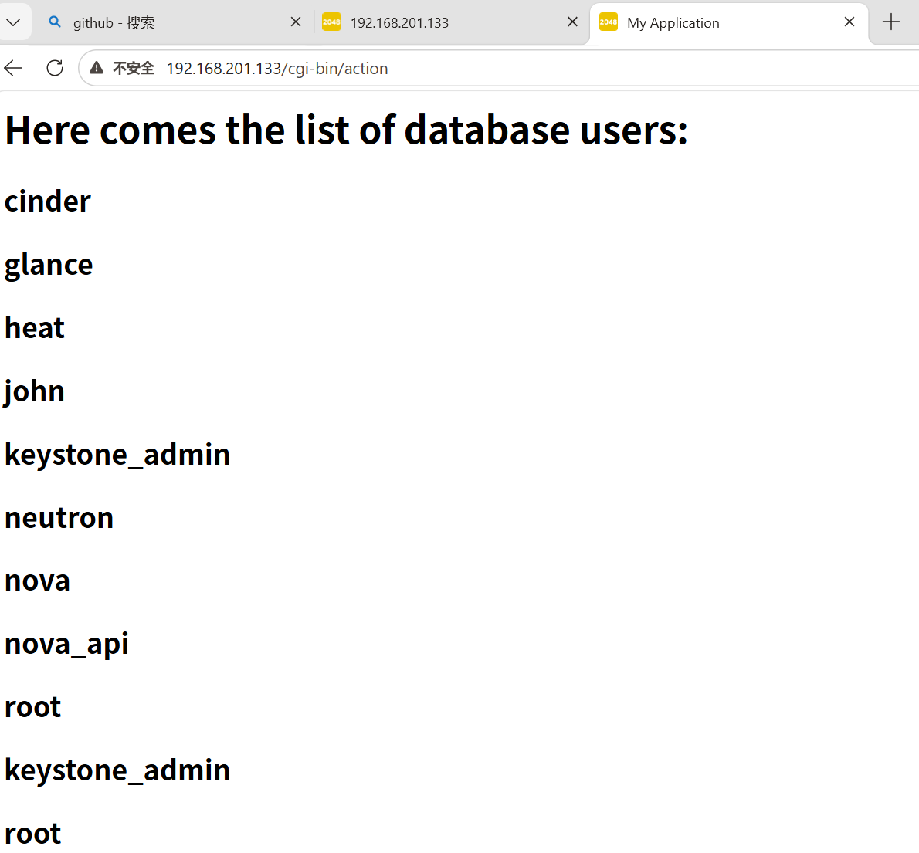
清除所有容器docker rm -f $(docker ps -aq)
完整镜像创建：
[root@server1 ~]# mdkir docker
[root@server1 ~]# cd docker/
[root@server1 docker]# vim Dockerfile
FROM centos:7
RUN rm -f /etc/yum.repos.d/*
COPY CentOS-Base.repo /etc/yum.repos.d/
ADD nginx-1.28.0.tar.gz /mnt
WORKDIR /mnt/nginx-1.28.0
RUN yum install -y gcc make pcre-devel openssl-devel
RUN sed -i 's/CFLAGS="$CFLAGS -g"/#CFLAGS="$CFLAGS -g"/g' auto/cc/gcc
RUN ./configure --with-http_ssl_module --with-http_stub_status_module
RUN make
RUN make install
EXPOSE 80
VOLUME ["/usr/local/nginx/html"]
CMD ["/usr/local/nginx/sbin/nginx", "-g", "daemon off;"]
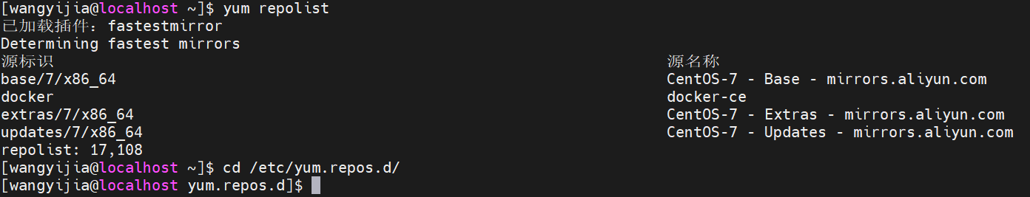
将两个文件复制到docker中来：cp /etc/yum.repos.d/CentOS-Base.repo .
cp /home/wangyijia/nginx-1.28.0.tar.gz .
确保资源文件都在当前目录
[root@server1 docker]# ls
CentOS-Base.repo Dockerfile nginx-1.28.0.tar.gz
构建镜像：docker build -t webserver:v1 .不要忘了. 表示当前目录。
[wangyijia@localhost docker]$ docker images webserver
REPOSITORY TAG IMAGE ID CREATED SIZE
webserver v1 83314380bdcf 11 minutes ago 553MB
docker history webserver:v1
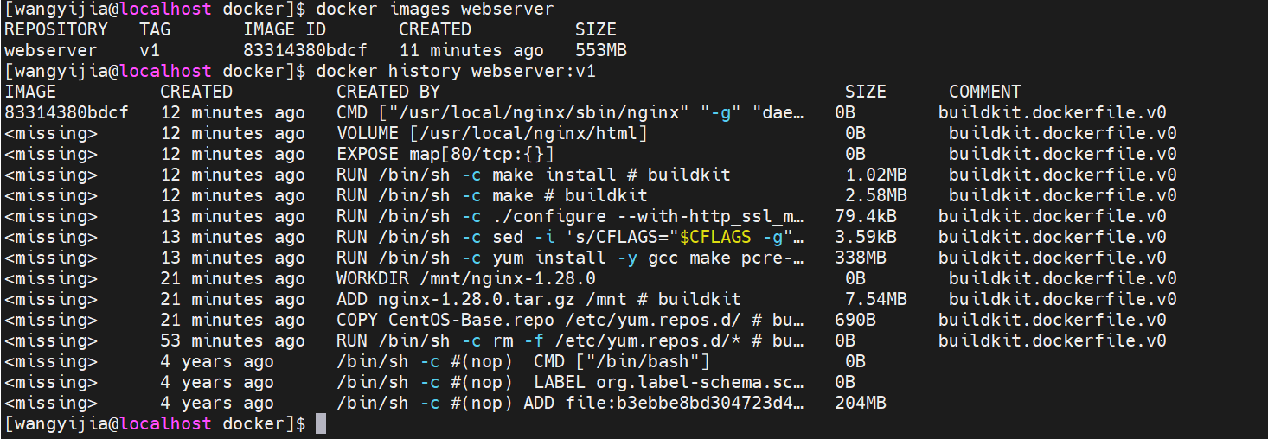
清理所有停止的容器 docker container prune
启动容器 docker run -d --name web1 webserver:v1
查看容器详情docker inspect web1
数据卷挂载
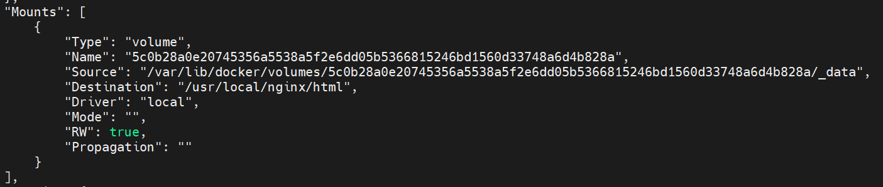
自动分配的ip
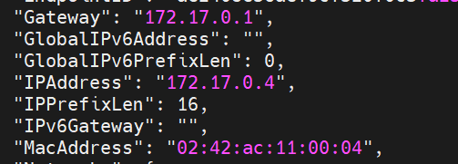
访问容器curl 172.17.0.4
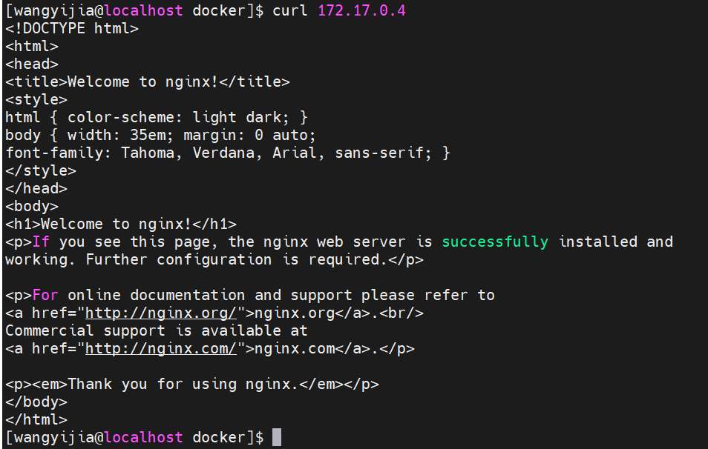
容器内部 IP 是 Docker 网桥分配的，仅用于容器间通信，外部网络无法路由。

1.4 镜像优化
缩减镜像层
[wangyijia@localhost docker]# vim Dockerfile
FROM centos:7
RUN rm -f /etc/yum.repos.d/*
COPY CentOS-Base.repo /etc/yum.repos.d/
ADD nginx-1.28.0.tar.gz /mnt
WORKDIR /mnt/nginx-1.28.0
RUN yum install -y gcc make pcre-devel openssl-devel && sed -i 's/CFLAGS="$CFLAGS -g"/#CFLAGS="$CFLAGS -g"/g' auto/cc/gcc && ./configure --with-http_ssl_module --with-http_stub_status_module && make && make install && cd .. && rm -fr nginx-1.28.0 && yum clean all
EXPOSE 80
VOLUME ["/usr/local/nginx/html"]
CMD ["/usr/local/nginx/sbin/nginx", "-g", "daemon off;"]
[wangyijia@localhost docker]# docker build -t webserver:v2 .
[wangyijia@localhost docker]$ docker images webserver
REPOSITORY TAG IMAGE ID CREATED SIZE
webserver v2 4417a038ebb1 16 minutes ago 318MB
webserver v1 83314380bdcf About an hour ago 553MB

多阶段构建
[wangyijia@localhost docker]# vim Dockerfile
FROM centos:7 as build
RUN rm -f /etc/yum.repos.d/*
COPY CentOS-Base.repo /etc/yum.repos.d/
ADD nginx-1.28.0.tar.gz /mnt
WORKDIR /mnt/nginx-1.28.0
RUN yum install -y gcc make pcre-devel openssl-devel && sed -i 's/CFLAGS="$CFLAGS -g"/#CFLAGS="$CFLAGS -g"/g' auto/cc/gcc && ./configure --with-http_ssl_module --with-http_stub_status_module && make && make install && cd .. && rm -fr nginx-1.28.0 && yum clean all
FROM centos:7
COPY --from=build /usr/local/nginx /usr/local/nginx
EXPOSE 80
VOLUME ["/usr/local/nginx/html"]
CMD ["/usr/local/nginx/sbin/nginx", "-g", "daemon off;"]
[wangyijia@localhost docker]# docker build -t webserver:v3 .
[wangyijia@localhost docker]# docker images webserver
REPOSITORY TAG IMAGE ID CREATED SIZE
webserver v3 1ac964f2cefe 29 seconds ago 205MB
webserver v2 caf0f80f2332 3 minutes ago 287MB
webserver v1 bfd6774cc216 About an hour ago 328MB
使用最精简的基础镜像
导入基础镜像
[wangyijia@localhost ~]$ docker load -i base-debian12.tar
Loaded image: gcr.io/distroless/base-debian12:latest
[wangyijia@localhost ~]$ mkdir new
[wangyijia@localhost ~]$ cd new
[wangyijia@localhost new]$ vim Dockerfile

FROM nginx:latest as base
RUN mkdir -p /opt/var/cache/nginx && \
cp -a --parents /usr/lib/nginx /opt && \
cp -a --parents /usr/share/nginx /opt && \
cp -a --parents /var/log/nginx /opt && \
cp -aL --parents /var/run /opt && \
cp -a --parents /etc/nginx /opt && \
cp -a --parents /etc/passwd /opt && \
cp -a --parents /etc/group /opt && \
cp -a --parents /usr/sbin/nginx /opt && \
cp -a --parents /usr/sbin/nginx-debug /opt && \
cp -a --parents /lib/x86_64-linux-gnu/ld-* /opt && \
cp -a --parents /usr/lib/x86_64-linux-gnu/libpcre* /opt && \
cp -a --parents /lib/x86_64-linux-gnu/libz.so.* /opt && \
cp -a --parents /lib/x86_64-linux-gnu/libc* /opt && \
cp -a --parents /lib/x86_64-linux-gnu/libdl* /opt && \
cp -a --parents /lib/x86_64-linux-gnu/libpthread* /opt && \
cp -a --parents /lib/x86_64-linux-gnu/libcrypt* /opt && \
cp -a --parents /lib/x86_64-linux-gnu/libzstd* /opt && \
cp -a --parents /usr/lib/x86_64-linux-gnu/libssl.so.* /opt && \
cp -a --parents /usr/lib/x86_64-linux-gnu/libcrypto.so.* /opt
FROM base-debian12:latest
COPY --from=base /opt /
EXPOSE 80 443
ENTRYPOINT ["nginx", "-g", "daemon off;"]
[wangyijia@localhost new]$ docker build -t webserver:v4 .
会报错，替换第二个FROM:FROM gcr.io/distroless/base-debian12:latest
[wangyijia@localhost new]$ docker images webserver
REPOSITORY TAG IMAGE ID CREATED SIZE
webserver v4 d9b2a8d70786 2 minutes ago 61.6MB
webserver v2 4417a038ebb1 44 minutes ago 318MB
webserver v1 83314380bdcf 2 hours ago 553MB
[root@server1 new]# docker run -d --name web1 webserver:v4
[root@server1 new]# curl 172.17.0.2

1.5 Docker仓库
docker hub
注册账号新建仓库：

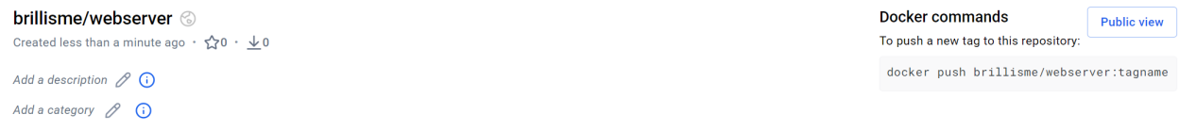
客户端登录docker hub
修改docker代理配置
sudo vi /etc/systemd/system/docker.service.d/http-proxy.conf
[Service]
Environment="HTTP_PROXY=http://192.168.0.103:7897"
Environment="HTTPS_PROXY=http://192.168.0.103:7897"
Environment="NO_PROXY=localhost,127.0.0.1,::1"
重载配置、重启 Docker
sudo systemctl daemon-reload
sudo systemctl restart docker
登录成功！
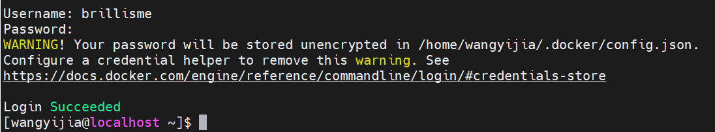
上传镜像
[wangyijia@localhost ~]$ docker tag webserver:v4 brillisme/webserver:v4
[wangyijia@localhost ~]$ docker push brillisme/webserver:v4
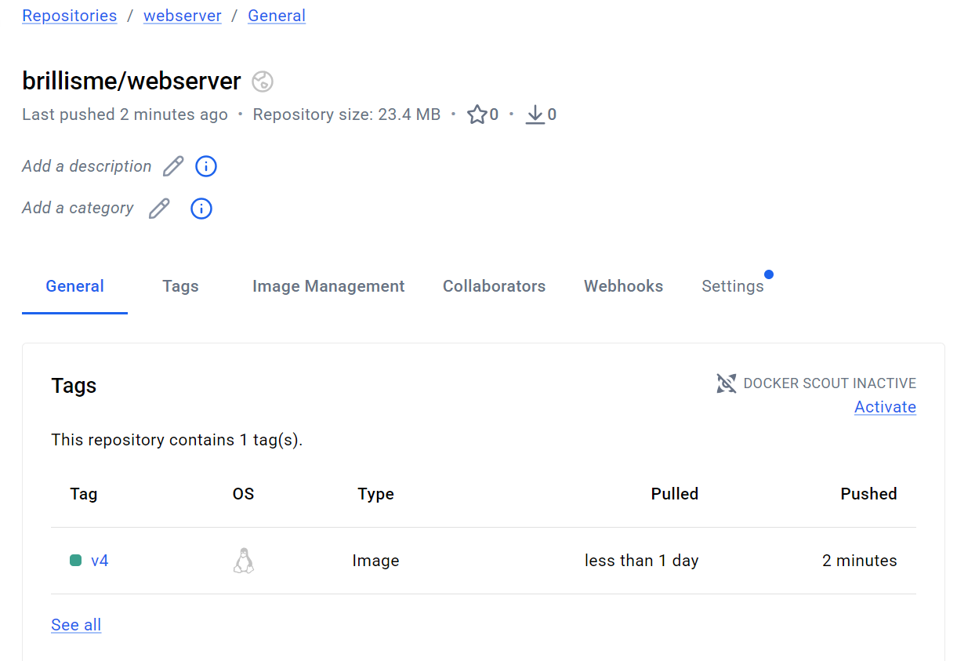
上传成功！
registry私有仓库
官网： https://docs.docker.com/registry/deploying/
拉取registry镜像docker pull registry
运行registry仓库
docker run -d --name registry -p 5000:5000 -v /opt/registry:/var/lib/registry registry
列出容器docker ps -l
配置仓库自启动vim /etc/systemd/system/registry.service
[Unit]
Description=Registry
Requires=docker.service
After=docker.service
[Service]
Type=simple
Restart=always
ExecStart=/usr/bin/docker start -a registry
ExecStop=/usr/bin/docker stop registry
[Install]
WantedBy=multi-user.target
刷新配置systemctl daemon-reload
停止容器docker stop registry
设置开机自启systemctl enable --now registry
docker ps -l
上传镜像
docker tag busybox:latest localhost:5000/busybox:latest
docker push localhost:5000/busybox
查询镜像
[root@localhost docker]# curl http://localhost:5000/v2/busybox/tags/list
{"name":"busybox","tags":["latest"]}
下载镜像
[root@localhost docker]# docker pull localhost:5000/busybox
Using default tag: latest
latest: Pulling from busybox
Digest: sha256:11f85134f388cff5f4c66f9bb4c5942249c1f6f7eb8b3889948d953487b5f7a8
Status: Image is up to date for localhost:5000/busybox:latest
localhost:5000/busybox:lates
insecure registry
配置使用非加密端口(替换为实际仓库IP)
[root@localhost docker]# vim /etc/docker/daemon.json
{
"insecure-registries" : ["http://192.168.201.133:5000"]
}
[root@localhost docker]# systemctl restart docker
[root@localhost docker]# docker pull 192.168.201.133:5000/nginx
拉取镜像
[root@server2 docker]# docker pull 192.168.201.133:5000/nginx
使用这个一直出错，就用回环地址：
[root@localhost docker]# cat > /etc/docker/daemon.json <<EOF
> {
> "insecure-registries": ["127.0.0.1:5000"]
> }
> EOF
[root@localhost docker]# systemctl restart docker
[root@localhost docker]# docker tag nginx 127.0.0.1:5000/nginx
[root@localhost docker]# docker push 127.0.0.1:5000/nginx
[root@localhost docker]# docker pull 127.0.0.1:5000/nginx
Using default tag: latest
latest: Pulling from nginx
Digest: sha256:d5590adee87e29c44bc13bfae4492585c861b9893e60b48c86728bf179f5d096
Status: Image is up to date for 127.0.0.1:5000/nginx:latest
127.0.0.1:5000/nginx:latest
仓库加密
wget https://mirrors.aliyun.com/epel/7/x86_64/Packages/o/openssl11-1.1.1k-7.el7.x86_64.rpm
wget https://mirrors.aliyun.com/epel/7/x86_64/Packages/o/openssl11-libs-1.1.1k-7.el7.x86_64.rpm
# 第二步：安装
sudo yum install -y openssl11-1.1.1k-7.el7.x86_64.rpm openssl11-libs-1.1.1k-7.el7.x86_64.rpm
添加域名解析
[root@localhost ~]# echo "192.168.201.133 localhost reg.westos.org" | sudo tee -a /etc/hosts
192.168.201.133 server1.reg.westos.org
[root@localhost ~]# cat /etc/hosts
127.0.0.1 localhost localhost.localdomain localhost4 localhost4.localdomain4
::1 localhost localhost.localdomain localhost6 localhost6.localdomain6
192.168.201.133 localhost reg.westos.org
用 OpenSSL 生成 HTTPS 自签名证书 + 私钥，用于给 Docker 私有仓库做加密认证，让仓库支持 HTTPS 访问:
[root@server1 ~]# mkdir certs
[root@server1 ~]# openssl11 req -newkey rsa:4096 -nodes -sha256 -keyout certs/westos.org.key -addext "subjectAltName = DNS:reg.westos.org" -x509 -days 365 -out certs/westos.org.crt
域名保持一致
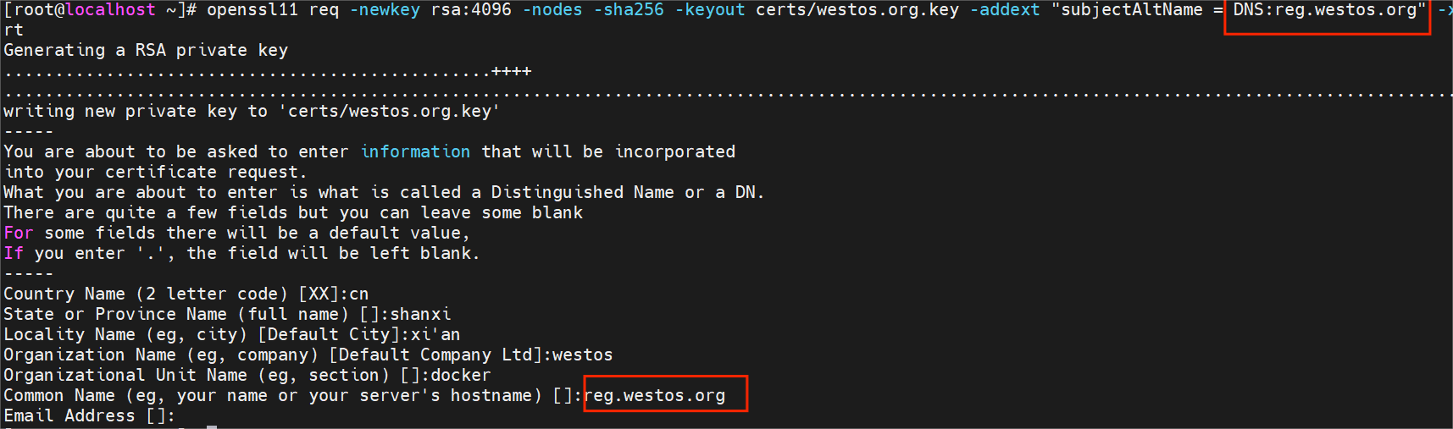
[root@localhost ~]# docker run -d -p 443:443 --restart=always --name registry -v /opt/registry:/var/lib/registry -v /root/certs:/certs -e REGISTRY_HTTP_ADDR=0.0.0.0:443 -e REGISTRY_HTTP_TLS_CERTIFICATE=/certs/westos.org.crt -e REGISTRY_HTTP_TLS_KEY=/certs/westos.org.key registry
部署客户端证书，不然会报错
[root@localhost ~]# docker tag nginx:latest reg.westos.org/nginx:latest
[root@localhost ~]# docker push reg.westos.org/nginx:latest
The push refers to repository [reg.westos.org/nginx]
Get "https://reg.westos.org/v2/": EOF
以上还是EOF不行，把域名指向本机：
echo "127.0.0.1 reg.westos.org" >> /etc/hosts
systemctl restart network
systemctl restart docker
docker push reg.westos.org/nginx:latest
仓库认证
[root@localhost ~]# mkdir auth
[root@localhost ~]# htpasswd -Bc auth/htpasswd admin
New password:
Re-type new password:
Adding password for user admin
第二次添加不要加“-c”选项，不然会覆盖
[root@localhost ~]# htpasswd -B auth/htpasswd wxh
New password:
Re-type new password:
Adding password for user wxh
[root@localhost ~]# cat auth/htpasswd
admin:$2y$05$t4cfaZI7q7QqQdJNJuG.zewaua4ZsSXL4FZ26G0PwuprTB2D6vcHK
wxh:$2y$05$wMZPAV0qiHYkXFOT050tCuefyj.d5A/lfVYZ/qdyWtH/lMiYdU3vW
删除registry，重建
[root@server1 ~]# docker rm -f registry
[root@server1 ~]# docker run -d -p 443:443 --restart=always --name registry -v /opt/registry:/var/lib/registry -v /root/certs:/certs -e REGISTRY_HTTP_ADDR=0.0.0.0:443 -e REGISTRY_HTTP_TLS_CERTIFICATE=/certs/westos.org.crt -e REGISTRY_HTTP_TLS_KEY=/certs/westos.org.key -v /root/auth:/auth -e "REGISTRY_AUTH=htpasswd" -e "REGISTRY_AUTH_HTPASSWD_REALM=Registry Realm" -e REGISTRY_AUTH_HTPASSWD_PATH=/auth/htpasswd registry
登录仓库，不然无法上传下载
[root@server1 ~]# docker login reg.westos.org
Username: admin
Password:
WARNING! Your password will be stored unencrypted in /root/.docker/config.json.
Configure a credential helper to remove this warning. See
https://docs.docker.com/engine/reference/commandline/login/#credentials-store
Login Succeeded

2 Harbor企业级私有仓库部署搭建

2.1 安装harbor
删除之前部署的registry，不然会冲突
[root@server1 ~]# docker rm -f registry
部署证书
[root@server1 ~ ]# mkdir /data
[root@server1 ~ ]# cp -r certs /data
[root@localhost wangyijia]# tar zxf harbor-offline-installer-v2.14.0.tgz
[root@localhost wangyijia]# cd harbor/
[root@localhost harbor]# cp harbor.yml.tmpl harbor.yml
[root@localhost harbor]# vim harbor.yml
hostname: reg.westos.org
http:
# port for http, default is 80. If https enabled, this port will redirect to https port
port: 80
https:
# https port for harbor, default is 443
port: 443
# The path of cert and key files for nginx
certificate: /data/certs/westos.org.crt
private_key: /data/certs/westos.org.key

...
harbor_admin_password: westos
部署harbor[root@server1 harbor]# ./install.sh --with-trivy
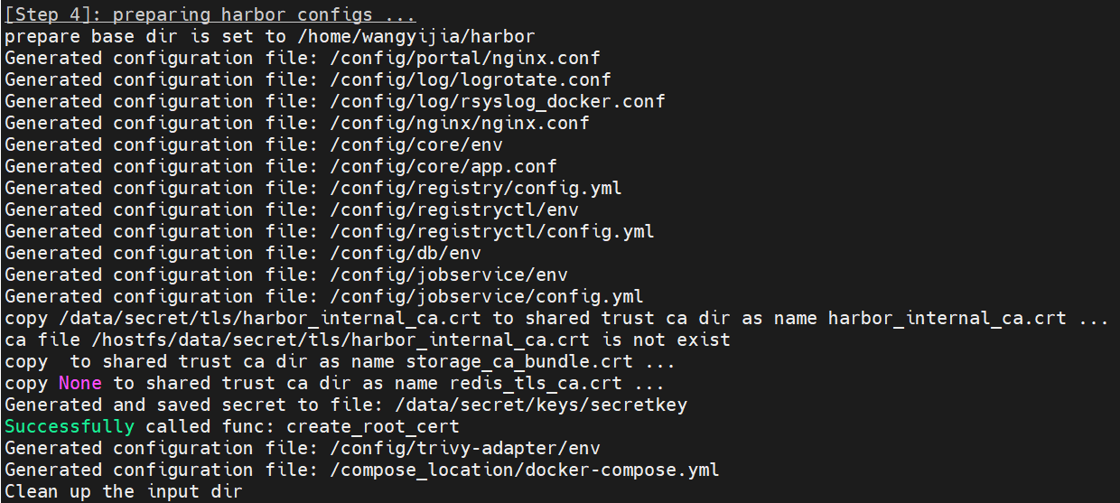
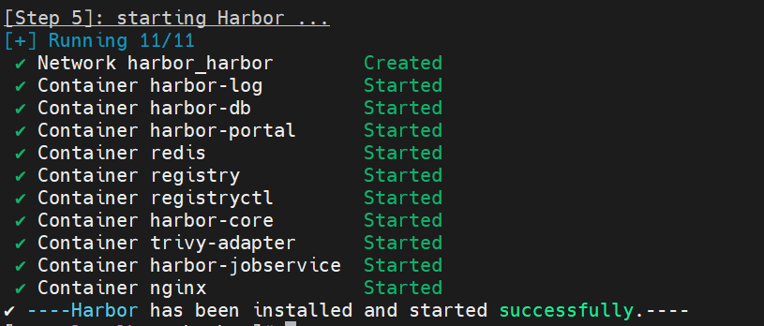
查看镜像docker compose images
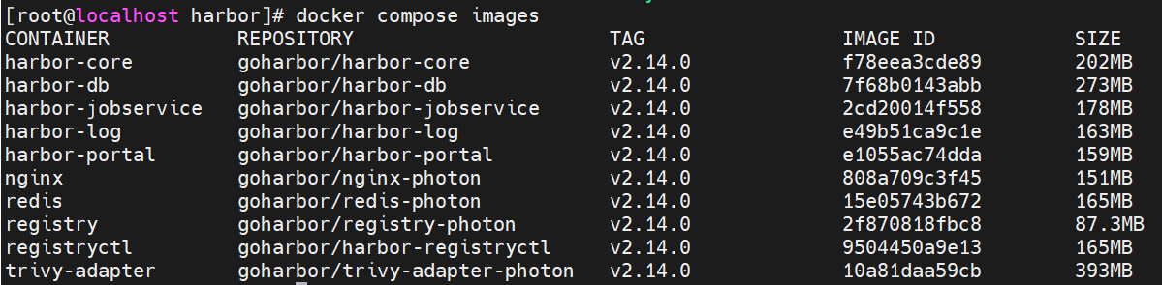
查看服务日志
docker compose logs；登录https://192.168.201.142
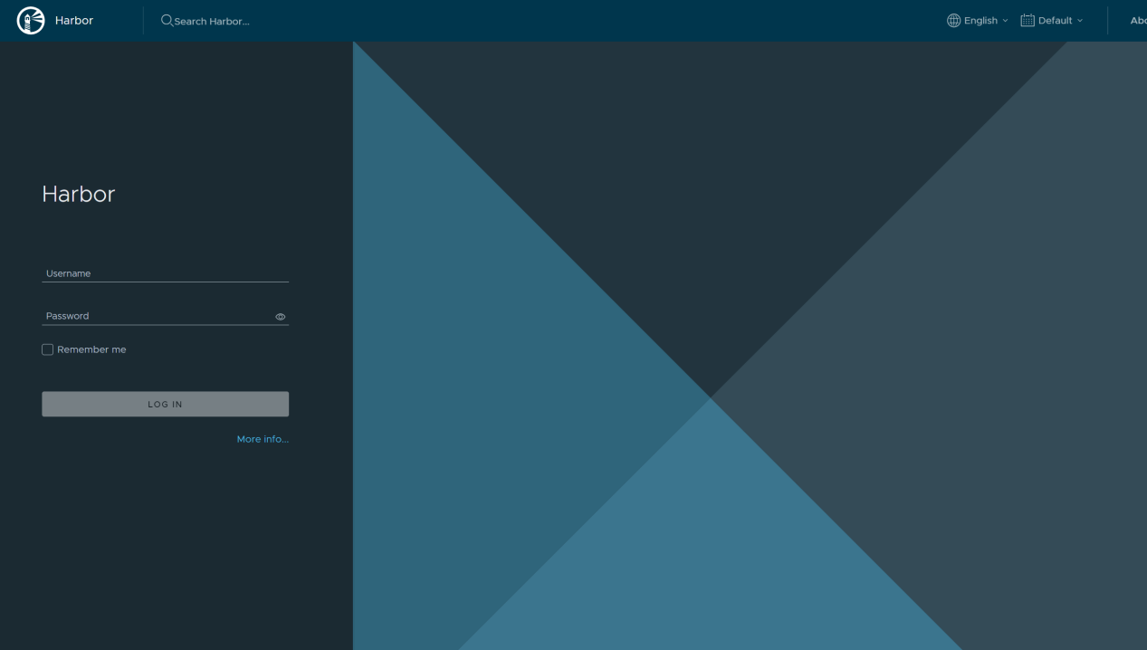
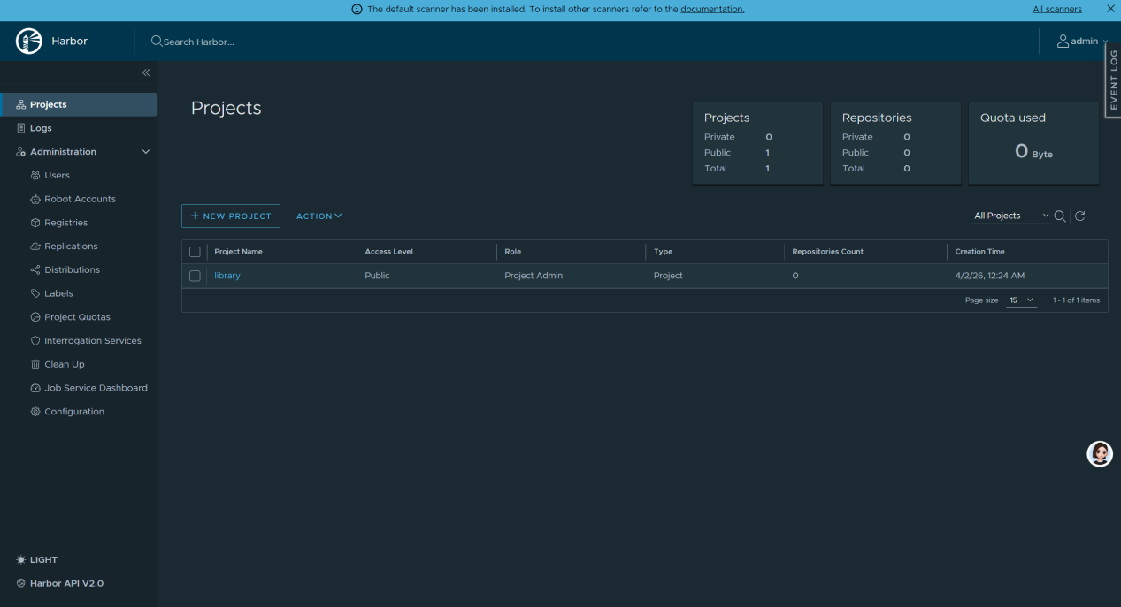

2.2 harbor使用
登录仓库
[root@localhost ~]# docker login reg.westos.org
最初登录不成功，测试如下：
[root@localhost harbor]# curl -I -k https://reg.westos.org
curl: (7) Failed connect to reg.westos.org:443; 没有到主机的路由
正确配置域名解析：
[root@localhost harbor]# echo "192.168.201.142 reg.westos.org" | sudo tee -a /etc/hosts
192.168.201.142 reg.westos.org
[root@localhost harbor]# docker login reg.westos.org
Username: admin
Password:
WARNING! Your password will be stored unencrypted in /root/.docker/config.json.
Configure a credential helper to remove this warning. See
https://docs.docker.com/engine/reference/commandline/login/#credentials-store

Login Succeeded
成功登录！
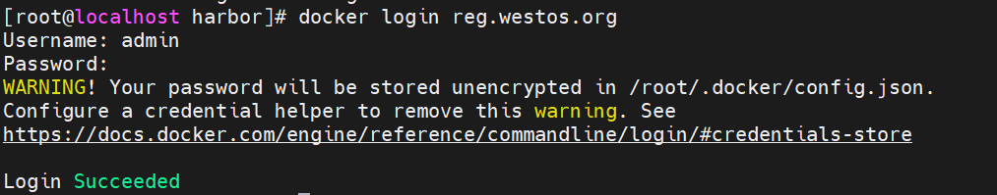
给镜像打标签
[root@server1 ~]# docker tag busybox:latest reg.westos.org/library/busybox:latest
[root@server1 ~]# docker tag nginx:latest reg.westos.org/library/nginx:latest
上传镜像
[root@localhost harbor]# docker push reg.westos.org/library/nginx:latest
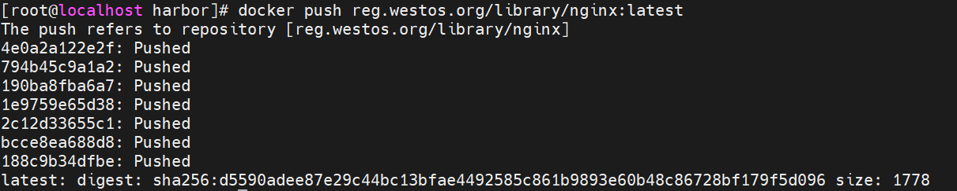
[root@localhost harbor]# docker push reg.westos.org/library/busybox:latest
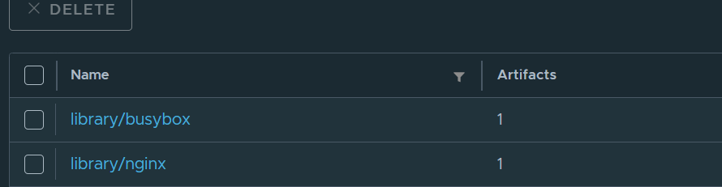
创建私有仓库：
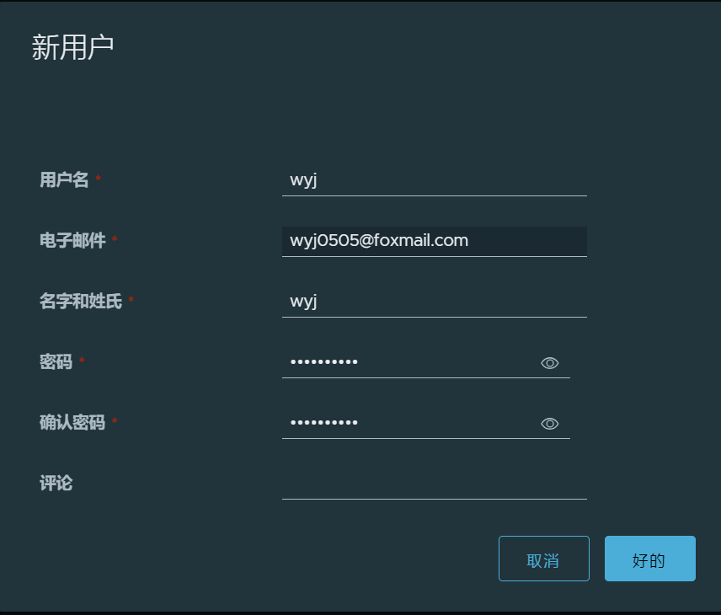
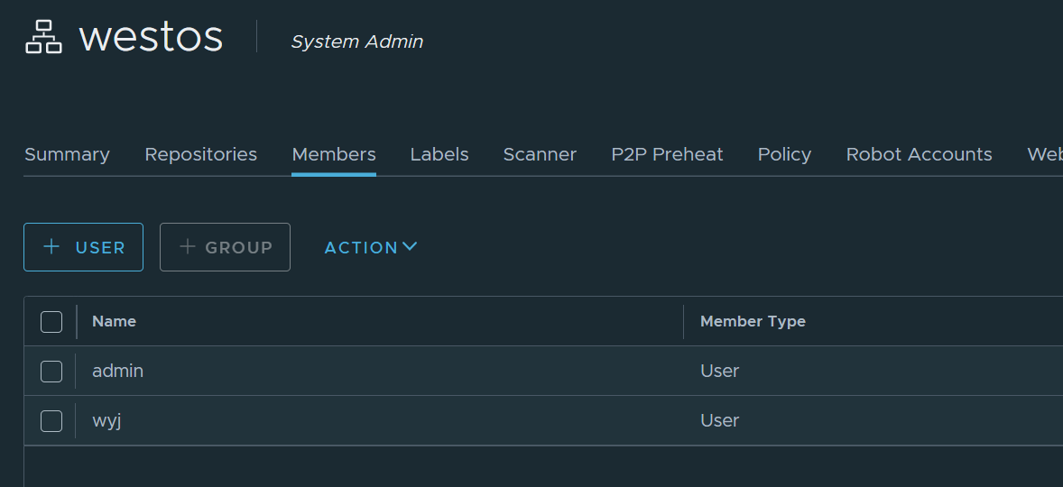
push 推送模式
选择主仓库做为推送端。
本次没有另一台部署好harbor的虚拟机，就在自己的原IP上练习，流程是一样的。
如果有另一台虚拟机，则目标URL填另一台虚拟机IP。
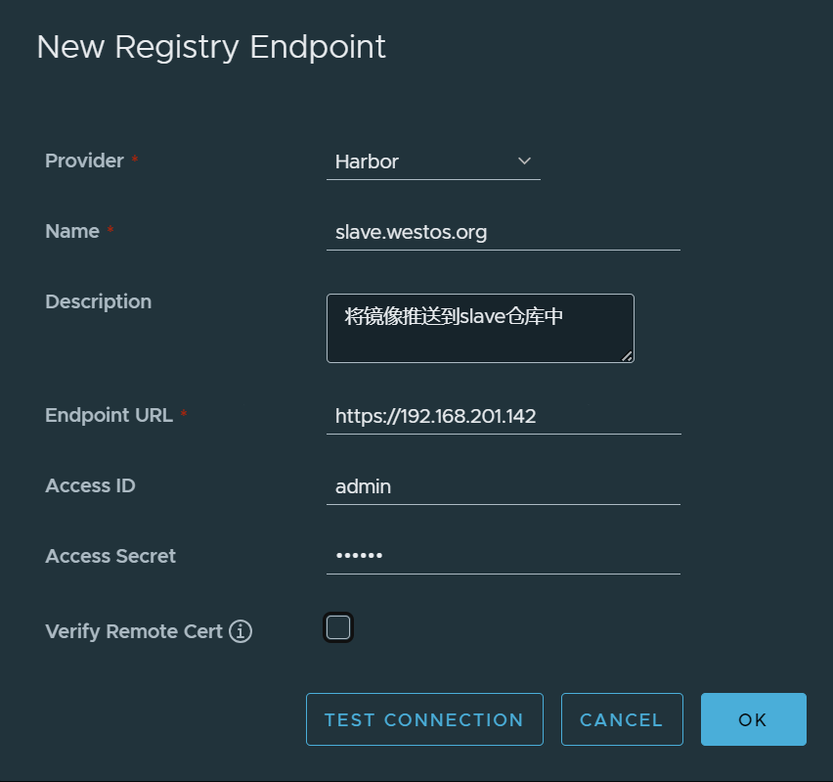
当前仓库的证书是自签名证书，所以去掉“验证远程证书”选项。
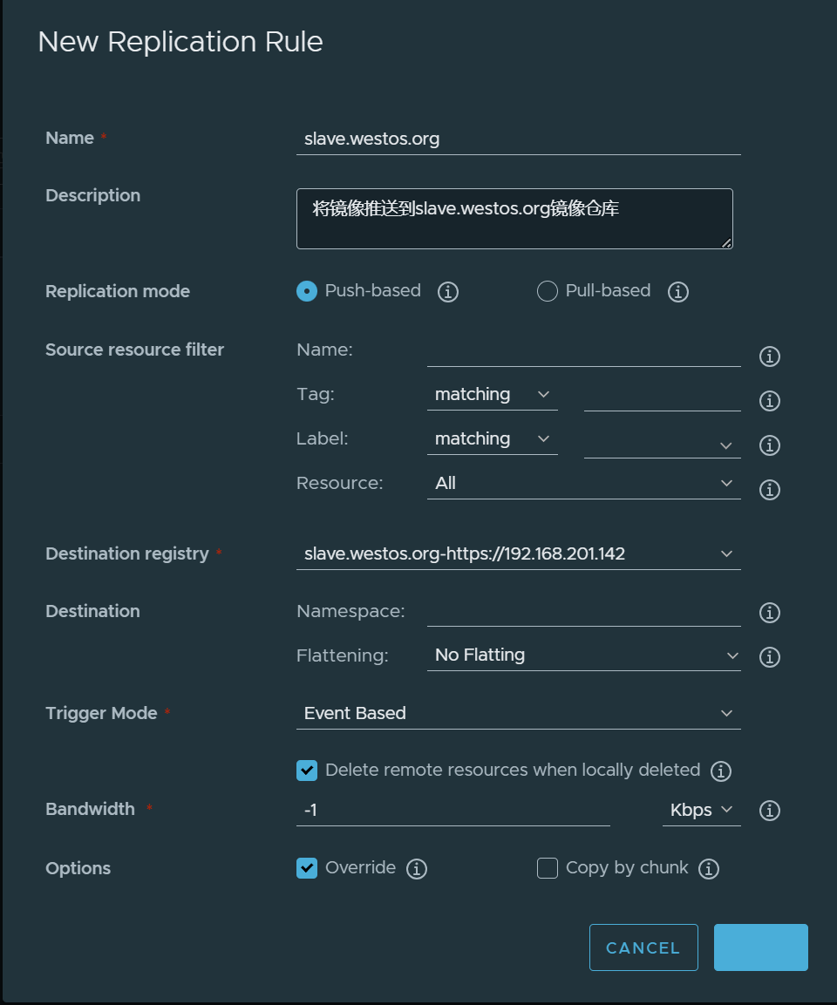
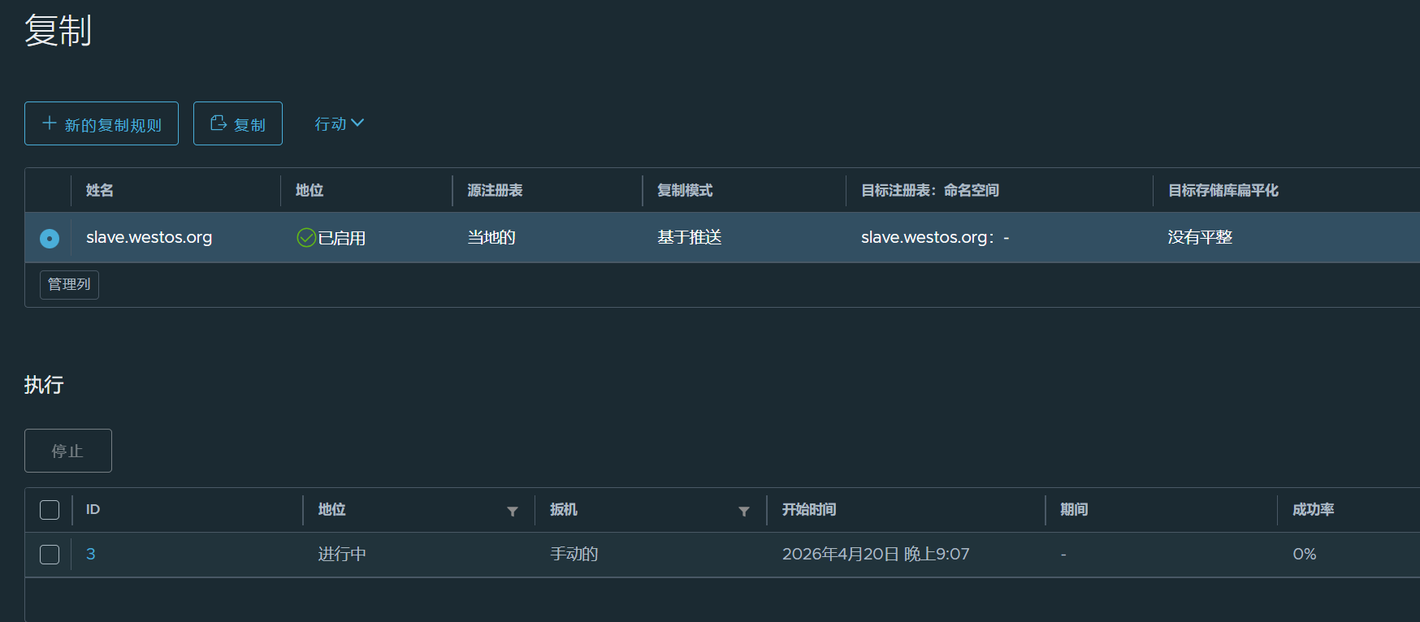
上传镜像测试触发复制，如果有另一台虚拟机，这里会显示pushed.
[root@localhost harbor]# docker push reg.westos.org/library/nginx:latest
自动触发同步，点击任务ID可以查看详情。
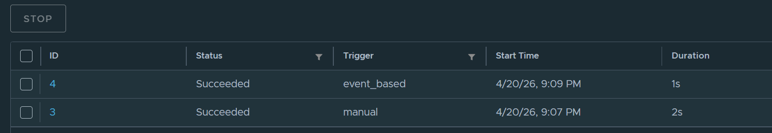
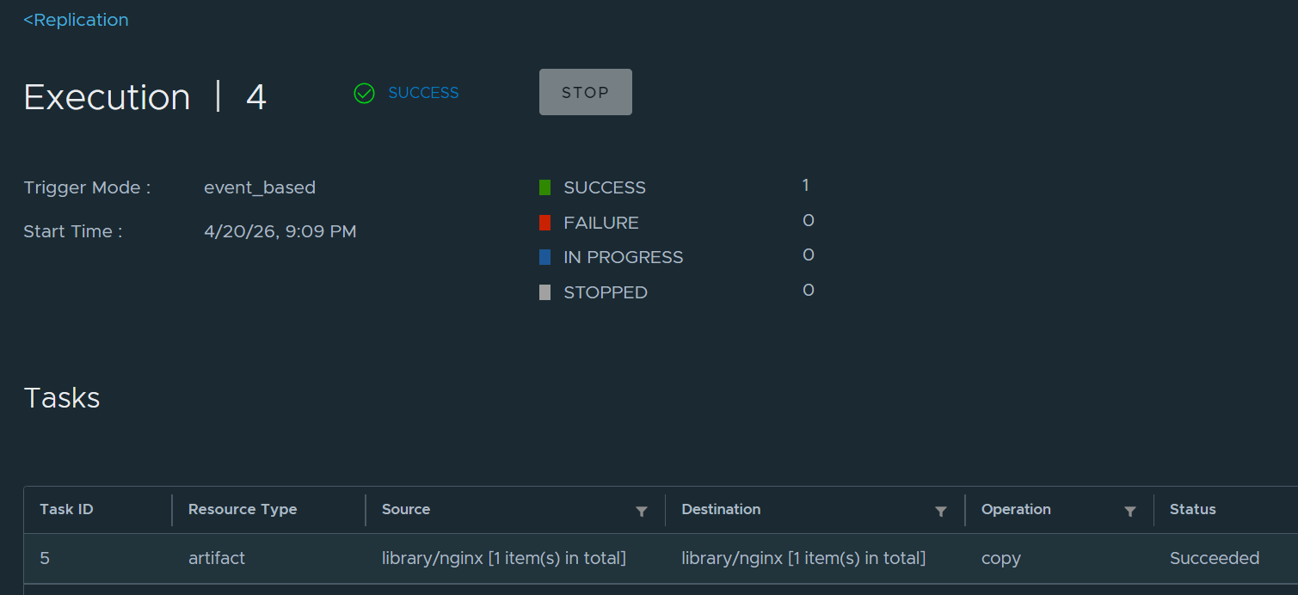

3 Docker安全

3.1 cpu资源限制
创建一个交互式容器，并限制其 CPU 使用量不超过 20%
[wangyijia@localhost ~]$ docker run -it --rm --cpu-period 100000 --cpu-quota 20000 busybox sh -c "while true; do :; done"

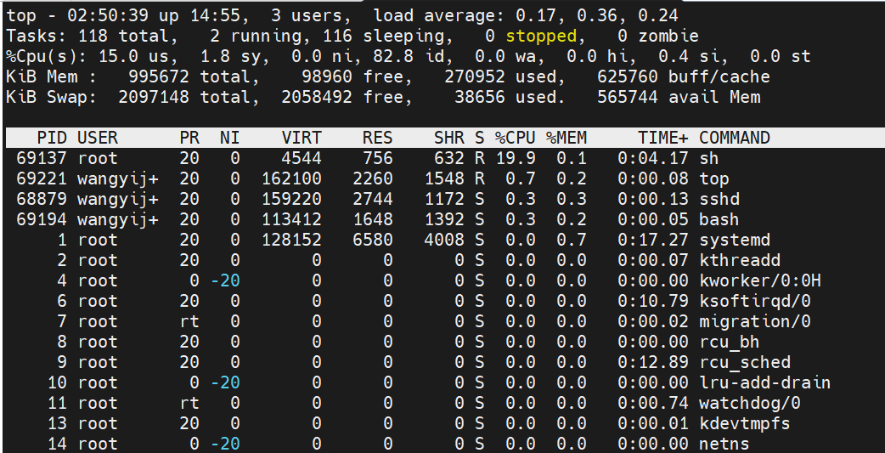
PID 69137 的 sh 进程（我启动的 busybox 死循环容器），%CPU 稳定在 19.9%，完美符合 --cpu-period 100000 --cpu-quota 20000 设定的 20% 上限。
总 CPU 空闲率 %Cpu(s): 82.8 id，说明系统资源充足，限制生效且无异常。

3.2 cpu优先级
[wangyijia@localhost proc]$ docker run -it --rm busybox
/ # dd if=/dev/zero of=/dev/null &
再开一个终端执行：
[wangyijia@reg ~]$ docker run -it --rm --cpu-shares 100 busybox
/ # dd if=/dev/zero of=/dev/null &
在宿主机top:
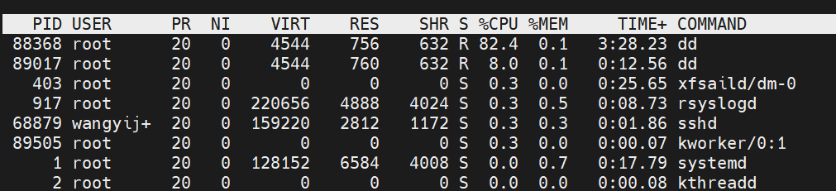
资源抢占生效。

3.3 内存资源限制
创建容器并严格限制其内存使用总量不超过 200MB
# docker run -d --name demo --memory 200M --memory-swap=200M nginx
查看容器内存限制配置
[wangyijia@localhost ~]$ docker run -d --name demo --memory 200M --memory-swap=200M nginx
e994fb7bcc8ce9b92cad367a38103a608f5565f7ec897d1644bf44c64fb5f188
[wangyijia@localhost ~]$ docker inspect -f '{{.HostConfig.Memory}} {{.HostConfig.MemorySwap}}' demo
209715200 209715200

3.4 lxcfs隔离
下载lxcf文件：
[wangyijia@localhost ~]$ yum install -y lxcfs-2.0.5-3.el7.centos.x86_64.rpm
[root@server1 ~]# yum install -y lxcfs
[root@server1 ~]# systemctl start lxcfs
[root@server1 ~]# docker run -it -m 256m \
-v /var/lib/lxcfs/proc/cpuinfo:/proc/cpuinfo:rw \
-v /var/lib/lxcfs/proc/diskstats:/proc/diskstats:rw \
-v /var/lib/lxcfs/proc/meminfo:/proc/meminfo:rw \
-v /var/lib/lxcfs/proc/stat:/proc/stat:rw \
-v /var/lib/lxcfs/proc/swaps:/proc/swaps:rw \
-v /var/lib/lxcfs/proc/uptime:/proc/uptime:rw \
Busybox

3.5 容器特权
默认容器内的用户是受限的
[root@server1 ~]# docker run -it --rm busybox
/ # ip a
1: lo: <LOOPBACK,UP,LOWER_UP> mtu 65536 qdisc noqueue qlen 1000
link/loopback 00:00:00:00:00:00 brd 00:00:00:00:00:00
inet 127.0.0.1/8 scope host lo
valid_lft forever preferred_lft forever
14: eth0@if15: <BROADCAST,MULTICAST,UP,LOWER_UP,M-DOWN> mtu 1500 qdisc noqueue
link/ether 02:42:ac:11:00:02 brd ff:ff:ff:ff:ff:ff
inet 172.17.0.2/16 brd 172.17.255.255 scope global eth0
valid_lft forever preferred_lft forever
/ # id
uid=0(root) gid=0(root) groups=0(root),10(wheel)
/ # ip link set down eth0
ip: SIOCSIFFLAGS: Operation not permitted
/ # fdisk -l
开启容器特权

[wangyijia@localhost proc]$ docker run -it --rm --privileged busybox
设置容器白名单
[wangyijia@localhost proc]$ docker run -it --rm --cap-add=NET_ADMIN busybox
/ # fdisk -l
/ # ip a a 10.0.0.1/24 dev eth0
/ # ip a
1: lo: <LOOPBACK,UP,LOWER_UP> mtu 65536 qdisc noqueue qlen 1000
link/loopback 00:00:00:00:00:00 brd 00:00:00:00:00:00
inet 127.0.0.1/8 scope host lo
valid_lft forever preferred_lft forever
inet6 ::1/128 scope host
valid_lft forever preferred_lft forever
192: eth0@if193: <BROADCAST,MULTICAST,UP,LOWER_UP,M-DOWN> mtu 1500 qdisc noqueue
link/ether 02:42:ac:11:00:03 brd ff:ff:ff:ff:ff:ff
inet 172.17.0.3/16 brd 172.17.255.255 scope global eth0
valid_lft forever preferred_lft forever
inet 10.0.0.1/24 scope global eth0
valid_lft forever preferred_lft forever
/ # ip a d 10.0.0.1/24 dev eth0
/ # ip a

4 Kubernetes集群部署与应用运维

4.1 集群环境初始化
首先将原虚拟机克隆四台，均为2CPU内核，2G内存，并远程连接。
sed -i 's/^SELINUX=.*/SELINUX=disabled/' /etc/selinux/config
[wangyijia@docker1 ~]$ getenforce
Disabled
安装软件yum install -y chrony

4.1.1 修改时间服务器
sudo bash -c 'cat > /etc/chrony.conf <<EOF
server ntp1.aliyun.com iburst
server ntp2.aliyun.com iburst
driftfile /var/lib/chrony/drift
makestep 1.0 3
rtcsync
allow 192.168.0.0/16
local stratum 10
EOF'
重启服务systemctl restart chronyd
测试chronyc sources -v
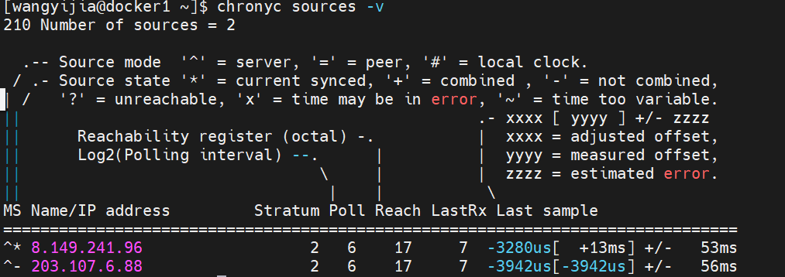
所有k8s集群节点执行以下步骤
[wangyijia@docker4 ~]$ sudo swapoff -a
[sudo] wangyijia 的密码：
[wangyijia@docker4 ~]$ sudo sed -i '/swap/s/^/#/' /etc/fstab
[wangyijia@docker4 ~]$ cat /etc/fstab
#
# /etc/fstab
# Created by anaconda on Tue Mar 31 08:55:22 2026
#
# Accessible filesystems, by reference, are maintained under '/dev/disk'
# See man pages fstab(5), findfs(8), mount(8) and/or blkid(8) for more info
#
/dev/mapper/centos-root / xfs defaults 0 0
UUID=9129554d-3c97-4a97-acbe-3c526a2dda11 /boot xfs defaults 0 0
#/dev/mapper/centos-swap swap swap defaults 0 0

4.1.2 修改内核参数
[wangyijia@docker1 ~]$ sudo bash -c 'cat > /etc/sysctl.d/k8s.conf <<EOF
> net.bridge.bridge-nf-call-iptables=1
> net.bridge.bridge-nf-call-ip6tables=1
> net.ipv4.ip_forward=1
> EOF'
[sudo] wangyijia 的密码：
[wangyijia@docker1 ~]$ sudo modprobe br_netfilter
[wangyijia@docker1 ~]$ sudo sysctl --system
[wangyijia@docker1 ~]$ sysctl net.bridge.bridge-nf-call-iptables net.ipv4.ip_forward
net.bridge.bridge-nf-call-iptables = 1
net.ipv4.ip_forward = 1

4.1.3 安装docker软件
[root@docker2 yum.repos.d]# vim docker.repo
[docker]
name=docker-ce
baseurl=https://mirrors.tuna.tsinghua.edu.cn/docker-ce/linux/centos/7/x86_64/stable/
gpgcheck=0
[centos]
name=extras
baseurl=https://mirrors.tuna.tsinghua.edu.cn/centos/7/extras/x86_64/
gpgcheck=0
[root@docker2 ~]# yum install -y docker-ce
[root@docker2 ~]# systemctl enable --now docker
[root@docker3 ~]# cat > /etc/docker/daemon.json <<EOF
> {
> "registry-mirrors": ["https://reg.westos.org"],
> "exec-opts": ["native.cgroupdriver=systemd"],
> "log-driver": "json-file",
> "log-opts": {
> "max-size": "100m"
> },
> "storage-driver": "overlay2",
> "insecure-registries": ["reg.westos.org"]
> }
> EOF
[root@docker2 ~]# systemctl restart docker
所有节点同步docker配置，以及拷贝harbor仓库的证书
[root@docker1 ~]# cd /etc/docker/
[root@docker1 docker]# ls
certs.d
[root@docker1 docker]# scp -r certs.d/ k8s2:/etc/docker/
确保所有k8s节点可以从私有仓库下载镜像
[root@docker2 docker]# docker pull nginx

4.1.4 所有节点安装kubeadm
# 1. 配置yum源
cat > /etc/yum.repos.d/k8s.repo <<EOF
[kubernetes]
name=Kubernetes
baseurl=https://mirrors.aliyun.com/kubernetes/yum/repos/kubernetes-el7-x86_64/
gpgcheck=0
EOF
# 2. 安装组件
yum install -y kubelet-1.23.17-0 kubeadm-1.23.17-0 kubectl-1.23.17-0
# 3. 启动kubelet
systemctl enable --now kubelet
克隆机部署Harbor
主机：[root@localhost ~]# scp harbor-all.tar.gz root@192.168.201.141:/root/
[root@localhost ~]# scp -r /etc/docker/certs.d root@192.168.201.141:/etc/docker/
克隆机docker1:
[root@docker1 ~]# tar zxf harbor-all.tar.gz
[root@docker1 ~]# mkdir -p /data
[root@docker1 ~]# cp -r certs /data/ 2>/dev/null
[root@docker1 ~]# systemctl stop firewalld
[root@docker1 ~]# echo "192.168.201.142 reg.westos.org" >> /etc/hosts
[root@docker1 ~]# echo '{"insecure-registries":["reg.westos.org"]}' > /etc/docker/daemon.json
[root@docker1 ~]# systemctl restart docker
[root@docker1 ~]# docker login reg.westos.org
Username: admin
Password:
WARNING! Your password will be stored unencrypted in /root/.docker/config.json.
Configure a credential helper to remove this warning. See
https://docs.docker.com/engine/reference/commandline/login/#credentials-store
Login Succeeded
拉取集群所需镜像
[root@k8s2 ~]# kubeadm config images pull --image-repository registry.aliyuncs.com/google_containers
先在harbor仓库上新建一个项目k8s
上传镜像
[root@docker1 ~]# docker images |grep google_containers | awk '{print $1":"$2}' | awk -F/ '{system("docker tag "$0" reg.westos.org/k8s/"$3"")}'
[root@docker1 ~]# docker images |grep k8s | awk '{system("docker push "$1":"$2"")}'

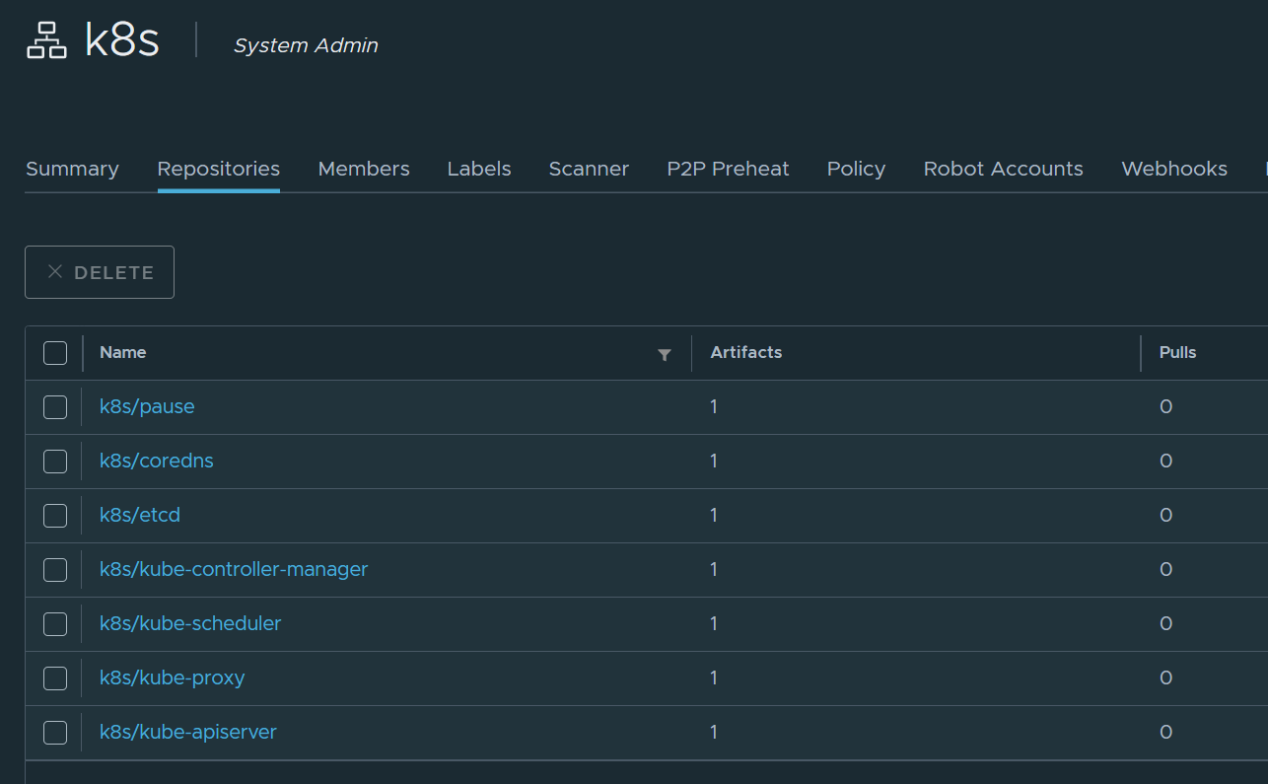

4.1.5 集群初始化
[root@docker1 ~]# systemctl daemon-reload
[root@docker1 ~]# systemctl restart docker
[root@docker1 ~]# systemctl restart kubelet
[root@docker1 ~]# kubeadm reset -f
[root@docker1 ~]# rm -rf /etc/cni/net.d /root/.kube
[root@docker1 ~]# iptables -F && iptables -t nat -F
[root@docker1 ~]# kubeadm init --pod-network-cidr=10.244.0.0/16 --image-repository reg.westos.org/k8s --kubernetes-version v1.23.17
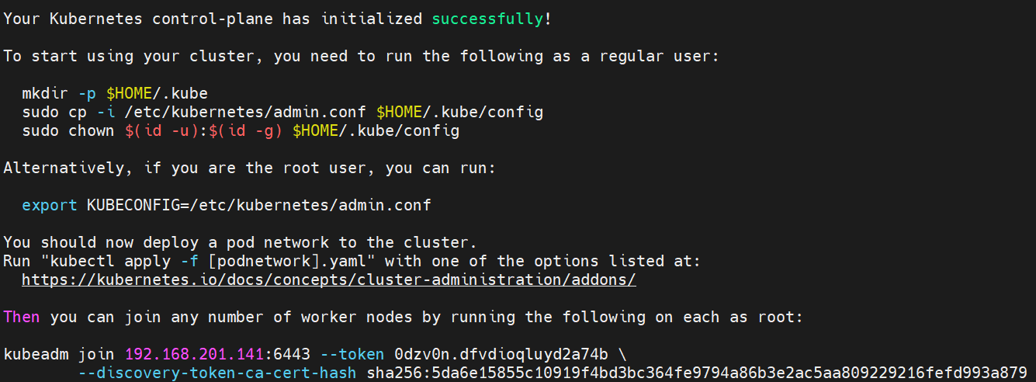

4.1.6 设置环境变量
[root@docker1 ~]# export KUBECONFIG=/etc/kubernetes/admin.conf
[root@docker1 ~]# vim .bash_profile
[root@docker1 ~]# export KUBECONFIG=/etc/kubernetes/admin.conf
查看集群状态
[root@docker1 ~]# kubectl get node
NAME STATUS ROLES AGE VERSION
docker1 NotReady control-plane,master 8m59s v1.23.17
当前节点还没有就绪，是因为没有安装网路插件，pod还没运行
[root@docker1 ~]# kubectl get pod -A
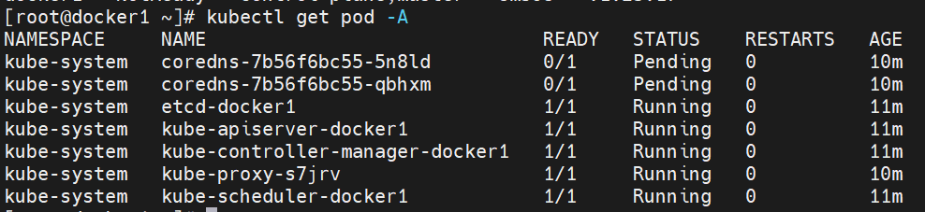

4.1.7 设置kubectl命令补齐
[root@docker1 ~]# yum install -y bash-completion
[root@docker1 ~]# echo "source <(kubectl completion bash)" >> ~/.bashrc
[root@docker1 ~]# source ~/.bashrc

4.2 安装calico网络插件

4.2.1 下载镜像
# docker pull quay.io/calico/cni:v3.31.0
# docker pull quay.io/calico/node:v3.31.0
# docker pull quay.io/calico/kube-controllers:v3.31.0
新建项目仓库calico.
# docker images |grep calico | awk '{print $1":"$2}' | awk -F/ '{system("docker tag "$0" reg.westos.org/calico/"$3"")}'
# docker images |grep 'reg.westos.org/calico' | awk '{system("docker push "$1":"$2"")}'
确保镜像上传成功
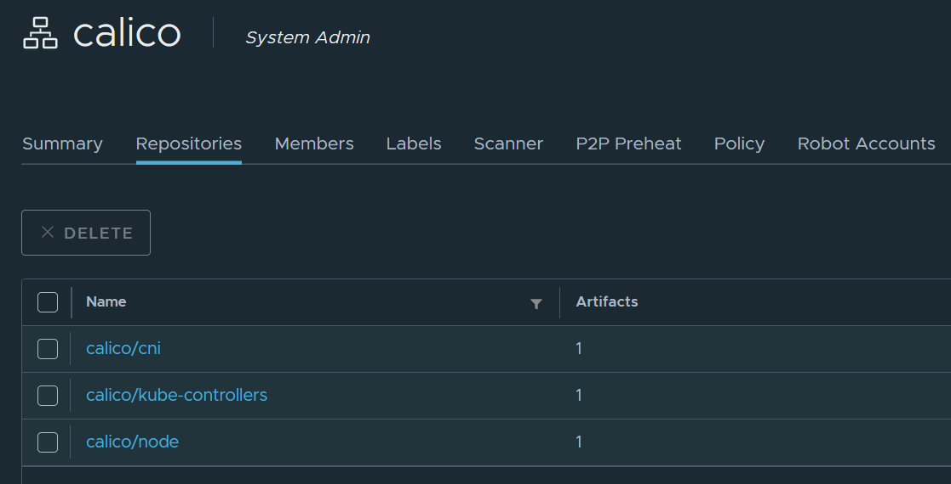
修改镜像位置，指向harbor仓库
# sed -i 's#quay.io/#reg.westos.org/#g' calico.yaml

4.2.2 部署网络插件
# kubectl apply -f calico.yaml
查看calico是否就绪
# kubectl get pod -A |grep calico
kube-system calico-kube-controllers-6ffd65b6f9-f8cxp 1/1 Running 0 112s
kube-system calico-node-wvgkc 1/1 Running 0 112s
查看节点状态
# kubectl get node
NAME STATUS ROLES AGE VERSION
server2 Ready control-plane 65m v1.23.17

4.2.3 扩容节点
首先确保其他三个节点能够登录harbor,其他节点走了docker代理，出现以下错误：
[root@docker2 ~]# docker login reg.westos.org
Username: admin
Password:
Error response from daemon: Get "http://reg.westos.org/v2/": proxyconnect tcp: dial tcp 192.168.0.103:7897: connect: connection refused
需要清理代理，重启docker:
mkdir -p /etc/systemd/system/docker.service.d
rm -rf /etc/systemd/system/docker.service.d/http-proxy.conf
rm -rf /etc/systemd/system/docker.service.d/proxy.conf
重启docker:
systemctl daemon-reload
systemctl restart docker
重新登录 Harbor成功：docker login reg.westos.org
再扩容节点，将其他节点加入集群，先在master机上查出有效哈希值：
[root@docker1 wangyijia]# kubeadm token create --print-join-command
kubeadm join 192.168.201.141:6443 --token ejlqfh.kjz4uakgopcv8lne --discovery-token-ca-cert-hash sha256:5da6e15855c10919f4bd3bc364fe9794a86b3e2ac5aa809229216fefd993a879
在三个节点虚拟机执行：
[root@docker2 ~]# kubeadm join 192.168.201.141:6443 --token ejlqfh.kjz4uakgopcv8lne --discovery-token-ca-cert-hash sha256:5da6e15855c10919f4bd3bc364fe9794a86b3e2ac5aa809229216fefd993a879
在master查看节点均已加入集群：
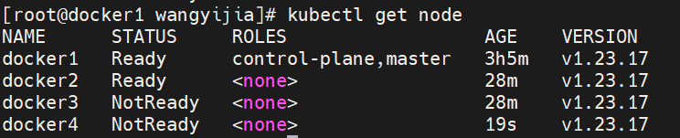

4.3 应用部署

4.3.1 下载测试镜像
在母机下载测试镜像，先将myapp.tar包拖入根目录执行：
docker load -i myapp.tar
打标签：
docker tag ikubernetes/myapp:v1 reg.westos.org/library/myapp:v1
docker tag ikubernetes/myapp:v2 reg.westos.org/library/myapp:v2
登录harbor,推送：
docker push reg.westos.org/library/myapp:v1
docker push reg.westos.org/library/myapp:v2
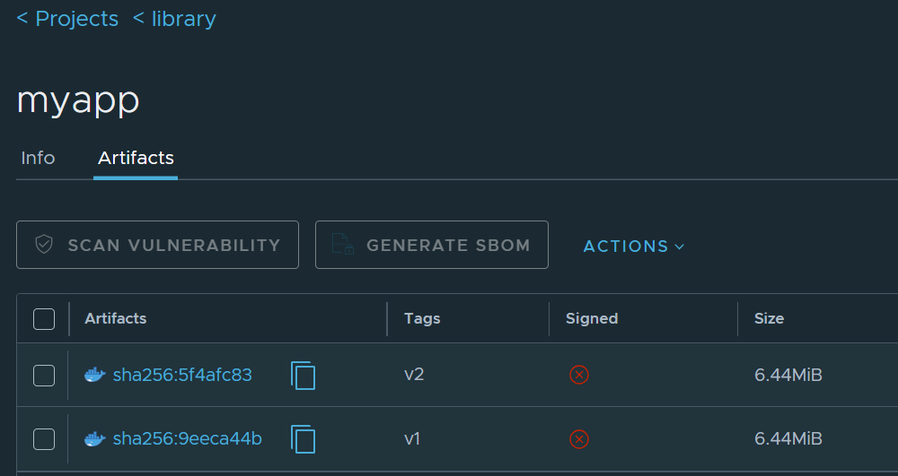

4.3.2 创建控制器
[root@docker1 wangyijia]# kubectl create deployment myapp --image=myapp:v1 --replicas=3
控制器自动维护pod副本数
[root@docker1 wangyijia]# kubectl get pod
NAME READY STATUS RESTARTS AGE
myapp-678fcbc488-jcjqg 1/1 Running 0 57s
myapp-678fcbc488-p7crf 1/1 Running 0 57s
myapp-678fcbc488-w4kvr 1/1 Running 0 57s
[root@docker1 wangyijia]# kubectl get deployments.apps
NAME READY UP-TO-DATE AVAILABLE AGE
myapp 3/3 3 3 82s
[root@docker1 wangyijia]# kubectl delete pod myapp-678fcbc488-jcjqg
pod "myapp-678fcbc488-jcjqg" deleted
[root@docker1 wangyijia]# kubectl get deployments.apps
NAME READY UP-TO-DATE AVAILABLE AGE
myapp 3/3 3 3 4m12s
[root@docker1 wangyijia]# kubectl get pod
NAME READY STATUS RESTARTS AGE
myapp-678fcbc488-p7crf 1/1 Running 0 4m57s
myapp-678fcbc488-ppzpv 1/1 Running 0 76s
myapp-678fcbc488-w4kvr 1/1 Running 0 4m57s
在远程pod中执行命令
[root@docker1 wangyijia]# kubectl exec myapp-678fcbc488-p7crf -- ls /usr/share/nginx/html
50x.html
index.html

4.3.3 扩容pod数量
[root@docker1 wangyijia]# kubectl scale deployment myapp --replicas=6
deployment.apps/myapp scaled
[root@docker1 wangyijia]# kubectl get pod
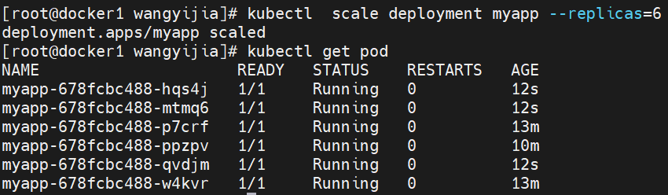

4.3.4 缩容
[root@docker1 wangyijia]# kubectl scale deployment myapp --replicas=3
deployment.apps/myapp scaled
[root@docker1 wangyijia]# kubectl get pod
NAME READY STATUS RESTARTS AGE
myapp-678fcbc488-p7crf 1/1 Running 0 16m
myapp-678fcbc488-ppzpv 1/1 Running 0 12m
myapp-678fcbc488-w4kvr 1/1 Running 0 16m
通过service暴露pod
[root@docker1 wangyijia]# kubectl expose deployment myapp --port=80 --target-port=80
service/myapp exposed
查看svc详情
[root@docker1 wangyijia]# kubectl describe svc myapp
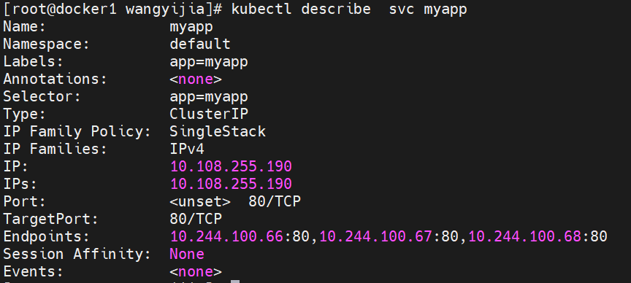
[root@docker1 wangyijia]# curl 10.108.255.190
Hello MyApp | Version: v1 | <a href="hostname.html">Pod Name</a>
[root@docker1 wangyijia]# curl 10.108.255.190/hostname.html
myapp-678fcbc488-p7crf
service自动发现pod扩容与缩容，自动更新endpoints，实现对应用的负载均衡
service默认使用clusterip类型，只能在集群中访问。

4.3.5 产看历史版本
[root@docker1 wangyijia]# kubectl rollout history deployment myapp
deployment.apps/myapp
REVISION CHANGE-CAUSE
1 <none>
2 <none>

4.3.6 回滚
[root@docker1 wangyijia]# kubectl rollout undo deployment myapp --to-revision=1
deployment.apps/myapp rolled back
[root@docker1 wangyijia]# curl 10.108.255.190
Hello MyApp | Version: v1 | <a href="hostname.html">Pod Name</a>

4.3.7 删除应用
[root@docker1 wangyijia]# kubectl delete deployments.apps myapp
deployment.apps "myapp" deleted
[root@docker1 wangyijia]# kubectl delete svc myapp
service "myapp" deleted
[root@docker1 wangyijia]# kubectl get pod
No resources found in default namespace.
集群通过namespace来做资源隔离，默认操作的资源都指向default：
[root@docker1 wangyijia]# kubectl get ns
NAME STATUS AGE
default Active 3h59m
kube-node-lease Active 3h59m
kube-public Active 3h59m
kube-system Active 3h59m

