**Setup and Deployment Guide**

**Setup Instructions**

The following steps will enable to run the application in local machine:

1. Install Node, Git, Robo 3T and Meteor in your machine. When the Meteor is installed, it will automatically install node if it is not already installed. The Meteor can be downloaded from following url:<https://www.meteor.com/install>

Robo 3T is a lightweight GUI for MongoDb and can be downloaded from: <https://robomongo.org/>

Git can be installed from the following url:

<https://git-scm.com/downloads>

The following commands can be used to verify the version of above mentioned packages:

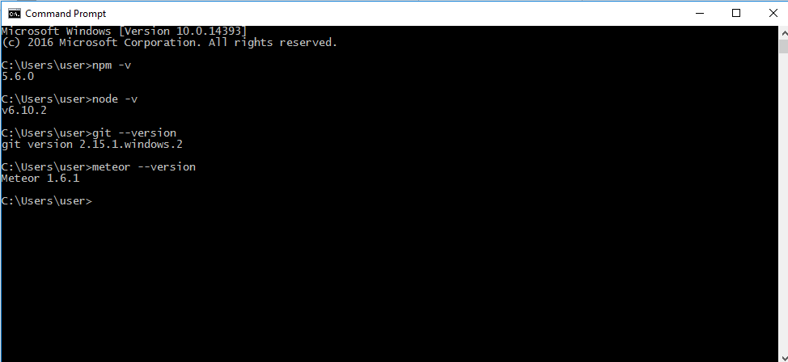

1. Create a folder and clone the following project:

Project Url: <https://github.com/brillob/HemoTrail>

Clone Url: <https://github.com/brillob/HemoTrail.git>

Once the project is cloned, execute the following command in the shell/terminal to install required npm packages: “*meteor npm install*”

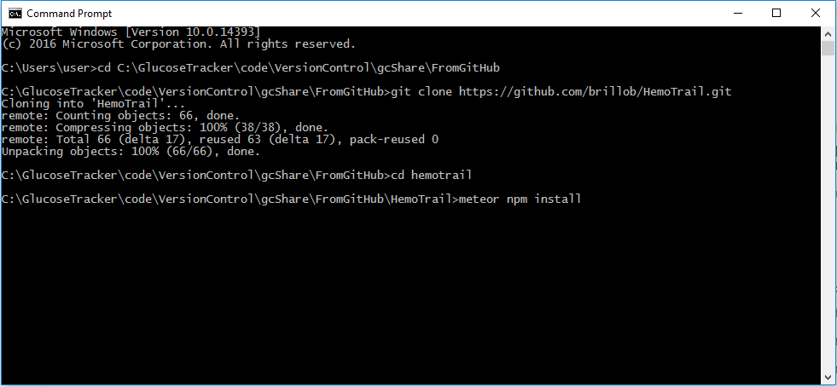

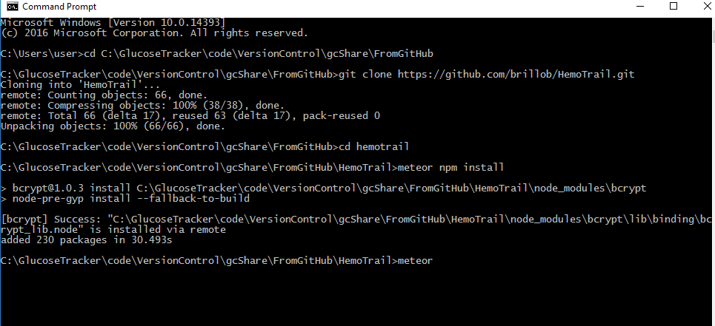

1. Execute the following command to Run the application: “*meteor --production*”. This will create the application for the web and also create MongoDb database and the web application will be available at:

<http://localhost:3000>

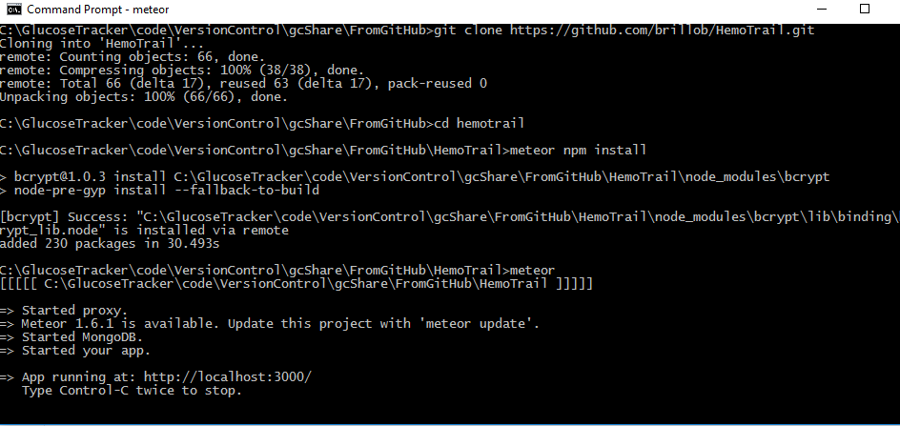

The MongoDb will be available at: <http://localhost:3001>

Open Robo 3T and click on File 🡪 Connect and then click on the “Create” link. Provide Address as “localhost” and the port as “3001” once the meteor app is running.

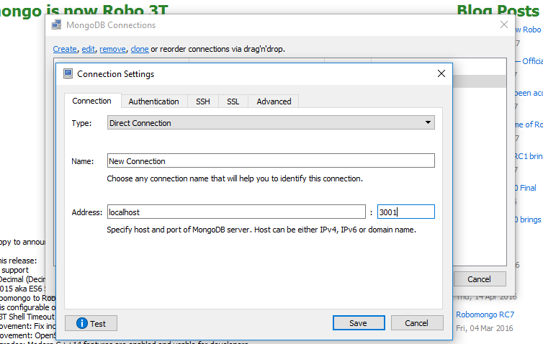

**Deployment Instructions:**

The following steps will enable to deploy the application to online remote machine:

1. Install Meteor Up package which will be used to setup and deploy the application to a remote online web server. Meteor Up can be installed by executing the following command: “npm install -g mup”
2. Navigate to the project folder and initialize the Meteor Up by executing the following command: “*mup init*”. Note: The Hemotrail project has already been initialized with Meteor up in the deploy folder before it was checked in to the source control and hence does not require additional initialization.

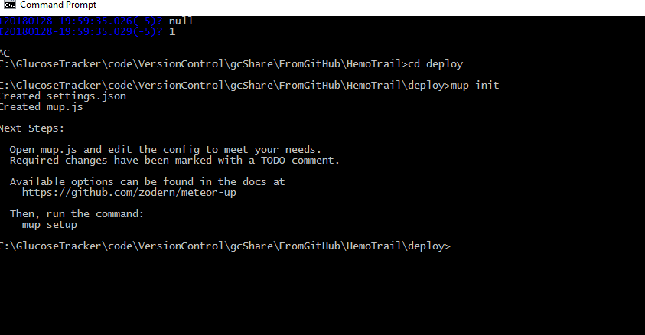

1. Update the mup.js file in the deploy folder to point the remote server and add any additional external database url if needed. This configuration file should contain the url of the remote server, username and password to connect to the server.

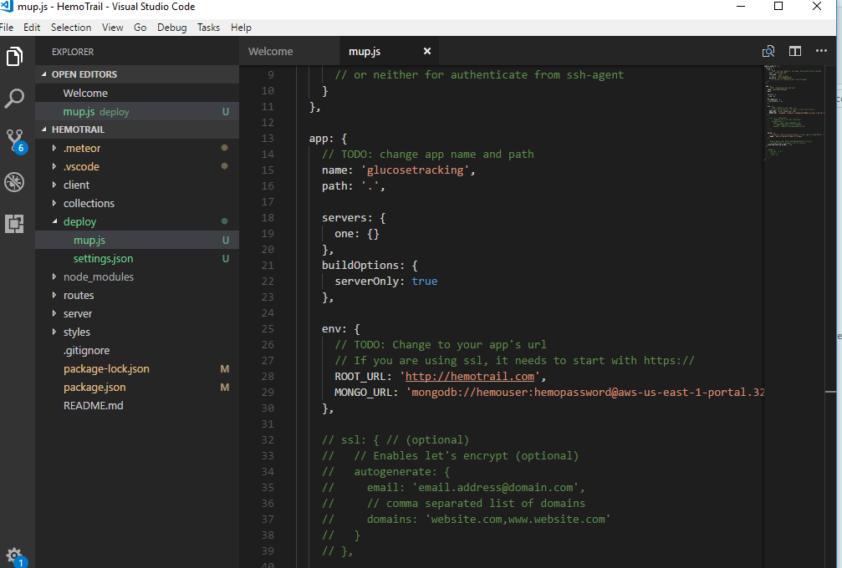

1. In the command terminal execute the following command to setup the configuration.

Windows: mup.cmd setup

Linux: mup setup.

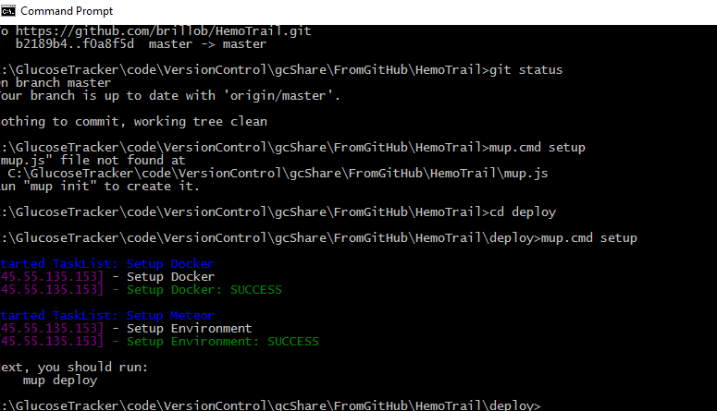

1. Once the configuration is completed, execute the following command to deploy the docker image to the remote online server:

Windows: mup.cmd deploy

Linux: mup deploy

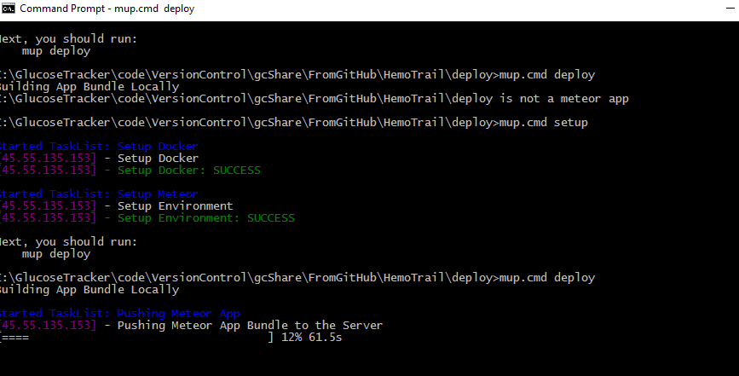

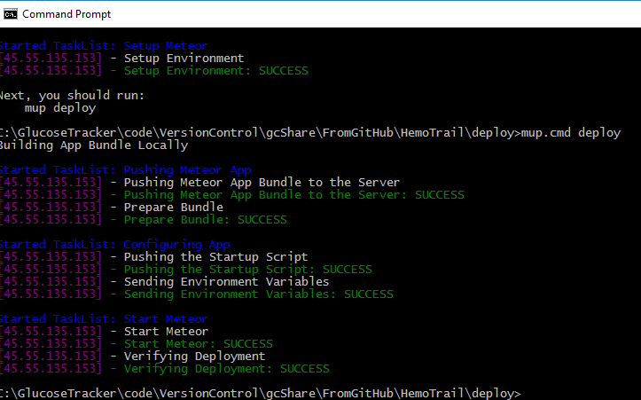

Once the deployment is successful, the web application will be available at the ip address of the remote server. The ip address can be later mapped to a domain name.