GHDx dataset

**Context:** Risk

**Location:** 8 regions

Global and

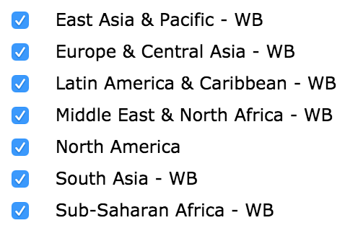

**Causes:**

N/A

**Risk:** 18 in total

Alcohol Use

Iron Deficiency

Vitamin A Deficiency

Zinc Deficiency

Diet Low in Fruits

Diet Low in Vegetables

Diet Low in Whole Grains

Diet Low in Nuts and Seeds

Diet Low in Milk

Diet High in Red Meat

Diet HIgh in Processed Meat

Diet High in Sugar-Sweetened Bev

Diet Low in Fiber

Diet suboptimal in calcium

Diet low in seafood omega 3 fatty acids

Diet low in polyunsaturated fatty acids

Diet high in trans fatty acids

Diet high in sodium

**Age:** All

**Sex:** All

**Year:** 1990, 1995, 2000, 2005, 2010, 2015

**Measure:** Death

**Metric:** Percent

Data download address:

<http://ghdx.healthdata.org/gbd-results-tool/result/f7faf4fb0c627d10d54ca002e712a335>