1背包
应该为：把objiect类改为私有变量，定义友员函数
//#include "stdafx.h"
#include <algorithm>
#include <iostream>
using namespace std;
template<class Typew,class Typep>
class Knap
{ friend Typep Knapsack(Typep [],Typew [],Typew,int);
private:
Typep Bound(int i);
void Backtrack(int i);
Typew c; //背包容量
int n; //物品数
Typew *w; //物品重量数组
Typep *p; //物品价值数组
Typew cw; //当前重量
Typep cp; //当前价值
Typep bestp;//当前最后价值
};
template<class Typew,class Typep>
void Knap<Typew,Typep>::Backtrack(int i)
{ if(i>n)//到达叶子节点
{ bestp = cp;
return; }
if(cw + w[i] <= c)//进入左子树
{ cw += w[i];
cp += p[i];
Backtrack(i+1);
cw -= w[i];
cp -= p[i];
}
if(Bound(i+1)>bestp) Backtrack(i+1); //进入右子树

}

template<class Typew, class Typep>
Typep Knap<Typew, Typep>::Bound(int i)// 计算上界
{ Typew cleft = c - cw; // 剩余容量
Typep b = cp;
// 以物品单位重量价值递减序装入物品
while (i <= n && w[i] <= cleft)
{ cleft -= w[i];
b += p[i];
i++; }

// 装满背包
if (i <= n) b += p[i]/w[i] * cleft;
return b;
}

class Object
{ friend int Knapsack(int *,int *,int,int);
friend bool compare(Object, Object);
public:
int operator <= (Object a) const
{ return (d>=a.d); }
private:
int ID;
float d;
};

bool compare(Object a, Object b) // sort使用
{
return a.d>b.d; //降序排列，如果改为return a<b，则为升序
}

template<class Typew,class Typep>
Typep Knapsack(Typep p[],Typew w[],Typew c,int n)
{ //为Knap::Backtrack初始化
Typew W = 0;
Typep P = 0;
Object *Q = new Object[n];
for(int i=1; i<=n; i++) {
Q[i-1].ID = i;
Q[i-1].d = 1.0 * p[i]/w[i];
P += p[i];
W += w[i];
}

if(W <= c) return P; //装入所有物品
sort(Q,Q+n, compare); //依物品单位重量价值排序

Knap<Typew,Typep> K;
K.p = new Typep[n+1];
K.w = new Typew[n+1];
for( i=1; i<=n; i++)
{ K.p[i] = p[Q[i-1].ID];
K.w[i] = w[Q[i-1].ID];
}
K.cp = 0;
K.cw = 0;
K.c = c;
K.n = n;
K.bestp = 0;
K.Backtrack(1); //回溯搜索
delete []Q;
delete []K.w;
delete []K.p;
return K.bestp;
}

void main()
{ // int n = 4;//物品数
// int c = 7;//背包容量
// int p[] = {0,9,10,7,4};//物品价值 下标从1开始
// int w[] = {0,3,5,2,1};//物品重量 下标从1开始

int n = 3;//物品数
int c = 50;//背包容量
int p[] = {0,60,120,100};//物品价值 下标从1开始
int w[] = {0,10,30,20};//物品重量 下标从1开始

cout<<"背包容量为："<<c<<endl;
cout<<"物品重量和价值分别为："<<endl;
for(int i=1; i<=n; i++)
cout<<"("<<w[i]<<","<<p[i]<<") ";
cout<<endl;
cout<<"背包能装下的最大价值为："<<Knapsack(p,w,c,n)<<endl;
}
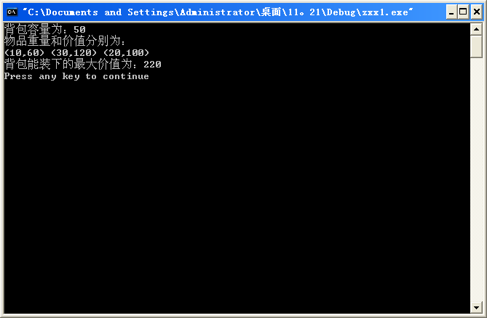

////2

//2 旅行员售货问题 回溯法求解
#include "stdafx.h"
#include <iostream>
#include <fstream>
using namespace std;
ifstream fin("ex3.txt");
const int N = 4;//图的顶点数
template<class Type>
class Traveling {
template<class Type>
friend Type TSP(Type **,int);
//friend Type TSP(Type **a,Type);

// private:
public:
void Backtrack(int i);
int n, // 图G的顶点数
*x, // 当前解
*bestx; // 当前最优解
Type **a, // 图G的领接矩阵
cc, // 当前费用
bestc; // 当前最优值
int NoEdge; // 无边标记
};

/*
template <class Type>
inline void Swap(Type &a, Type &b);

template<class Type>
Type TSP(Type **a, int n);

*/

template<class Type>
void Traveling<Type>::Backtrack(int i)
{
if (i == n)
{
if (a[x[n-1]][x[n]] != 0 && a[x[n]][1] != 0 &&
(cc + a[x[n-1]][x[n]] + a[x[n]][1] < bestc || bestc == 0))
{
for (int j = 1; j <= n; j++) bestx[j] = x[j];
bestc = cc + a[x[n-1]][x[n]] + a[x[n]][1];
}
}
else
{
for (int j = i; j <= n; j++)
{
// 是否可进入x[j]子树?
if (a[x[i-1]][x[j]] != 0 && (cc + a[x[i-1]][x[i]] < bestc || bestc == 0))
{
// 搜索子树
Swap(x[i], x[j]);
cc += a[x[i-1]][x[i]]; //当前费用累加
Backtrack(i+1); //排列向右扩展,排列树向下一层扩展
cc -= a[x[i-1]][x[i]];
Swap(x[i], x[j]);
}
}
}
}

template<class Type>
//Type TSP(Type **a, int n,Type NoEdge)
Type TSP(Type **a, int n)
{
Traveling<Type> Y;
Y.n=n;
Y.x=new int[n+1];
Y.bestx=new int[n+1];

for(int i=1;i<=n;i++)
Y.x[i]=i;
Y.a=a;
Y.cc=0;
Y.bestc=0;
Y.NoEdge=0;
Y.Backtrack(2);
cout<<"最短回路为："<<endl;
for( i=1;i<=n;i++)
cout<<Y.bestx[i]<<" --> ";
cout<<Y.bestx[1]<<endl;
delete [] Y.x;
Y.x=0;
delete [] Y.bestx;
Y.bestx=0;
return Y.bestc;
}

template <class Type>
inline void Swap(Type &a, Type &b)
{ Type temp=a;
a=b;
b=temp;
}

void main() {
cout<<"图的顶点个数 n="<<N<<endl;
int **a=new int*[N+1];
for(int i=0;i<=N;i++)
a[i]=new int[N+1];
cout<<"图的邻接矩阵为:"<<endl;
for(i=1;i<=N;i++)
{ for(int j=1;j<=N;j++)
{ fin>>a[i][j];
cout<<a[i][j]<<" ";
}
cout<<endl;
}
cout<<"最短回路的长为："<<TSP(a,N)<<endl;
for(i=0;i<=N;i++)
delete []a[i];

delete []a;
a=0;
}

Ex3.txt
0 30 6 4
30 0 5 10
6 5 0 20
4 10 20 0

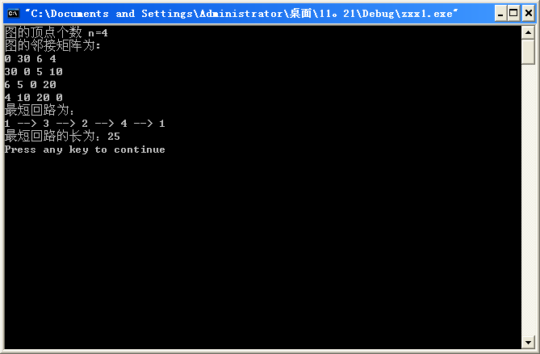

///完整代码：与教材一致：
Ex3.txt
0 30 6 4
30 0 5 10
6 5 0 20
4 10 20 0

//旅行员售货问题 回溯法求解

#include <fstream>
#include <iostream>
using namespace std;
ifstream fin("ex3.txt");
const int N = 4;//图的顶点数
template <class Type>
class Traveling {
friend Type TSP(Type **,int [],int,Type);
private:
void Backtrack(int i);
int n, // 图G的顶点数
*x, // 当前解
*bestx; // 当前最优解
Type **a, // 图G的领接矩阵
cc, // 当前费用
bestc, // 当前最优值
NoEdge; // 无边标记
};

template<class Type>
void Traveling<Type>::Backtrack(int i)
{
if (i == n)
{
if (a[x[n-1]][x[n]] != NoEdge && a[x[n]][1] != NoEdge &&
(cc + a[x[n-1]][x[n]] + a[x[n]][1] < bestc || bestc == NoEdge))
{
for (int j = 1; j <= n; j++) bestx[j] = x[j];
bestc = cc + a[x[n-1]][x[n]] + a[x[n]][1];
}
}
else
{
for (int j = i; j <= n; j++)
{
// 是否可进入x[j]子树?
if (a[x[i-1]][x[j]] != NoEdge && (cc + a[x[i-1]][x[i]] < bestc || bestc == NoEdge))
{
// 搜索子树
Swap(x[i], x[j]);
cc += a[x[i-1]][x[i]]; //当前费用累加
Backtrack(i+1); //排列向右扩展,排列树向下一层扩展
cc -= a[x[i-1]][x[i]];
Swap(x[i], x[j]);
}
}
}
}

template<class Type>
Type TSP(Type **a, int v[],int n,Type NoEdge)
{ Traveling<Type> Y;
Y.x=new int[n+1];
for(int i=1;i<=n;i++)
Y.x[i]=i;
Y.a=a;
Y.n=n;
Y.bestc=NoEdge;
Y.bestx=v;
Y.cc=0;
Y.NoEdge=NoEdge;
Y.Backtrack(2);
delete [] Y.x;
return Y.bestc;
}

template <class Type>
inline void Swap(Type &a, Type &b)
{ Type temp=a;
a=b;
b=temp;
}

void main() {
cout<<"图的顶点个数 n="<<N<<endl;
int *bestx=new int [N+1];

int **a=new int*[N+1];
for(int i=0;i<=N;i++)
a[i]=new int[N+1];

for( i=0;i<=N;i++)
bestx[i]=0;
cout<<"图的邻接矩阵为:"<<endl;
for(i=1;i<=N;i++)
{ for(int j=1;j<=N;j++)
{ fin>>a[i][j];
cout<<a[i][j]<<" ";
}
cout<<endl;
}
cout<<"最短回路的长为："<<TSP(a,bestx,N,0)<<endl;
cout<<"最短回路为is ："<<endl;
for( i=1;i<=N;i++)
cout<<bestx[i]<<" --> ";
cout<<bestx[1]<<endl;
delete bestx;
for(i=0;i<=N;i++)
delete []a[i];
delete []a;
}
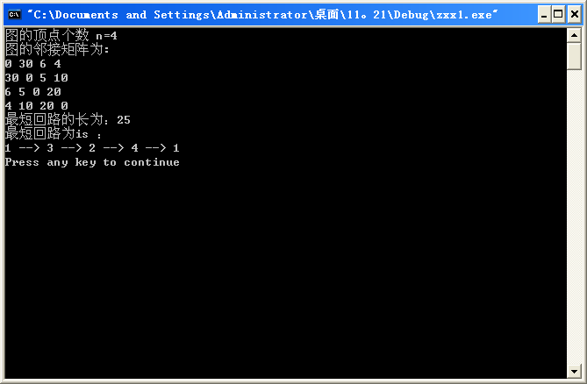

3装载问题
#include <iostream>
using namespace std;
template <class Type>
class Loading
{ friend Type MaxLoading(Type[],Type,int,int []);
private:
void Backtrack(int i);
int n, //集装箱数
*x, //当前解
*bestx; //当前最优解
Type *w, //集装箱重量数组
c, //第一艘轮船的载重量
cw, //当前载重量
bestw, //当前最优载重量
r; //剩余集装箱重量
};
template <class Type>
void Loading <Type>::Backtrack (int i)// 搜索第i层结点

{ if (i > n)// 到达叶结点
{ if (cw>bestw)
{ for(int j=1;j<=n;j++)
{ bestx[j]=x[j];//更新最优解
bestw=cw;
}
}
return;
}
r-=w[i];
if (cw + w[i] <= c) // 搜索左子树
{ x[i] = 1;
cw += w[i];
Backtrack(i+1);
cw-=w[i];
}

if (cw + r > bestw)
{ x[i] = 0; // 搜索右子树
Backtrack(i + 1);
}
r+=w[i];
}

template<class Type>
Type MaxLoading(Type w[], Type c, int n, int bestx[])//返回最优载重量
{ Loading<Type>X;
X.x=new int[n+1]; //初始化X
X.w=w;
X.c=c;
X.n=n;
X.bestx=bestx;
X.bestw=0;
X.cw=0;
X.r=0; //初始化r
for (int i=1;i<=n;i++)
X.r+=w[i];
X.Backtrack(1);
delete []X.x;
return X.bestw;
}

void main()
{//int n=3,m=0;
//int w[4]={0,10,40,40},c1=50,c2=50,bestx[4];
int n=5,m=0;
int w[6]={0,10,40,20,50,30}, c1=80, c2=70,bestx[6];
cout<<" BestW = "<<MaxLoading(w, c1, n, bestx)<<endl;
cout<<"\n X1:";
for ( int i=1;i<=n;i++)
cout<<" "<<bestx[i];
cout<<endl;
cout<<"\n X2:";
for (i=1; i<=n; i++)
cout<<" "<<(bestx[i]?0:1);
for (i=1;i<=n;i++)
m=m+w[i]*(1-bestx[i]);
cout<<"m= "<<m<<endl;
}

