完整代码:

#include <iostream.h>
void sort(int a[],int t[],int n)
{ int temp,min;
for(int i=1;i<=n;i++)
t[i]=i;
for( i=1;i<=n;i++)
{ min=i;//先假设最小下标为i
for(int j=i+1;j<=n;j++)
if(a[j]<a[min]) min=j;//对i之后的数进行扫描将最小的数赋予min
temp=a[i]; a[i]=a[min]; a[min]=temp;
temp=t[i]; t[i]=t[min]; t[min]=temp;
}}
void Loading(int x[],int w[],int c,int n)
{int *t = new int [n+1]; int i;
sort(w, t, n);
for (i=1;i<=n;i++) x[i] = 0;
for (i=1;i<=n&&w[i]<=c;i++) {x[t[i]]=1; c-=w[i];}
}
void main()//用main函数验证
{int w[9]={0,100,200,50,90,150,50,20,80},x[9]={0};int c=400;
Loading(x,w,c,8);
for(int i=1;i<=8;i++)
cout<<x[i]<<" ";
cout<<endl;

}

//运行结果为390
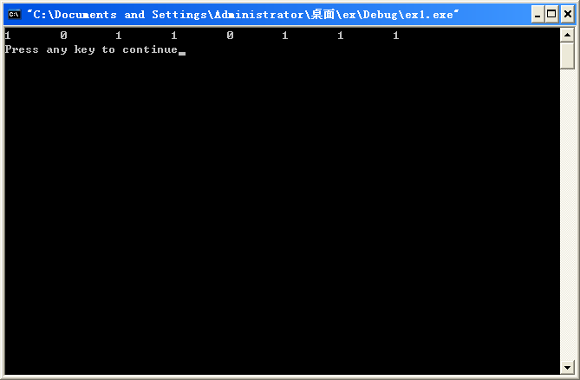

请把运行结果输出,下面这样输出为什么不对?
for(i=1;i<=8;i++)
{ sum=sum+w[i]*x[i];
cout<<x[i]<<" ";}
cout<<"sum="<<sum<<endl;

2.注意排序之后:

#include <iostream.h>
void sort(int a[],int t[],int n)
{ int temp,min;
for(int i=1;i<=n;i++)
t[i]=i;
for( i=1;i<=n;i++)
{ min=i;//先假设最小下标为i
for(int j=i+1;j<=n;j++)
if(a[j]<a[min]) min=j;//对i之后的数进行扫描将最小的数赋予min
temp=a[i]; a[i]=a[min]; a[min]=temp;
temp=t[i]; t[i]=t[min]; t[min]=temp;
}}
void Loading(int x[],int w[],int c,int n)
{int *t = new int [n+1]; int i;
sort(w, t, n);
for (i=1;i<=n;i++) x[i] = 0;
for (i=1;i<=n&&w[i]<=c;i++) {x[t[i]]=1; c-=w[i];}
}
void main()//用main函数验证
{int w[9]={0,100,200,50,90,150,50,20,80},x[9]={0},a[9];int c=400,sum=0;
for(int i=1;i<=8;i++)
a[i]=w[i];
Loading(x,w,c,8);
for(i=1;i<=8;i++)
{ sum=sum+w[i]*x[i];
cout<<x[i]<<" ";}
cout<<"sum="<<sum<<endl;
sum=0;
for(i=1;i<=8;i++)
{ sum=sum+a[i]*x[i];
cout<<x[i]<<" ";}
cout<<"sum="<<sum<<endl;

}
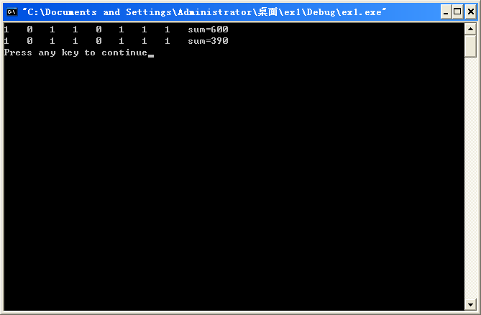

3.类定义:
为什么结果不对?
#define N 8
#define M 400
#include <iostream>
#include <algorithm>
using namespace std;
class Loadtype
{public:
int operator<=(Loadtype a) const
{ return (w<=a.w); }
int w;
int index;

};
bool compare(Loadtype a, Loadtype b) // sort使用
{
return a.w<b.w; //如果改为return a<b，则为升序
}
void Loading(int n, int w[],int x[])
{int t[N];
Loadtype *d=new Loadtype[n];
for (int i=0; i<n; i++)
{d[i].w=w[i]; //30,20,10
d[i].index=i; // 0, 1, 2
}
sort(d, d+N, compare);
for (i=0;i<n;i++) {x[i]=0;t[i]=d[i].index;}
float c=M;
for (i=0;i<n&&w[i]<=c;i++) {x[t[i]]=1; c-=w[i];}
delete d;
}
void main()
{int w[N]={100,200,50,90,150,50,20,80},x[N]={0};
Loading(N, w, x);
for(int i=0;i<8;i++)
cout<<x[i]<<" ";
}

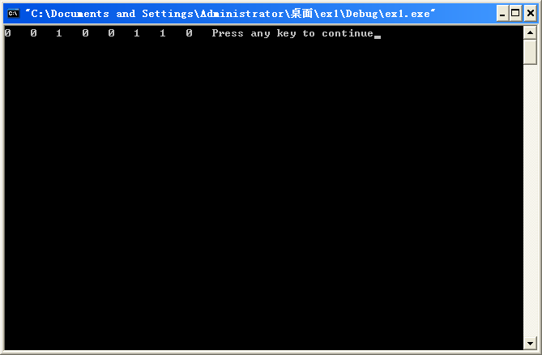

下面的代码是正确的:
#define N 8
#define M 400
#include <iostream>
#include <algorithm>
using namespace std;
class Loadtype
{public:
int operator<=(Loadtype a) const
{ return (w<=a.w); }
int w;
int index;

};
bool compare(Loadtype a, Loadtype b) // sort使用
{
return a.w<b.w; //如果改为return a<b，则为升序
}
void Loading(int n, int w[],int x[])
{int t[N];
Loadtype *d=new Loadtype[n];
for (int i=0; i<n; i++)
{d[i].w=w[i]; //30,20,10
d[i].index=i; // 0, 1, 2
}
sort(d, d+N, compare);
for (i=0;i<n;i++) {x[i]=0;t[i]=d[i].index;}
float c=M;
for (i=0;i<n&&w[t[i]]<=c;i++) {x[t[i]]=1; c-=w[t[i]];}
delete d;
}
void main()
{int w[N]={100,200,50,90,150,50,20,80},x[N]={0},sum=0;
Loading(N, w, x);
for(int i=0;i<8;i++)
{cout<<x[i]<<" ";
sum=sum+w[i]*x[i];}
cout<<"sum="<<sum<<endl;
}

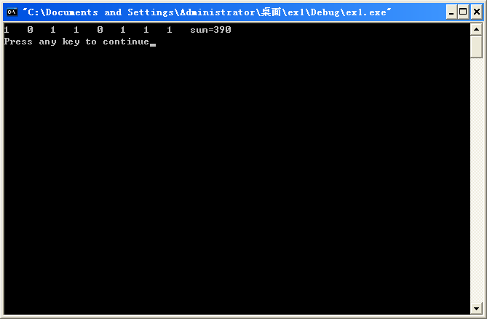

二、找零钱问题：
参考下面结果对吗？说出原因：如果不对请完给排序，使结果正确
#include <iostream.h>
void pay(int m[], int V)
{int i,R,n[12];
for (i=0;i<12;i++)
n[i]=0;
R=V;i=0;
while (R>0)
{ if (m[i]<=R) { R-=m[i];n[i]++;}
else i++;
}
for (i=0;i<12;i++)
cout<<n[i]<<" ";}
void main()
{int m[]={2000,5000,1000,500,200,100,50,20,10,5,2,1};
pay(m,6500);}

正确代码：

#define N 12
#include <iostream.h>
#include <algorithm>
using namespace std;
class PayType
{public:
int operator>=(PayType a) const
{ return (w>=a.w); }
int w;
int index;
};
bool compare(PayType a, PayType b) // sort使用
{
return a.w>b.w; //如果改为return a<b，则为升序
}
void pay(int m[],int R)
{int t[N]={0},n[N]={0};
PayType *d=new PayType[N];
for (int i=0; i<N; i++)
{d[i].w=m[i]; //30,20,10
d[i].index=i; // 0, 1, 2
}
sort(d, d+N, compare);
for (i=0;i<N;i++)
t[i]=d[i].index;
i=0;
while (R>0)
{ if (m[t[i]]<=R) { R-=m[t[i]];n[t[i]]++;}
else i++;
}
for (i=0;i<N;i++)
cout<<n[i]<<" ";}
void main()
{int m[]={2000,5000,1000,500,200,100,50,20,10,5,2,1};
pay(m,6500);}

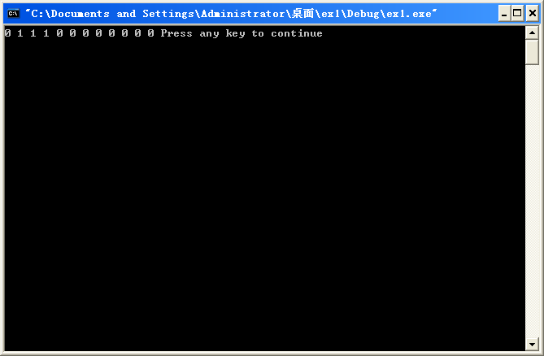

活动安排问题：
不对：???

#include <stdio.h>
#define N 11
#include <algorithm>
using namespace std;
class Activity
{public:
int operator<=(Activity a) const
{ return (f<=a.f); }
int s,f;
int index;
};
bool compare(Activity a, Activity b) // sort使用
{ return a.f<b.f; //return a<b，为升序
}
void GreedySelector(int n, int s[], int f[], bool A[],int t[])
{Activity *d=new Activity[n+1];
for (int i=1; i<=n; i++)
{d[i].s=s[i]; //start time
d[i].f=f[i]; // finish time
d[i].index=i; } // 活动编号1, 2, 3
sort(d+1, d+N+1, compare);
for (i=1;i<=n;i++) {s[i]=d[i].s;f[i]=d[i].f;A[i]=0;t[i]=d[i].index;}
A[t[1]]=1;int j=1;
for (i=2; i<=n; i++ )
if (s[i]>=f[j]) {A[t[i]]=1;j=i;}
else A[t[i]]=0;
delete d;
}

void main()
{int s[]={0,3,1,0,5,3,5,6,8,8,2,12};
int f[]={0,5,4,6,7,8,9,10,11,12,13,14};
int x[N+1]={0};int t[N+1]={0};bool A[N+1]={0};
GreedySelector(N, s, f, A,t);
for (int i=1; i<=N; i++)
if (A[i]) printf("项目 %d [%d,%d]\n",i,s[t[i]],f[t[i]]);}

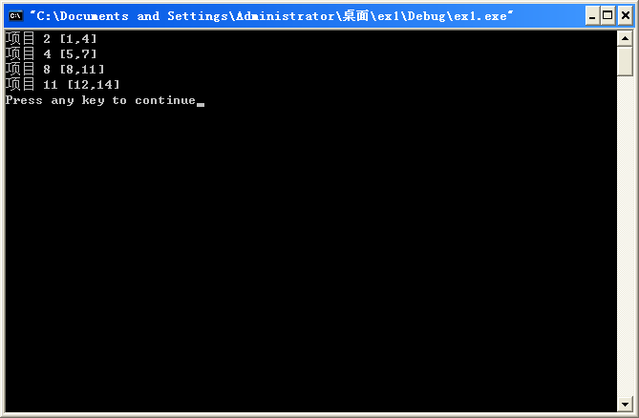

不对：???
#include <stdio.h>
#define N 11
#include <algorithm>
using namespace std;
class Activity
{public:
int operator<=(Activity a) const
{ return (f<=a.f); }
int s,f;
int index;
};
bool compare(Activity a, Activity b) // sort使用
{ return a.f<b.f; //return a<b，为升序
}
void GreedySelector(int n, int s[], int f[], bool A[],int t[])
{Activity *d=new Activity[n+1];
for (int i=1; i<=n; i++)
{d[i].s=s[i]; //start time
d[i].f=f[i]; // finish time
d[i].index=i; } // 活动编号1, 2, 3
sort(d+1, d+N+1, compare);
for (i=1;i<=n;i++)
{A[i]=0;t[i]=d[i].index;}
A[t[1]]=1;int j=1;
for (i=2; i<=n; i++ )
if (s[t[i]]>=f[t[j]]) {A[t[i]]=1;j=i;}
else A[t[i]]=0;
delete d;
}

void main()
{int s[]={0,3,1,0,5,3,5,6,8,8,12,2};
int f[]={0,5,4,6,7,8,9,10,11,12,14,13};
int x[N+1]={0};int t[N+1]={0};bool A[N+1]={0};
GreedySelector(N, s, f, A,t);
for (int i=1; i<=N; i++)
if (A[i]) printf("项目 %d [%d,%d]\n",i,s[t[i]],f[t[i]]);}

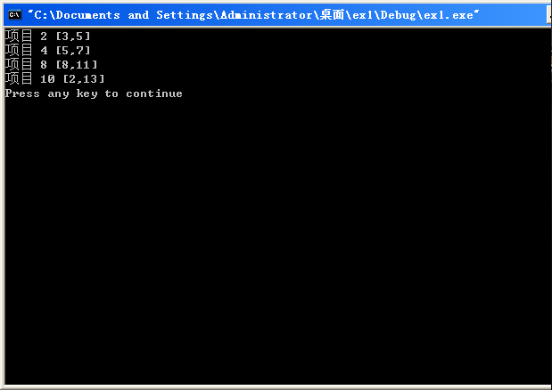

另：
//

#include <stdio.h>
#define N 11
#include <algorithm>
using namespace std;
class Activity
{public:
int operator<=(Activity a) const
{ return (f<=a.f); }
int s,f;
int index;
};
bool compare(Activity a, Activity b) // sort使用
{ return a.f<b.f; //return a<b，为升序
}
void GreedySelector(int n, int s[], int f[], bool A[],int t[])
{Activity *d=new Activity[n+1];
for (int i=1; i<=n; i++)
{d[i].s=s[i]; //start time
d[i].f=f[i]; // finish time
d[i].index=i; } // 活动编号1, 2, 3
sort(d+1, d+N+1, compare);
for (i=1;i<=n;i++)
{A[i]=0;t[i]=d[i].index;}
A[t[1]]=1;int j=1;
for (i=2; i<=n; i++ )
if (s[t[i]]>=f[t[j]]) {A[t[i]]=1;j=i;}
else A[t[i]]=0;
delete d;
}

void main()
{int s[]={0,3,1,0,5,3,5,6,8,8,12,2};
int f[]={0,5,4,6,7,8,9,10,11,12,14,13};
int x[N+1]={0};int t[N+1]={0};bool A[N+1]={0};
GreedySelector(N, s, f, A,t);
for (int i=1; i<=N; i++)
if (A[i]) printf("项目 %d [%d,%d]\n",i,s[i],f[i]);}

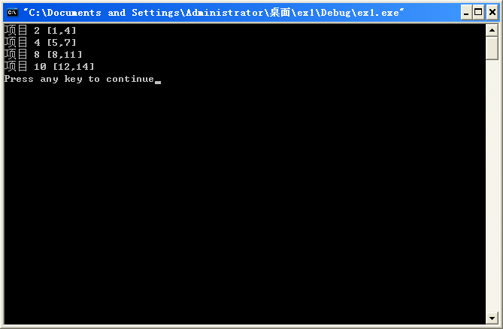

背包问题：

贪心背包：
#define N 3
#define M 50
#include <iostream>
#include <algorithm>
using namespace std;
class Knaptype
{public:
int operator>=(Knaptype a) const
{ return (vw>=a.vw); }
float v,w,vw;
int index;
};
bool compare(Knaptype a, Knaptype b) // sort使用
{
return a.vw>b.vw; //降序排列，如果改为return a<b，则为升序
}

void Knapsack(int n, float w[], float v[], float x[])
{int t[N+1];
Knaptype *d=new Knaptype[n+1];
for (int i=1; i<=n; i++)
{d[i].w=w[i]; //30,20,10
d[i].v=v[i]; // 120,100,60
d[i].vw=v[i]/w[i]; // 120,100,60
d[i].index=i; // 1, 2, 3
}
sort(d+1, d+N+1, compare);
//sort(d, d+N, compare);

for (i=1;i<=n;i++) {x[i]=0;t[i]=d[i].index;}
float c=M;
for (i=1;i<=n;i++)
{if (w[t[i]]>c) break;
x[t[i]]=1;c-=w[t[i]];}
if (i<=n) x[t[i]]=c/w[t[i]];
}

void main()
{//float w[]={0,10,20,30},value=0;
//float v[]={0,60,100,120};

float w[]={0,10,30,20},value=0;
float v[]={0,60,120,100};

float x[]={0,0,0,0};
Knapsack(3,w,v,x);
for (int i=1;i<4;i++)
value=value+x[i]*v[i];
printf("Total Value:%f ", value);}

运行结果240

