实 验 报 告

辽宁科技大学软件学院（系） 2023 年 5月 17日
课名：Java框架SpringMVC |  | 实验项目名称： 四、Spring MVC
班级：软件204 | 姓名： 于有为 |  | 学号：120203504005 | 任课教师：杨松波
实验目的：
- 掌握Spring MVC模式
实验内容：
（书9.2节）
<?xml version="1.0" encoding="UTF-8"?>
<web-app xmlns:xsi="http://www.w3.org/2001/XMLSchema-instance"
xmlns="http://java.sun.com/xml/ns/javaee"
xmlns:web="http://java.sun.com/xml/ns/javaee/web-app_2_5.xsd"
xsi:schemaLocation="http://java.sun.com/xml/ns/javaee
http://java.sun.com/xml/ns/javaee/web-app_3_0.xsd"
id="WebApp_ID" version="3.0">
<display-name>部署DispatcherServlet</display-name>
<servlet>
<servlet-name>springmvc</servlet-name>
<servlet-class>org.springframework.web.servlet.DispatcherServlet</servlet-class>
<load-on-startup>1</load-on-startup>
</servlet>
<servlet-mapping>
<servlet-name>springmvc</servlet-name>
<url-pattern>/</url-pattern>
</servlet-mapping>
</web-app>

<?xml version="1.0" encoding="UTF-8"?>
<beans xmlns="http://www.springframework.org/schema/beans"
xmlns:xsi="http://www.w3.org/2001/XMLSchema-instance"
xsi:schemaLocation="http://www.springframework.org/schema/beans
http://www.springframework.org/schema/beans/spring-beans.xsd">
<bean name="/login" class="controller.LoginController"/>
<bean name="/register" class="controller.RegisterController"/>
</beans>

<%@ page language="java" contentType="text/html; charset=UTF-8"
pageEncoding="UTF-8"%>
<!DOCTYPE html PUBLIC "-//W3C//DTD HTML 4.01 Transitional//EN" "http://www.w3.org/TR/html4/loose.dtd">
<html>
<head>
<meta http-equiv="Content-Type" content="text/html; charset=UTF-8">
<title>Insert title here</title>
</head>
<body>
未注册的用户，请<a href="${pageContext.request.contextPath }/register.jsp">
注册</a>!<br>
已注册的用户，请<a href="${pageContext.request.contextPath }/login.jsp">
登陆</a>!
</body>
</html>
package controller;

import javax.servlet.http.HttpServletRequest;
import javax.servlet.http.HttpServletResponse;

import org.springframework.web.servlet.ModelAndView;
import org.springframework.web.servlet.mvc.Controller;

public class LoginController implements Controller {

@Override
public ModelAndView handleRequest(HttpServletRequest arg0,
HttpServletResponse arg1) throws Exception {
// TODO Auto-generated method stub
return new ModelAndView("/WEB-INF/jsp/login.jsp");
}

}

package controller;

import javax.servlet.http.HttpServletRequest;
import javax.servlet.http.HttpServletResponse;

import org.springframework.web.servlet.ModelAndView;
import org.springframework.web.servlet.mvc.Controller;

public class RegisterController implements Controller {

@Override
public ModelAndView handleRequest(HttpServletRequest arg0,
HttpServletResponse arg1) throws Exception {
// TODO Auto-generated method stub
return new ModelAndView("/WEB-INF/jsp/register.jsp");
}

}
实验结果及思考题分析：
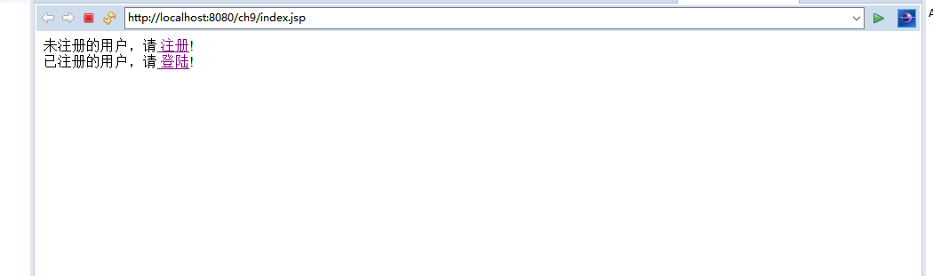
心得体会：
评语：

