实 验 报 告

辽宁科技大学软件学院（系） 2023 年 5 月 24 日
课名：Java框架SpringMVC |  | 实验项目名称：五、 Spring MVC的Controller（一）
班级：软件204 | 姓名： 于有为 |  | 学号：120203504005 | 任课教师：杨松波
实验目的：
- 掌握基于注解的控制器
- 掌握Controller接收请求参数的常见方式

实验内容：
（书10.1节）
package controller;
import org.springframework.stereotype.Controller;
import org.springframework.web.bind.annotation.RequestMapping;
@Controller
@RequestMapping("/index")
public class IndexController {
@RequestMapping("/login")
public String login() {
return "login";//跳转到“/WEB-INF/jsp/login.jsp”
}
@RequestMapping("/register")
public String register() {
return "register";
}
}

<?xml version="1.0" encoding="UTF-8"?>
<beans xmlns="http://www.springframework.org/schema/beans"
xmlns:xsi="http://www.w3.org/2001/XMLSchema-instance"
xmlns:context="http://www.springframework.org/schema/context"
xmlns:mvc="http://www.springframework.org/schema/mvc"
xsi:schemaLocation="
http://www.springframework.org/schema/beans
http://www.springframework.org/schema/beans/spring-beans.xsd
http://www.springframework.org/schema/context
http://www.springframework.org/schema/context/spring-context.xsd
http://www.springframework.org/schema/mvc
http://www.springframework.org/schema/mvc/spring-mvc.xsd">
<!-- 使用扫描机制，扫描控制器类 -->
<context:component-scan base-package="controller"/>
<context:component-scan base-package="service"/>
<mvc:annotation-driven />
<bean class="org.springframework.web.servlet.view.InternalResourceViewResolver"
id="internalResourceViewResolver">
<!-- 前缀 -->
<property name="prefix" value="WebContent/WEB-INF/jsp/" />
<!-- 后缀 -->
<property name="suffix" value=".jsp" />
</bean>
</beans>

<?xml version="1.0" encoding="UTF-8"?>
<web-app
xmlns:xsi="http://www.w3.org/2001/XMLSchema-instance"
xmlns="http://xmlns.jcp.org/xml/ns/javaee"
xsi:schemaLocation="http://xmlns.jcp.org/xml/ns/javaee http://xmlns.jcp.org/xml/ns/javaee/web-app_3_1.xsd"
id="WebApp_ID" version="3.1">
<!--部署DispatcherServlet-->
<servlet>
<servlet-name>springmvc</servlet-name>
<servlet-class>org.springframework.web.servlet.DispatcherServlet</servlet-class>
<!-- 表示容器在启动时立即加载servlet -->
<load-on-startup>1</load-on-startup>
</servlet>
<servlet-mapping>
<servlet-name>springmvc</servlet-name>
<!-- 处理所有URL-->
<url-pattern>/</url-pattern>
</servlet-mapping>
</web-app>

（书10.2节）
package controller;
import javax.servlet.http.HttpSession;

import org.apache.commons.logging.Log;
import org.apache.commons.logging.LogFactory;
import org.springframework.beans.factory.annotation.Autowired;
import org.springframework.stereotype.Controller;
import org.springframework.ui.Model;
import org.springframework.web.bind.annotation.ModelAttribute;
import org.springframework.web.bind.annotation.RequestMapping;

import pojo.UserForm;
import service.UserService;
@Controller
@RequestMapping("/user")
public class UserController {
//得到一个用来记录日志的对象，这样打印信息的时候能够标记打印的是那个类的信息
private static final Log logger = LogFactory.getLog(UserController.class);
//将服务依赖注入到属性userService
@Autowired
public UserService userService;
/**
* 处理登录
*/
@RequestMapping("/login")
public String login(UserForm user, HttpSession session, Model model) {
if(userService.login(user)){
session.setAttribute("u", user);
logger.info("成功");
return "main";//登录成功，跳转到main.jsp
}else{
logger.info("失败");
model.addAttribute("messageError", "用户名或密码错误");
return "login";
}
}
/**
*处理注册
*/
@RequestMapping("/register")
public String register(@ModelAttribute("user") UserForm user) {
if(userService.register(user)){
logger.info("成功");
return "login";//注册成功，跳转到login.jsp
}else{
logger.info("失败");
//使用@ModelAttribute("user")与model.addAttribute("user", user)功能相同
//在register.jsp页面上可以使用EL表达式${user.uname}取出ModelAttribute的uname值
return "register";//返回register.jsp
}
}
}

package pojo;
public class UserForm {
private String uname;//与请求参数名称相同
private String upass;
private String reupass;
public String getUname() {
return uname;
}
public void setUname(String uname) {
this.uname = uname;
}
public String getUpass() {
return upass;
}
public void setUpass(String upass) {
this.upass = upass;
}
public String getReupass() {
return reupass;
}
public void setReupass(String reupass) {
this.reupass = reupass;
}
}

package service;
import pojo.UserForm;
public interface UserService {
boolean login(UserForm user);
boolean register(UserForm user);
}

package service;
import org.springframework.stereotype.Service;
import pojo.UserForm;
//注解为一个服务
@Service
public class UserServiceImpl implements UserService{
@Override
public boolean login(UserForm user) {
if("zhangsan".equals(user.getUname())
&& "123456".equals(user.getUpass()))
return true;
return false;
}
@Override
public boolean register(UserForm user) {
if("zhangsan".equals(user.getUname())
&& "123456".equals(user.getUpass()))
return true;
return false;
}
}

<%@ page language="java" contentType="text/html; charset=UTF-8" pageEncoding="UTF-8"%>
<!DOCTYPE html PUBLIC "-//W3C//DTD HTML 4.01 Transitional//EN" "http://www.w3.org/TR/html4/loose.dtd">
<html>
<head>
<meta http-equiv="Content-Type" content="text/html; charset=UTF-8">
<title>后台登录</title>
<style type="text/css">
table{
text-align: center;
}
.textSize{
width: 120px;
height: 25px;
}
* {
margin: 0px;
padding: 0px;
}
body {
font-family: Arial, Helvetica, sans-serif;
font-size: 12px;
margin: 10px 10px auto;
background-image: url(${pageContext.request.contextPath }/images/bb.jpg);
}
</style>
<script type="text/javascript">
//确定按钮
function gogo(){
document.forms[0].submit();
}
//取消按钮
function cancel(){
document.forms[0].action = "";
}
</script>
</head>
<body>
<form action="${pageContext.request.contextPath }/user/login" method="post">
<table>
<tr>
<td colspan="2"><img src="${pageContext.request.contextPath }/images/login.gif"></td>
</tr>
<tr>
<td>姓名：</td>
<td><input type="text" name="uname" class="textSize"></td>
</tr>
<tr>
<td>密码：</td>
<td><input type="password" name="upass" class="textSize"></td>
</tr>
<tr>
<td colspan="2">
<input type="image" src="${pageContext.request.contextPath }/images/ok.gif" onclick="gogo()" >
<input type="image" src="${pageContext.request.contextPath }/images/cancel.gif" onclick="cancel()" >
</td>
</tr>
</table>
${messageError }
</form>
</body>
</html>

<%@ page language="java" contentType="text/html; charset=UTF-8" pageEncoding="UTF-8"%>
<!DOCTYPE html PUBLIC "-//W3C//DTD HTML 4.01 Transitional//EN" "http://www.w3.org/TR/html4/loose.dtd">
<html>
<head>
<meta http-equiv="Content-Type" content="text/html; charset=UTF-8">
<style type="text/css">
.textSize{
width: 100pt;
height: 15pt
}
</style>
<title>注册画面</title>
<script type="text/javascript">
//注册时检查输入项
function allIsNull(){
var name=document.registForm.uname.value;
var pwd=document.registForm.upass.value;
var repwd=document.registForm.reupass.value;
if(name==""){
alert("请输入姓名！");
document.registForm.uname.focus();
return false;
}
if(pwd==""){
alert("请输入密码！");
document.registForm.upass.focus();
return false;
}
if(repwd==""){
alert("请输入确认密码！");
document.registForm.reupass.focus();
return false;
}
if(pwd!=repwd){
alert("2次密码不一致，请重新输入！");
document.registForm.upass.value="";
document.registForm.reupass.value="";
document.registForm.upass.focus();
return false;
}
document.registForm.submit();
return true;
}
</script>
</head>
<body>
<form action="${pageContext.request.contextPath }/user/register" method="post" name="registForm">
<table
border=1
bgcolor="lightblue"
align="center">
<tr>
<td>姓名：</td>
<td>
<input class="textSize" type="text" name="uname" value="${user.uname }"/>
</td>
</tr>

<tr>
<td>密码：</td>
<td><input class="textSize" type="password" maxlength="20" name="upass"/></td>
</tr>

<tr>
<td>确认密码：</td>
<td><input class="textSize" type="password" maxlength="20" name="reupass"/></td>
</tr>

<tr>
<td colspan="2" align="center"><input type="button" value="注册" onclick="allIsNull()"/></td>
</tr>
</table>
</form>

</body>
</html>

<%@ page language="java" contentType="text/html; charset=UTF-8"
pageEncoding="UTF-8"%>
<!DOCTYPE html PUBLIC "-//W3C//DTD HTML 4.01 Transitional//EN" "http://www.w3.org/TR/html4/loose.dtd">
<html>
<head>
<meta http-equiv="Content-Type" content="text/html; charset=UTF-8">
<title>Insert title here</title>
</head>
<body>
未注册的用户，请<a href="${pageContext.request.contextPath }/register">
注册</a>!<br>
已注册的用户，请<a href="${pageContext.request.contextPath }/login">
登陆</a>!
</body>
</html>

实验结果及思考题分析：
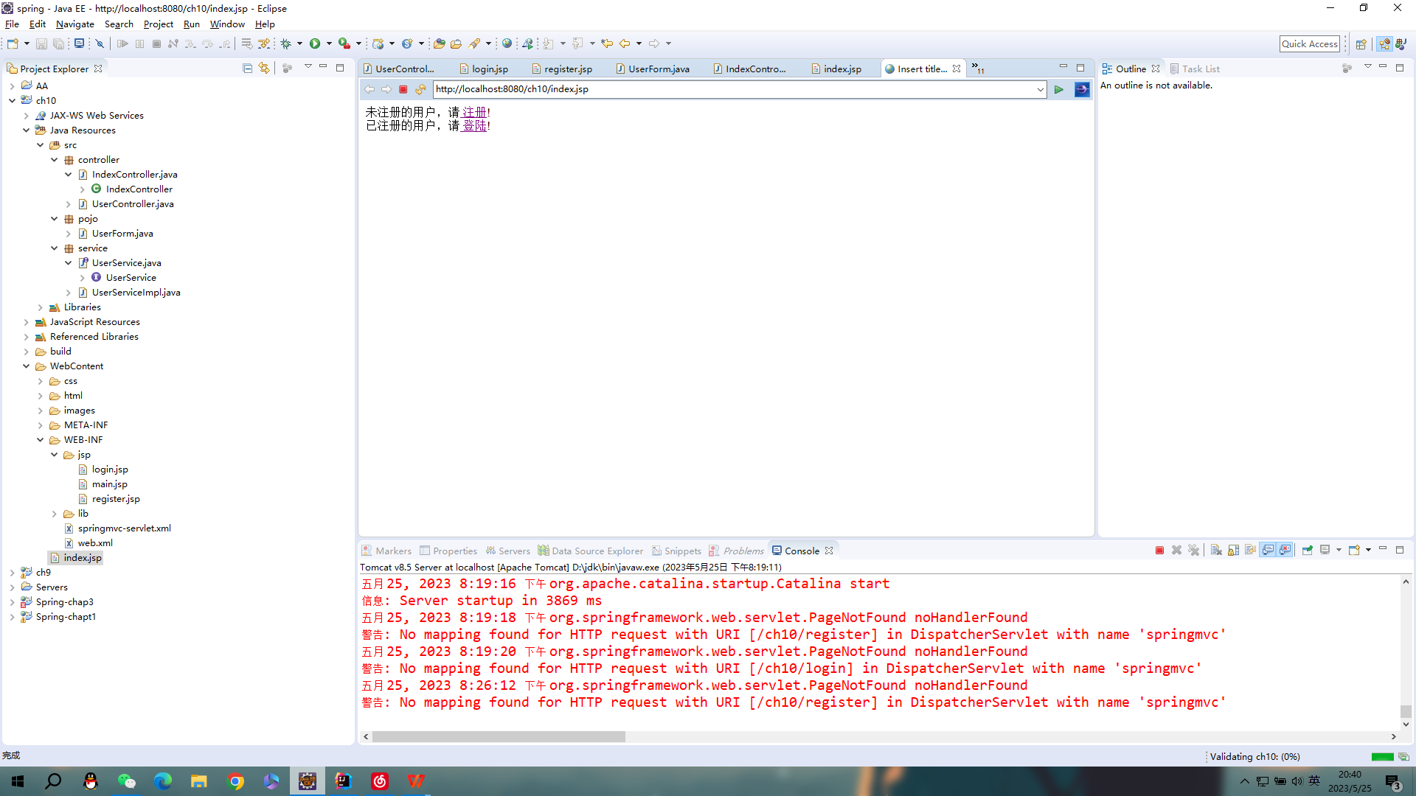
心得体会：
本次实验掌握了掌握Controller接收请求参数的常见方式，回顾了课上知识。

评语：

