实 验 报 告

辽宁科技大学软件学院（系） 2023年 6 月 7 日
课名：Java框架SpringMVC |  | 实验项目名称：七、类型转换和格式化
班级：软件204 | 姓名： 于有为 |  | 学号：120203504005 | 任课教师：杨松波
实验目的：
- 掌握类型转换Converter
- 掌握Formatter
实验内容：
（书11.2.2节）
<?xml version="1.0" encoding="UTF-8"?>
<web-app
xmlns:xsi="http://www.w3.org/2001/XMLSchema-instance"
xmlns="http://xmlns.jcp.org/xml/ns/javaee"
xsi:schemaLocation="http://xmlns.jcp.org/xml/ns/javaee http://xmlns.jcp.org/xml/ns/javaee/web-app_3_1.xsd"
id="WebApp_ID" version="3.1">
<!--部署DispatcherServlet-->
<servlet>
<servlet-name>springmvc</servlet-name>
<servlet-class>org.springframework.web.servlet.DispatcherServlet</servlet-class>
<!-- 表示容器在启动时立即加载servlet -->
<load-on-startup>1</load-on-startup>
</servlet>
<servlet-mapping>
<servlet-name>springmvc</servlet-name>
<!-- 处理所有URL-->
<url-pattern>/</url-pattern>
</servlet-mapping>
</web-app>
<?xml version="1.0" encoding="UTF-8"?>
<beans xmlns="http://www.springframework.org/schema/beans"
xmlns:xsi="http://www.w3.org/2001/XMLSchema-instance"
xmlns:context="http://www.springframework.org/schema/context"
xmlns:mvc="http://www.springframework.org/schema/mvc"
xsi:schemaLocation="
http://www.springframework.org/schema/beans
http://www.springframework.org/schema/beans/spring-beans.xsd
http://www.springframework.org/schema/context
http://www.springframework.org/schema/context/spring-context.xsd
http://www.springframework.org/schema/mvc
http://www.springframework.org/schema/mvc/spring-mvc.xsd">
<!-- 使用扫描机制，扫描controller包 -->
<context:component-scan base-package="controller"/>
<!-- 注册类型转换器GoodsConverter -->
<bean id="conversionService" class="org.springframework.context.support.ConversionServiceFactoryBean">
<property name="converters">
<list>
<bean class="converter.GoodsConverter"/>
</list>
</property>
</bean>
<mvc:annotation-driven conversion-service="conversionService"/>
<!-- 配置视图解析器 -->
<bean class="org.springframework.web.servlet.view.InternalResourceViewResolver"
id="internalResourceViewResolver">
<!-- 前缀 -->
<property name="prefix" value="/WEB-INF/jsp/" />
<!-- 后缀 -->
<property name="suffix" value=".jsp" />
</bean>
</beans>
1.GoodsModel
package pojo;
public class GoodsModel {
private String goodsname;
private double goodsprice;
private int goodsnumber;
public String getGoodsname() {
return goodsname;
}
public void setGoodsname(String goodsname) {
this.goodsname = goodsname;
}
public double getGoodsprice() {
return goodsprice;
}
public void setGoodsprice(double goodsprice) {
this.goodsprice = goodsprice;
}
public int getGoodsnumber() {
return goodsnumber;
}
public void setGoodsnumber(int goodsnumber) {
this.goodsnumber = goodsnumber;
}

}
2.ConverterController
package controller;
import org.springframework.stereotype.Controller;
import org.springframework.ui.Model;
import org.springframework.web.bind.annotation.RequestMapping;
import org.springframework.web.bind.annotation.RequestParam;
import pojo.GoodsModel;
@Controller
@RequestMapping("/my")
public class ConverterController {
@RequestMapping("/converter")
/*使用@RequestParam("goods")接收请求参数，
然后调用自定义类型转换器GoodsConverter将字符串值转换为GoodsModel的对象gm
*/
public String myConverter(@RequestParam("goods") GoodsModel gm, Model model){
model.addAttribute("goods",gm);
return "showGoods";
}
}
3.GoodsConverter
package converter;
import org.springframework.core.convert.converter.Converter;
import pojo.GoodsModel;
public class GoodsConverter implements Converter<String, GoodsModel>{
@Override
public GoodsModel convert(String source) {
//创建一个Goods实例
GoodsModel goods = new GoodsModel();
//以“,”分隔的
String stringValues[] = source.split(",");
if(stringValues != null &&
stringValues.length == 3){
//为Goods实例赋值
goods.setGoodsname(stringValues[0]);
goods.setGoodsprice(Double.parseDouble(stringValues[1]));
goods.setGoodsnumber(Integer.parseInt(stringValues[2]));
return goods;
}else{
throw new IllegalArgumentException(String.format("类型转换失败，需要格式‘apple,10.58,200’，但格式是[%s]", source));
}
}
}
6.input.jsp
<%@ page language="java" contentType="text/html; charset=UTF-8" pageEncoding="UTF-8"%>
<!DOCTYPE html PUBLIC "-//W3C//DTD HTML 4.01 Transitional//EN" "http://www.w3.org/TR/html4/loose.dtd">
<html>
<head>
<meta http-equiv="Content-Type" content="text/html; charset=UTF-8">
<title>Insert title here</title>
</head>
<body>
<form action="${pageContext.request.contextPath }/my/converter" method="post">
请输入商品信息（格式为：apple,10.58,200）：
<input type="text" name="goods"/><br>
<input type="submit" value="提交"/>
</form>
</body>
</html>
7.showGoods.jsp
<%@ page language="java" contentType="text/html; charset=UTF-8" pageEncoding="UTF-8"%>
<!DOCTYPE html PUBLIC "-//W3C//DTD HTML 4.01 Transitional//EN" "http://www.w3.org/TR/html4/loose.dtd">
<html>
<head>
<meta http-equiv="Content-Type" content="text/html; charset=UTF-8">
<title>Insert title here</title>
</head>
<body>
您创建的商品信息如下：<br>
<!-- 使用EL表达式取出model中goods的信息 -->
商品名为：${goods.goodsname }，
商品价格为：${goods.goodsprice }，
商品数量为：${goods.goodsnumber }。
</body>
</html>

（书11.3节）

<?xml version="1.0" encoding="UTF-8"?>
<web-app
xmlns:xsi="http://www.w3.org/2001/XMLSchema-instance"
xmlns="http://xmlns.jcp.org/xml/ns/javaee"
xsi:schemaLocation="http://xmlns.jcp.org/xml/ns/javaee http://xmlns.jcp.org/xml/ns/javaee/web-app_3_1.xsd"
id="WebApp_ID" version="3.1">
<!--部署DispatcherServlet-->
<servlet>
<servlet-name>springmvc</servlet-name>
<servlet-class>org.springframework.web.servlet.DispatcherServlet</servlet-class>
<!-- 表示容器在启动时立即加载servlet -->
<load-on-startup>1</load-on-startup>
</servlet>
<servlet-mapping>
<servlet-name>springmvc</servlet-name>
<!-- 处理所有URL-->
<url-pattern>/</url-pattern>
</servlet-mapping>
</web-app>
<?xml version="1.0" encoding="UTF-8"?>
<beans xmlns="http://www.springframework.org/schema/beans"
xmlns:xsi="http://www.w3.org/2001/XMLSchema-instance"
xmlns:context="http://www.springframework.org/schema/context"
xmlns:mvc="http://www.springframework.org/schema/mvc"
xsi:schemaLocation="
http://www.springframework.org/schema/beans
http://www.springframework.org/schema/beans/spring-beans.xsd
http://www.springframework.org/schema/context
http://www.springframework.org/schema/context/spring-context.xsd
http://www.springframework.org/schema/mvc
http://www.springframework.org/schema/mvc/spring-mvc.xsd">
<!-- 使用扫描机制，扫描controller包 -->
<context:component-scan base-package="controller"/>
<!-- 注册MyFormatter-->
<bean id="conversionService" class="org.springframework.format.support.FormattingConversionServiceFactoryBean">
<property name="formatters">
<set>
<bean class="formatter.MyFormatter"/>
</set>
</property>
</bean>
<mvc:annotation-driven conversion-service="conversionService"/>
<!-- 配置视图解析器 -->
<bean class="org.springframework.web.servlet.view.InternalResourceViewResolver"
id="internalResourceViewResolver">
<!-- 前缀 -->
<property name="prefix" value="/WEB-INF/jsp/" />
<!-- 后缀 -->
<property name="suffix" value=".jsp" />
</bean>
</beans>
package pojo;
import java.util.Date;
public class GoodsModelb {
private String goodsname;
private double goodsprice;
private int goodsnumber;
private Date goodsdate;
public String getGoodsname() {
return goodsname;
}
public void setGoodsname(String goodsname) {
this.goodsname = goodsname;
}
public double getGoodsprice() {
return goodsprice;
}
public void setGoodsprice(double goodsprice) {
this.goodsprice = goodsprice;
}
public int getGoodsnumber() {
return goodsnumber;
}
public void setGoodsnumber(int goodsnumber) {
this.goodsnumber = goodsnumber;
}
public Date getGoodsdate() {
return goodsdate;
}
public void setGoodsdate(Date goodsdate) {
this.goodsdate = goodsdate;
}
}
package formatter;
import java.text.ParseException;
import java.text.SimpleDateFormat;
import java.util.Date;
import java.util.Locale;
import org.springframework.format.Formatter;
public class MyFormatter implements Formatter<Date> {
SimpleDateFormat dateFormat=new SimpleDateFormat("yyyy-MM-dd");
@Override
public String print(Date object, Locale arg1) {
// TODO Auto-generated method stub
return dateFormat.format(object);
}
@Override
public Date parse(String source, Locale arg1) throws ParseException {
// TODO Auto-generated method stub
return dateFormat.parse(source);
}
}

package controller;
import org.springframework.stereotype.Controller;
import org.springframework.ui.Model;
import org.springframework.web.bind.annotation.RequestMapping;
import pojo.GoodsModelb;
@Controller
@RequestMapping("/my")
public class FormatterController {
@RequestMapping("/formatter")
public String myConverter(GoodsModelb gm,Model model) {
model.addAttribute("goods",gm);
return "showGoodsb";
}
}
<%@ page language="java" contentType="text/html; charset=UTF-8" pageEncoding="UTF-8"%>
<!DOCTYPE html PUBLIC "-//W3C//DTD HTML 4.01 Transitional//EN" "http://www.w3.org/TR/html4/loose.dtd">
<html>
<head>
<meta http-equiv="Content-Type" content="text/html; charset=UTF-8">
<title>Insert title here</title>
</head>
<body>
<form action="${pageContext.request.contextPath }/my/formatter" method="post">
商品名称：<input type="text" name="goodsname"/><br>
商品价格：<input type="text" name="goodsprice"/><br>
商品数量：<input type="text" name="goodsnumber"/><br>
商品日期：<input type="text" name="goodsdate"/>（yyyy-MM-dd）<br>
<input type="submit" value="提交"/>
</form>
</body>
</html>
<%@ page language="java" contentType="text/html; charset=UTF-8" pageEncoding="UTF-8"%>
<!DOCTYPE html PUBLIC "-//W3C//DTD HTML 4.01 Transitional//EN" "http://www.w3.org/TR/html4/loose.dtd">
<html>
<head>
<meta http-equiv="Content-Type" content="text/html; charset=UTF-8">
<title>Insert title here</title>
</head>
<body>
您创建的商品信息如下：<br>
<!-- 使用EL表达式取出Action类的属性goods的值 -->
商品名称为：${goods.goodsname }<br>
商品价格为：${goods.goodsprice }<br>
商品数量为：${goods.goodsnumber }<br>
商品日期为：${goods.goodsdate }
</body>
</html>

实验结果及思考题分析：
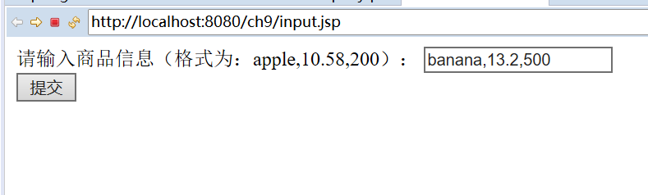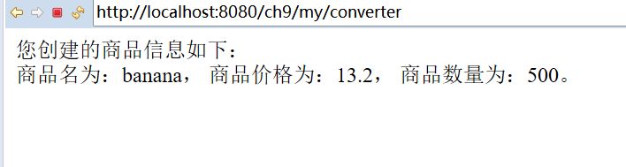
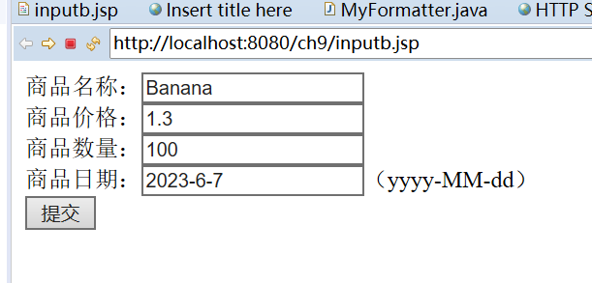
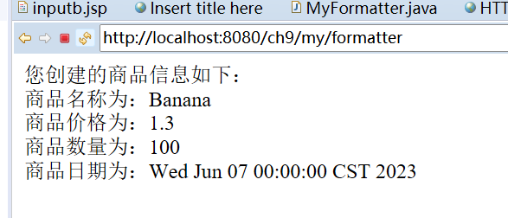

心得体会：

评语：

