实 验 报 告

辽宁科技大学软件学院（系） 年 月 日
课名：Java框架SpringMVC |  | 实验项目名称： 八、数据绑定的应用
班级： | 姓名： |  | 学号： | 任课教师：杨松波
实验目的：
- 掌握数据绑定
- 掌握表单标签库
实验内容：
（书12.3节）
package pojo;
public class User {
private String userName;
private String[] hobby;//兴趣爱好
private String[] friends;//朋友
private String carrer;
private String houseRegister;
private String remark;
public String getUserName() {
return userName;
}
public void setUserName(String userName) {
this.userName = userName;
}
public String[] getHobby() {
return hobby;
}
public void setHobby(String[] hobby) {
this.hobby = hobby;
}
public String[] getFriends() {
return friends;
}
public void setFriends(String[] friends) {
this.friends = friends;
}
public String getCarrer() {
return carrer;
}
public void setCarrer(String carrer) {
this.carrer = carrer;
}
public String getHouseRegister() {
return houseRegister;
}
public void setHouseRegister(String houseRegister) {
this.houseRegister = houseRegister;
}
public String getRemark() {
return remark;
}
public void setRemark(String remark) {
this.remark = remark;
}
}
package service;
import java.util.ArrayList;
import pojo.User;
public interface UserService {
boolean addUser(User u);
ArrayList<User> getUsers();
}
package service;
import java.util.ArrayList;
import org.springframework.stereotype.Service;
import pojo.User;
@Service
public class UserServiceImpl implements UserService{
//使用静态集合变量users模拟数据库
private static ArrayList<User> users = new ArrayList<User>();
@Override
public boolean addUser(User u) {
if(!"IT民工".equals(u.getCarrer())){//不允许添加IT民工
users.add(u);
return true;
}
return false;
}
@Override
public ArrayList<User> getUsers() {
return users;
}
}
package controller;
import java.util.HashMap;
import java.util.List;
import org.apache.commons.logging.Log;
import org.apache.commons.logging.LogFactory;
import org.springframework.beans.factory.annotation.Autowired;
import org.springframework.stereotype.Controller;
import org.springframework.ui.Model;
import org.springframework.web.bind.annotation.ModelAttribute;
import org.springframework.web.bind.annotation.RequestMapping;
import pojo.User;
import service.UserService;
@Controller
@RequestMapping("/user")
public class UserController {
// 得到一个用来记录日志的对象，这样打印信息的时候能够标记打印的是那个类的信息
private static final Log logger = LogFactory.getLog(UserController.class);
@Autowired
private UserService userService;
@RequestMapping(value = "/input")
public String inputUser(Model model) {
HashMap<String, String> hobbys = new HashMap<String, String>();
hobbys.put("篮球", "篮球");
hobbys.put("乒乓球", "乒乓球");
hobbys.put("电玩", "电玩");
hobbys.put("游泳", "游泳");
// 如果model中没有user属性，userAdd.jsp会抛出异常，因为表单标签无法找到
// modelAttribute属性指定的form backing object
model.addAttribute("user", new User());
model.addAttribute("hobbys", hobbys);
model.addAttribute("carrers", new String[] { "教师", "学生", "coding搬运工", "IT民工", "其它" });
model.addAttribute("houseRegisters", new String[] { "北京", "上海", "广州", "深圳", "其它" });
return "userAdd";
}
@RequestMapping(value = "/save")
public String addUser(@ModelAttribute User user, Model model) {
if (userService.addUser(user)) {
logger.info("成功");
return "redirect:/user/list";
} else {
logger.info("失败");
HashMap<String, String> hobbys = new HashMap<String, String>();
hobbys.put("篮球", "篮球");
hobbys.put("乒乓球", "乒乓球");
hobbys.put("电玩", "电玩");
hobbys.put("游泳", "游泳");
// 这里不需要model.addAttribute("user", new
// User())，因为@ModelAttribute指定form backing object
model.addAttribute("hobbys", hobbys);
model.addAttribute("carrers", new String[] { "教师", "学生", "coding搬运工", "IT民工", "其它" });
model.addAttribute("houseRegisters", new String[] { "北京", "上海", "广州", "深圳", "其它" });
return "userAdd";
}
}
@RequestMapping(value = "/list")
public String listUsers(Model model) {
List<User> users = userService.getUsers();
model.addAttribute("users", users);
return "userList";
}
}
<%@ page language="java" contentType="text/html; charset=UTF-8" pageEncoding="UTF-8"%>
<%@ taglib prefix="form" uri="http://www.springframework.org/tags/form" %>
<!DOCTYPE html PUBLIC "-//W3C//DTD HTML 4.01 Transitional//EN" "http://www.w3.org/TR/html4/loose.dtd">
<html>
<head>
<meta http-equiv="Content-Type" content="text/html; charset=UTF-8">
<title>Insert title here</title>
</head>
<body>
<form:form modelAttribute="user" method="post" action=" ${pageContext.request.contextPath }/user/save">
<fieldset>
<legend>添加一个用户</legend>
<p>
<label>用户名:</label>
<form:input path="userName"/>
</p>
<p>
<label>爱好:</label>
<form:checkboxes items="${hobbys}" path="hobby" />
</p>
<p>
<label>朋友:</label>
<form:checkbox path="friends" value="张三"/>张三
<form:checkbox path="friends" value="李四"/>李四
<form:checkbox path="friends" value="王五"/>王五
<form:checkbox path="friends" value="赵六"/>赵六
</p>
<p>
<label>职业:</label>
<form:select path="carrer">
<option/>请选择职业
<form:options items="${carrers }"/>
</form:select>
</p>
<p>
<label>户籍:</label>
<form:select path="houseRegister">
<option/>请选择户籍
<form:options items="${houseRegisters }"/>
</form:select>
</p>
<p>
<label>个人描述:</label>
<form:textarea path="remark" rows="5"/>
</p>
<p id="buttons">
<input id="reset" type="reset">
<input id="submit" type="submit" value="添加">
</p>
</fieldset>
</form:form>
</body>
</html>
<%@ page language="java" contentType="text/html; charset=UTF-8" pageEncoding="UTF-8"%>
<%@ taglib uri="http://java.sun.com/jsp/jstl/core" prefix="c" %>
<!DOCTYPE html PUBLIC "-//W3C//DTD HTML 4.01 Transitional//EN" "http://www.w3.org/TR/html4/loose.dtd">
<html>
<head>
<meta http-equiv="Content-Type" content="text/html; charset=UTF-8">
<title>Insert title here</title>
</head>
<body>
<h1>用户列表</h1>
<a href="${pageContext.request.contextPath}/user/input">继续添加</a>
<table>
<tr>
<th>用户名</th>
<th>兴趣爱好</th>
<th>朋友</th>
<th>职业</th>
<th>户籍</th>
<th>个人描述</th>
</tr>
<!-- JSTL标签，请参考本书的相关内容 -->
<c:forEach items="${users}" var="user">
<tr>
<td>${user.userName }</td>
<td>
<c:forEach items="${user.hobby }" var="hobby">
${hobby }&nbsp;
</c:forEach>
</td>
<td>
<c:forEach items="${user.friends }" var="friend">
${friend }&nbsp;
</c:forEach>
</td>
<td>${user.carrer }</td>
<td>${user.houseRegister }</td>
<td>${user.remark }</td>
</tr>
</c:forEach>
</table>
</body>
</html>

实验结果及思考题分析：
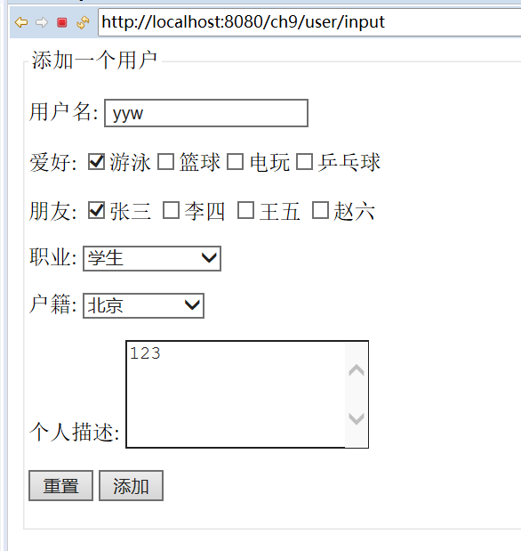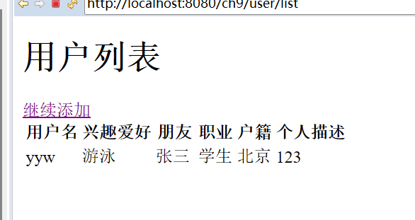
心得体会：

评语：

