实 验 报 告

辽宁科技大学软件学院（系） 2023年6月14日
课名：Java框架SpringMVC |  | 实验项目名称： 九、拦截器
班级：软件204 | 姓名：于有为 |  | 学号：120203504005 | 任课教师：杨松波
实验目的：
- 掌握拦截器的执行流程
- 掌握拦截器的应用
实验内容：
（书13.1节）
InterceptorController：
package controller;
import org.springframework.web.bind.annotation.RequestMapping;
import org.springframework.stereotype.Controller;

@Controller
public class InterceptorController{
@RequestMapping("/gotoTest")
public String gotoTest() {
System.out.println("正在测试拦截器，执行控制器的处理请求方法中.....");
return "test";
}
}
TestInterceptor：
package interceptor;

import javax.servlet.http.HttpServletRequest;
import javax.servlet.http.HttpServletResponse;

import org.springframework.web.servlet.HandlerInterceptor;
import org.springframework.web.servlet.ModelAndView;

public class TestInterceptor implements HandlerInterceptor{
@Override
public boolean preHandle(HttpServletRequest request, HttpServletResponse response, Object handler) throws Exception {
System.out.println("preHandle方法在控制器的处理请求方法前执行");
return true;
}
@Override
public void postHandle(HttpServletRequest request, HttpServletResponse response, Object handler, ModelAndView modelAndView) throws Exception {
System.out.println("postHandle方法在控制器的处理请求方法调用之后，解析视图之前执行。");
}
@Override
public void afterCompletion(HttpServletRequest request, HttpServletResponse response, Object handler, Exception ex) throws Exception {
System.out.println("afterCompletion方法在控制器的处理请求方法执行完成后执行，即视图渲染结束后执行");
}

}
Test.jsp:
<%@ page language="java" contentType="text/html; charset=UTF-8"
pageEncoding="UTF-8"%>
<!DOCTYPE html PUBLIC "-//W3C//DTD HTML 4.01 Transitional//EN" "http://www.w3.org/TR/html4/loose.dtd">
<html>
<head>
<meta http-equiv="Content-Type" content="text/html; charset=UTF-8">
<title>Insert title here</title>
</head>
<body>
视图
<%System.out.println("视图渲染结束....."); %>
</body>
</html>
Springmvc-servlet:
<?xml version="1.0" encoding="UTF-8"?>
<beans xmlns="http://www.springframework.org/schema/beans"
xmlns:xsi="http://www.w3.org/2001/XMLSchema-instance"
xmlns:context="http://www.springframework.org/schema/context"
xmlns:mvc="http://www.springframework.org/schema/mvc"
xsi:schemaLocation="
http://www.springframework.org/schema/beans
http://www.springframework.org/schema/beans/spring-beans.xsd
http://www.springframework.org/schema/context
http://www.springframework.org/schema/context/spring-context.xsd
http://www.springframework.org/schema/mvc
http://www.springframework.org/schema/mvc/spring-mvc.xsd">
<!-- 使用扫描机制，扫描控制器类 -->
<context:component-scan base-package="controller"/>
<!-- 配置视图解析器 -->
<bean class="org.springframework.web.servlet.view.InternalResourceViewResolver"
id="internalResourceViewResolver">
<!-- 前缀 -->
<property name="prefix" value="/WEB-INF/jsp/" />
<!-- 后缀 -->
<property name="suffix" value=".jsp" />
</bean>
<mvc:interceptors>
<bean class="interceptor.TestInterceptor"/>
</mvc:interceptors>
</beans>

（书13.2节）
InterceptorController:
package controller;
import org.springframework.web.bind.annotation.RequestMapping;
import org.springframework.stereotype.Controller;

@Controller
public class InterceptorController{
@RequestMapping("/gotoTest")
public String gotoTest() {
System.out.println("正在测试拦截器，执行控制器的处理请求方法中.....");
return "test";
}
}
Interceptor1:
package interceptor;

import javax.servlet.http.HttpServletRequest;
import javax.servlet.http.HttpServletResponse;

import org.springframework.web.servlet.HandlerInterceptor;
import org.springframework.web.servlet.ModelAndView;

public class Interceptor1 implements HandlerInterceptor{
@Override
public boolean preHandle(HttpServletRequest request, HttpServletResponse response, Object handler) throws Exception {
System.out.println("Interceptor1 preHandle方法执行");
return true;
}
@Override
public void postHandle(HttpServletRequest request, HttpServletResponse response, Object handler, ModelAndView modelAndView) throws Exception {
System.out.println("Interceptor1 postHandle方法执行。");
}
@Override
public void afterCompletion(HttpServletRequest request, HttpServletResponse response, Object handler, Exception ex) throws Exception {
System.out.println("Interceptor1 afterCompletion方法执行.");
}

}
Interceptor2:
package interceptor;

import javax.servlet.http.HttpServletRequest;
import javax.servlet.http.HttpServletResponse;

import org.springframework.web.servlet.HandlerInterceptor;
import org.springframework.web.servlet.ModelAndView;

public class Interceptor2 implements HandlerInterceptor{
@Override
public boolean preHandle(HttpServletRequest request, HttpServletResponse response, Object handler) throws Exception {
System.out.println("Interceptor2 preHandle方法执行");
return true;
}
@Override
public void postHandle(HttpServletRequest request, HttpServletResponse response, Object handler, ModelAndView modelAndView) throws Exception {
System.out.println("Interceptor2 postHandle方法执行。");
}
@Override
public void afterCompletion(HttpServletRequest request, HttpServletResponse response, Object handler, Exception ex) throws Exception {
System.out.println("Interceptor2 afterCompletion方法执行.");
}

}
Springmvc-servlet:
<?xml version="1.0" encoding="UTF-8"?>
<beans xmlns="http://www.springframework.org/schema/beans"
xmlns:xsi="http://www.w3.org/2001/XMLSchema-instance"
xmlns:context="http://www.springframework.org/schema/context"
xmlns:mvc="http://www.springframework.org/schema/mvc"
xsi:schemaLocation="
http://www.springframework.org/schema/beans
http://www.springframework.org/schema/beans/spring-beans.xsd
http://www.springframework.org/schema/context
http://www.springframework.org/schema/context/spring-context.xsd
http://www.springframework.org/schema/mvc
http://www.springframework.org/schema/mvc/spring-mvc.xsd">
<!-- 使用扫描机制，扫描控制器类 -->
<context:component-scan base-package="controller"/>
<!-- 配置视图解析器 -->
<bean class="org.springframework.web.servlet.view.InternalResourceViewResolver"
id="internalResourceViewResolver">
<!-- 前缀 -->
<property name="prefix" value="/WEB-INF/jsp/" />
<!-- 后缀 -->
<property name="suffix" value=".jsp" />
</bean>
<mvc:interceptors>
<mvc:interceptor>
<mvc:mapping path="/**"/>
<bean class="interceptor.Interceptor1"/>
</mvc:interceptor>

<mvc:interceptor>
<mvc:mapping path="/gotoTest"/>
<bean class="interceptor.Interceptor2"/>
</mvc:interceptor>
</mvc:interceptors>
</beans>

（书13.3节）
Web.xml:
<?xml version="1.0" encoding="UTF-8"?>
<web-app xmlns:xsi="http://www.w3.org/2001/XMLSchema-instance" xmlns="http://xmlns.jcp.org/xml/ns/javaee" xsi:schemaLocation="http://xmlns.jcp.org/xml/ns/javaee http://xmlns.jcp.org/xml/ns/javaee/web-app_3_1.xsd" id="WebApp_ID" version="3.1">
<servlet>
<servlet-name>springmvc</servlet-name>
<servlet-class>org.springframework.web.servlet.DispatcherServlet</servlet-class>
<load-on-startup>1</load-on-startup>
</servlet>
<servlet-mapping>
<servlet-name>springmvc</servlet-name>
<url-pattern>/</url-pattern>
</servlet-mapping>
</web-app>
UserController:
package controller;
import javax.servlet.http.HttpSession;
import org.springframework.stereotype.Controller;
import org.springframework.ui.Model;
import org.springframework.web.bind.annotation.RequestMapping;
import pojo.User;
@Controller
public class UserController {
/**
* 登录页面初始化
*/
@RequestMapping("/toLogin")
public String initLogin() {
return "login";
}
/**
* 处理登录功能
*/
@RequestMapping("/login")
public String login(User user, Model model,HttpSession session) {
System.out.println(user.getUname());
if("chenheng".equals(user.getUname()) &&
"123456".equals(user.getUpwd())) {
session.setAttribute("user", user);
//重定向到主页面的跳转方法
return "redirect:main";
}
model.addAttribute("msg","用户名或密码错误，请重新登录！");
return "login";
}
/**
* 跳转到主页面
*/
@RequestMapping("/main")
public String toMain() {
return "main";
}
/**
* 退出登录
*/
@RequestMapping("/logout")
public String logout(HttpSession session) {
//清除session
session.invalidate();
return "login";
}
}
LoginInterceptor:
package interceptor;
import javax.servlet.http.HttpServletRequest;
import javax.servlet.http.HttpServletResponse;
import javax.servlet.http.HttpSession;

import org.springframework.web.servlet.HandlerInterceptor;
public class LoginInterceptor implements HandlerInterceptor{
@Override
public boolean preHandle(HttpServletRequest request, HttpServletResponse response, Object handler)
throws Exception {
//获取请求的URL
String url = request.getRequestURI();
//login.jsp或登录请求放行，不拦截
if(url.indexOf("/toLogin") >= 0 || url.indexOf("/login") >= 0) {
return true;
}
//获取Session
HttpSession session = request.getSession();
Object obj = session.getAttribute("user");
if(obj != null)
return true;
//没有登录且不是登录页面，转发到登录页面，并给出提示错误信息
request.setAttribute("msg", "还没登录，请先登录！");
request.getRequestDispatcher("/WEB-INF/jsp/login.jsp").forward(request, response);
return false;
}
}
User:
package pojo;
public class User {
private String uname;
private String upwd;
public String getUname() {
return uname;
}
public void setUname(String uname) {
this.uname = uname;
}
public String getUpwd() {
return upwd;
}
public void setUpwd(String upwd) {
this.upwd = upwd;
}
}
Login.jsp:
<%@ page language="java" contentType="text/html; charset=UTF-8"
pageEncoding="UTF-8"%>
<!DOCTYPE html PUBLIC "-//W3C//DTD HTML 4.01 Transitional//EN" "http://www.w3.org/TR/html4/loose.dtd">
<html>
<head>
<meta http-equiv="Content-Type" content="text/html; charset=UTF-8">
<title>Insert title here</title>
</head>
<body>
${msg}
<form action="${pageContext.request.contextPath }/login" method="post">
用户名：<input type="text" name="uname"/><br>
密码：<input type="password" name="upwd"/><br>
<input type="submit" value="登录"/>
</form>
</body>
</html>
Main.jsp:
<%@ page language="java" contentType="text/html; charset=UTF-8"
pageEncoding="UTF-8"%>
<!DOCTYPE html PUBLIC "-//W3C//DTD HTML 4.01 Transitional//EN" "http://www.w3.org/TR/html4/loose.dtd">
<html>
<head>
<meta http-equiv="Content-Type" content="text/html; charset=UTF-8">
<title>Insert title here</title>
</head>
<body>
当前用户：${user.uname }<br>
<a href="${pageContext.request.contextPath }/logout">退出</a>
</body>
</html>

实验结果及思考题分析：
13.1:
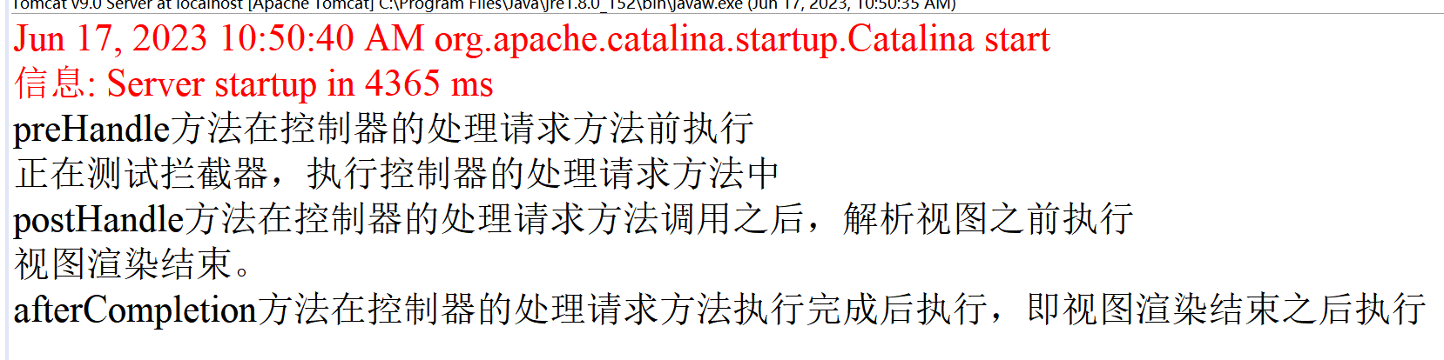
13.2:
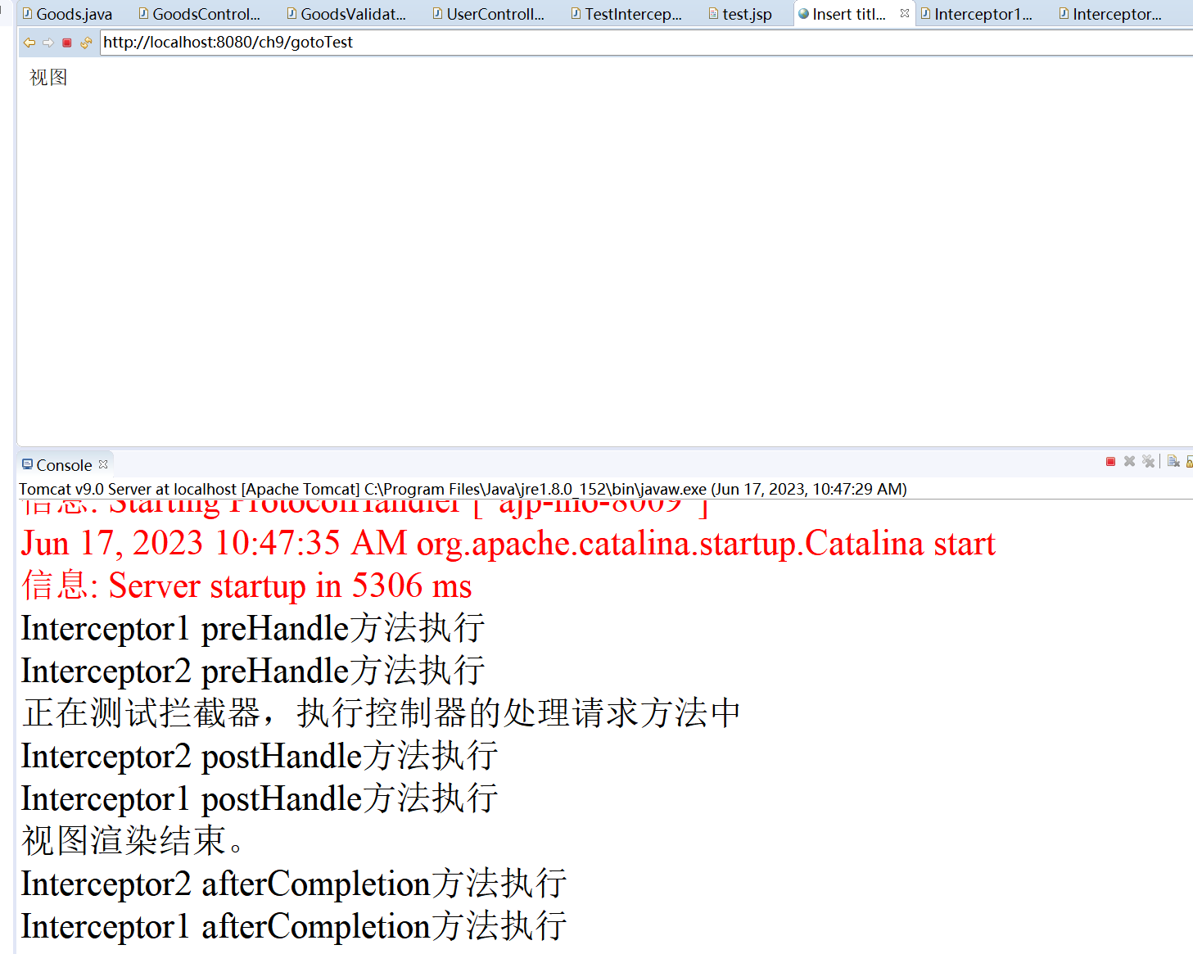
13.3:
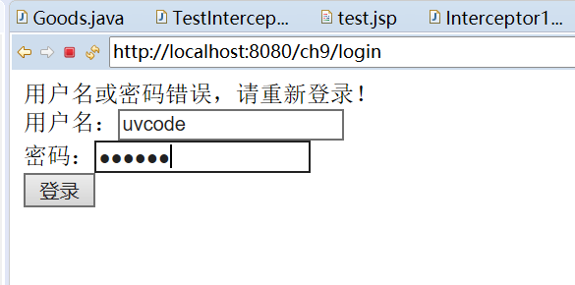

心得体会：
本次实验学会了很多，巩固了课上所学的知识。
评语：

