实 验 报 告

辽宁科技大学软件学院（系） 2023年6月14日
课名：Java框架SpringMVC |  | 实验项目名称： 数据验证
班级：软件204 | 姓名：于有为 |  | 学号：120203504005 | 任课教师：杨松波
实验目的：
- 掌握Spring 验证器
- 掌握JSR303验证
实验内容：
（书14.2节）
GoodsController：
package controller;
import javax.annotation.Resource;
import org.apache.commons.logging.Log;
import org.apache.commons.logging.LogFactory;
import org.springframework.beans.factory.annotation.Autowired;
import org.springframework.stereotype.Controller;
import org.springframework.ui.Model;
import org.springframework.validation.BindingResult;
import org.springframework.validation.Validator;
import org.springframework.web.bind.annotation.ModelAttribute;
import org.springframework.web.bind.annotation.RequestMapping;

import pojo.Goods;
import service.GoodsService;
@Controller
@RequestMapping("/goods")
public class GoodsController {
// 得到一个用来记录日志的对象，这样打印信息的时候能够标记打印的是那个类的信息
private static final Log logger = LogFactory.getLog(GoodsController.class);
@Autowired
private GoodsService goodsService;
//注解验证器相当于 GoodsValidator validator = new GoodsValidator();
@Resource
private Validator validator;
@RequestMapping("/input")
public String input(Model model){
// 如果model中没有goods属性，addGoods.jsp会抛出异常，因为表单标签无法找到modelAttribute属性指定的form
// backing object
model.addAttribute("goods", new Goods());
return "addGoods";
}
@RequestMapping("/save")
public String save(@ModelAttribute Goods goods, BindingResult result, Model model){
this.validator.validate(goods, result);//添加验证
if (result.hasErrors()) {
return "addGoods";
}
goodsService.save(goods);
logger.info("添加成功");
model.addAttribute("goodsList", goodsService.getGoods());
return "goodsList";
}

}

Goods：
package pojo;
import java.util.Date;
import org.springframework.format.annotation.DateTimeFormat;
public class Goods {
private String gname;
private String gdescription;
private double gprice;
//日期格式化（需要在配置文件配置FormattingConversionServiceFactoryBean）
@DateTimeFormat(pattern="yyyy-MM-dd")
private Date gdate;
public String getGname() {
return gname;
}
public void setGname(String gname) {
this.gname = gname;
}
public String getGdescription() {
return gdescription;
}
public void setGdescription(String gdescription) {
this.gdescription = gdescription;
}
public double getGprice() {
return gprice;
}
public void setGprice(double gprice) {
this.gprice = gprice;
}
public Date getGdate() {
return gdate;
}
public void setGdate(Date gdate) {
this.gdate = gdate;
}
}

GoodsService：
package service;
import java.util.ArrayList;

import pojo.Goods;
public interface GoodsService {
boolean save(Goods g);
ArrayList<Goods> getGoods();
}

GoodsServiceImpl：
package service;
import java.util.ArrayList;
import org.springframework.stereotype.Service;

import pojo.Goods;
@Service
public class GoodsServiceImpl implements GoodsService{
//使用静态集合变量users模拟数据库
private static ArrayList<Goods> goods = new ArrayList<Goods>();
@Override
public boolean save(Goods g) {
goods.add(g);
return true;
}
@Override
public ArrayList<Goods> getGoods() {
return goods;
}
}

GoodsValidator：
package validator;
import java.util.Date;
import org.springframework.stereotype.Component;
import org.springframework.validation.Errors;
import org.springframework.validation.ValidationUtils;
import org.springframework.validation.Validator;

import pojo.Goods;
@Component
public class GoodsValidator implements Validator{
@Override
public boolean supports(Class<?> klass) {
// 要验证的Model，返回值为false则不验证。
return Goods.class.isAssignableFrom(klass);
}
@Override
public void validate(Object object, Errors errors) {
Goods goods = (Goods)object;//object要验证的对象
//goods.gname.required是错误消息属性文件中的编码
ValidationUtils.rejectIfEmpty(errors, "gname", "goods.gname.required");
ValidationUtils.rejectIfEmpty(errors, "gdescription", "goods.gdescription.required");
if(goods.getGprice() > 100 || goods.getGprice() < 0){
errors.rejectValue("gprice", "gprice.invalid");
}
Date goodsDate = goods.getGdate();
//在系统时间之后
if(goodsDate != null && goodsDate.after(new Date())){
errors.rejectValue("gdate", "gdate.invalid");
}
}
}

addgoods.jsp：
<%@ page language="java" contentType="text/html; charset=UTF-8" pageEncoding="UTF-8"%>
<%@ taglib prefix="form" uri="http://www.springframework.org/tags/form" %>
<!DOCTYPE html PUBLIC "-//W3C//DTD HTML 4.01 Transitional//EN" "http://www.w3.org/TR/html4/loose.dtd">
<html>
<head>
<meta http-equiv="Content-Type" content="text/html; charset=UTF-8">
<title>Insert title here</title>
</head>
<body>
<form:form modelAttribute="goods" action="${pageContext.request.contextPath }/goods/save" method="post">
<fieldset>
<legend>添加一件商品</legend>
<p>
<label>商品名:</label>
<form:input path="gname"/>
</p>
<p>
<label>商品详情:</label>
<form:input path="gdescription"/>
</p>
<p>
<label>商品价格:</label>
<form:input path="gprice"/>
</p>
<p>
<label>创建日期:</label>
<form:input path="gdate"/>(yyyy-MM-dd)
</p>
<p id="buttons">
<input id="reset" type="reset">
<input id="submit" type="submit" value="添加">
</p>
</fieldset>
<!-- 取出所有验证错误 -->
<form:errors path="*"/>
</form:form>
</body>
</html>
goodsList.jsp:
<%@ page language="java" contentType="text/html; charset=UTF-8" pageEncoding="UTF-8"%>
<%@ taglib uri="http://java.sun.com/jsp/jstl/core" prefix="c" %>
<!DOCTYPE html PUBLIC "-//W3C//DTD HTML 4.01 Transitional//EN" "http://www.w3.org/TR/html4/loose.dtd">
<html>
<head>
<meta http-equiv="Content-Type" content="text/html; charset=UTF-8">
<title>Insert title here</title>
</head>
<body>
<table>
<tr>
<td>商品名</td>
<td>商品详情</td>
<td>商品价格</td>
<td>创建日期</td>
</tr>
<c:forEach items="${goodsList }" var="goods">
<tr>
<td>${goods.gname }</td>
<td>${goods.gdescription }</td>
<td>${goods.gprice }</td>
<td>${goods.gdate }</td>
</tr>
</c:forEach>
</table>
</body>
</html>
Web.xml:
<?xml version="1.0" encoding="UTF-8"?>
<web-app xmlns:xsi="http://www.w3.org/2001/XMLSchema-instance" xmlns="http://xmlns.jcp.org/xml/ns/javaee" xsi:schemaLocation="http://xmlns.jcp.org/xml/ns/javaee http://xmlns.jcp.org/xml/ns/javaee/web-app_3_1.xsd" id="WebApp_ID" version="3.1">
<servlet>
<servlet-name>springmvc</servlet-name>
<servlet-class>org.springframework.web.servlet.DispatcherServlet</servlet-class>
<load-on-startup>1</load-on-startup>
</servlet>
<servlet-mapping>
<servlet-name>springmvc</servlet-name>
<url-pattern>/</url-pattern>
</servlet-mapping>
<!-- 避免中文乱码 -->
<filter>
<filter-name>characterEncodingFilter</filter-name>
<filter-class>org.springframework.web.filter.CharacterEncodingFilter</filter-class>
<init-param>
<param-name>encoding</param-name>
<param-value>UTF-8</param-value>
</init-param>
<init-param>
<param-name>forceEncoding</param-name>
<param-value>true</param-value>
</init-param>
</filter>
<filter-mapping>
<filter-name>characterEncodingFilter</filter-name>
<url-pattern>/*</url-pattern>
</filter-mapping>
</web-app>
Springmvc-servlet.xml:
<?xml version="1.0" encoding="UTF-8"?>
<beans xmlns="http://www.springframework.org/schema/beans"
xmlns:xsi="http://www.w3.org/2001/XMLSchema-instance"
xmlns:context="http://www.springframework.org/schema/context"
xmlns:mvc="http://www.springframework.org/schema/mvc"
xsi:schemaLocation="
http://www.springframework.org/schema/beans
http://www.springframework.org/schema/beans/spring-beans.xsd
http://www.springframework.org/schema/context
http://www.springframework.org/schema/context/spring-context.xsd
http://www.springframework.org/schema/mvc
http://www.springframework.org/schema/mvc/spring-mvc.xsd">
<!-- 使用扫描机制，扫描包 -->
<context:component-scan base-package="controller"/>
<context:component-scan base-package="service"/>
<context:component-scan base-package="validator"/>
<!-- 注册格式化转换器，因为用到日期转换-->
<bean id="conversionService" class="org.springframework.format.support.FormattingConversionServiceFactoryBean">
</bean>
<mvc:annotation-driven conversion-service="conversionService"/>
<!-- 配置消息属性文件 -->
<bean id="messageSource" class="org.springframework.context.support.ReloadableResourceBundleMessageSource">
<property name="basename" value="/WEB-INF/resource/errorMessages"/>
</bean>
<!-- 配置视图解析器 -->
<bean class="org.springframework.web.servlet.view.InternalResourceViewResolver"
id="internalResourceViewResolver">
<!-- 前缀 -->
<property name="prefix" value="/WEB-INF/jsp/" />
<!-- 后缀 -->
<property name="suffix" value=".jsp" />
</bean>
</beans>
（书14.3节）
GoodsController:
package controller;
import javax.validation.Valid;
import org.apache.commons.logging.Log;
import org.apache.commons.logging.LogFactory;
import org.springframework.beans.factory.annotation.Autowired;
import org.springframework.stereotype.Controller;
import org.springframework.ui.Model;
import org.springframework.validation.BindingResult;
import org.springframework.web.bind.annotation.ModelAttribute;
import org.springframework.web.bind.annotation.RequestMapping;

import pojo.Goods;
import service.GoodsService;
@Controller
@RequestMapping("/goods")
public class GoodsController {
// 得到一个用来记录日志的对象，这样打印信息的时候能够标记打印的是那个类的信息
private static final Log logger = LogFactory.getLog(GoodsController.class);
@Autowired
private GoodsService goodsService;
@RequestMapping("/input")
public String input(Model model){
// 如果model中没有goods属性，addGoods.jsp会抛出异常，因为表单标签无法找到modelAttribute属性指定的form
// backing object
model.addAttribute("goods", new Goods());
return "addGoods";
}
@RequestMapping("/save")
public String save(@Valid @ModelAttribute Goods goods, BindingResult result, Model model){
if(result.hasErrors()){
return "addGoods";
}
goodsService.save(goods);
logger.info("添加成功");
model.addAttribute("goodsList", goodsService.getGoods());
return "goodsList";
}

}

Goods:
package pojo;
import java.util.Date;
import javax.validation.constraints.Past;
import org.hibernate.validator.constraints.NotBlank;
import org.hibernate.validator.constraints.Range;
import org.springframework.format.annotation.DateTimeFormat;
public class Goods {
//goods.gname.required错误消息key（国际化后，对应的就是国际化的信息）
@NotBlank(message="{goods.gname.required}")
private String gname;
@NotBlank(message="{goods.gdescription.required}")
private String gdescription;
@Range(min=0,max=100,message="{gprice.invalid}")
private double gprice;
//日期格式化（需要在配置文件配置FormattingConversionServiceFactoryBean）
@DateTimeFormat(pattern="yyyy-MM-dd")
@Past(message="{gdate.invalid}")
private Date gdate;
public String getGname() {
return gname;
}
public void setGname(String gname) {
this.gname = gname;
}
public String getGdescription() {
return gdescription;
}
public void setGdescription(String gdescription) {
this.gdescription = gdescription;
}
public double getGprice() {
return gprice;
}
public void setGprice(double gprice) {
this.gprice = gprice;
}
public Date getGdate() {
return gdate;
}
public void setGdate(Date gdate) {
this.gdate = gdate;
}
}

GoodsService:
package service;
import java.util.ArrayList;

import pojo.Goods;
public interface GoodsService {
boolean save(Goods g);
ArrayList<Goods> getGoods();
}

GoodsServiceImpl:
package service;
import java.util.ArrayList;
import org.springframework.stereotype.Service;

import pojo.Goods;
@Service
public class GoodsServiceImpl implements GoodsService{
//使用静态集合变量users模拟数据库
private static ArrayList<Goods> goods = new ArrayList<Goods>();
@Override
public boolean save(Goods g) {
goods.add(g);
return true;
}
@Override
public ArrayList<Goods> getGoods() {
return goods;
}
}

addgoods.jsp：
<%@ page language="java" contentType="text/html; charset=UTF-8" pageEncoding="UTF-8"%>
<%@ taglib prefix="form" uri="http://www.springframework.org/tags/form" %>
<!DOCTYPE html PUBLIC "-//W3C//DTD HTML 4.01 Transitional//EN" "http://www.w3.org/TR/html4/loose.dtd">
<html>
<head>
<meta http-equiv="Content-Type" content="text/html; charset=UTF-8">
<title>Insert title here</title>
</head>
<body>
<form:form modelAttribute="goods" action="${pageContext.request.contextPath }/goods/save" method="post">
<fieldset>
<legend>添加一件商品</legend>
<p>
<label>商品名:</label>
<form:input path="gname"/>
</p>
<p>
<label>商品详情:</label>
<form:input path="gdescription"/>
</p>
<p>
<label>商品价格:</label>
<form:input path="gprice"/>
</p>
<p>
<label>创建日期:</label>
<form:input path="gdate"/>(yyyy-MM-dd)
</p>
<p id="buttons">
<input id="reset" type="reset">
<input id="submit" type="submit" value="添加">
</p>
</fieldset>
<!-- 取出所有验证错误 -->
<form:errors path="*"/>
</form:form>
</body>
</html>
goodsList.jsp:
<%@ page language="java" contentType="text/html; charset=UTF-8" pageEncoding="UTF-8"%>
<%@ taglib uri="http://java.sun.com/jsp/jstl/core" prefix="c" %>
<!DOCTYPE html PUBLIC "-//W3C//DTD HTML 4.01 Transitional//EN" "http://www.w3.org/TR/html4/loose.dtd">
<html>
<head>
<meta http-equiv="Content-Type" content="text/html; charset=UTF-8">
<title>Insert title here</title>
</head>
<body>
<table>
<tr>
<td>商品名</td>
<td>商品详情</td>
<td>商品价格</td>
<td>创建日期</td>
</tr>
<c:forEach items="${goodsList }" var="goods">
<tr>
<td>${goods.gname }</td>
<td>${goods.gdescription }</td>
<td>${goods.gprice }</td>
<td>${goods.gdate }</td>
</tr>
</c:forEach>
</table>
</body>
</html>
Web.xml:
<?xml version="1.0" encoding="UTF-8"?>
<web-app xmlns:xsi="http://www.w3.org/2001/XMLSchema-instance" xmlns="http://xmlns.jcp.org/xml/ns/javaee" xsi:schemaLocation="http://xmlns.jcp.org/xml/ns/javaee http://xmlns.jcp.org/xml/ns/javaee/web-app_3_1.xsd" id="WebApp_ID" version="3.1">
<servlet>
<servlet-name>springmvc</servlet-name>
<servlet-class>org.springframework.web.servlet.DispatcherServlet</servlet-class>
<load-on-startup>1</load-on-startup>
</servlet>
<servlet-mapping>
<servlet-name>springmvc</servlet-name>
<url-pattern>/</url-pattern>
</servlet-mapping>
<!-- 避免中文乱码 -->
<filter>
<filter-name>characterEncodingFilter</filter-name>
<filter-class>org.springframework.web.filter.CharacterEncodingFilter</filter-class>
<init-param>
<param-name>encoding</param-name>
<param-value>UTF-8</param-value>
</init-param>
<init-param>
<param-name>forceEncoding</param-name>
<param-value>true</param-value>
</init-param>
</filter>
<filter-mapping>
<filter-name>characterEncodingFilter</filter-name>
<url-pattern>/*</url-pattern>
</filter-mapping>
</web-app>
Springmvc-servlet.xml:
<?xml version="1.0" encoding="UTF-8"?>
<beans xmlns="http://www.springframework.org/schema/beans"
xmlns:xsi="http://www.w3.org/2001/XMLSchema-instance"
xmlns:p="http://www.springframework.org/schema/p"
xmlns:context="http://www.springframework.org/schema/context"
xmlns:mvc="http://www.springframework.org/schema/mvc"
xsi:schemaLocation="
http://www.springframework.org/schema/beans
http://www.springframework.org/schema/beans/spring-beans.xsd
http://www.springframework.org/schema/context
http://www.springframework.org/schema/context/spring-context.xsd
http://www.springframework.org/schema/mvc
http://www.springframework.org/schema/mvc/spring-mvc.xsd">
<!-- 使用扫描机制，扫描包 -->
<context:component-scan base-package="controller"/>
<context:component-scan base-package="service"/>
<!-- 配置消息属性文件 -->
<bean id="messageSource"
class="org.springframework.context.support.ReloadableResourceBundleMessageSource">
<!-- 资源文件名-->
<property name="basenames">
<list>
<value>/WEB-INF/resource/errorMessages</value>
</list>
</property>
<!-- 资源文件编码格式 -->
<property name="fileEncodings" value="utf-8" />
<!-- 对资源文件内容缓存时间，单位秒 -->
<property name="cacheSeconds" value="120" />
</bean>
<!-- 注册校验器 -->
<bean id="validator"
class="org.springframework.validation.beanvalidation.LocalValidatorFactoryBean">
<!-- hibernate校验器-->
<property name="providerClass" value="org.hibernate.validator.HibernateValidator" />
<!-- 指定校验使用的资源文件，在文件中配置校验错误信息，如果不指定则默认使用classpath下的ValidationMessages.properties -->
<property name="validationMessageSource" ref="messageSource" />
</bean>
<!-- 开启spring的Valid功能 -->
<mvc:annotation-driven conversion-service="conversionService" validator="validator"/>
<!-- 注册格式化转换器 -->
<bean id="conversionService" class="org.springframework.format.support.FormattingConversionServiceFactoryBean">
<property name="formatters">
<set>
<!-- 注册自定义格式化转换器 -->
</set>
</property>
</bean>
<!-- 配置视图解析器 -->
<bean class="org.springframework.web.servlet.view.InternalResourceViewResolver"
id="internalResourceViewResolver">
<!-- 前缀 -->
<property name="prefix" value="/WEB-INF/jsp/" />
<!-- 后缀 -->
<property name="suffix" value=".jsp" />
</bean>
</beans>

实验结果及思考题分析：
14.2:
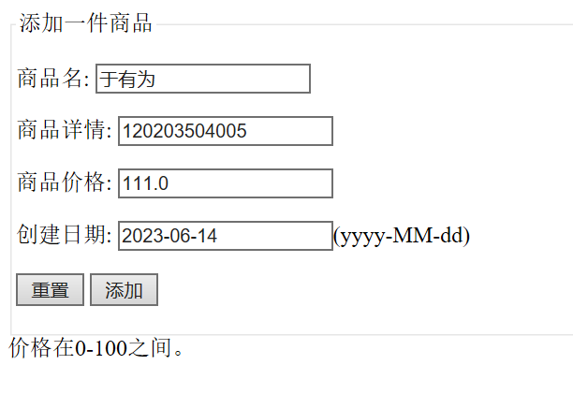
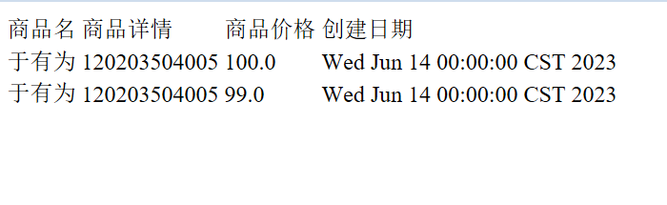
14.3:

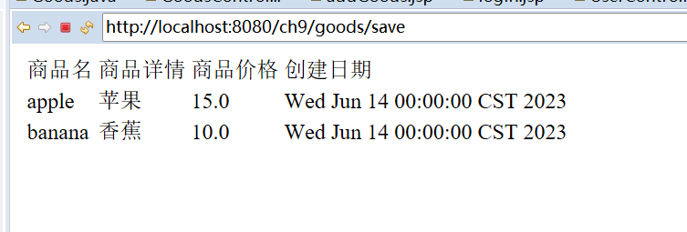
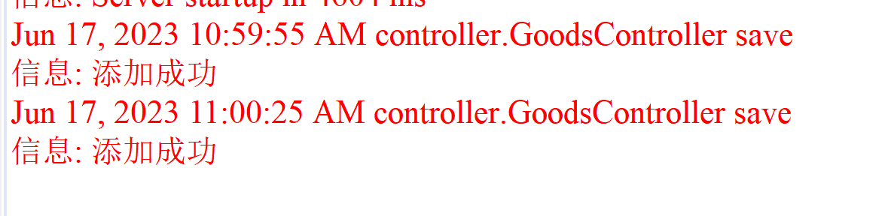

心得体会：
本次实验掌握了Spring 验证器以及JSR303验证，巩固了课上所学，受益匪浅。
评语：

