实 验 报 告

辽宁科技大学软件学院（系） 2023 年 4 月 26 日
课名：Java框架SpringMVC |  | 实验项目名称： Bean的装配方式
班级：软件204 | 姓名： 于有为 |  | 学号：120203504005 | 任课教师：杨松波
实验目的：
- 掌握基于XML配置的装配
- 掌握基于注解的装配
实验内容：
（书3.5节）
（书3.2节选做）
3.2
package instance;

public class BeanClass {
public String message;
public BeanClass() {
message="构造方法实例化Bean";
}
public BeanClass(String s) {
message=s;
}
}
package instance;

public class BeanInstanceFactory {
public BeanClass createBeanClassInstance() {
//不，三种Bean实例化的方法结果是一样的，并不会影响获取Bean的单例或多例
//影响单例或多礼的只有bean的作用域
return new BeanClass("调用实例工厂方法实例化Bean");
}
}
package instance;

public class BeanStaticFactory {
private static BeanClass beanInstance = new BeanClass("调用静态工厂实例化Bean");
public static BeanClass createInstance() {
return beanInstance;
}
}
package test;

import org.springframework.context.ApplicationContext;
import org.springframework.context.support.ClassPathXmlApplicationContext;

import instance.BeanClass;

public class TestInstance {

public static void main(String[] args) {
// TODO Auto-generated method stub
ApplicationContext appCon=new ClassPathXmlApplicationContext("applicationContext.xml");
BeanClass b11=(BeanClass)appCon.getBean("constructorInstance");
System.out.println(b11+b11.message);
BeanClass b12=(BeanClass)appCon.getBean("constructorInstance");
System.out.println(b12+b12.message);
BeanClass b21=(BeanClass)appCon.getBean("staticFactoryInstance");
System.out.println(b21+b21.message);
BeanClass b22=(BeanClass)appCon.getBean("staticFactoryInstance");
System.out.println(b22+b22.message);
BeanClass b31=(BeanClass)appCon.getBean("instanceFactoryInstance");
System.out.println(b31+b31.message);
BeanClass b32=(BeanClass)appCon.getBean("instanceFactoryInstance");
System.out.println(b32+b32.message);
}

}
<?xml version="1.0" encoding="UTF-8"?>
<beans xmlns="http://www.springframework.org/schema/beans"
xmlns:xsi="http://www.w3.org/2001/XMLSchema-instance"
xsi:schemaLocation="http://www.springframework.org/schema/beans
http://www.springframework.org/schema/beans/spring-beans.xsd">
<!--构造方法实例化-->
<bean id="constructorInstance" class="instance.BeanClass"/>
<!--静态工厂实例化-->
<bean id="staticFactoryInstance" class="instance.BeanStaticFactory" factory-method="createInstance"/>
<!--实例工厂实例化-->
<bean id="myFactory" class="instance.BeanInstanceFactory"/>
<bean id="instanceFactoryInstance" factory-bean="myFactory" factory-method="createBeanClassInstance"/>
</beans>
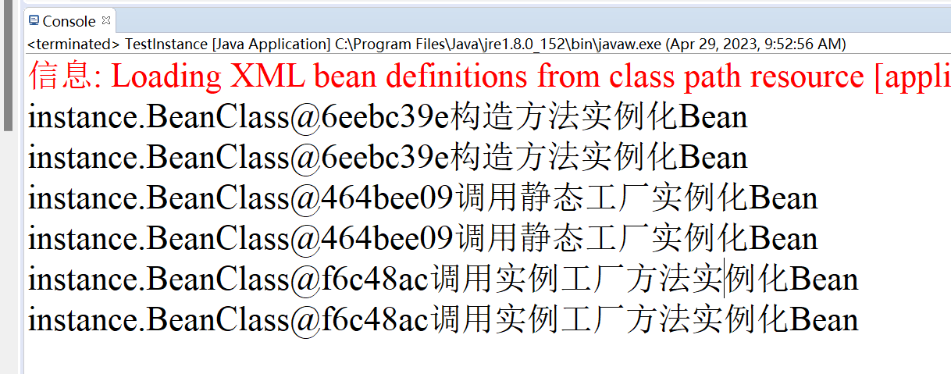
3.5
package assemble;

import java.util.Arrays;
import java.util.List;
import java.util.Map;
import java.util.Set;

public class ComplexUser {
private String uname;
private List<String>hobbyList;
private Map<String,String> residenceMap;
private Set<String>aliasSet;
private String[] array;
public ComplexUser(String uname, List<String> hobbyList, Map<String, String> residenceMap, Set<String> aliasSet,
String[] array) {
super();
this.uname = uname;
this.hobbyList = hobbyList;
this.residenceMap = residenceMap;
this.aliasSet = aliasSet;
this.array = array;
}
public ComplexUser() {
super();
}

public String getUname() {
return uname;
}
public void setUname(String uname) {
this.uname = uname;
}
public List<String> getHobbyList() {
return hobbyList;
}
public void setHobbyList(List<String> hobbyList) {
this.hobbyList = hobbyList;
}
public Map<String, String> getResidenceMap() {
return residenceMap;
}
public void setResidenceMap(Map<String, String> residenceMap) {
this.residenceMap = residenceMap;
}
public Set<String> getAliasSet() {
return aliasSet;
}
public void setAliasSet(Set<String> aliasSet) {
this.aliasSet = aliasSet;
}
public String[] getArray() {
return array;
}
public void setArray(String[] array) {
this.array = array;
}
@Override
public String toString() {
return "ComplexUser [uname=" + uname + ", hobbyList=" + hobbyList + ", residenceMap=" + residenceMap
+ ", aliasSet=" + aliasSet + ", array=" + Arrays.toString(array) + "]";
}

}
package test;

import org.springframework.context.ApplicationContext;
import org.springframework.context.support.ClassPathXmlApplicationContext;

import instance.BeanClass;

public class TestInstance {

public static void main(String[] args) {
// TODO Auto-generated method stub
ApplicationContext appCon=new ClassPathXmlApplicationContext("applicationContext.xml");
BeanClass b1=(BeanClass)appCon.getBean("constructorInstance");
System.out.println(b1+b1.message);
BeanClass b2=(BeanClass)appCon.getBean("constructorInstance");
System.out.println(b2+b2.message);
}

}
<?xml version="1.0" encoding="UTF-8"?>
<beans xmlns="http://www.springframework.org/schema/beans"
xmlns:xsi="http://www.w3.org/2001/XMLSchema-instance"
xsi:schemaLocation="http://www.springframework.org/schema/beans
http://www.springframework.org/schema/beans/spring-beans.xsd">
<!--构造方法实例化-->
<bean id="constructorInstance" class="instance.BeanClass" scope="singleton"/>
<bean id="staticFactoryInstance" class="instance.BeanStaticFactory" factory-method="createInstance"/>
<bean id="myFactory" class="instance.BeanInstanceFactory"/>
<bean id="instanceFactoryInstance" factory-bean="myFactory" factory-method="createBeanClassInstance"/>
<bean id="user1" class="assemble.ComplexUser">
<constructor-arg index="0" value="youwei1"/>
<constructor-arg index="1">
<list>
<value>唱歌</value>
<value>跳舞</value>
<value>篮球</value>
</list>
</constructor-arg>
<constructor-arg index="2">
<map>
<entry key="dalian" value="大连"/>
<entry key="beijing" value="北京"/>
<entry key="shanghai" value="上海"/>
</map>
</constructor-arg>
<constructor-arg index="3">
<set>
<value>有为100</value>
<value>有为101</value>
<value>有为102</value>
</set>
</constructor-arg>
<constructor-arg index="4">
<array>
<value>aaaaa</value>
<value>bbbbb</value>
</array>
</constructor-arg>
</bean>

<bean id="user2" class="assemble.ComplexUser">
<property name="uname" value="youwei2"/>
<property name="hobbyList">
<list>
<value>唱歌</value>
<value>跳舞</value>
<value>Rap</value>
</list>
</property>
<property name="residenceMap">
<map>
<entry key="dalian" value="德州"/>
<entry key="beijing" value="济南"/>
<entry key="shanghai" value="青岛"/>
</map>
</property>
<property name="aliasSet">
<set>
<value>有为103</value>
<value>有为104</value>
<value>有为105</value>
</set>
</property>
<property name="array">
<array>
<value>ccccc</value>
<value>ddddd</value>
</array>
</property>
</bean>

</beans>
package test;

import org.springframework.context.ApplicationContext;
import org.springframework.context.support.ClassPathXmlApplicationContext;

import assemble.ComplexUser;

public class TestAssemble {

public static void main(String[] args) {
// TODO Auto-generated method stub
ApplicationContext appCon=new ClassPathXmlApplicationContext("applicationContext.xml");
ComplexUser u1=(ComplexUser)appCon.getBean("user1");
ComplexUser u2=(ComplexUser)appCon.getBean("user2");
System.out.println(u1);
System.out.println(u2);
}

}
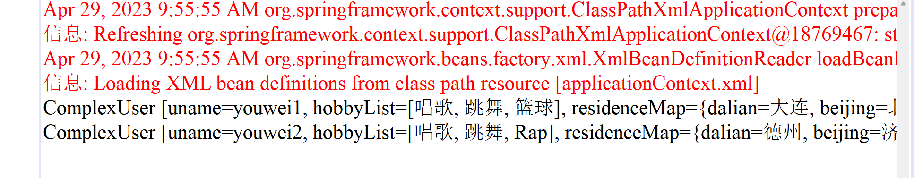
package annotation;

import org.springframework.beans.factory.annotation.Value;
import org.springframework.stereotype.Component;
//注解 这个类是组件 Component是最基础的注解，只要写上，他就能自动装配成bean
//如果括号里不写东西 默认为首字母小写，其余不变，beanid是这个
//相当于@Component("annotationUser")
@Component()
public class AnnotationUser {
//配置bean的属性
@Value("youwei")
private String uname;
public String getUname() {
return uname;
}

public void setUname(String uname) {
this.uname = uname;
}

}
package test;

import org.springframework.context.ApplicationContext;
import org.springframework.context.support.ClassPathXmlApplicationContext;

import annotation.AnnotationUser;

public class TestAnnotation {

public static void main(String[] args) {
// TODO Auto-generated method stub
ApplicationContext appCon=new ClassPathXmlApplicationContext("annotationContext.xml");
AnnotationUser au=(AnnotationUser)appCon.getBean("annotationUser");
System.out.println(au.getUname());
}

}
<?xml version="1.0" encoding="UTF-8"?>

<beans xmlns="http://www.springframework.org/schema/beans"
xmlns:xsi="http://www.w3.org/2001/XMLSchema-instance"
xmlns:context="http://www.springframework.org/schema/context"
xsi:schemaLocation="http://www.springframework.org/schema/beans
http://www.springframework.org/schema/beans/spring-beans-3.0.xsd
http://www.springframework.org/schema/context
http://www.springframework.org/schema/context/spring-context-3.0.xsd">

<context:component-scan base-package="annotation"/>

</beans>
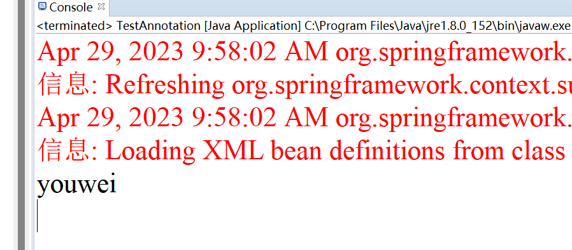
实验结果及思考题分析：
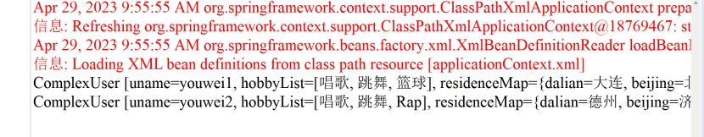
心得体会：
通过本次实验，学习了注解的开发以及三种实例化方式。收获很多。
评语：

