Final Project OOAD
By: Mohammad Rashid 3927-FBAS/BSSE/F18
Submitted to: Sir Mohammad Imran Said

DrawingKit Software System
Documentations

Project Vision
This software is from the family of digital drawing technologies that will enable user draw using a drawing tablet device in computer.

Stakeholders for the project are:
- Developer
- End User

The business need for developing this is that I’m required to prepare a small project for Object Oriented Analysis Course.

Scope of the Project

This software will provide following functionalities:
- User can draw into a canvas using digital drawing tablet device.
- User can erase from the canvas using the digital drawing tablet device.
- User can choose pencil type.
- User can choose eraser intensity.
- Choose eraser size.
- User can create new work.
- User can change current canvas size.
- User can load already existed work.
- User can exit the system.

Final Use Case Diagram:

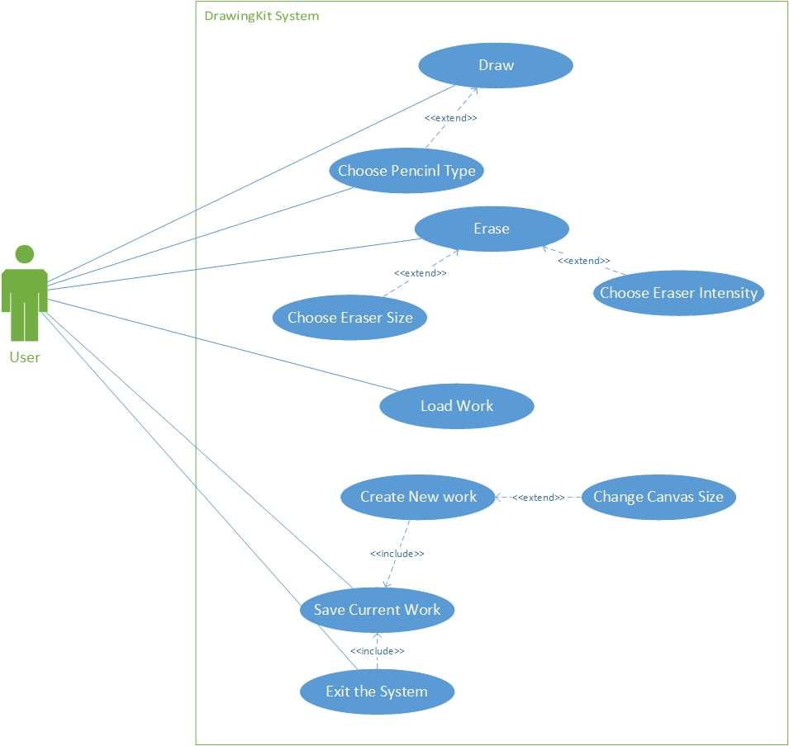

Conceptual Mode:

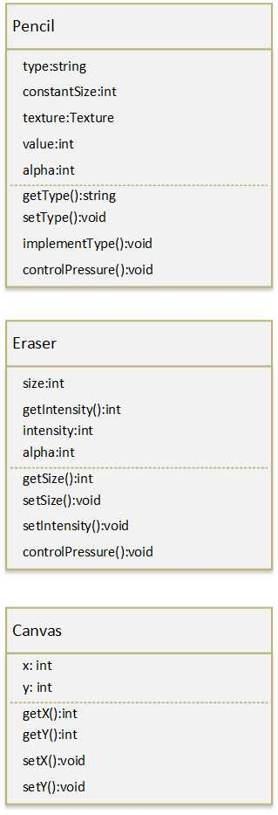

Use Cases:

Name: | Draw
Short Description: | User draw on the desired area of canvas.
Precondition: | - System is started successfully.  - Canvas is created.  - Drawing pen device work properly.
Post-condition: | - User has drawn his artwork.
Error Situation: | - Drawing pen device does not work properly
System state in the event of an error: | - System display error dialog saying the device is not working properly.
Actors: | - User
Trigger: | - Pen device is moving by user.
Standard Process: | 1- User move pen on the tablet face.  2- Pen send data coordinate to the system.  3- System detect the strokes.  4- System draw the strokes as pen is moved.  5- User stop moving the pen on the tablet face.
Alternative Processes: | -None
Exceptional Processes: | 2E1- Pen device does not send data to the System.  2E2- System show error dialog.

Name: | Choose Pencil Type
Short Description: | User choose different pencil type for his drawing.
Precondition: | - System has been started.  - Canvas has been created.
Post-condition: | - Pencil type has been changed.
Error Situation: | - None
System state in the event of an error: | - None
Actors: | - User
Trigger: | - User select different type from the pencil type list.
Standard Process: | 1- User select pencil type menu on the system.  2- System display pencil types list.  3- User select desired pencil type from the list.  4- System change pencil type.
Alternative Processes: | 3A1- User cancel choosing different type.  3A2- System close list.
Exceptional Processes: | - None

Name: | Erase
Short Description: | User erase desired area on the canvas.
Precondition: | - System has been started.  - Canvas has been created.  - Drawing pen device work properly.
Post-condition: | - User has erased the desired area.
Error Situation: | - Drawing pen device does not work properly
System state in the event of an error: | - System display error dialog saying the device is not working properly.  - Pen device cannot draw on canvas.
Actors: | -User
Trigger: | - Pen device is moving by user.
Standard Process: | 1- User move pen on the tablet face.  2- Pen send data coordinate to the system.  3- System detect the strokes.  4- System erase the area belong to strokes as pen is moved.  5- User stop moving the pen on the tablet face.
Alternative Processes: | - None
Exceptional Processes: | 2E1- Pen device does not send data to the System.  2E2- System show error dialog.

Name: | Choose Eraser Size
Short Description: | User choose different eraser size.
Precondition: | - System has been started.  - Canvas has been created.
Post-condition: | - Eraser size has been changed.
Error Situation: | - None
System state in the event of an error: | - None
Actors: | - User
Trigger: | - User select different size eraser from the standard sizes type list.
Standard Process: | 1- User select eraser size menu on the system.  2- System display standard eraser sizes list.  3- User select desired eraser size from the list.  4- System change eraser size.
Alternative Processes: | - User cancel choosing different standard eraser size.
Exceptional Processes: | - None

Name: | Choose Eraser Intensity
Short Description: | User choose different eraser intensity.
Precondition: | - System has been started.  - Canvas has been created.
Post-condition: | - Eraser intensity has been changed.
Error Situation: | - None
System state in the event of an error: | - None
Actors: | - User
Trigger: | - User change eraser intensity value in value field.
Standard Process: | 1- User move intensity slider on the system.  2- System reflect value change on the field.  3- User stop moving slider.  4- System change eraser intensity to the user generated value by slider.
Alternative Processes: | 1A1- User click in the value field.  1A2- System allow user to enter value via keyboard.  1A3- User enter desired value from the keyboard.
Exceptional Processes: | - None

Name: | Create New canvas.
Short Description: | User create new canvas.
Precondition: | - System has been started.
Post-condition: | - New canvas is created.
Error Situation: | - Illegal canvas dimension value is set.
System state in the event of an error: | - System show error dialog saying “Illegal canvas dimension”.
Actors: | - User
Trigger: | - Create New Canvas button is clicked the system.
Standard Process: | 1- User click Create New Canvas button on the system.  2- System save current work.  3- System display New Canvas dialog.  4- User enter desired dimension from the keyboard into the fields.  5- User click Create button.  6- System create new canvas with dimension according to the entry fields values.
Alternative Processes: | 3A1- User click on predefined dimension pattern list.  3A2- System display predefined dimension pattern list.  3A3- User choose the desired pattern from the list.  3A4- User click Create button.  3A5- System create new canvas according to the selected pattern.
Exceptional Processes: | 3E1- User enter illegal dimension.  3E2- System display dimension error dialog box.

Name: | Change Canvas Size
Short Description: | User can change current canvas size.
Precondition: | - System has been started.  - Canvas has been created.
Post-condition: | - Current canvas size has been changed.
Error Situation: | - Illegal canvas dimension value is set.
System state in the event of an error: | - System show error dialog saying “Illegal canvas dimension”.
Actors: | - User
Trigger: | - Create New Canvas button is clicked the system.
Standard Process: | 1- User click Resize button on the system.  2- System save current work.  3- System display Canvas Size Change dialog.  4- User enter desired dimension from the keyboard into the fields.  5- User click Resize button.  6- System change canvas size with dimension according to the entry fields values.
Alternative Processes: | 3A1- User click on predefined dimension pattern list.  3A2- System display predefined dimension pattern list.  3A3- User choose the desired pattern from the list.  3A4- User click Change button.  3A5- System change canvas size according to the selected pattern.
Exceptional Processes: | 3E1- User enter illegal dimension.  3E2- System display dimension error dialog box.

Name: | Save Current Work
Short Description: | User can save current work.
Precondition: | - System has been started.  - Canvas has been created.
Post-condition: | - Work has been saved to the HDD.
Error Situation: | - None
System state in the event of an error: | - None
Actors: | - User
Trigger: | - Save button is clicked.
Standard Process: | 1- User click Save button on System.  2- System display Save dialog.  3- User enter a name for the work in related field.  4- User choose one of the standard graphical type.  5- User choose a path for file to save in.  5- User click on Save button.  6- System save the work with given attributes.  7- System close Save dialog.
Alternative Processes: | - None
Exceptional Processes: | - None

Name: | Load File
Short Description: | User can load an existing file into the system.
Precondition: | - System has been started.
Post-condition: | - Work is loaded into the a new canvas from HDD.
Error Situation: | - None
System state in the event of an error: | - None
Actors: | - User
Trigger: | - Load button is clicked.
Standard Process: | 1- User click Load button on System.  2- System display Load dialog.  3- User choose a file from HDD.  4- User click Load button.  5- System fetch the attributes from the file.  6- System assign related attribute to initialize new canvas accordingly.  7- System load file information into the canvas.  8- System close Load dialog.  9- System create the canvas.
Alternative Processes: | - None
Exceptional Processes: | - None

Name: | Exit System
Short Description: | User can exit the system.
Precondition: | - System has been started.
Post-condition: | - System has been exited.
Error Situation: | - None
System state in the event of an error: | - None
Actors: | - User
Trigger: | - Exit button is clicked.
Standard Process: | 1- User click Exit button on System.  2- System save the work.  4- System exit.
Alternative Processes: | - None
Exceptional Processes: | - None

Class Diagram:
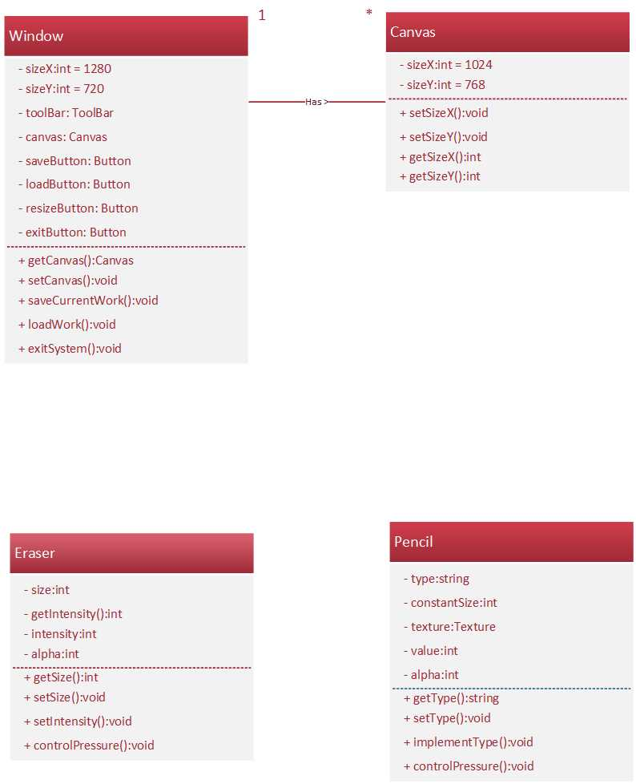

Collaboration Diagram:

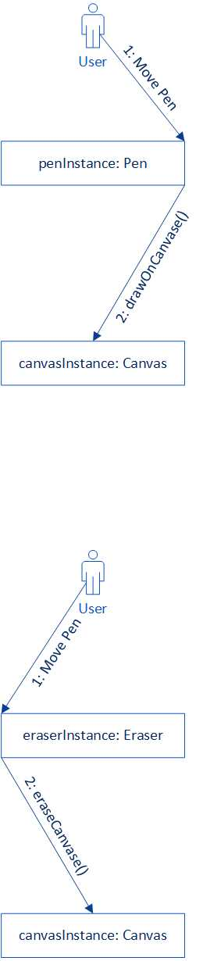

Sequence Diagrams:

