Repository: GitLab

API Path: <http://172.18.2.18/brimsfriendsHub/TaskManagerAPI>

UI Path: <http://172.18.2.18/brimsfriendsHub/AngularUI>

CI Jenkins: <http://localhost:8080/>

Jenkins GitLab API Configuration:

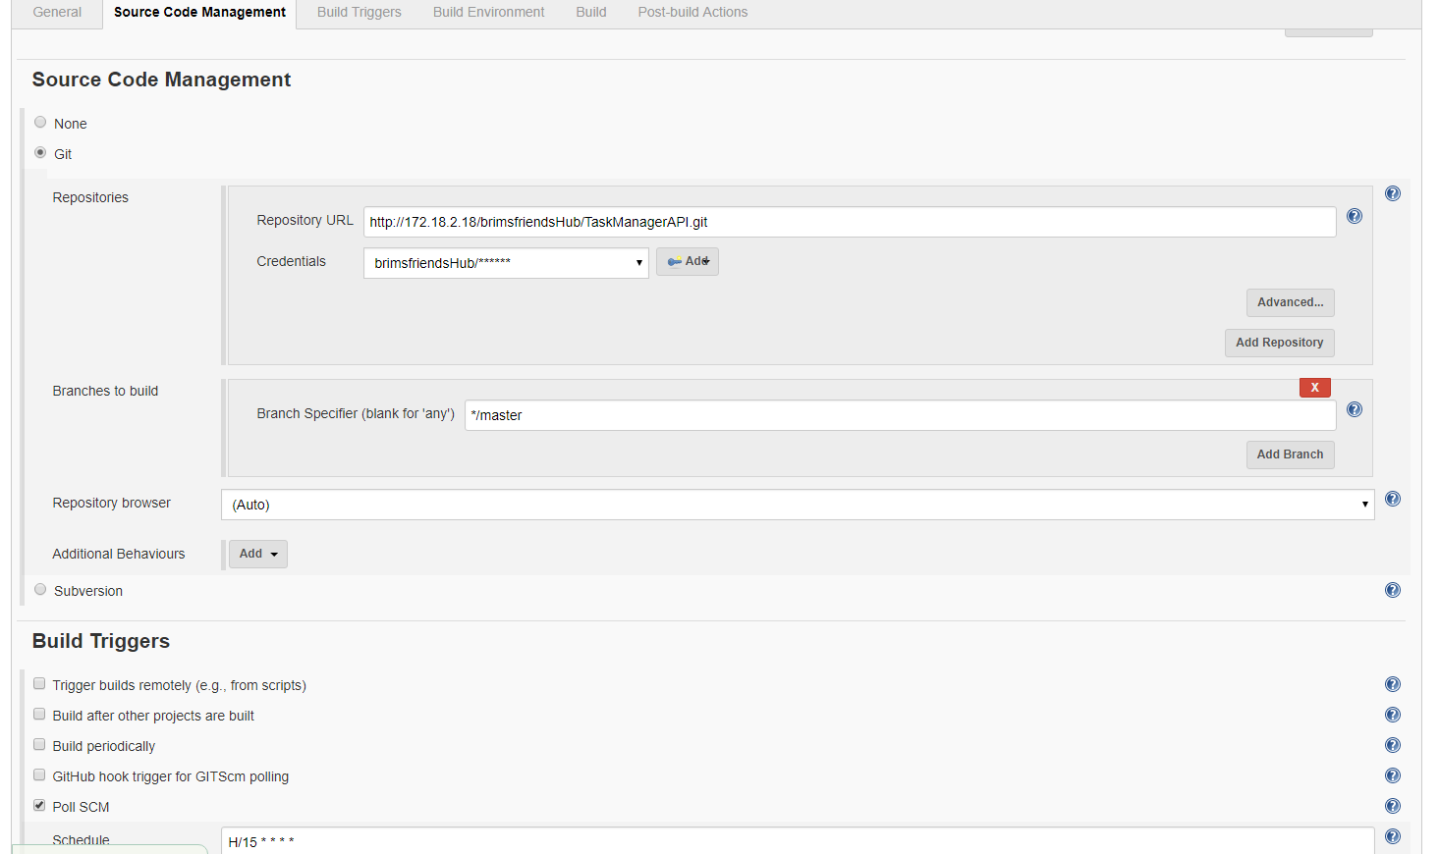

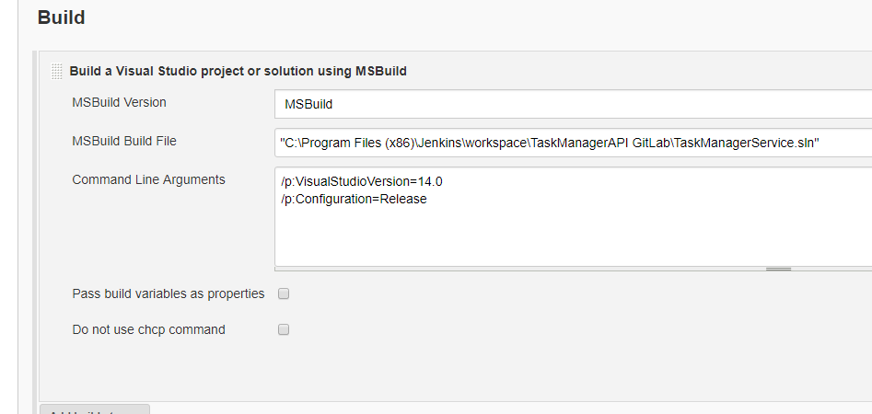

Job Status:

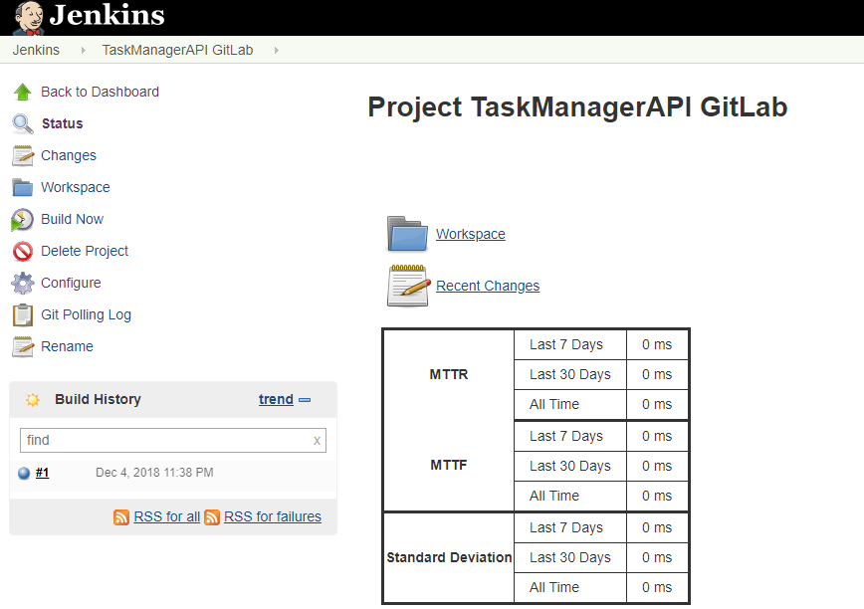

Jenkins GitLab UI Configuration:

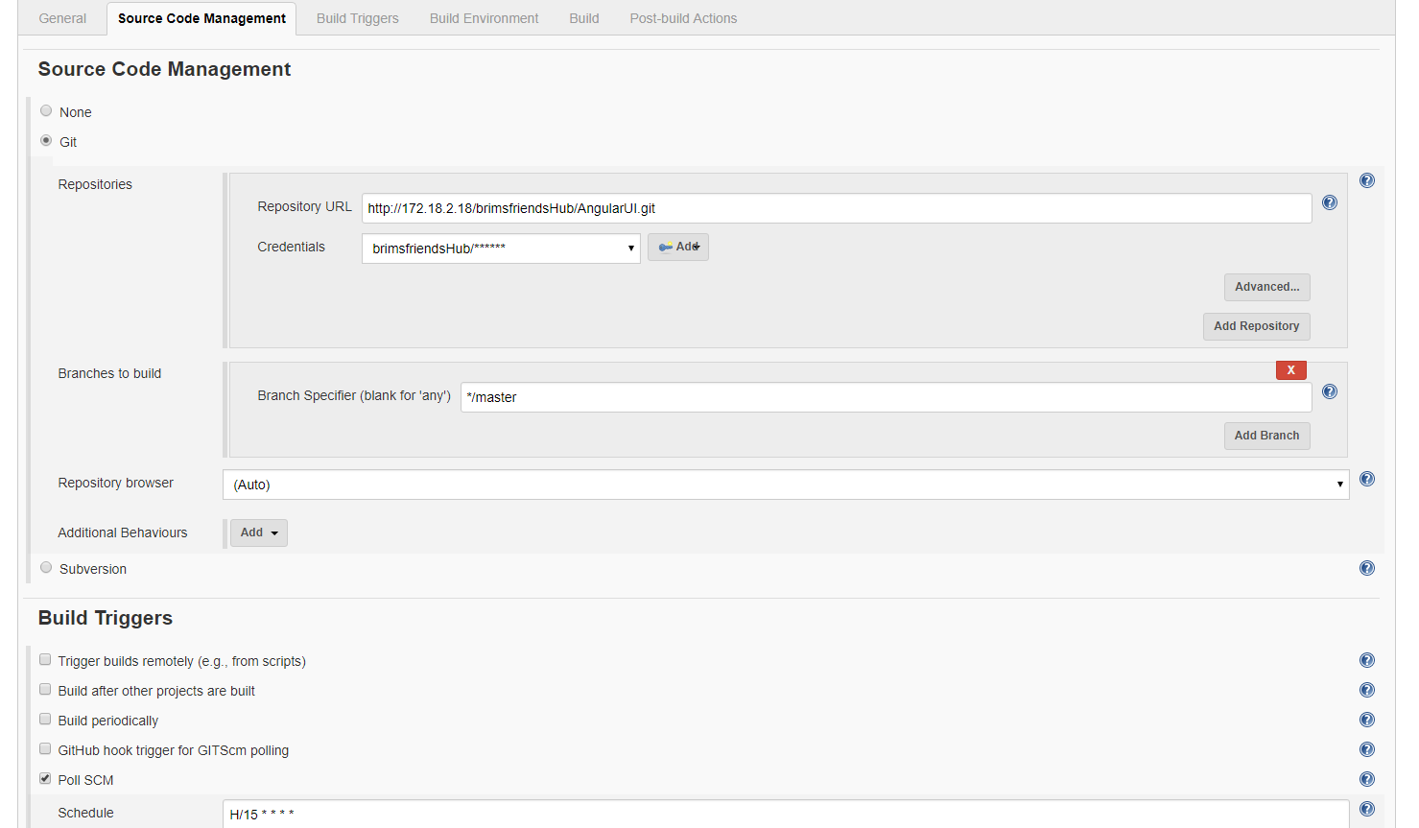

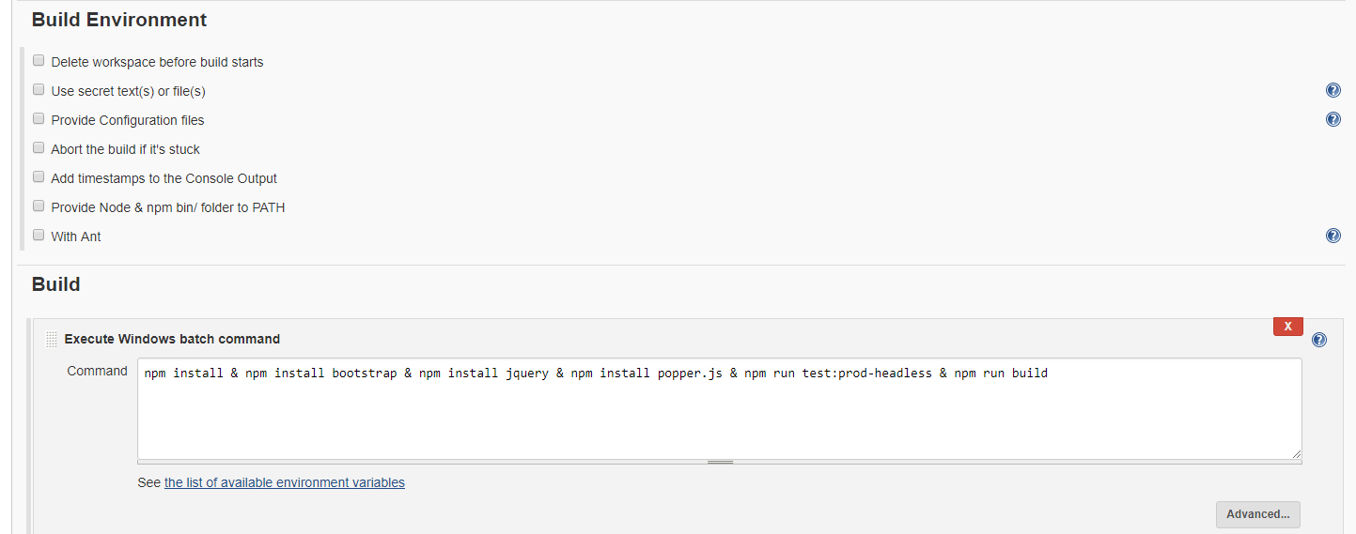

Job Status:

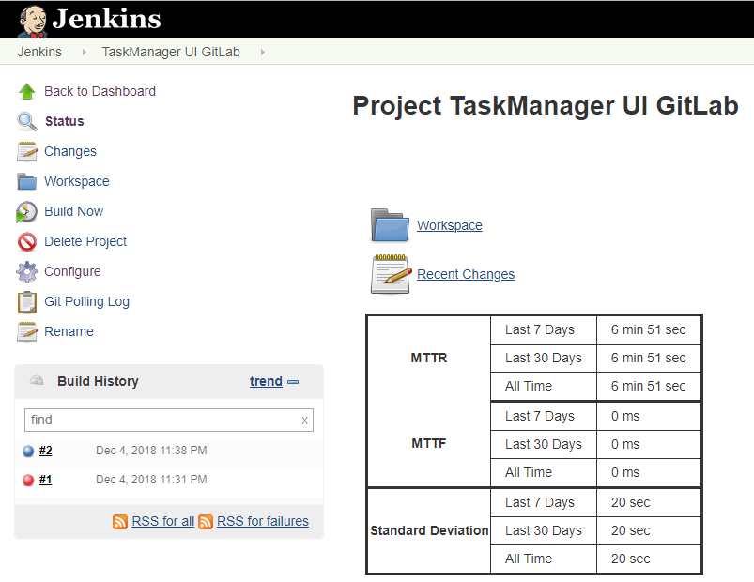

Overall JOB status:

