Mini Project Report

On

TRAVEL EASY WEB APPLICATION

A dissertation submitted to the Jawaharlal Nehru Technological University, Hyderabad in partial fulfillment of the requirement for the award of degree of

BACHELOR OF TECHNOLOGY IN

COMPUTER SCIENCE AND ENGINEERING

Submitted by

M Bharath Kumar(22B81A05Z3) G Brinda(22B81A05Z4)

S Sreeharshitha (22B81A05BM)

Under the Guidance of Ms.V. N. V. L. S. Swathi Internal Guide



Department of Computer Science and Engineering

CVR COLLEGE OF ENGINEERING

(An UGC Autonomous Institution, Affiliated to JNTUH, Accredited by NBA, and NAAC)

Vastunagar,Mangalpalli(V), Ibrahimpatnam(M), Ranga Reddy (Dist.) - 501510, Telangana State.

2024-25



CVR COLLEGE OF ENGINEERING

(An UGC Autonomous Institution, Affiliated to JNTUH, Accredited by NBA, and NAAC)

Vastunagar,Mangalpalli(V),Ibrahimpatnam(M), Ranga Reddy (Dist.) - 501510, Telangana State.

DEPARTMENT OF COMPUTER SCIENCE AND ENGINEERING

CERTIFICATE

This is to certify that the project entitled "Travel Easy Web Application" is being submitted by M Bharath Kumar(22B81A05Z3), G Brinda(22B81A05Z4) and S Sreeharshitha (22B81A05BM) in partial fulfilment for the award of Bachelor of Technology in Computer Science and Engineering to the CVR College of Engineering, is a record of Bonafide work carried out by them under my guidance and supervision during the year 2024-2025.

The results embodied in this project work have not been submitted to any other University or Institute for the award of any degree or diploma.

|  |
| --- |
| Signature of Supervisor, Ms V.N.V.L.S Swathi |
| (Assistant Professor) |

|  |
| --- |
| Signature of HOD, |
| Dr. A Vani Vathsala  Department of CSE |

Professor in charge External Examiner

Dr.Ch.Niranjan Kumar

# DECLARATION

I hereby declare that this project report titled "Travel Easy Web Application" submitted to the Department of Computer Science and Engineering, CVR College of Engineering, is a record of original work done by me. The information and data given in the report is authentic to the best of my knowledge. This Mini Project report is not submitted to any other university or institution for the award of any degree or diploma or published at any time before.

M Bharath Kumar(22B81A05Z3) G Brinda(22B81A05Z4)

S Sreeharshitha(22B81A05BM)

Date: Place:

# ACKNOWLEDGEMENT

The satisfaction that accompanies the successful completion of any task would be incomplete without the mention of the people who made it possible and whose encouragement and guidance has been a source of inspiration throughout the course of the project.

It is a great pleasure to convey our profound sense of gratitude to our Principal Dr. K. Ramamohan Reddy, Dr. A. Vani Vathsala, Head of CSE Department, CVR College of Engineering, for having been kind enough to arrange necessary facilities for executing the project in the college.

We deem it a pleasure to acknowledge our sense of gratitude to our project coordinator S.M.Ali , under whom we have carried out the project work. His incisive and objective guidance and timely advice encouraged us with constant flow of energy to continue the work.

We also take the pleasure to convey our profound sense of gratitude to our faculty supervisor Ms.V.N.V.L.S.Swathi under whom we carried our project.

We wish a deep sense of gratitude and heartfelt thanks to the management for providing excellent lab facilities and tools. Finally, we thank all those whose guidance helped us in this regard. We place highest regards to our Parents, our Friends and Well-wishers who helped a lot in making the report of this project.

M Bharath Kumar(22B81A05Z3)

G Brinda(22B81A05Z4)

S Sreeharshitha(22B81A05BM)

# ABSTRACT

*Travel Easy* is a dynamic, AI-enhanced web application designed to simplify and personalize the travel planning process. The platform features a structured-input chatbot powered by Gemini, Google's advanced AI model, which helps users create customized itineraries, suggest travel destinations, and guide them through the planning experience. Unlike traditional chatbots built on natural language processing or tools like Dialogflow, the Travel Easy chatbot operates through guided interactions and does not rely on real- time communication or NLP techniques.

To support practical travel needs, the application integrates real-time APIs that provide up-to-date weather forecasts, currency conversion rates, and the latest travel news. These features ensure that travelers receive accurate and timely information essential for planning and navigating their journeys.

A key highlight of Travel Easy is its community-driven blogging module, where users can share travel stories, experiences, and tips. These user-generated posts enrich the platform by offering peer insights and inspiration for fellow travelers, fostering cultural exchange and engagement.

By combining Gemini-powered AI assistance, real-time information via APIs, and a socially interactive blogging feature, *Travel Easy* delivers a comprehensive and engaging travel planning experience for users worldwide.

|  |  |  |  |
| --- | --- | --- | --- |
| **Table of Contents** | | | |
|  | | | Page No. |
|  |  | **List of Tables** | vi |
|  |  | **List of Figures** | vii |
| 1 |  | **Introduction** |  |
|  | 1.1 | Motivation | 1 |
|  | 1.2 | Problem statement | 1 |
|  | 1.3 | Project Objectives | 2 |
|  | 1.4 | Project report Organization | 2 |
| 2 |  | **Literature Survey** |  |
|  | 2.1 | Existing work | 3-4 |
|  | 2.2 | Limitations of Existing work | 4-5 |
| 3 |  | **Software & Hardware specifications** |  |
|  | 3.1 | Software requirements | 6-9 |
|  | 3.2 | Hardware requirements | 9 |
| 4 |  | **Proposed System Design** |  |
|  | 4.0 | Proposed methods | 10-11 |
|  | 4.1 | Class Diagram | 11 |
|  | 4.2 | Use case Diagram | 12 |
|  | 4.3 | Activity Diagram | 13 |
|  | 4.4 | Sequence Diagram | 14 |
|  | 4.5 | Technology Description | 14-15 |
| 5 |  | **Implementation & Testing** |  |
|  | 5.1 | Implementation | 16-17 |
|  | 5.2 | Testing | 18-19 |
| 6 |  | **Conclusion & Future scope** | 20 |
|  |  | **References:** | 21 |

LIST OF TABLES

|  |  |  |
| --- | --- | --- |
| Table No. | Title | Page No. |
| 3.2.1 | Hardware Requirements | 9 |
| 5.2.1 | Testing Situation | 18 |

LIST OF FIGURES

|  |  |  |
| --- | --- | --- |
| Figure No. | Title | Page No. |
| 4.2 | Class Diagram | 11 |
| 4.3 | Use Case Diagram | 12 |
| 4.4 | Activity Diagram | 13 |
| 4.5 | Sequence Diagram | 14 |

# INTRODUCTION

## Motivation

The motivation behind developing **Travel Easy** is to streamline and enrich the travel planning process by integrating the intelligence of Google Gemini with powerful APIs for weather, location data, and travel services. Planning a trip can often be time- consuming and overwhelming, with information scattered across multiple platforms. Travel Easy addresses this by offering a smart, centralized web application that provides personalized destination recommendations, real-time updates, and useful travel insights—all in one user-friendly interface. Our goal is to make travel planning not only more efficient and reliable but also more engaging and enjoyable, empowering users to explore the world with confidence and ease.

## Problem statement

Planning a trip often involves navigating multiple platforms to gather information about destinations, weather conditions, local news, and travel tips, which can be time-consuming and overwhelming. There is a need for a centralized solution that simplifies this process while also providing real-time updates and personalized assistance. Our web application, Travel Easy, addresses this problem by offering a one-stop platform that includes live weather updates, a smart chatbot for travel queries, news feeds about popular travel destinations, and a space for users to post and explore travel blogs. With secure user authentication, Travel Easy ensures a personalized and interactive experience, making travel planning more efficient, informed, and community-driven.

## Project Objectives

The primary objective of the Travel Easy web application is to simplify and enhance the travel planning process by offering an all-in-one platform that combines convenience, personalization, and real-time information. This project aims to provide users with live weather updates for various destinations through integrated APIs, while also featuring an intelligent chatbot powered by Google Gemini to assist with travel-related queries and suggestions. Additionally, Travel Easy seeks to keep users informed with the latest news about popular travel spots and encourages community engagement by allowing users to post and explore travel blogs. With secure user authentication, the application ensures a personalized and safe experience, all within a user-friendly and responsive interface designed to make travel planning more efficient, enjoyable, and interactive.

## Project Report Organization

This report provides an overview of the development and implementation of the *Travel Easy* web application. It begins with an **Introduction** outlining the project’s goals, followed by the **Problem Statement**, which addresses the challenges in current travel planning. The **Objectives** section highlights key features like real-time weather updates, chatbot assistance, and user-generated content. The **System Design and Architecture** explains how Google Gemini and APIs are integrated for smooth functionality. The **Implementation** section details the development of the app’s key features, such as the chatbot and blog system. The report concludes with **Conclusion**, reflecting on the app's performance, and **Future Enhancements** and **References** sections to suggest improvements and list resources used during the project.

# LITERATURE REVIEW

## Existing work

The *Travel Easy* website leverages several existing technologies and concepts to deliver a cutting-edge travel experience. The primary components of the existing work relevant to this project include:

### Travel Recommendation Systems

Many platforms, such as **TripAdvisor**, **Expedia**, and **Google Travel**, offer personalized travel recommendations based on user preferences, locations, and past travel data. These platforms suggest destinations, hotels, and activities using basic algorithms but often lack deep personalization or interactivity.

### Chatbots in Travel

While AI-powered chatbots like those built on Dialogflow or IBM Watson are often used to handle basic queries and assist with bookings, they tend to operate with limited contextual understanding and personalization. In contrast, Travel Easy leverages Gemini, a more advanced AI model, to power its chatbot. This allows the application to offer richer, more personalized travel planning assistance through structured conversations, helping users build customized itineraries and receive curated destination suggestions based on their inputs.

### Weather Updates

Many travel platforms integrate weather APIs like **OpenWeatherMap** and **Weatherstack** to provide real-time weather updates. These features give users essential weather information, but they are often isolated from other travel planning tools, lacking interactivity or integration with the broader planning experience.

### Community-Driven Platforms

Platforms like **TripAdvisor** and **Lonely Planet** feature user-generated content such as travel reviews, tips, and blogs. These platforms foster community engagement, allowing users to share their travel experiences. However, the content is often not integrated into personalized travel planning, making it harder for users to access tailored advice.

### Currency Conversion Tools

Travel apps and websites like **XE** and **Google** provide currency conversion tools using real-time exchange rates. However, these tools are typically standalone features, not integrated into a broader, interactive travel platform that offers personalized advice and real-time data.

## Limitations of existing work

### Lack of Deep Personalization

While **TripAdvisor** and **Google Travel** provide personalized recommendations, these are often limited to basic data, such as location and past behavior. They do not offer real-time, adaptive recommendations based on evolving user preferences or interactions. *Travel Easy* overcomes this by using **Google Gemini** for real-time, dynamic personalization that adapts to each user’s unique needs.

### Basic Chatbot Capabilities

While Gemini enhances the Travel Easy chatbot with intelligent, structured responses, it also has some limitations. It doesn't natively handle user context across sessions, requiring extra effort for personalization. Prompt design needs to be precise to guide conversations effectively. Additionally, there may be usage limits or latency depending on how the model is accessed. Since it doesn't rely on real-time APIs for responses, its adaptability is limited to predefined or static information.

### Weather Information in Isolation

Weather updates are usually provided as separate features, often without integration into the broader context of travel planning. Platforms like **OpenWeatherMap** offer weather data but don’t personalize it based on specific user interests or preferences. *Travel Easy* integrates weather updates with personalized travel recommendations, ensuring that users have a holistic view of their trip planning.

### Limited Community Integration

While platforms like **TripAdvisor** and **Lonely Planet** offer user-generated content, they often do not integrate this into the travel planning process. Users can read reviews and blogs, but they do not receive personalized travel recommendations based on community input. *Travel Easy* enhances community-driven content by offering an integrated blog space and personalized travel advice powered by **Google Gemini**.

### Standalone Currency Conversion

Currency conversion tools, such as those offered by **XE**, provide basic conversion rates but are typically separate from the travel experience. They do not offer contextual or personalized recommendations for managing travel finances. *Travel Easy* integrates currency conversion directly into the user’s travel planning process, providing real-time, context-aware financial advice.

# SOFTWARE AND HARDWARE SPECIFICATIONS

The Travel Easy web application is a robust platform designed to offer users a complete travel management experience. It features a chatbot for real-time assistance, a user dashboard for profile management, a community interaction page, a blogging section, and secure user authentication. The following is a detailed breakdown of the requirements necessary for developing and operating this application.

## Software Requirements

This section outlines the software stack and tools required for the front-end, back-end, database, chatbot integration, and user authentication of the Travel Easy application.

### Front-End Development

* + - * **HTML Structure for Core Pages**: HTML (HyperText Markup Language) forms the foundational structure of the Travel Easy web application. It is used to define key pages such as:
      * **CSS for Responsive Design and Styling**: CSS (Cascading Style Sheets) is used to style the HTML elements, ensuring that the Travel Easy application is visually appealing and consistent across various devices. Key CSS functionalities include:
      * **Responsive Design**: Ensures that the application is accessible on desktops, tablets, and smartphones by adapting layouts and elements to different screen sizes.
      * **Custom Styling**: Adds branding elements such as colors, fonts, and spacing to create a unique visual identity for the platform.
      * **Responsive Front-End with Bootstrap**: The application uses Bootstrap to develop a clean, responsive, and user-friendly interface, ensuring consistent layout and styling across various devices and screen sizes.

### Back-End Development

* + - * **Node.js & Express**: Used for building a fast and scalable server-side application and managing API routes. It also facilitates seamless communication between the chatbot, database, and external APIs, ensuring smooth handling of user requests and real-time data retrieval for travel planning features.
      * **Handling API Requests**: Node.js manages requests from the front-end, such as user login, and handling community posts.
      * **Asynchronous Operations**: Node.js handles multiple user requests simultaneously without slowing down, making it ideal for real-time applications like Travel Easy.
      * **REST API for Front-End and Back-End Communication**: REST APIs (Representational State Transfer) are used to facilitate communication between the front-end and back-end.
      * **User Profile Management**: Fetching, updating, and storing user data, including profile information, travel preferences.
      * **Community and Blog Data**: Handling requests for creating, reading, updating, and deleting posts on the community and blogging pages.
      * **PostgreSQL Database**: Handles data storage for user details, itineraries, blogs, and travel records with reliable relational data management.
      * **API Integration**: Real-time APIs are used to fetch weather updates, travel news, and currency conversion data to enrich the travel planning experience.

### Database Management

* **PostgreSQL for Structured Data Handling**: PostgreSQL, a powerful open-source relational database, is used in Travel Easy for managing structured data securely and efficiently. Key use cases include:
* **User Authentication and Profiles**: Stores user credentials, personal information, and login data with strong relational integrity.
* **Travel Blogs and Posts**: Manages user-generated content such as travel stories, blog entries, and comments, supporting relationships between users and their content.
* **Scalability and Data Integrity**: Ensures consistent performance and data accuracy as the application grows, thanks to PostgreSQL’s robust support for complex queries and transactions.

### Gemini API

The Gemini API is a versatile tool used in Travel Easy to power the chatbot functionality. While Gemini is capable of advanced features like natural language processing, in this project it is primarily used for generating structured, prompt-based responses rather than full NLP capabilities. This allows the chatbot to interact with users in a conversational format, helping them build personalized travel plans and itineraries based on specific inputs. Gemini’s ease of integration and response generation make it suitable for delivering an interactive user experience without relying on deep language understanding..

### Authentication and Security

* + - * **User Authentication with Node.js**: User authentication in Travel Easy is handled via a secure login/signup system using Node.js.
      * **Secure Login and Signup**: Users can create accounts and log in securely, with password hashing and encryption mechanisms in place to protect user data.
      * **JWT (JSON Web Token) Authentication**: JWT is used to authenticate users across sessions, allowing them to access personalized features like their dashboard and bookings.
    1. **Web Browser:** Preferred web browser to view and interact with the application (e.g., Chrome, Firefox, Safari).

## Hardware requirements

**Hardware requirements**

Table 3.2.1: Hardware Requirements

|  |  |
| --- | --- |
| **Item** | **Description** |
| Processor | 13th Gen Intel(R) Core(TM) i5-1340P 1.90 GHz |
| Installed RAM | 16.0 GB (15.7 GB usable) |
| Device | ID042345FC-56D4-4CB2-96D4-BB46CE5E46C1 |
| Product ID | 00342-42635-50417-AAOEM |
| System type | 64-bit operating system, x64-based processor |
| Edition | Windows 11 Home Single Language |
| Version | 23H2 |
| OS build | 22631.3593 |

# PROPOSED SYSTEM DESIGN

## Proposed Methods

### Profile Management

* Method: Use OAuth or JWT for user authentication and secure profile management.
* Description: Users can create and update their profiles, including travel preferences and history.

### Home Page with Famous Places

* Method: Integrate Google Places API or TripAdvisor API for dynamic place suggestions.
* Description: Display famous places with brief descriptions, personalized by Gemini AI.

### Chatbot Integration

* Method: Use Google Gemini for AI-driven, conversational interactions.
* Description: The chatbot provides personalized recommendations, itinerary help, and answers travel-related queries.

### Planning Itinerary

* Method: Use Google Maps API and Event APIs for personalized itinerary creation.
* Description: Users can generate custom itineraries based on travel preferences and dates, guided by Gemini AI.

### Weather Updates

* Method: Integrate OpenWeatherMap API for real-time weather information.
* Description: The chatbot provides weather updates and forecasts for selected destinations.

### Currency Converter

* Method: Use Fixer.io API or CurrencyLayer API for real-time currency conversion.
* Description: The chatbot assists users with currency conversions based on up-to-date exchange rates.

### News Regarding Places

* Method: Integrate NewsAPI for the latest travel-related news.
* Description: The chatbot delivers up-to-date news and safety information about destinations.
  1. **Class Diagram**

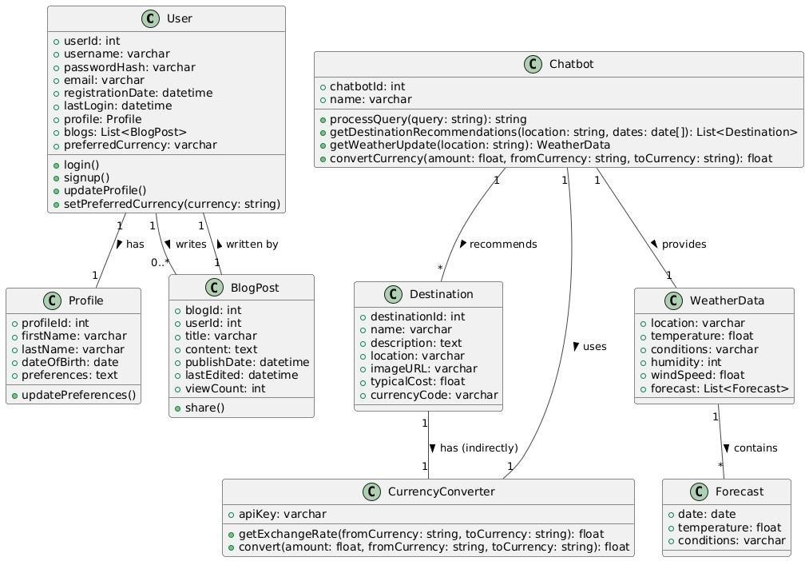

* 1. **Use Case Diagram**

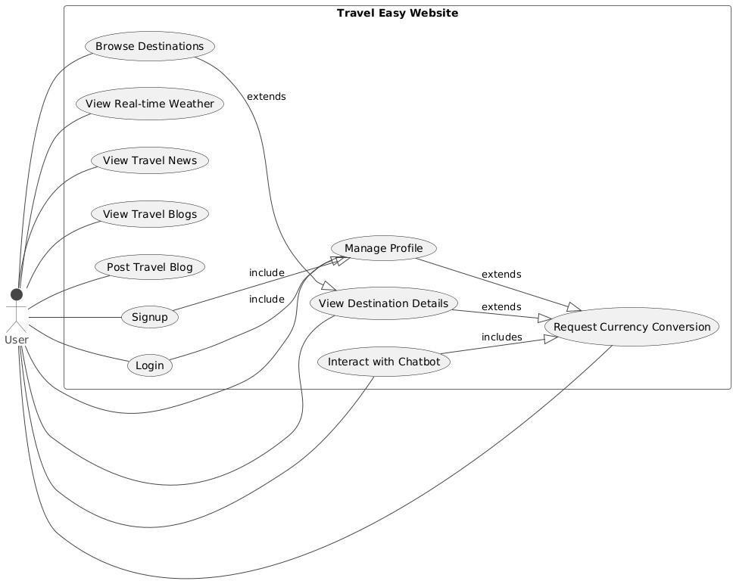

* 1. **Activity Diagram**

Travel Ea sy - Simplified Activity Diagra m

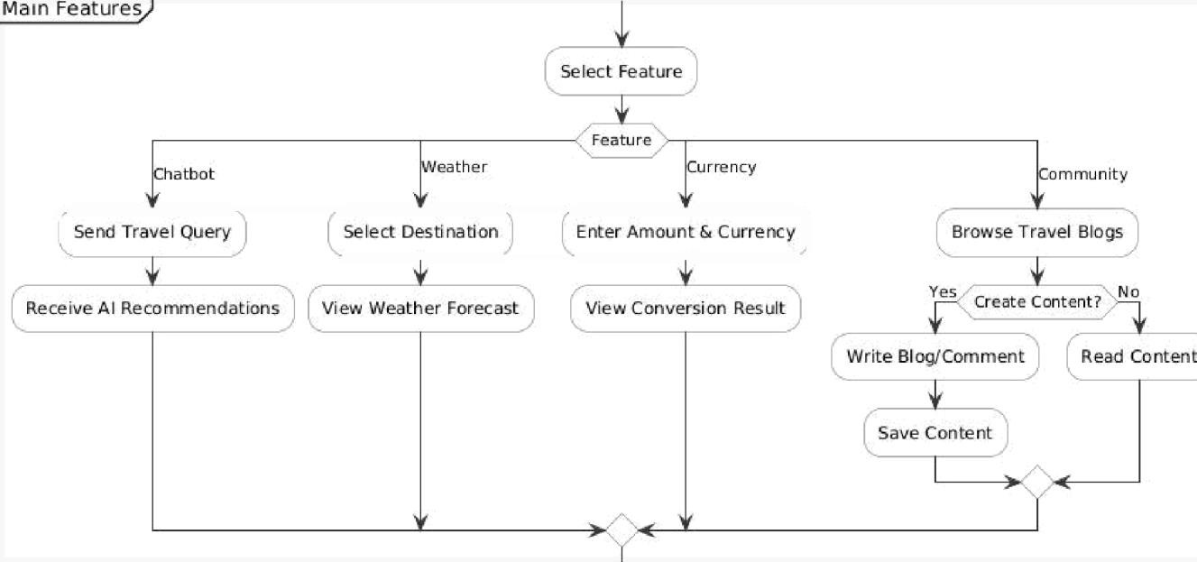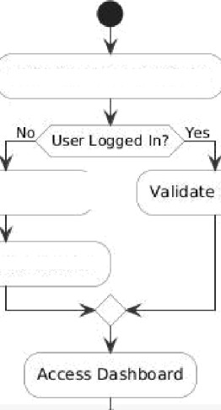

Display y Login

Session

Update Profile

## Sequence Diagram

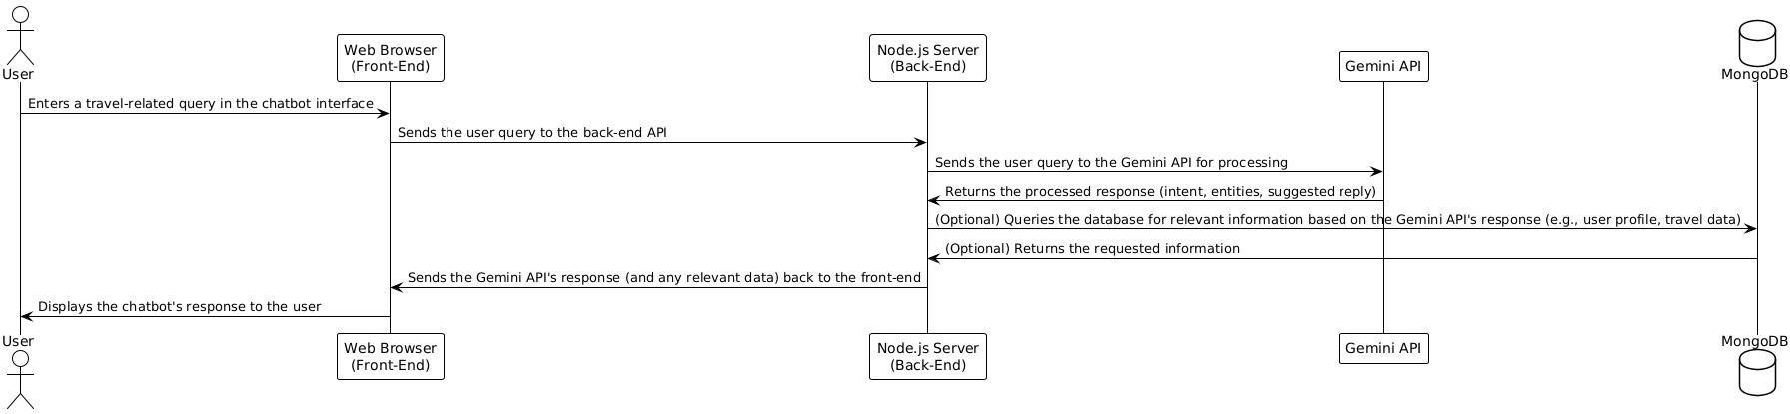

* 1. **Technology Description**

The Travel Easy platform combines modern web technologies and AI-driven features to deliver an interactive and personalized travel planning experience. HTML, CSS, and JavaScript are used to structure and style the pages, making the platform user-friendly. The backend of the website is powered by Node.js and Express.js, which manage server-side logic, handle API requests, and support real-time communication. PostgreSQL is used for storing user data, such as profiles, authentication details, and travel itineraries, offering reliable and structured data management. JWT (JSON Web Tokens) is implemented to ensure secure user authentication and session management, allowing safe access to user- specific features and data.

One of the standout features of Travel Easy is its integration with Google Gemini, an advanced AI model that powers a personalized chatbot. This chatbot offers users real-time travel recommendations, assists with itinerary planning, provides weather updates, and answers travel-related queries. The AI's conversational abilities enable more dynamic and adaptive interactions, far beyond basic customer service chatbots. The platform also integrates several third-party APIs, such as Google Maps API for location services and itinerary creation, OpenWeatherMap and Weatherstack for weather forecasts, and CurrencyLayer API for real-time currency conversion. These integrations allow users to get all their

travel-related information in one place.

To ensure the platform's reliability, Travel Easy employs robust security measures, including Bcrypt.js for password hashing and HTTPS for encrypted communication. The application is tested using Jest and Mocha for unit and backend testing, ensuring each component functions as expected. By leveraging these advanced technologies and frameworks, Travel Easy provides a seamless, secure, and personalized travel planning experience that adapts to the unique needs of each user.

# IMPLEMENTATION AND TESTING

The implementation of the **Travel Easy Web Application** involved translating the planned system architecture and design into a working, responsive, and secure full-stack web application. This development phase emphasized modularity, user experience, real-time responsiveness, and seamless integration with third-party APIs for dynamic data retrieval.

The platform adopts a **component-based architecture** using modern technologies like **React.js** for the frontend and **Node.js/Express** for the backend, connected via RESTful APIs. Key functionalities such as user authentication, personalized chatbot interactions, weather updates, blog posting, and real-time currency conversions were implemented using dedicated modules.

**5.1 MODULE-WISE IMPLEMENTATION**

The Travel Easy application is composed of the following core modules:

**• User Authentication and Profile Module**

Handles user onboarding, secure authentication, and profile management using **JWT** tokens and hashed passwords.

**Key Functions:**

* registerUser(), loginUser(): Secure user signup and login with encrypted credentials.
* getUserProfile(), updateUserProfile(): Fetches and updates user data including preferences.

**• Chatbot Interaction Module**

This module integrates **Google Gemini AI** to deliver structured, guided travel recommendations via a prompt-based chatbot.

**Key Functions:**

* + getRecommendations(): Returns AI-generated suggestions for destinations, travel tips, and itineraries.
  + planItinerary(): Helps users generate personalized travel itineraries based on interests and duration.

**• Itinerary and Planning Module**

Allows users to build and manage travel itineraries using **Google Maps API** and AI guidance.

**Key Functions:**

* + createItinerary(): Stores custom itineraries including date, time, and places.
  + getItinerary(), editItinerary(): View and modify saved itineraries.

**• Weather and Currency API Module**

Connects to third-party services to provide real-time weather forecasts and currency conversion.

**Key Functions:**

* + getWeather(location): Fetches current weather using OpenWeatherMap API.
* convertCurrency(base, target): Provides up-to-date exchange rates via CurrencyLayer API.

**• Travel News Module**

Fetches travel-related news updates from external sources using **NewsAPI**.

**Key Functions:**

* + fetchTravelNews(): Returns relevant articles based on user’s destination and interests.

**• Community Blog Module**

Empowers users to write, read, and comment on travel stories, enhancing community engagement.

Key Functions:

* + createBlogPost(), getAllPosts(): Manage blog content.
  + commentOnPost(): Enables community interaction via comments.

**5.2 TESTING**

Testing for the **Travel Easy Web Application** was performed through comprehensive evaluation of each module to ensure reliable, secure, and efficient operation. Given its user-centric, real-time, and API-driven nature, the system underwent various layers of testing with emphasis on user input handling, data integrity, responsiveness, and cross-module interaction—critical for a globally accessible travel assistant platform.

| **Requirement** | **Test Scenario** | **Input Data** | **Expected Output** |
| --- | --- | --- | --- |
| User Registration/Login | Register/Login with email and password | Valid user details | User registered or logged in; redirected to dashboard |
| Chatbot Interaction | Query travel recommendation or itinerary plan | User message, destination | AI returns tailored suggestions via Gemini API |
| Create Blog Post | Submit a blog post | Title, content, user ID | Post stored and appears in community feed |
| Weather Fetch | View current weather for selected city | City name | Weather details (temp, condition) fetched via API |
| Currency Conversion | Convert amount between currencies | Base and target currency, amount | Conversion result shown using real-time rates |
| Plan Itinerary | Create personalized itinerary | Location list, dates, user preferences | Itinerary saved and accessible under user’s profile |
| Fetch Travel News | Display recent travel news | Destination or keyword | Relevant news articles shown using NewsAPI |

**• Unit Testing**

All individual functions and API endpoints were tested using **Postman** and **Jest** to ensure logic consistency, error handling, and security mechanisms like JWT authentication. Each function such as registerUser(), createBlogPost(), and convertCurrency() was tested under:

* **Valid conditions**: Expected inputs with correct outputs
* Invalid conditions: Missing fields, malformed data, expired tokens, etc.
* Security checks: Unauthorized access, token tampering, input sanitization

This phase helped catch issues early, such as empty form submissions, incorrect HTTP status codes, or incorrect API payloads.

**• Integration Testing**

The interaction between modules—such as chatbot-assisted itinerary planning, user authentication, and profile updates—was tested to ensure the frontend, backend, and database worked in harmony. Examples include:

* Chatbot-generated itineraries correctly stored in the user profile
* Community blog posts reflected instantly after submission
* Currency and weather APIs returning dynamic data as expected
* Testing user journey across login → chatbot → blog posting → logout

**• System Testing**

End-to-end testing was performed to simulate real-world usage. The application was deployed locally and hosted in a controlled environment. This phase validated:

* Session management and persistence across page reloads
* Proper routing/navigation between components
* Data synchronization between the UI, backend APIs, and PostgreSQL
* Frontend responsiveness on various screen sizes and browsers

**• Performance Testing**

Basic performance evaluation was conducted to assess how the system handles multiple, concurrent requests to APIs such as weather and currency services. Metrics observed:

* API response time: < 500ms under typical load
* Memory usage: Within acceptable limits for Node.js applications
* Front**-end rendering:** Smooth transitions with React.js and Bootstrap

Although large-scale load testing is reserved for future deployment phases, initial tests confirmed the system's ability to handle moderate concurrent users without performance degradation.

This comprehensive testing process ensured that the **Travel Easy Web Application** is stable, secure, and ready for broader deployment. Future enhancements may include automated UI tests, continuous integration pipelines, and advanced load balancing simulations for scalability.

# CONCLUSION AND FUTURE SCOPE

The Travel Easy platform successfully combines technologies like React.js, Node.js, Google Gemini AI, and third-party APIs to offer a personalized and interactive travel planning experience. By integrating real-time weather, currency conversion, and destination recommendations, along with an AI-powered chatbot, it provides users with a seamless and dynamic travel experience. The platform has been rigorously tested for performance, security, and usability to ensure a smooth, efficient user experience.

The future of Travel Easy involves expanding AI-driven features, including personalized travel predictions and voice assistant integration for hands-free planning. Additionally, the platform could expand to include flight bookings, hotel reservations, and multi-language support to serve a global audience. Enhanced community features like travel forums and social sharing could foster more collaboration among users, making the platform more engaging and comprehensive.

As digital travel solutions evolve, Travel Easy has the potential to become a leading platform by continually improving its AI capabilities, integrating more services, and creating a more personalized, user-friendly travel planning experience. With future updates, the platform can better serve the global travel community and enhance overall user satisfaction.

# REFERENCES:

1. Node.js Documentation

Node.js. (2025). *Node.js – JavaScript runtime built on Chrome's V8 JavaScript engine*. Retrieved from [https://nodejs.org](https://nodejs.org/)

1. OpenWeatherMap API

OpenWeather. (2025). *OpenWeatherMap API documentation*. Retrieved from <https://openweathermap.org/api>

1. Google Gemini

Google AI. (2025). *Introducing Gemini: A breakthrough in conversational AI*. Retrieved from [https://ai.googl](https://ai.google/)e.com