# HW1

SETTING UP PYTHON AND GIT

For this class we will be coding exclusively in Python and using Git for submitting some assignments and collaborating with your project team.   How you ultimately decide to setup your Python environment is up to you but in this first assignment, you will practice two approaches.  The first is using Jupyter Notebooks which is a popular tool for demonstrating code and data visualization.  It is also the backbone of Google Colab which we will use later in the course.   For the second Python environment you choose your own IDE or simply a text editor to demonstrate writing a simple Python script and executing it.

Next is setting up a GitHub account and initializing a repository.   You need to understand the [basics (Links to an external site.)](https://confluence.atlassian.com/bitbucketserver/basic-git-commands-776639767.html) of how this version control system works so please make sure you can init, clone, add, commit, push, pull, and remote add. We won’t be worrying too much about branches in this class and you will generally just be working off the master branch of either your or your team’s master branch.   Please, please, please get in the habit of pushing your changes often when working together on your teams!!! We may very well use commit metrics to evaluate project participation!

SETTING UP PYTHON

1. Install python 3.8

[https://realpython.com/installing-python/ (Links to an external site.)](https://realpython.com/installing-python/)

**attach screen capture of `python –version` command.**

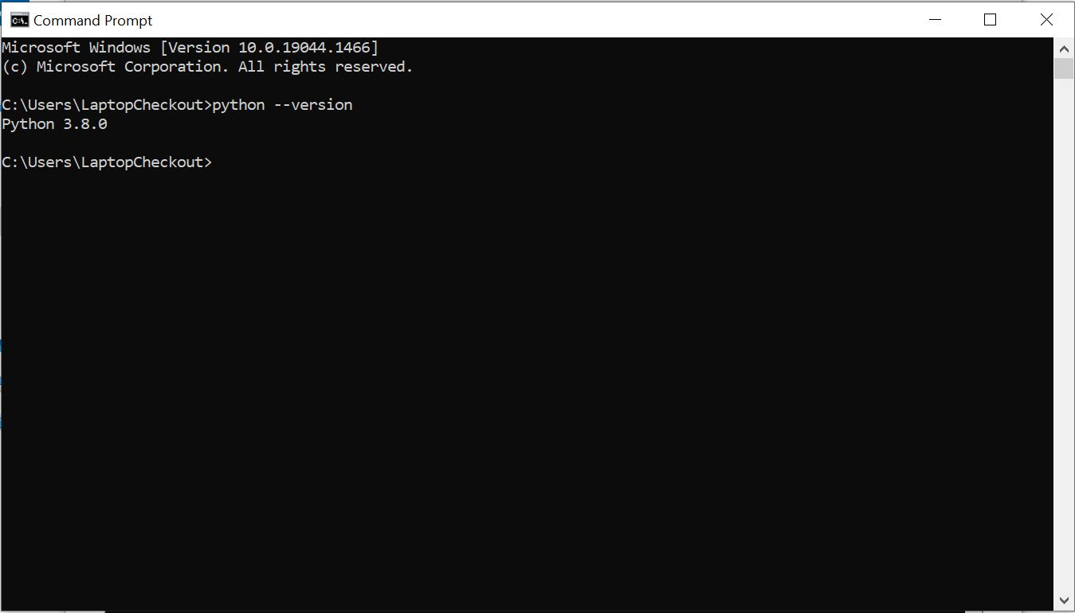

1. Create a folder for your class files, make a python virtual environment called *venv* in this folder, activate it, and

**attach screen capture of `python –version` command.**

[https://docs.python.org/3/tutorial/venv.html (Links to an external site.)](https://docs.python.org/3/tutorial/venv.html)

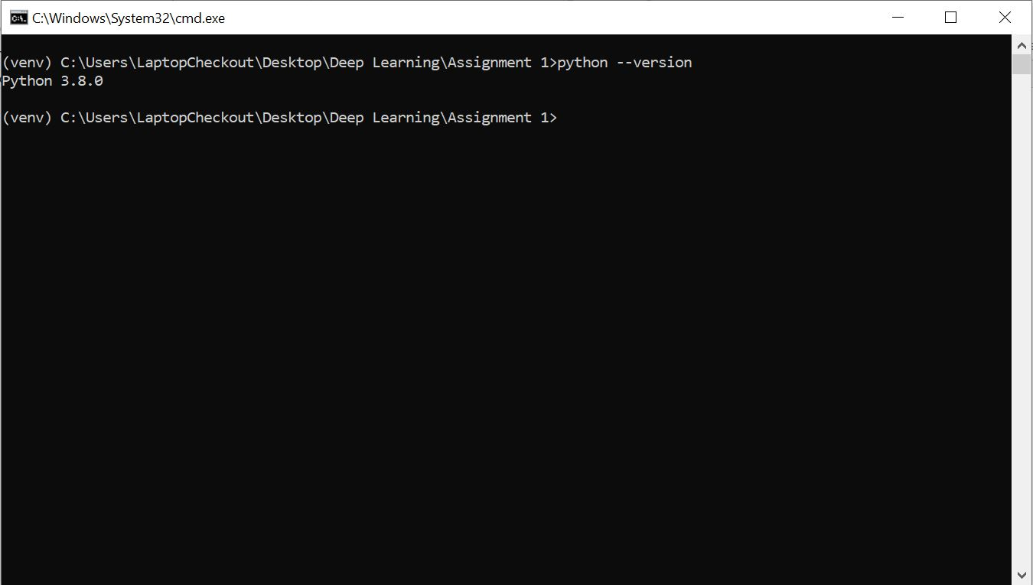

1. Install Jupyter Notebook (or JupyterLab) in your environment, preferably using pip, and run the notebook server.

Install

[https://docs.jupyter.org/en/latest/install/notebook-classic.html (Links to an external site.)](https://docs.jupyter.org/en/latest/install/notebook-classic.html)

Run

[https://docs.jupyter.org/en/latest/running.html (Links to an external site.)](https://docs.jupyter.org/en/latest/running.html)

Create a notebook called *My First Notebook*, execute a print statement to print your name and

**attach screen capture**

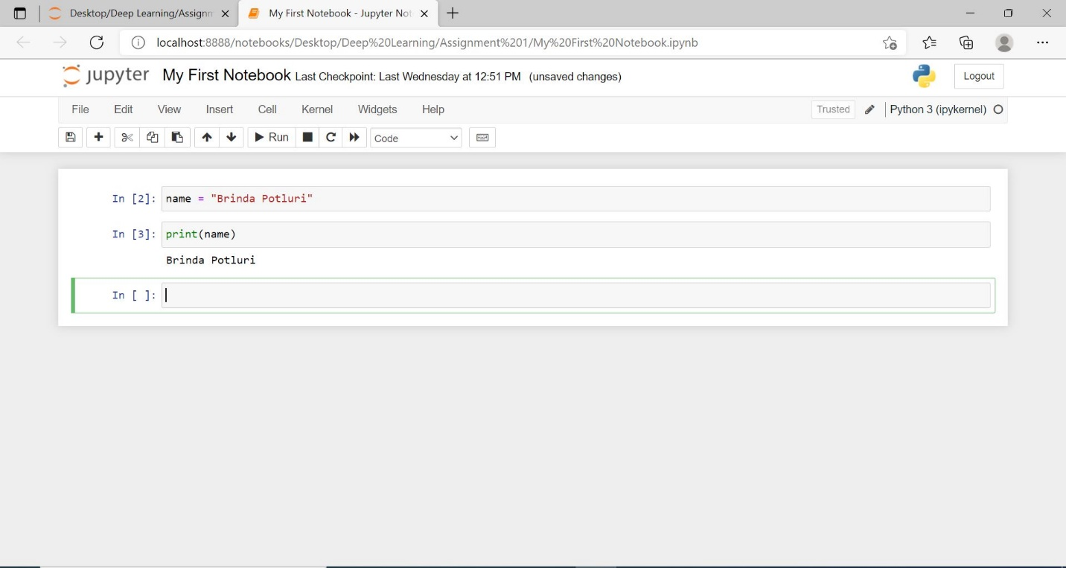

1. Pick one other IDE from this [list (Links to an external site.)](https://hackr.io/blog/best-python-ide) (I like VS code) and create a python script that’s prints your name, run it, and

**show a screen capture with the IDE and the output.**

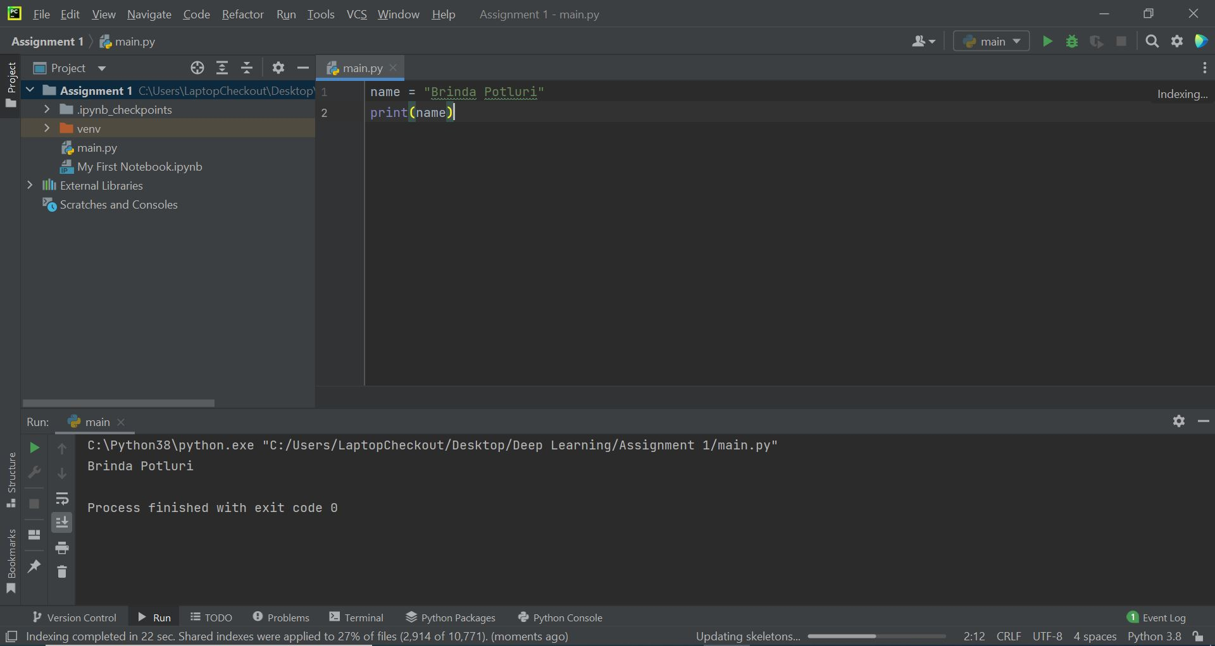

SETTING UP GIT.

1. If you do not have one, create an account on [https://github.com/ (Links to an external site.)](https://github.com/).  Initialize a repository for your class files,  add and commit myname.py to the repository on your local machine, commit changes, and push it to GitHub.

**Show a screen capture with your GitHub repository.**

**Also provide the link here like this:** <https://github.com/constant5/minitorch>

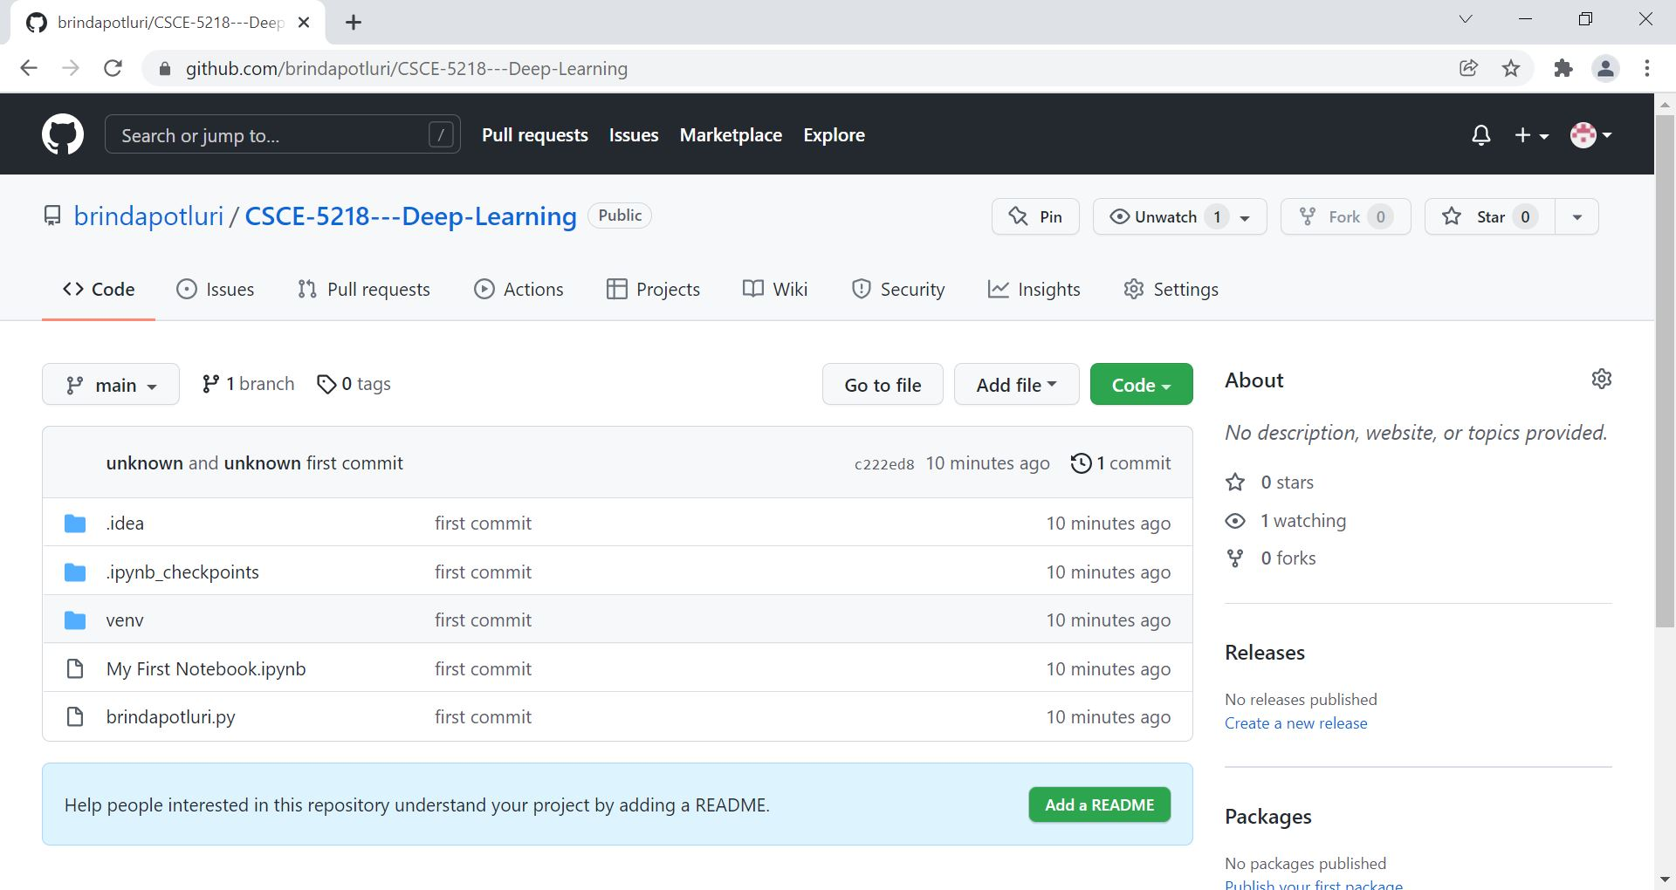

link : <https://github.com/brindapotluri/CSCE-5218---Deep-Learning>