PES UNIVERSITY
B.TECH 5TH SEMESTER CSE

DATA ANALYTICS PROJECT REPORT

HOUSE SALE PRICES FOR KING COUNTY

BHAVANA NAGA SAI MALEPATY - 01FB15ECS068
BRINDAVANA SACHIDANAND - 01FB15ECS072
SHREYA PK - 01FB15ECS283

INTRODUCTION

Objective:
To build models using regression and check the correctness of the predicted model with actual data, and to come up with the best model. (i.e., the one model which is the closest to the predicted model) and analyse the features of that model.

ABOUT THE DATASET

Dataset Used: “House Sales in King County”
Source: Kaggle
The data describes about the house sale prices for King County, including Seattle. It includes homes sold between May 2014 and May 2015. It's a great dataset for evaluating simple regression models.

The attributes of the dataset are:
- ID: to uniquely identify the house
- Date: Date on which the house was sold
- Price: Price at which the house is sold
- Bedrooms: Number of bedrooms per house
- Bathrooms: Number of bathrooms per house (0.5 accounts for a room with a toilet but without a shower)
- Sqft_living: Total area of the house in square feet
- Sqft_lot: The lot size of the house
- Number of floors: The number of floors per house
- Waterfront: 1, if facing a water body; 0, otherwise
- View: The rating of the view from the house(between 0 to 4)
- Condition: The index of the condition of the house(between 1 to 5)
- Grade: Index from 1 to 13 where
  - 1-3 :- Falls short of building construction and design
  - 4-9 :- Average level of construction and design
  - 10-13 :- High quality level of construction and design.
- Sqft_above: Area of the fllor above basement in square feet
- Sqft_basement: Area of the basement in square feet
- yr_built: Year of initial construction
- yr_renovated: Year of last renovation(0 indicates house wasn't renovated)
- Zipcode: Pin code of the location of the house
- Lat & Long: The coordinates, i.e, latitude and longitude of the location of the house
- Sqft_living15: The average area of 15 neighbouring houses
- Sqft_lot15: The average lot size of the 15 neighbouring houses

PLOT OF ATTRIBUTES

Before modelling the data, it’s necessary to study the relations between the attributes. The following graphs are plotted to visualize the patterns in the attributes.

- The Number Of Houses Based on Their Condition(1-5)

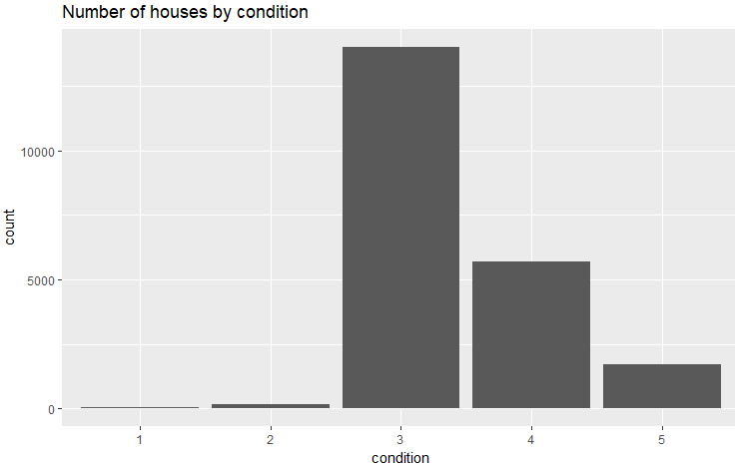

Analysis: A majority of the houses are fairly conditioned, and average priced. There are only a couple of houses, which are fully conditioned, suiting the needs of the rich. King County, has had very few poorly conditioned houses, that have given it a greater advantage, to attract customers for well-conditioned houses.

- The Number Of Houses Based on Their Grade(1-13)

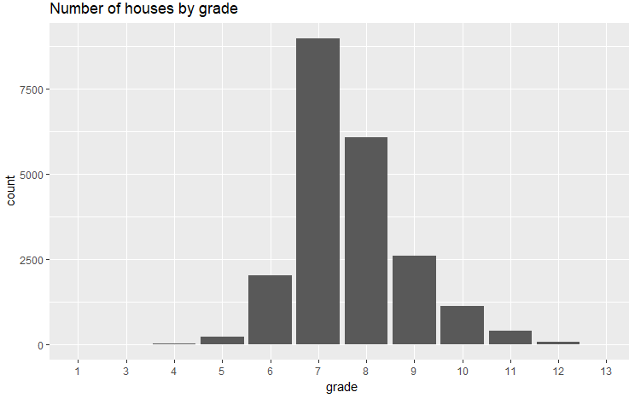

Analysis: This graph indicates that all houses of King County are well constructed and designed, as there are no houses falling under grade 1-3(falling short of construction and design). It’s remarking to see many houses are fairly constructed and designed. The luxurious have an option for detailed design

- Price Distribution
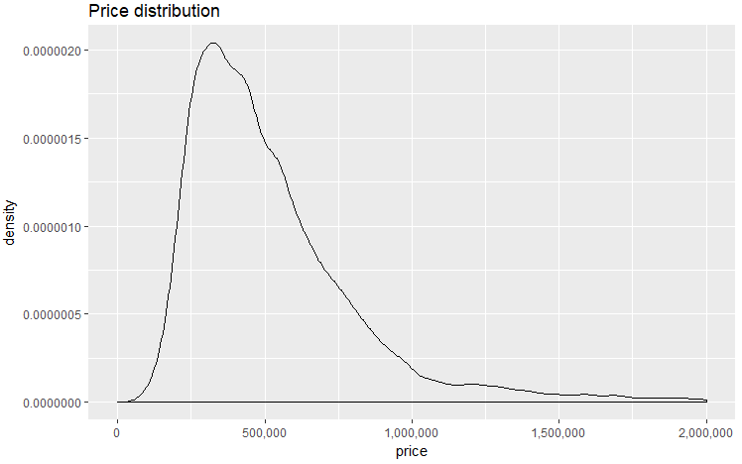
- Price(log 10) v/s sqft_living
Price is taken scaled to logarithmic values for a better fit and scaling of the graph

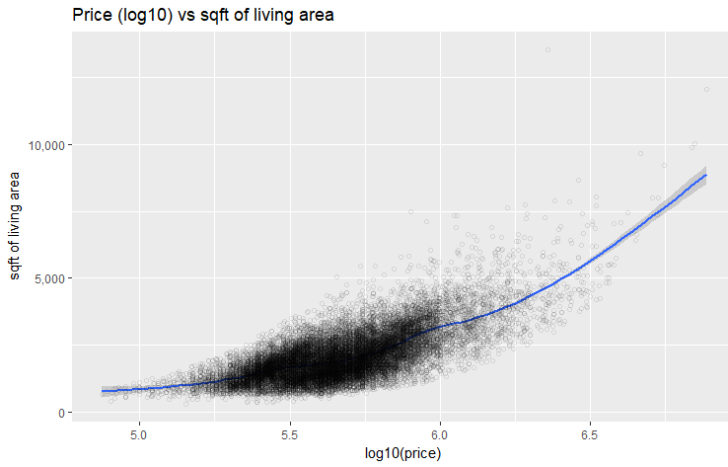

- Price(log 10) v/s grade
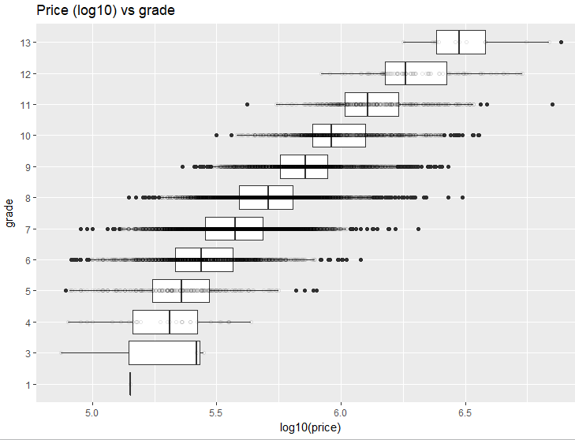
- Price(log 10) v/s condition

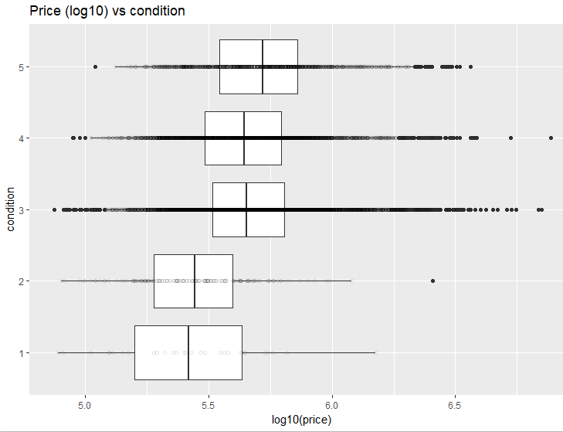

- Price(log 10) v/s number of floors
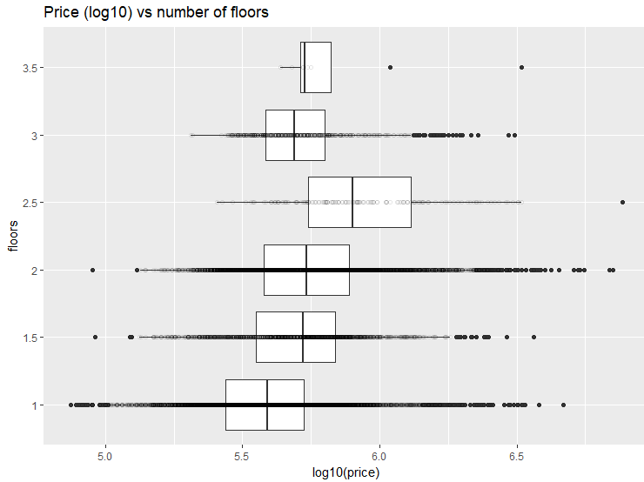
- Feature Correlation
We are plotting correlation of all attributes by taking all combinations of attributes. So, the boxes which have a lighter shade have lesser correlation between the attributes represented by them. And, the boxes with a darker shade have correlation between the attributes represented by them.
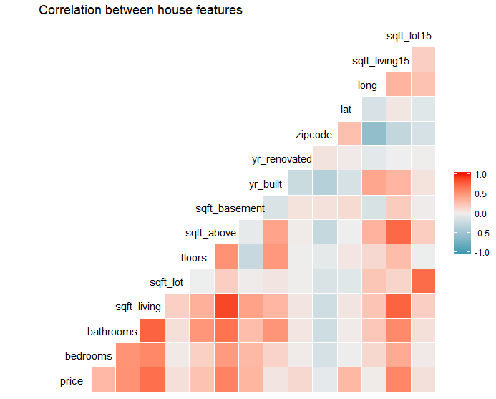

MODEL CHOICE
The dataset is partitioned into training (90% of the data) and testing (10%). We first use the training data to train the model for better accuracy. A model is predicted, using the testing data set, and designed to fit with the actual model. The predicted model indicates the result we are actually supposed to obtain.

We build two models:

- Fitted using a decision tree:
The decision tree splits at root node ‘grade’. There are further splits at nodes-coordinates, and square feet area of the house.
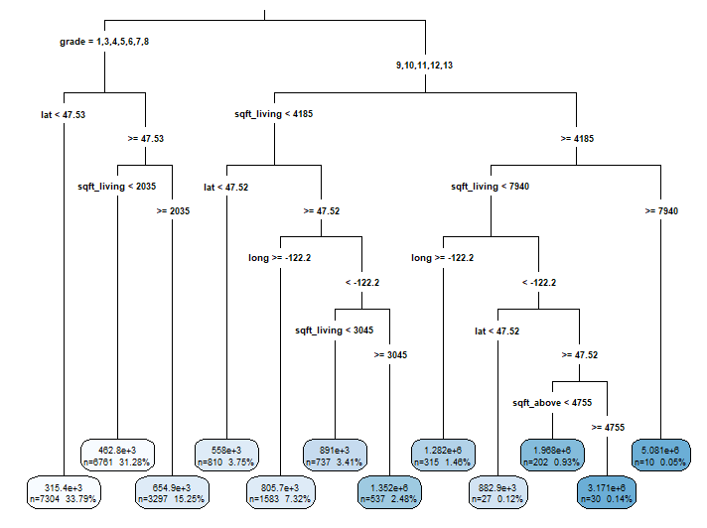

Following is the plot which shows the price distribution for the houses. It shows the correlation between the actual and the predicted model.
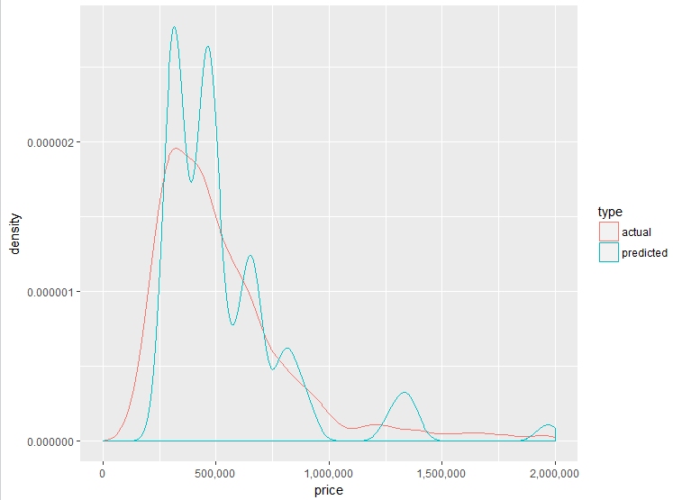
We observe that the correlation between the two is 0.813 which is good but not good enough to conclude. So, a more accurate model is attempted.

- Linear Regression Model:
The initial linear regression model is built by considering only a few attributes- sqft_living, sqft_above, sqft_basement, view, condition, floors, yr_renovated, and bedrooms
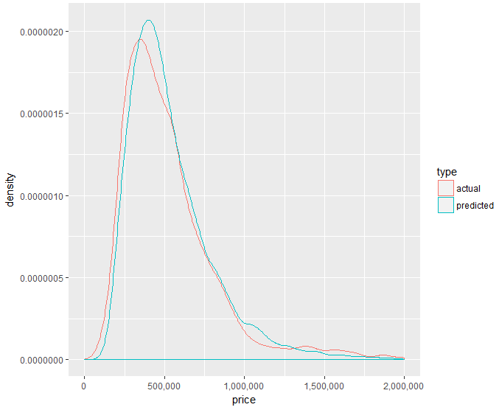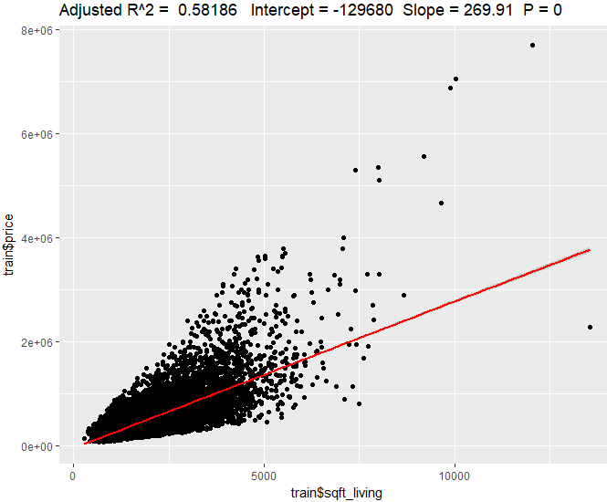
The adjusted value of R2 is too low, and hence another model is attempted which factors zipcode, view, grade, and condition

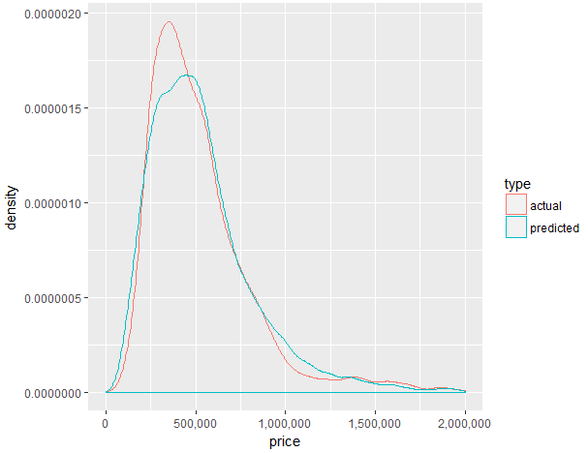
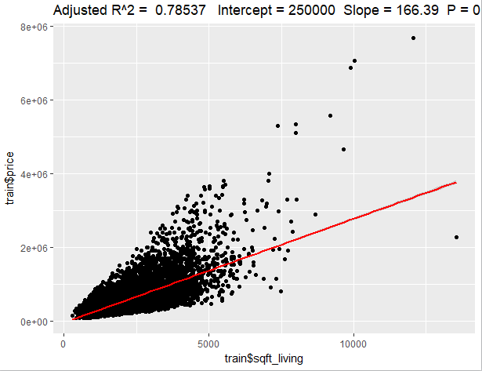
A final model is attempted to get an appropriate R2, and a better fit. The density plot looks similar, but the following graph indicates a better value for adjusted R2
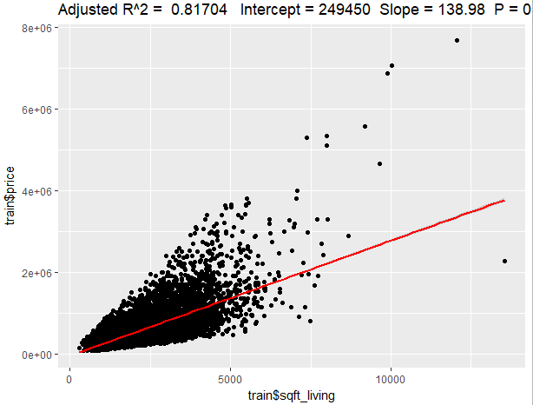
- Fitted using a XGB tree: Following is the plot which shows the price distribution for the houses. It shows the correlation between the actual and the predicted model.

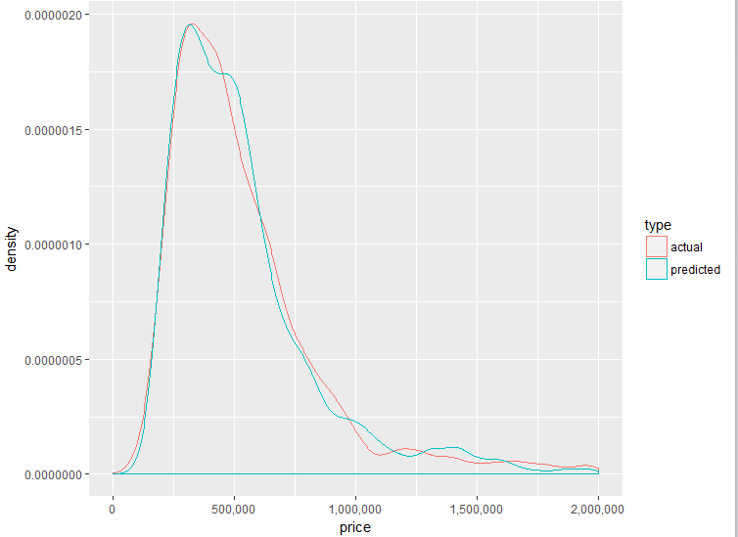

We observe that the correlation between the actual model and the predicted model is 0.937. So compared to the earlier model, we can conclude that the model fitted using the XGB tree is a better one. So we use this model to calculate feature importance.

Following is the plot depicting the comparison of both the predicted models with the actual model that is built.
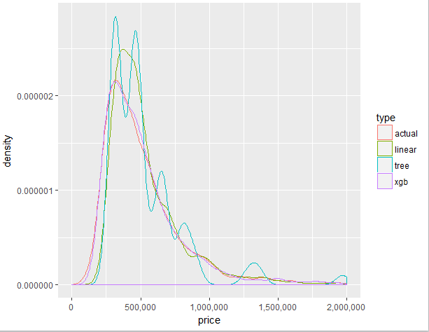

Above is the plot showing the price versus density for both the predicted models compared with the actual model. We observe that the predicted model in the second case (XGB Tree) has higher correlation with the actual model, compared to the first case (Decision Tree).

APPLYING THE MODEL

We apply the model built using XGB tree to calculate the feature importance.
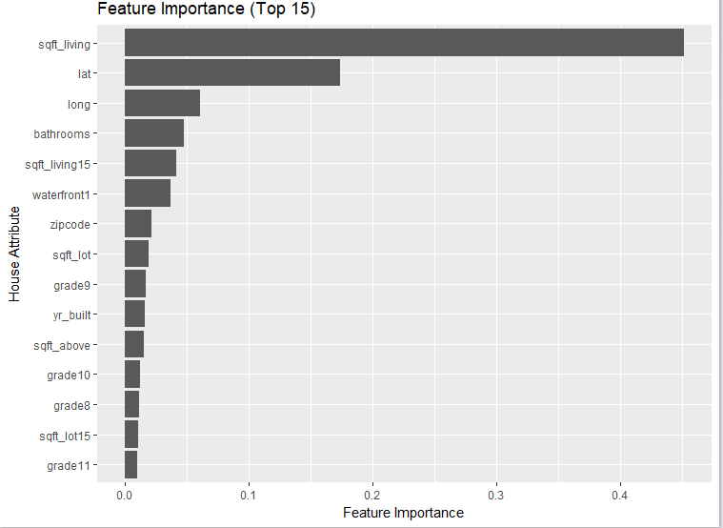

Above is the plot showing the feature importance of various attributes. We observe that the attribute sqft_living has the highest feature importance and the attribute sqft_basement has the lowest feature importance.

VALIDATING OUR MODEL

The difference between the predicted and actual values of the attribute price is calculated. The more negative the value, lesser is the deviation of the actual price from the predicted price. And thus, more accurate is the actual value. This is how we validate the regression model built using XGB tree to evaluate the housing prices.
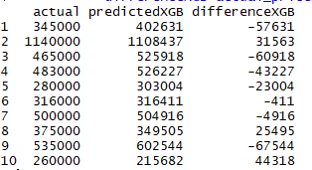

We thus got a better idea of the concept of linear regression by analysing this dataset step by step. We progressed to build more accurate models and hence, could infer the most appropriate model that meets our objective and thus, the most appropriate model to apply.

CONCLUSION

We can conclude that since predicted model has higher correlation with the actual model in case of the XGB Tree, it is the best model to calculate feature importance, compared to decision tree or a pure regression model. Hence, we make use of the same for this dataset.

CONTRIBUTIONS
SRN | Name | Role
01FB15ECS068 | Bhavana Naga Sai Malepaty | Linear Regression Model, Report Compilation
01FB15ECS072 | Brindavana Sachidanand | Dataset Research, Decision Tree Model
01FB15ECS283 | Shreya PK | Dataset Decision, XGB Model

R CODE

library(readr)
library(ggplot2)
library(reshape2)
library(plyr)
library(dplyr)
library(rpart)
library(rpart.plot)
library(caret)
library(scales)
library(GGally)
df<-read.csv("kc_house_data.csv",stringsAsFactors = F)

#Remove id and date columns and instruct R to interpret condition, view, grade and waterfront as factors
df <- df[-c(1, 2)]
df$condition <- as.factor(df$condition)
df$view <- as.factor(df$view)
df$grade <- as.factor(df$grade)
df$waterfront <- as.factor(df$waterfront)

#distribution of house condition, grade and price:
p1 <- qplot(condition, data=df, geom = "bar",
main="Number of houses by condition")
p2 <- qplot(grade, data=df, geom = "bar",
main="Number of houses by grade")
p3 <- ggplot(df, aes(price)) + geom_density() +
scale_y_continuous(labels = comma) +
scale_x_continuous(labels = comma, limits = c(0, 2e+06)) + xlab("price") + ggtitle("Price distribution")
#multiplot(p1, p2, p3)
plot(p1)
plot(p2)
plot(p3)

#price (log10) vs other features
#1.Sqft of Living Area
ggplot(df,aes(x=log10(price),y=sqft_living)) +
geom_smooth() + scale_y_continuous(labels=comma) +
scale_x_continuous(labels=comma) +
ylab("sqft of living area") +
geom_point(shape=1, alpha=1/10) +
ggtitle("Price (log10) vs sqft of living area")

#2.Grade
ggplot(df, aes(x=grade, y=log10(price))) +
geom_boxplot() + scale_y_continuous(labels=comma)+
coord_flip() + geom_point(shape=1, alpha=1/10) +
ggtitle("Price (log10) vs grade")

#3.Condition
ggplot(df, aes(x=condition, y=log10(price))) +
geom_boxplot() + scale_y_continuous(labels=comma) +
coord_flip() + geom_point(shape=1, alpha=1/10) +
ggtitle("Price (log10) vs condition")

#4.Number of Floors
ggplot(df, aes(x=as.factor(floors), y=log10(price))) +
geom_boxplot() + scale_y_continuous(labels = comma)+
xlab("floors") + coord_flip() +
geom_point(shape=1, alpha=1/10) +
ggtitle("Price (log10) vs number of floors")

#Feature Correlation
ggcorr(df, hjust=0.8, layout.exp=1) +
ggtitle("Correlation between house features")

#Splitting Data
train_idx<-sample.int(n=nrow(df),size= floor(.90*nrow(df)), replace = F)
train <- df[train_idx, ]
test <- df[-train_idx, ]
#extract the labels(true values) from our test dataset
test_labels <- test[, 1]

#Model 1-Decision Tree
tree_fit <- rpart(price ~ ., data=df)
tree_predicted <- predict(tree_fit, test)
summary(tree_predicted)
summary(test_labels)
cor(tree_predicted, test_labels)
#Model 1: Predicted v/s Actual
res <-data.frame(price=c(tree_predicted, test_labels), type=c(replicate(length(tree_predicted), "predicted"), replicate(length(test_labels), "actual")))

ggplot(res, aes(x=price, colour=type)) +
scale_x_continuous(labels=comma,limits=c(0, 2e+06))+
scale_y_continuous(labels = comma) + geom_density()

#Model1 Decision Tree
rpart.plot(tree_fit, digits = 4, fallen.leaves = TRUE,
type = 3, extra = 101)

#Model 2 – Linear regression Model
set.seed(101)
sample <- sample.int(n=nrow(df),size=floor(0.80* nrow(df)),replace = F)
train <- df[sample, ]
test <- df[-sample, ]

#Initial Model2A
linearModel <- lm(train$price~ (train$sqft_living+train$sqft_above+train$sqft_basement+factor(train$view)+factor(train$condition)+factor(train$floors)+factor(train$view)+ factor(train$yr_renovated)+factor(train$bedrooms)+factor(train$floors)))

linearPredicted <- predict(linearModel, test)
ggplotRegression(linearModel)

res <- data.frame(price=c(linearPredicted, test_labels),type=c(replicate(length(linearPredicted), "predicted"),
replicate(length(test_labels), "actual")))

ggplot(res, aes(x=price, colour=type)) +
scale_x_continuous(labels=comma,limits=c(0, 2e+06))+
scale_y_continuous(labels = comma) + geom_density()

#Model 2B
#zipcode and view to factor
#columns grade,condition to ordered factor
zc1<-df$zipcode
zc1 <- as.factor(zc1)
df$view <- as.factor(df$view)
df$grade <- as.ordered(df$grade)
df$condition <- as.ordered(df$condition)

linearMod2 <- lm(train$price ~ train$sqft_living + train$sqft_lot + train$grade + train$zipcode + train$sqft_living15 + train$sqft_above + train$sqft_basement + train$sqft_lot + train$sqft_lot15)

linearPredicted2 <- predict(linearMod2, test)
ggplotRegression(linearMod2)

res <- data.frame(price=c(linearPredicted2, test_labels),type=c(replicate length(linearPredicted2), "predicted"), replicate(length(test_labels), "actual")))

ggplot(res, aes(x=price, colour=type)) +
scale_x_continuous(labels=comma,limits=c(0, 2e+06))+
scale_y_continuous(labels = comma) + geom_density()

#Model 2C adding train$view
linearMod3 <- lm(train$price ~ train$sqft_living + train$sqft_lot + train$grade + train$zipcode + train$sqft_living15 + train$sqft_above + train$sqft_basement + train$sqft_lot + train$sqft_lot15+train$view)

linearPredicted3 <- predict(linearMod3, test)
ggplotRegression(linearMod3)

res <- data.frame(price= c(linearPredicted3, test_labels), type=c(replicate length(linearPredicted3), predicted"), replicate(length(test_labels), "actual")))

ggplot(res, aes(x=price, colour=type)) +
scale_x_continuous(labels=comma,limits=c(0, 2e+06))+
scale_y_continuous(labels = comma) + geom_density()

#Model3: XGBTree Model
#trainControl()-Control the computational nuances of the train function
ctrl=trainControl(method="cv",number=10,allowParallel =T)
#Combns of Vectors
param_grid <- expand.grid(eta = c(0.3, 0.5, 0.8),
max_depth = c(4:10), gamma = c(0), colsample_bytree = c(0.5, 0.6, 0.7), nrounds = c(120, 140, 150, 170), min_child_weight = c(1))

#Combn chosen
param_grid <- expand.grid(eta=c(0.3), max_depth= c(6), gamma = c(0), colsample_bytree = c(0.6), nrounds = c(120), min_child_weight = c(1), subsample=c(0.7))

#Model 3: Fitting the predicted model
xgb_fit = train(price~., data=df, method="xgbTree", metric="RMSE", trControl=ctrl, subset = train_idx, tuneGrid=param_grid)
xgb_predicted = predict(xgb_fit, test, "raw")

summary(xgb_predicted)
summary(test_labels)
cor(xgb_predicted, test_labels)

#Model3: Actual v/s Predicted
res <- data.frame(price=c(xgb_predicted, test_labels), type=c(replicate(length(xgb_predicted), "predicted"), replicate(length(test_labels), "actual")))

ggplot(res, aes(x=price, colour=type)) + scale_x_continuous(labels = comma,limits=c(0, 2e+06))+
scale_y_continuous(labels = comma)+geom_density()

#Model features
#Feature Importance
imp <- varImp(xgb_fit, scale = FALSE)
imp_names = rev(rownames(imp$importance))
imp_vals = rev(imp$importance[, 1])

var_importance <- data_frame(variable=imp_names,
importance=imp_vals)

var_importance <- arrange(var_importance, importance)
var_importance$variable <- factor(var_importance$variable, levels=var_importance$variable)

var_importance_top_15 = var_importance[with(var_importance,order(-importance)),][1:15, ]

ggplot(var_importance_top_15, aes(x=variable, weight=importance)) +
geom_bar(position="dodge") + ggtitle("Feature Importance (Top 15)") + coord_flip() + xlab("House Attribute") + ylab("Feature Importance") +
theme(legend.position="none")

#Comparing all predicted distributions
res <- data.frame(price=c(tree_predicted, xgb_predicted, linearPredicted3,test_labels), type=c(replicate(length(tree_predicted), "tree"), replicate(length(xgb_predicted), "xgb"), replicate(length(linearPredicted3),"linear"), replicate(length(test_labels), "actual")))

ggplot(res, aes(x=price, colour=type)) +
scale_x_continuous(labels+comma,limits=c(0,2e+06)) +
scale_y_continuous(labels = comma) + geom_density()

#Difference between values of XGBModel and Actual
test_sample <- sample_n(test, 10, replace=FALSE)
test_predictionsXGB <- predict(xgb_fit, test_sample, "raw")
actual_prices <- round(test_sample$price, 0)
predicted_pricesXGB <- round(test_predictionsXGB, 0)
data.frame(actual=actual_prices,
predictedXGB=predicted_pricesXGB,
differenceXGB=actual_prices-predicted_pricesXGB)

#ggplotRegression Function(used in Linear Model)
ggplotRegression <- function(fit){
require(ggplot2)
ggplot(fit$model,aes_string(x = names(fit$model)[2], y = names(fit$model)[1])) + geom_point() +
stat_smooth(method = "lm", col = "red") +
labs(title = paste("Adjusted R^2 = ", signif(summary(fit)$adj.r.squared, 5), "Intercept=", signif(fit$coef[[1]],5 ), "Slope ", signif(fit$coef[[2]], 5),"P ", signif(summary(fit)$coef[2,4], 5)))
}

FEEDBACK

We can make future improvements by implementing Random Forest. Right now, we’ve implemented decision trees. We could extend the decision trees to implement Random Forest.

1. Assume number of cases in the training set is N. Then, sample of these N cases is taken at random but with replacement. This sample will be the training set for growing the tree.
2. If there are M input variables, a number m<M is specified such that at each node, m variables are selected at random out of the M. The best split on these m is used to split the node. The value of m is held constant while we grow the forest.
3. Each tree is grown to the largest extent possible and there is no pruning.
4. Predict new data by aggregating the predictions of the ntree trees (i.e., majority votes for classification, average for regression).

