**Use-Case Diagram:**

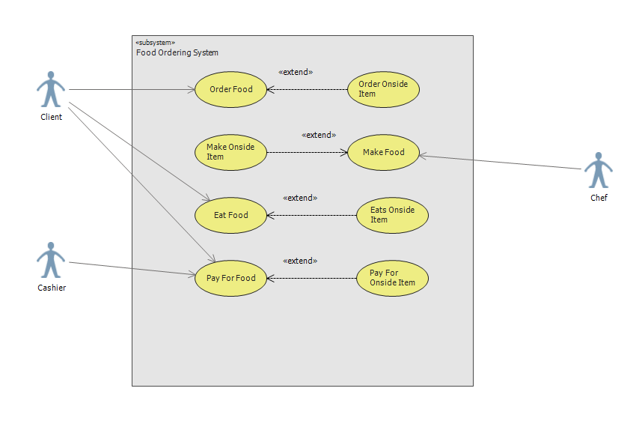

**Use-Case Description:**

|  |
| --- |
| Use Case Title: Oder Food |
| Primary Actor: Customer |
| Level: Sea-Level |
| Stakeholders: Customer |
| Precondition: Customer must be present there or should login to the website to order food online. |
| Minimal Guarantee: Repayment of any declined payment by customer. |
| Success Guarantee: Customer gets desirable food. |
| Trigger: Customer comes to the store or places order online. |
| Main Success Scenario:   1. Customer gets to select a main food item. 2. Customer gets to select an onside item or drink to make it a meal. 3. Customer gets to select the type of main food item they want to have with the drink. 4. They also get to choose if they want to have food in store or to take out. |
| Extensions:   1. Customer will get a webpage to connect it to local Wi-Fi. 2. If not available, then they will get a “Error” message. 3. If the desirable item is not available. 4. They will get suggestions for another items that they would like to have. 5. Transaction is not done. 6. They can pay by another mode. May options available such as credit cards, debit cards, cash or any gift cards. 7. Wrong order handed out to a customer. 8. The correct order is made and given to them. 9. Also, money can be refunded if they have the receipt and the wrong order with them. |