Naan Mudhalvan
Data Analytics using IBM Cognos
Phase 5 : Project Documentation and Submission

Project Title : Customer Churn Prediction
Project Abstract : Customer churn poses a significant challenge for businesses across industries, leading to revenue loss and decreased profitability. This project aims to develop an effective customer churn prediction model for [Your Company's Name] using advanced machine learning techniques. By leveraging historical customer data, including demographic information, purchase history, and customer interactions, our model employs predictive analytics to identify customers at risk of churning.
Project Objectives :
To develop a robust and precise machine learning model that can accurately predict customer churn. This entails leveraging historical customer data encompassing demographics, transaction history, and interactions to create a predictive tool.
Steps involved and done :

Importing necessary libraries :
Libraries that are required for developing the project are imported
Step 1

Step 2

Data Collection and preprocessing:
Collection of data from reliable source and preprocessing of data
Step 5

Finding the most accurate model and predicting individual customer churn :
Find out the most accurate model by comparing their accuracies, and at last, predict the churn probability of an individual customer.
Utilizing various Machine Learning algorithms to predict customer churn :
Feed the training data to various ML classification models, observe the accuracy in their outputs.
Step 4

Step 3

Visualization :
Visualizing customer churn through various tools like Bar charts and plots.

Code :
The development of the project has been done in three phases. We have included the Code that we developed in order to achieve the desired result below. The dataset used is Telco customer churn dataset with 7043 Entries and 21 attributes.
PART – 1 : Importing necessary libraries and Data Preprocessing :
#Import necessary libraries
import numpy as np
import pandas as pd
import matplotlib.pyplot as plt
import seaborn as sns
import plotly.offline as po
import plotly.graph_objs as go

#Import Customer Churn Dataset
churn_dataset = pd.read_csv("Telco-Customer-Churn.csv")
print(churn_dataset.shape)

#Convert String values (Yes and No) of Churn column to 1 and 0
churn_dataset.loc[churn_dataset.Churn == 'No','Churn'] = 0
churn_dataset.loc[churn_dataset.Churn == 'Yes','Churn'] = 1

#Convert 'No Internet Service' to 'No' for the below mentioned columns
cols = ['OnlineBackup','StreamingMovies','DeviceProtection','TechSupport','OnlineSecurity','StreamingTV']
for i in cols :
churn_dataset[i] = churn_dataset[i].replace({'No internet service' : 'No'})

#Replace all the spaces with null values
churn_dataset['TotalCharges'] = churn_dataset['TotalCharges'].replace(" ",np.nan)

#Drop null values of 'Total Charges' feature
churn_dataset = churn_dataset[churn_dataset['TotalCharges'].notnull()]
churn_dataset = churn_dataset.reset_index()[churn_dataset.columns]

#Convert 'Total Charges' column values to float data type
churn_dataset['TotalCharges'] = churn_dataset['TotalCharges'].astype(float)
print(churn_dataset['Churn'].value_counts().values)
PART – 2 : Visualizing Customer Churn under various categories
#Visualize Total Customer Churn
plot_by_churn_labels = churn_dataset["Churn"].value_counts().keys().tolist()
plot_by_churn_values = churn_dataset["Churn"].value_counts().values.tolist()

plot_data = [
go.Pie(labels = plot_by_churn_labels,
values = plot_by_churn_values,
marker = dict(colors=['Teal','Grey'],
line=dict(color="white",
width=1.5)),
rotation=90,
hoverinfo="label+value+text",
hole= .6)
]
plot_layout = go.Layout(dict(title = "Customer Churn",
plot_bgcolor="rgb(243,243,243)",
paper_bgcolor="rgb(243,243,243)",))
fig=go.Figure(data=plot_data,layout=plot_layout)
po.iplot(fig)
#Visualize churn rate by Gender :
plot_by_gender = churn_dataset.groupby('gender').Churn.mean().reset_index()
plot_data = [
go.Bar(
x = plot_by_gender['gender'],
y = plot_by_gender['Churn'],
width = [0.3,0.3],
marker = dict(
color = ['orange','green'])
)
]
plot_layout = go.Layout(
xaxis = {"type" : "category"},
yaxis = {"title" : "Churn Rate"},
title = 'Churn Rate by Gender',
plot_bgcolor = 'rgb(243,243,243)',
paper_bgcolor = 'rgb(243,243,243)',
)
fig = go.Figure(data = plot_data,layout=plot_layout)
po.iplot(fig)

# Visualize churn rate by Tech Support
plot_by_techsupport = churn_dataset.groupby('TechSupport').Churn.mean().reset_index()
plot_data = [
go.Bar(
x = plot_by_techsupport['TechSupport'],
y = plot_by_techsupport['Churn'],
width = [0.3, 0.3, 0.3],
marker = dict(
color = ['orange','green', 'teal'])
)
]

plot_layout = go.Layout(
xaxis = {"type": "category"},
yaxis = {"title" : "Churn Rate"},
title = 'Churn Rate by Tech Support',
plot_bgcolor = "rgb(243,243,243)",
paper_bgcolor = 'rgb(243,243,243)'
)
fig = go.Figure(data = plot_data, layout = plot_layout)
po.iplot(fig)
# Visualize Churn Rate by Internet Services

plot_by_internet_service = churn_dataset.groupby('InternetService').Churn.mean().reset_index()
plot_data = [
go.Bar(
x=plot_by_internet_service['InternetService'],
y=plot_by_internet_service['Churn'],
width = [0.3, 0.3, 0.3],
marker=dict(
color=['orange', 'green', 'teal'])
)
]
plot_layout = go.Layout(
xaxis={"type": "category"},
yaxis={"title": "Churn Rate"},
title='Churn Rate by Internet Service',
plot_bgcolor = 'rgb(243,243,243)',
paper_bgcolor = 'rgb(243,243,243)',
)
fig = go.Figure(data=plot_data, layout=plot_layout)
po.iplot(fig)

# Visualize Churn Rate by Contract Duration

plot_by_contract = churn_dataset.groupby('Contract').Churn.mean().reset_index()
plot_data = [
go.Bar(
x=plot_by_contract['Contract'],
y=plot_by_contract['Churn'],
width = [0.3, 0.3,0.3],
marker=dict(
color=['orange', 'green','teal'])
)
]
plot_layout = go.Layout(
xaxis={"type": "category"},
yaxis={"title": "Churn Rate"},
title='Churn Rate by Contract Duration',
plot_bgcolor = 'rgb(243,243,243)',
paper_bgcolor = 'rgb(243,243,243)',
)
fig = go.Figure(data=plot_data, layout=plot_layout)
po.iplot(fig)

# Visualize Relation between Tenure & Churn rate

plot_by_tenure = churn_dataset.groupby('tenure').Churn.mean().reset_index()
plot_data = [
go.Scatter(
x=plot_by_tenure['tenure'],
y=plot_by_tenure['Churn'],
mode='markers',
name='Low',
marker= dict(size= 5,
line= dict(width=0.8),
color= 'green'
),
)
]
plot_layout = go.Layout(
yaxis= {'title': "Churn Rate"},
xaxis= {'title': "Tenure"},
title='Relation between Tenure & Churn rate',
plot_bgcolor = "rgb(243,243,243)",
paper_bgcolor = "rgb(243,243,243)",
)
fig = go.Figure(data=plot_data, layout=plot_layout)
po.iplot(fig)

PART – 3 : Machine Learning Algorithms to predict customer churn
#Perform One Hot Encoding using get_dummies method

churn_dataset = pd.get_dummies(churn_dataset, columns = ['Contract','Dependents','DeviceProtection','gender',
'InternetService','MultipleLines','OnlineBackup',
'OnlineSecurity','PaperlessBilling','Partner',
'PaymentMethod','PhoneService','SeniorCitizen',
'StreamingMovies','StreamingTV','TechSupport'],
drop_first=True)

#Perform Feature Scaling and One Hot Encoding

from sklearn.preprocessing import StandardScaler

#Perform Feature Scaling on 'tenure', 'MonthlyCharges', 'TotalCharges' in order to bring them on same scale

standardScaler = StandardScaler()
columns_for_ft_scaling = ['tenure', 'MonthlyCharges', 'TotalCharges']

#Apply the feature scaling operation on dataset using fit_transform() method

churn_dataset[columns_for_ft_scaling] = standardScaler.fit_transform(churn_dataset[columns_for_ft_scaling])

# See subset of values

churn_dataset.head()

#Number of columns increased and have suffixes attached, as a result of get_dummies method.

churn_dataset.columns

#Create Feature variable X and Target variable y

y = churn_dataset['Churn']
X = churn_dataset.drop(['Churn','customerID'], axis = 1)

#Split the data into training set (70%) and test set (30%)

from sklearn.model_selection import train_test_split
X_train, X_test, y_train, y_test = train_test_split(X, y, test_size = 0.30, random_state = 50)

# Machine Learning classification model libraries

from sklearn.linear_model import LogisticRegression
from sklearn.neighbors import KNeighborsClassifier
from sklearn.svm import SVC
from sklearn.tree import DecisionTreeClassifier
from sklearn.ensemble import RandomForestClassifier
from sklearn import metrics

#Fit the logistic Regression Model

logmodel = LogisticRegression(random_state=50)
logmodel.fit(X_train,y_train)

#Predict the value for new, unseen data

pred = logmodel.predict(X_test)

# Find Accuracy using accuracy_score method

logmodel_accuracy = round(metrics.accuracy_score(y_test, pred) * 100, 2)

#Fit the Support Vector Machine Model

svcmodel = SVC(kernel='linear', random_state=50, probability=True)
svcmodel.fit(X_train,y_train)

#Predict the value for new, unseen data

svc_pred = svcmodel.predict(X_test)

# Find Accuracy using accuracy_score method

svc_accuracy = round(metrics.accuracy_score(y_test, svc_pred) * 100, 2)

#Fit the K-Nearest Neighbor Model

from sklearn.neighbors import KNeighborsClassifier
knnmodel = KNeighborsClassifier(n_neighbors=5, metric='minkowski', p=2) #p=2 represents Euclidean distance, p=1 represents Manhattan Distance
knnmodel.fit(X_train, y_train)

#Predict the value for new, unseen data

knn_pred = knnmodel.predict(X_test)

# Find Accuracy using accuracy_score method

knn_accuracy = round(metrics.accuracy_score(y_test, knn_pred) * 100, 2)

#Fit the Decision Tree Classification Model

from sklearn.tree import DecisionTreeClassifier
dtmodel = DecisionTreeClassifier(criterion = "gini", random_state = 50)
dtmodel.fit(X_train, y_train)

#Predict the value for new, unseen data

dt_pred = dtmodel.predict(X_test)

# Find Accuracy using accuracy_score method

dt_accuracy = round(metrics.accuracy_score(y_test, dt_pred) * 100, 2)

#Fit the Random Forest Classification Model

from sklearn.ensemble import RandomForestClassifier
rfmodel = RandomForestClassifier(n_estimators = 100, criterion = 'entropy', random_state = 0)
rfmodel.fit(X_train, y_train)

#Predict the value for new, unseen data

rf_pred = rfmodel.predict(X_test)

# Find Accuracy using accuracy_score method

rf_accuracy = round(metrics.accuracy_score(y_test, rf_pred) * 100, 2)

# Compare Several models according to their Accuracies

Model_Comparison = pd.DataFrame({
'Model': ['Logistic Regression', 'Support Vector Machine', 'K-Nearest Neighbor',
'Decision Tree', 'Random Forest'],
'Score': [logmodel_accuracy, svc_accuracy, knn_accuracy,
dt_accuracy, rf_accuracy]})
Model_Comparison_df = Model_Comparison.sort_values(by='Score', ascending=False)
Model_Comparison_df = Model_Comparison_df.set_index('Score')
Model_Comparison_df.reset_index()

# Predict the probability of Churn of each customer

churn_dataset['Probability_of_Churn'] = logmodel.predict_proba(churn_dataset[X_test.columns])[:,1]

# Create a Dataframe showcasing probability of Churn of each customer

churn_dataset[['customerID','Probability_of_Churn']].head()

Output :

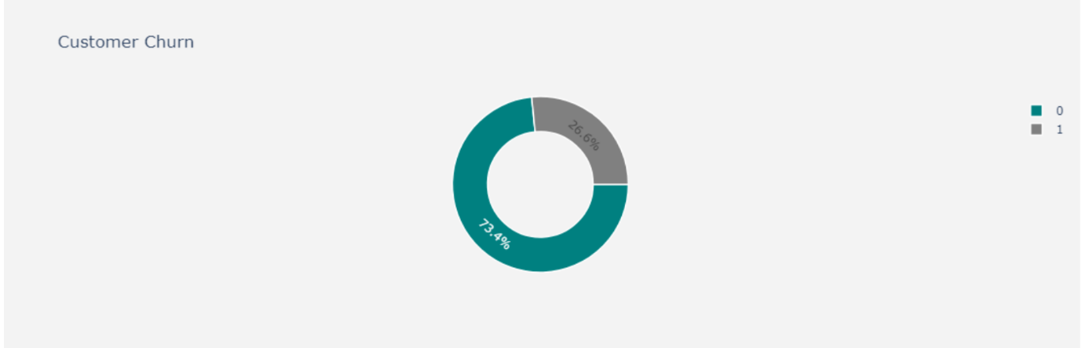

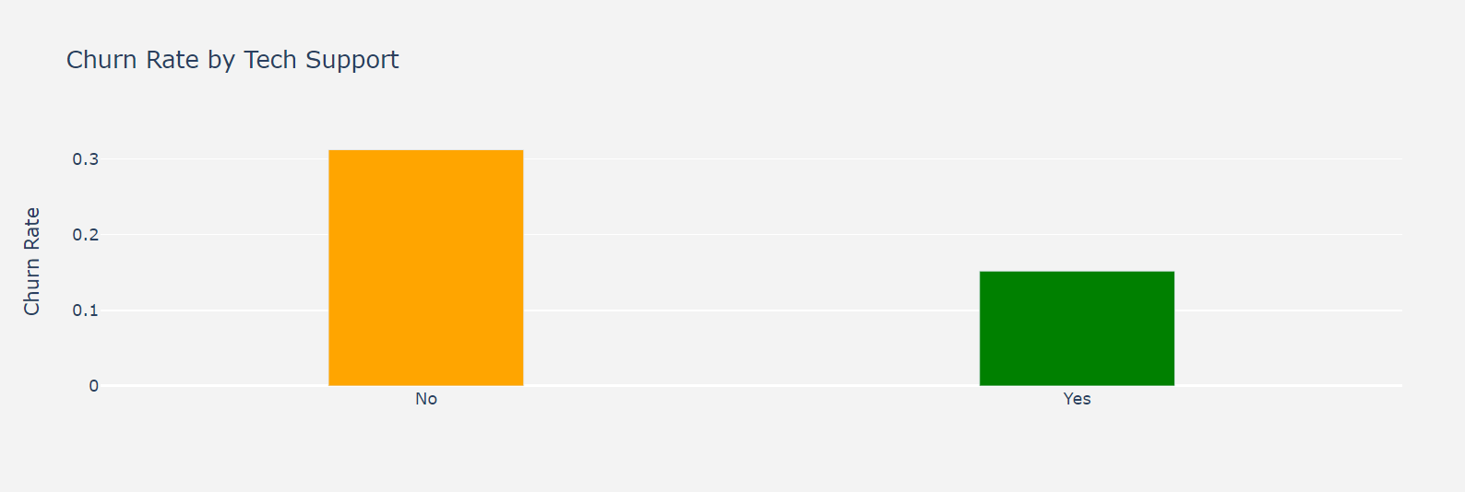

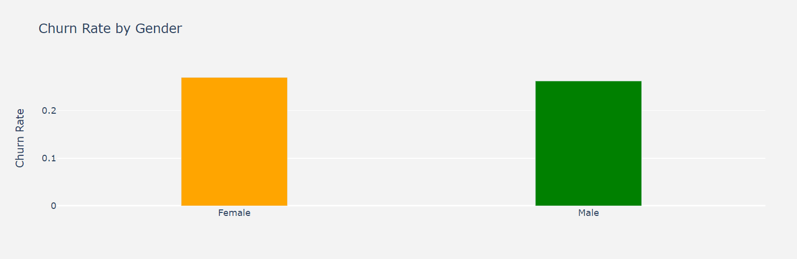
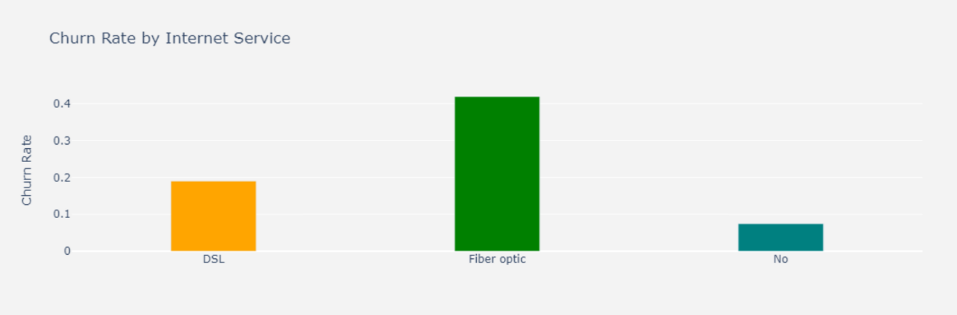

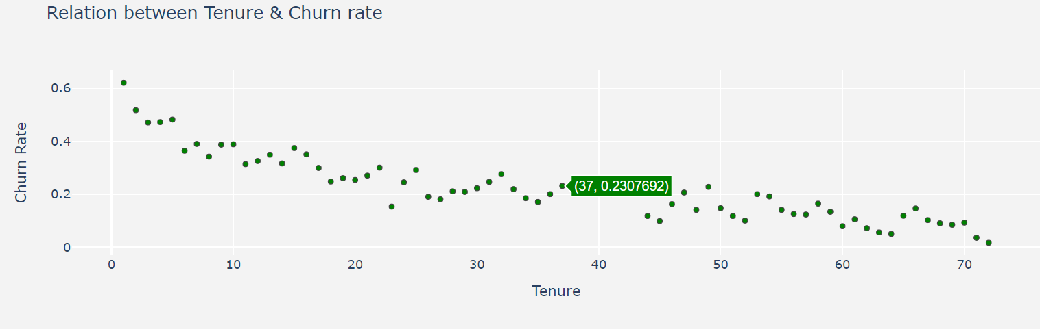
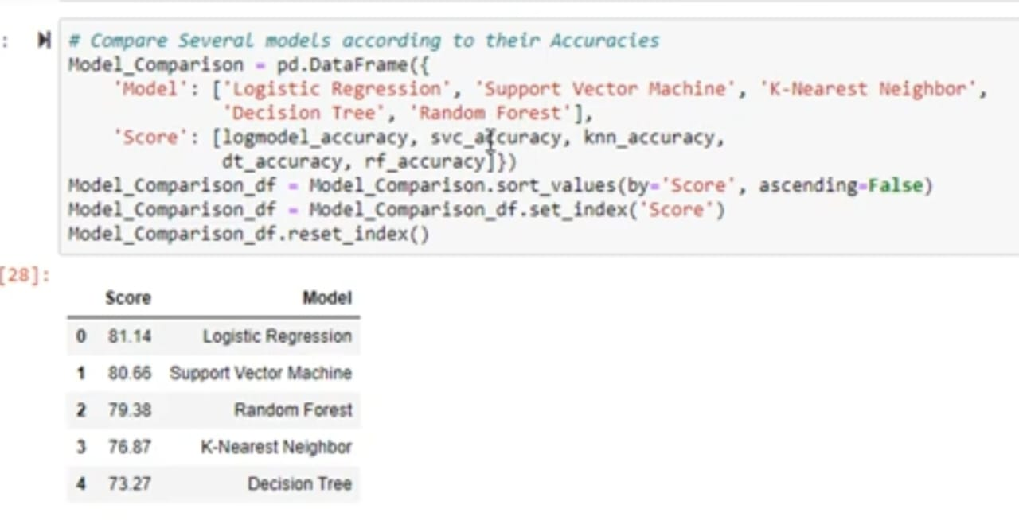
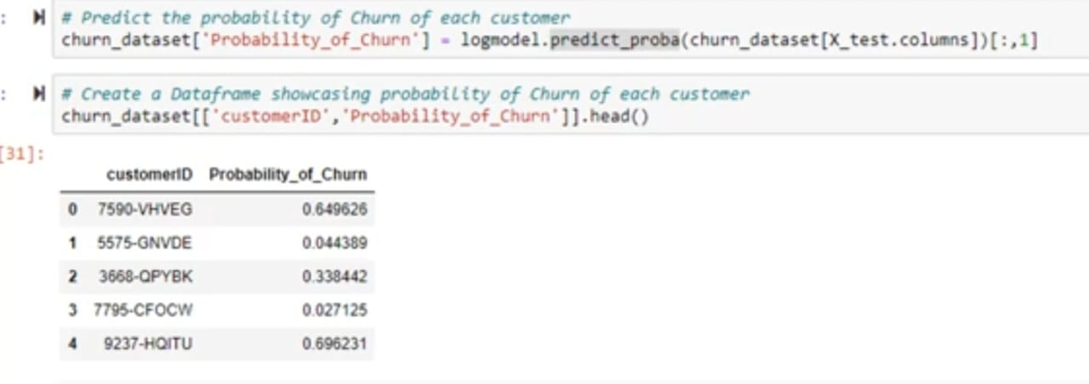
Conclusion :
Thus we have built a Customer Churn prediction model, using which we can get the analysis of customers churning out Category-wise, and that predicts the individual probability whether a particular customer will churn out or not. It also compares the accuracy at which the various machine learning classification algorithms predict the output, which helps us to find the best out of the group.

Phase – 5 Submission done by :
Brindha. B
810021205014

