# 

# IMPLEMENTATION

Step 1: Azure Blob Storage Backup Script for MongoDB & PostgreSQL

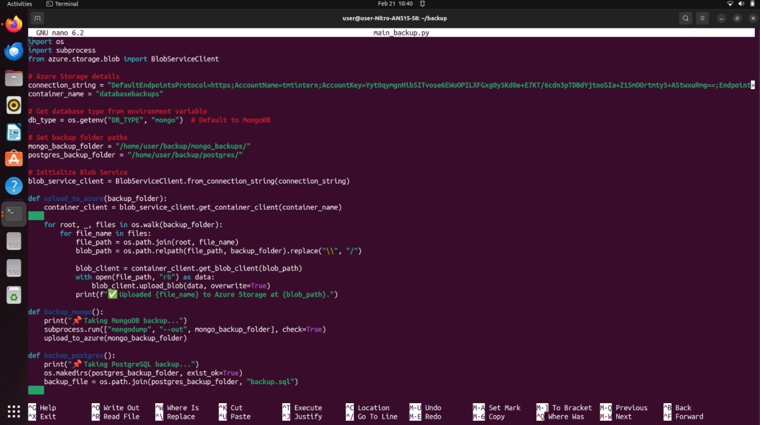

Step 2: MongoDB Backup and Operations:

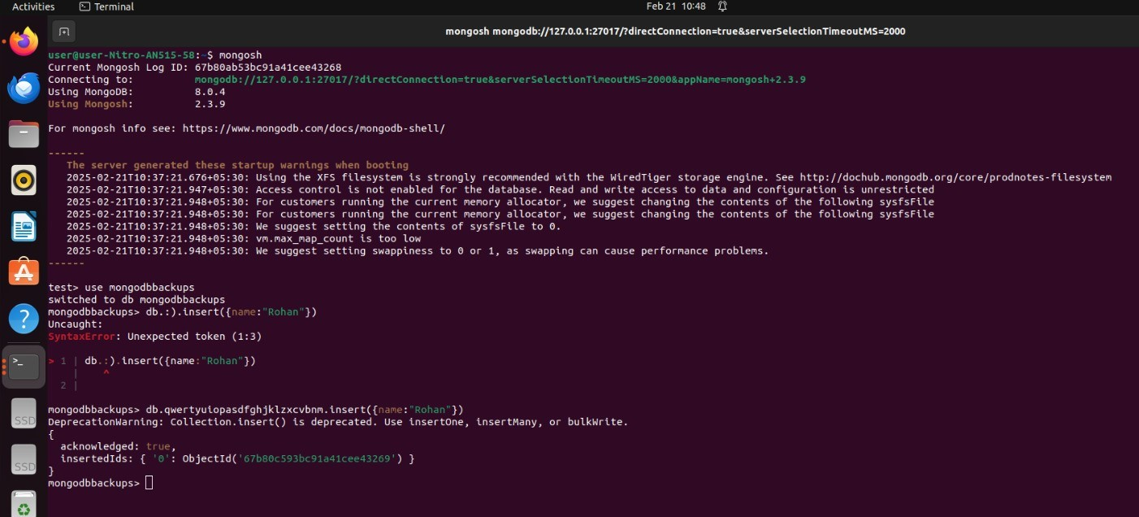

Step 3: MongoDB Backup and Upload to Azure Blob Storage:

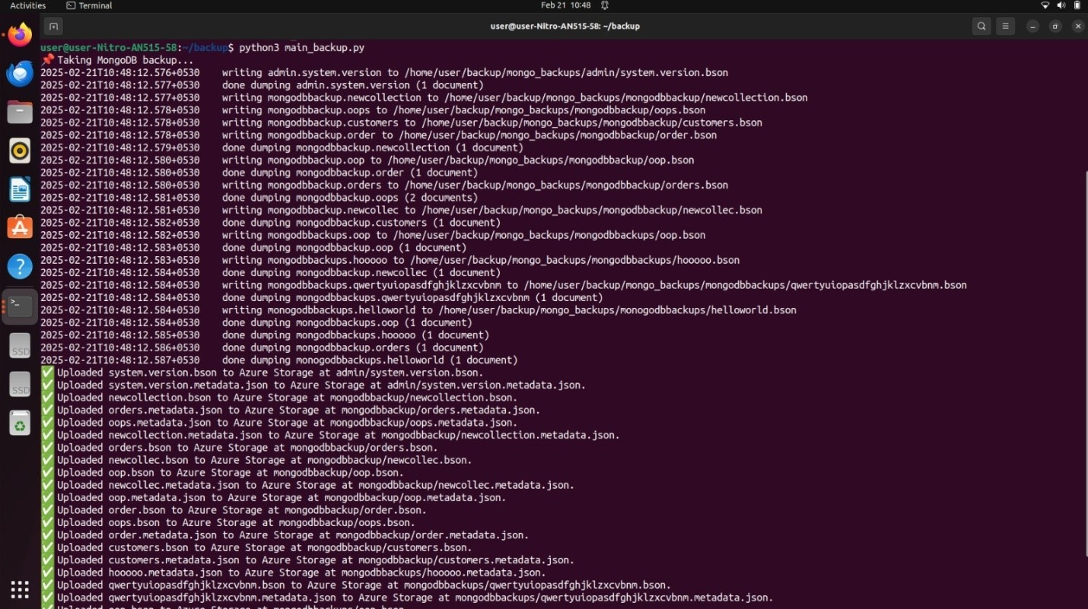

Step 4: Creating Azure Blob Stoarge in Azure Portal:

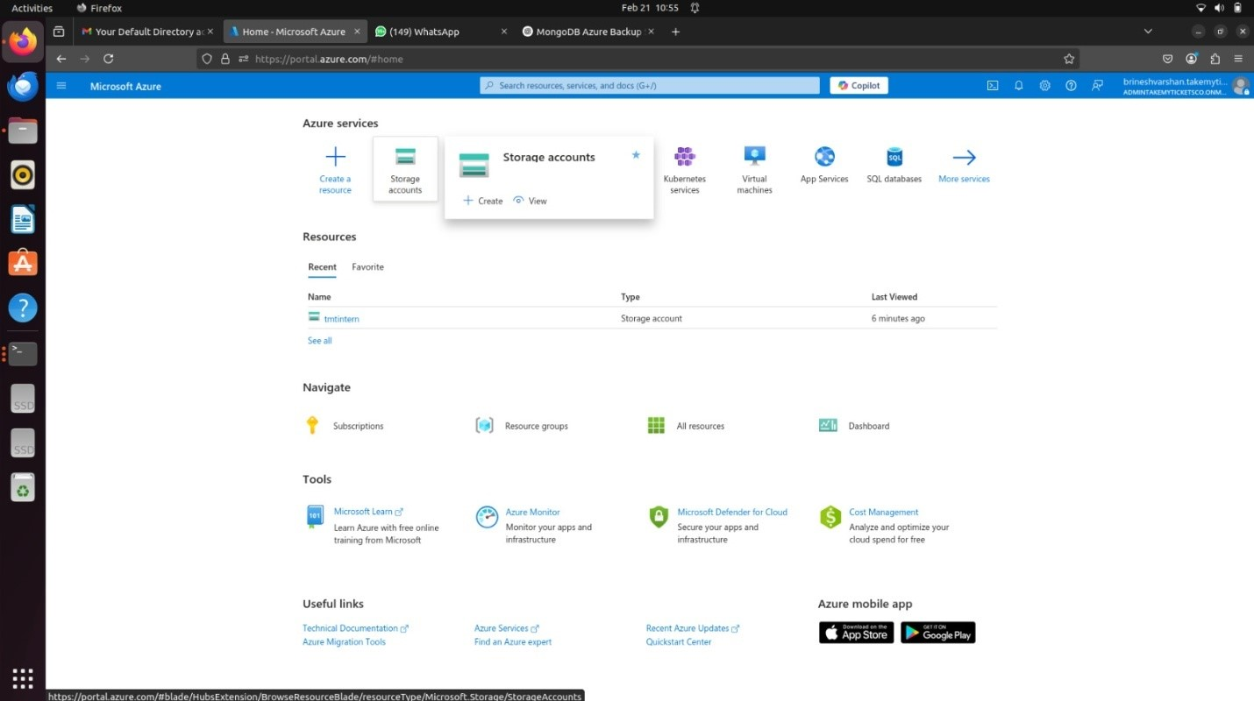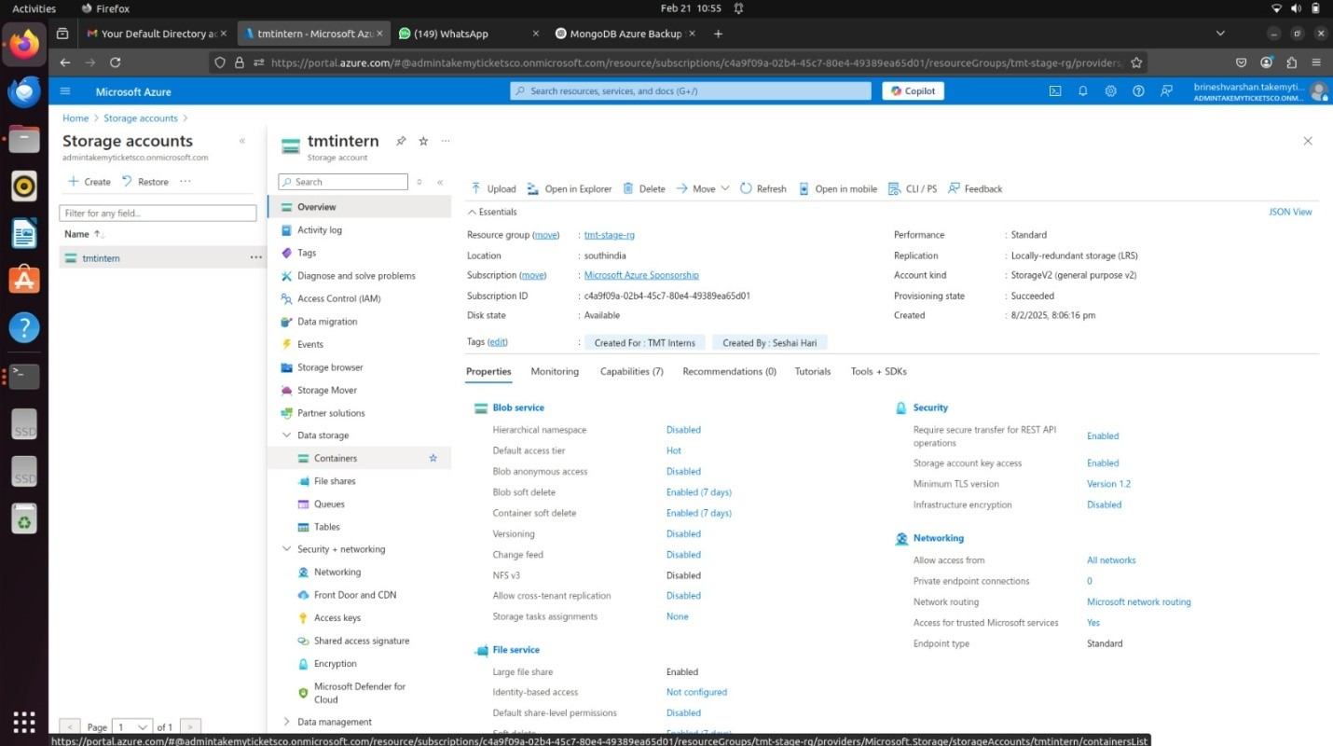

Step 5: Backedup Files from Local Environment to Azure Blob:

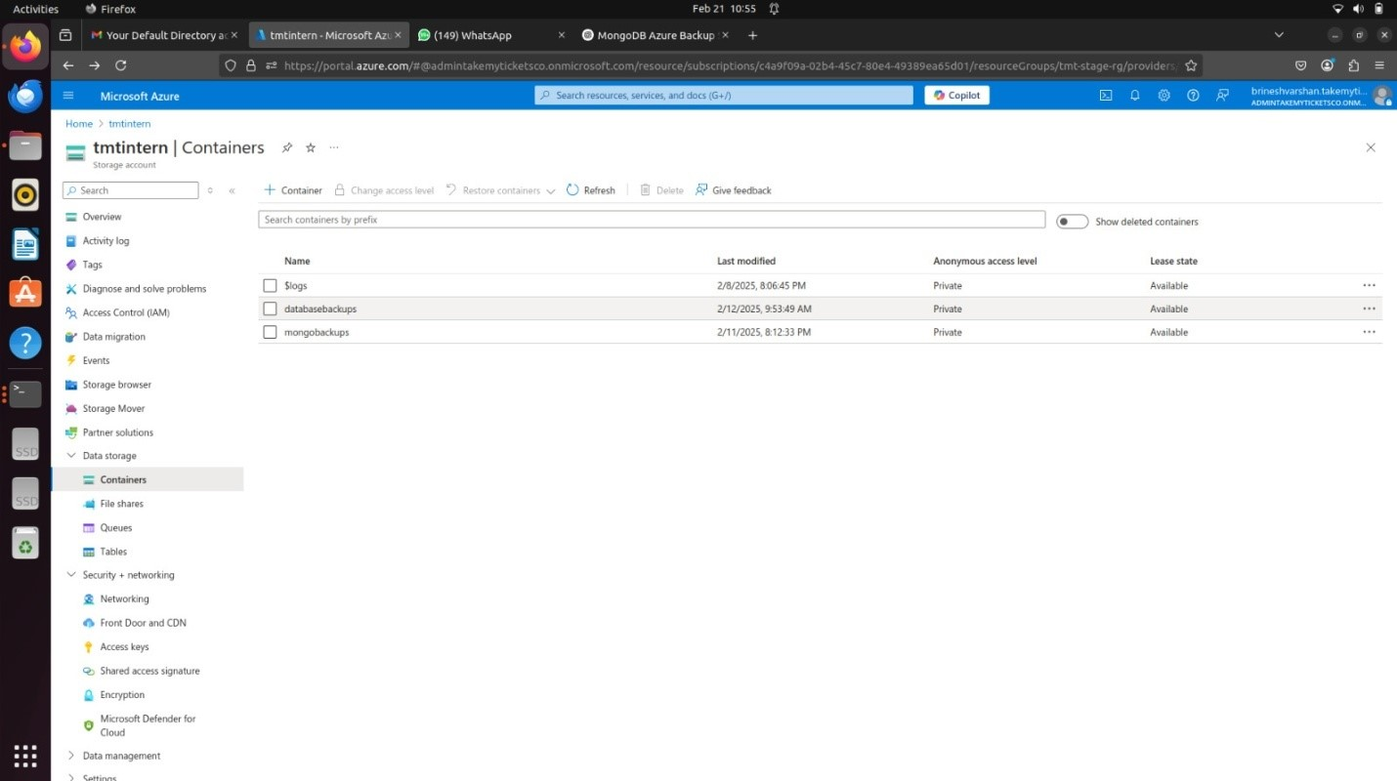

Step 6: Backedup MongoDB Database in Azure Blob Storage:

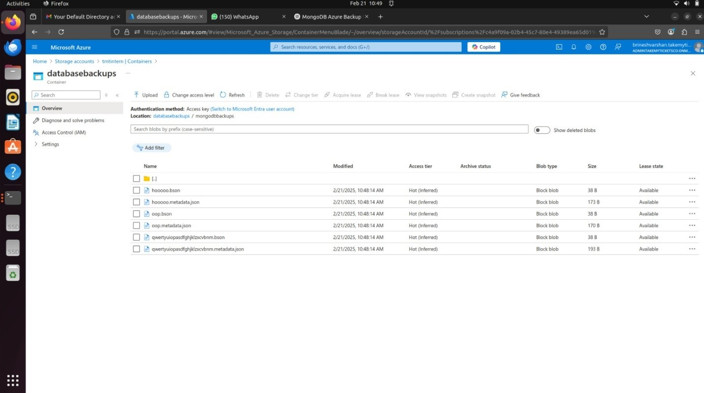

Step 7: Postgres Backup and Operations:

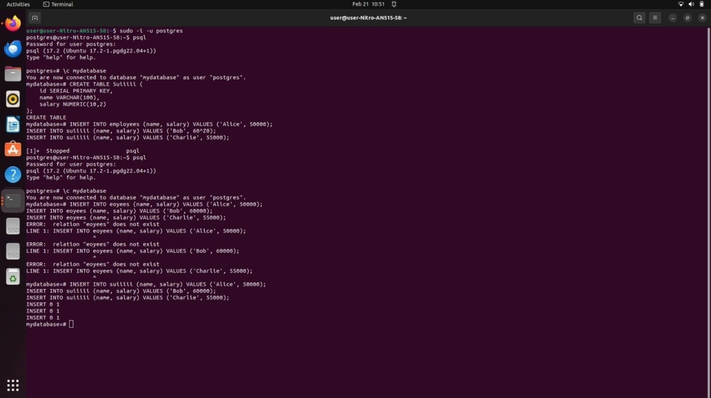

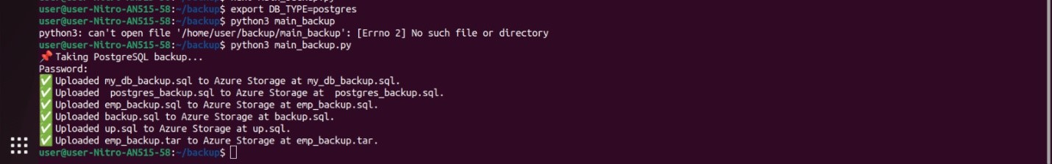

Step 9: Backedup Postgres Database in Azure Blob Storage:

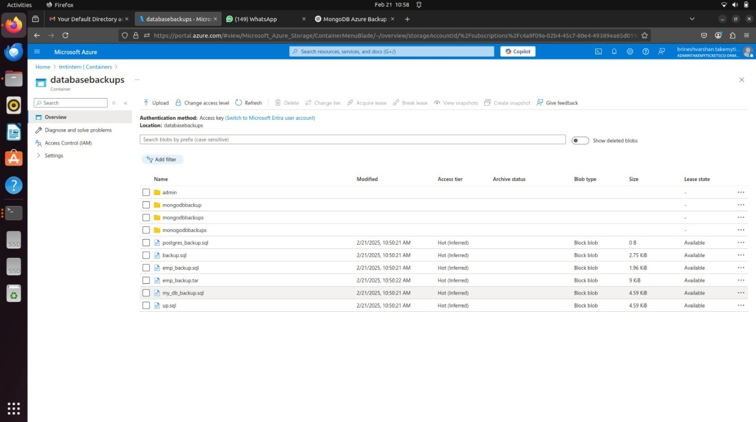

Step 10: Cronjob for automating backup at 2 am:

