Patient 4 – (good+medium) vs poor

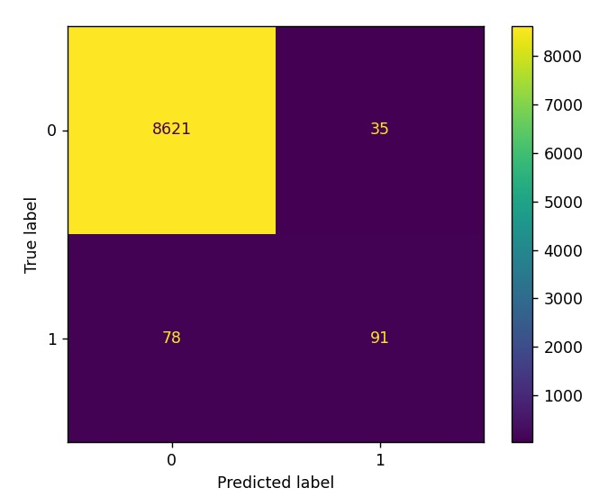Test Accuracy: 98.719%

Sensitivity – 100%

Specificity – 54%

Patient 2 – (good+medium) vs poor

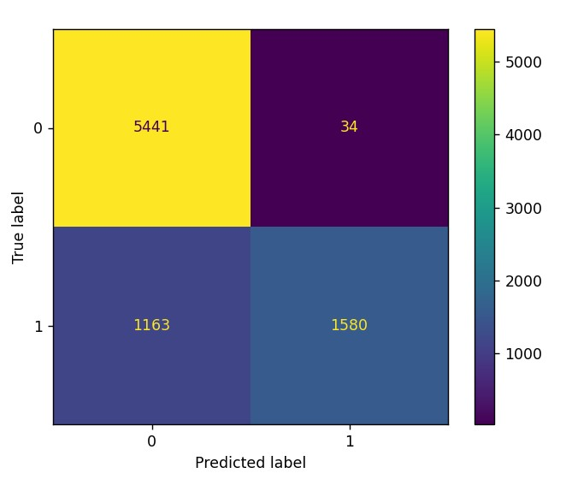Test Accuracy: 85.434%

Sensitivity – 99%

Specificity – 58%

**Paper Name: Deep Learning-Based Signal Quality Assessment for Wearable ECGs**

**Dataset Table**:

|  |  |
| --- | --- |
| Signals Type | ECG signals of lead II |
| Training Data | Total 9000 segments (Good(0) – 3000, medium(1) - 3000, poor(2) – 3000) of 20 patients |
| Test Data | CPSC 2020 database (Total 87888 segments of 10 patients, good – 48811, medium – 32099, poor – 6978 segments)  https://physionet.org/content/challenge-2020/1.0.2/ |
| Recording time | 10s |
| Sampling frequency | 400Hz |
| Results | Test accuracy – (good+medium) vs poor - 98.72%  Test accuracy – (good vs medium vs poor) – 92.31% |

**The dataset used on our computer:**

|  |  |
| --- | --- |
| Training Data | The PhysioNet Challenge 2011 database (1000 segments of lead II of 1000 patients)  <https://physionet.org/content/challenge-2011/1.0.0/>  No of acceptable segments – 775  No of unacceptable segments - 225 |
| Test Data | CPSC 2020 database (8825 segments for patient 04, 8218 segments for patient 02)  Patient 04 -  No of acceptable segments - 8656  No of unacceptable segments – 169  Patient 02 -  No of acceptable segments - 5475  No of unacceptable segments - 2743  (Good + medium) -> acceptable  Poor -> unacceptable |
| Sampling time | 10s |
| Sampling frequency | 400Hz |
| Results | Training Accuracy – 92.76%  Validation Accuracy – 89% |

The model trained on 800 segments and then tested on the 200 segments of PhysioNet Challenge 2011 database:

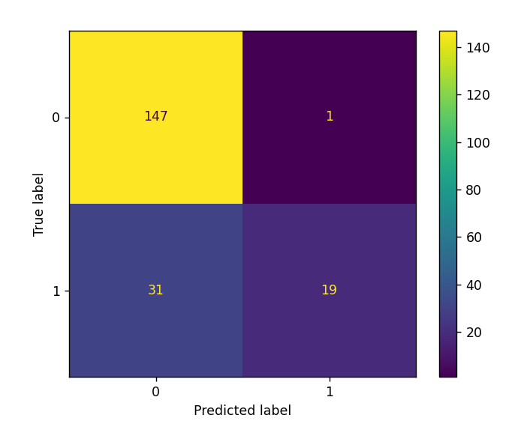

Test Accuracy – 83.83%

Sensitivity – 99%

Specificity – 38%

Acceptable segments – 148

Unacceptable segments - 50

The model trained on 7060 segments and then tested on the 1765 segments of patient 04 of CPSC 2020 database:

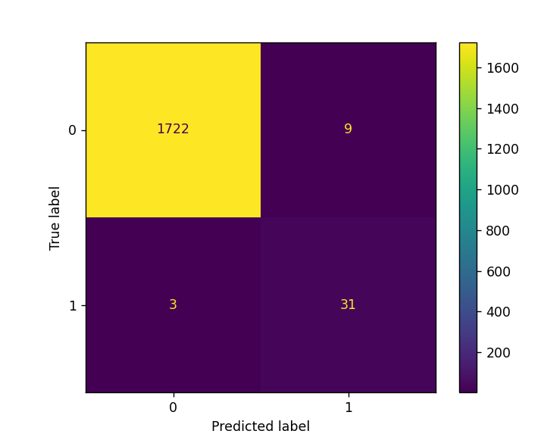

Test Accuracy – 99.32%

Sensitivity – 99%

Specificity – 91%

Acceptable segments – 1731

Unacceptable segments - 34

The model trained on 7060 segments of patient 04 of CPSC 2020 database and then tested on the test dataset of the PhysioNet Challenge 2011 database:

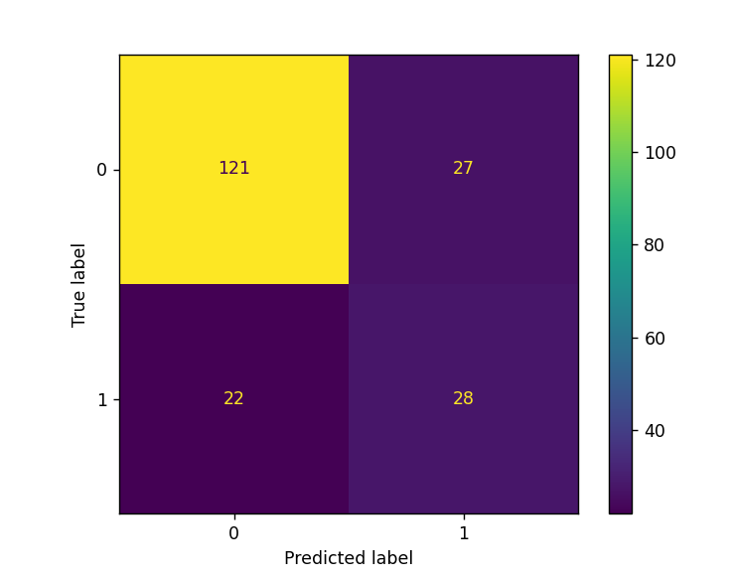

Test Accuracy – 75.25%

Sensitivity – 82%

Specificity – 56%

Acceptable segments – 148

Unacceptable segments – 50

The model trained on 6574 segments and then tested on the 1644 segments of patient 02 of CPSC 2020 database:

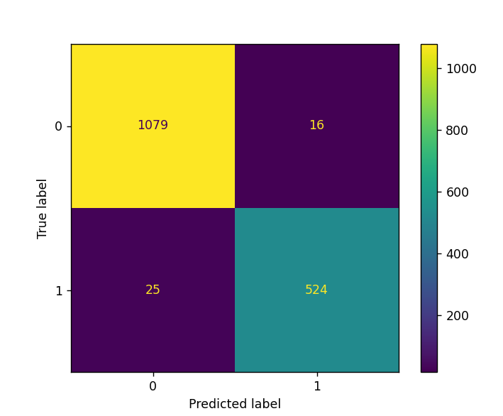

Test Accuracy – 97.5%

Sensitivity – 99%

Specificity – 95%

Acceptable segments – 1095

Unacceptable segments – 549

The model trained on 6574 segments of patient 02 of CPSC 2020 database and then tested on the test dataset of the PhysioNet Challenge 2011 database:

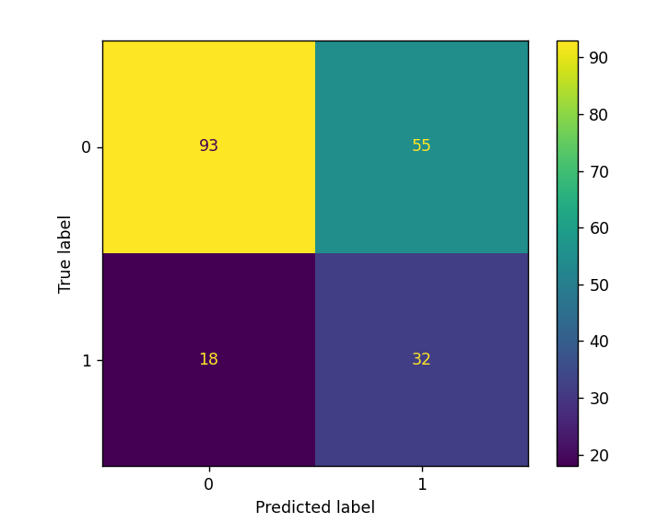

Test Accuracy – 63.13%

Sensitivity – 63%

Specificity – 64%

Acceptable segments – 148

Unacceptable segments – 50