ARCHITECTURE DIAGRAM & EXPLANATION
FoodTrack — System Architecture
The diagram below maps FoodTrack's real architecture — traced from the current source, not an idealized plan — onto a network-topology style layout: one central hub, two primary branches gated by a trust boundary, and a secondary dashed branch for the one feature that isn't part of the core transaction path. The explanation that follows walks through every node and every arrow, in the same order a request actually travels.
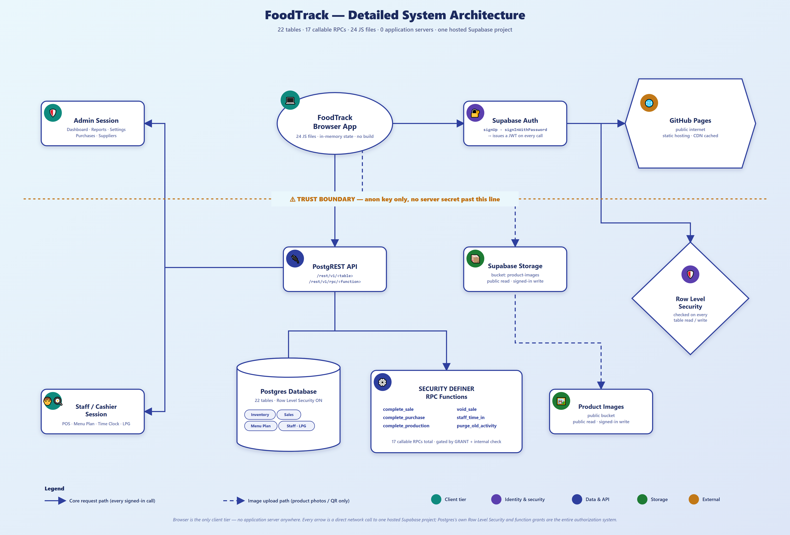
FoodTrack — Detailed System Architecture. 22 tables · 17 callable RPCs · 24 JS files · 0 application servers.

How to Read This Diagram
Every shape carries a specific meaning, borrowed from classic network-diagram convention and reused here for a software architecture instead of physical hardware. The ellipse at the top — FoodTrack Browser App — is the single hub everything else connects to; literally every arrow in this diagram either starts there or traces back to something that does. Rounded rectangles are services or sessions — a running piece of Supabase, or a person's signed-in session. The hexagon marks a boundary to the outside world (GitHub Pages, the public internet). Diamonds mark an inspection or decision point — here, the Row Level Security check that runs on every table access. And the cylinder is, as in most diagrams, a data store — the Postgres database itself.
Color follows the same five-tier scheme throughout: teal for the client tier (the browser and the two kinds of session running inside it), indigo for identity and security (authentication and Row Level Security), navy for the data and API layer (PostgREST, the database, and the RPC functions), green for file storage, and amber for the one node that sits outside FoodTrack's own infrastructure entirely — GitHub Pages.
Arrows follow one more rule: a solid line is part of the core path every signed-in action takes — checkout, stock movement, time in/out, reporting. A dashed line is a secondary path used only for uploading an image — a product photo or the GCash QR code — never touched by the transactions that actually run the cafeteria day to day.

The Trust Boundary
The dashed amber line running across the middle of the diagram is not decorative — it is the single most important fact this diagram communicates. Everything above it (the Browser App and the three services it talks to directly — Auth, PostgREST, Storage) runs in code anyone can open in their browser's developer tools and read line by line. The only credential that code ever holds is the Supabase anon key, which is meant to be public — it identifies the project, not a user, and grants nothing by itself.
What this means in practice: there is no server secret anywhere past this line. Every protection FoodTrack has — who can see what, who can write what, who can call which function — has to be enforced on the far side of this boundary, inside Postgres itself, because the near side is assumed to be fully exposed. That is exactly what the Row Level Security diamond and the "gated by GRANT + internal check" note under the RPC Functions box both represent: the real gate isn't in the browser, it's in the database.

The Hub: FoodTrack Browser App
At the center of the diagram sits the browser itself — twenty-four plain JavaScript files, no build step, no bundler, loaded as ordinary <script> tags. It keeps one in-memory state object that every page on screen reads from, hydrated once from Supabase when the app starts and written back through a small set of persistence functions whenever something changes. This is the only client tier in the entire system — there is nothing between it and Supabase except the public internet.
From this hub, three branches leave, matching the three real surfaces the browser ever calls: one to Supabase Auth (solid, for every sign-in and every subsequent authenticated request), one to PostgREST (solid, for every table read/write and every RPC call), and one to Supabase Storage (dashed, used only when uploading an image).

The Identity Branch: Auth, GitHub Pages &amp; RLS
The Browser App's first branch leads to Supabase Auth, which handles exactly two calls — signUp and signInWithPassword — and in return issues a JWT that rides along with every request the browser makes afterward. From Auth, the diagram splits two ways, mirroring how a firewall in a real network both passes traffic through to the outside world and reports to a monitoring system at the same time.
One path leads out to GitHub Pages — drawn as a hexagon because it represents the actual boundary to the public internet. This is simply where FoodTrack's static files are hosted; it has no awareness of the application's data at all, it just serves the same HTML, CSS, and JavaScript to anyone who requests it, cached at the edge.
The other path branches down to the Row Level Security diamond. This is the one node in the diagram that doesn't correspond to a single Supabase feature you'd find in its dashboard — it represents a check that happens automatically, inside Postgres, on every single table read or write, regardless of which path the request took to get there. It's drawn branching from Auth because identity is what RLS checks against — a policy typically reads "is this the signed-in user's own row" or "does this user have the admin role," both of which only make sense once Auth has already established who's asking.

The Data Branch: PostgREST, the Database &amp; RPC Functions
The Browser App's second branch leads straight down to PostgREST, the component that turns the Postgres database into something the browser can call directly over HTTP — either as a plain table read/write under /rest/v1/<table>, or as a function call under /rest/v1/rpc/<function>. This single node fans out into four children, each representing a different kind of thing PostgREST connects the browser to.
To the left, a trunk line carries two kinds of session — an Admin Session, which reaches Dashboard, Reports, Settings, Purchases, and Suppliers, and a Staff / Cashier Session, which reaches POS, Menu Plan, the Time Clock, and LPG Usage logging. These aren't separate pieces of infrastructure; they're the same Browser App and the same PostgREST connection, just carrying a different role on the JWT — which page a signed-in account can actually reach is enforced twice: once in the UI (hiding a nav link), and once for real, down inside Postgres, by the role check every RLS policy performs.
Directly below PostgREST sits the Postgres Database itself, drawn as a cylinder — twenty-two tables in total, with Row Level Security switched on across every one of them, loosely grouped here into the five domains the tables themselves fall into: Inventory, Sales, Menu Plan, and Staff/LPG, alongside Identity and Settings (not shown as a separate tag, since every domain ultimately depends on it).
Beside the database sits the SECURITY DEFINER RPC Functions box — seventeen callable functions in total, six of which are shown by name: complete_sale, complete_purchase, and complete_production (the three atomic, all-or-nothing business transactions), void_sale (one of six functions that correct history without ever allowing a direct edit), staff_time_in (the idempotent attendance-clock function, safe even if clicked twice at once), and purge_old_activity (the retention-window housekeeping job). Every one of these is gated the same way: a Postgres GRANT decides who may call it at all, and an internal check inside the function itself decides whether this particular call is allowed to succeed.

The Secondary Branch: Supabase Storage &amp; Product Images
The one dashed path in the whole diagram leads to Supabase Storage, and from there to the Product Images bucket — the only place in FoodTrack where a raw file, rather than a row of data, gets uploaded. It's drawn dashed deliberately: no sale, no stock movement, no report, and no login depends on this path at all. It exists purely so a product's photo (or the shop's GCash QR code) has somewhere to live, with public read access so those images display anywhere in the app, and write access restricted to signed-in accounts only.

What This Diagram Is Really Saying
Strip away the shapes and colors, and the diagram is making one architectural claim: FoodTrack has exactly two tiers, a trust boundary with nothing but a public key on the near side of it, and a single database that does all of its own security enforcement through Row Level Security and function grants. There is no hidden third tier, no queue, no cache, and no custom authorization server anywhere — everything this system protects, it protects from inside Postgres itself.
This document explains the diagram published as FoodTrack-System-Architecture-Diagram.png. For the full prose system design — including every table, every function, and every known gap in the current implementation — see FoodTrack-System-Design.docx.

