|  |
| --- |
| Loreto Jr Briones |
| Grader 1 |
| Grader Prog. in Java |

|  |
| --- |
| Loreto Jr. Esmenio Briones  4-7-2017 |

This Java console application process student marks. The number of students is fixed to 10.

Grades are allocated as shown in the table below.

|  |  |
| --- | --- |
| **Grade** | **Mark Range** |
| HD | 85-100 |
| D | 75-84 |
| C | 65-74 |
| P | 50-64 |
| F | 0-49 |

Table 1: Grades

When a mark is entered, the application calculates and displays the corresponding grade which is in letter format. When all (10) marks have been entered, a summary report will show up including the following:

1. The lowest mark
2. The highest mark
3. The average mark
4. The number of students passed (i.e. achieved a mark of 50-100)
5. The number of students who failed (i.e. achieved a mark of 0-49)

Below is are the screenshot of the program output.

Compilation of file doesn’t commit any error.



Figure1

Upon running the program it will ask the user to input/enter student number.

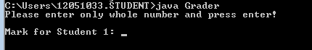

Figure2

After student mark has been entered the corresponding letter grade will be calculated show to the program.

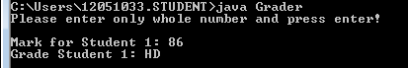

Figure3

Since the program is fixed to 10 student to be mark. User need to enter marks 10 times to get the summary result.

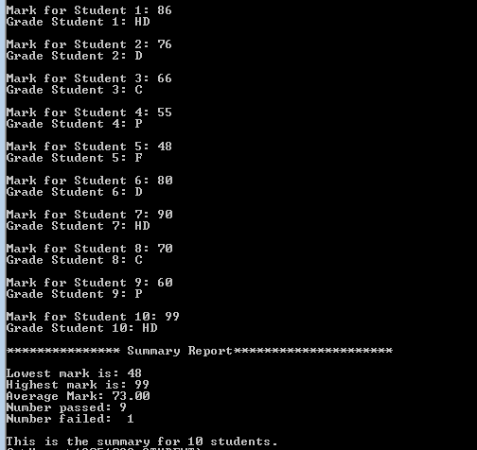

Figure 4

The summary report in the figure shows the lowest marks which 48 entered for student 5. Highest 99 which entered for student 10. Average mark is 73.00 because the sum up of the 10 marks is equivalent to 730.00 divided by 10 is 73.00. We set passing mark to 50-100 and failing mark to 0-49. That’s why the number of passed is 9 and number of failed is 1 because in the markings only student 5 got the lowest marking which is 48 and not satisfied our scope in passing marking and the rest is passed because they meet the passing marks.