HTTPS Everywhere (In Chrome)

Find the https everywhere homepage (By the EFF)

Go to the first link https://www.eff.org/https-everywhere%20
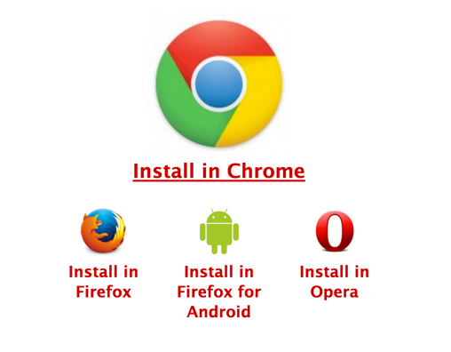

Click Install in Chrome
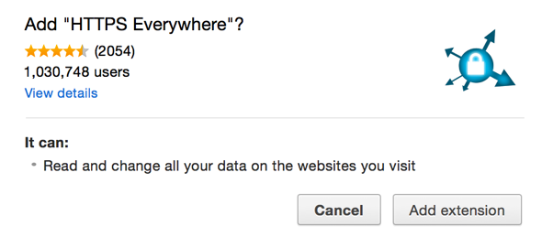

Https Everywhere will be installed and appear in the browser bar
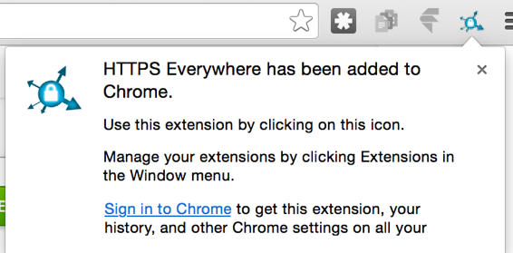

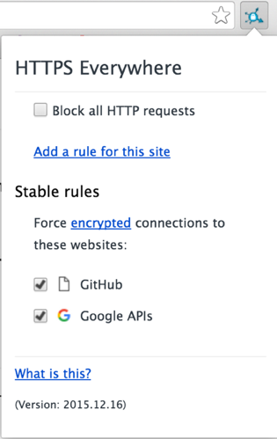
Settings:

Stable rules: Redirect to use HTTPS on these websites

Experimental rules: Off by default, websites which seem to support HTTPS but haven’t been thoroughly tested.

Block all HTTPS requests: If you want to boycott websites that don't use encryption and ensure that your session cannot be hijacked.

HTTPS Everywhere (In Firefox)

Navigate to https://www.eff.org/https-everywhere%20
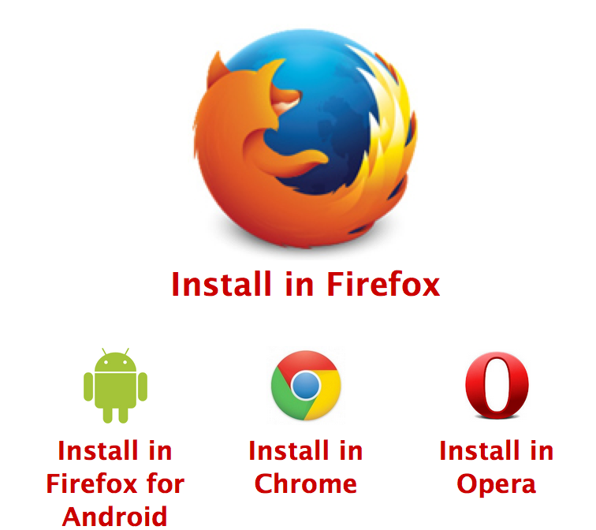

Click through the steps to install the plugin.
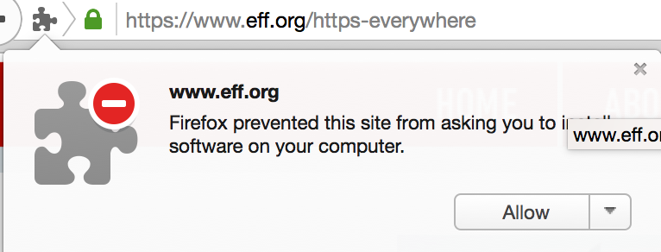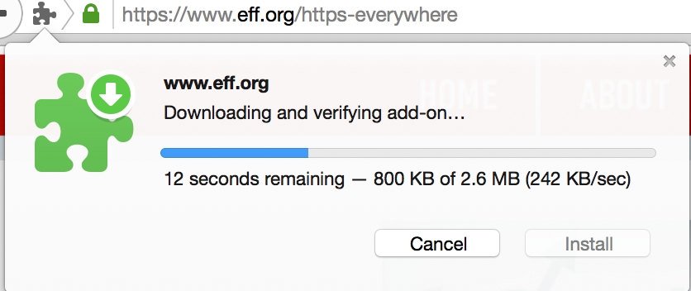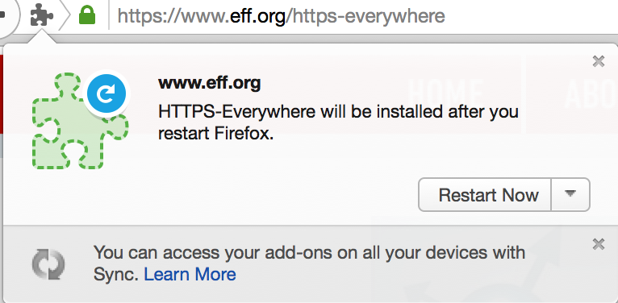

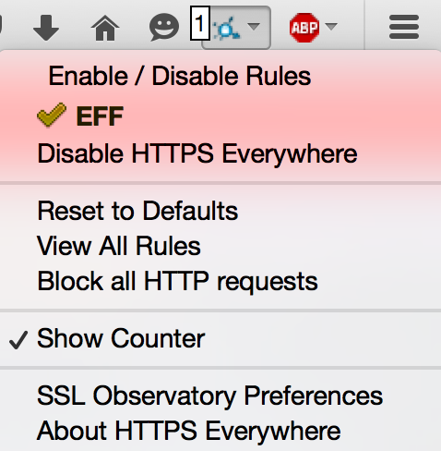
Https Everywhere has a simpler interface and shows you the number of connections upgraded to HTTPS.

Enable/Disable rules allows you to find more sites that support HTTPS

AdBlock Plus (In Chrome)
Go to the adblock plus site
https://adblockplus.org/

Click Install for Chrome or (Firefox/Other browser)
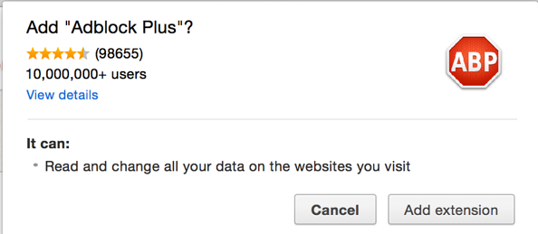

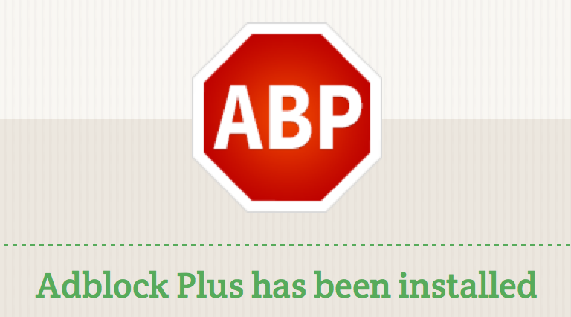
Ad block gives a summary of the blocked ads, and even allows you to pinpoint extra ads to block
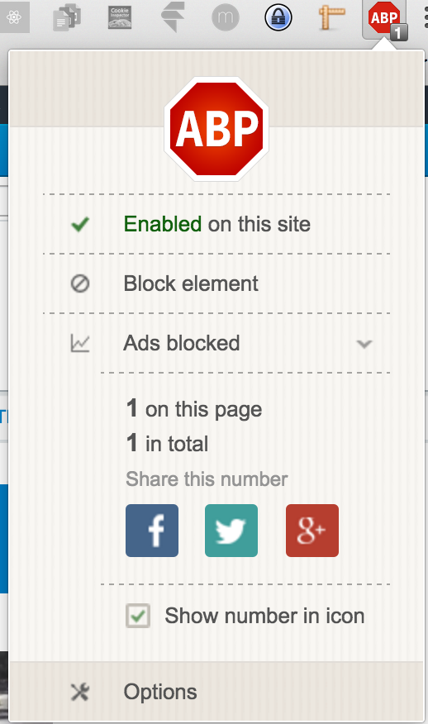

- You can disable adblock for certain sites if it interferes with them.
It gives you a summary of how many ads have been blocked.
- If you see an intrusive ad that it’s missed you can easily add it to the filter.
- By default, ABP allows non-obtrusive advertising, these ads can also be blocked from the Options page

Disconnect.me (In Chrome)
https://disconnect.me/freeprotection
The disconnect.me sells a desktop app and VPN service, just choose the ‘Get Free Protection’ option

Then choose Get Private Browsing
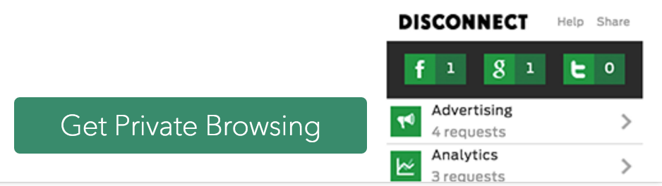

Disconnect browser plugin will be installed

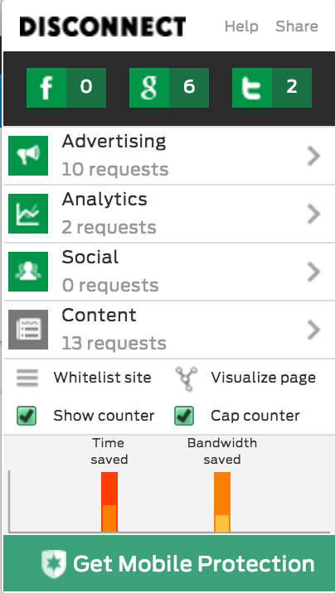

- Disconnect summarises the third party trackers that it has blocked.
- Here it has blocked 6 requests to google, 2 to twitter, 10 requests to Ad networks, 2 to Analytics platforms.
- There were also 13 requests allowed because they were probably required for the website to work properly.
- Disconnect gives a summary of how much time and data it has saved you by blocking the tracker content.
- If disconnect has blocked a third party request which is required for the website, you can enable that third party, or just use Whitelist Site to allow all trackers on that web page.

TunnelBear (Windows and OSX)
https://www.tunnelbear.com/
Go to the TunnelBear website and choose to download, it should automatically choose the correct version for your operating system.
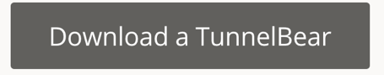

Install the tunnelbear:

OSX:
Download and extract the Zip File. Select Open and Move to Applications Folder
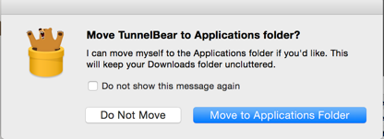
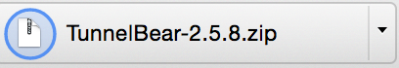
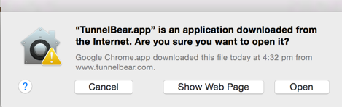

Windows:
Download and run the tunnelbear executable
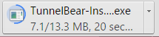

Both platforms:
An installer will open; it requires a valid email address so that it can start a trial.
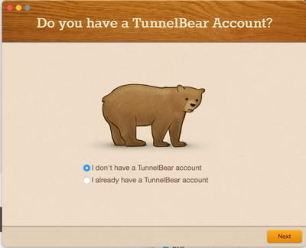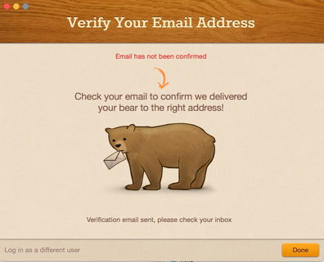

Check your email to activate your account
Then go back into the installer and click Done

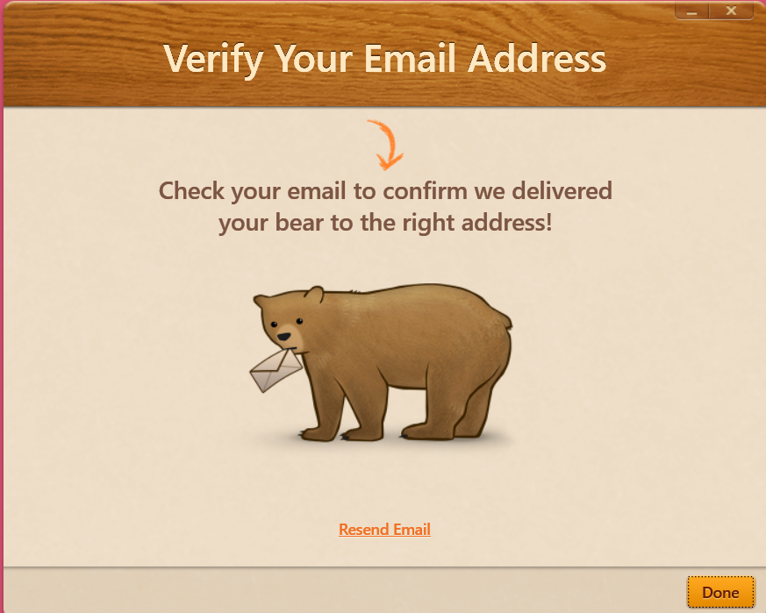
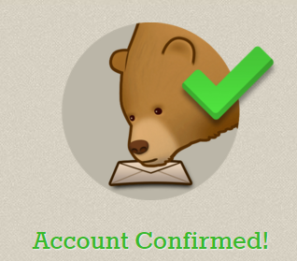
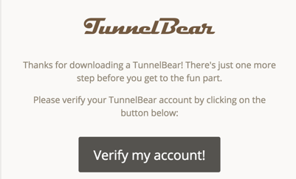

Congratulations! Your VPN is now installed, you can now turn it on.

OSX: The TunnelBear icon will be added as a service to the top right corner of your screen. Open it and click the On/Off Dial to turn on the VPN
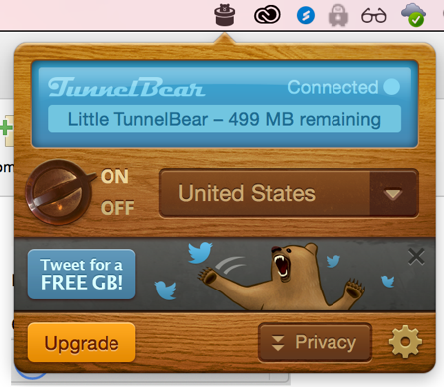

Windows: The TunnelBear page will appear immediately, turn it on then close it and it will be minimised to the tray.
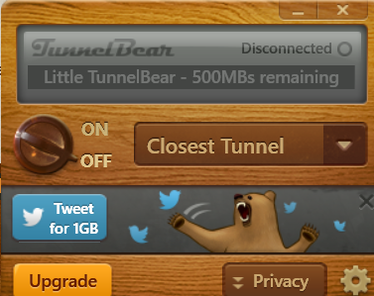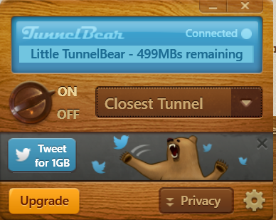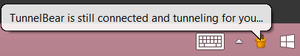

Testing the VPN
- Search for 'what’s my IP' You should get different IP addresses when you turn the VPN on and off.
- Go to what’s my IP address and your location should match the location you selected from TunnelBear.
- https://www.whatismyip.com/what-my-ip-says-about-me/

