Brisa Halviatti
Dr. Fischer
DATA 5100
October 20, 2025

Education Project: Modeling Relationships Between ACT Scores and Socio-Economic Factors

The objective of this project is to analyze the relationships between various socio-economic factors, and their effect on the average ACT score at a given school. Where SAT tests were administered, scores have been normalized to the ACT scale and are reported as ACT data. Two datasets were provided, the EdGap dataset the main source of various data about the school and the surrounding Census Tract, along with the average ACT scores for nearly 8,000 High Schools across 20 states. An additional dataset was also provided with additional school characteristics of over 100,000 schools in the United States. Four other datasets were then sourced and joined to the EdGap data to provide characteristics such as the number of arrests and referrals to law enforcement at each school, the student-teacher ratio, and the number of higher education institutions in the same zip code as each school. Lastly, schools in states that mandated standardize testing were flagged. After immense pre-processing and data cleansing, many different multivariate linear regression models were run and compared. Ultimately, the most statistically significant and practical variable was the % of students at the school who received free or reduced lunch; and a model with only three variables proved to have the most weight where explanatory power across variables is concerned.

Introduction
The main dataset is from EdGap, provided by the Memphis Teacher Residency. This data combines socio-economic data for the census tract of each included school with school-specific characteristics. The Census Tract data comes from the Census Bureau’s American Community Survey, and includes household income, unemployment, adult educational attainment, and family structure. The school specific data includes the average ACT score and the percent of the student body receiving free or reduced lunch. Because some students take the SAT and not the ACT, the providers of the EdGap data have done the necessary transformations to scale the scores to that of the ACT. A secondary data source was provided from the Common Core of Data (CCD), a U.S. Department of Education database for public schools. This data was limited to the 2016-2017 school year and provided detailed location data and information about each school. Additional data sources were added to create a more robust dataset. The number of arrests and/or referrals to law enforcement by school are provided by the U.S. Department of Education’s Civil Rights Data Collection (CRDC), with the hypothesis that the more referrals and arrests there are at a given school, the lower the ACT scores will be. This data was pulled for the 2017-2018 school year, since the 2016-2017 school year was not an option. Also at the school level, additional CCD data was pulled for the 2017-2018 that included student counts, teacher counts, student teacher ratios, a description of the area, and whether the school was a Magnet or Shared Time school. Two other data sources provided information at a higher level: the count of higher education institutions by zip code was gathered from the National Center for Education Statistics and joined to the zip code of each school in our data set. Lastly, using what information was available online, a flag was created at the state level to indicate whether college entrance exams such as the ACT or SAT are mandatory, provided, or optional. States that do not mandate testing will have slightly higher scores than those who do, as students who opt in are biased towards college.

Methodology and Background
Once all the data was imported, extensive cleaning began. Data from EdGap and the CCD School Information was relatively clean; columns were renamed and re-formatted for clarity and ease of use. Initial relationships within the EdGap data were verified visually using a pair plot, regression line, and checking individual variable distributions. It was determined that some multicollinearity existed between variables, but not enough to cast doubt. Most importantly, some initial relationships between ACT score and the socioeconomic factors begun to emerge; warranting the regression analysis we would complete to quantify them.
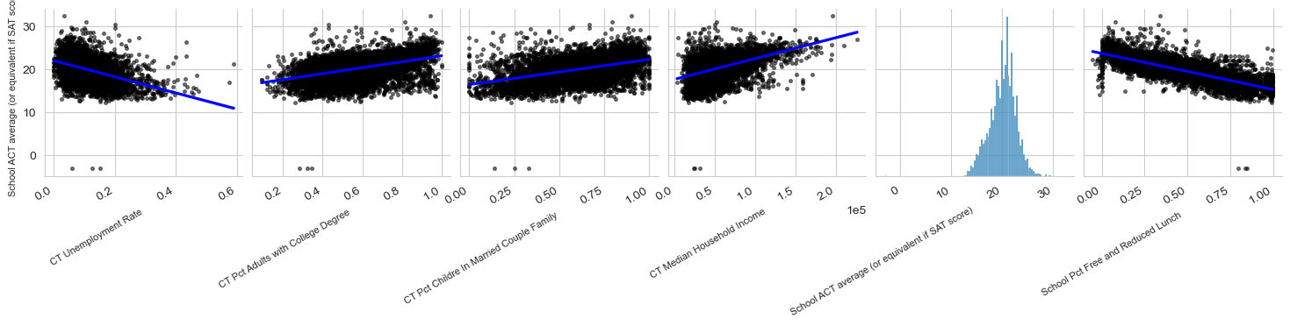
The ’School to Prison Pipeline’ is a well-established phenomenon, multiple studies have identified educational gaps between schools and linked various factors to the differences in student outcomes. Parents want to ensure their child receives a good education, and determining what variables are related to student performance is a key consideration to families, educators, and policymakers. Included as additional datasets were school level data that such as the student count, the teacher count, student teacher ratio, the number of arrests and referrals to law enforcement. Student:Teacher ratio is often used as a measure of how attentive to student needs a classroom can be. It is assumed this will be an indicator of improved ACT scores. On the other hand, arrests and referrals would be a significant detractor from a healthy learning environment, so it is expected that more issues within the student body would lower a school’s average ACT scores.

The preprocessing of these data took longer than any other part of the analysis. Downloading and importing the data such that the CSV file did not lose precision of the IDs necessary for joins was a major hurdle, as once a field was represented with scientific notation I could no longer use it. Ensuring data types were identical and dealing with mismatching object types hinder joins. Repeatedly finding numerous symbols such as dashes (-), daggers (†) and double daggers (‡) required creative replacement. Since I could not simply copy and paste the non-numeric characters, I found the index positions where they occurred, initialized a variable to capture that value, and then replaced all cells matching that value with Panda’s “Not a Number” (NaN) data type. Column names were long, filled with unnecessary characters, and required adjustment. Categorical data required splitting in some cases, where area_description became two separate columns for area_type and area_size, and the “Yes” and “No” values for Magnet School and Shared Time Schools were stripped of numeric codes. Additionally, missing data in these datasets were set as NaN rather than imputed. Once the data was cleaned, and were joined together and a secondary visual assessment of our relationship to ACT score was performed: 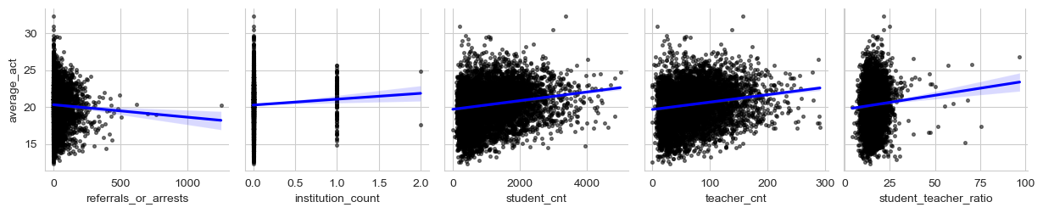

These variables also showed indication of possible relationships, but with much more variability compared to what was shown in the EdGap Data.
Computational Results
Before beginning the final analysis, it is important to note some of the limitations of the final dataset. The final dataset includes one year of data for 7,251 High Schools in 20 of 50 U.S. states. The West Coast and Midwest are severely underrepresented, the vast majority of the states are in the Great Lakes region, and nearly 30% of the data comes from three states: Texas, Ohio and Illinois. In all three of these states, neither the SAT nor the ACT are mandatory. Texas is one of six States in this sample that provides access to testing free of charge, but does not require students take them. It is important to understand how scores differ across states based on the population of students taking the tests, as this is a crucial bias in our sampling.
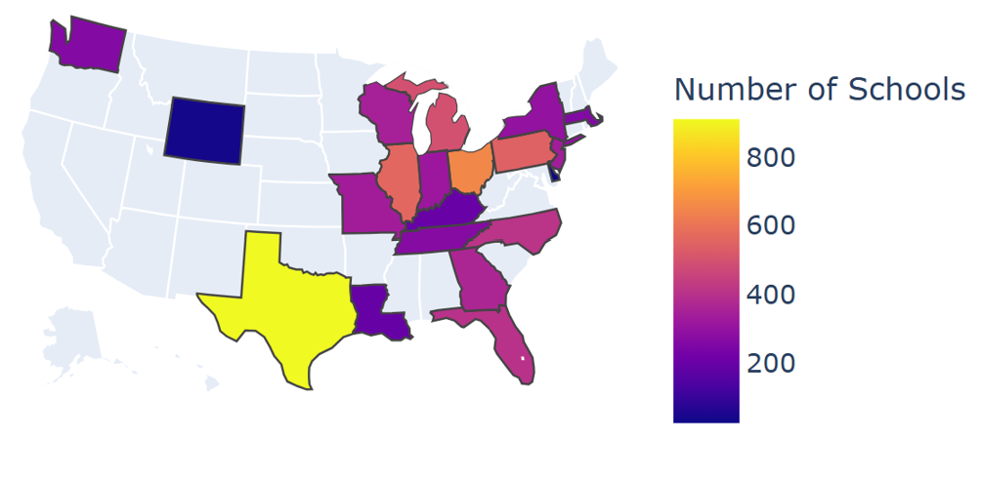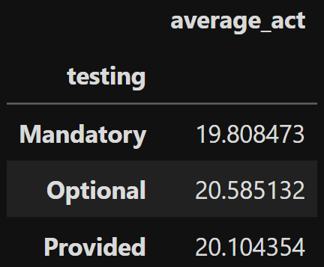
Ultimately, when looking at the correlation matrix of all our numeric data, the strongest relationship to ACT scores that emerged was a negative correlation to the percent of students on free or reduced lunch. None of the data sourced independently produced a correlation of greater than 0.20. Additionally, slicing numeric data by various categorical data did not appear to tease out any additional meaning, when viewing pair plots.
For the final analysis, a multivariate linear regression model was selected as the method to quantify the relationships between the predictors and ACT score. A backward selection method was used, beginning with all the variables and determining which can be eliminated until all data was relevant, statistically significant, and had sufficient explanatory power and fit. Using the statsmodels package, an Ordinary Least Squares model was constructed with the following formula:
multivariate_model = smf.ols(
formula='average_act ~ rate_unemployment + percent_college + percent_lunch + student_cnt + teacher_cnt + student_teacher_ratio + institution_count + referrals_or_arrests + C(charter) + C(magnet_sch) + C(shared_time_sch) + C(testing) + C(area_type) + C(area_size) + any_institutions + any_ref_or_arr',
data=df_final).fit()
Using a design matrix and backward selection, all coefficients with a p-value of 0.05 or greater were eliminated, and the model was rerun. Additional variables were backed out and re-run two more times before settling on 14 statistically significant variables:
'C(shared_time_sch)[T.No]', 'C(shared_time_sch)[T.Yes]', 'C(testing)[T.Optional]', 'C(testing)[T.Provided]', 'C(area_type)[T.Rural]', 'C(area_type)[T.Town]', ‘C(area_size)[T.Large]', 'C(area_size)[T.Mid-size]', 'C(area_size)[T.Small]', any_ref_or_arr[T.False]', 'any_ref_or_arr[T.True]', 'rate_unemployment', 'percent_college', 'percent_lunch'
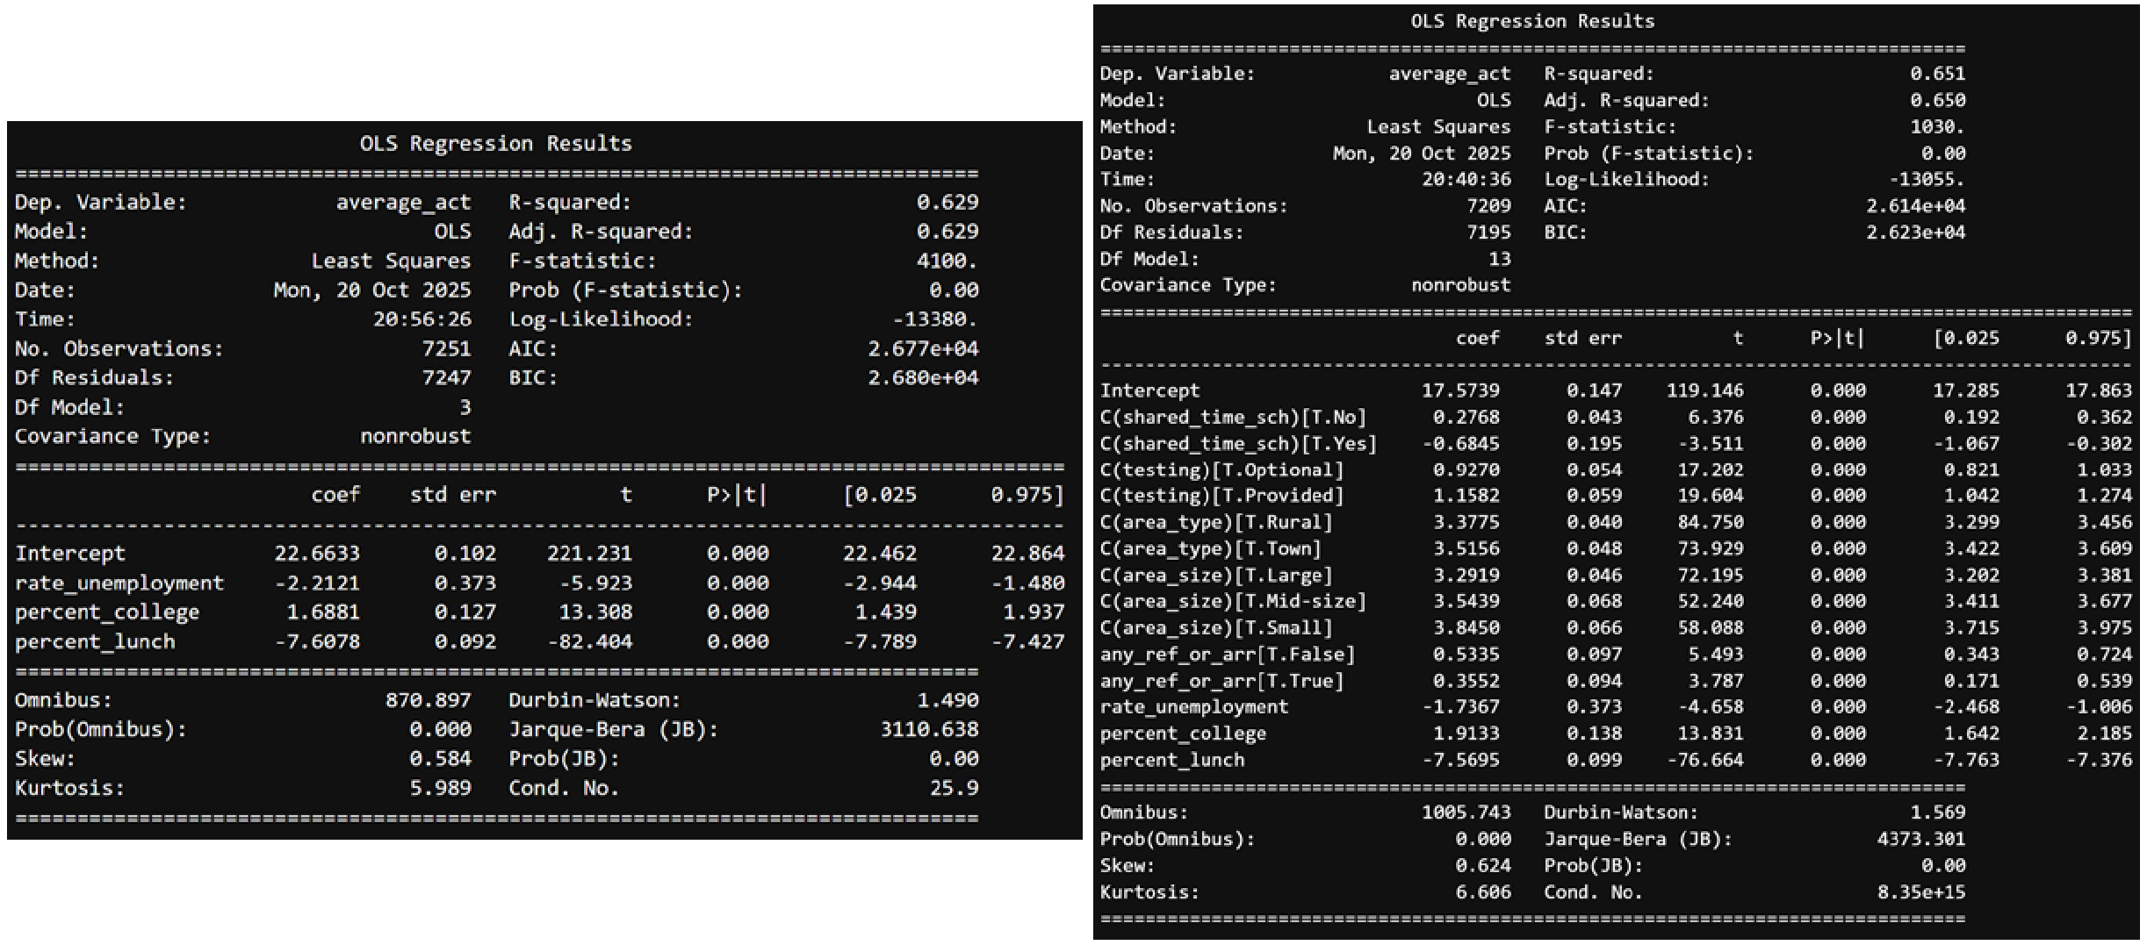
As one final comparison, a highly reduced model was computed using only three predictors: rate_unemployment, percent_college, and percent_lunch.
Discussion
While all of the remaining variables included in the initial backwards selection model are statistically significant, as indicated both by each individual coefficient P-Value and the high and statistically significant F-Statistic, the reduced model has 96% of the explanatory power (R-squared of 0.629 vs 0.651) and uses 78% fewer predictors (3 vs 14). Furthermore, The F Statistic is almost 1000 points higher and equally significant, and there is no multicollinearity warning is in the reduced model summary. While an ANOVA comparison between the two indicates statistically significant improvement over the reduced model, the complexity cost of 11 additional variables for a 2% improvement in explanatory power (as indicated by the R-Squared) does not offer practical justification for utilizing the more complex model.
Conclusion
After significant pre-processing, cleaning, joining, and analysis, the most influential variable for predicting ACT scores in our sample comes from the percent of the student body receiving free or reduced lunch. This variable is specific to each school (rather than the surrounding area), and is a more direct measure of the school's economic need. Since families must qualify for free or reduced lunch via federal programs, it normalizes and accounts for local cost-of-living differences across different regions better than median income alone. While many of the variables introduced from sources outside of EdGap had some significant relationship, they failed to move the score in a meaningful way. All else held constant, both models predict that a 1-unit increase in the percent of students receiving free or reduced lunch will lower ACT scores by just over 7 points. The only variables in the more complex model that caused a significant shift in ACT scores were related to area type and size; however, nearly every type or size category contributed roughly the same increase of about 3 points, making these variables largely uninformative. This data is also biased by the sample itself, since very few Midwestern states were included and could have shifted the mix of area types. In summary, while many of the data points included in the EdGap data and sourced elsewhere provided evidence of statistically significant predictive relationships to a school’s average ACT score, only the percent of students receiving free or reduced lunch proved to be the most meaningful. By omitting 11 of the 14 predictors in a multivariate OLS model we retain 96% of the explanatory power. The vast majority of the explanatory power in both models comes from the ‘percent_lunch’ variable. In fact, the R-Squared of a single variate model that only uses the free and reduced lunch variable to predict average ACT score is 0.616. Thus, using the reduced 3 variable model strikes the right balance of model simplicity, explainability, accuracy, and goodness of fit.

