Introduction

In marketing, customer lifetime value (CLV) is an estimation and prediction of the net profit that a customer contributes to during the entire future relationship with a customer. Customer lifetime value is an important metric because it represents an upper limit on spending to acquire new customers. CLV helps firms identify their most valuable customers by allocating marketing resources efficiently and designing retention strategies. In industries such as insurance where recurring policies and renewals are common, accurately predicting CLV is especially important for strategic decision-making. PwC (2023) defines CLV as “a total financial contribution (revenue minus costs) of a customer over his/her lifetime with the company,” encompassing both profit and time horizon. Accurately predicting CLV improves revenue growth, marketing spend, and competitive advantage (PwC, 2023).

The aim of this study is to predict the Customer Lifetime Value (CLV) based on a customer’s profile to determine whether a prospective customer would represent a profitable policy to write. By building a model that can estimate CLV, we can help the insurance company decide whether a new customer would be profitable to write a policy for. This project also explores which features have the strongest impact on CLV, how accurately CLV can be predicted using the chosen models and how these predictions can support better decision making when evaluating prospective customers.

This study uses IBM Watson Marketing Customer Value dataset that is available in Kaggle. This dataset includes 9,134 observations and 24 features describing demographic, behavioral, and policy-related characteristics of insurance customers. The dataset contains a mix of numerical and categorical variables describing each customer’s demographic profile, policy information and vehicle characteristics. The categorical variables include State (Arizona, Nevada, Oregon, California, Washington), Coverage type (Basic, Extended, Premium), Education level (High School or below, College, Bachelor, Master, Doctor), Employment Status (Employed, Unemployed, Retired, Medical Leave, Disabled), Gender (Male, Female), Location Code (Rural, Suburban, Urban), Marital Status (Married, Single, Divorced), Policy Type (Corporate Auto, Personal Auto, Special Auto), Vehicle Class (Two-Door Car, Four-Door Car, SUV, Luxury SUV, Sports Car, Luxury Car), and Vehicle Size (Small, Medsize, Large). These categorical variables were later one-hot encoded for modeling. The dataset also includes numerical variables such as income, monthly premium, number of policies, total claim amount, and months since last claim, providing a comprehensive feature set for predicting Customer Lifetime Value. Data preparation involved checking for missing values and duplicate entries, examining the features, standardizing column names and examining distributions for outliers or inconsistencies. The dataset was provided as a single CSV file, so no merging with other dataset was required. There were no missing values in the dataset, so no imputation was required. These preprocessing steps ensured that the dataset was suitable for statistical analysis and predictive modeling. These preprocessing steps ensured that the dataset was suitable for statistical analysis and predictive modeling.

Exploratory data analysis
The exploratory data analysis began by examining the distribution of Customer Lifetime Value (CLV) across key categorical groups. We conducted a segmented analysis of the independent variables which included both categorical and numerical variables. Some of the categorical variables included policy type, coverage type, vehicle class, gender, and state of residence. Initial findings revealed notable imbalance and skewness within the dataset. For instance, policies from California and Oregon together accounted for 63% of the total sample, while policies from Arizona have a much lower CLV relative to other states. Coverage types also showed meaningful variation. Premium coverage policies exhibited substantially higher CLV values but represented only about 12% of the dataset.
The dependent variable (CLV) displayed substantial skewness and several extreme outliers. The mean CLV was 8,004, while the median was much lower at 5,780 which indicated a right skewed distribution. CLV had values exceeding 80,000. Monthly premium variable showed no extreme outliers as the most expensive policies were below $300.
To better understand the relationships between CLV and numerical predictors, we generated pair plots. These visualizations revealed a distinctive striped pattern between CLV and monthly premium. The presence of four clear stripes suggested an interaction effect from another variable most likely the number of policies held by the customer.
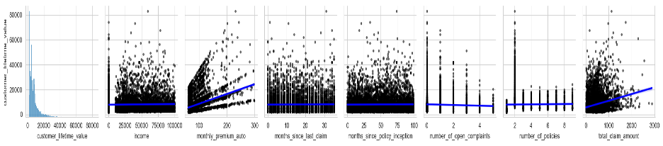
To investigate this further, we constructed a FacetGrid and treated numerical variables with fewer than 10 unique values as categorical for visualisation. During this step, we consistently observed instability in patterns whenever the number of policies interacted with CLV and another numeric variable. These unstable patterns were irregular, difficult to interpret and did not align with trends observed elsewhere in the dataset.

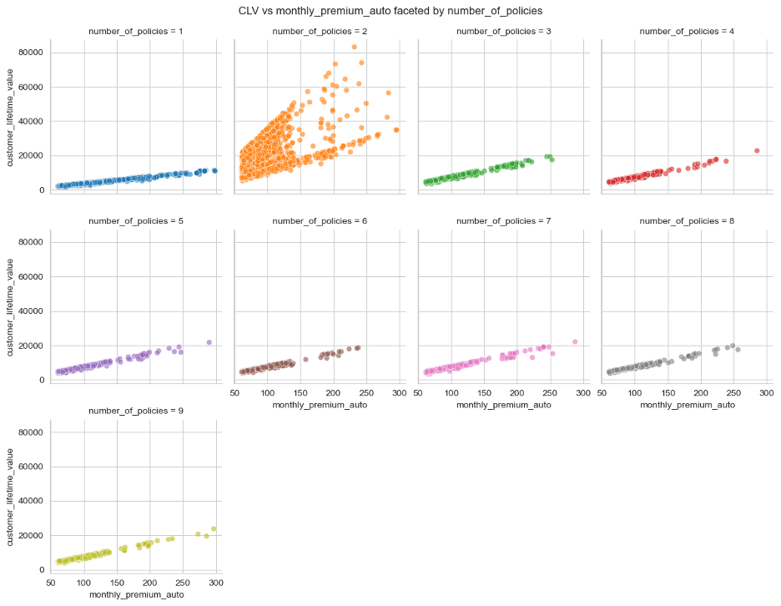
We observed that customers with exactly two policies showed unstable patterns in the exploratory analysis outputs. Even after further investigation, we were unable to identify a clear reason for this behavior, which suggests that the instability may be driven by some underlying factor not captured in the dataset. Because of this, we decided to handle the two policy group separately during modeling and evaluate which modeling approach performs best when this group is treated differently.

Computation Results
Our first model (Model 1) produced an R-Squared of 0.16 with 48 degrees of freedom. Out of the 49 variables, 10 demonstrated predictive power with a P-value below 0.05. Statistically significant variables included monthly premium, number of open complaints, number of policies, high school and below education, employed employment status, single marital status, corporate policy and 3 types of renewal offers.
In Model 2, we limited the data to customers in the top 75th percentile of CLV and refit the same OLS regression model using all variables, the R-squared slightly improved to 0.247 and 20 variables showed statistical significance.
In Model 3, we added a dummy variable for customers with exactly two policies and an interaction term between this dummy and monthly premium. This model performed much better, achieving an R-squared of 0.666. We then tested a reduced model using only monthly premium and the interaction term. This simpler model still achieved an R-squared of 0.627.
In Model 4, we built models based on number of policies separately. For most policy counts, the models produced extremely high R-squared values (above 0.993). However, for customers with exactly two policies, the R-squared dropped to 0.340, confirming that this group behaves differently.
In Model 5, we removed customers with exactly two policies and refit the OLS regression model, the R-squared was 0.796, with 18 significant variables.
In Model 6, we built a model using Random Forest after removing customers with two policies. This model achieved an R-squared of 0.995.

Methodology
This project relied on an existing dataset provided by IBM, eliminating the need for additional data collection procedures. The original dataset was supplied in comma-separated values(.csv) format and contained a range of customer and policy attributes, including the target variable, CLV. Some variables were removed from the analysis because they offered no predictive value specifically, customer ID and policy expiration date.
To meet the assumptions of an Ordinary Least Squares (OLS) regression framework, all categorical variables were converted into binary indicators using one-hot encoding, with the first category dropped in each case to prevent multicollinearity. The analysis followed an iterative modeling approach, beginning with an OLS model that included all available customer attributes. The model summary provided key evaluation metrics such as R-squared values, predictor coefficients, and corresponding p-values.
A secondary model was developed using a subset of customers whose CLV values fell above the 75th percentile and who held exactly two policies. This allowed for a closer examination of how policy count influences CLV. A new dummy variable was created to indicate whether a customer had exactly two policies, and an interaction term was introduced between monthly auto premium and the two-policy indicator. An OLS model incorporating these terms and selected categorical variables was then estimated, with results assessed through model summaries and residual diagnostics. A final OLS model was constructed using data segmented by policy count.

To investigate potential non-linear relationships and improve predictive accuracy, a Random Forest Regressor was also implemented. The dataset was split into training and testing sets, the model was fitted, and performance was evaluated using R-squared. Because the two-policy group showed inconsistencies, an additional subset excluding this group was created, and the Random Forest model was trained and evaluated on this reduced dataset as well.

Discussion
Effectively uses data to address scientific aim. Key data are interpreted correctly. Deeply thought out argument that logically leads to conclusions. All data that support or contradict your conclusions are discussed.
As shown in our exploratory data analysis, the number of policies a customer holds has a substantial impact on model performance. In particular, customers with exactly two policies display extreme stratification in their monthly premium. This was highlighted previously (see the FacetGrid referenced in our Methodology), but is important to reiterate as we discuss the outcomes of our models.
Our first two models attempted to model the data without specifically addressing the number of policies themselves; and neither provided significant value. Our third model addressed the number of policies directly, by creating a new variable that acts as a flag for when a customer has exactly two policies. This binary categorization can then be modeled as an interaction term on monthly premium to capture the clear relationship these two predictors have. This relationship became apparent in the aforementioned FacetGrid, as the main explanation for the ‘striped’ pattern witnessed between CLV and monthly premium. It was observed that only customers with exactly two policies appear to have this stratification; all other customers have a strong linear relationship between monthly premium and CLV. While this interaction term provided immense improvement, with the R-Squared increasing to 0.666, we found two other methods that yield greater success.
The insurance industry is highly regulated, and for that reason model explainability is a key consideration. Our forth model is actually 9 individual models, one for each number of policies a customer has. If a prospective customer profile is drafted for a client with one policy, the model for single-policy customers would be used. If a customer has 9 policies, the 9-policy model would be used. This method found extreme success, provided the customer does not have exactly two policies. The R-Squared for customers with 1 or 3 policies was 0.996 and 0.995 respectively. Granted, additionally tuning would be required to remove model inputs for the many statistically insignificant values which would drive down the R-Squared values slightly. However, in a business where transparency is a key consideration for Office of Insurance Commissioner audits, customer data requests, and other regulatory considerations; these individual models would be a highly desirable methodology to predict CLV.
While model transparency may be ideal, it can also hinder a competitive advantage. If a ‘black box’ approach is permitted, then our 6th and final model may be the best option: a Random Forest. This model is designed for customers that do not have exactly two policies, producing an R-Squared of 0.996 without requiring a separate model for the exact number of policies a customer has. This approach provides convenience, accuracy, and less transparency – which could be a value add in an industry where competitors can often view one another’s filings.
Despite much success with these final two models, the area in which all of our modeling has suffered is with customers who own exactly two policies. As it stands, we have no statistically significant way to predict a meaningful CLV from these clients. The Random Forest that included all customers had an R-Squared of 0.684 which is only marginally better than our linear regression model that included the interaction term of the two-policy flag on monthly premium (0.666). Yet, the Random Forest was able to achieve a near perfect R-squared when customers with two policies are omitted. Clearly there is a need to further investigate what makes customers with two policies so different, especially where premium is concerned. We exhausted our ability to reach any meaningful conclusions with the dataset provided us, as the categorical variables and discrete numerical variables did not unlock any insight as to why these customers may have significant variation in their monthly premium. This discrepancy on such a potent predictor therefore impedes our ability to perform meaningful predictions. Ultimately, it would be our business recommendation to allocate further research into these customers and obtain additional data to help identify and explain what else may be causing the relative changes in premium. In the interim, we provide two methods for modeling CLV for customers who do not have exactly two policies; specific models for the number of policies or a random forest that excludes customers with two policies. The performance of these models are comparable, therefore the best model would be determined by the level of explainability desired by the business.

Conclusion
Scientific aim is restated clearly without using the same language found in the introduction. Discusses relevance to the world in the context of the data and original problem. Summary is clear, concise, complete, and correct.
Our goal was to build a tool that reliably estimates the long-term financial contribution of a prospective customer, using the customer profile information obtained in the customer application. We have built two models, a linear regression model specific to the number of policies a customer has and a Random Forest model, both achieve a similar and highly accurate prediction of a given customer’s CLV based on their profile. The former provides ample explainability, allowing regulatory bodies or business leaders direct insight into each variable’s effect on CLV. The latter provides a single model that can be used for any applicable customer, and is a ‘black box’ that can obscure the specific variable weights and predictive powers. For a given target of CLV, these models can determine how desirable a policy may be to write. These models can easily become classification models, if provided a specific threshold after which the predicted CLV suggests a policy should be written, or denied. However, significant work remains necessarily to unmask the issues observed with two-policy customers. It remains to be seen what specifically is causing the disparity in monthly premium for these customers; perhaps there are additional bundling discounts or risks carried by the secondary (non-auto) policy. A major limitation of our model is its inability to accurately predict for this population.

