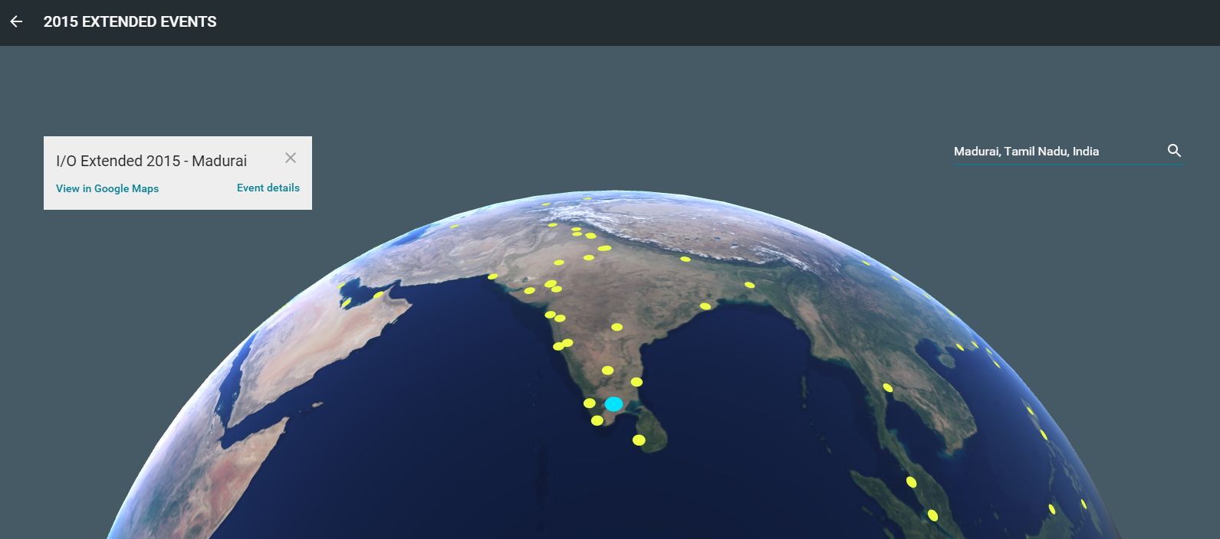

Google I/O Extended Madurai Proposal

# Logistics

Location: American College

Date: 29, 30 May 2015

Duration – 2 Day (10 AM- 5 PM)

Participants: 200 - 250 Students/Developers

Target audience: Students, Developers, Startups

# Event Details

We are excited to organize the First ever **Google International conference** (Google I/O annual conference of Google Where they will release New Android OS, Nexus devices and update on latest Google Technology) in Madurai.

Madurai is one of the place selected by Google to conduct this year I/O Extended program. We have live session directly from San Francisco.

### 

### WHAT IS GOOGLE I/O?

Google I/O is an annual developer-focused conference held by Google in San Francisco, California. Google I/O features highly technical, in-depth sessions focused on building web, mobile, and enterprise applications with Google and open web technologies such as Android, Chrome, Chrome OS, Google APIs, Google Web Toolkit, App Engine, and more.

Google I/O was started in 2008. The "I" and "O" stand for input/output, and "Innovation in the Open". The format of the event is similar to that of the Google Developer Day.

### WHAT IS THE GOOGLE I/O EXTENDED?

Brought to you by Google Developer Group Mumbai, Google Student Ambassadors, and Google Business Group Mumbai, Google I/O Extended lets you experience the magic and innovation of Google I/O remotely. Part viewing experience and part community building, I/O Extended programmer includes everything from live streaming the Google I/O content to local developer demos and speaker sessions.

# Agenda

Tentative Agenda so far is as follows:

Date: May 29-2015

Time: 10AM to 5 PM

10-11AM: Google I/O 2015 Updates

11 AM -1 PM: Google Android M in Developer point of view.

1-1:30 PM: Lunch

1:30 -3:30 PM: Polymer 1.0 New Google Web Tools Details

3:30-4:30 PM- Iceberg games with Google Toys and Android M

4:30-5PM- Google Software distribution of Hands on work

Date: May 30-2015

Time: 10AM to 5 PM

10-11AM: Introduction about CodeLab

11 AM -1 PM: GitHub Profile creation

1-1:30 PM: Lunch

1:30 -3:30 PM: Developing your first app using Polymer 1.0

3:30-4:30 PM- Presentation Apps to the judge

4:30-5PM- Prize Distribution and Networking

Requirements

* Auditorium capable of accommodating 200+ students.
* Mic (2) with good laude speaker
* Projector with good visibility for the 200 students.
* Internet connectivity for the Laptop which is connected to the Projector.
* We are having a Conference call so Good quality internet is necessary.

# Outcome

Students and Developer from Madurai will get opportunity to interact with Google Team. They will have a hands on session about Google Latest Technology, Android M new android Os released by Google, Polymer 1.0. It helps student community to show their potential to Google during this event.