Assignment – 10:
Problem Statement: Deploy project from GitHub to EC2 by creating new security group and user data.
Steps:
- The AWS account is signed in and the EC2 dashboard is opened.
- The Security Groups option is selected from the left navigation panel under Network & Security. 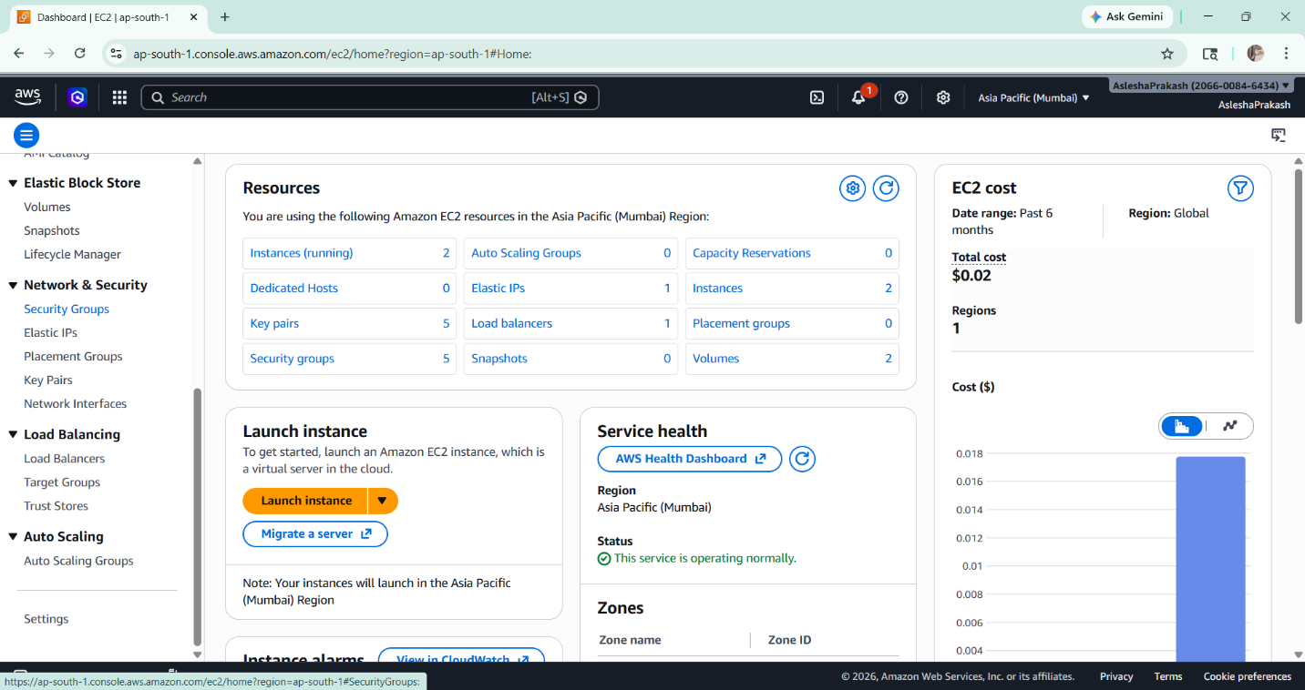
- All security groups except the default group are selected and deleted using the Actions menu. 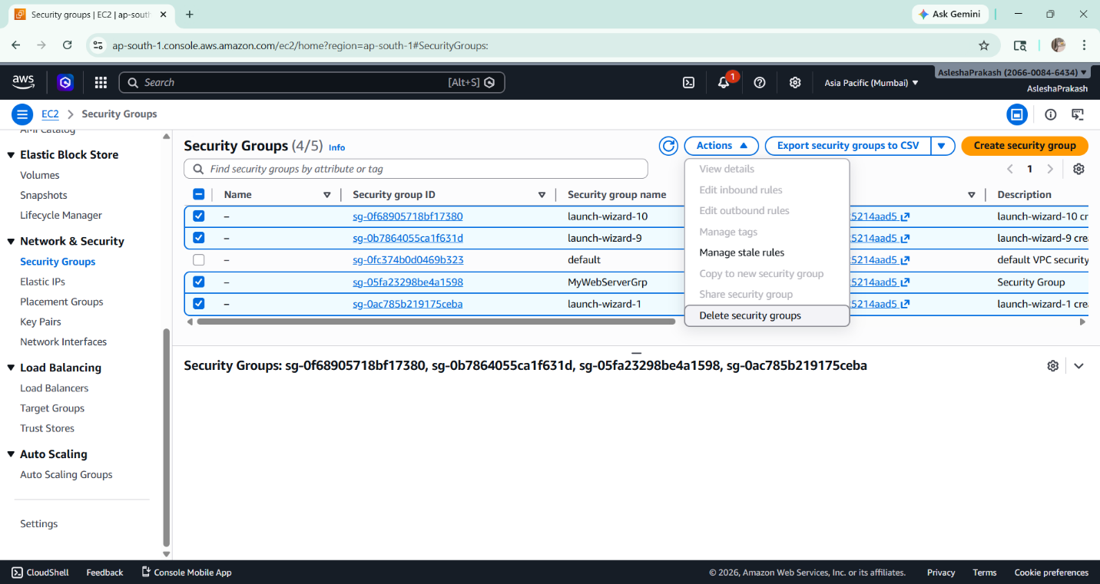

- A new security group is created by clicking on the Create Security Group button. A name and description are provided, and the VPC is left unchanged. 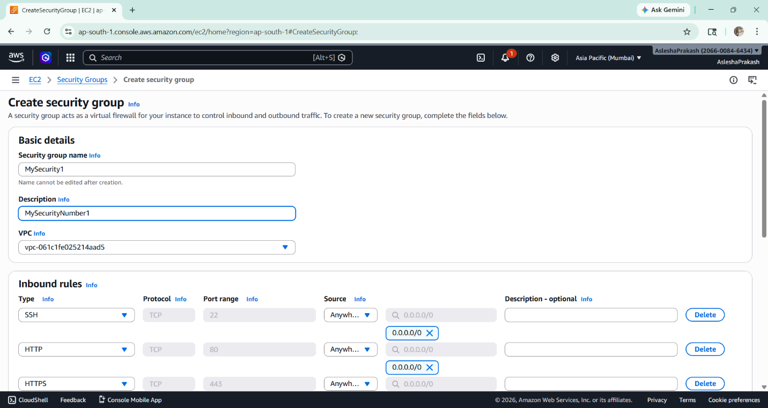

- Inbound rules are added by selecting:
  - SSH
  - HTTP
  - HTTPS
- Custom TCP (with required port, e.g., 4000 from index.js) 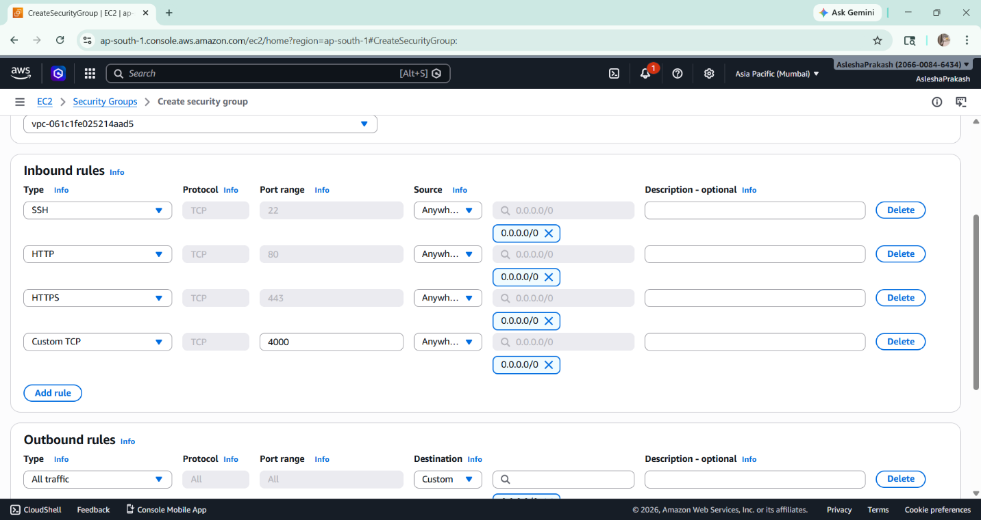

- The security group is created and verified from the security groups list. 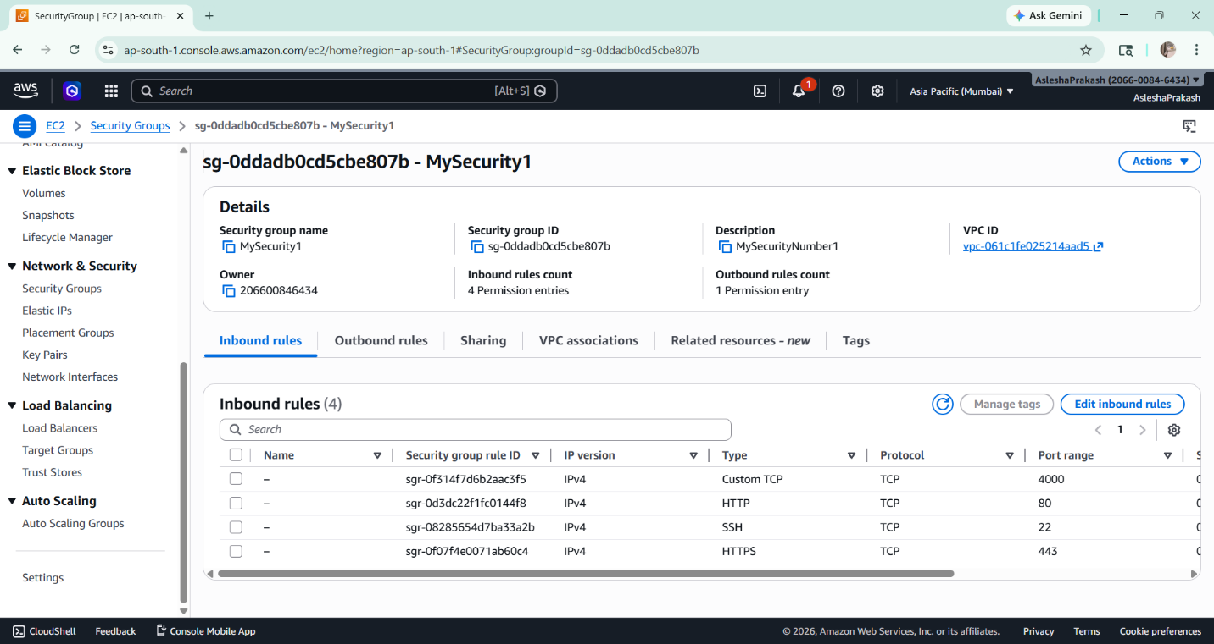

- A new EC2 instance is launched. The instance is configured by:
  - Providing a name
  - Selecting Ubuntu OS
  - Choosing or creating a key pair
  - Selecting the created security group under network settings
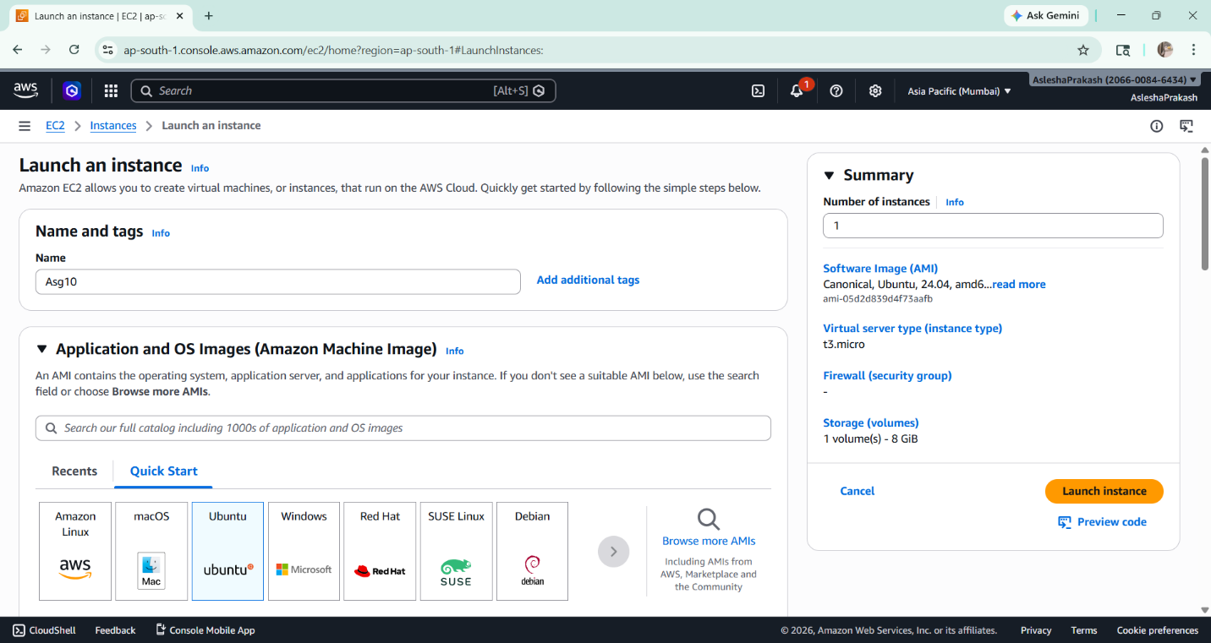
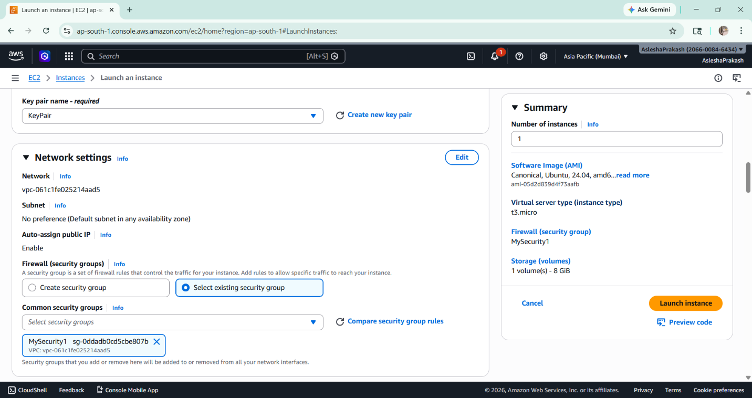

- Under Advanced Details, user data is provided to execute commands during instance startup:
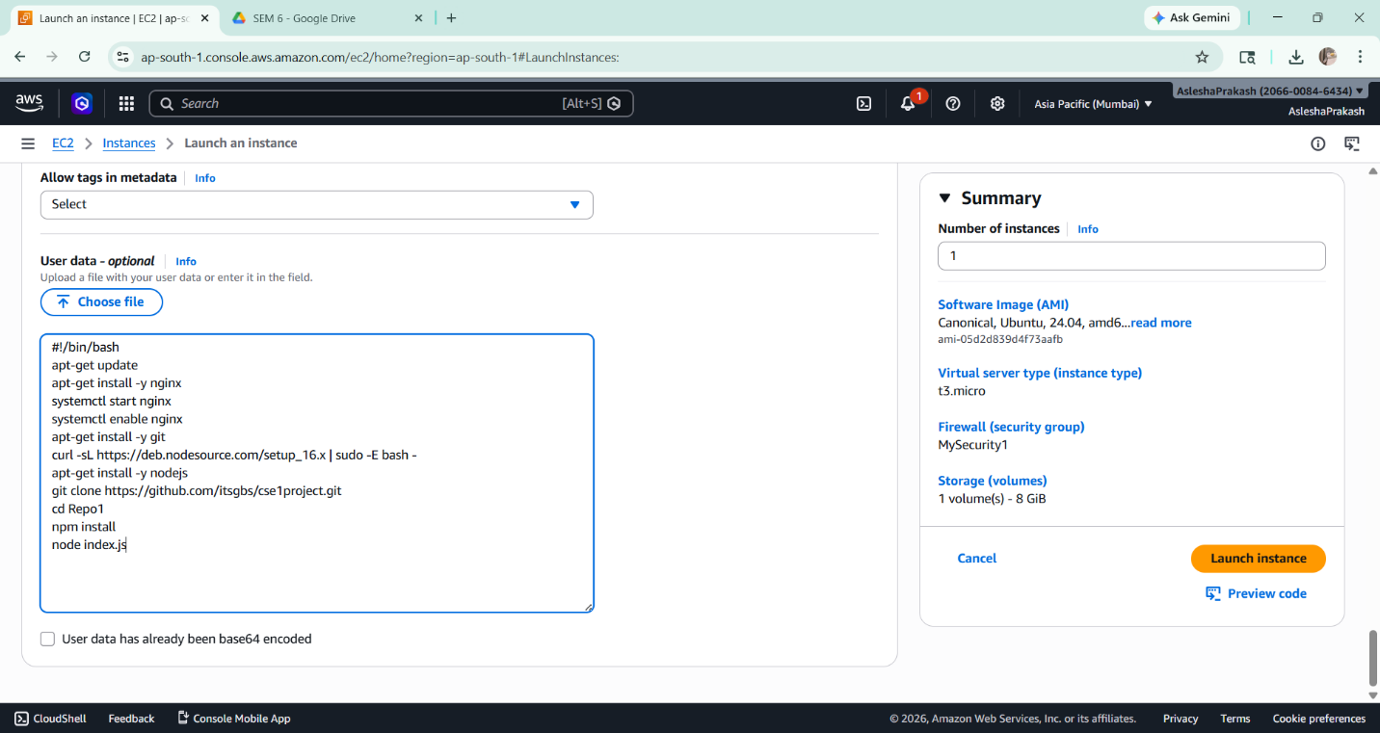

- The instance is launched and accessed using the Connect option, which opens a browser-based terminal.
- The GitHub repository is cloned into the instance:
git clone <repository-link>
cd <repository-name>
npm install
node index.js
- The public IPv4 address of the EC2 instance is copied and accessed in a browser.