Assignment – 14:
Problem Statement: Create an Elastic IP for an Instance.
Steps:
- The AWS console is signed in and the EC2 dashboard is opened. A new EC2 instance is created without using any user data or custom security group.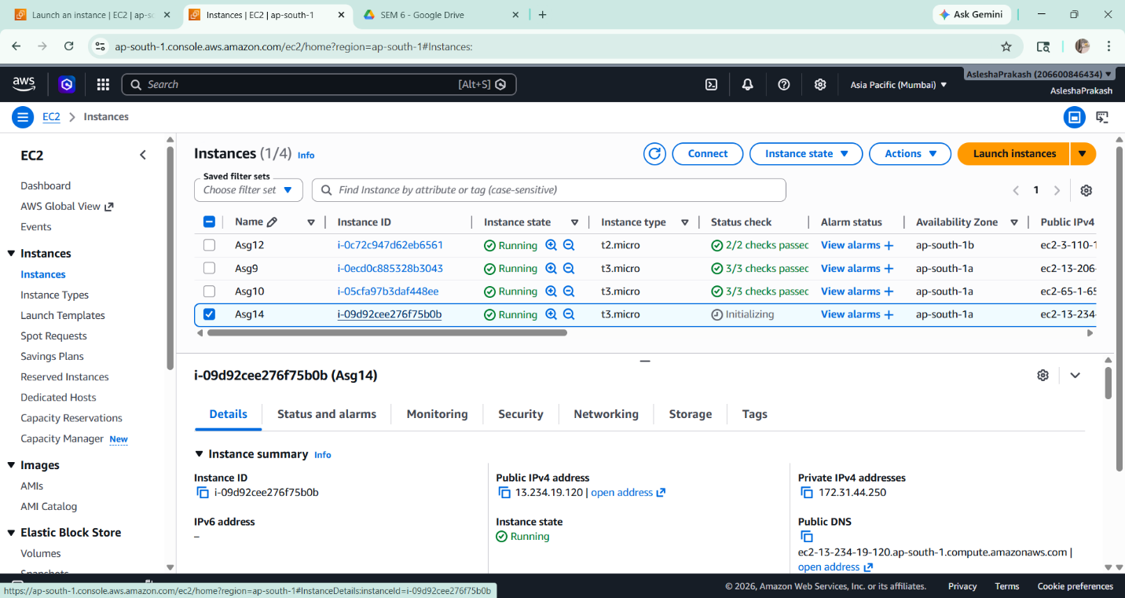

- After the instance is successfully launched, it is selected and its public IPv4 address is copied and saved in a text file for reference.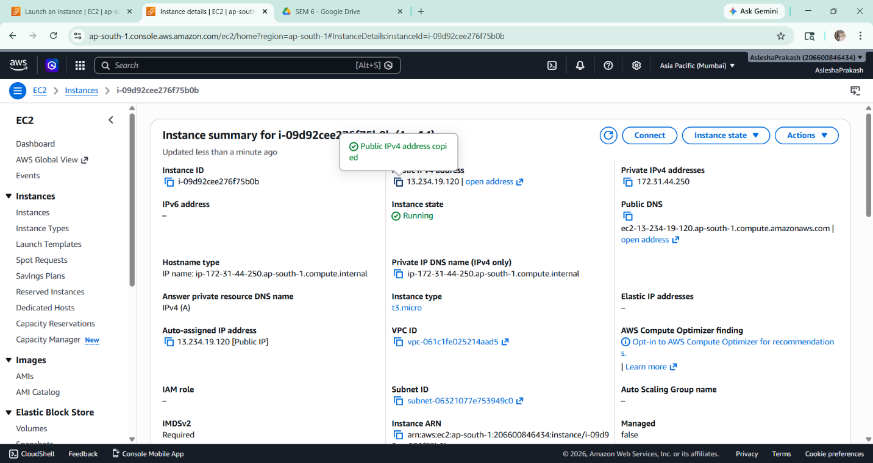

- The instance is then stopped using the Instance State → Stop Instance option. After a few seconds, the instance is started again using the Start Instance option.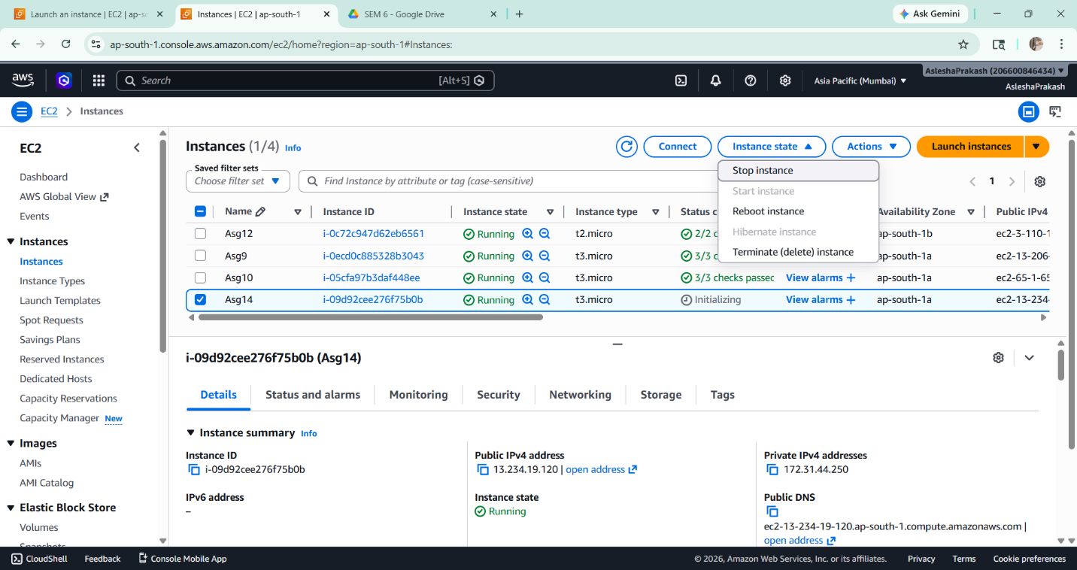

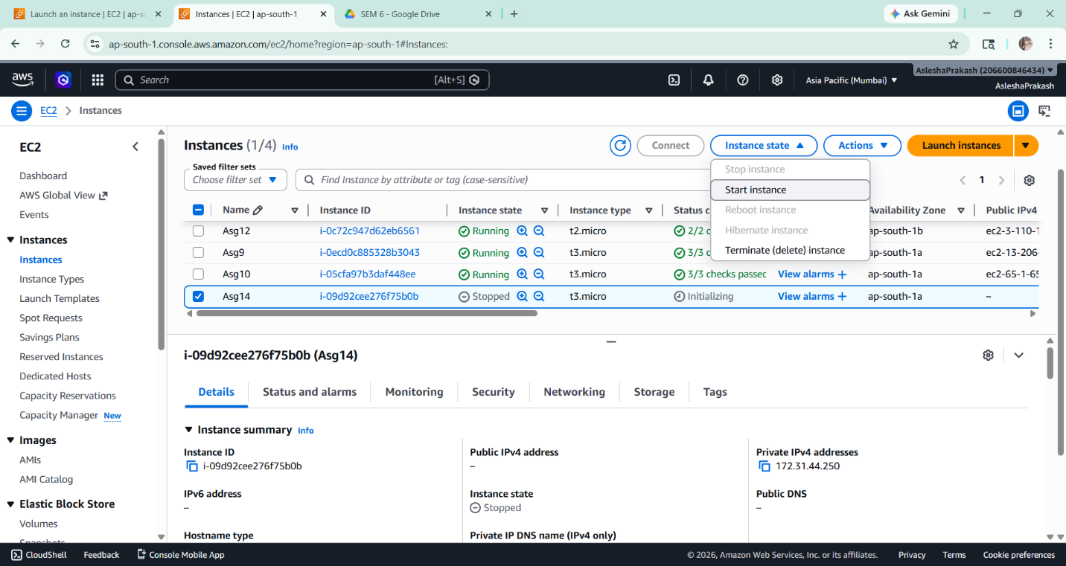

- Once the instance is running, its public IPv4 address is copied again and compared with the previously saved address. It is observed that the IP address has changed after restarting the instance.
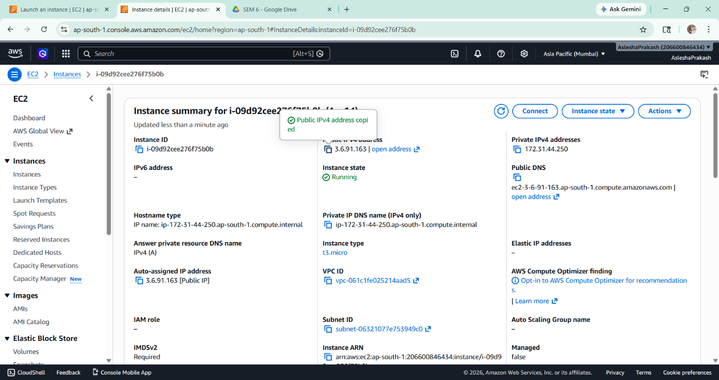

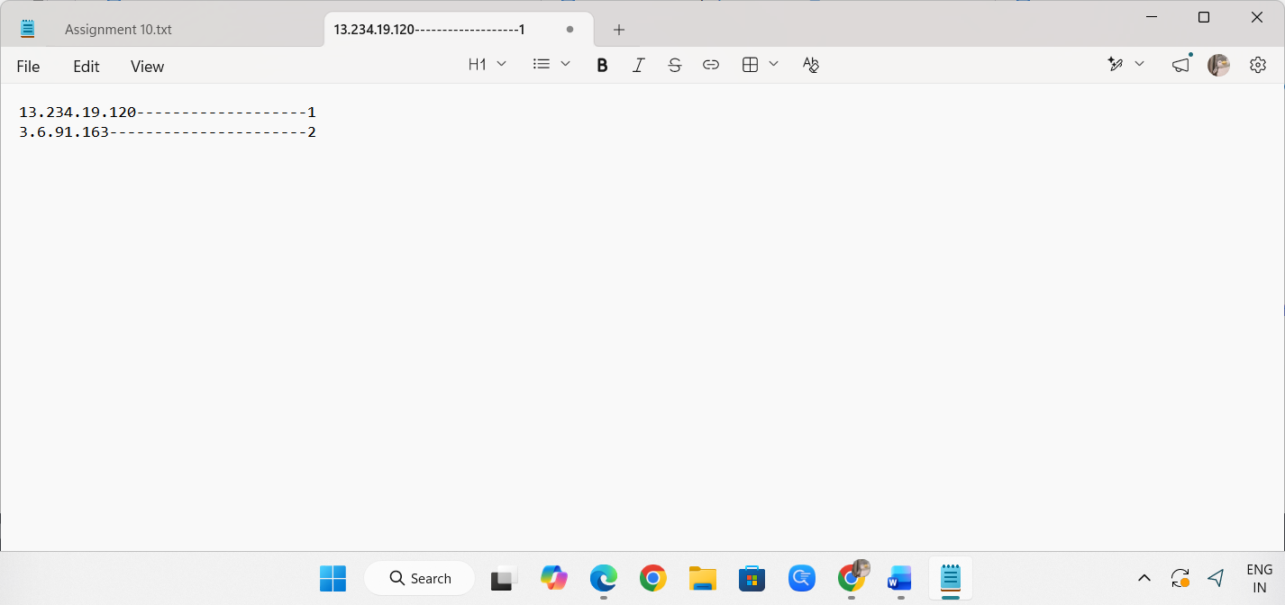

- To ensure a static IP address, an Elastic IP is created. For this, the Elastic IPs option is selected from the Network & Security section in the left navigation panel.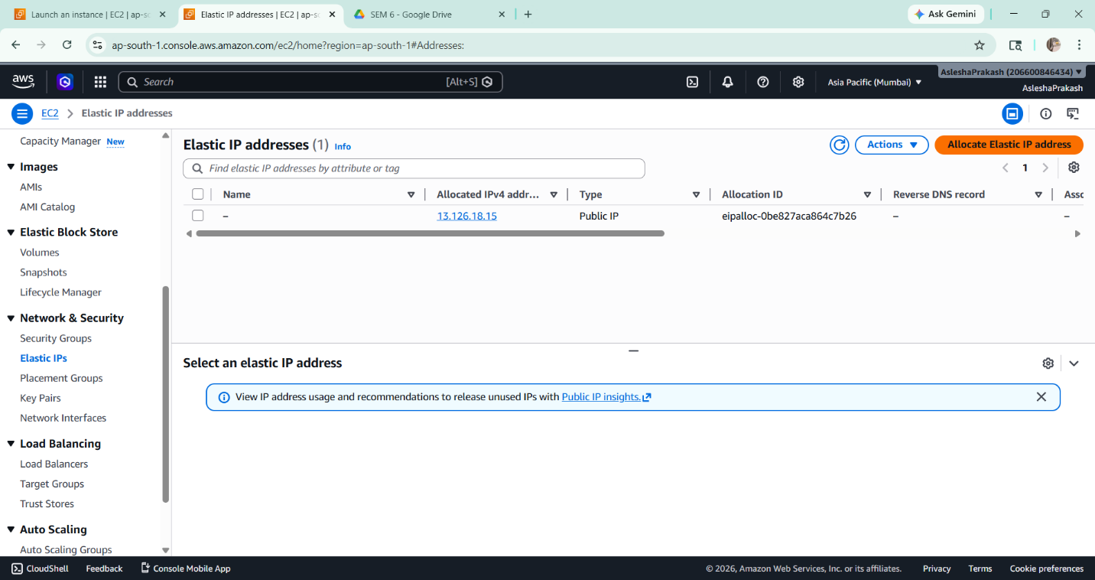

- A new Elastic IP address is allocated by clicking on the Allocate Elastic IP address button. Default settings are used, and the allocation is confirmed. 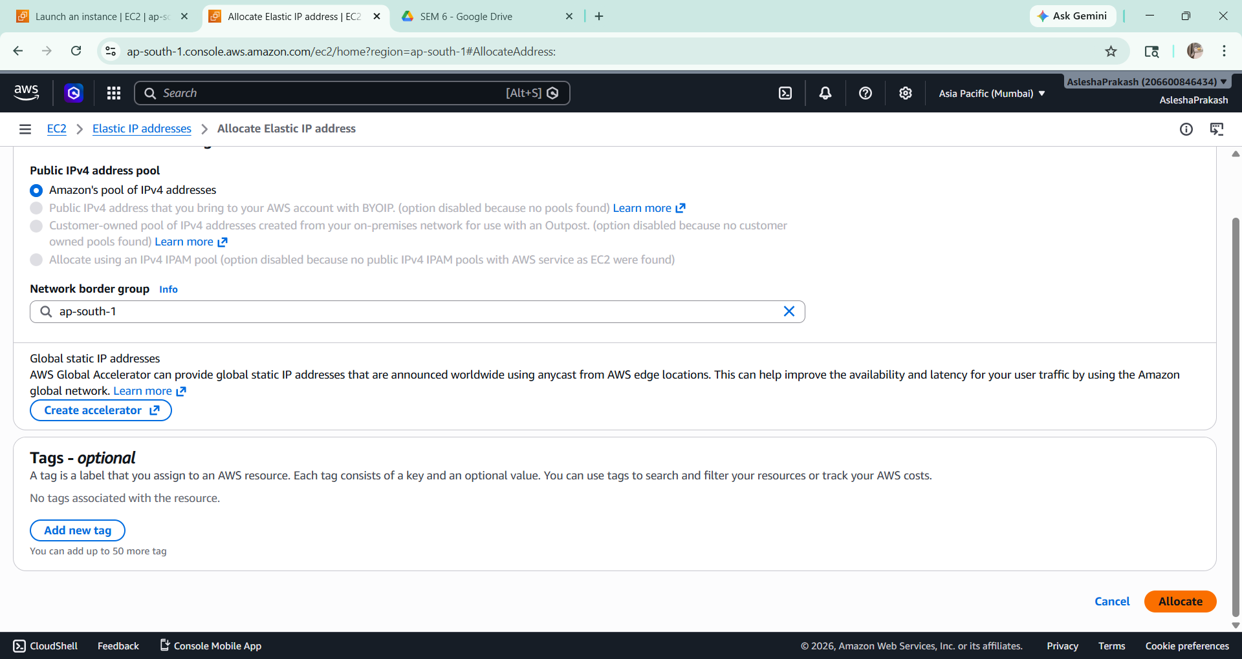

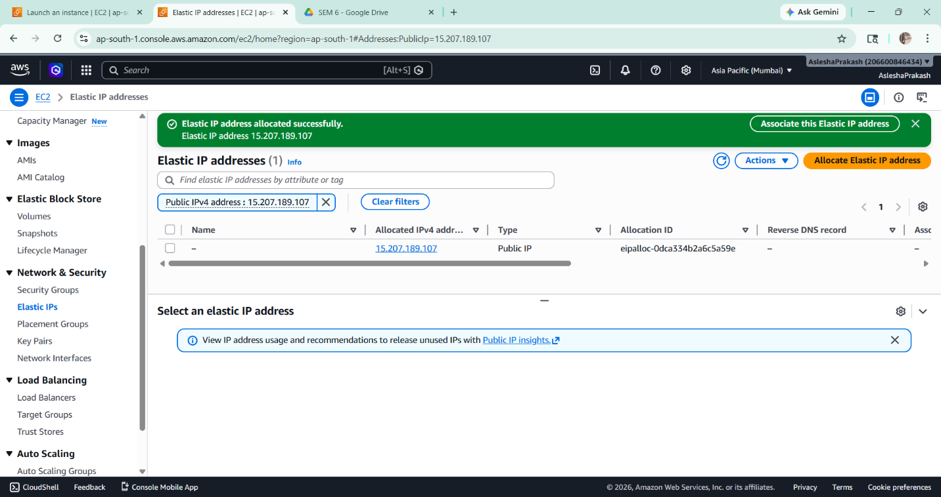

- The allocated Elastic IP is selected, and the Associate Elastic IP address option is chosen. 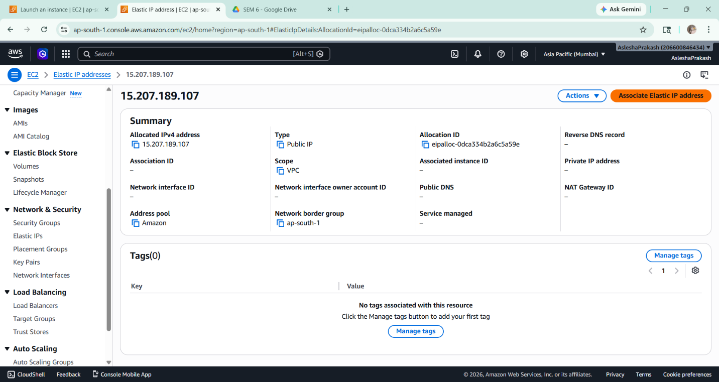

- The required EC2 instance is selected from the list, and the private IP address is kept as default. The association is completed successfully.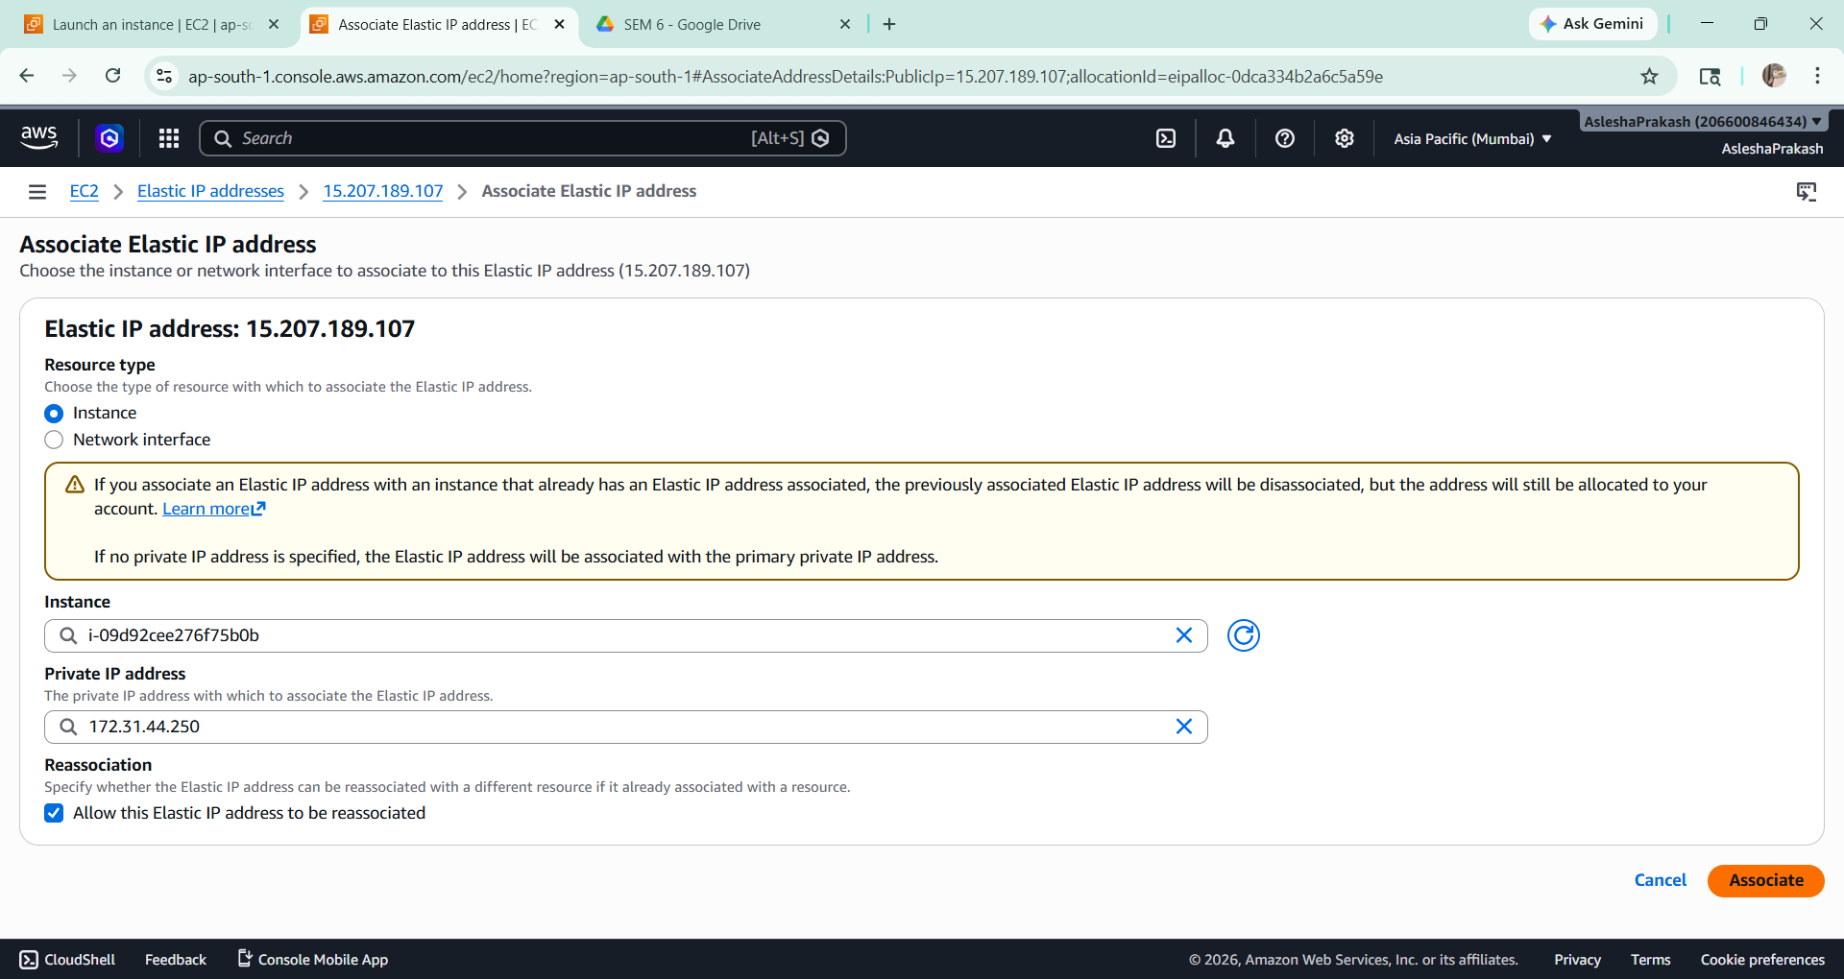

- The instance details page is opened again, and it is verified that the public IPv4 address is now replaced by the Elastic IP address, indicating successful association.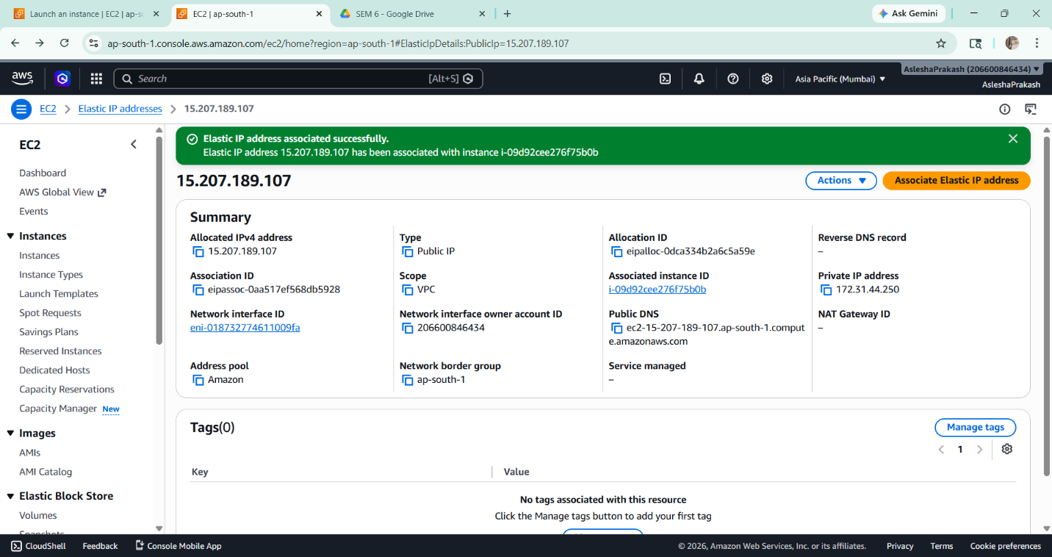 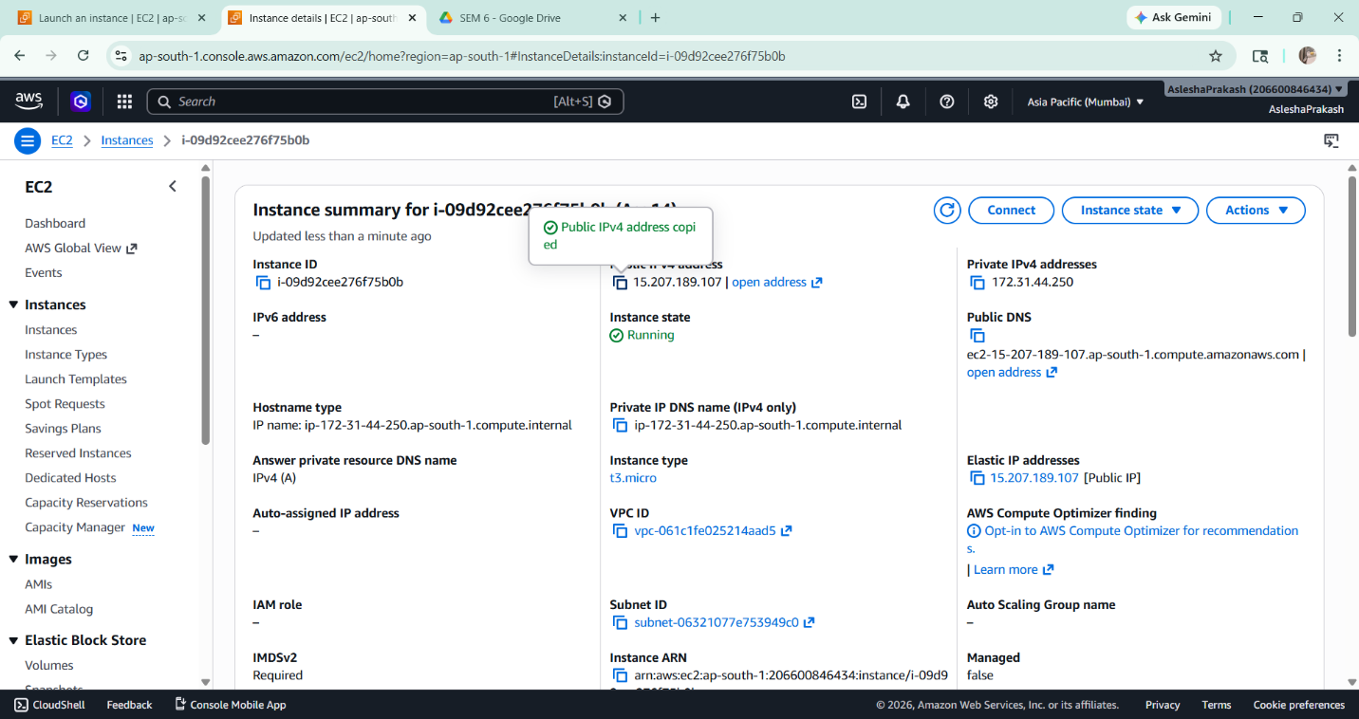

- The instance is stopped and started again to verify the behavior. It is observed that the public IP address remains unchanged after restar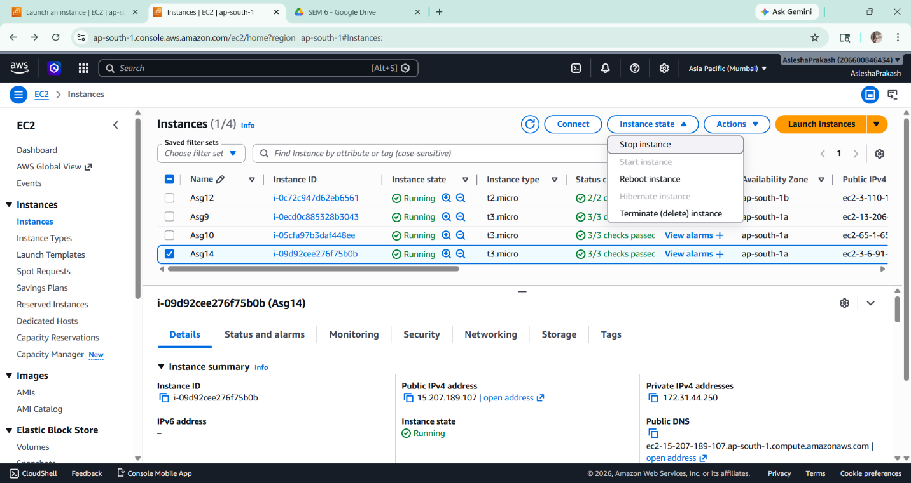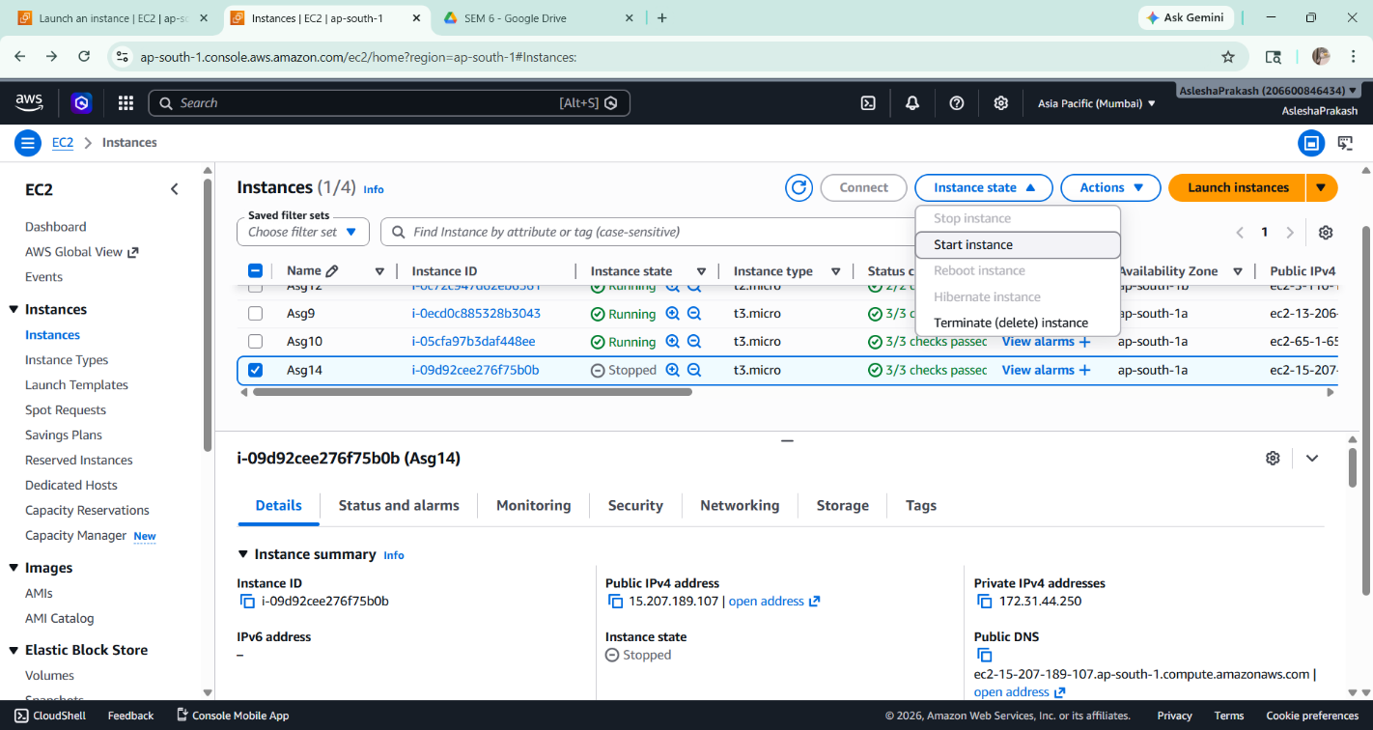
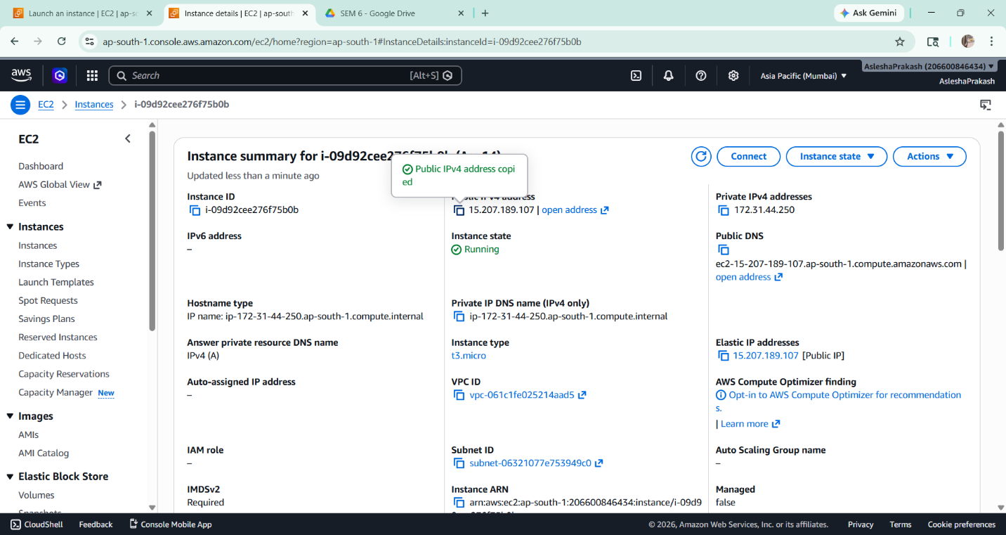
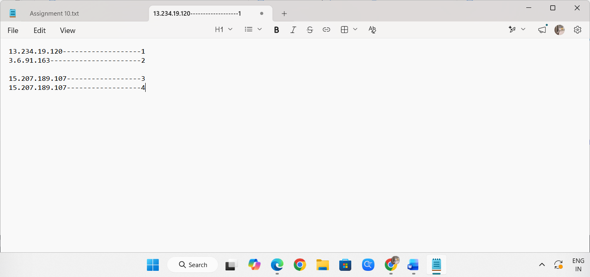

An Elastic IP address was successfully created and associated with the EC2 instance. The public IP address remained constant even after stopping and restarting the instance, ensuring a stable and static IP for the server.

