Assignment – 01:
Create an account in AWS and configure a budget.

Steps:
- Login to AWS console and select the Root-User.
- Type the email address and do next.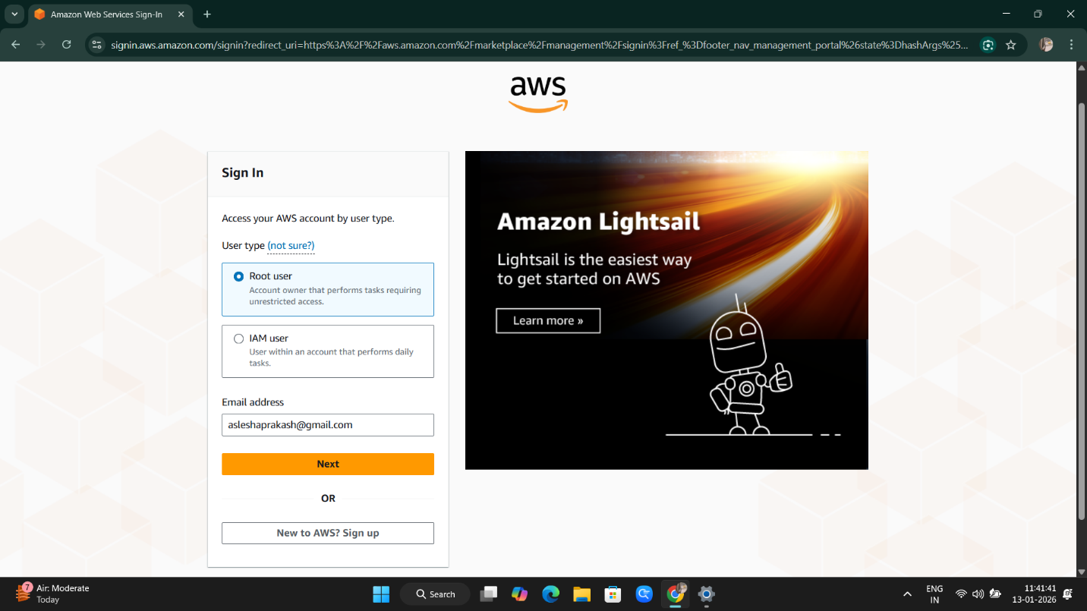

- Go to the Billing and Cost Management.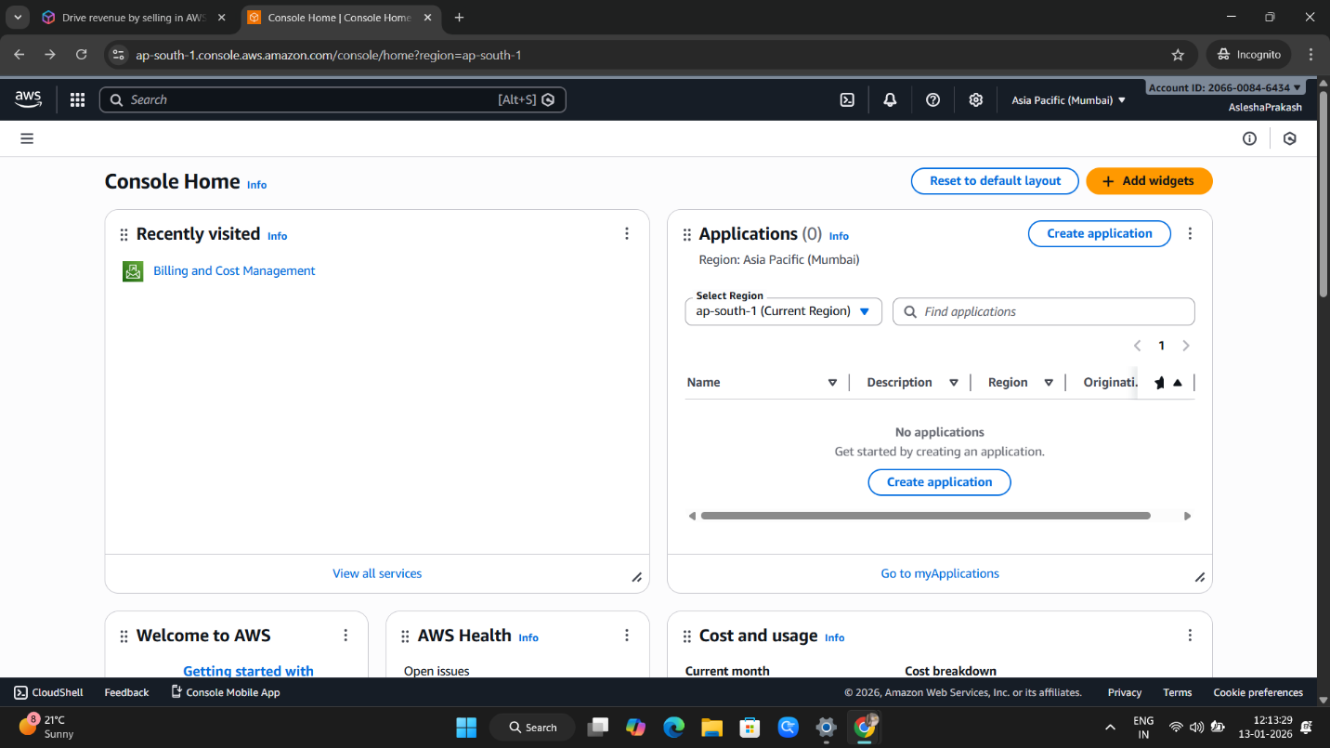

- Choose the Budget from the left panel.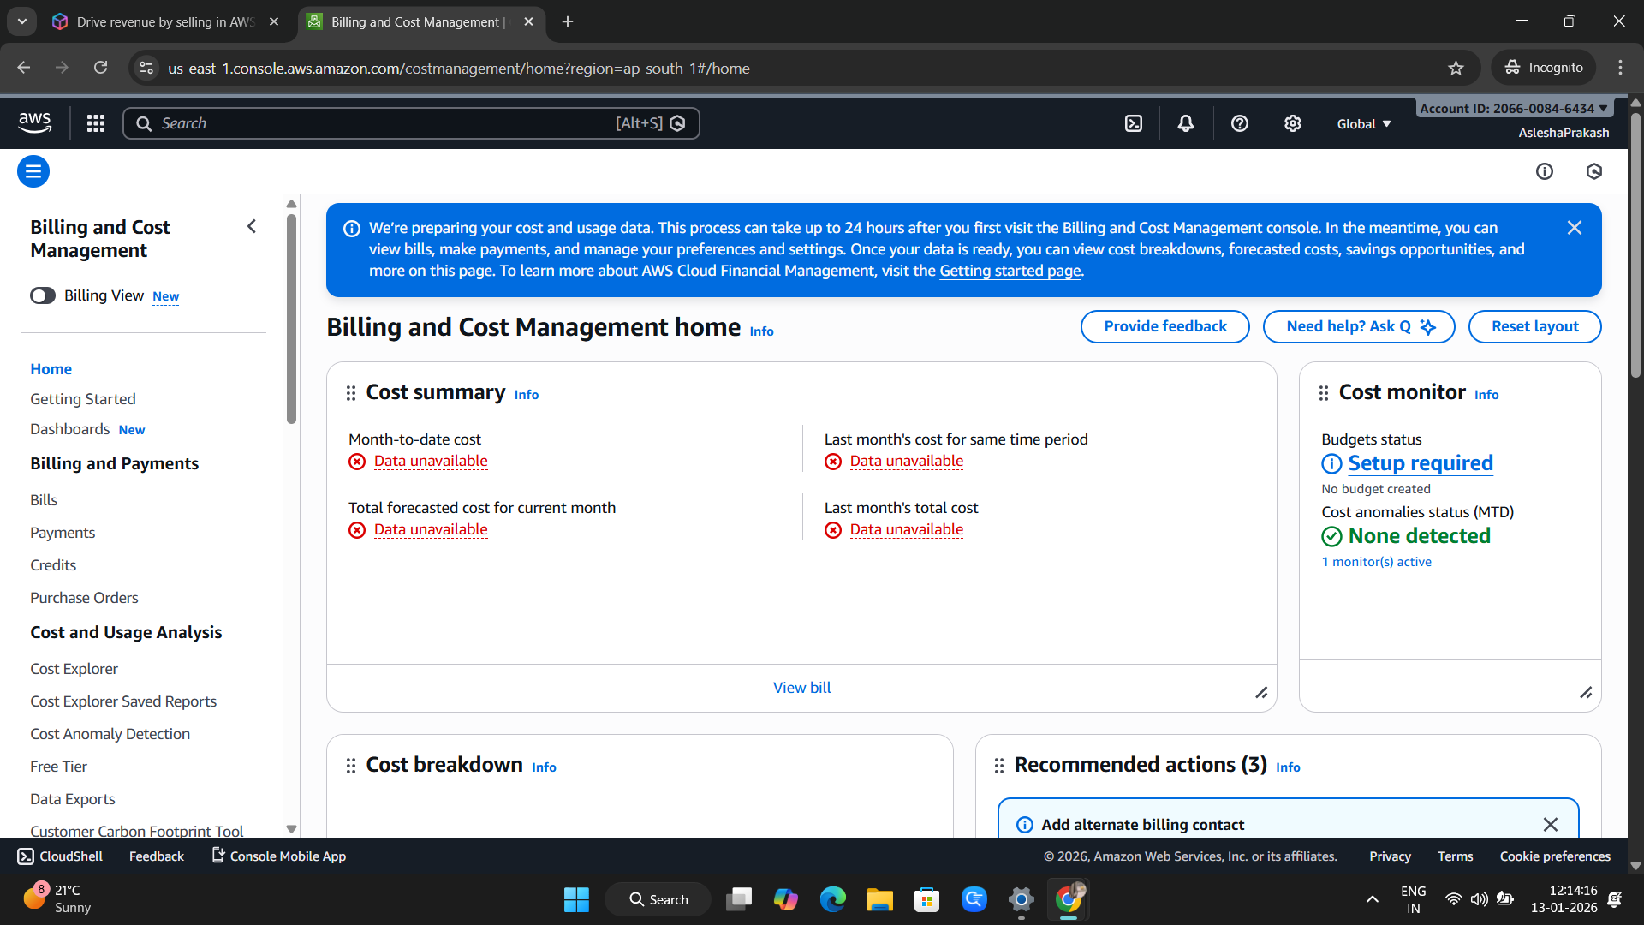

- Choose Create Budget.
- Choose Budget Type as follows options are chosen.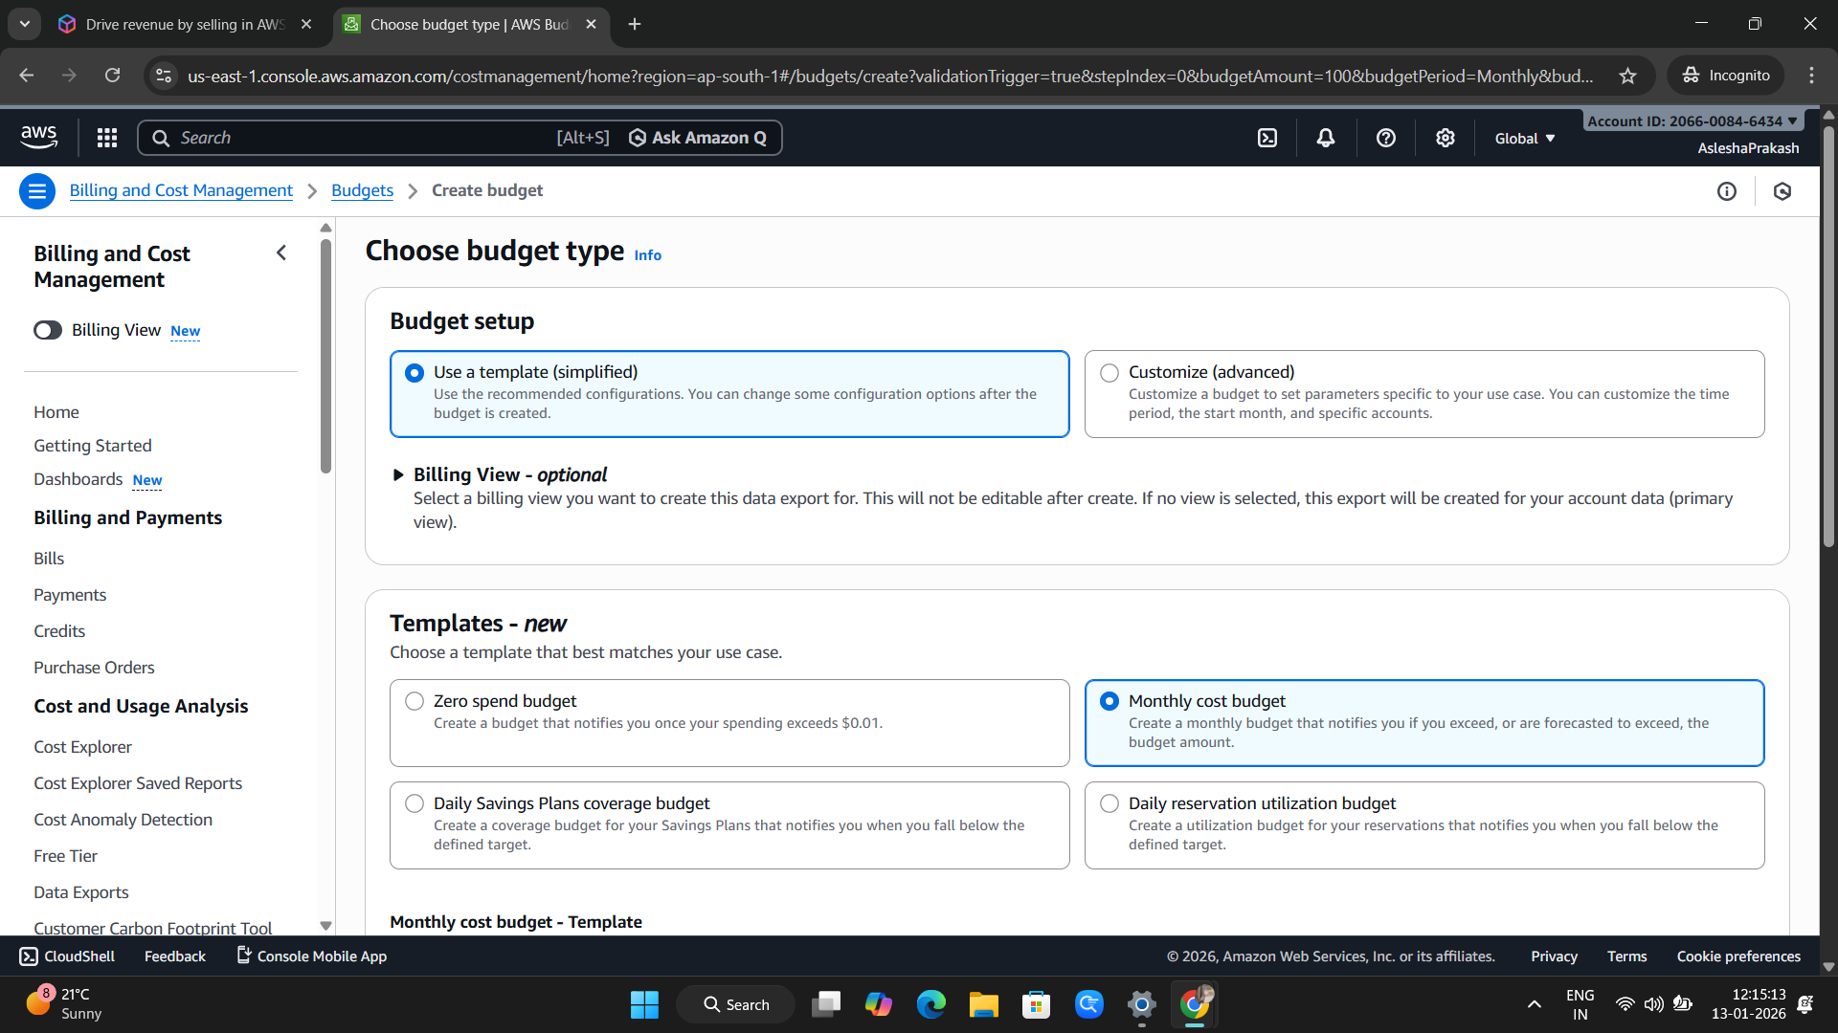

- Choose the Create Budget option below. 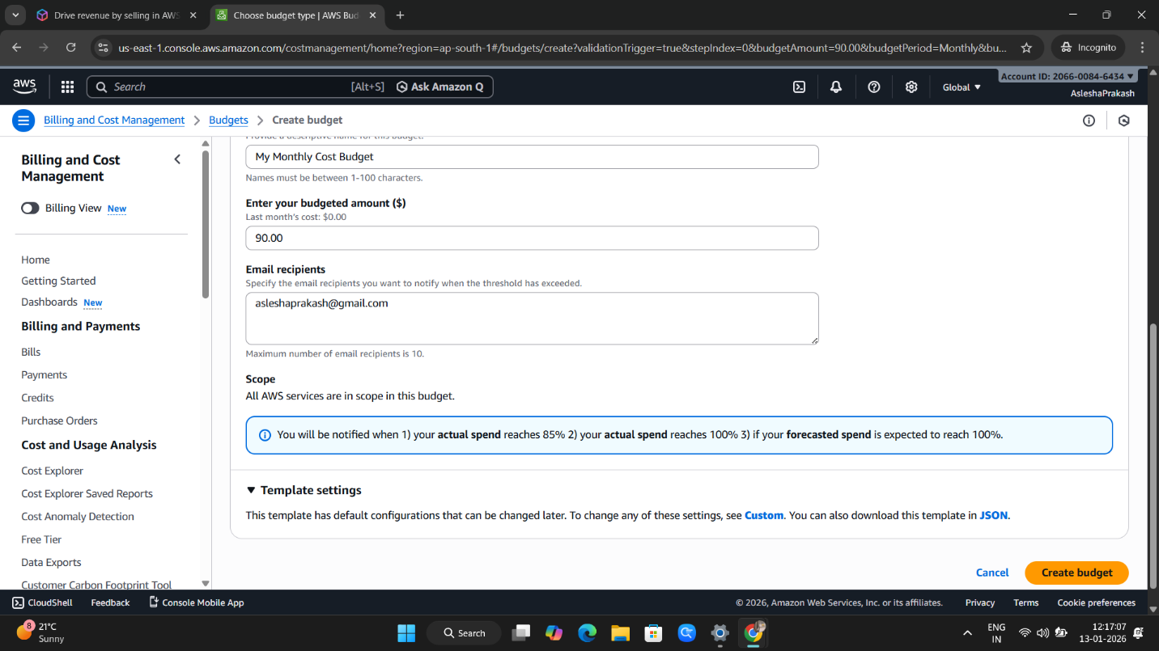

- Budget is created of name – My Monthly Cost Budget.