Assignment – 02:
Create MFA for authentication.

Steps:
- Sign-in to the AWS console account.
- Choose the Security credentials from the right-side panel.
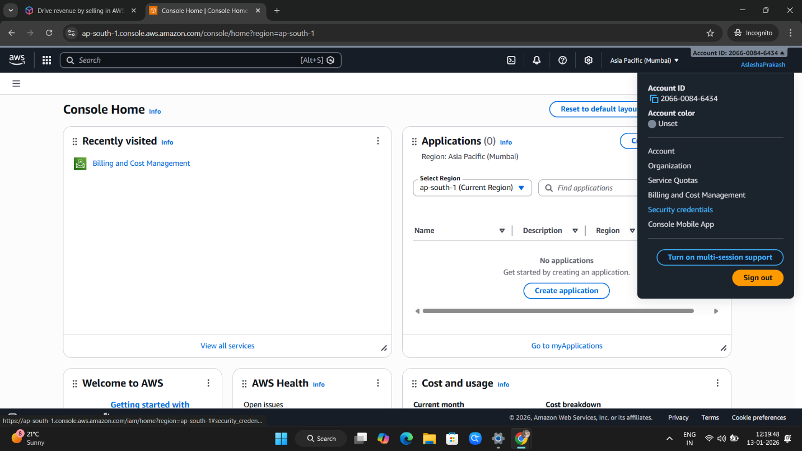

- Now Assign MFA device.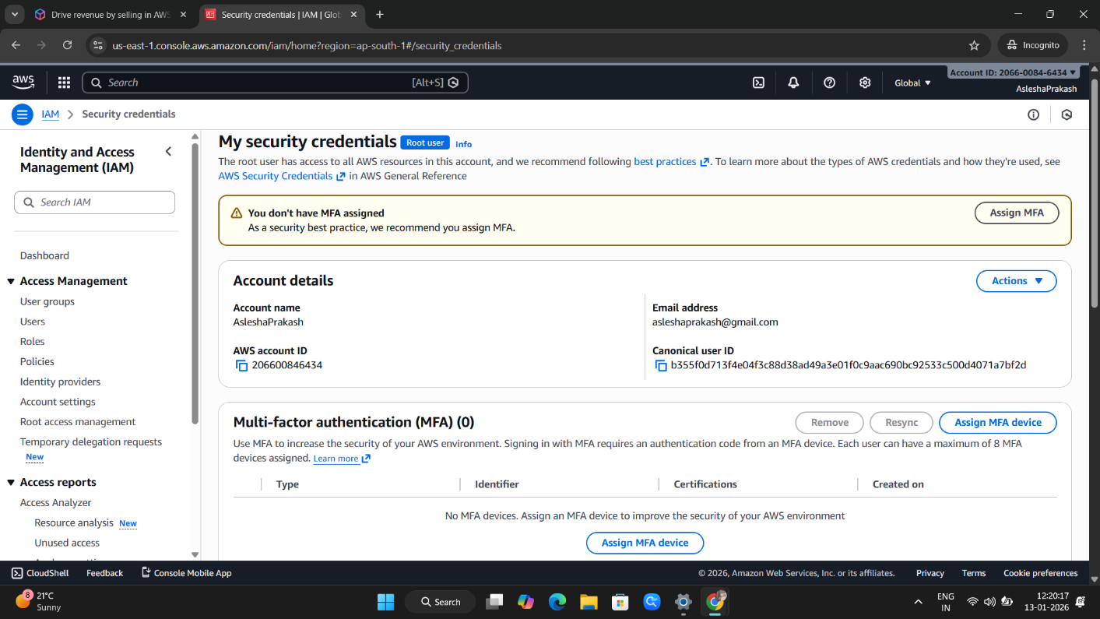

- Choose the Authenticator app.
**Note: Install Google Authentication app in phone.
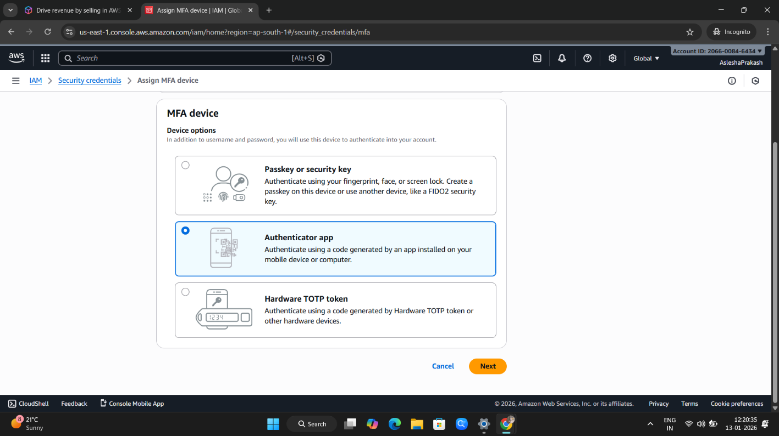

- Set an MFA device name. 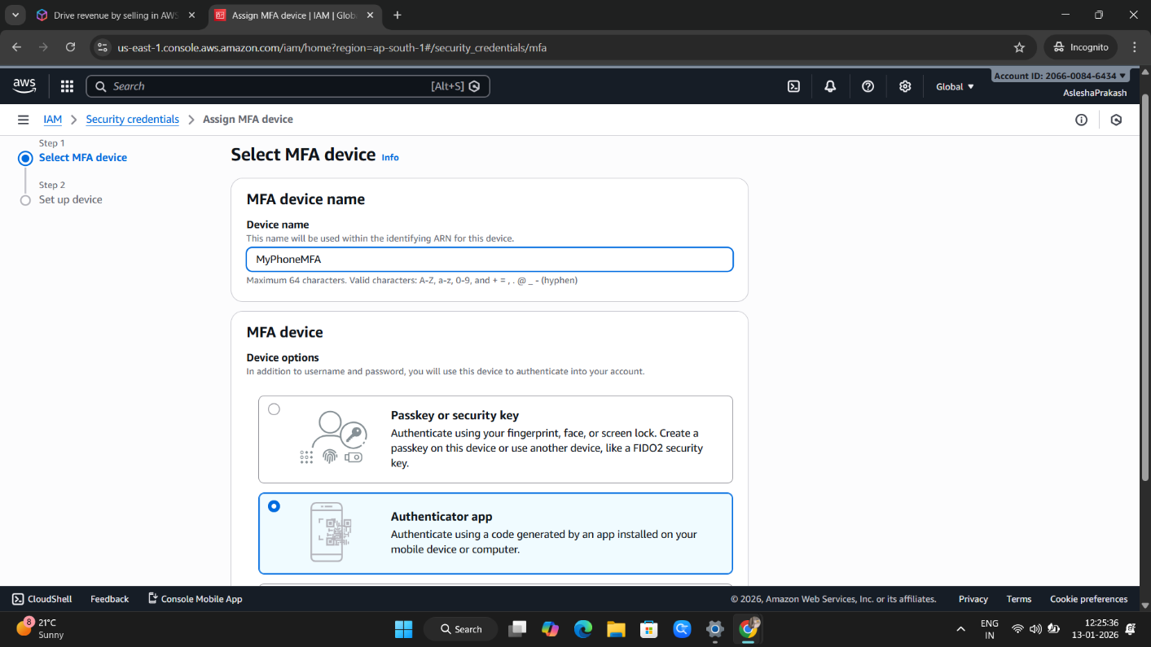

- Scan the QR by the Authentication app from the mobile which we have installed earlier and type the two consecutive MFA code from the authenticator.
- Choose the Add MFA button below.