Assignment – 09:
Problem Statement: Deploy a project from GitHub to EC2.
Steps:
- The GitHub website is opened in a web browser and the user is signed in using valid credentials. If an account does not exist, a new account is created.

- The AWS account is also signed in and an EC2 instance is created. The instance is then connected using the Bitvise SSH Client.

- The New Terminal Console option is selected from the left sidebar of Bitvise. A terminal window is opened and the system is updated and required software is installed using:
  - sudo apt-get update && sudo apt-get upgrade
  - sudo apt-get install nginx
  - nginx -v
  - curl -Sl https://deb.nodesource.com/setup_18.x | sudo -E bash -
  - sudo apt install nodejs
  - node -v
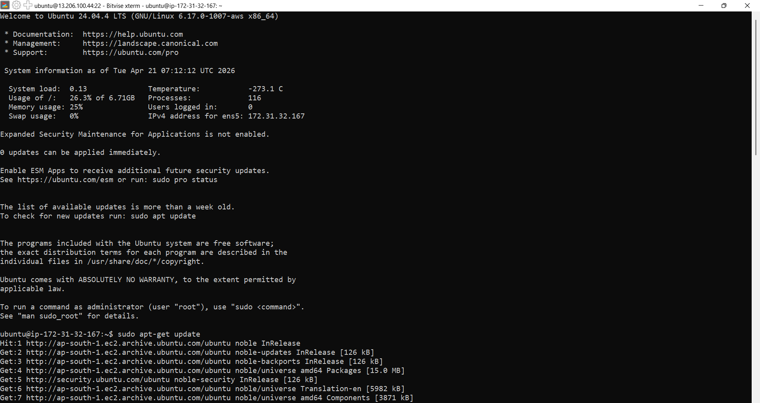
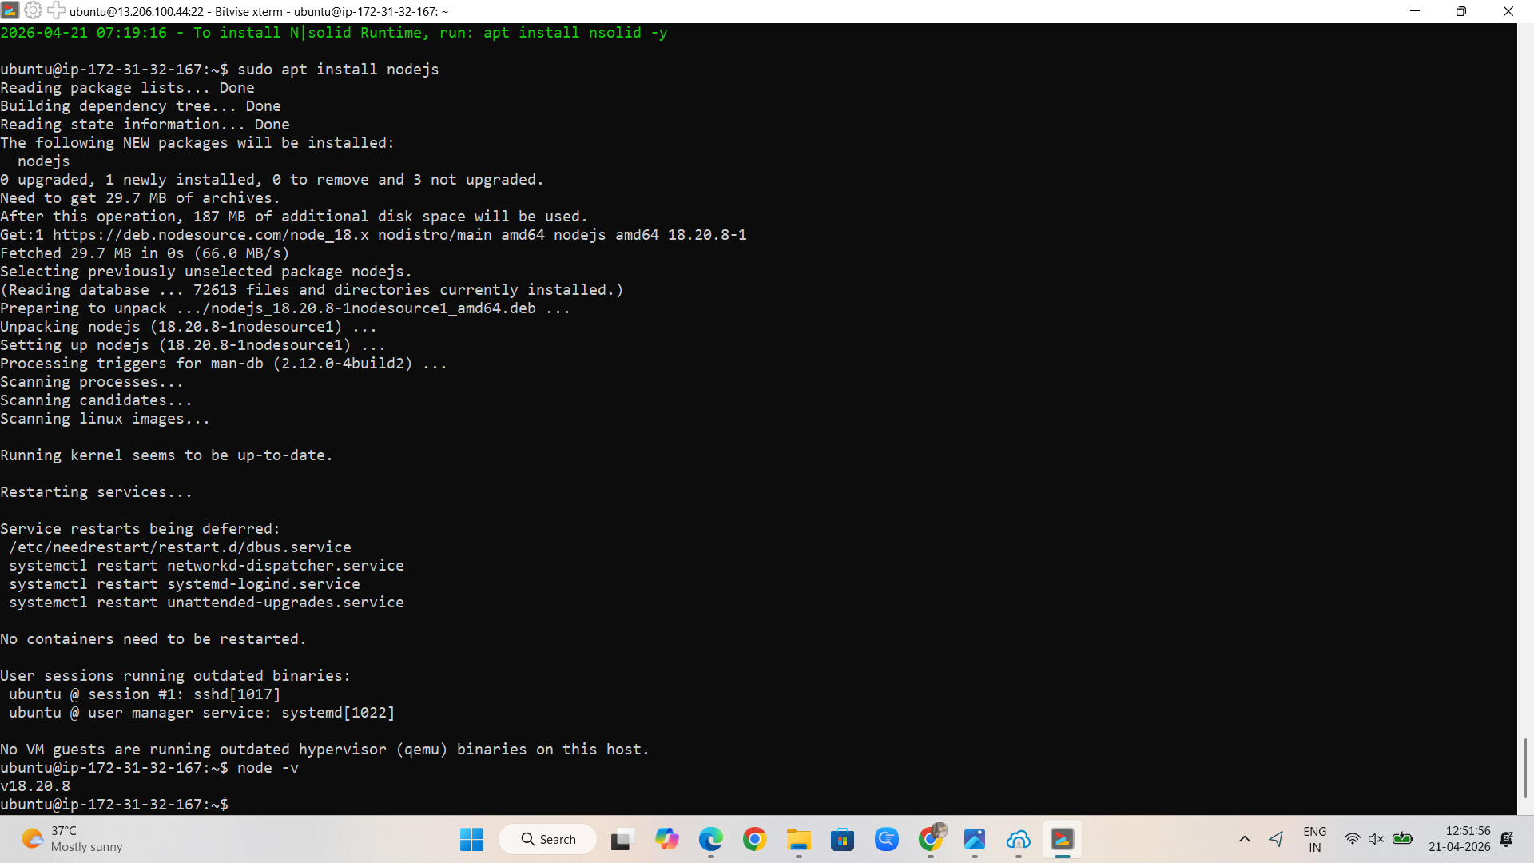
- The terminal is minimized and the GitHub repository is opened in a browser. The repository URL is copied using the Code option.
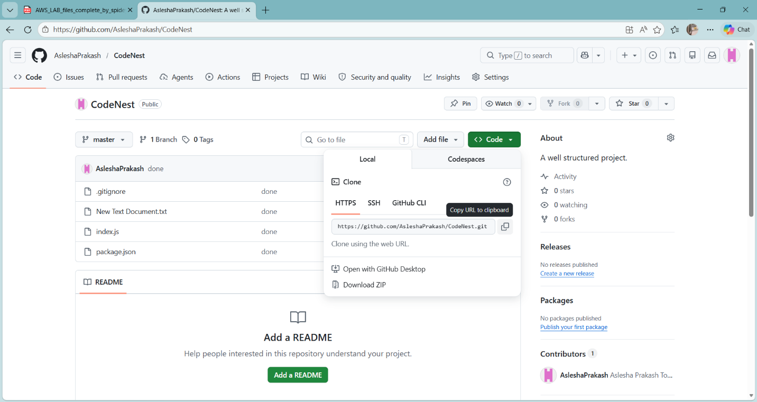

- The terminal is accessed again and the repository is cloned into the server using:
  - git clone <repository-link>
- The repository directory is opened and files are verified:
  - cd <repository-name>
  - ls -A
- The required dependencies are installed:
  - npm install
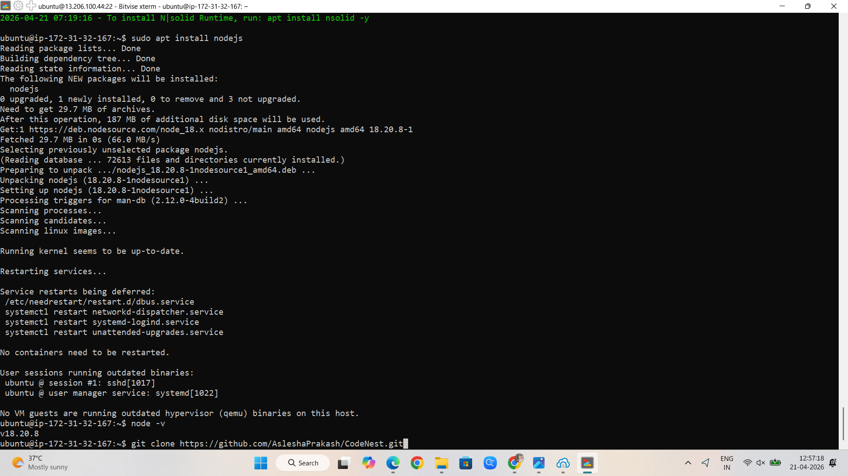

- The AWS EC2 Instances page is opened and the required instance is selected. The page is scrolled down and the Security tab is selected from the section bar.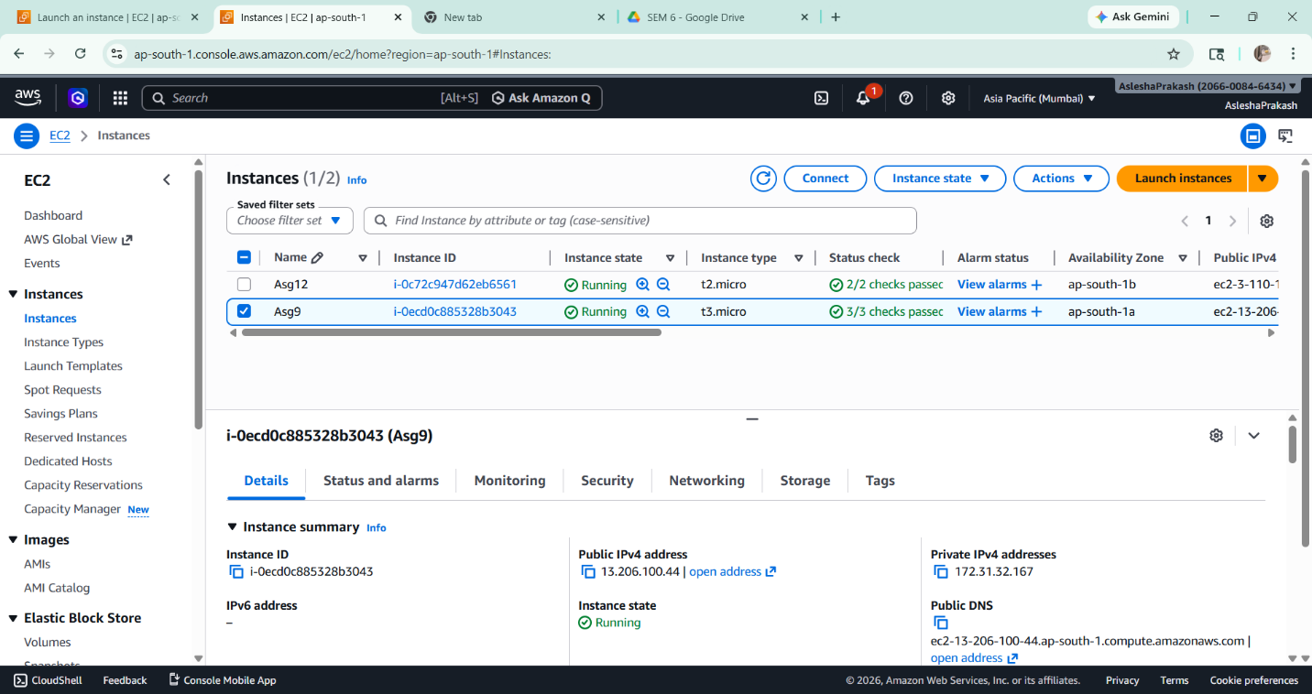
- The Security Groups link is opened and the Edit Inbound Rules option is selected. 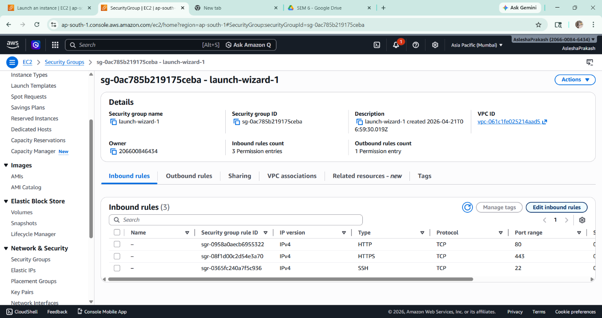

- A new rule is added by clicking on the Add Rule button.
- The rule is configured with type as Custom TCP, the required port number (e.g., 4000) is entered, and the source is set to 0.0.0.0/0.
- The changes are saved by clicking on the Save Rules button.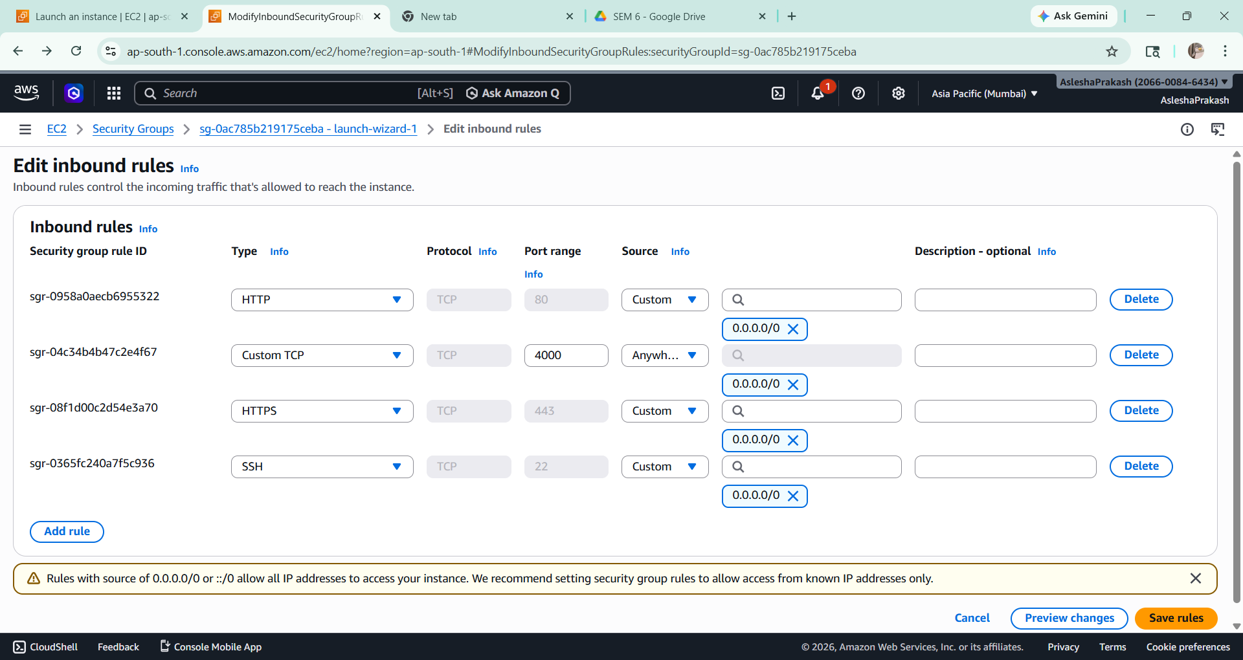

- The server is started in the terminal using:
  - node index.js
- The public IPv4 address of the EC2 instance is copied and accessed in a browser along with the port number:
  - http://<public-ip>:<port>
- The website is successfully loaded, confirming deployment.
- Changes are made in the GitHub repository and committed.
- The running server is stopped using:
  - Ctrl + C
- The updated files are pulled into the EC2 instance:
  - git pull
- The server is restarted:
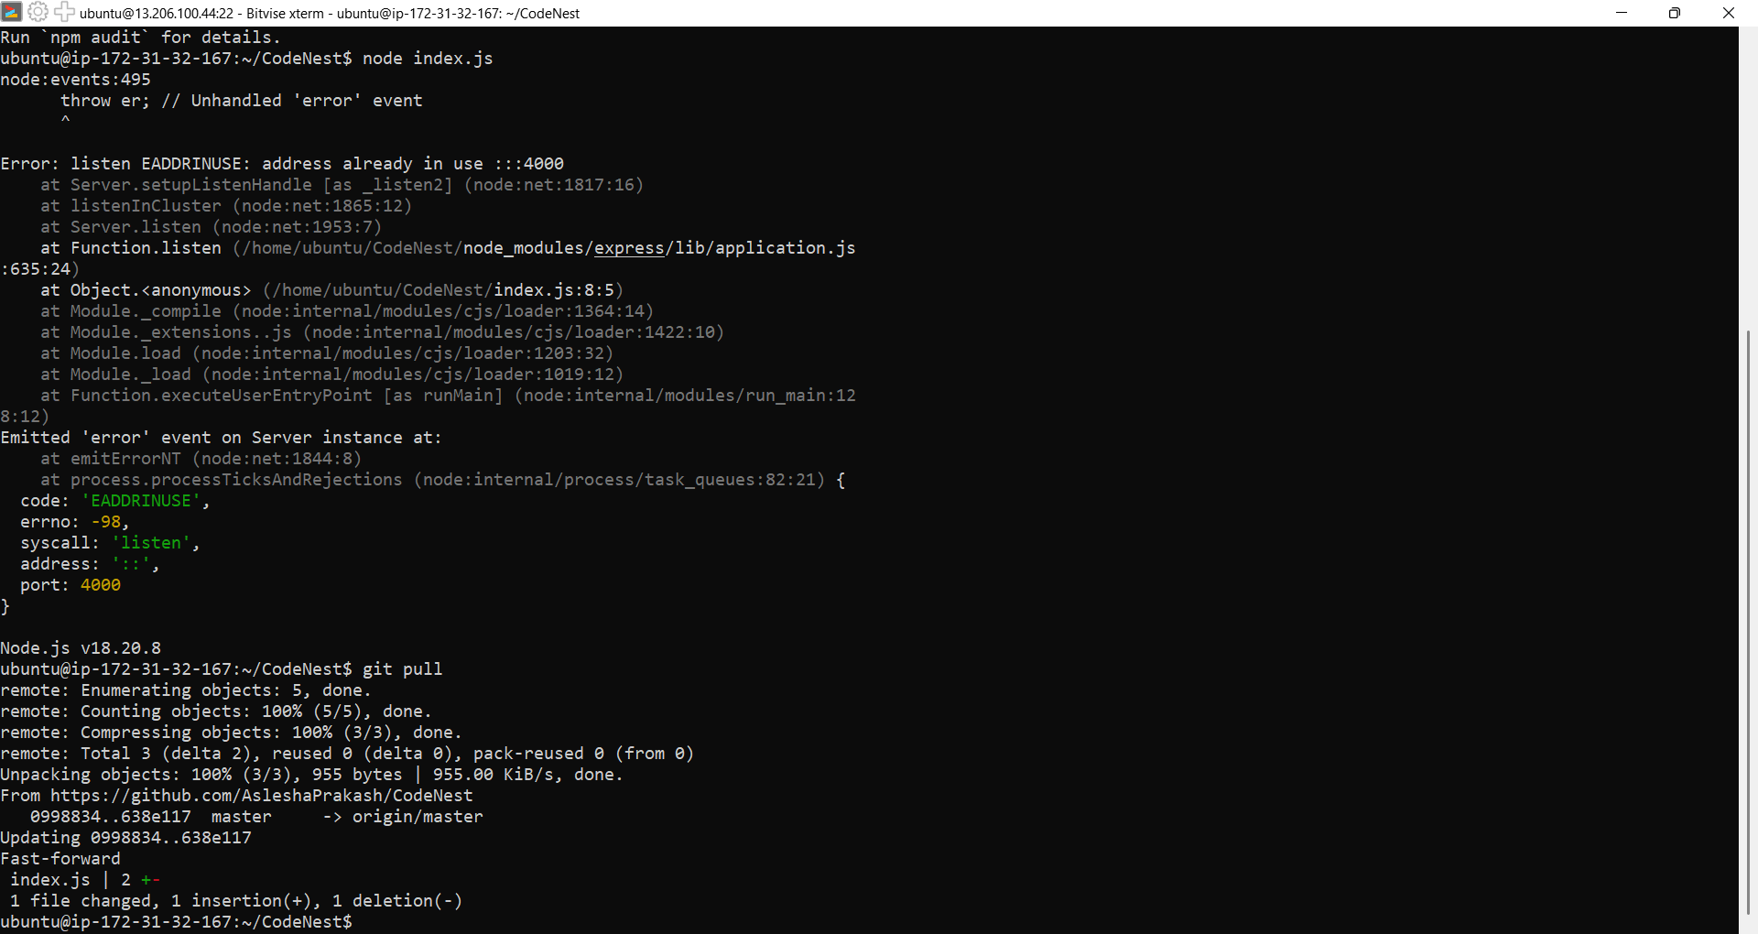
  - node index.js

- The browser is refreshed and the changes are observed successfully.